Movement graphs

Lisa

Wednesday, September 07, 2016

This document contains graphs of each recovered pinpoint tag.

Daily_dist is the distance traveled between 07:00 and 17:00.

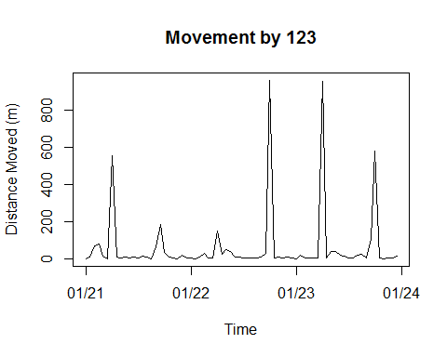

## Mean_daily_distance= 265.39 m  
## Number of days monitored: 3  
## Velocity= 1.04 m/min

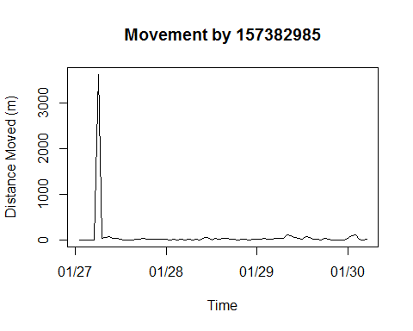

## Mean_daily_distance= 256.11 m  
## Number of days monitored: 4  
## Velocity= 1.19 m/min

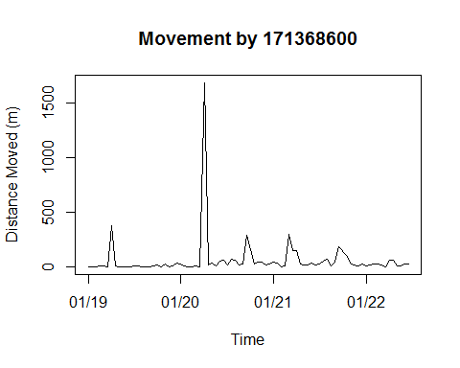

## Mean_daily_distance= 259.74 m  
## Number of days monitored: 5  
## Velocity= 0.94 m/min

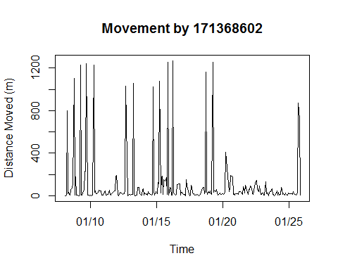

## Mean_daily_distance= 682.69 m  
## Number of days monitored: 18  
## Velocity= 1.02 m/min

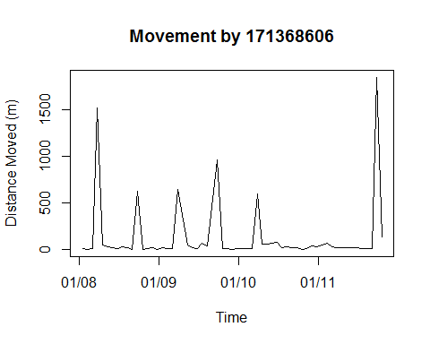

## Mean_daily_distance= 1047.15 m  
## Number of days monitored: 4  
## Velocity= 1.38 m/min

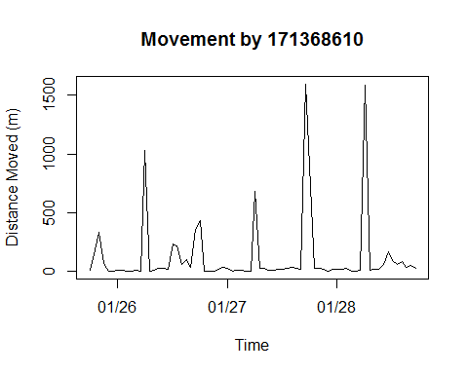

## Mean_daily_distance= 867.27 m  
## Number of days monitored: 4  
## Velocity= 1.89 m/min

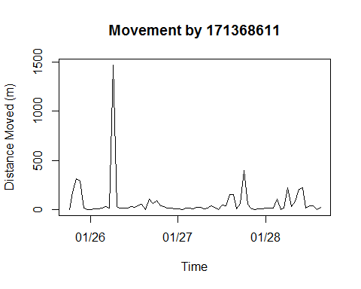

## Mean_daily_distance= 414.7 m  
## Number of days monitored: 4  
## Velocity= 1.26 m/min

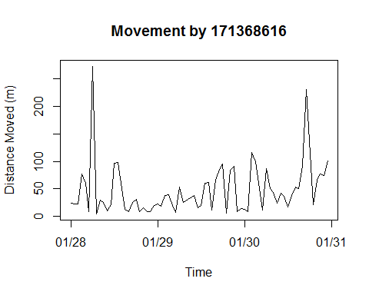

## Mean_daily_distance= 361.01 m  
## Number of days monitored: 4  
## Velocity= 0.75 m/min