Thanks for downloading a sample plan
from Bplans.com

A sample plan is a great way to get started, but you can’t just print this plan out and turn it into the bank. You’re still going to have to put in all your own information and do all of your own financial forecasts.

With LivePlan, you can easily use this sample as inspiration and create your own plan, complete with financial tables and graphs. You’ll also be able to:

• Save time with linked financial tables (the formulas are built in,
so you don’t have to do the calculations!)
• Benefit from tons of help, advice, and resources.
• Present your plan with confidence, with automatic charts and
graphs corresponding to your financial data.
• Work on your plan anywhere, on any computer.

“For 20 dollars I ended up getting a quarter of a million dollars of funding. That’s worth it!” – Todd C. Tablegate

Click here to save 50% off the first month of LivePlan!
Cover Page


This sample business plan has been made available to users of Business Plan Pro®, business planning software published by Palo Alto Software, Inc. Names, locations and numbers may have been changed, and substantial portions of the original plan text may have been omitted to preserve confidentiality and proprietary information.
You are welcome to use this plan as a starting point to create your own, but you do not have permission to resell, reproduce, publish, distribute or even copy this plan as it exists here.
Requests for reprints, academic use, and other dissemination of this sample plan should be emailed to the marketing department of Palo Alto Software at marketing@paloalto.com. For product information visit our Website: www.paloalto.com or call: 1-800-229-7526.
Copyright © Palo Alto Software, Inc., 1995-2009 All rights reserved.
Legal Page
Confidentiality Agreement
The undersigned reader acknowledges that the information provided by _______________ in this business plan is confidential; therefore, reader agrees not to disclose it without the express written permission of _______________.
It is acknowledged by reader that information to be furnished in this business plan is in all respects confidential in nature, other than information which is in the public domain through other means and that any disclosure or use of same by reader, may cause serious harm or damage to _______________.
Upon request, this document is to be immediately returned to _______________.
___________________
Signature
___________________
Name (typed or printed)
___________________
Date
This is a business plan. It does not imply an offering of securities.

1.0 Executive Summary 1
Chart: Highlights 1
2.0 Company Summary 2
Table: Past Performance 3
3.0 Products 3
4.0 Market Analysis Summary 4
4.1 Market Segmentation 5
Chart: Market Analysis (Pie) 6
Table: Market Analysis 6
4.2 Distribution Strategy 6
4.3 Market Trends 7
5.0 Competition and Buying Patterns 9
5.1 Competitive Edge 9
6.0 Strategy and Implementation Summary 10
6.1 Sales Strategy 10
Table: Sales Forecast 11
Chart: Sales Monthly 12
Chart: Sales by Year 12
7.0 Management Summary 13
Table: Personnel 13
8.0 Financial Plan 13
8.1 Important Assumptions 13
Table: General Assumptions 13
Chart: Break-even Analysis 14
Table: Break-even Analysis 14
Table: Profit and Loss 15
Chart: Profit Monthly 16
Chart: Profit Yearly 16
Chart: Gross Margin Monthly 17
Chart: Gross Margin Yearly 17
8.4 Projected Cash Flow 18
Chart: Cash 18
Table: Cash Flow 19
8.5 Projected Balance Sheet 20
8.5 Projected Balance Sheet 20
Table: Balance Sheet 20
8.6 Business Ratios 21
8.6 Business Ratios 21
Table: Ratios 21
Table: Sales Forecast 1
Table: Personnel 2
Table: Personnel 2
Table: General Assumptions 3
Table: General Assumptions 3
Table: Profit and Loss 4
Table: Profit and Loss 4
Table: Cash Flow 5
Table: Cash Flow 5
Table: Balance Sheet 6

1.0 Executive Summary
New Look is a recent (last spring) start-up manufacturer of an upscale clothing line targeted at males between the ages of 20 and 40. New Look not only develops the clothing line, but supports it with advertising and promotion campaigns. The company plans to strengthen its partnership with retailers by developing brand awareness. New Look intends to market its line as an alternative to existing clothing lines, and differentiate itself by marketing strategies, exclusiveness, and high brand awareness.
The key message associated with the New Look line is classy, upscale, versatile, and expensive clothing. The company's promotional plan is diverse and includes a range of marketing communications. In the future, the company hopes to develop lines of accessories for men, women, and children. These accessories will include cologne/perfume, jewelry, eyewear, watches, etc.

Chart: Highlights
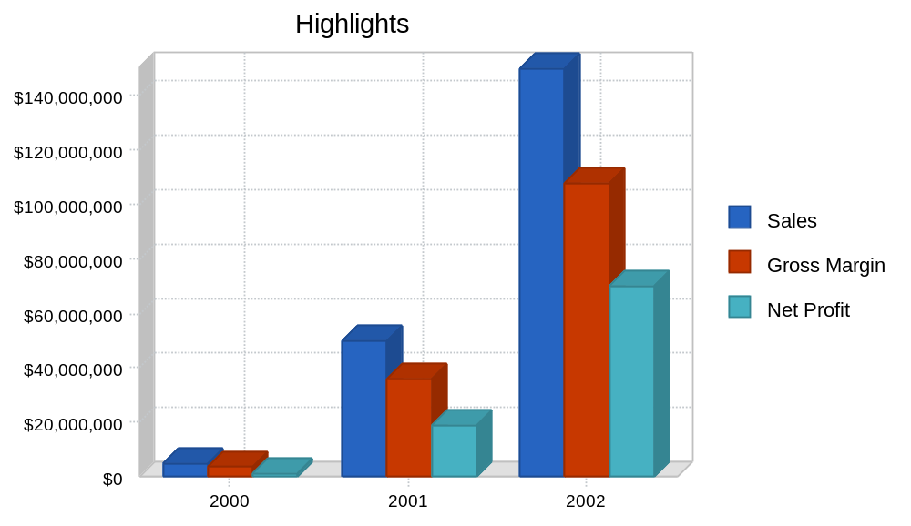

2.0 Company Summary
Mission
The mission of the company is to provide a new look for consumers, based on style and quality.
Legal Business Description
New Look was founded as a Tennessee C-Corporation with principal offices located in Memphis, TN. All operations, from administration to marketing strategies, take place at this leased office location of approximately 500 square feet.
Strategy
The New Look strategy is to aggressively develop and market a full range collection to consumers. The company intends to market its line as an alternative to existing clothing lines and differentiate itself through its marketing strategies, exclusiveness, and brand awareness. New Look intends to build on its core portfolio of products and overcome any obstacles by using the company's expertise in the clothing industry.
The company's goal in the next year is to make an overwhelming impact on the fashion industry and create a large consumer demand for the product. The company's goal in the next 2-5 years is to venture into women's and children's clothing. It plans to also license a line of cologne and perfume, bedding, underwear, small leather goods, jewelry, and eyewear. According to Standard & Poor's (S&P's), women's apparel accounted for 52% of total apparel sales in 1998.
Strategic Relationships
The company has strategic alliances with Music Records and the Entertainment Group. These alliances are valuable to New Look because they provide the needed exposure for its line and the association of its products with celebrities. Celebrities are valuable assets because they receive free clothing for interviews, concerts, and music videos.

Table: Past Performance

Past Performance
 | 1997 | 1998 | 1999
Sales | $0 | $0 | $3,000,000
Gross Margin | $0 | $0 | $750,000
Gross Margin % | 0.00% | 0.00% | 25.00%
Operating Expenses | $0 | $0 | $1,200,000
Collection Period (days) | 0 | 0 | 34
Inventory Turnover | 0.00 | 0.00 | 6.00
Balance Sheet
 | 1997 | 1998 | 1999
Current Assets
Cash | $0 | $0 | $445,000
Accounts Receivable | $0 | $0 | $420,000
Inventory | $0 | $0 | $1,545,000
Other Current Assets | $0 | $0 | $105,000
Total Current Assets | $0 | $0 | $2,515,000
Long-term Assets
Long-term Assets | $0 | $0 | $525,000
Accumulated Depreciation | $0 | $0 | $80,000
Total Long-term Assets | $0 | $0 | $445,000
Total Assets | $0 | $0 | $2,960,000
Current Liabilities
Accounts Payable | $0 | $0 | $1,000,000
Current Borrowing | $0 | $0 | $1,090,000
Other Current Liabilities (interest free) | $0 | $0 | $410,000
Total Current Liabilities | $0 | $0 | $2,500,000
Long-term Liabilities | $0 | $0 | $355,000
Total Liabilities | $0 | $0 | $2,855,000
Paid-in Capital | $0 | $0 | $70,000
Retained Earnings | $0 | $0 | $35,000
Earnings | $0 | $0 | $0
Total Capital | $0 | $0 | $105,000
Total Capital and Liabilities | $0 | $0 | $2,960,000
Other Inputs
Payment Days | 0 | 0 | 30
Sales on Credit | $0 | $0 | $2,250,000
Receivables Turnover | 0.00 | 0.00 | 5.36

3.0 Products
New Look products will be priced at the high end to reflect the quality and exclusiveness associated with the brand. The company will use high-end materials such as cashmere, a wool blend, and high gauge denim. When a mark up is placed on New Look products, customers are willing to pay the premium because of the perceived value and quality guarantee that comes with all products. The New Look line is targeted at males between the ages of 20 and 40.

4.0 Market Analysis Summary
Market Description
Apparel sales are driven by economic conditions, demographic trends, and pricing. Fashion, while important for an individual company, plays a limited role in overall market demand. Sales of apparel at the retail level rose approximately 4.7% in 1998, according to NPD Group, Inc., a market research firm located in Port Washington, New York.
In 1998, Americans purchased approximately $215 billion of apparel and footwear. According to NPD Group Inc., approximately $177 billion was spent on clothing in 1998. The remaining $38 billion was used to purchase more than 1.1 billion pairs of shoes, based on data from Footwear Market Insights (FMI), a market research firm based in Nashville, TN. With the U.S. population at 270 million, this works out to roughly $800 a year per capita spent on apparel and footwear.
The apparel and footwear industries are highly competitive, and both have attempted to lower manufacturing costs by moving production to such places as Mexico, Central America, and Asia. As a result, employment levels for U.S. manufacturing industry employees fell to 713,000 in February 1999, according to the Department of Labor. This was down 10% from the year-earlier level and 52% from 1970. The number of domestic non-rubber footwear employees declined 15%, year to year, in 1998, and 86% since 1968, according to the Footwear Industries of America, an industry trade group based in Washington, D.C.
The Apparel Industry
The U.S. apparel industry is large, mature, and highly fragmented. Apparel sold in the United States is produced both domestically and in foreign locations. According to estimates from the American Apparel Manufacturers Association (AAMA), an industry trade group based in Arlington, Virginia, the dollar value of domestic apparel production was $39 billion at the wholesale level in 1997 (latest available), which was less than the $46 billion (U.S. wholesale value) of goods imported into the United States. In addition, $15 billion of goods were produced in both the United States and other countries.
The U.S. apparel market can be divided into two tiers: national brands and other apparel. National brands are produced by approximately 20 sizable companies and currently account for some 30% of all U.S. wholesale apparel sales. The second tier, accounting for 70% of all apparel distributed, comprises small brands and store (or private-label) goods.
Apparel is sold at a variety of retail outlets. Based on data from NPD Group, discount stores, off-price retailers, and factory outlets accounted for 30% of 1998 apparel sales, while specialty stores and department stores accounted for 22% and 18%, respectively. Another 17% were sold at major chains, and direct mail/catalogs accounted for 6%. The remaining 7% of apparel sales occurred through other means of distribution.

4.1 Market Segmentation
The company plans to target males between the ages of 20 and 40 with a combined household income of more than $40,000. Within this group, there are no color barriers, and customers have diverse backgrounds. The New Look customer is a versatile man who can fit into any environment and is willing to pay a high price for quality clothing.
The company's target group is seen as having enough disposable income to spend on high priced quality clothing. From 1984 to 1991, for example, disposable personal income grew at a healthy average annual of 7.0%. Apparel and footwear expenditures increased at a strong .2% annual rate during the same period. In the 1990s, however, growth in personal income slowed somewhat and so did apparel expenditures. From 1991 to 1998, disposable personal income rose at an average annual rate of 4.7%, while apparel and footwear expenditures grew 4.5% per year.
According to S&P's, in the men's apparel segment, much of the growth in spending is being driven by consumers with annual household incomes of more than $60,000. Spending in this segment increased by approximately 13% in 1998. Apparel purchases by men from households with incomes between $40,000 and $59,999 grew by 7% in 1998. Men's apparel sales at department stores and off-price retailers grew at double-digit rates in 1998.
As growth slows in the mature U.S. apparel and footwear markets, companies are increasingly looking overseas for growth opportunities. American brands translate well internationally, and many expanding economies overseas are interested in buying U.S. products. International business has therefore become a focus of some U.S. companies.
Many apparel and footwear manufacturers see Europe, with a population of 350 million, as an attractive market. Tommy Hilfiger and Polo Ralph Lauren recently opened flagship stores in London in an effort to build up their brands in Europe. Expansion in Asia, however, has been sidelined by economic troubles. In other parts of the world, footwear company Payless ShoeSource Inc., has been performing well in Canada and South America.

Chart: Market Analysis (Pie)
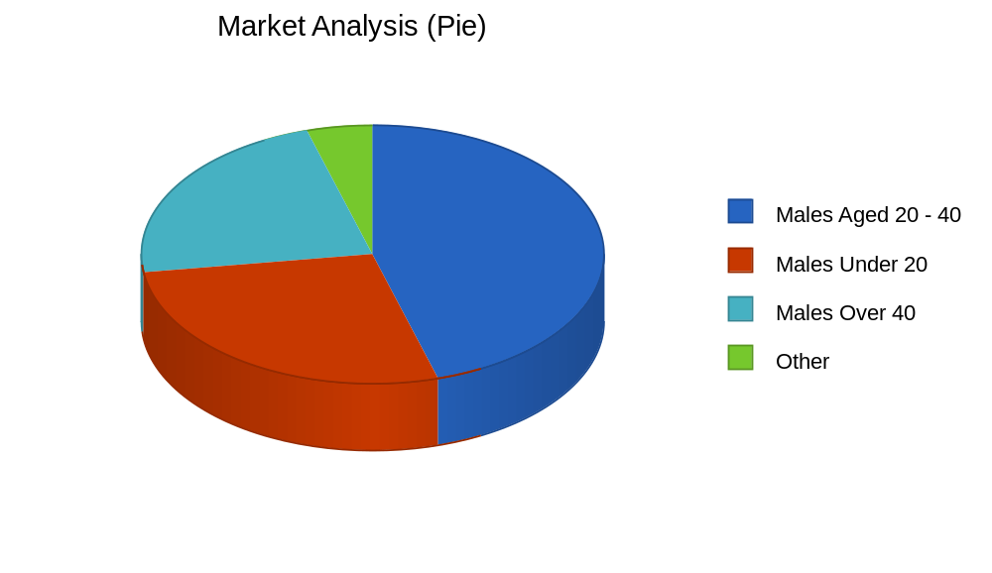

Table: Market Analysis

Market Analysis
 |  | 2000 | 2001 | 2002 | 2003 | 2004
Potential Customers | Growth |  |  |  |  |  | CAGR
Males Aged 20 - 40 | 15% | 2,500,000 | 2,875,000 | 3,306,250 | 3,802,188 | 4,372,516 | 15.00%
Males Under 20 | 10% | 1,500,000 | 1,650,000 | 1,815,000 | 1,996,500 | 2,196,150 | 10.00%
Males Over 40 | 10% | 1,250,000 | 1,375,000 | 1,512,500 | 1,663,750 | 1,830,125 | 10.00%
Other | 0% | 250,000 | 250,000 | 250,000 | 250,000 | 250,000 | 0.00%
Total | 11.98% | 5,500,000 | 6,150,000 | 6,883,750 | 7,712,438 | 8,648,791 | 11.98%

4.2 Distribution Strategy
New Look plans to use a direct sales force, retailers, and the Internet to reach its markets. These channels are most appropriate because of time to market, reduced capital requirements, and fast access to established distribution channels. The manufacture of denim is expected to take place in Mexico. Sweaters will be manufactured locally at first, and will later take place in Italy and Hong Kong. Upon arrival, the clothing will be placed in a warehouse. Initially, the company plans to use a consolidated warehouse before acquiring a warehouse of its own.
As companies in these mature industries continually look for ways to compete effectively, U.S. apparel and footwear manufacturers have increasingly moved their production facilities to lower-cost locations outside of the United States. Although some manufacturers have moved operations completely offshore, others are retaining a few production facilities in the United States to manufacture products requiring a quick turnaround time.
While manufacturing in Asia remains substantial, the growth of apparel manufacturing in Mexico and the Caribbean has been significant due to the North American Free Trade Agreement (NAFTA) and the lowering of tariffs. Apparel assembled in Mexico and the Caribbean nations from fabric formed and cut in the United States accounted for 27% of all apparel imports in 1998, up from 9% in 1990.
With an improved economic outlook, Asian currencies have strengthened against the U.S. dollar over the past year. For example, the Thai bhat and Korean won appreciated 13% and 20%, respectively, from June 1998 to June 1999. While this has benefited U.S. exports somewhat, it has put pricing pressures on imported Asian goods. For the vast amount of goods manufactured in China, however, no such benefit is currently expected, as this country's currency has remained fixed in value versus the U.S. dollar.

4.3 Market Trends
Leaner inventories, but continued pricing pressures
After several years of inventory build-ups, the apparel industry's inventory-to-sales ratio declined steeply in 1996, and through 1998 it remained near its lowest levels in 16 years. According to the U.S. Department of Commerce, the inventory-to-sales ratio was 1.49 as of May 1999, significantly below the 1.74 of a year earlier.
After several difficult years and many bankruptcies in the early 1990s, the apparel industry is relatively healthier overall, and its lower inventory levels are a sign of that. Despite the lean inventories, however, prices of women's apparel declined in the first 6 months of 1999, compared with year-earlier levels, after rising slightly in 1998. S&P's still expects some degree of apparel pricing pressure to persist in the near future. Intensifying competition doesn't bode well for apparel manufacturers' ability to raise prices. Companies are continually searching around the globe for cheaper sourcing and are looking for ways to cut operating costs. Consumers are also very value conscious-they want quality merchandise at the lowest possible price. This trend is evident in the successful growth of off-price retail stores.
Modest growth in '99
As with most mature industries, the apparel and footwear industries are experiencing intense competition and pricing pressures, while facing the need for constant product innovation. However, these industries are enjoying a great economic cycle, with low interest rates, low unemployment, strong consumer confidence, and a low savings rate. Consumers are continuing to spend at a healthy clip. As a result, S&Ps expects sales for the apparel industry to rise about 4% in 1999. We believe that maker's with strong brand recognition and those that are closely in tune with consumers' needs will enjoy average growth. The footwear industry faces a tougher environment, however, considering the still-high inventory levels and low-margin price points.
Apparel outlook still positive
Although S&P's doesn't expect the economy and consumer spending to sustain growth forever, we expect the overall apparel industry to continue to post-modest gains through 1999. Among apparel makers, we expect the best performances to come from companies with strong brand recognition, such as Tommy Hilfiger Inc., Gap, Abercrombie & Fitch, and Jones Apparel Group Inc. As more and more companies have adopted casual attire in the workplace, the trend toward casual dressing continues. This has sustained the need for men and women to establish new wardrobes or alter their existing ones. S&P's believes this has had more of an effect in the men's segment, as evidenced by the higher growth rate in sales of that segment in the past year. Eventually, the casual trend will slow to a level of demand that satisfies basic replenishment needs, but for now we expect heightened consumer confidence to encourage spending beyond basic needs. Current career offerings have less structured looks, and consumers have favorably received these.
S&P's expects the branded apparel companies that sell to the department store channel of distribution to grow somewhat faster than the overall industry. In addition to favorable demographic trends, this segment is benefiting from its strength in design and marketing, which has led to a high consumer awareness of and demand for branded apparel. Nonetheless, because there's little pent-up demand for apparel, the need for freshness is still a vital part of keeping customers interested.
In response to a challenging and saturated domestic market with slower growth prospects, S&P's expects that companies with strong brands will increasingly turn to international markets for growth. Companies are hoping that the international consumer's interest in the U.S. lifestyle will translate into sales of brands that represent that lifestyle. Many companies as a significant growth area see Europe, and Asia appears to be recovering from the economic turmoil experienced in the past couple of years.
Apparel companies have been quick to recognize the importance of the youth market and have started to establish product lines to target this group. Generation Y--those individuals between four and 21 years of age--is a large demographic group with considerable spending power. This group is also significant in setting styles and trends that influence the styles for older consumers.
The current environment of abundant supply, consolidation, and intense competition has forced companies to maximize profits, not only for growth but for survival as well. Companies are constantly searching for ways to maximize efficiencies, cut costs, and increase sales. S&P's believes this improved condition of apparel companies has positioned the successful ones for a greater degree of growth and should serve to develop a healthier industry.
Buy now, wear now
In the past, consumers purchased apparel and footwear for the upcoming season when retail stores decided it was best to carry the merchandise, usually months in advance. Times are changing, however, consumers are buying apparel and footwear closer to or during the season. The industry has had to adjust to this trend, or risk losing sales and carrying unwanted inventory. Companies have had to shorten design, development, production, and distribution cycles.
In order to stay in tune with consumer needs and trends and to aid in product planning, companies have established internal teams or have hired firms to gather feedback from relevant consumer groups. For example, Tommy Hilfiger recently established what it calls Quick Response Capsules (QRC), teams of designers and production staff to work in collaboration with retail stores to bring out fresh, new fashions within a month. When Nike recently reorganized its apparel division, it created a strategic response division to monitor consumer trends. Other companies are doing this as well.
S&P's believes that the abbreviated production cycles brought about by this "buy now, wear now" phenomenon has caused companies to re-evaluate their manufacturing processes. With more and more production taking place offshore, the turnaround time for garments can be lengthy. Shortened cycles call for production sites in closer proximity to distribution points.
At the moment, a few apparel companies are using domestic plants to fulfill small orders for fresh products. Although indications now are that most merchandise will continue to be sources offshore, some seasonal/special items may need to be produced domestically. If such demand increases, there may be some benefit to the rapidly shrinking domestic production industry. This buy now, wear now trend is a manifestation of the power that consumers now have in the mature apparel and footwear industries. Consumers dictate price, location, styles, and time of purchase more, something we don't see changing anytime soon.
What's in a name?
In a market where consumers are barraged by advertising and marketing campaigns delivering an onslaught of lifestyle and fashion messages, a brand name is a powerful weapon. Brands have become an increasingly significant factor in apparel and footwear. Many consumers have less time to shop an are spending their disposable income more carefully. Established brand names, with their quality image, make the shopping experience easier and faster for many consumers. For manufacturers, brands build consumer loyalty, which translates into repeat business.
Many established brand manufacturers, such as Tommy Hilfiger, Polo Ralph Lauren Corp., Jones Apparel, Liz Claiborne Inc., and Nautica Enterprises Inc., are leveraging their existing brand names by adding various accessory lines, such as sunglasses, watches, fragrances, wallets, and footwear. Jones Apparel's recent acquisition of shoe retailer Nine West Group Inc. was a strategic move aimed at broadening the company's product lines and creating opportunities to cross-sell products between the two brands. However, most companies choose to extend their product lines through licensing. Most recently, Tommy Hilfiger announced new licensing deals to market jewelry, hosiery and, most notably, watches through Movado.
A company with an impressive brand name must exercise caution when entering into licensing agreements. If a new product line doesn't live up to the quality standards that consumers have come to expect from the brand name, the brand's image can be tarnished. It remains to be seen how consumers will react to this onslaught of new brand name product introductions. To date consumers have embraced the extended product lines.

5.0 Competition and Buying Patterns
Although the apparel industry is mature and slow growing, it exists in a dynamic and competitive environment. In order to improve profitability, many companies are restructuring to create leaner organizations and adopt new technologies. Consolidation has been prevalent in this industry in the past few years, as larger companies gain leverage in market position and cost cutting. In the apparel industry, companies can operate as retailers or manufacturers (wholesalers) or both. For instance, Gap, Inc., a vertical retailer, manufactures and markets their own apparel and accessories. A company like VG Corporation is a manufacturer and sells solely to retail channels. A company like Tommy Hilfiger does both, selling its products to both retailers and consumers (through retail outlets).

5.1 Competitive Edge
In a market where consumers are barraged by advertising and marketing campaigns delivering an onslaught of lifestyle and fashion messages, a brand name is a powerful weapon. Brands have become an increasingly significant factor in apparel and footwear. Many consumers have less time to shop an are spending their disposable income more carefully. Established brand names, with their quality image, make the shopping experience easier and faster for many consumers. For manufacturers, brands build consumer loyalty, which translates into repeat business.
The company's name, New Look, is a competitive advantage in itself. The name is not attached to any particular group of customers and it allows entry into different segments of the industry. Another competitive advantage is the company's marketing strategy. Through the use of celebrities, advertising, promotion, and giveaways, the company is able to develop its presence in the market. Although the company uses retailers to sell its line, most of the marketing and advertising is done in-house.

6.0 Strategy and Implementation Summary
Marketing
New Look not only develops the clothing line but supports it with advertising and promotion campaigns. The company plans to strengthen its partnership with retailers by developing brand awareness.
Marketing Communications
The key message associated the New Look line is classy, upscale, versatile, and expensive clothing. The company's promotional plan is diverse and includes a range of marketing communications:
- Public relations. Press releases are issued to both technical trade journals and major business publications such as DNR Magazine.
- Trade shows. Company representatives will attend and participate in several trade shows such as Magic in Las Vegas.
- Print advertising. The company's print advertising program includes advertisements in magazines such as Code, and Rap Pages.
- Internet. New Look plans to establish a presence on the Internet by developing a website. Plans are underway to develop a professional and effective site that will be interactive and from which sales will be generated worldwide. In the future, this is expected to be one of the company's primary marketing channels.
- Other. The company also plans to use various other channels including billboards, radio and television commercials, and a street team.

6.1 Sales Strategy
Sales and Distribution Strategy
New Look intends to build a sales team that will be tasked with generating sales leads on a regional and national basis. They will also be responsible for establishing connections with retail outlets.
A key factor in the success of New Look will be its distribution. The company plans to use the following retail distribution channels:
- Department stores
- Apparel specialty stores
- Internet store
In recent years, several large retail chains-particularly in the athletic footwear sector-have developed formats called superstores, which have more square footage dedicated to a particular product category.
Consumers buy apparel and footwear from a variety of retail outlets. In 1998, discount, off-price, and factory outlet stores accounted for 30% of apparel sales, specialty stores accounted for roughly 22%, department stores for 18%, and major chains for 17%, according to data from NPD Group Inc., the remaining 13% was sold through mail order and other means.
Differences exist in the distribution mix for men's, women's, and children's items. For example, more women's apparel is purchased in specialty and department stores than is the case for men's apparel. Men's apparel is more prevalent in discount stores and general merchandise chains. In the children's segment, a considerably higher portion of apparel is purchased in discount stores.
Catalogs are another important method of distribution. Consumers have less time to shop, and for some, catalog shopping offers a more convenient and pleasant alternative. In 1996 (latest available) an estimated 13.3 billion direct mail catalogs were printed in the United States--more than 50 for every man, woman, and child in the nation. According to NPD Group, approximately 6% of apparel retail sales were through direct mail/catalogs in 1998, representing a 29% decline from 1997.
The distribution channel that has received the most attention recently is the Internet. Although it now represents only a small portion of apparel sales, this distribution channel has the most potential for growth. Consumers like the convenience of being able to shop from anywhere and at anytime they wish. Manufacturers with Internet sites use them for marketing and informational purposes. With expected technological advances in hardware, software, and data pipelines in the future, shopping for apparel and footwear should gain popularity.
Currently, however, due to technological and infrastructure limitations, consumers are not fully satisfied with the speed, quality, security, and cost of Internet shopping. Another hindrance to wider acceptance is the fact that consumers cannot see and touch the product. Although some manufacturers have started to sell directly to consumers on the Internet, many of them are being cautious not to alienate their retail (brick-and-mortar) customers. We expect these issues will be resolved eventually, however, and that the Internet will become an important method of distribution.

Table: Sales Forecast

Sales Forecast
 | 2000 | 2001 | 2002
Sales
All product lines | $5,000,000 | $50,000,000 | $150,000,000
Other | $0 | $0 | $0
Total Sales | $5,000,000 | $50,000,000 | $150,000,000
Direct Cost of Sales | 2000 | 2001 | 2002
All product lines | $1,400,000 | $14,000,000 | $42,000,000
Other | $0 | $0 | $0
Subtotal Direct Cost of Sales | $1,400,000 | $14,000,000 | $42,000,000

Chart: Sales Monthly
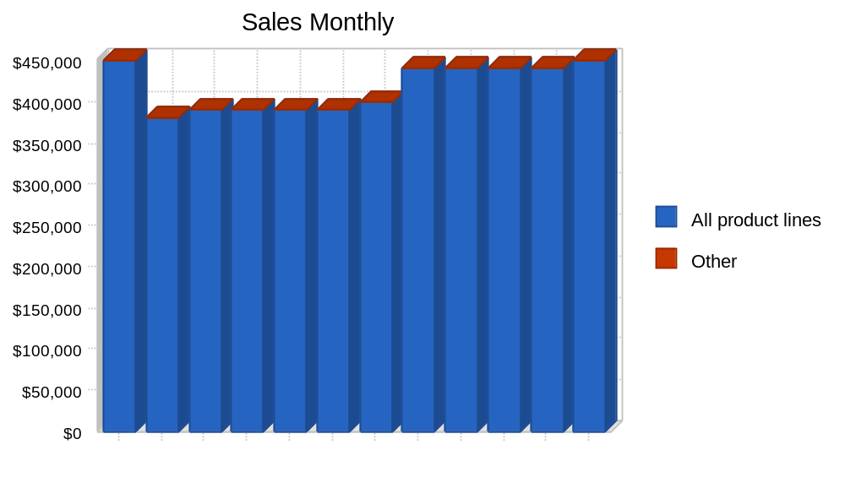

Chart: Sales by Year
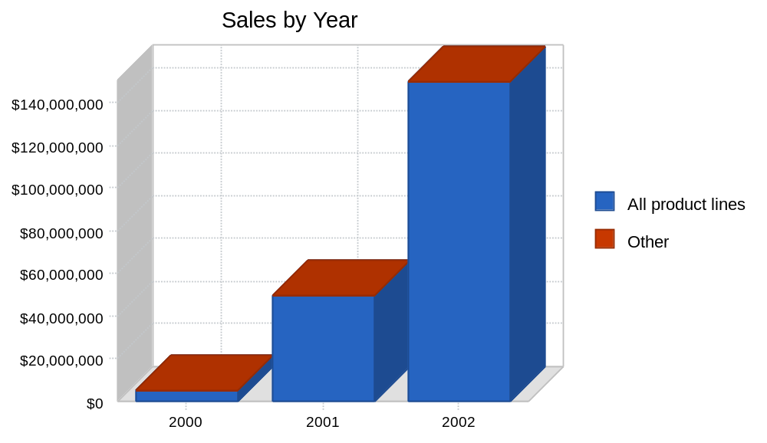

7.0 Management Summary
The company's management philosophy is based on responsibility and mutual respect. New Look has an environment and structure that encourages productivity and respect for customers and fellow employees.

Table: Personnel

Personnel Plan
 | 2000 | 2001 | 2002
All departments | $565,217 | $800,000 | $1,000,000
Other | $0 | $0 | $0
Total People | 15 | 20 | 25
Total Payroll | $565,217 | $800,000 | $1,000,000

8.0 Financial Plan
The company is seeking a substantial long-term business loan for the purpose of developing the clothing line. This funding will cover operating expenses and product development leading to the launch in July 2000.

8.1 Important Assumptions
The table below contains important assumptions which the company will use to ensure its success, the primary assumption is that the economy will remain in its present upturn.

Table: General Assumptions

General Assumptions
 | 2000 | 2001 | 2002
Plan Month | 1 | 2 | 3
Current Interest Rate | 10.00% | 10.00% | 10.00%
Long-term Interest Rate | 10.00% | 10.00% | 10.00%
Tax Rate | 25.42% | 25.00% | 25.42%
Other | 0 | 0 | 0

8.2 Break-even Analysis
With a high gross margin and estimated fixed monthly expenses, the required monthly break-even sales volume is shown below.

Chart: Break-even Analysis
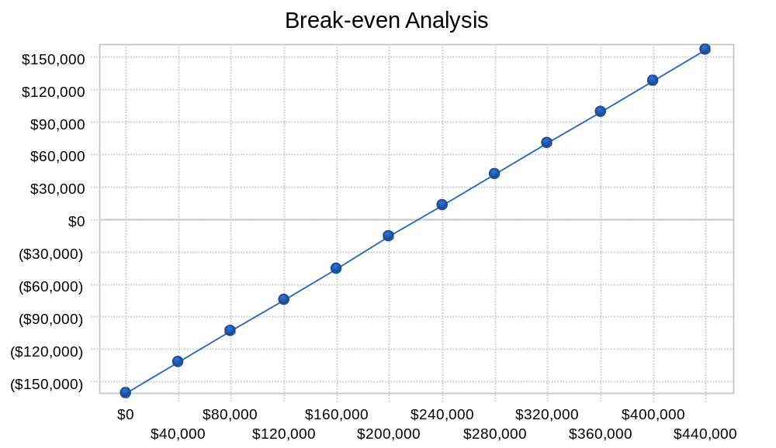

Table: Break-even Analysis

Break-even Analysis
Monthly Revenue Break-even | $222,738
Assumptions:
Average Percent Variable Cost | 28%
Estimated Monthly Fixed Cost | $160,371

8.3 Projected Profit and Loss
New Look is in the early stage of development, thus initial projections have only been made on accounts that are believed to most drive the income statement.

Table: Profit and Loss

Pro Forma Profit and Loss
 | 2000 | 2001 | 2002
Sales | $5,000,000 | $50,000,000 | $150,000,000
Direct Cost of Sales | $1,400,000 | $14,000,000 | $42,000,000
Other | $50,000 | $50,000 | $50,000
Total Cost of Sales | $1,450,000 | $14,050,000 | $42,050,000
Gross Margin | $3,550,000 | $35,950,000 | $107,950,000
Gross Margin % | 71.00% | 71.90% | 71.97%
Expenses
Payroll | $565,217 | $800,000 | $1,000,000
Sales and Marketing and Other Expenses | $1,188,058 | $9,260,000 | $11,830,000
Depreciation | $26,400 | $26,400 | $26,400
Communications | $26,400 | $90,000 | $150,000
Client Relations | $24,000 | $120,000 | $200,000
Rent | $9,600 | $30,000 | $30,000
Payroll Taxes | $84,783 | $120,000 | $150,000
Other | $0 | $0 | $0
Total Operating Expenses | $1,924,458 | $10,446,400 | $13,386,400
Profit Before Interest and Taxes | $1,625,542 | $25,503,600 | $94,563,600
EBITDA | $1,651,942 | $25,530,000 | $94,590,000
Interest Expense | $364,435 | $387,597 | $331,004
Taxes Incurred | $322,231 | $6,279,001 | $23,950,785
Net Profit | $938,876 | $18,837,002 | $70,281,811
Net Profit/Sales | 18.78% | 37.67% | 46.85%

Chart: Profit Monthly
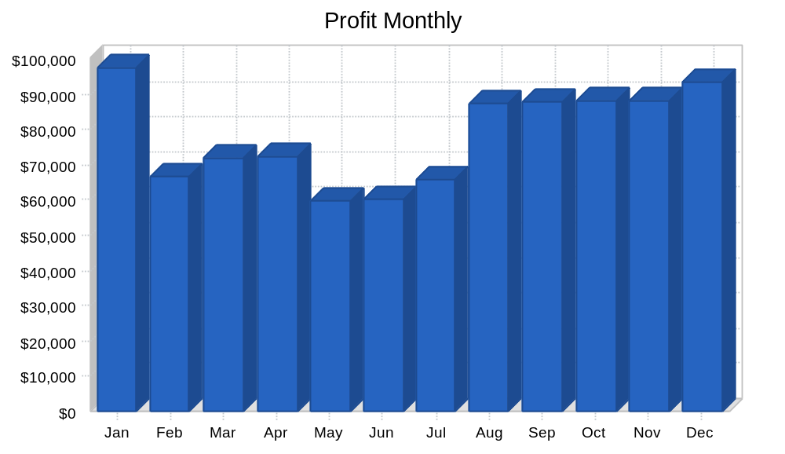

Chart: Profit Yearly
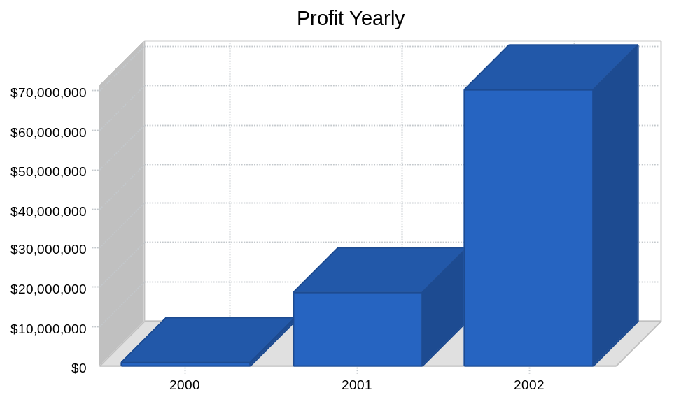

Chart: Gross Margin Monthly
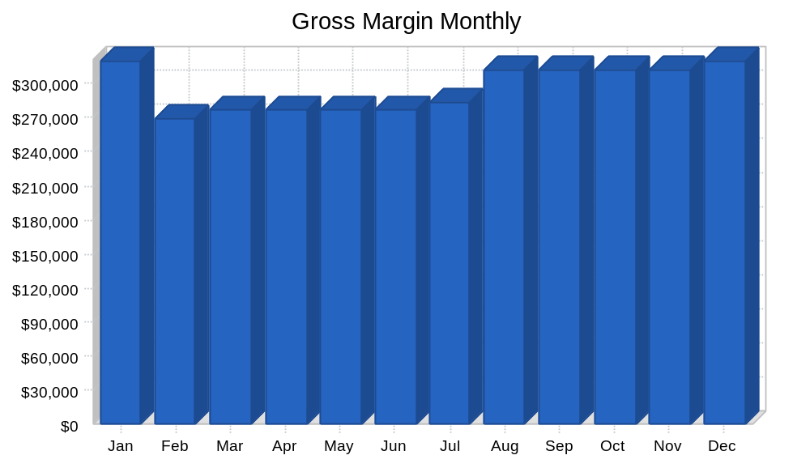

Chart: Gross Margin Yearly
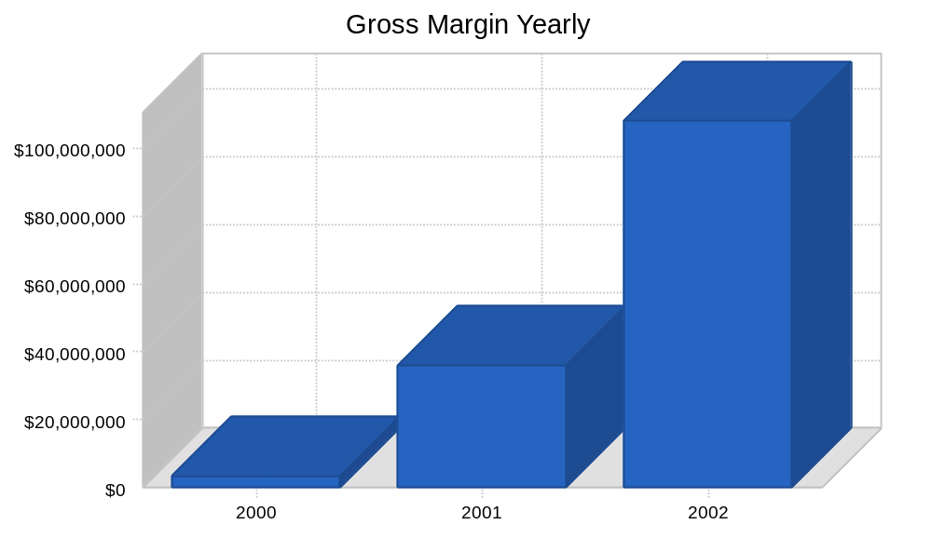

8.4 Projected Cash Flow
The projected cash flow assumes the company receives the required loan in two credit installments--in January, and in May 2000.

Chart: Cash
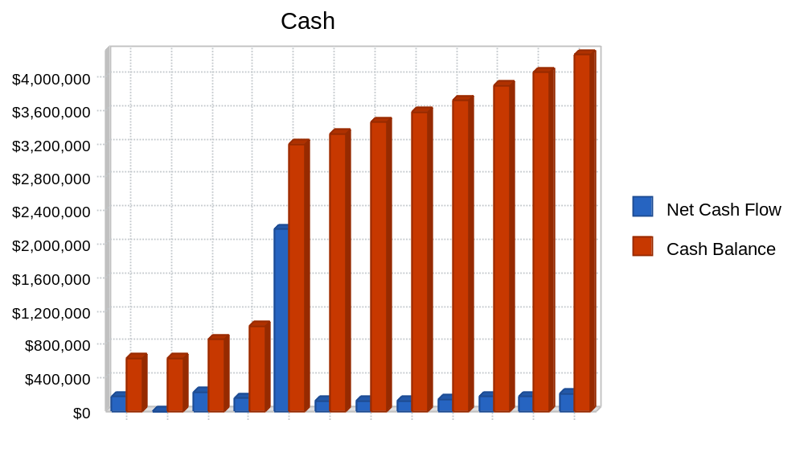

Table: Cash Flow

Pro Forma Cash Flow
 | 2000 | 2001 | 2002
Cash Received
Cash from Operations
Cash Sales | $250,000 | $2,500,000 | $7,500,000
Cash from Receivables | $4,338,433 | $40,015,900 | $125,868,667
Subtotal Cash from Operations | $4,588,433 | $42,515,900 | $133,368,667
Additional Cash Received
Sales Tax, VAT, HST/GST Received | $0 | $0 | $0
New Current Borrowing | $0 | $0 | $0
New Other Liabilities (interest-free) | $0 | $0 | $0
New Long-term Liabilities | $3,000,000 | $0 | $0
Sales of Other Current Assets | $0 | $0 | $0
Sales of Long-term Assets | $0 | $0 | $0
New Investment Received | $0 | $0 | $0
Subtotal Cash Received | $7,588,433 | $42,515,900 | $133,368,667
Expenditures | 2000 | 2001 | 2002
Expenditures from Operations
Cash Spending | $565,217 | $800,000 | $1,000,000
Bill Payments | $2,894,534 | $29,215,892 | $77,486,294
Subtotal Spent on Operations | $3,459,751 | $30,015,892 | $78,486,294
Additional Cash Spent
Sales Tax, VAT, HST/GST Paid Out | $0 | $0 | $0
Principal Repayment of Current Borrowing | $0 | $0 | $0
Other Liabilities Principal Repayment | $0 | $0 | $0
Long-term Liabilities Principal Repayment | $300,137 | $537,779 | $594,092
Purchase Other Current Assets | $0 | $0 | $0
Purchase Long-term Assets | $0 | $0 | $0
Dividends | $0 | $0 | $0
Subtotal Cash Spent | $3,759,888 | $30,553,671 | $79,080,386
Net Cash Flow | $3,828,546 | $11,962,229 | $54,288,281
Cash Balance | $4,273,546 | $16,235,775 | $70,524,056

8.5 Projected Balance Sheet
New Look's projected balance sheets for 2000-2002 are provided below.

Table: Balance Sheet

Pro Forma Balance Sheet
 | 2000 | 2001 | 2002
Assets
Current Assets
Cash | $4,273,546 | $16,235,775 | $70,524,056
Accounts Receivable | $831,567 | $8,315,667 | $24,947,000
Inventory | $145,000 | $1,450,000 | $4,350,000
Other Current Assets | $105,000 | $105,000 | $105,000
Total Current Assets | $5,355,112 | $26,106,441 | $99,926,056
Long-term Assets
Long-term Assets | $525,000 | $525,000 | $525,000
Accumulated Depreciation | $106,400 | $132,800 | $159,200
Total Long-term Assets | $418,600 | $392,200 | $365,800
Total Assets | $5,773,712 | $26,498,641 | $100,291,856
Liabilities and Capital | 2000 | 2001 | 2002
Current Liabilities
Accounts Payable | $174,973 | $2,600,679 | $6,706,174
Current Borrowing | $1,090,000 | $1,090,000 | $1,090,000
Other Current Liabilities | $410,000 | $410,000 | $410,000
Subtotal Current Liabilities | $1,674,973 | $4,100,679 | $8,206,174
Long-term Liabilities | $3,054,863 | $2,517,084 | $1,922,992
Total Liabilities | $4,729,836 | $6,617,763 | $10,129,166
Paid-in Capital | $70,000 | $70,000 | $70,000
Retained Earnings | $35,000 | $973,876 | $19,810,878
Earnings | $938,876 | $18,837,002 | $70,281,811
Total Capital | $1,043,876 | $19,880,878 | $90,162,689
Total Liabilities and Capital | $5,773,712 | $26,498,641 | $100,291,856
Net Worth | $1,043,876 | $19,880,878 | $90,162,689

8.6 Business Ratios
The following table contains important business ratios from the men's clothing industry, as determined by the Standard Industry Classification (SIC) Index, code 2329.

Table: Ratios
Ratio Analysis
 | 2000 | 2001 | 2002 | Industry Profile
Sales Growth | 66.67% | 900.00% | 200.00% | -5.70%
Percent of Total Assets
Accounts Receivable | 14.40% | 31.38% | 24.87% | 22.70%
Inventory | 2.51% | 5.47% | 4.34% | 34.90%
Other Current Assets | 1.82% | 0.40% | 0.10% | 20.60%
Total Current Assets | 92.75% | 98.52% | 99.64% | 78.20%
Long-term Assets | 7.25% | 1.48% | 0.36% | 21.80%
Total Assets | 100.00% | 100.00% | 100.00% | 100.00%
Current Liabilities | 29.01% | 15.48% | 8.18% | 28.60%
Long-term Liabilities | 52.91% | 9.50% | 1.92% | 19.30%
Total Liabilities | 81.92% | 24.97% | 10.10% | 47.90%
Net Worth | 18.08% | 75.03% | 89.90% | 52.10%
Percent of Sales
Sales | 100.00% | 100.00% | 100.00% | 100.00%
Gross Margin | 71.00% | 71.90% | 71.97% | 29.30%
Selling, General & Administrative Expenses | 52.08% | 34.23% | 24.85% | 16.00%
Advertising Expenses | 12.00% | 14.00% | 6.00% | 0.80%
Profit Before Interest and Taxes | 32.51% | 51.01% | 63.04% | 3.50%
Main Ratios
Current | 3.20 | 6.37 | 12.18 | 2.67
Quick | 3.11 | 6.01 | 11.65 | 1.14
Total Debt to Total Assets | 81.92% | 24.97% | 10.10% | 47.90%
Pre-tax Return on Net Worth | 120.81% | 126.33% | 104.51% | 5.60%
Pre-tax Return on Assets | 21.84% | 94.78% | 93.96% | 10.80%
Additional Ratios | 2000 | 2001 | 2002
Net Profit Margin | 18.78% | 37.67% | 46.85% | n.a
Return on Equity | 89.94% | 94.75% | 77.95% | n.a
Activity Ratios
Accounts Receivable Turnover | 5.71 | 5.71 | 5.71 | n.a
Collection Days | 59 | 35 | 43 | n.a
Inventory Turnover | 1.75 | 17.55 | 14.48 | n.a
Accounts Payable Turnover | 11.83 | 12.17 | 12.17 | n.a
Payment Days | 41 | 16 | 21 | n.a
Total Asset Turnover | 0.87 | 1.89 | 1.50 | n.a
Debt Ratios
Debt to Net Worth | 4.53 | 0.33 | 0.11 | n.a
Current Liab. to Liab. | 0.35 | 0.62 | 0.81 | n.a
Liquidity Ratios
Net Working Capital | $3,680,139 | $22,005,762 | $91,719,881 | n.a
Interest Coverage | 4.46 | 65.80 | 285.69 | n.a
Additional Ratios
Assets to Sales | 1.15 | 0.53 | 0.67 | n.a
Current Debt/Total Assets | 29% | 15% | 8% | n.a
Acid Test | 2.61 | 3.98 | 8.61 | n.a
Sales/Net Worth | 4.79 | 2.51 | 1.66 | n.a
Dividend Payout | 0.00 | 0.00 | 0.00 | n.a

Table: Sales Forecast

Sales Forecast
 |  | Jan | Feb | Mar | Apr | May | Jun | Jul | Aug | Sep | Oct | Nov | Dec
Sales
All product lines | 0% | $450,000 | $380,000 | $390,000 | $390,000 | $390,000 | $390,000 | $400,000 | $440,000 | $440,000 | $440,000 | $440,000 | $450,000
Other | 0% | $0 | $0 | $0 | $0 | $0 | $0 | $0 | $0 | $0 | $0 | $0 | $0
Total Sales |  | $450,000 | $380,000 | $390,000 | $390,000 | $390,000 | $390,000 | $400,000 | $440,000 | $440,000 | $440,000 | $440,000 | $450,000
Direct Cost of Sales |  | Jan | Feb | Mar | Apr | May | Jun | Jul | Aug | Sep | Oct | Nov | Dec
All product lines |  | $126,000 | $106,400 | $109,200 | $109,200 | $109,200 | $109,200 | $112,000 | $123,200 | $123,200 | $123,200 | $123,200 | $126,000
Other |  | $0 | $0 | $0 | $0 | $0 | $0 | $0 | $0 | $0 | $0 | $0 | $0
Subtotal Direct Cost of Sales |  | $126,000 | $106,400 | $109,200 | $109,200 | $109,200 | $109,200 | $112,000 | $123,200 | $123,200 | $123,200 | $123,200 | $126,000

Table: Personnel

Personnel Plan
 |  | Jan | Feb | Mar | Apr | May | Jun | Jul | Aug | Sep | Oct | Nov | Dec
All departments | 0% | $47,101 | $47,101 | $47,101 | $47,101 | $47,101 | $47,101 | $47,101 | $47,101 | $47,101 | $47,101 | $47,101 | $47,106
Other | 0% | $0 | $0 | $0 | $0 | $0 | $0 | $0 | $0 | $0 | $0 | $0 | $0
Total People |  | 15 | 15 | 15 | 15 | 15 | 15 | 15 | 15 | 15 | 15 | 15 | 15
Total Payroll |  | $47,101 | $47,101 | $47,101 | $47,101 | $47,101 | $47,101 | $47,101 | $47,101 | $47,101 | $47,101 | $47,101 | $47,106

Table: General Assumptions

General Assumptions
 |  | Jan | Feb | Mar | Apr | May | Jun | Jul | Aug | Sep | Oct | Nov | Dec
Plan Month |  | 1 | 2 | 3 | 4 | 5 | 6 | 7 | 8 | 9 | 10 | 11 | 12
Current Interest Rate |  | 10.00% | 10.00% | 10.00% | 10.00% | 10.00% | 10.00% | 10.00% | 10.00% | 10.00% | 10.00% | 10.00% | 10.00%
Long-term Interest Rate |  | 10.00% | 10.00% | 10.00% | 10.00% | 10.00% | 10.00% | 10.00% | 10.00% | 10.00% | 10.00% | 10.00% | 10.00%
Tax Rate |  | 30.00% | 25.00% | 25.00% | 25.00% | 25.00% | 25.00% | 25.00% | 25.00% | 25.00% | 25.00% | 25.00% | 25.00%
Other |  | 0 | 0 | 0 | 0 | 0 | 0 | 0 | 0 | 0 | 0 | 0 | 0

Table: Profit and Loss

Pro Forma Profit and Loss
 |  | Jan | Feb | Mar | Apr | May | Jun | Jul | Aug | Sep | Oct | Nov | Dec
Sales |  | $450,000 | $380,000 | $390,000 | $390,000 | $390,000 | $390,000 | $400,000 | $440,000 | $440,000 | $440,000 | $440,000 | $450,000
Direct Cost of Sales |  | $126,000 | $106,400 | $109,200 | $109,200 | $109,200 | $109,200 | $112,000 | $123,200 | $123,200 | $123,200 | $123,200 | $126,000
Other |  | $4,167 | $4,167 | $4,167 | $4,167 | $4,167 | $4,167 | $4,167 | $4,167 | $4,167 | $4,167 | $4,167 | $4,167
Total Cost of Sales |  | $130,167 | $110,567 | $113,367 | $113,367 | $113,367 | $113,367 | $116,167 | $127,367 | $127,367 | $127,367 | $127,367 | $130,167
Gross Margin |  | $319,833 | $269,433 | $276,633 | $276,633 | $276,633 | $276,633 | $283,833 | $312,633 | $312,633 | $312,633 | $312,633 | $319,833
Gross Margin % |  | 71.07% | 70.90% | 70.93% | 70.93% | 70.93% | 70.93% | 70.96% | 71.05% | 71.05% | 71.05% | 71.05% | 71.07%
Expenses
Payroll |  | $47,101 | $47,101 | $47,101 | $47,101 | $47,101 | $47,101 | $47,101 | $47,101 | $47,101 | $47,101 | $47,101 | $47,106
Sales and Marketing and Other Expenses |  | $99,005 | $99,005 | $99,005 | $99,005 | $99,005 | $99,005 | $99,005 | $99,005 | $99,005 | $99,005 | $99,005 | $99,005
Depreciation |  | $2,200 | $2,200 | $2,200 | $2,200 | $2,200 | $2,200 | $2,200 | $2,200 | $2,200 | $2,200 | $2,200 | $2,200
Communications |  | $2,200 | $2,200 | $2,200 | $2,200 | $2,200 | $2,200 | $2,200 | $2,200 | $2,200 | $2,200 | $2,200 | $2,200
Client Relations |  | $2,000 | $2,000 | $2,000 | $2,000 | $2,000 | $2,000 | $2,000 | $2,000 | $2,000 | $2,000 | $2,000 | $2,000
Rent |  | $800 | $800 | $800 | $800 | $800 | $800 | $800 | $800 | $800 | $800 | $800 | $800
Payroll Taxes | 15% | $7,065 | $7,065 | $7,065 | $7,065 | $7,065 | $7,065 | $7,065 | $7,065 | $7,065 | $7,065 | $7,065 | $7,066
Other |  | $0 | $0 | $0 | $0 | $0 | $0 | $0 | $0 | $0 | $0 | $0 | $0
Total Operating Expenses |  | $160,371 | $160,371 | $160,371 | $160,371 | $160,371 | $160,371 | $160,371 | $160,371 | $160,371 | $160,371 | $160,371 | $160,377
Profit Before Interest and Taxes |  | $159,462 | $109,062 | $116,262 | $116,262 | $116,262 | $116,262 | $123,462 | $152,262 | $152,262 | $152,262 | $152,262 | $159,457
EBITDA |  | $161,662 | $111,262 | $118,462 | $118,462 | $118,462 | $118,462 | $125,662 | $154,462 | $154,462 | $154,462 | $154,462 | $161,657
Interest Expense |  | $20,375 | $20,266 | $20,157 | $20,047 | $36,602 | $36,266 | $35,926 | $35,584 | $35,239 | $34,891 | $34,541 | $34,541
Taxes Incurred |  | $41,726 | $22,199 | $24,026 | $24,054 | $19,915 | $19,999 | $21,884 | $29,170 | $29,256 | $29,343 | $29,430 | $31,229
Net Profit |  | $97,361 | $66,597 | $72,079 | $72,162 | $59,745 | $59,998 | $65,652 | $87,509 | $87,767 | $88,028 | $88,291 | $93,687
Net Profit/Sales |  | 21.64% | 17.53% | 18.48% | 18.50% | 15.32% | 15.38% | 16.41% | 19.89% | 19.95% | 20.01% | 20.07% | 20.82%

Table: Cash Flow

Pro Forma Cash Flow
 |  | Jan | Feb | Mar | Apr | May | Jun | Jul | Aug | Sep | Oct | Nov | Dec
Cash Received
Cash from Operations
Cash Sales |  | $22,500 | $19,000 | $19,500 | $19,500 | $19,500 | $19,500 | $20,000 | $22,000 | $22,000 | $22,000 | $22,000 | $22,500
Cash from Receivables |  | $210,000 | $224,250 | $425,283 | $361,317 | $370,500 | $370,500 | $370,500 | $370,817 | $381,267 | $418,000 | $418,000 | $418,000
Subtotal Cash from Operations |  | $232,500 | $243,250 | $444,783 | $380,817 | $390,000 | $390,000 | $390,500 | $392,817 | $403,267 | $440,000 | $440,000 | $440,500
Additional Cash Received
Sales Tax, VAT, HST/GST Received | 0.00% | $0 | $0 | $0 | $0 | $0 | $0 | $0 | $0 | $0 | $0 | $0 | $0
New Current Borrowing |  | $0 | $0 | $0 | $0 | $0 | $0 | $0 | $0 | $0 | $0 | $0 | $0
New Other Liabilities (interest-free) |  | $0 | $0 | $0 | $0 | $0 | $0 | $0 | $0 | $0 | $0 | $0 | $0
New Long-term Liabilities |  | $1,000,000 | $0 | $0 | $0 | $2,000,000 | $0 | $0 | $0 | $0 | $0 | $0 | $0
Sales of Other Current Assets |  | $0 | $0 | $0 | $0 | $0 | $0 | $0 | $0 | $0 | $0 | $0 | $0
Sales of Long-term Assets |  | $0 | $0 | $0 | $0 | $0 | $0 | $0 | $0 | $0 | $0 | $0 | $0
New Investment Received |  | $0 | $0 | $0 | $0 | $0 | $0 | $0 | $0 | $0 | $0 | $0 | $0
Subtotal Cash Received |  | $1,232,500 | $243,250 | $444,783 | $380,817 | $2,390,000 | $390,000 | $390,500 | $392,817 | $403,267 | $440,000 | $440,000 | $440,500
Expenditures |  | Jan | Feb | Mar | Apr | May | Jun | Jul | Aug | Sep | Oct | Nov | Dec
Expenditures from Operations
Cash Spending |  | $47,101 | $47,101 | $47,101 | $47,101 | $47,101 | $47,101 | $47,101 | $47,101 | $47,101 | $47,101 | $47,101 | $47,106
Bill Payments |  | $1,005,911 | $176,683 | $157,759 | $159,417 | $159,751 | $171,745 | $171,553 | $173,278 | $179,982 | $179,723 | $179,462 | $179,268
Subtotal Spent on Operations |  | $1,053,012 | $223,784 | $204,860 | $206,518 | $206,852 | $218,846 | $218,654 | $220,379 | $227,083 | $226,824 | $226,563 | $226,374
Additional Cash Spent
Sales Tax, VAT, HST/GST Paid Out |  | $0 | $0 | $0 | $0 | $0 | $0 | $0 | $0 | $0 | $0 | $0 | $0
Principal Repayment of Current Borrowing |  | $0 | $0 | $0 | $0 | $0 | $0 | $0 | $0 | $0 | $0 | $0 | $0
Other Liabilities Principal Repayment |  | $0 | $0 | $0 | $0 | $0 | $0 | $0 | $0 | $0 | $0 | $0 | $0
Long-term Liabilities Principal Repayment |  | $0 | $13,021 | $13,130 | $13,239 | $13,350 | $40,382 | $40,719 | $41,058 | $41,400 | $41,745 | $42,093 | $0
Purchase Other Current Assets |  | $0 | $0 | $0 | $0 | $0 | $0 | $0 | $0 | $0 | $0 | $0 | $0
Purchase Long-term Assets |  | $0 | $0 | $0 | $0 | $0 | $0 | $0 | $0 | $0 | $0 | $0 | $0
Dividends |  | $0 | $0 | $0 | $0 | $0 | $0 | $0 | $0 | $0 | $0 | $0 | $0
Subtotal Cash Spent |  | $1,053,012 | $236,805 | $217,990 | $219,757 | $220,202 | $259,228 | $259,373 | $261,437 | $268,483 | $268,569 | $268,656 | $226,374
Net Cash Flow |  | $179,488 | $6,445 | $226,793 | $161,059 | $2,169,798 | $130,772 | $131,127 | $131,379 | $134,784 | $171,431 | $171,344 | $214,126
Cash Balance |  | $624,488 | $630,932 | $857,725 | $1,018,785 | $3,188,583 | $3,319,354 | $3,450,481 | $3,581,860 | $3,716,644 | $3,888,075 | $4,059,419 | $4,273,546

Table: Balance Sheet

Pro Forma Balance Sheet
 |  | Jan | Feb | Mar | Apr | May | Jun | Jul | Aug | Sep | Oct | Nov | Dec
Assets | Starting Balances
Current Assets
Cash | $445,000 | $624,488 | $630,932 | $857,725 | $1,018,785 | $3,188,583 | $3,319,354 | $3,450,481 | $3,581,860 | $3,716,644 | $3,888,075 | $4,059,419 | $4,273,546
Accounts Receivable | $420,000 | $637,500 | $774,250 | $719,467 | $728,650 | $728,650 | $728,650 | $738,150 | $785,333 | $822,067 | $822,067 | $822,067 | $831,567
Inventory | $1,545,000 | $1,419,000 | $1,312,600 | $1,203,400 | $1,094,200 | $985,000 | $875,800 | $763,800 | $640,600 | $517,400 | $394,200 | $271,000 | $145,000
Other Current Assets | $105,000 | $105,000 | $105,000 | $105,000 | $105,000 | $105,000 | $105,000 | $105,000 | $105,000 | $105,000 | $105,000 | $105,000 | $105,000
Total Current Assets | $2,515,000 | $2,785,988 | $2,822,782 | $2,885,592 | $2,946,635 | $5,007,233 | $5,028,804 | $5,057,431 | $5,112,794 | $5,161,111 | $5,209,342 | $5,257,486 | $5,355,112
Long-term Assets
Long-term Assets | $525,000 | $525,000 | $525,000 | $525,000 | $525,000 | $525,000 | $525,000 | $525,000 | $525,000 | $525,000 | $525,000 | $525,000 | $525,000
Accumulated Depreciation | $80,000 | $82,200 | $84,400 | $86,600 | $88,800 | $91,000 | $93,200 | $95,400 | $97,600 | $99,800 | $102,000 | $104,200 | $106,400
Total Long-term Assets | $445,000 | $442,800 | $440,600 | $438,400 | $436,200 | $434,000 | $431,800 | $429,600 | $427,400 | $425,200 | $423,000 | $420,800 | $418,600
Total Assets | $2,960,000 | $3,228,788 | $3,263,382 | $3,323,992 | $3,382,835 | $5,441,233 | $5,460,604 | $5,487,031 | $5,540,194 | $5,586,311 | $5,632,342 | $5,678,286 | $5,773,712
Liabilities and Capital |  | Jan | Feb | Mar | Apr | May | Jun | Jul | Aug | Sep | Oct | Nov | Dec
Current Liabilities
Accounts Payable | $1,000,000 | $171,427 | $152,445 | $154,106 | $154,026 | $166,029 | $165,785 | $167,279 | $173,991 | $173,741 | $173,488 | $173,234 | $174,973
Current Borrowing | $1,090,000 | $1,090,000 | $1,090,000 | $1,090,000 | $1,090,000 | $1,090,000 | $1,090,000 | $1,090,000 | $1,090,000 | $1,090,000 | $1,090,000 | $1,090,000 | $1,090,000
Other Current Liabilities | $410,000 | $410,000 | $410,000 | $410,000 | $410,000 | $410,000 | $410,000 | $410,000 | $410,000 | $410,000 | $410,000 | $410,000 | $410,000
Subtotal Current Liabilities | $2,500,000 | $1,671,427 | $1,652,445 | $1,654,106 | $1,654,026 | $1,666,029 | $1,665,785 | $1,667,279 | $1,673,991 | $1,673,741 | $1,673,488 | $1,673,234 | $1,674,973
Long-term Liabilities | $355,000 | $1,355,000 | $1,341,979 | $1,328,849 | $1,315,610 | $3,302,260 | $3,261,878 | $3,221,159 | $3,180,101 | $3,138,701 | $3,096,956 | $3,054,863 | $3,054,863
Total Liabilities | $2,855,000 | $3,026,427 | $2,994,424 | $2,982,955 | $2,969,636 | $4,968,289 | $4,927,663 | $4,888,438 | $4,854,092 | $4,812,442 | $4,770,444 | $4,728,097 | $4,729,836
Paid-in Capital | $70,000 | $70,000 | $70,000 | $70,000 | $70,000 | $70,000 | $70,000 | $70,000 | $70,000 | $70,000 | $70,000 | $70,000 | $70,000
Retained Earnings | $35,000 | $35,000 | $35,000 | $35,000 | $35,000 | $35,000 | $35,000 | $35,000 | $35,000 | $35,000 | $35,000 | $35,000 | $35,000
Earnings | $0 | $97,361 | $163,958 | $236,037 | $308,199 | $367,944 | $427,941 | $493,593 | $581,102 | $668,869 | $756,898 | $845,189 | $938,876
Total Capital | $105,000 | $202,361 | $268,958 | $341,037 | $413,199 | $472,944 | $532,941 | $598,593 | $686,102 | $773,869 | $861,898 | $950,189 | $1,043,876
Total Liabilities and Capital | $2,960,000 | $3,228,788 | $3,263,382 | $3,323,992 | $3,382,835 | $5,441,233 | $5,460,604 | $5,487,031 | $5,540,194 | $5,586,311 | $5,632,342 | $5,678,286 | $5,773,712
Net Worth | $105,000 | $202,361 | $268,958 | $341,037 | $413,199 | $472,944 | $532,941 | $598,593 | $686,102 | $773,869 | $861,898 | $950,189 | $1,043,876

