KEA - Københavns Erhvervsakademi

Multimedia Design and Communication

International line

2017

Report

<http://www.herportfolio.dk/casual_games/re-exam/>

Eliana A. Nicolau

Report with 12 pages and 9891 characters

INDEX

INTRODUCTION . . . . . . . . . . 3

PROBLEM AREA . . . . . . . . . . 3

HIGH CONCEPT STATEMENT . . . . . . . . 4

GAME CONCEPT KEY POINTS . . . . . . . . 4

GAME CONCEPT DESCRIPTION . . . . . . . . 4

GAME DESIGN . . . . . . . . . . 4

DEVELOPMENT PROCESS . . . . . . . . . 5

TARGET AUDIENCE . . . . . . . . . . 5

CHALLENGES . . . . . . . . . . . 5

TARGET AUDIENCE . . . . . . . . . . 6

EXPECTED PLAYER TYPES . . . . . . . . . 6

AUDIO . . . . . . . . . . . 6

CASUAL ELEMENTS . . . . . . . . . . 6

FUTURE CONSIDERATIONS . . . . . . . . . 6

BIBLIOGRAPHY . . . . . . . . . . . 7

APPENDIX . . . . . . . . . . . 8

INTRODUCTION

By casual game it is expected a game directed towards casual gamers with little time available and a small learning curve. With simple instructions, rules and commands.

*Gomu* is a platform game composed by 4 levels named after his main character.

*Gomu* must jump over platforms, collect items, shoot over enemies while avoiding falling. If he succeeds the different challenges presented to him he’ll be reaching successfully the next level.

PROBLEM AREA

Game development requires active participation of the developer in all stages of the process. From researching and testing games, creating the concept, considering and designing the visuals, implementing and testing.

If it is fundamental for the developer to participate actively at every stage of the process, how should one correctly estimate the different stages of the project?

As stated before the process of game development is composed by different stages. However, the workflow is iterative providing the possibility to go back, fix things and perfect them. If initially the game development process was linear, the “waterfall” design methodology, nowadays is more flexible. The more times you iterate, the better the outcome will be.

The iterative methodology is similar to the scientific method. After the design and implementation, the project is tested followed by the outcome’s evaluation. Then a decision is made towards what to improve and fix. The game is finished when a decision is made or a timeline is met.

Considering the different stages of game development and the little experience designing and implementing a game concept, the problem area centre’s around effectively making a time estimate of the game as a whole, in order to meet a timeline.

How far can one go and what the level of complexity can be delivered?

These challenges will be tackled along the implementation of the project, whilst constant experimentation of the game to achieve the goals such as: concept creation, designing different levels, different outcomes possibility of the game, implementing gravity and firing mechanics or collectable items.

GAME CONCEPT KEYPOINTS

Gomu is an independent action game developed for families.

It’s played in single mode with simple instructions. The player should run and get as much points as possible. But beware of the obstacles and enemies!

It’s developed for computers, more specifically to be played in a browser. However, a version of the game for console with extended storytelling and levels is considered.

As an independent game, there’s no profit from it or intellectual property. It’s for experimental purposes, a playground to improve programming skills.

Gomu is mission oriented per level.

HIGH CONCEPT STATEMENT

Venue

*Gomu* is a platform game inspired by old school platform games designed for computers.

Features

* Different scenarios available on every level
* Fun and easy to play
* Extended tilesheet of the character with different expressions and actions
* Recognition to similar casual platform games

Premise

A fun little alien strives to travel from planet to planet until he gets home. To find he’s way home he must find he’s spaceship at every level.

Gameplay

*Gomu*’s is in a mission to go back home. He travels from planet to planet to find the way back to he’s home planet. Jump over dangerous obstacles, and shoot your enemies until you find your spaceship.

GAME CONCEPT DESCRIPTION

*Gomu* is a game meant to be played online and for free. It requires little time to understand the interface and control the actions of the player in order to be successful.

The opening page presents the main character and 4 options:

* Start Game: to play the game
* How to play: instructions to the player
* My report: report of the game development
* Zip: zipped files of all the components of the game

The demo of the game is meant to have 4 levels with different backgrounds and platform challenges. However, the number of levels can grow indefinitely.

All levels include jumping (up: case 38), moving to the left (case 37), to the right (case 37), dodge (case 40) or fire (space: case 32).

The score is kept by the number of collected items: stars.

There are two possible outcomes for the game: one where the player may survive and therefore win the game, the other where the player may not survive and therefore lose the game. A final screen is prepared for both possible scenarios.

The levels have different backgrounds. All inspired by alien fantasy. Themes such as foreign planets, the universe exploration and intergalactic travelling. The feeling of the game is light, with friendly characters and images. It is therefore prepared to younger audiences, both male and female from 6 to 12 years old. However, considering that 56% percent of the casual gamers nowadays are women, the friendly graphics, familiar usability to other platform games and small learning curve, *Gomu* can be played online by women between chores, especially if adapted to mobile devices.

There are two levels of game sounds in the game. First: the background music. Which integrates two different tunes: the first for the opening page of the game, the second for the game itself. Second: the sounds that are activated by the keyboard or by events in the game. E.g: jumping or firing.

Being IEZA the framework that describes the sound environment of video games, by using two dimensions (one: the audio from the fictional world. E.g.: footsteps. And two: the sound coming from outside the fictional world. E.g.: musical score), Gomu contemplates two of the four domains of the audio dimension of the game. The game contemplates the zone audio, part of the diegetic or the storytelling of the game, which expresses the setting of the game. E.g.: soundtrack. It also contemplates interface audio, part of the non-diegetic framework. E.g.: jumping track.

GAME DESIGN

*Gomu* is a mission oriented game where the player pursues the goal to reach he’s spaceship at the end of each level.

It is a dynamic game that demands the active participation of the player. The player must make quick decisions such as: if he should jump, or when to jump. There is a set of rules and goals on the game that is presented in the *How to play* page the aims to prepare the player for the game. From mechanical guidelines to goals. Depending on the player’s performance the outcome changes between a successful game or a lost game.

However, *Gomu* is not a core game and doesn’t demand a lot of attention or time to learn the skills required to play a fun, light, casual game. The game can be played anywhere or among chores.

The demo version, composed by 4 levels is an iteration of the final product. Where constant improvements and testing are executed.

The different stages of development the game are recurring and repeated periodically.

From the initial stage of researching, to the design, implementation, the playtest and the evaluation. The evaluation is not a final stage, but instead it is a stepping stone to an improved version of the game. The more or the better elements the developer decides to design, the more iterations are required, which also may result on a bigger risk by creating more complex sequences of programming or more complex visuals. This ongoing process aims to elaborate and beautify the game. Resulting in a more engaging experience to the audience.

While developing this game, the design of the graphic elements and the implementation of the functions where developed hand by hand. Once a challenge was finished, new grapgic elements were created to integrate new features of the game.

This game aimed to integrate appealing aesthetic elements in order to appeal to the player. The more worlds and features of the characters were incorporated, the more engaging the game would become. Also the mechanics of the game aim to promote the user friendliness of the game, by presenting a low level of complexity and familiarity to control the main character’s actions.

*Gomu* is dynamic and challenges the player through the speed of the game, the screen movement, which is limited and continuously forward.

Finally, at a final stage of the game development qualitative and quantitative tests to the target audience are planned. This approach could be guided through interviews to players and observation of players to improve the game and the overall experience.

DEVELOPMENT PROCESS

The development of this game is iterative and ongoing.

The process started with the research for games of the same genre and animations for aesthetic and concept purposes.

The first iteration was inspired by the animation movie “My neighbour Totoro” by Hayao Miyazaki.

However due to: the visual differences between the main character (*Michiu*) and the enemies, the unsatisfying visuals, the existing errors on the code and the aim to create an original game with original soundtrack, the idea of using Totoro as a reference was abandoned. Video games inspired by this animated movie already exist and there were too many inconsistencies in the characters.

However, the platform game as the genre to implement was settled. One for being a fan of this game genre, and two, because of the specific programming challenges that it presents.

From this initial stage of evaluation, it was decided to follow one aesthetic style. Either by following *Michiu*’s sketches or the Enemies sketches as a direction. The decision layed on the ghosts for the plurality of possible storytelling scenarios. This decision was followed by researching alternative worlds that could be associated to this creature, from environments, to characters’ stylesheets, or music. This brainstorming process enabled the construction of *Gomu*’s concept little by little.

From the concept development and design of the visual elements, the next step was the mechanics, followed by implementation and testing. For every observation, whilst implementation and testing (visuals, actions and effects) a hypothesis was formulated. If the improvements needed are observed in the visuals aspect of the game, new design is created along with the JSON code manually created. If the observation is related to the mechanics or the dynamics, new code is created and tested. As well for the research of programming methodologies. This process aimed in one hand the continuous improvement of the game, and on the other hand the development of more programming experience.

CHALLENGES

* To create original functions that improve the playing experience and the complexity of the game
* E.g.: the first “game over” function didn’t work, although the logic was apparently simple and dependent on the player’s falling off the canvas
* To activate different backgrounds on different levels
* To count the score by the collected items

EXPECTED PLAYER TYPES

Bartle Personality types

Explorer: unlocking new scenarios and visuals

The achiever by incorporating a score board in the end fed by the different turn-based players and by finishing all the levels.

AUDIO

The game includes two dimensional sounds. One dimension provides the sounds from what the character does or experiences (diegetic). And another dimension musical framework and context of the game (non-diegetic). Types of audio:

* soundtrack that provides the environment of the game
* Interface sounds

CASUAL ELEMENTS

* Interaction & Game Theory
* Interaction
* Procedural programming
* Code-flow
* JSON

FUTURE CONSIDERATIONS

Herewith I list some considerations of how could this game be developed in the future

* Integrate “You Lost” final screen;
* Integrate “You Win” final screen”;
* More interactivity between enemies and the hero;
* Dynamic player score board in the end;
* User Testing (Qualitative and quantitative);
* Kill enemies;
* Integrate big boss in new level;
* Integrate more sounds;
* Integrate more storytelling elements.

BIBLIOGRAPHY

<http://blogs.adobe.com/edge/2014/09/18/export-sprite-sheet-from-adobe-photoshop/>

<http://www.trainsimple.com/CourseDetailUser.aspx?id=228>

<http://captivatingsound.com/ieza-framework-for-game-audio/>

<http://www.gamasutra.com/view/feature/3509/ieza_a_framework_for_game_audio.php>

https://en.wikipedia.org/wiki/HUD_(video_gaming)

<https://opengameart.org/>

https://en.wikipedia.org/wiki/Platform_game

<http://creativehero.es/ieza-game-audio-framework/>

http://mud.co.uk/richard/hcds.htm

<http://kenney.nl/>

The MDA framework article

https://www.slideshare.net/bayusembada/game-development-<https://gamedesignconcepts.wordpress.com/2009/06/29/level-1-overview-what-is-a-game/>

<http://www.pebbleversion.com/html/Ink/InkHighConcept.html>

http://www.escapistmagazine.com/forums/read/7.860239-Core-Gamers-Mostly-Male-Casual-Gamers-Mostly-Female-Says-NPD

https://www.theguardian.com/commentisfree/2014/sep/18/52-percent-people-playing-games-women-industry-doesnt-know

APPENDIX

RESEARCH



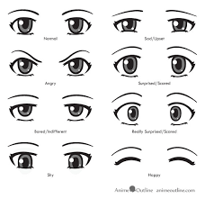 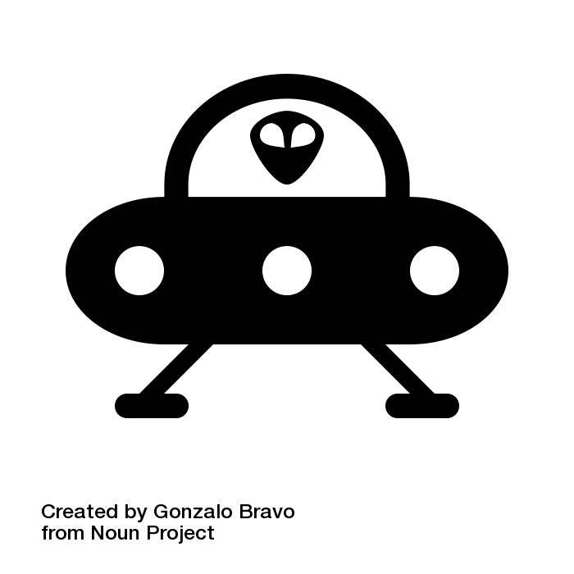

EVOLUTION

../../../../Documents/1.Study/1.%20KEA/Casual%20Games/re-exam/gfx/img/enemy.p

SKETCHES

FIRST ITERATION CHARACTERS

a) Michiu’s evolution (main character) b) Ghost

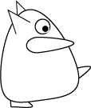  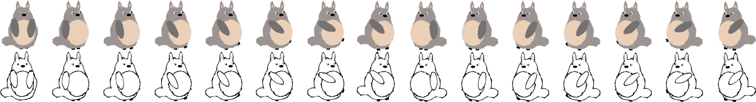 

Goal: to create characters more consistent to one style or another.

SECOND ITERATION CHARACTERS

a) Gomu (Main character)



b) Ghosts (Enemies) c) Big ghost (Big Enemy)

 

d) Star (collectable items)

../img/star.png

BACKGROUNDS

01 02

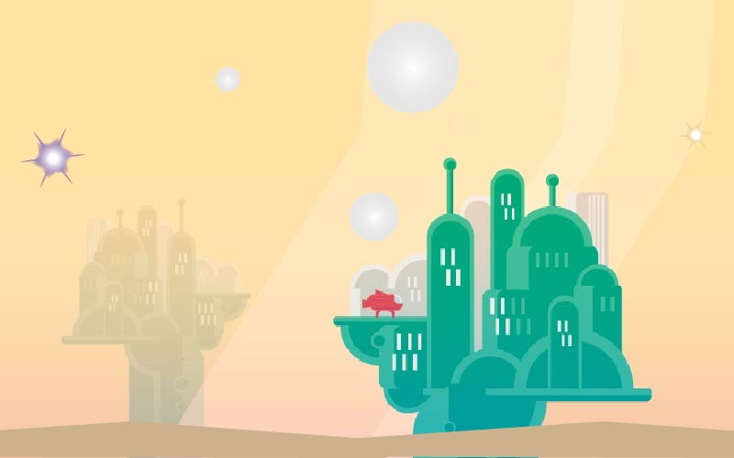 

03 04

 

Game over screen Game won screen

 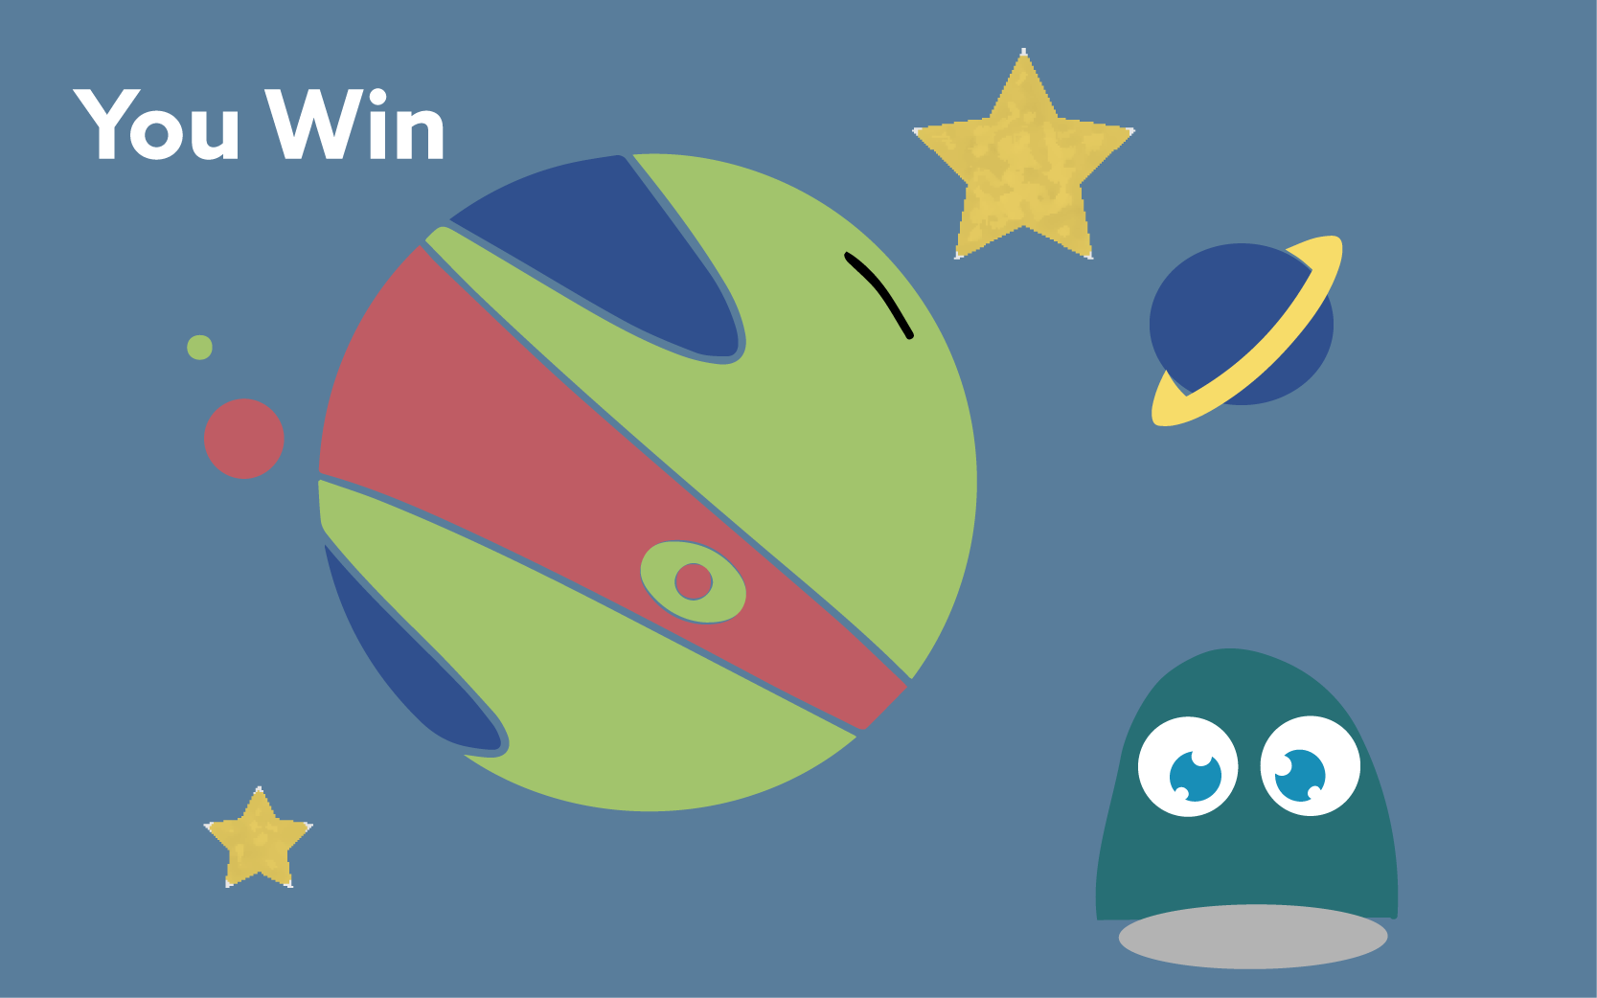

TILESHEET

../img/tiles2.png

Other exercises developed for this elective “Casual Games”

<http://www.herportfolio.dk/casual_games/week_first/>

<http://www.herportfolio.dk/casual_games/week_second/myCoinGame.html>

Level 2 and Final Screen: <http://kea.starfeesh.com/casualgames/dc/>

Exam project, first iteration: <http://www.herportfolio.dk/casual_games/exam_project/>