University of Barishal

Department of English

English Literature

English literature is a vast and rich tapestry of storytelling, poetry, and drama that reflects the culture, history, and human experience of its time. From the epic tales of Beowulf to the timeless works of Shakespeare, the profound novels of Jane Austen and Charles Dickens, and the modern voices of Virginia Woolf and George Orwell, English literature has shaped and been shaped by society. It explores themes of love, power, identity, and morality, offering insight into the complexities of human nature across centuries. Whether through poetry, plays, or novels, English literature continues to inspire and challenge readers worldwide.

## Prose

The earliest English prose work, the [law code](https://www.britannica.com/topic/law-code) of King [Aethelberht I](https://www.britannica.com/biography/Aethelberht-I) of Kent, was written within a few years of the arrival in [England](https://www.britannica.com/place/England) (597) of [St. Augustine of Canterbury](https://www.britannica.com/biography/Saint-Augustine-of-Canterbury). Other 7th- and 8th-century prose, similarly practical in character, includes more laws, wills, and charters. According to Cuthbert, who was a monk at Jarrow, Bede at the time of his death had just finished a translation of the Gospel of [St. John](https://www.britannica.com/place/St-Johns-Newfoundland-and-Labrador), though this does not survive. Two medical tracts, *Herbarium* and *Medicina de quadrupedibus*, very likely date from the 8th century.

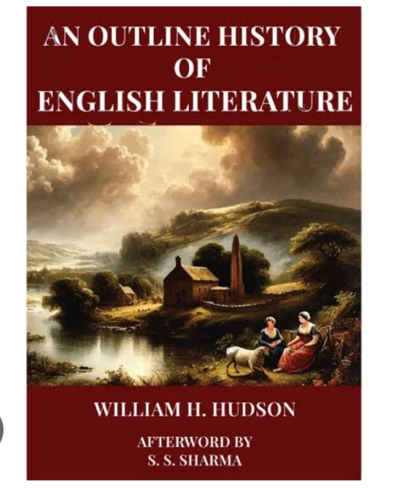

Most Old English poetry is preserved in four manuscripts of the late 10th and early 11th centuries. The Beowulf manuscript (British Library) contains [*Beowulf*](https://www.britannica.com/topic/Beowulf), *Judith*, and three prose tracts; the [Exeter Book](https://www.britannica.com/topic/Exeter-Book) (Exeter Cathedral) is a miscellaneous gathering of lyrics, riddles, [didactic](https://www.merriam-webster.com/dictionary/didactic) poems, and religious narratives; the [Junius Manuscript](https://www.britannica.com/topic/Caedmon-manuscript) (Bodleian Library, Oxford)—

*Few poems can be dated as closely as Caedmon’s “Hymn.” King Alfred’s*[*compositions*](https://www.merriam-webster.com/dictionary/compositions)*fall into the late 9th century, and Bede composed his “Death Song” within 50 days of his death on May 25, 735. Historical poems such as*[*“The Battle of Brunanburh”*](https://www.britannica.com/topic/The-Battle-of-Brunanburh)*(after 937) and*[*“The Battle of Maldon”*](https://www.britannica.com/topic/The-Battle-of-Maldon)*(after 991) are fixed by the dates of the events they*[*commemorate*](https://www.merriam-webster.com/dictionary/commemorate)*. A translation of one of*[*Aldhelm*](https://www.britannica.com/biography/Aldhelm)*’s riddles is found not only in the Exeter Book but also in an early 9th-century manuscript at Leiden, Neth. And at least a part of*[*“The Dream of the Rood”*](https://www.britannica.com/topic/The-Dream-of-the-Rood)*can be dated by an excerpt carved on the 8th-century*

If few poems can be dated accurately, still fewer can be attributed to particular poets. The most important [author](https://www.britannica.com/art/author) from whom a considerable body of work survives is [Cynewulf](https://www.britannica.com/biography/Cynewulf-English-poet), who [wove](https://www.britannica.com/dictionary/wove) his runic signature into the epilogues of four poems. Aside from his name, little is known of him; he probably lived in the 9th century in Mercia or Northumbria. His works include *The Fates of the Apostles*, a short martyrology; *The Ascension*(also called *Christ II*), a homily and biblical narrative;

## [**Alliterative verse**](https://www.britannica.com/art/alliterative-verse)

Virtually all Old English poetry is written in a single meter, a four-stress line with a syntactical break, or caesura, between the second and third stresses, and with [alliteration](https://www.merriam-webster.com/dictionary/alliteration) linking the two halves of the line; this pattern is occasionally varied by six-stress lines. The poetry is formulaic, drawing on a common set of stock phrases and phrase patterns, applying standard epithets to various classes of characters, and depicting scenery with such recurring images as the eagle and the wolf, which wait during battles to feast on carrion, and ice and snow, which appear in the landscape to signal sorrow. In the best poems such formula

## 

***The 13th century saw a rise in the popularity of long didactic poems presenting biblical narrative, saints’ lives, or moral instruction for those untutored in Latin or French. The most***[***idiosyncratic***](https://www.merriam-webster.com/dictionary/idiosyncratic)***of these is the [Ormulum](https://www.britannica.com/topic/Ormulum) by***[***Orm***](https://www.britannica.com/biography/Orm)***, an Augustinian canon in the north of***[***England***](https://www.britannica.com/place/England)