ASSIGNMENT-2

Task: Crete 3 VPCs and connect them using Transit Gateway

* Search for VPC in search bar of AWS home page and click on VPC under Services

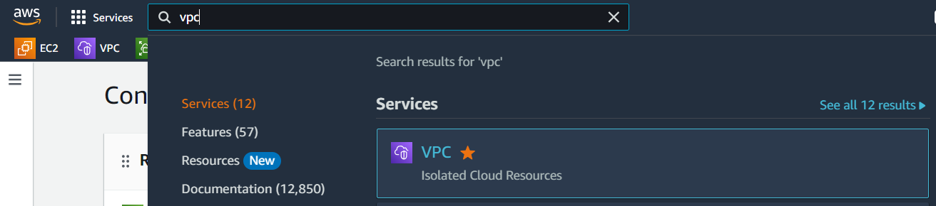

* Click on Your VPCs option under Virtual private cloud and Click on Create VPC

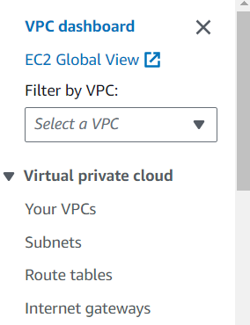

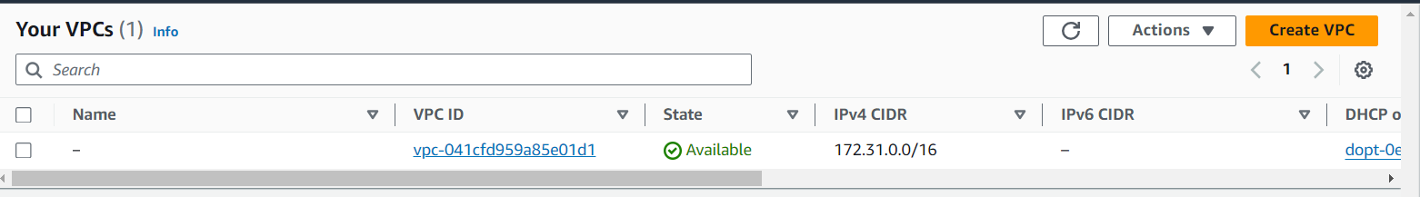

* Fill details like name and IPv4 CIDR and click on Create VPC button (here I have named my VPC as VPC1 and CIDR is 10.0.0.0/16)

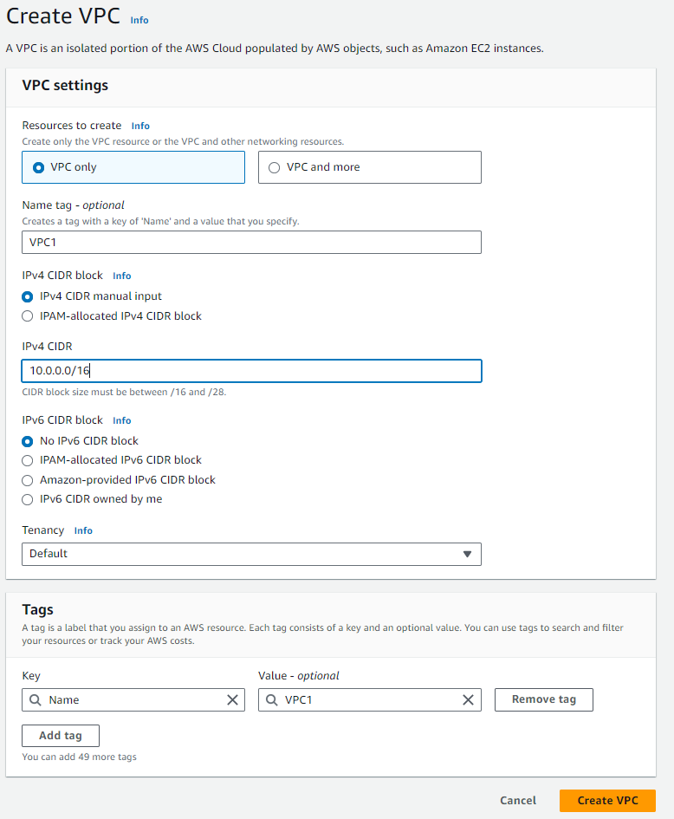

* Now Create 2 more VPCs in same way (name second VPC as VPC2, give IPv4 CIDR as 11.0.0.0/16 and name third VPC as VPC3 and IPv4 CIDR is 12.0.0.0/16)
* Now go to Your VPCs and we can see our 3 VPCs

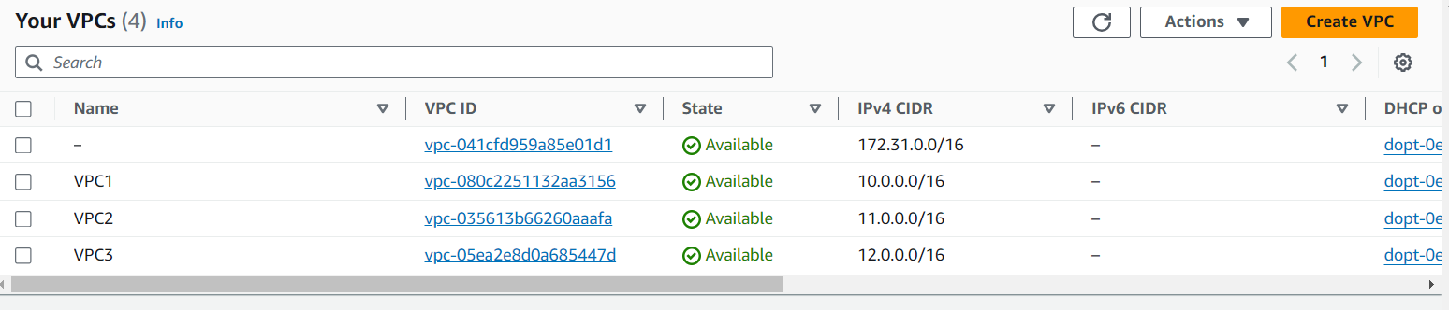

* Now we have to create 3 Internet Gateways as we have 3 VPCs. So, click on Internet gateways option under virtual private cloud and click on Create internet gateway button.

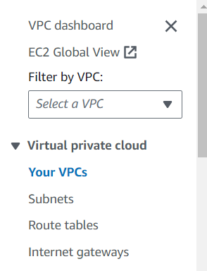

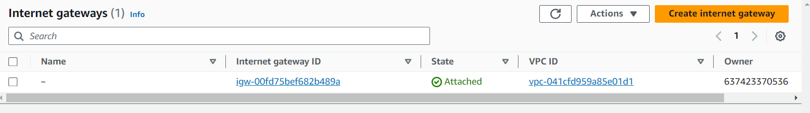

* Give any name to our Internet gateway (ex: IGW-1) and click on Create internet gateway.

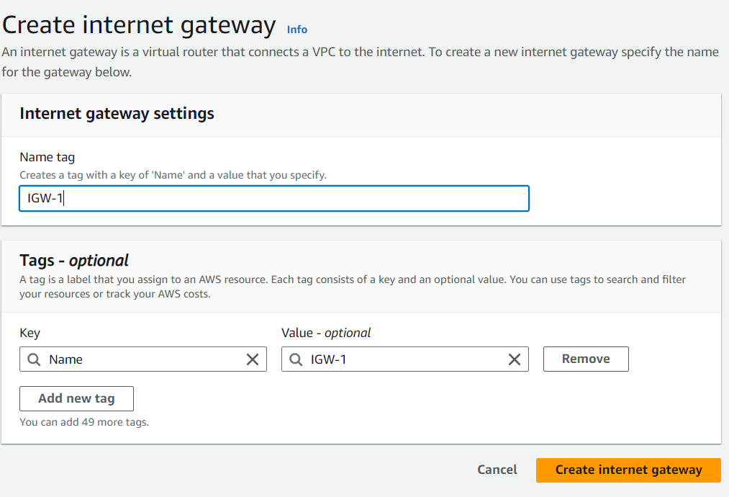

* Create 2 more Internet gateways in the same way (for second Internet gateway give name as IGW-2, and for third one give name as IGW-3).
* Now click on Internet gateways option and we can see our 3 internet gateways.

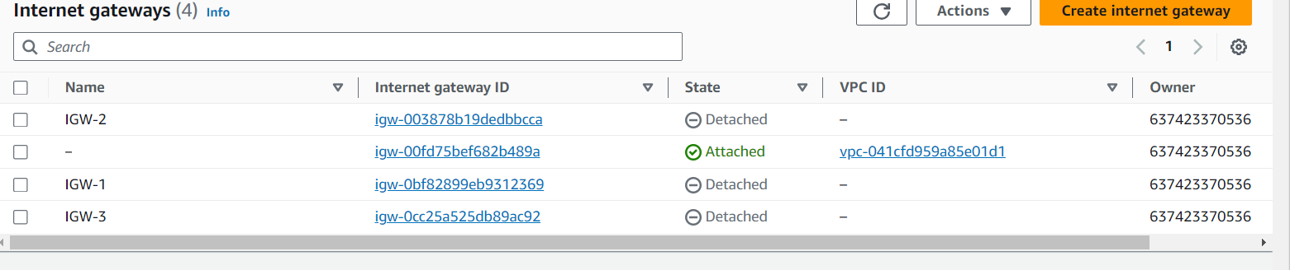

* Now we have to attach our internet gateways with our VPCs. Observe the above picture, we can see the State as Detached.
* So, select IGW-1 🡪 click on Actions and click on Attach to VPC 🡪 Select our VPC1 and finally click on Attach internet gateway.

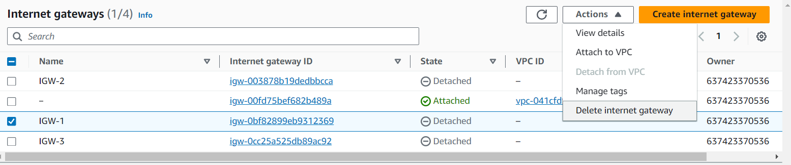

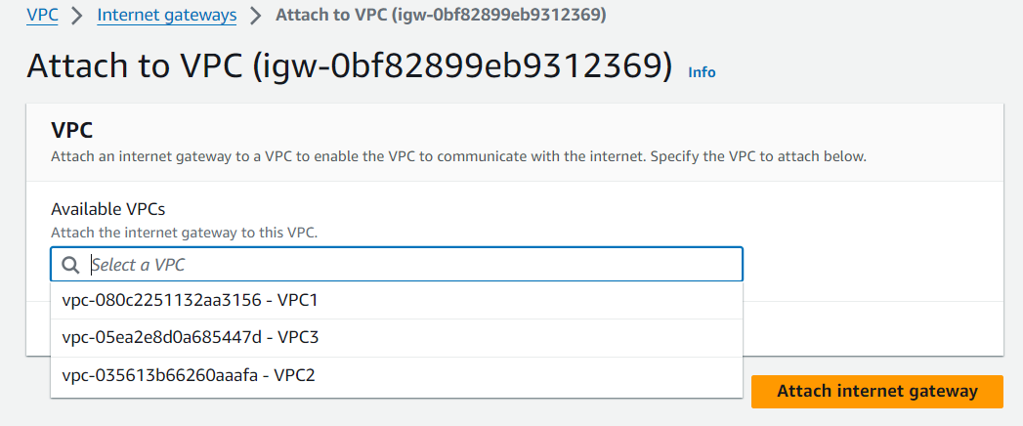

* Now do the same for remaining Internet gateways. (select IGW-2 and attach it with VPC2 and IGW-3 with VPC3)
* Now go to Internet gateways and we can see our internet gateways in Attached state.

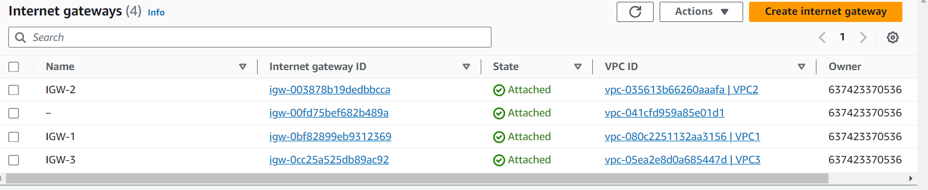

* Click on Subnets option under Virtual private cloud and click on Create subnet button.

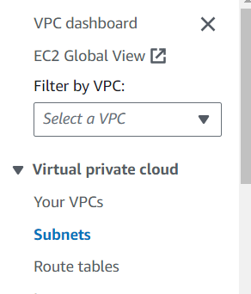

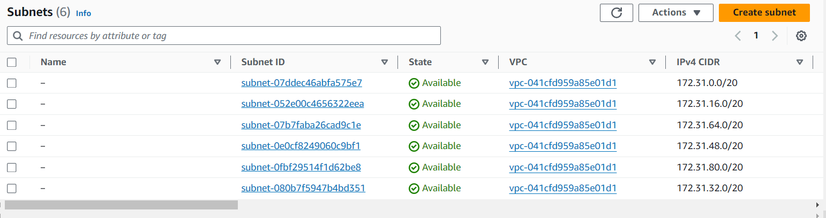

* Under VPC ID, select our VPC1 from drop down and under Subnet settings, name the subnet (subnet-1), select the Availability Zone (us-east-1a) and give CIDR in IPv4 subnet CIDR block (10.0.0.0/24) and finally click on Create subnet button.

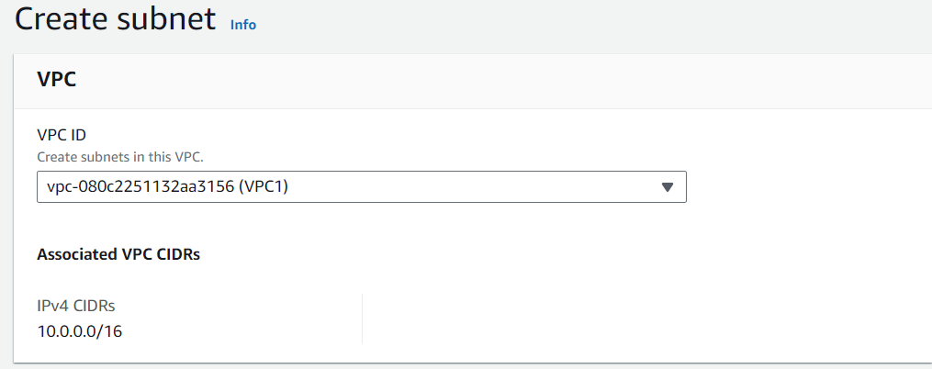

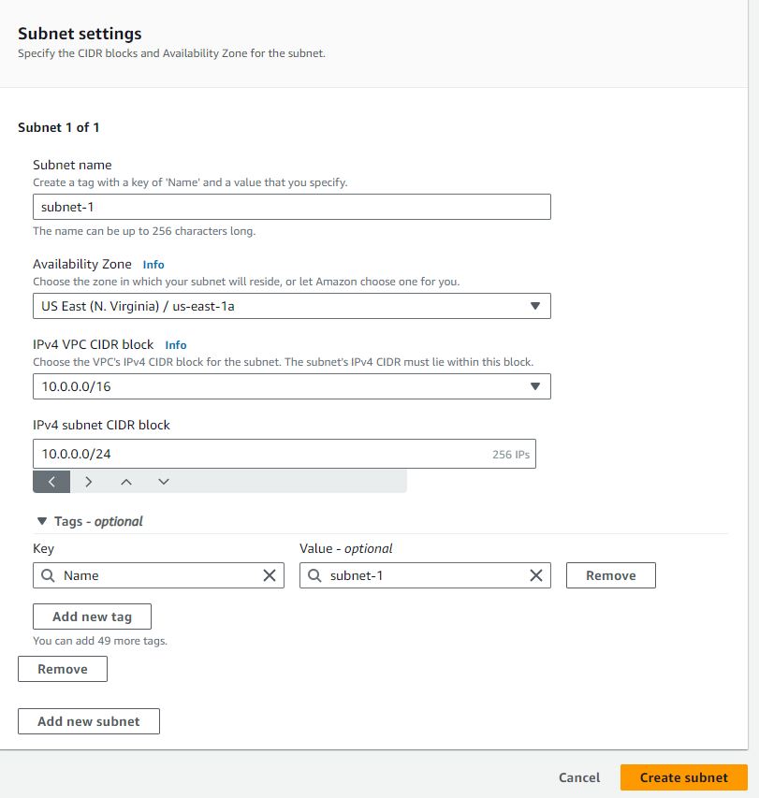

* Create two more subnets

🡪select VPC2 for second subnet and name it as subnet-2, select AZ as us-east-1b, IPv4 subnet CIDR is 11.0.0.0/24

🡪 select VPC3 for third subnet and name it as subnet-3, select AZ as us-east-1c, IPv4 subnet CIDR is 12.0.0.0/24

* Have a look on below 2 pictures for clear understanding.

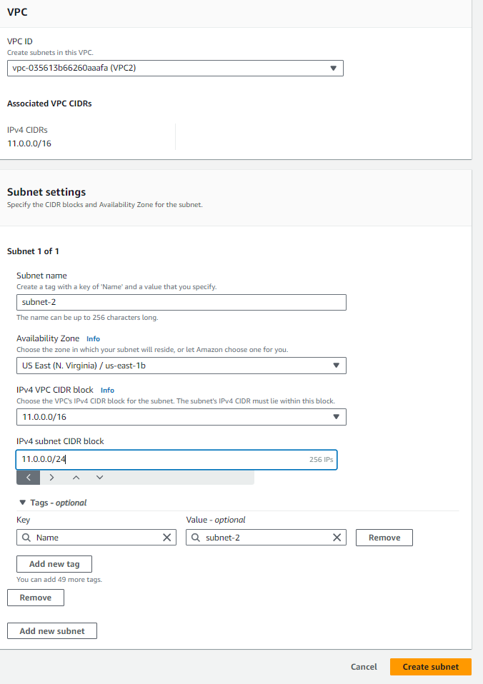

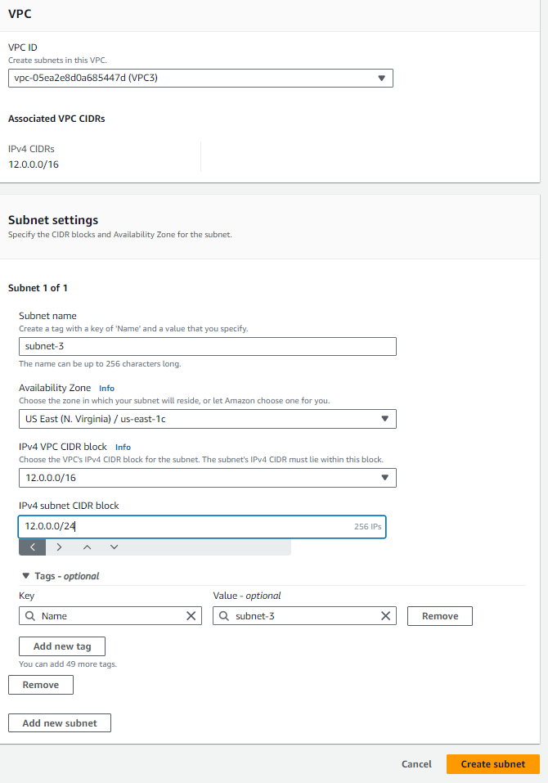

* Now go to subnets and see our 3 subnets created.

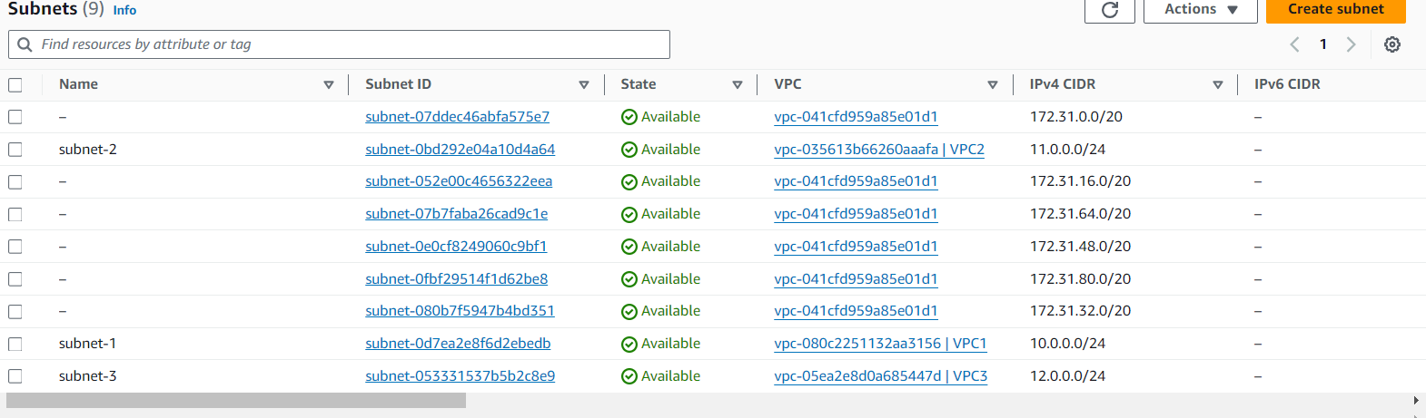

* Now create 3 route tables for three subnets.
* Click on Route tables under Virtual private cloud and click on Create route table button.

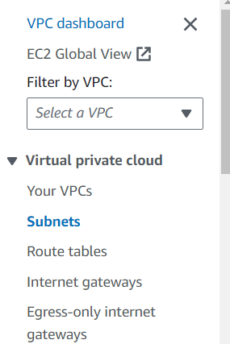

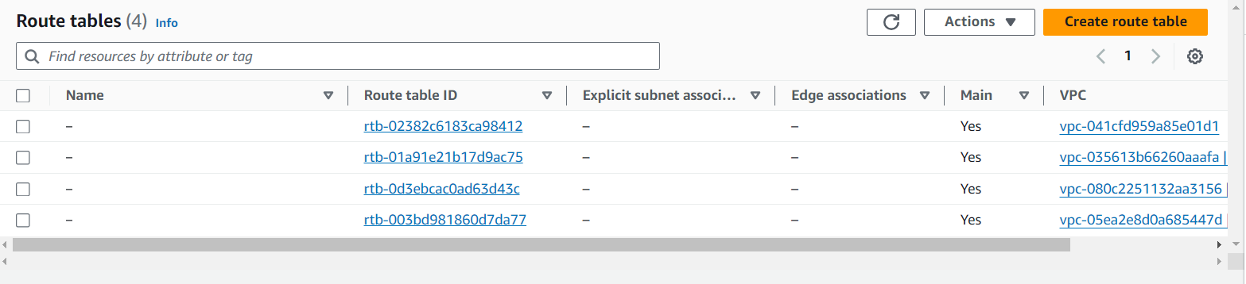

* Name our route table (RT-1) and select our VPC1 under VPC form drop down and finally click on Create route table.

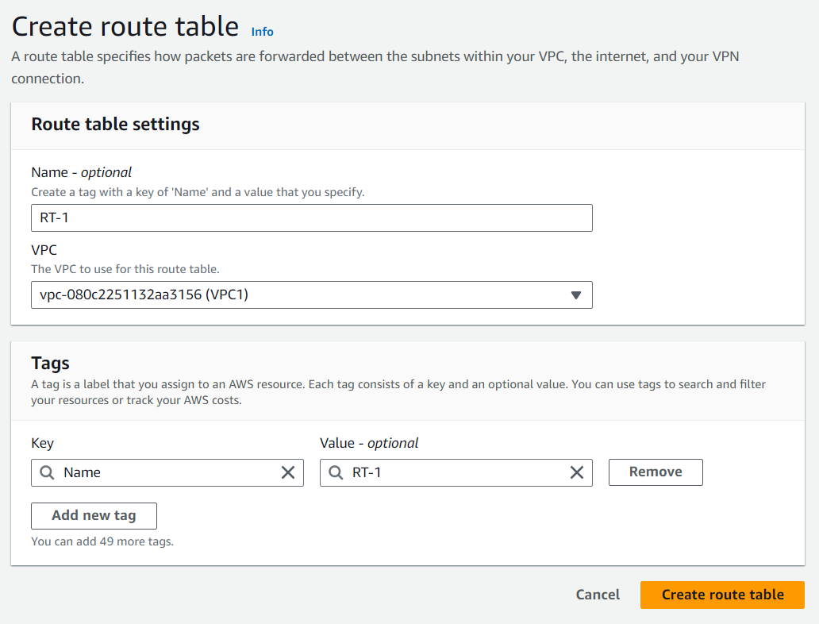

* Create 2 more rote tables

🡪for second route table give name as RT-2 and select VPC2

🡪for third one, give name as RT-3 and select VPC3

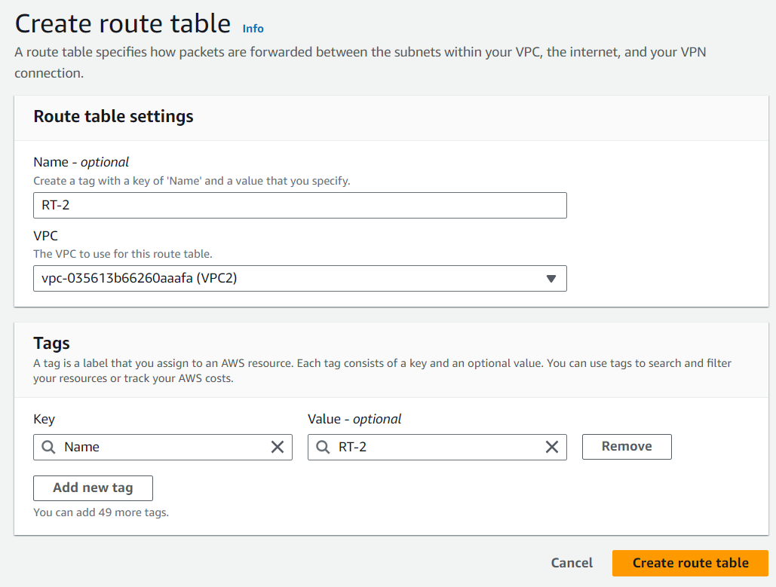

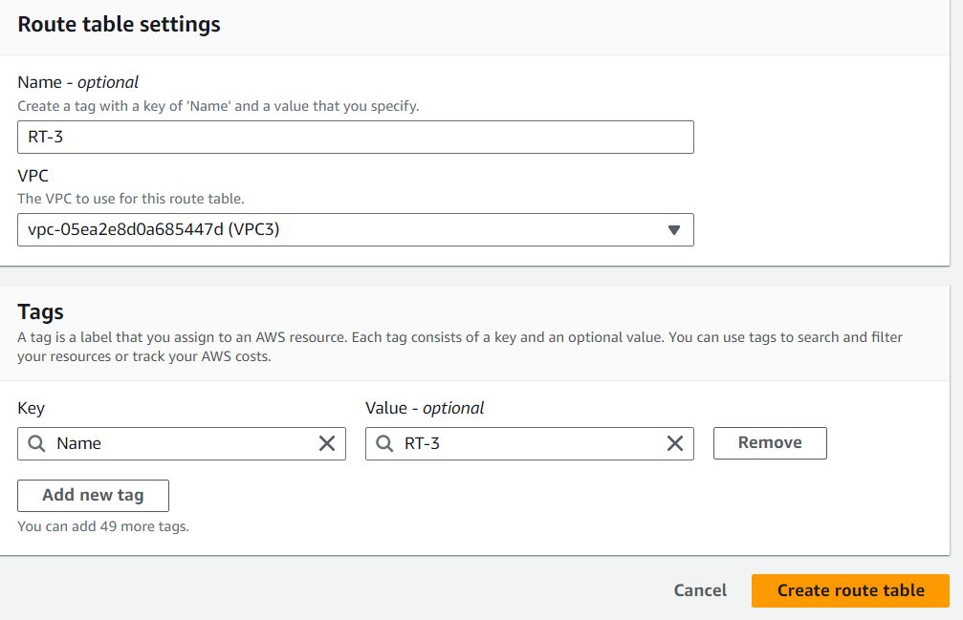

* Now go to Route tables and can see our route tables are created.

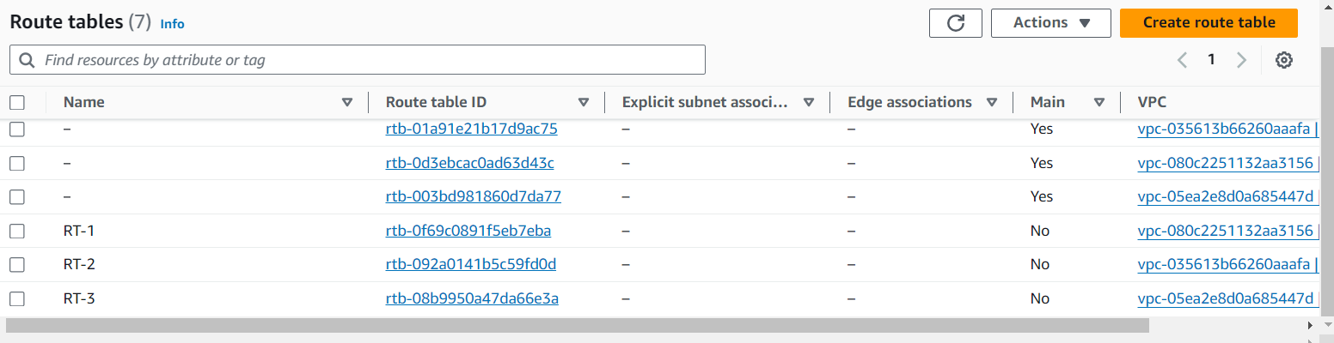

* Now go to route table 1 i.e. RT-1 (click on RT-1’s Route table ID), click on Subnet associations and click on Edit subnet associations

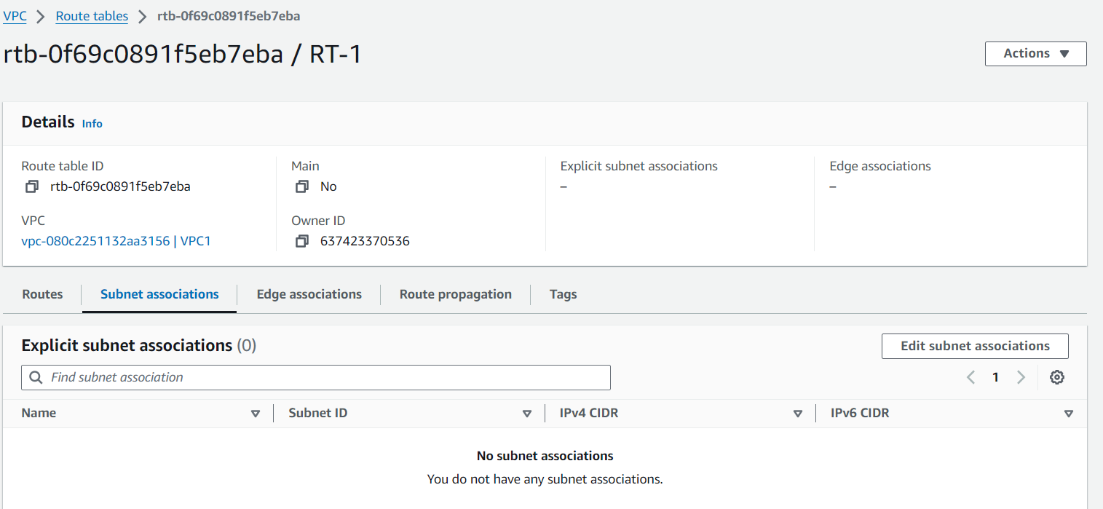

* Select subnet-1 and click on Save associations button.

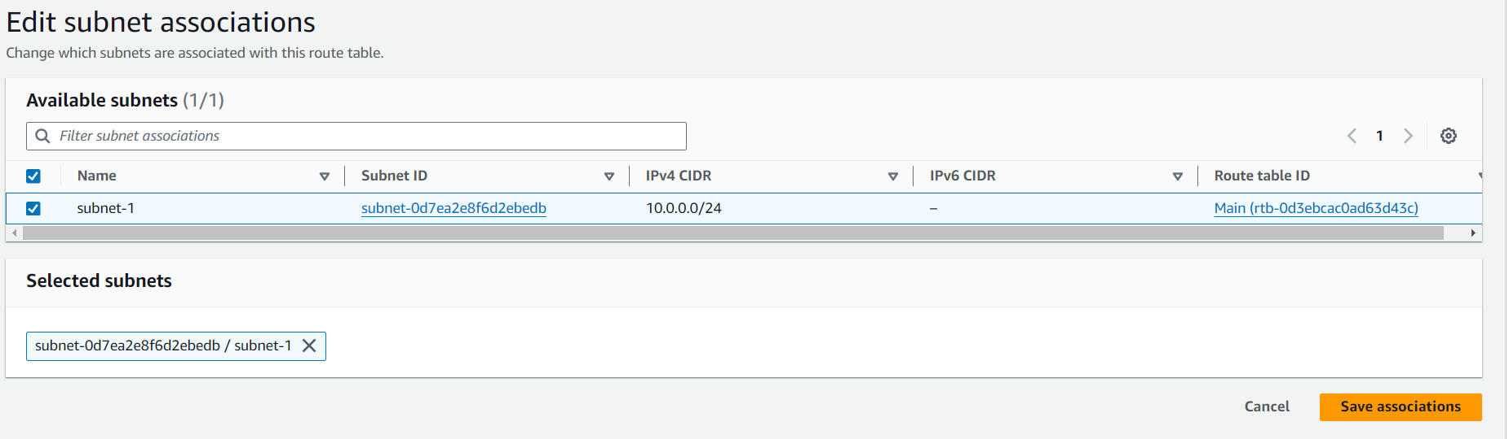

* Now click on Actions and click on Edit routes

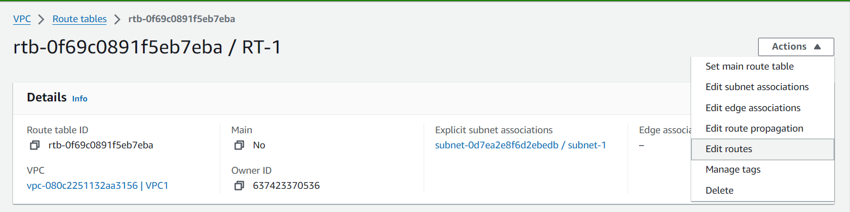

* Click on Add route, give 0.0.0.0/0 as Destination and select Internet gateway from drop down under Target and select our IGW-1 and finally click on Save changes button.

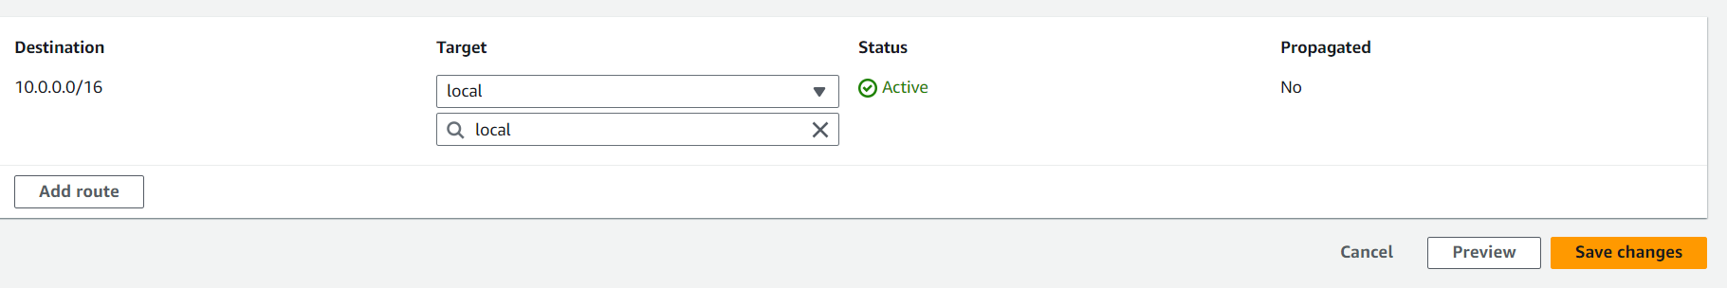

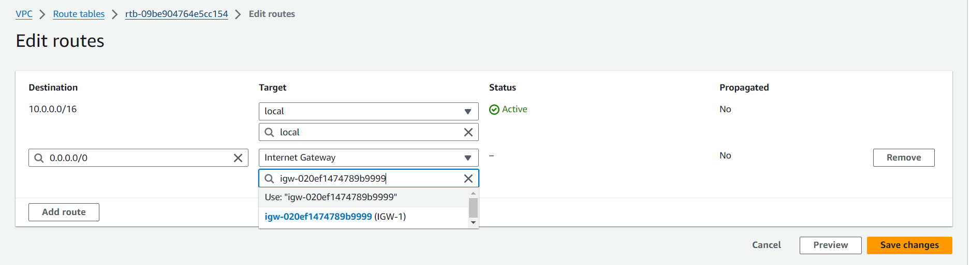

* Now go to route tables, go to second route table (RT-2), click on Subnet associations and click on Edit subnet associations. Select our subnet-2 and finally click on Save associations button.

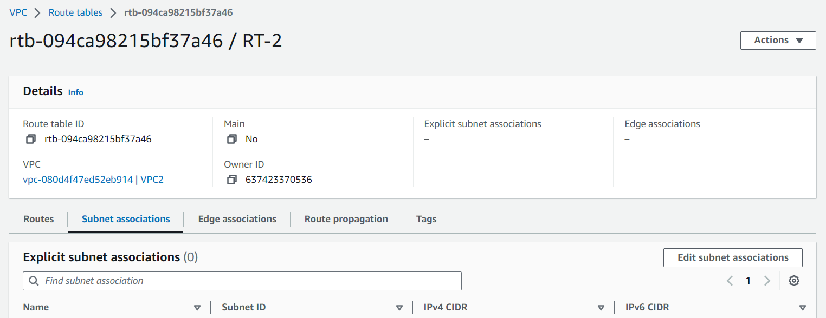

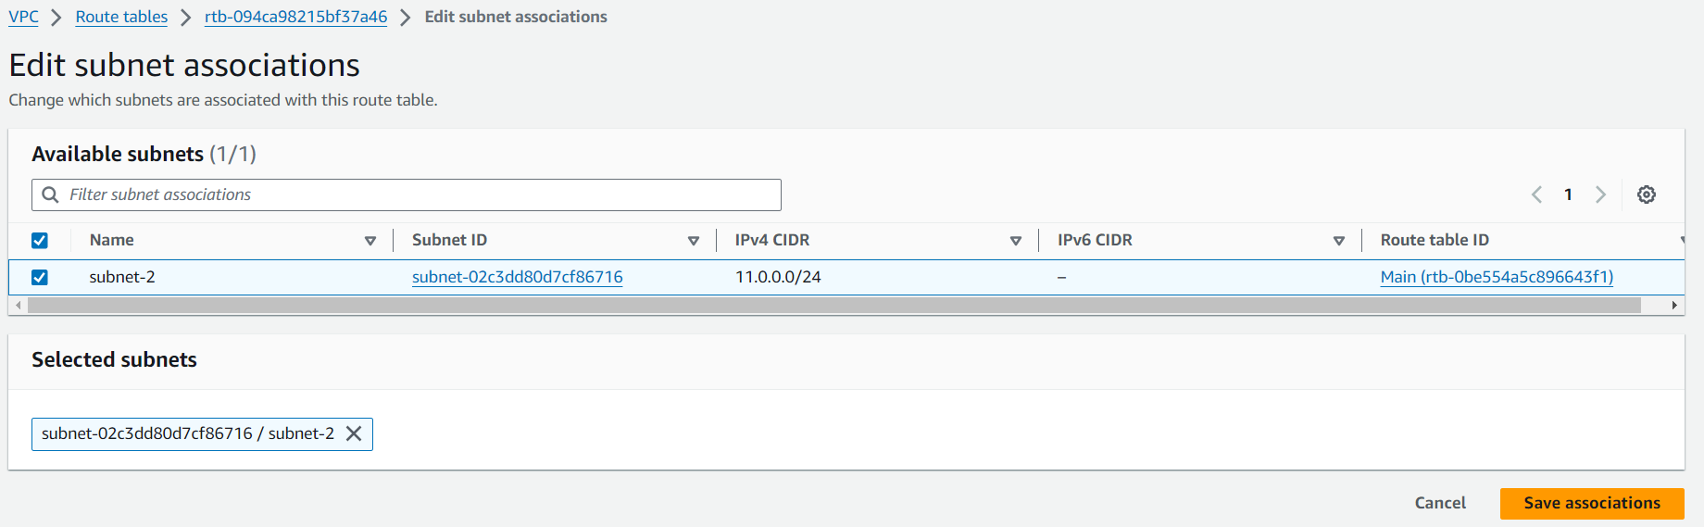

* Click on Actions and click on Edit routes and click on Add route, give Destination as 0.0.0.0/0 and under Target, select Internet Gateway option from drop down list and select our IGW-2 and finally click on Save changes.

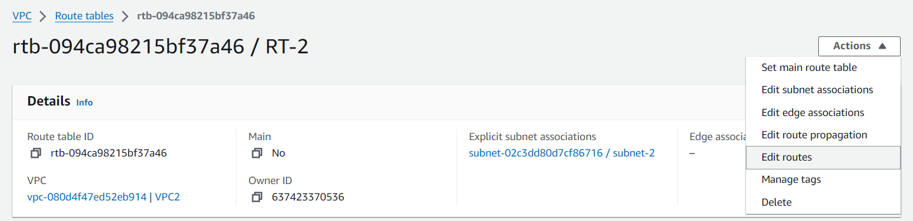

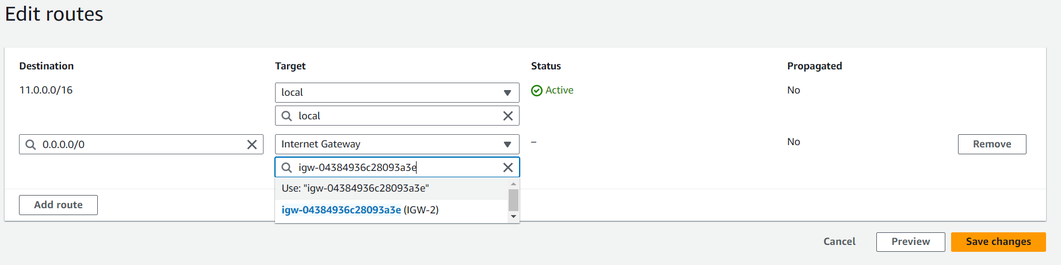

* Now go the same 3rd route table (RT-3), Edit subnet association and select subnet-3, Save associations. Go to Actions, click on Edit routes, Add route and give Destination as 0.0.0.0/0, select Internet Gateway under Target and Select our IGW-3 and click on Save changes.

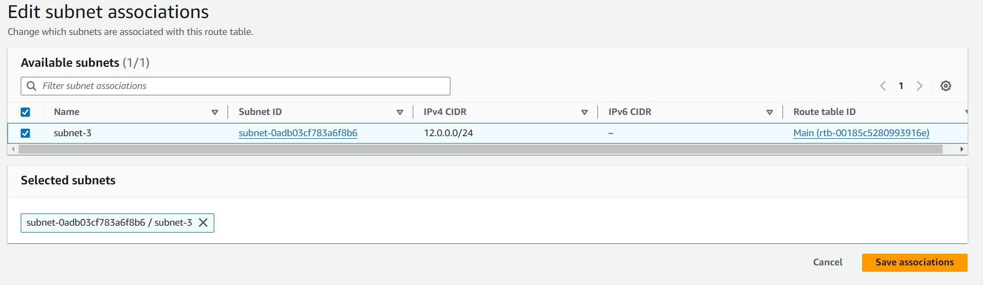

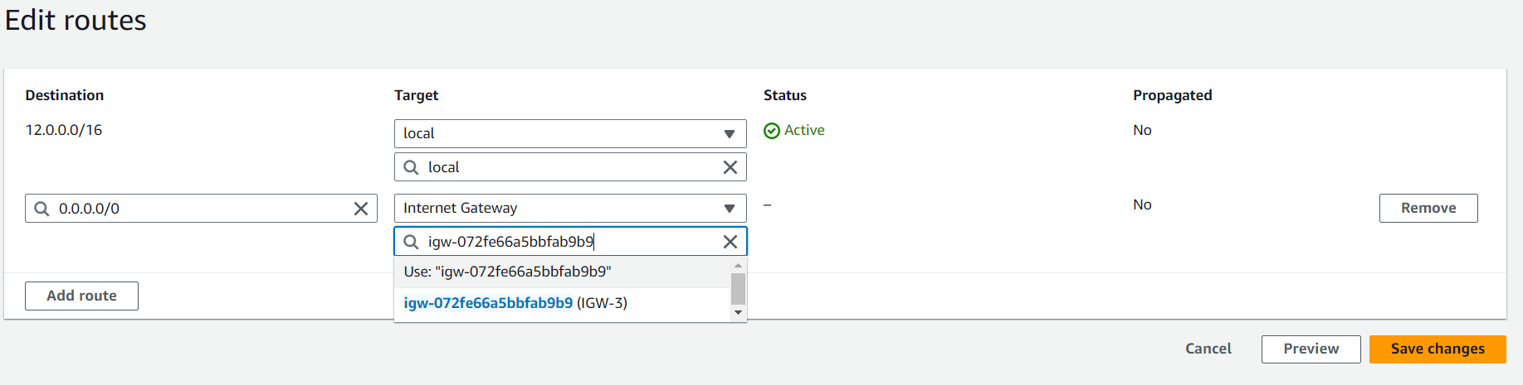

* Now we have to create Transit Gateway, for that click on Transit gateways and click on Create transit gateway.

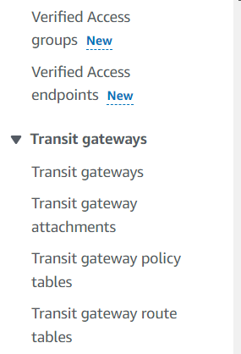

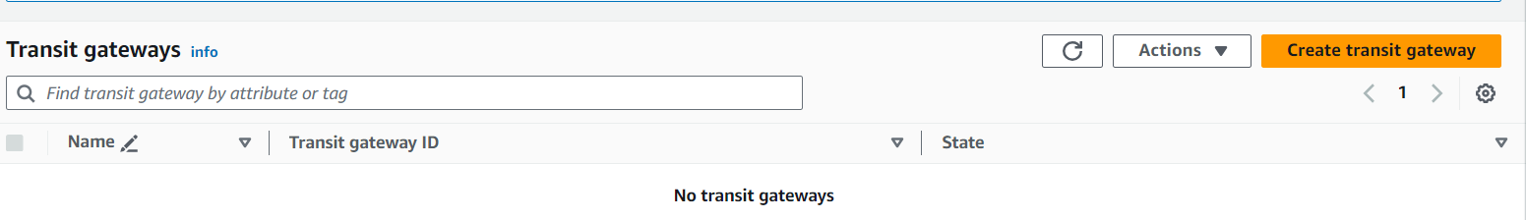

* Name our Transit gateway (my-TGW), give Description as nothing and click on Create transit gateway.

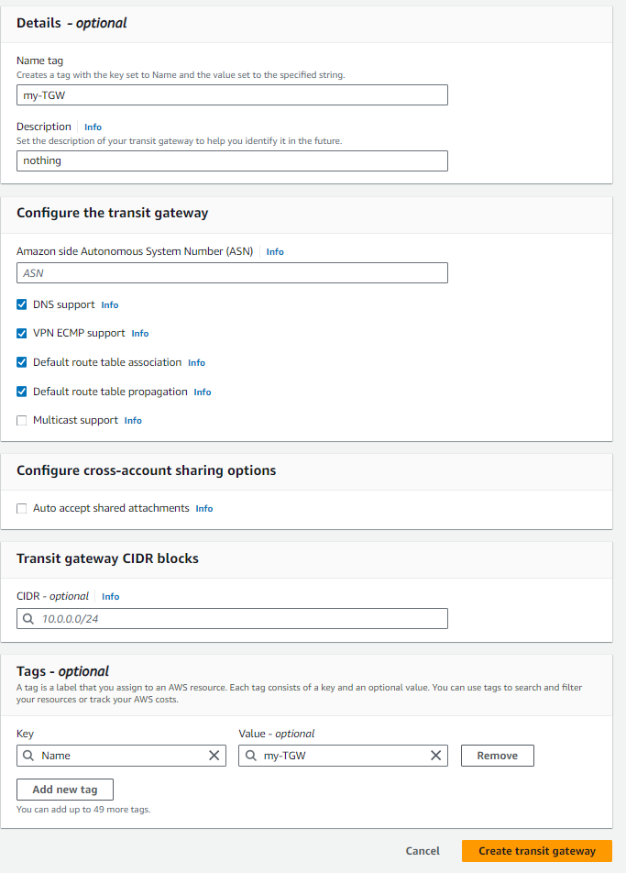

* Now click on Transit gateway attachments and click on Create transit gateway attachment

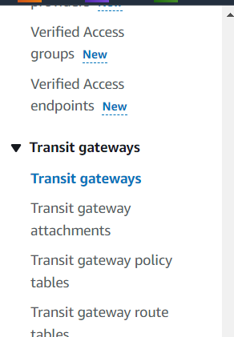

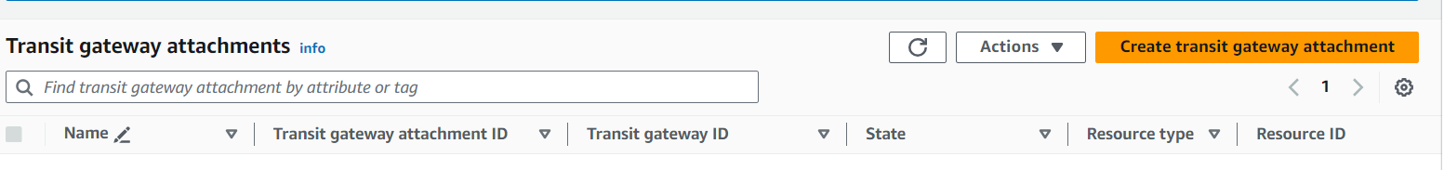

* Give name to attachment (TGW-attach1), under Transit gateway ID, select our Transit gateway that we already created (my-TGW). Under VPC ID, select our VPC1 and finally click on Create transit gateway attachment.

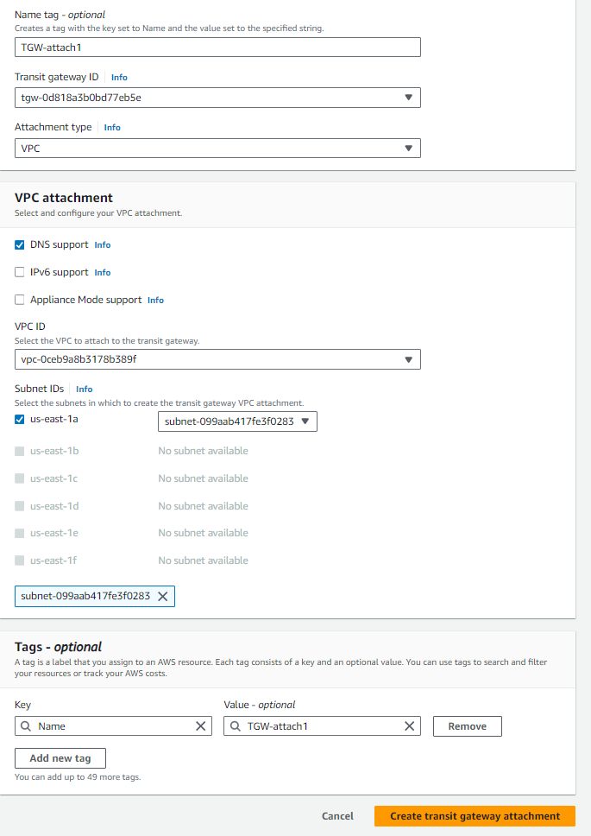

* Again click on Create transit gateway attachment, name the attachment (TGW-attach2), under Transit gateway ID, select our Transit gateway. Under VPC ID, select our VPC2 and finally click on Create transit gateway attachment

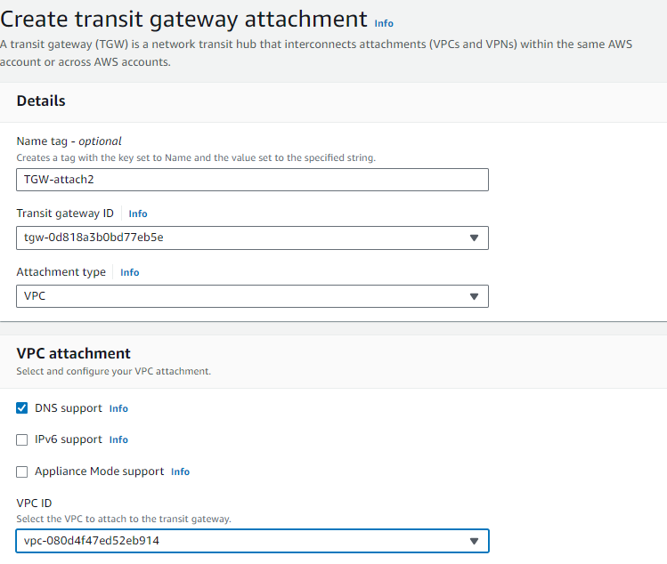

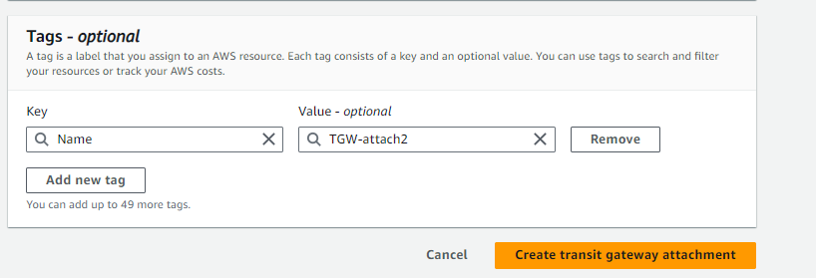

* Do the same once more. Click on Create transit gateway attachment, name the attachment (TGW-attach3), under Transit gateway ID, select our Transit gateway. Under VPC ID, select our VPC3 and finally click on Create transit gateway attachment

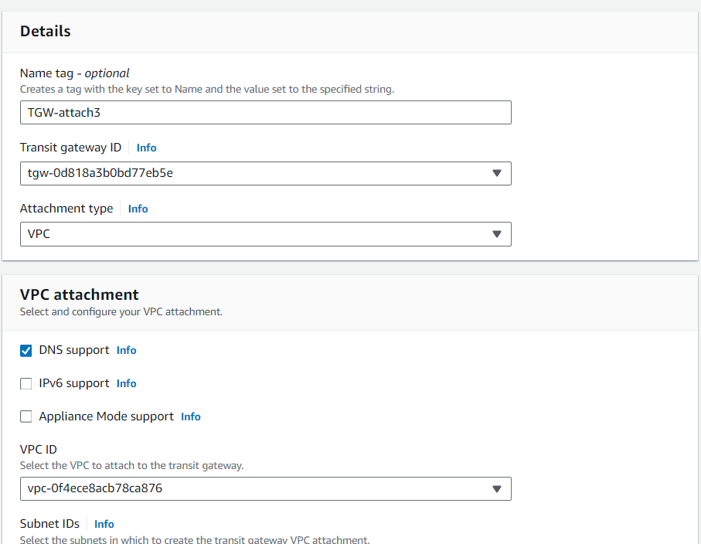



* Go to route tables, go to first route table (RT-1), click on Actions, click on Edit routes

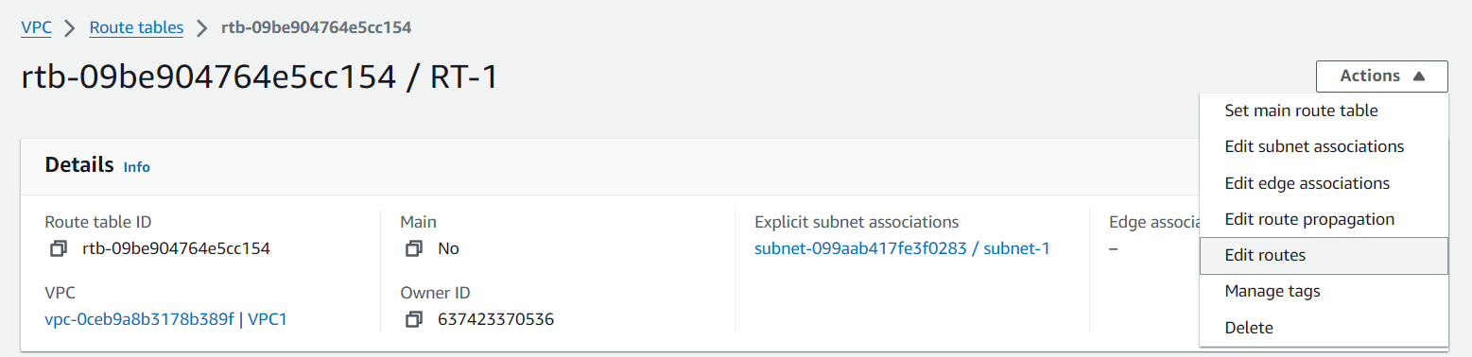

* First click on Add route, give Destination as 11.0.0.0/16, under Target, select Transit Gateway form drop down and select our Transit gateway attachment (TGW-attach1). Again click on Add route, give Destination as 12.0.0.0/16, select Transit Gateway form drop down as Target and select our Transit gateway attachment (TGW-attach1). Finally click on Save changes.

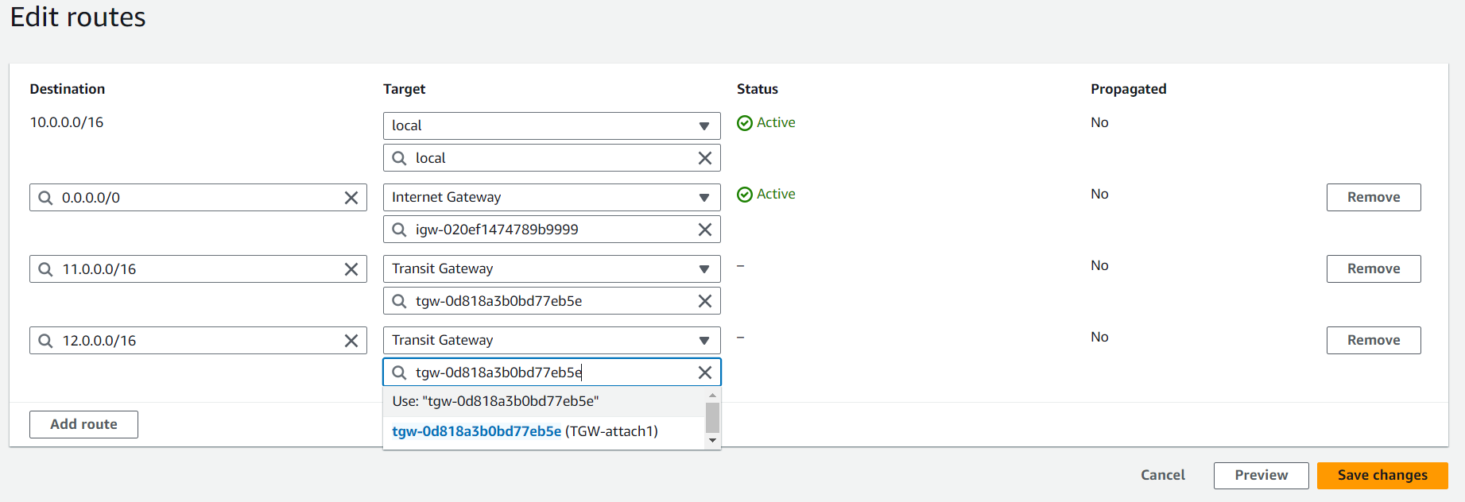

\*Note: here we are in rote table one (RT-1), and its Destination is 10.0.0.0/16. So, we have to give another two IPv4 addresses as Destinations.

* Now do the same for remaining two route tables. Go to second route table (RT-2), click on Actions, click on Edit routes. click on Add route, give Destination as 10.0.0.0/16, under Target, select Transit Gateway form drop down and select our Transit gateway attachment (TGW-attach2). Again click on Add route, give Destination as 12.0.0.0/16, select Transit Gateway form drop down as Target and select our Transit gateway attachment (TGW-attach2). Finally click on Save changes

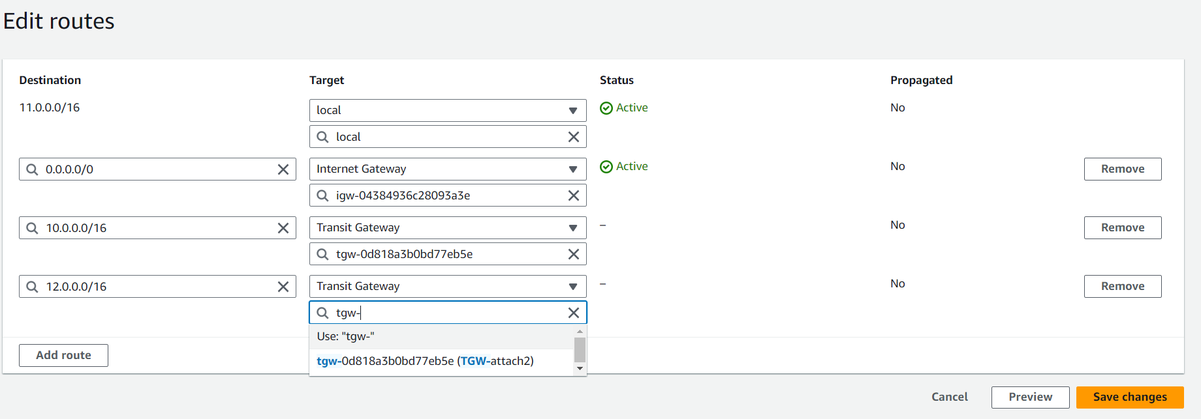

* Now do the same for third route table (gives Destinations as 10.0.0.0/16 and 11.0.0.0/16. And select Transit gateway (TGW-attach3). Have a look on below pic.

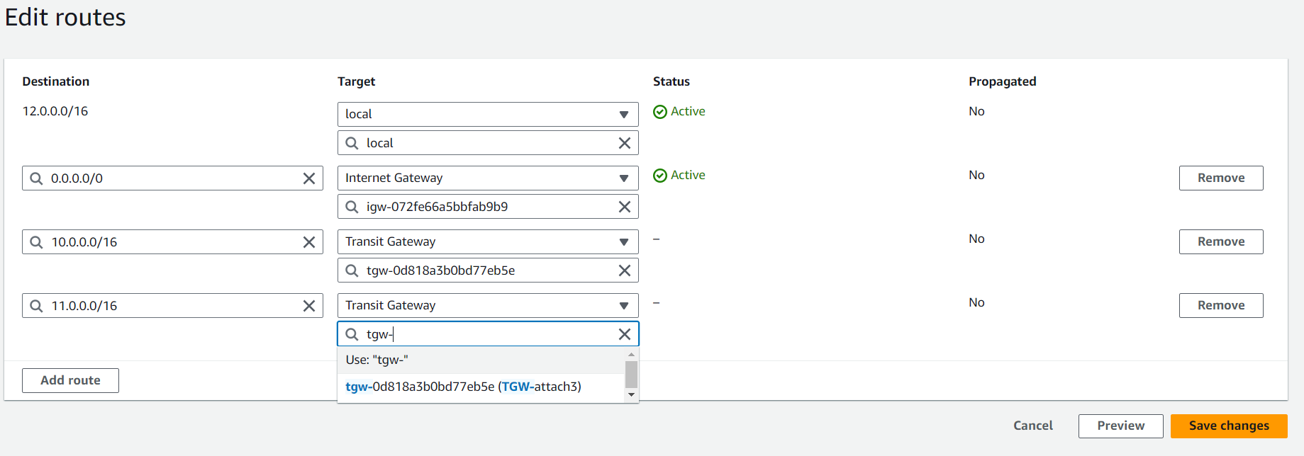

* Now we are going launch three (3) instances.
* Search for EC2 in search bar in AWS home page, click on EC2 under Services. And click instances form menu and click on Launch instance

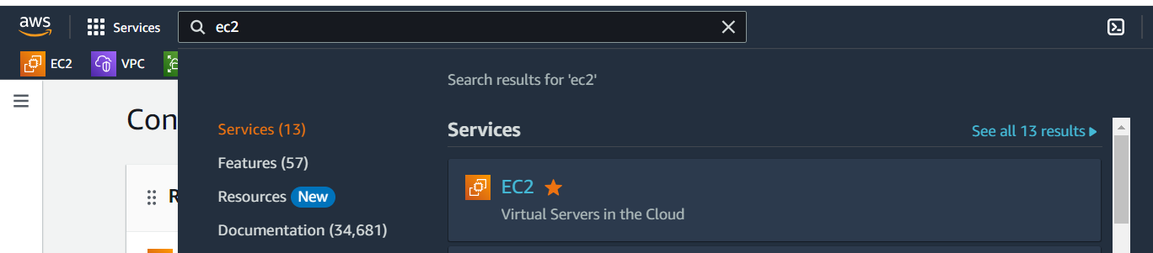

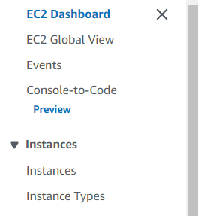

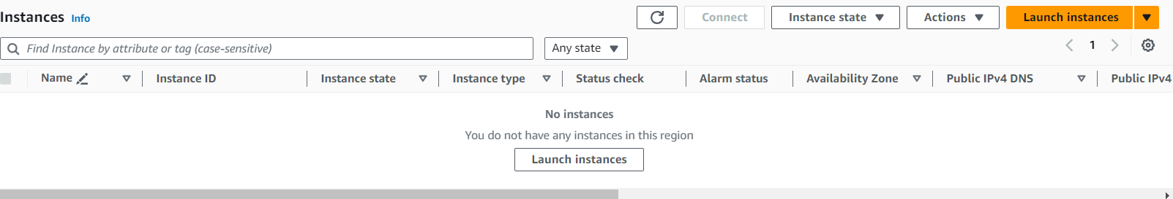

* Give any to our instance (VPC1-EC2). Select OS of your choice (I have selected Amazon Linux) and instance type as t2.micro.

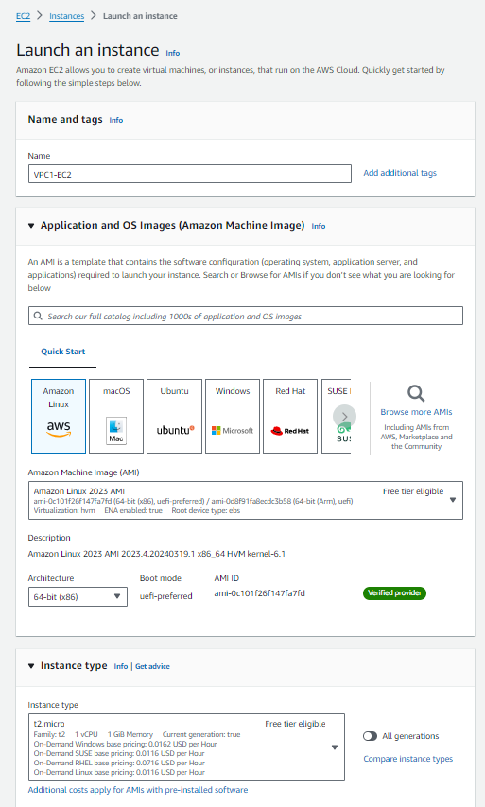

* We have to create a key pair. So, click on Create new key pair option. Give name to our key pair and click on Create key pair button.

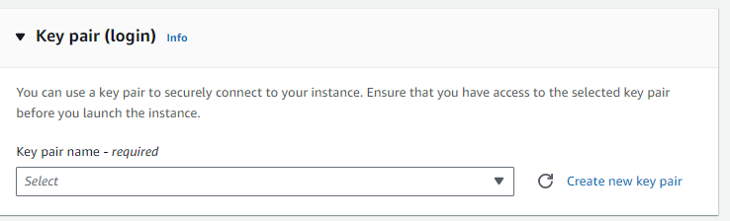

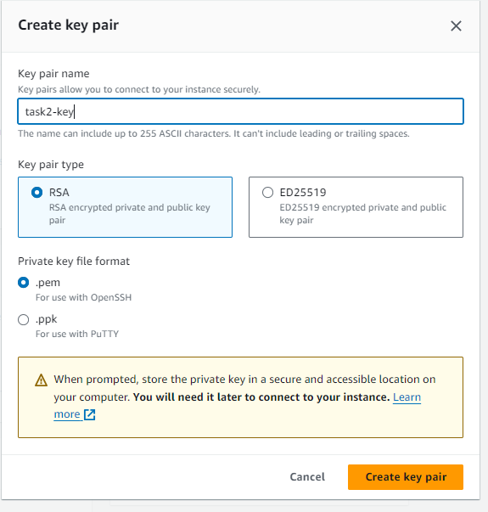

* In Network settings area, click on Edit button to configure with our custom VPCs.
* Under VPC section, select our VPC1. Enable Auto-assign public IP. Select Create security group (if we already have a security group, we can select, Select existing security group option)

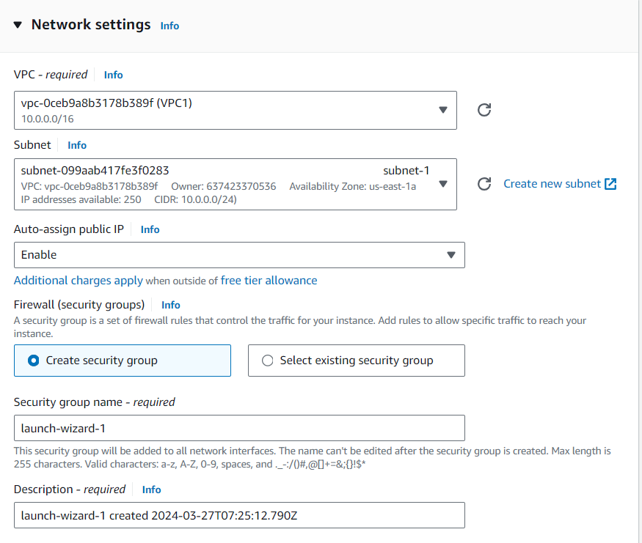

* Now click on Add security group rule (under Network settings), instead of Custom TCP, give Type as HTTP and under source give 0.0.0.0/0 and finally click on Launch instance button.

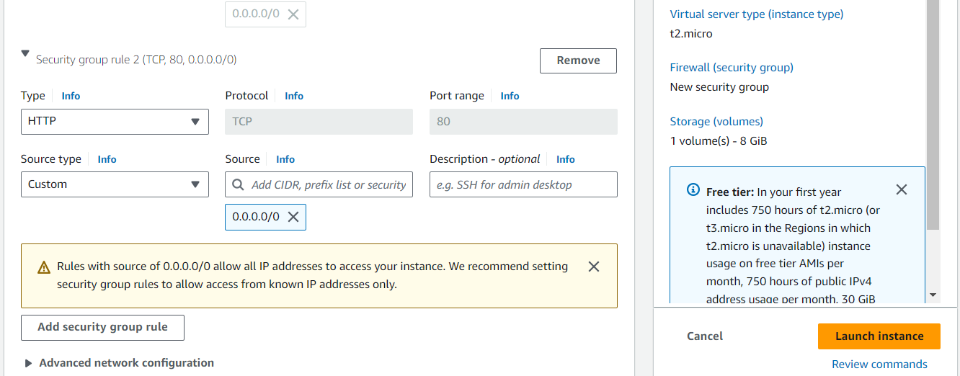

* Now launch two more instances in the same way as we launched our first instance. But we have change few things, observe the points below

🡪for second instance, name (VPC2-EC2), select the key pair under Key pair section that we already created when launching our first instance. Edit network settings, select VPC2, Give HTTP inbound rule and launch instance.

🡪 for third instance, name (VPC3-EC2), select the key pair, Edit network settings, select VPC3, Give HTTP inbound rule and launch instance.

* We have successfully launched our instances. Now, go to instances
* Go to instance one (VPC1-EC2), scroll down and click on Security. Now click on the link under Security groups

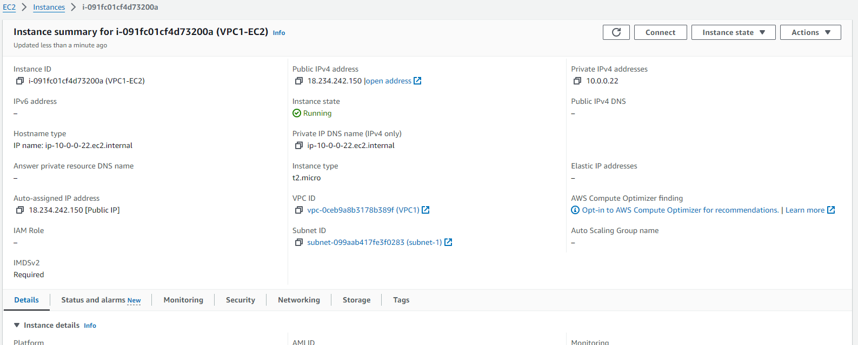

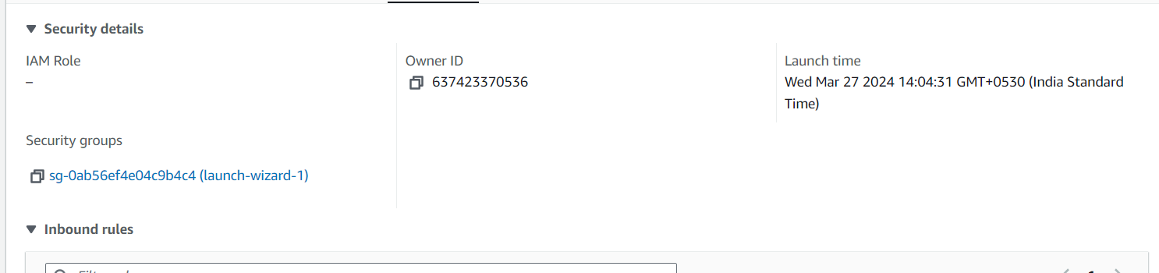

* Click on Actions, click on Edit inbound rules

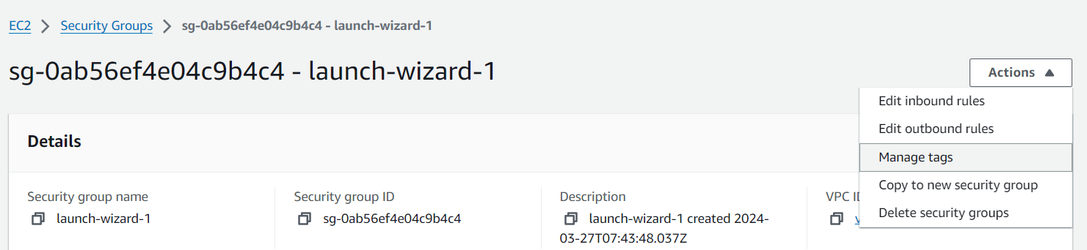

* Click on Add rule, select HTTP instead of Custom TCP and give 11.0.0.0/16 as Source. Add one more rule for HTTP and give source as 12.0.0.0/16. And click on save rules.

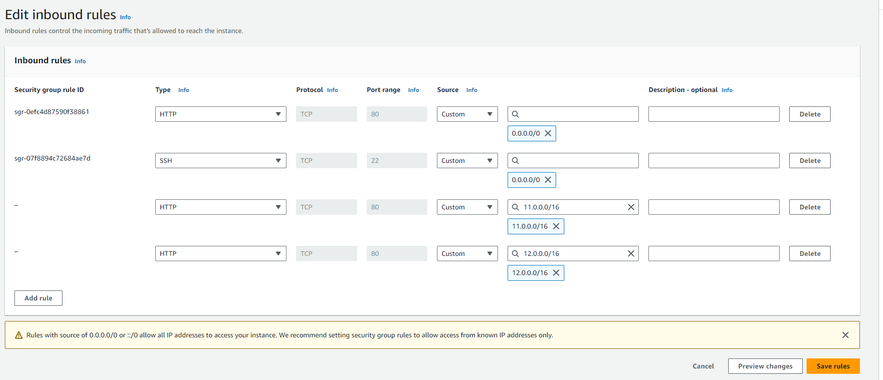

* Now go to second instance and do the same things. (add two rules with HTTP, one for source 10.0.0.0/16 and another one is for 12.0.0.0/16) and Save rules
* Now go to second instance and do the same things. (add two rules with HTTP, one for source 10.0.0.0/16 and another one is for 12.0.0.0/16)
* Have a look on below pics

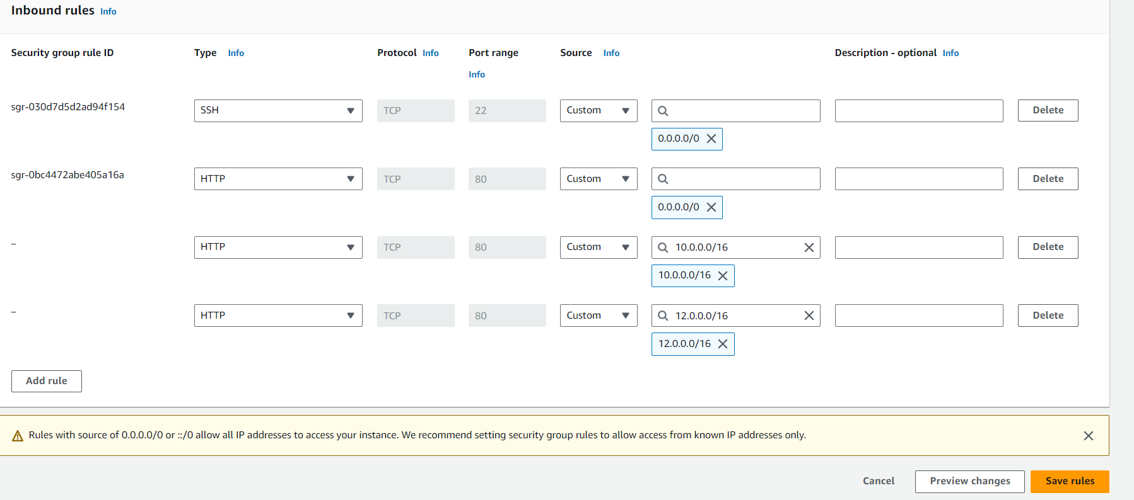

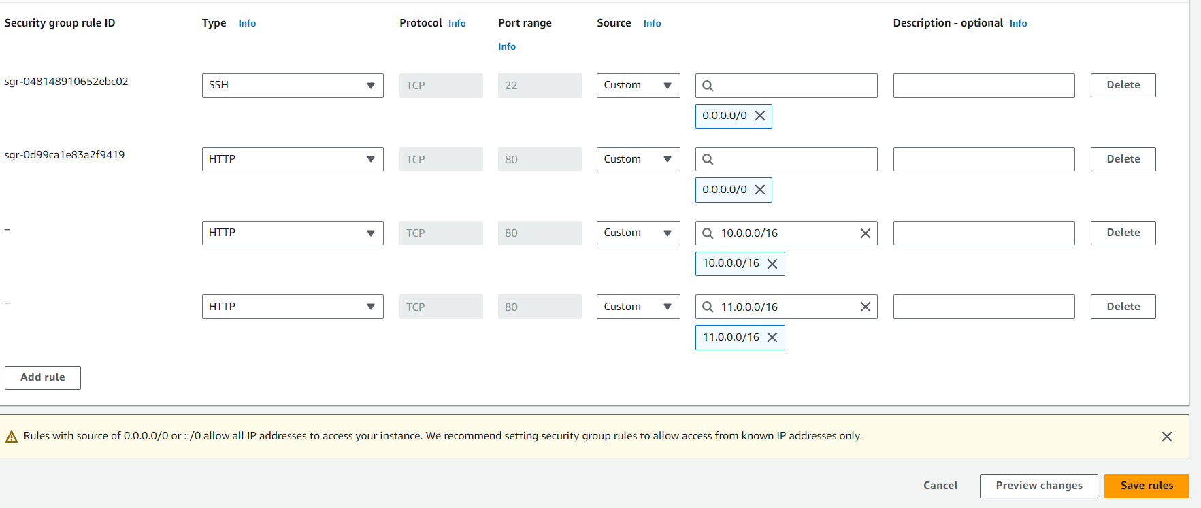

* We have to connect the instances one by one.
* Go to instances, select first instance (VPC1-EC2) and click on connect option and finally click on Connect

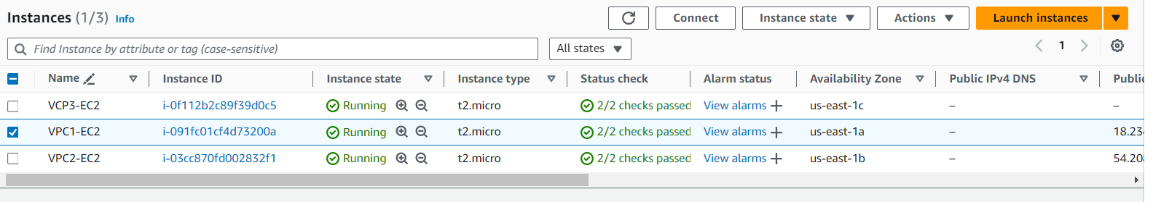

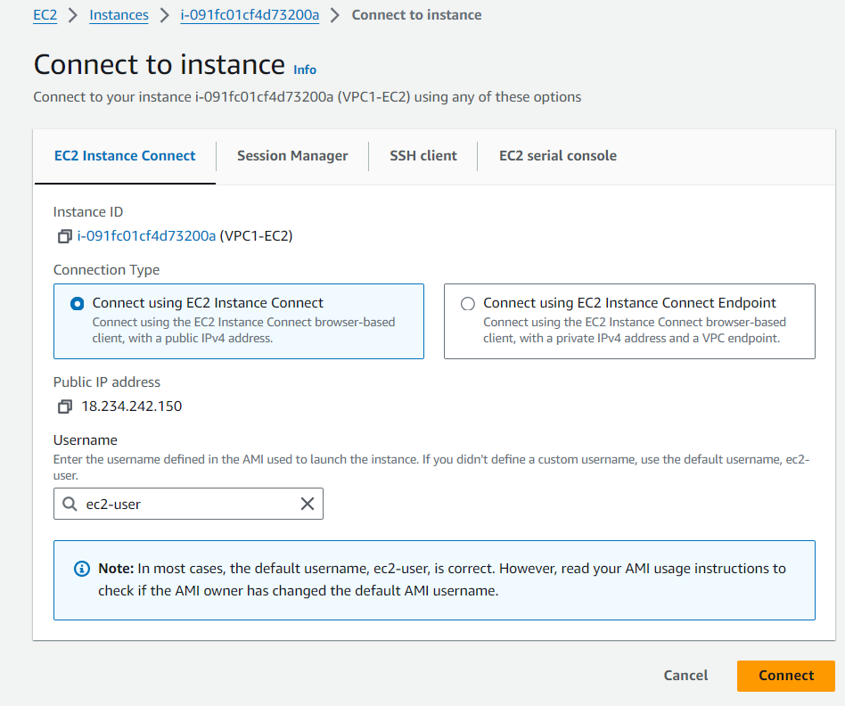

* After successful connection of our instance (server), give sudo -i to change to root user.

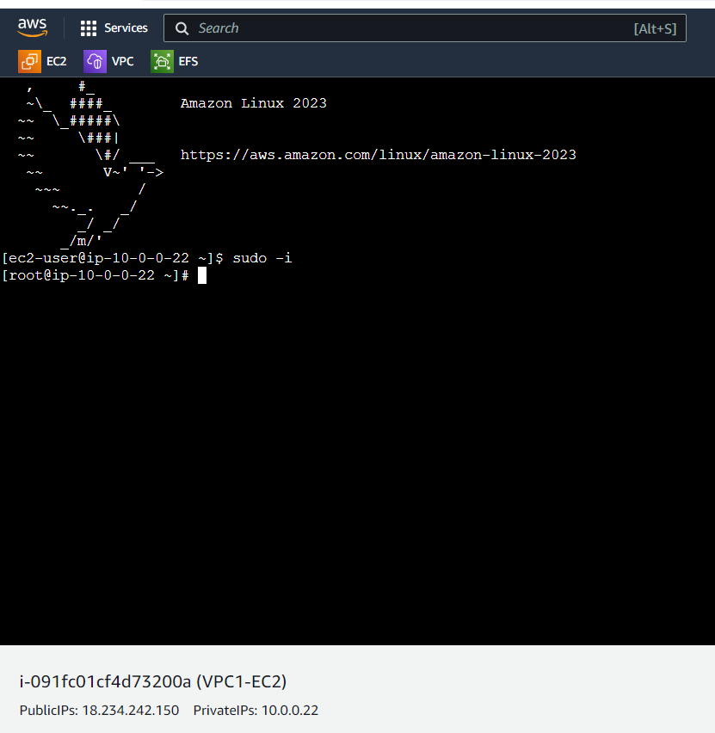

* I’m going to install nginx in connected server

🡪yum update –y

🡪yum install nginx –y

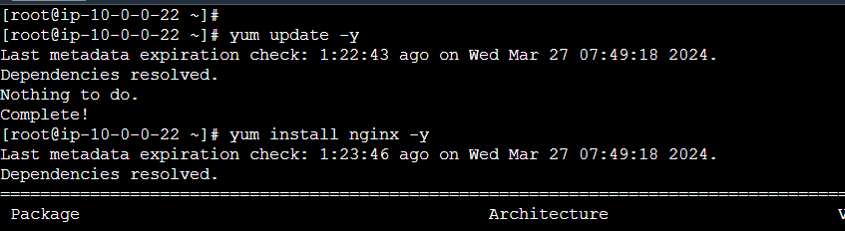

* After successful installation, will get below

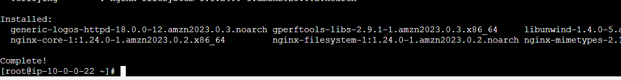

* Now go to /usr/share/nginx/html path, there we have index.html file. Please remove it and create the same file (index.html) with our own content. And save the file.

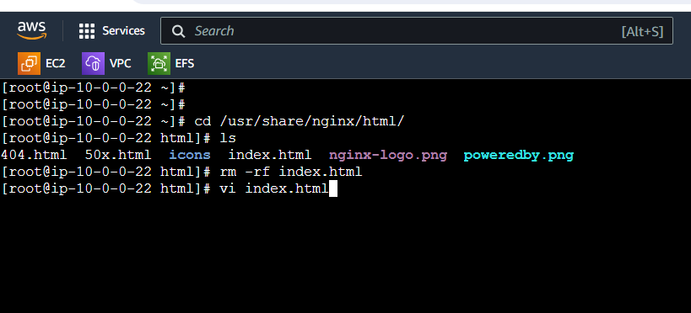

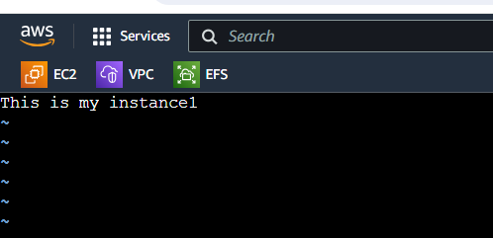

* Now restart nginx with following command

🡪 systemctl restart nginx

* Now copy the public IP of connected server and use below command to see the connect in the index.html file

🡪curl 18.234.242.150:80 (see the below pic for clarity)

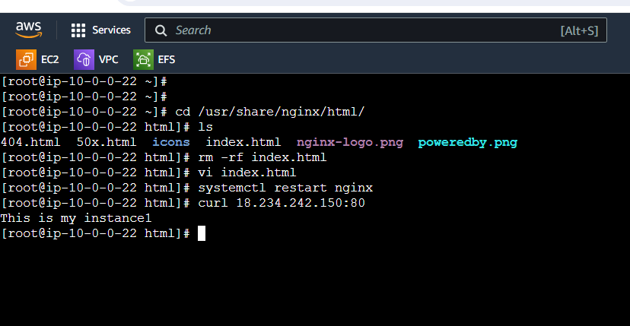

* Now connect to second instance (VPC2-EC2) and follow same process and commands (in index.html, type This is my instance2). Refer below pic

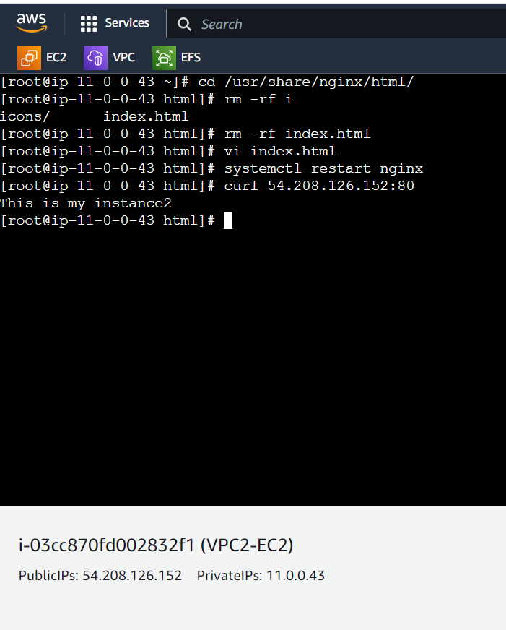

* Now connect to third instance (VPC3-EC2) and follow same process and commands (in index.html, type This is my instance3). Refer below pic

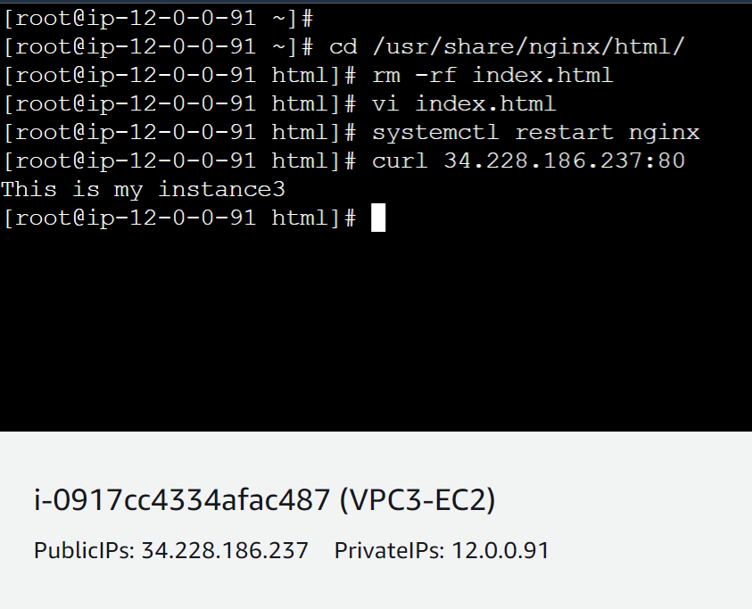

* Now copy the private IP of any connected instance and go to another connected instance (for example I have copied IP of instance one i.e. our VPC1-EC2 and paste that IP in third instance i.e. our VPC3-EC2) and use curl command. Refer below pic

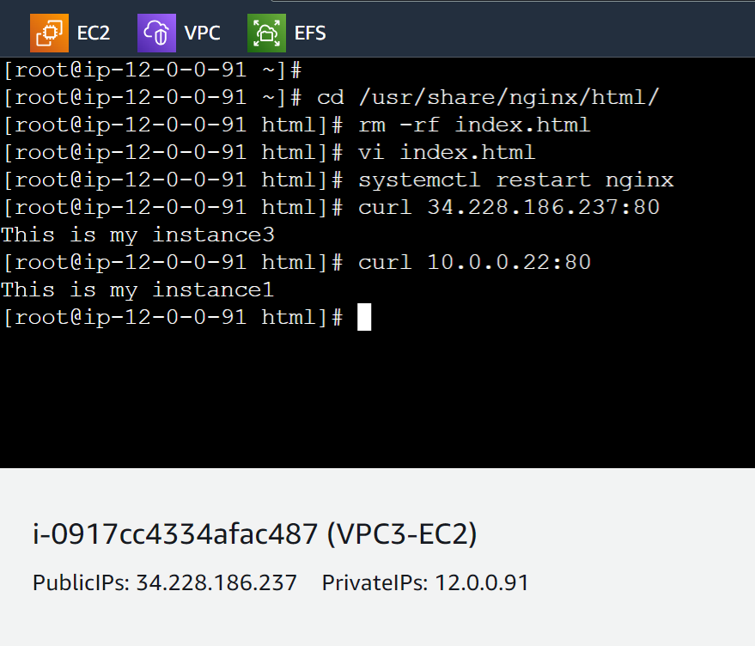

* If we observe above pic, I have copied the private IP of instance1 and pasted on instance3. And after using curl command we got – This is my instance1 content/message in instance3 (VPC3-EC2).
* So our Transit gateway task successfully completed.