Name: Liew Ee Mei (RMB3)

Course: BAME Integrated Circuit Design

|  |  |
| --- | --- |
| Flow Chart: | Block Diagram: |
|  |  |

RTL View:

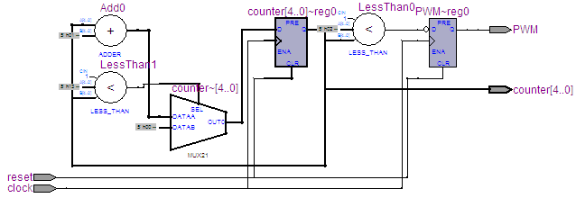

Analyzing of input/output signals of PWM:

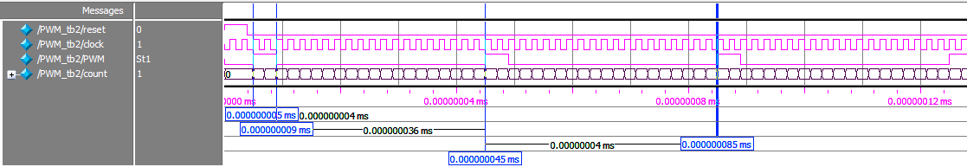

|  |  |
| --- | --- |
| Area, Total logic element: | Power: |
|  |  |

Setup time:

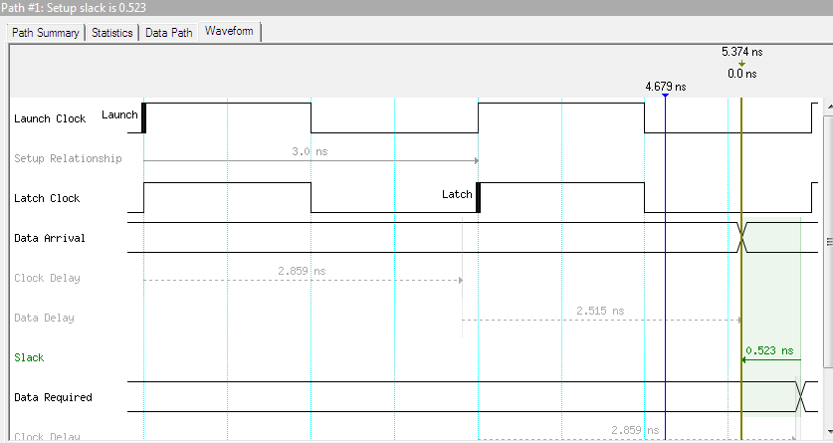

Hold time:

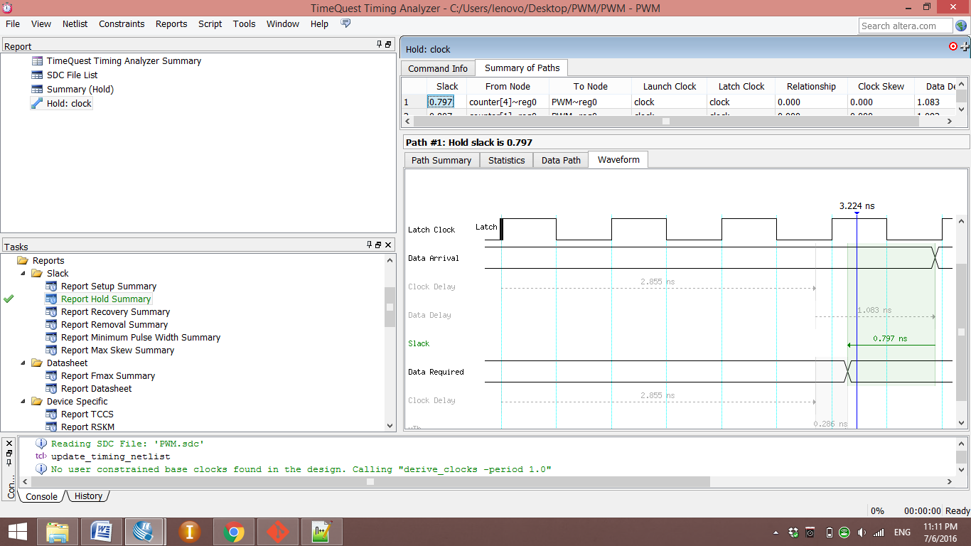

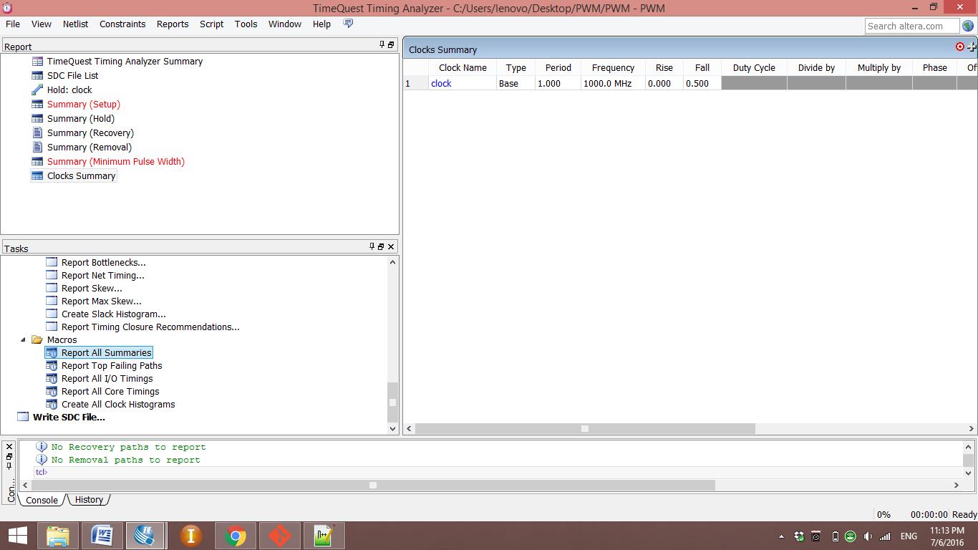

Code:

