Black Hats JSON File Development Specifications

Program Specifications

*General Scope:*

To develop a bot that, when a user with specific privileges (admin role), calls a command (!bhwagon_countNumber) which will returns a list of users and how many occurrences of “bhwagon” was said by that user through a specific time period (7d,14d,21d,30d). This file should be stored in JSON format.

Visual Example

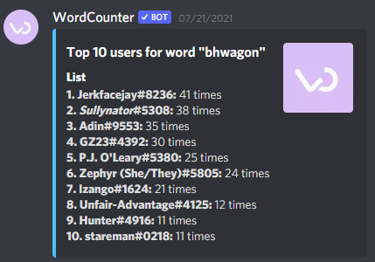

Call Example

* !wagonCounter 7 – returns the top users whose had the most occurrences in the last 7 days
* ! wagonCounter 14 – returns the top users whose had the most occurrences in the last 14 day
* ! wagonCounter 21 – returns the top users whose had the most occurrences in the last 21 days
* ! wagonCounter 30 – returns the top users whose had the most occurrences in the last 30 days