DemoFlowLayout.java

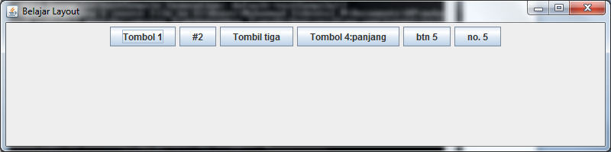

DemoGridLayout.java

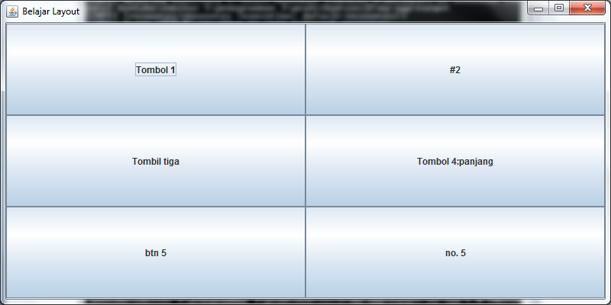

DemoBorderLayout.java

