Results – Shuffled Frog Leaping Algorithm

**Development – 1: When 13 bits shuffled at the development stage**  
Reference: Results_R1_1500.mat (path: E:\Chaminda\14. GSP\2_SFLA_Algorithm\SFLA_V2)

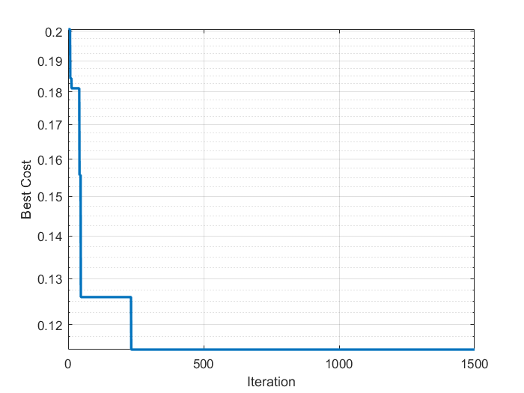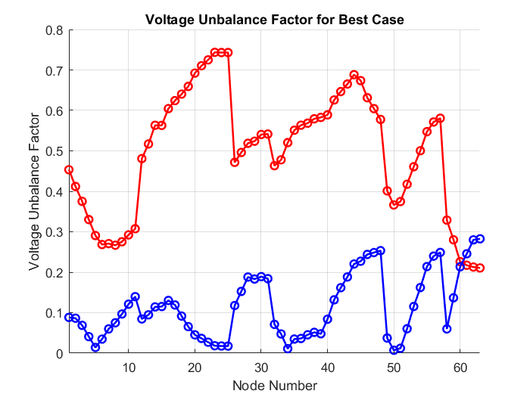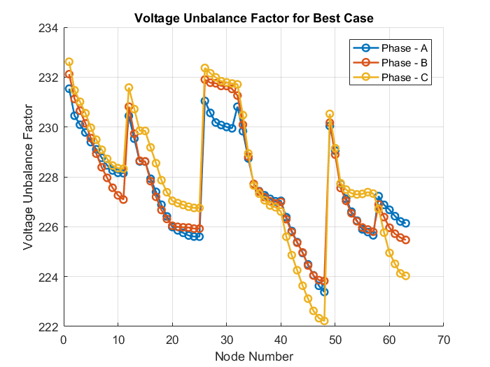

**Development – 2: When only 2 bits shuffled at the development stage**

