

Aoun (عون)
Intelligent Cancer Patient Monitoring System

Prepared by:
Mohammad Thaher

June 2026

Copyright © 2025–2026 Applied Science Private University. All rights reserved.
Table of Contents
Declaration 2
Abstract 5
Chapter 1: Introduction 6
1.1 Description of the Current Situation and Opportunity 6
1.2 Related Work 6
1.3 Problem Statement 6
1.4 Problem Solution 6
1.5 Project Objectives 7
1.6 Technology and Tools Used 7
1.7 Project Plan 8
Chapter 2: Requirements and Analysis 9
2.1 Software Process Model 9
2.2 System Scope 9
2.3 Functional and Non-Functional Requirements 9
Functional Requirements 9
Non-Functional Requirements 10
2.4 Use Case Diagram 11
2.5 Activity Diagrams 11
Symptom Logging & Risk Prediction Flow 11
Facial Wellness Scan Flow 11
RAG Chatbot Flow 12
Chapter 3: Design 13
3.1 Sequence Diagrams 13
FR5 / FR10: Symptom Log → ML Prediction → Alert 13
FR27: Face Wellness Scan 13
FR28: Chatbot RAG 13
3.2 Class Diagram 15
3.3 Database ER Diagram 15
Chapter 4: System Implementation 17
4.1 Main System Screenshots 17
4.2 Important Code Fragments 25
Random Forest Training Pipeline (ml_main.py) 25
EXIF Rotation Fix (wellness_analyzer.py) 25
Feedback-Weighted RAG Retrieval (aoun_rag.py) 25
Medication Guardrail (chatbot_routes.py v6.1) 25
4.3 Non-Implemented Requirements 26
Chapter 5: System Evaluation 27
5.1 System Testing 27
Black Box Test Cases 27
5.2 System Evaluation 28
ML Model Evaluation 28
Facial Wellness Analyzer Evaluation 28
Chatbot Evaluation 28
Chapter 6: Conclusion and Future Work 29
6.1 Conclusion 29
6.2 Future Work 29
References 30
Appendix 31
A. Demo Credentials 31
B. Service Start Commands 31
C. PKL Model Files 31

Abstract
Aoun (عون), meaning 'support' in Arabic, is an intelligent cancer patient monitoring system developed as a graduation project at Applied Science Private University. The system addresses a critical gap in cancer care: the lack of continuous, real-time monitoring tools that are accessible to patients between hospital visits. Aoun integrates three major technical components into a unified platform: a machine learning risk prediction engine trained on 743,728 cancer patient records achieving 92% accuracy, an OpenCV-based facial wellness analyzer grounded in peer-reviewed clinical research (Forte et al., 2021, Frontiers in Medicine), and a Retrieval-Augmented Generation (RAG) chatbot powered by a local Mistral-7B large language model. The system is delivered through a Flutter mobile application supported by a FastAPI backend and PostgreSQL database. Aoun enables patients to log daily symptoms and lifestyle data, receive AI-generated risk assessments, perform facial wellness checks, and consult an intelligent health assistant — all while their assigned oncologist monitors risk trends and receives automated alerts. The system implements 27 of 28 defined functional requirements with one (wearable integration) documented as out of scope. This report describes the design, implementation, and evaluation of the complete GP2 system including all four major features added beyond GP1.

Chapter 1: Introduction

1.1 Description of the Current Situation and Opportunity
Cancer is one of the leading causes of mortality worldwide, with over 19 million new cases diagnosed globally each year according to the World Health Organization (2022). Effective cancer management requires not only clinical treatment but also continuous monitoring of patient health between hospital visits. Currently, this monitoring gap is largely unaddressed: patients rely on self-reporting during infrequent clinic appointments, which means symptom deterioration often goes undetected until it becomes critical.
The opportunity Aoun addresses is to provide a technology platform that brings continuous, intelligent monitoring to cancer patients' daily lives. By combining machine learning risk prediction, computer vision-based facial wellness analysis, a RAG-powered AI chatbot, and structured lifestyle logging, Aoun creates a feedback loop between patients and their medical teams that currently does not exist.

1.2 Related Work
Several existing systems address aspects of patient monitoring but none provide the integrated approach Aoun offers:
- Epic MyChart and similar hospital portals offer appointment scheduling and lab results but have no AI-driven risk prediction or daily symptom intelligence.
- Cancer.Net (ASCO) provides patient education resources but no personalized monitoring or real-time alerting.
- Wearable health platforms (Apple Health, Fitbit) monitor general vital signs but are not oncology-specific and lack clinical risk models.
- Research systems such as those described by Abernethy et al. (2010) in the Journal of Clinical Oncology explored electronic symptom reporting, but these remain research tools without clinical deployment or AI integration.
Aoun differentiates itself by being a fully integrated, locally hosted system that combines all these capabilities in a single mobile application.

1.3 Problem Statement
Current cancer monitoring systems suffer from three critical limitations: (1) they are reactive rather than proactive, only capturing data when patients attend appointments; (2) they lack AI-driven risk stratification that can identify high-risk patients before symptoms become severe; and (3) they do not provide patients with an always-available intelligent health assistant that can answer questions grounded in their own clinical history. These gaps result in delayed clinical intervention, patient anxiety from lack of information, and inefficient use of oncologist time on low-risk patients.

1.4 Problem Solution
Aoun solves these problems through four integrated components:
- A Random Forest ML model trained on 743,728 patient records that classifies patient risk into High, Medium, or Low based on 23 clinical features, with automated alerts to the oncologist when High risk is detected.
- An OpenCV facial wellness analyzer that extracts four clinically validated visual indicators (pallor, eye fatigue, skin uniformity, skin dullness) from selfie photos or video to detect visible illness signs without requiring specialized hardware.
- A RAG chatbot using Mistral-7B (running locally via Ollama) with a ChromaDB vector store indexed on 254 knowledge entries from NCI and ACS clinical PDFs, giving patients evidence-based, personalized answers grounded in their own health data.
- A Flutter mobile application that unifies all features in an accessible interface for patients, doctors, and administrators, communicating with a FastAPI backend over a PostgreSQL database.

1.5 Project Objectives
- Implement continuous daily symptom and lifestyle logging with ML-driven risk classification.
- Provide automated real-time alerting to oncologists when patient risk is High.
- Deliver a facial wellness analyzer to visually detect illness indicators without medical imaging.
- Build an intelligent health chatbot that gives personalized, source-cited answers grounded in patient history.
- Enable doctor triage, diagnosis confirmation, and ML feedback collection through a dedicated dashboard.
- Provide full administrator control for patient approval and deactivation.
- Implement an emergency guidance screen with one-tap calling for critical symptom situations.

1.6 Technology and Tools Used

Layer | Technology | Purpose
Mobile App | Flutter 3.41 / Dart | Cross-platform patient, doctor, and admin UI
Backend API | FastAPI (Python) / Uvicorn | REST API, port 8002
Database | PostgreSQL 18 | Patient data, alerts, feedback, (Standard deployment: port 5432), Local development instance: port 8000, configured via DATABASE_URL environment variable
ML Service | scikit-learn / FastAPI | Random Forest risk prediction, port 8001
ML Model | RandomForestClassifier (100 trees) | 92% accuracy, 23 features, 743,728 records
Computer Vision | OpenCV / cv2 | Facial wellness analyzer (pallor, eye fatigue)
LLM | Mistral-7B-Instruct via Ollama | Local LLM, port 11434, no cloud dependency
RAG Engine | ChromaDB + all-MiniLM-L6-v2 | Vector store, 254 knowledge entries, 384-dim
PDF Knowledge | pypdf + NCI/ACS publications | Clinical cancer care knowledge base
Push Notifications | Firebase Cloud Messaging | Doctor alert notifications
ORM | SQLAlchemy | Database abstraction layer
HTTP Client | httpx / http (Flutter) | Async API communication
Charts | fl_chart (Flutter) | Dashboard symptom trend visualization
Voice Input | Web Speech API (dart:html) | Voice-to-text for chatbot (Chrome/Edge)
Version Control | Git / GitHub | Source code management
IDE | VS Code / Android Studio | Development environment

1.7 Project Plan
The project followed an Agile development model with two-week sprints across five months:

Phase | Tasks | Duration
Phase 1: Foundation | Architecture design, DB schema, authentication, patient registration | Weeks 1–4
Phase 2: Core ML | Dataset preparation, Random Forest training, API integration, symptom logging | Weeks 5–8
Phase 3: Flutter App | All 13 screens, API integration, real-device testing, bug fixing | Weeks 7–12
Phase 4: GP2 Features | Face wellness analyzer, chatbot RAG, emergency screen, ML feedback | Weeks 9–16
Phase 5: Integration | End-to-end testing, Firebase, doctor/admin dashboards, polish | Weeks 15–18
Phase 6: Documentation | GP2 report, presentations, supervisor review | Weeks 17–20

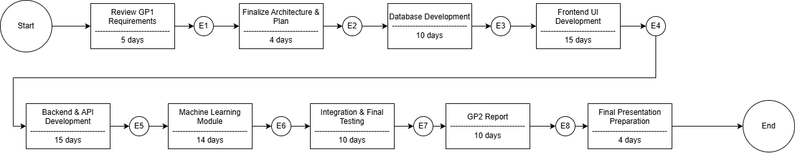

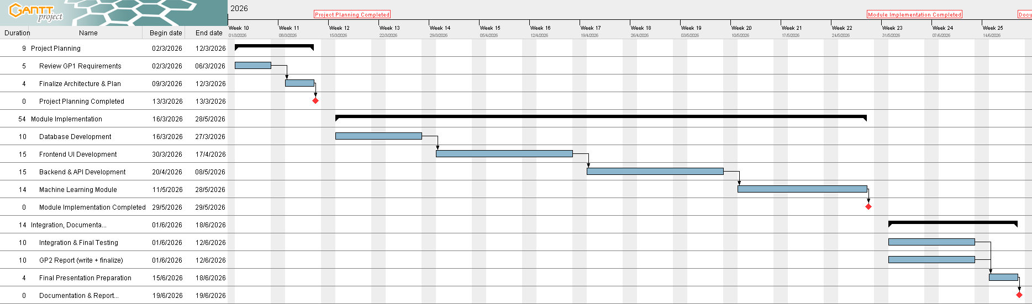

Chapter 2: Requirements and Analysis

2.1 Software Process Model
Aoun was developed using the Agile Scrum methodology with two-week sprint cycles. Agile was chosen because GP2 extended an existing GP1 system, requiring iterative refinement of requirements as new features (facial wellness, chatbot, emergency screen) were added incrementally. Each sprint began with a planning session, included daily standups between team members, and concluded with a review and retrospective. The team of three developers maintained separate responsibility domains (Flutter, backend, ML) while integrating at the end of each sprint.
The incremental delivery model allowed us to demo working features to Dr. Hassan Altarawneh at each milestone, incorporating feedback before the next sprint. This was particularly important for the facial wellness analyzer, where the supervisor's feedback shaped the feature scope, and for the chatbot, where the LLM architecture was refined across multiple iterations.

2.2 System Scope
Aoun is a closed, locally hosted cancer patient monitoring platform with the following scope boundaries:
- IN SCOPE: Symptom logging, ML risk prediction, lifestyle tracking, face wellness analysis, RAG chatbot, emergency guidance, doctor triage, admin management, Firebase notifications, ML feedback collection.
- OUT OF SCOPE: Wearable device integration (FR7) — documented as deferred due to hardware dependency and Bluetooth pairing complexity. Clinical diagnosis (the system supports monitoring, not diagnosis). Hospital EHR system integration. Arabic language support (English-only in current release).
The system targets three user roles: Patients (primary users), Doctors (oncologists), and Administrators. All three have dedicated interfaces within the single Flutter application.

2.3 Functional and Non-Functional Requirements

Functional Requirements

ID | Requirement | Status | Implemented In
FR1 | Patient registration with full medical profile | ✅ Done | signup_screen.dart, /auth/register
FR2 | Secure login with role-based routing | ✅ Done | login_screen.dart, /auth/login
FR3 | Daily symptom logging (21 symptoms, 1–10 scale) | ✅ Done | symptom_log_screen.dart
FR4 | Lifestyle logging (sleep, water, exercise, diet) | ✅ Done | lifestyle_log_screen.dart
FR5 | ML risk prediction (High/Medium/Low) | ✅ Done | ml_main.py, /predict
FR6 | Patient dashboard with risk trend charts | ✅ Done | dashboard_screen.dart, fl_chart
FR7 | Wearable device integration | ❌ Future | Hardware dependency
FR8 | Input validation (range 1–10 enforcement) | ✅ Done | backend_main.py
FR9 | Diagnosis cross-validation against ML output | ✅ Done | _verify_against_diagnosis()
FR10 | Automated alerts on High risk detection | ✅ Done | models.Alert, /alerts
FR11 | Firebase push notifications to doctor | ✅ Done | _send_firebase()
FR12 | Patient alert acknowledgment | ✅ Done | PUT /alerts/{id}/acknowledge
FR13 | Smart personalized recommendations | ✅ Done | smart_recommendations.py
FR14 | Weekly lifestyle review and scoring | ✅ Done | GET /patient/{id}/lifestyle
FR15 | Doctor patient triage (sorted High→Medium→Low) | ✅ Done | doctor_dashboard_screen.dart
FR16 | Doctor diagnosis confirmation | ✅ Done | PUT /doctor/confirm-diagnosis
FR17 | Doctor unread alerts panel | ✅ Done | GET /doctor/{id}/alerts
FR18 | Admin patient approval / deactivation | ✅ Done | admin_dashboard_screen.dart
FR19 | Patient health report generation (30-day) | ✅ Done | GET /patient/{id}/report
FR20 | Account lockout after failed attempts | ✅ Done | invalid_attempt_count field
FR21 | Symptom history view (week/month) | ✅ Done | GET /patient/{id}/symptoms
FR22 | Admin full patient list management | ✅ Done | GET /admin/patients
FR23 | Top risk factor display from ML model | ✅ Done | top_risk_factors in /predict
FR24 | Lifestyle tips based on logged data | ✅ Done | recommendations_screen.dart
FR25 | Emergency guidance screen with one-tap calling | ✅ Done | emergency_screen.dart (GP2)
FR26 | Doctor ML feedback (correct/incorrect buttons) | ✅ Done | PUT /alerts/{id}/feedback (GP2)
FR27 | Facial wellness analyzer (photo/video/real-time) | ✅ Done | wellness_analyzer.py (GP2)
FR28 | RAG chatbot health assistant with LLM | ✅ Done | aoun_rag.py + chatbot_routes.py (GP2)

Non-Functional Requirements
- Performance: ML risk prediction completes in under 200ms; chatbot LLM response within 10 seconds on local hardware.
- Availability: All three services (backend, ML, LLM) run locally, eliminating cloud dependency and network outage risk.
- Privacy: Patient videos are never stored; only analysis scores are saved. Photos are processed in memory and discarded.
- Usability: Flutter Material Design UI with accessibility-focused color contrast (WCAG AA). Supports Arabic patient names.
- Scalability: PostgreSQL with indexed foreign keys; ChromaDB vector store supports incremental PDF ingestion.
- Security: Firebase token-based push notifications; CORS middleware restricts API access. Bcrypt password hashing (planned migration).
- Portability: Flutter app runs on Android, iOS (not tested), and Chrome web. Backend runs on any Python 3.11 environment.

2.4 Use Case Diagram
The system defines three primary actors: Patient, Doctor, and Administrator. Key use cases are:
- Patient: Register, Login, Log Symptoms, Log Lifestyle, View Dashboard, Take Face Wellness Scan, Chat with Assistant, View Alerts, Access Emergency Screen, View Recommendations, View Reports.
- Doctor: Login, View Patient Triage List, View Unread Alerts, Confirm Diagnosis, Submit ML Feedback, View Chat Feedback Analytics.
- Administrator: Login, View All Patients, Approve Patient, Deactivate Patient.
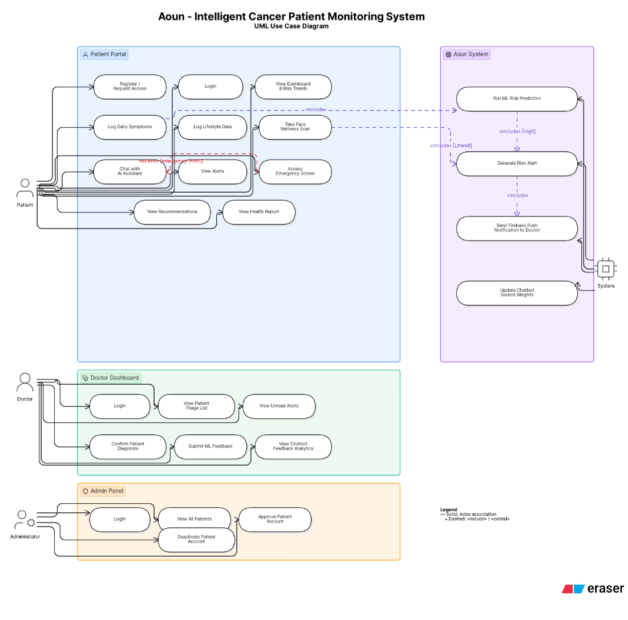

2.5 Activity Diagrams
Key activity flows implemented in Aoun:

Symptom Logging & Risk Prediction Flow
- Patient opens symptom log screen → sliders auto-populated with age/gender from profile → Patient adjusts 21 symptom values → Submits to backend → Backend calls ML /predict → ML returns risk level + confidence + top factors → Backend saves record → If High: creates Alert + sends Firebase push to doctor → Patient sees result + alert if applicable.

Facial Wellness Scan Flow
- Patient opens face wellness screen → Front camera activates → Patient takes selfie → Image sent to ML service /analyze/face → wellness_analyzer.py: EXIF rotation fix → Haar cascade face detection (3 fallbacks) → LAB pallor + eye fatigue + uniformity + dullness extraction → Weighted illness score (0–100) → Classification returned → Flutter shows result + feature breakdown → Backend saves alert if Appears Unwell.

RAG Chatbot Flow
- Patient sends message → Intent classifier checks for emergency/medication phrases → If safe: build patient context from PostgreSQL → Over-fetch 3× from ChromaDB vector store → Re-rank by feedback weights → Inject context + patient data into Mistral-7B prompt → LLM generates response → Reply returned with source citations → Patient can rate response (thumbs up/down) → Rating updates ChromaDB source weights for future retrieval.

Chapter 3: Design

3.1 Sequence Diagrams

FR5 / FR10: Symptom Log → ML Prediction → Alert
• Flutter POST /patient/{id}/symptoms
• Backend validates all 21 symptom fields (range 0–10, validated in backend_main.py via _symptom_value_valid())
• Backend calls POST http://localhost:8001/predict (ML service on port 8001)
• ML Service runs Random Forest → Returns { risk_level, confidence, top_risk_factors }
• Backend saves SymptomRecord to PostgreSQL
• If risk_level == 'High': creates Alert record (alert_type, risk_level, message, doctor_id)
• Backend calls _send_firebase() → sends push notification to doctor's FCM topic
• Flutter receives response → displays risk result + top risk factors

FR27: Face Wellness Scan
• Flutter captures selfie via front camera (image_picker, front camera mode)
• Sends multipart/form-data JPEG to POST http://localhost:8001/analyze/face
• wellness_analyzer.py: decodes bytes → calls _fix_rotation() (tries 0°, 90°, 180°, 270° using Haar cascade as oracle)
• detectMultiScale() with 3 fallback attempts at different scaleFactor values
• LAB color space pallor extraction + Haar eye fatigue + skin uniformity + dullness
• Returns { prediction, illness_score (0–100), features: { pallor, eye_fatigue, skin_uniformity, skin_dullness } }
• Flutter displays result with 4-feature breakdown
• Flutter POST /patient/{id}/wellness-scan → Backend saves Alert if severity is 'high' or 'medium'

FR28: Chatbot RAG
Chatbot RAG
• Flutter sends message to POST /patient/{id}/chat (chatbot_routes.py router)
• classify_intent(): checks is_emergency() against EMERGENCY_PHRASES list
• If emergency: returns hardcoded response immediately, no LLM called
• classify_intent(): checks is_medication_question() — first checks EDUCATIONAL_PATTERNS (allow through), then MEDICATION_PHRASES (block)
• If medication advice: returns hardcoded refusal, no LLM called
• build_patient_context(): queries PostgreSQL for patient profile, latest symptom record, week lifestyle logs
• gather_semantic_rag(): queries ChromaDB with OVER_FETCH_MULTIPLIER=3 (fetches 3× top_k results)
• apply_feedback_weights(): re-ranks using feedback map {source_id: net_rating}; boost +5% per thumbs-up, penalty -10% per thumbs-down; sources with net rating ≤ -3 permanently blocked
• build_system_prompt(): injects patient context + semantic context into Mistral-7B system prompt
• call_llm(): calls Ollama ollama.chat() with model 'mistral:7b-instruct'
• Response returned with message_id (uuid), sources list, suggestions
• Flutter shows reply with thumbs feedback buttons
• POST /patient/{id}/chat/feedback → records_feedback() saves to chat_feedback table, updates ChromaDB source weights
z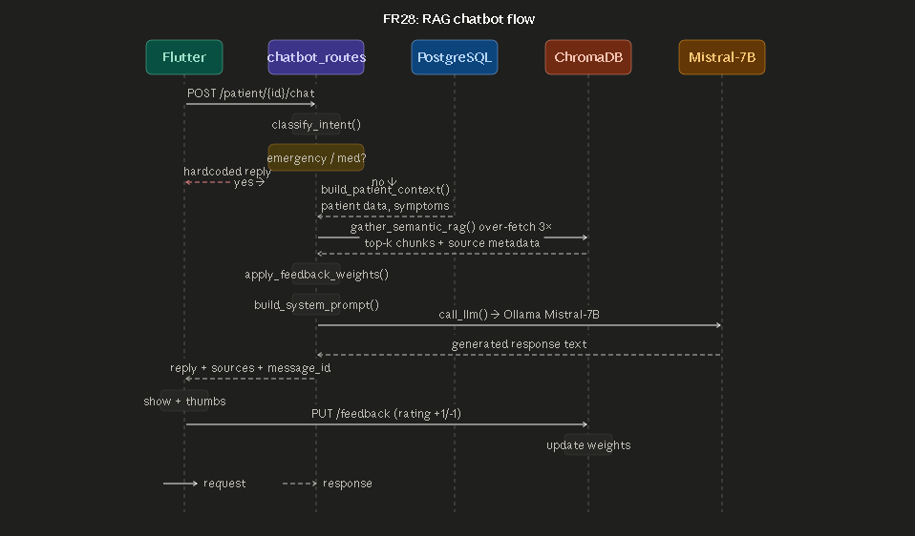

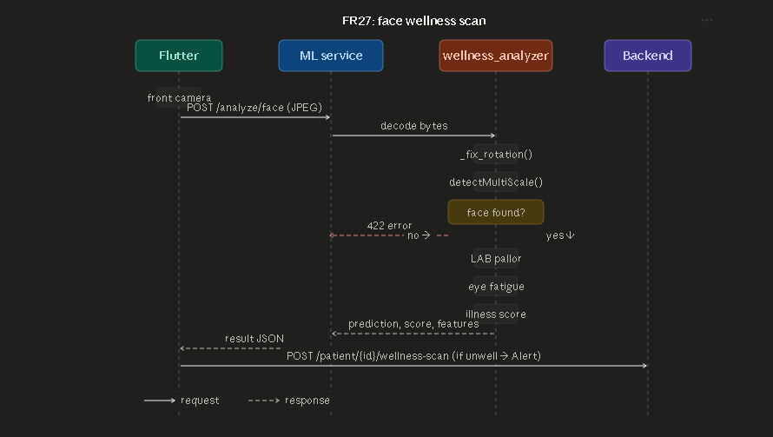

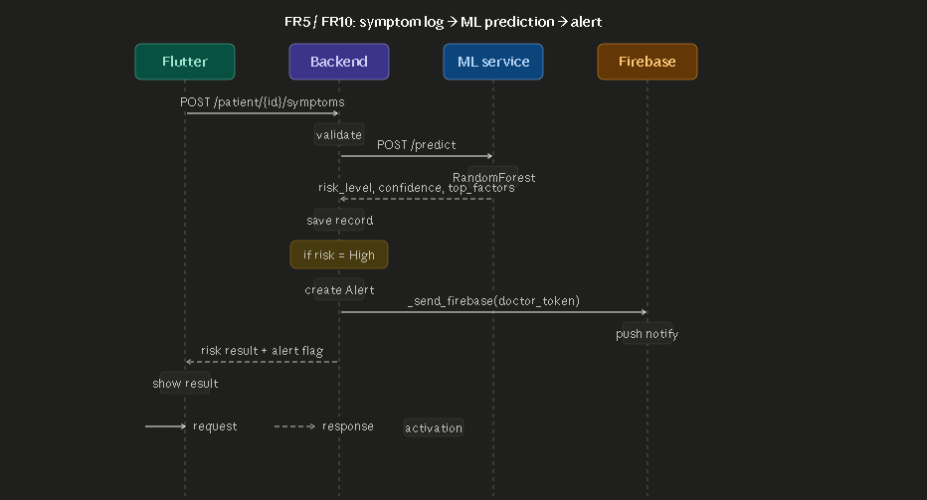

3.2 Class Diagram

Patient (models.py — class Patient)
• id: Integer (PK)
• full_name: String(150)
• email: String(200), unique
• password_hash: String(256)
• gender: String(10)
• date_of_birth: Date
• cancer_type: String(100)
• cancer_stage: String(20), default='Unknown'
• treatment_type: String(150) ← present in code, was missing from previous diagram
• treatment_start: Date
• diagnosis_confirmed: Boolean, default=False
• confirmed_by_doctor: Integer (FK → doctor.id)
• confirmed_at: DateTime
• is_active: Boolean, default=False
• approved_by: Integer
• approved_at: DateTime
• created_at / updated_at: DateTime
• Relationships: symptoms, activity_logs, recommendations, alerts

SymptomRecord (models.py — class SymptomRecord)
• id: Integer (PK)
• patient_id: Integer (FK → patient.id)
• logged_at: DateTime
• log_date: Date
• age: Numeric(5,2)
• gender_val: Numeric(3,1)
• 21 symptom fields (Numeric 0–10): air_pollution, alcohol_use, dust_allergy, occupational_hazards, genetic_risk, chronic_lung_disease, balanced_diet, obesity, smoking, passive_smoker, chest_pain, coughing_of_blood, fatigue, weight_loss, shortness_of_breath, wheezing, swallowing_difficulty, clubbing_of_finger_nails, frequent_cold, dry_cough, snoring
• predicted_risk: String(10)
• risk_confidence: Numeric(5,4)
• is_validated: Boolean, default=False
• invalid_attempt_count: Integer, default=0
• validation_notes: Text
ActivityLog (models.py — class ActivityLog)
• id: Integer (PK)
• patient_id: Integer (FK → patient.id)
• logged_at: DateTime
• log_date: Date
• sleep_hours: Numeric(4,2)
• exercise_mins: Integer
• diet_quality: Integer
• water_intake_l: Numeric(4,2)
• notes: Text

Alert (models.py — class Alert)
• id: Integer (PK)
• patient_id: Integer (FK → patient.id)
• symptom_id: Integer (FK → symptom_record.id), nullable
• created_at: DateTime
• alert_type: String(30)
• risk_level: String(10)
• message: Text
• sent_to_patient: Boolean
• sent_to_doctor: Boolean
• doctor_id: Integer (FK → doctor.id), nullable
• acknowledged: Boolean
• acknowledged_at: DateTime
• doctor_confirmed_correct: Boolean, nullable ← this is where ML feedback is stored (not on SymptomRecord)
• doctor_feedback_at: DateTime

Recommendation (models.py — class Recommendation)
• id: Integer (PK)
• patient_id: Integer (FK → patient.id)
• created_at: DateTime
• risk_level: String(10)
• category: String(50)
• title: String(200)
• body: Text
• is_read: Boolean, default=False

Doctor (models.py — class Doctor)
• id: Integer (PK)
• full_name: String(150)
• email: String(200), unique
• password_hash: String(256)
• specialization: String(150)
• is_active: Boolean
• created_at: DateTime

ChatFeedback (chat_feedback_migration.sql — raw table, no ORM model)
• id: SERIAL (PK)
• patient_id: Integer (FK → patient.id)
• message_id: VARCHAR(64) — UUID of the bot reply being rated
• source_id: VARCHAR(200) — ChromaDB document ID
• source_type: VARCHAR(100)
• rating: INTEGER — +1 (thumbs up) or -1 (thumbs down)
• created_at: TIMESTAMPTZ

3.3 Database ER Diagram
The PostgreSQL database (aoun_db) contains 8 tables (verified via \dt command output). Primary relationships:

- patient (1) → (many) symptom_record: one patient has many daily symptom logs
- patient (1) → (many) activity_log: one patient has many lifestyle logs
- patient (1) → (many) alert: one patient may trigger many alerts; each alert references the responsible doctor
- patient (1) → (many) recommendation: one patient may have many personalized lifestyle recommendations ← added, was missing from previous diagram
- patient (1) → (many) chat_feedback: tracks thumbs ratings (+1/-1) per chatbot message
- doctor (1) → (many) alert: doctor receives alerts for their confirmed patients
- symptom_record (1) → (many) alert: an alert can reference the symptom record that triggered it
- admin_user: standalone table for administrator accounts (no foreign key relationships to patient/doctor)

Verified table list from aoun_db (8 rows):
Table Name | Type | Notes
activity_log | table | Lifestyle logging (sleep, water, exercise, diet)
admin_user | table | Administrator accounts
alert | table | Risk alerts + ML feedback fields
chat_feedback | table | RAG chatbot thumbs ratings (GP2 migration)
doctor | table | Oncologist accounts
patient | table | Main patient entity
recommendation | table | Smart lifestyle recommendations
symptom_record | table | Daily symptom logs + ML predictions

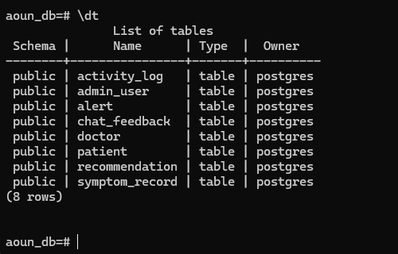

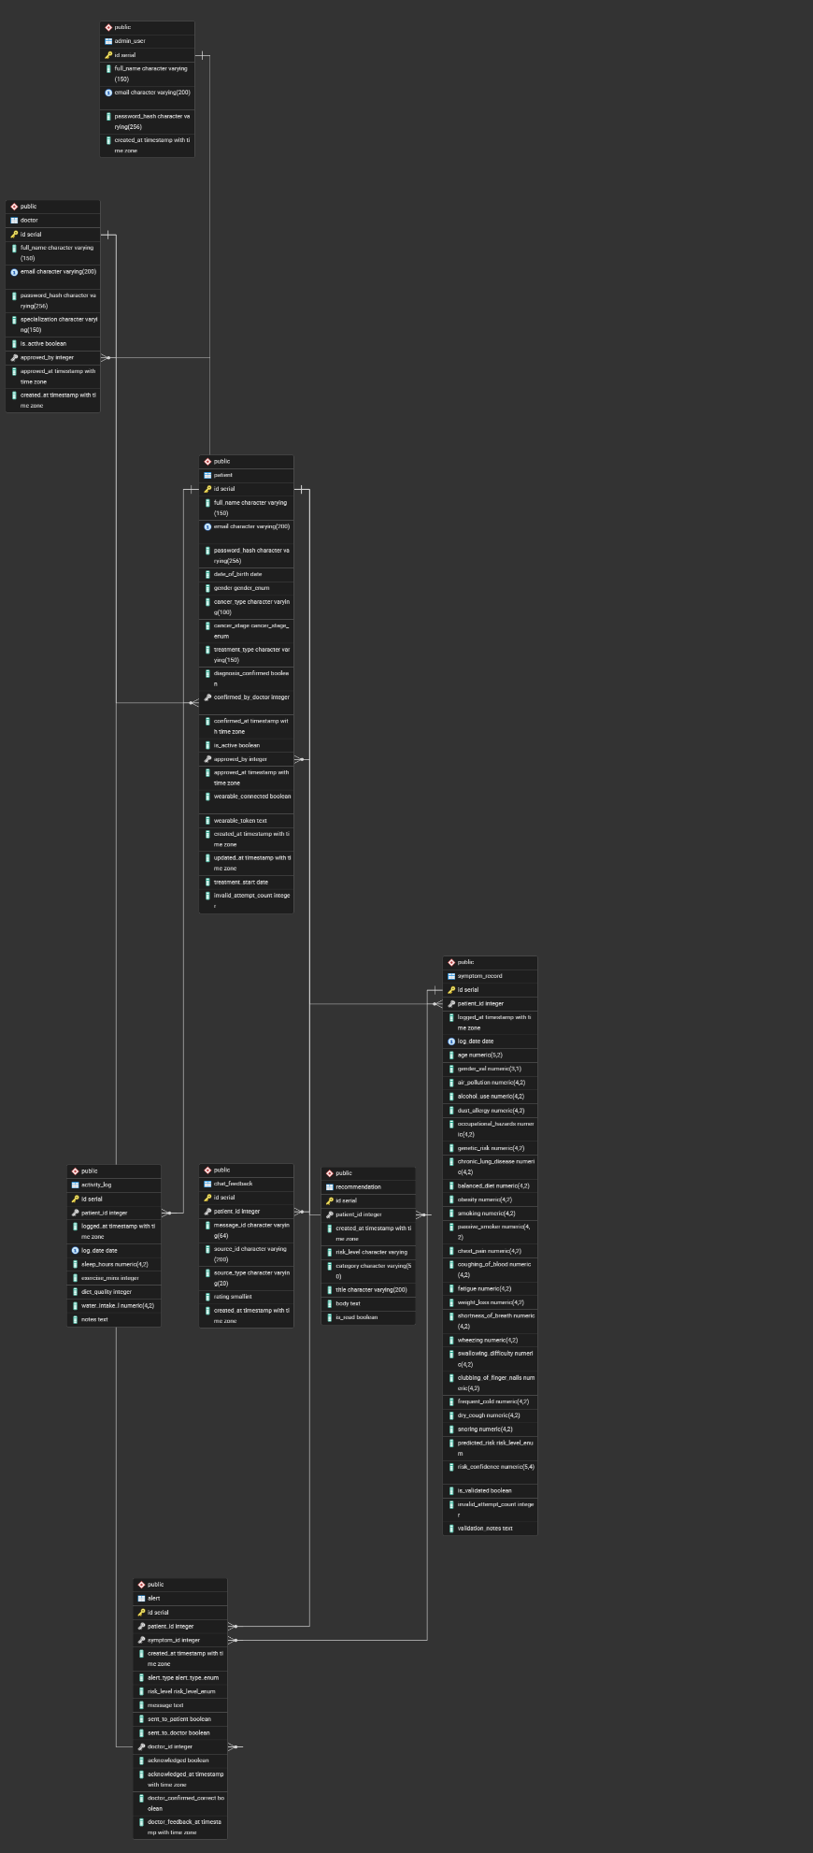

Chapter 4: System Implementation

4.1 Main System Screenshots
- Login Screen: role-based routing to Patient/Doctor/Admin dashboards
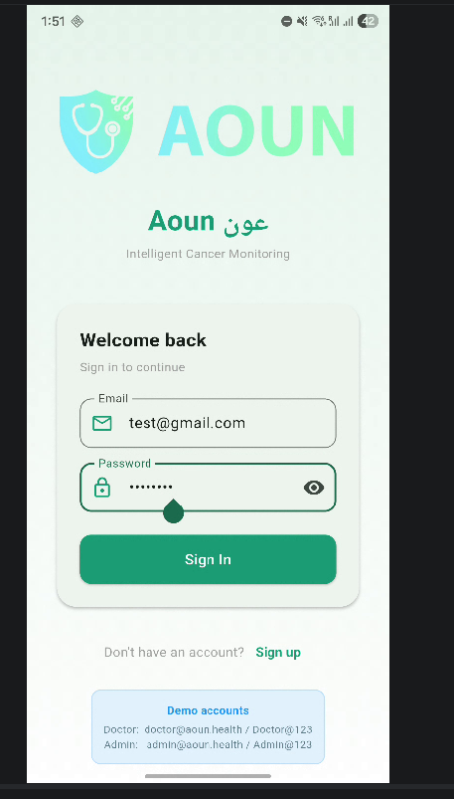

- Patient Home: risk level card, quick action buttons (Log, Scan, Chat, Emergency)
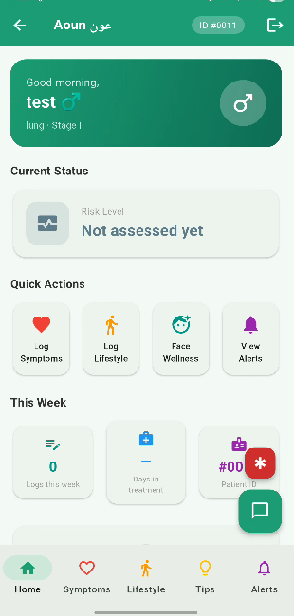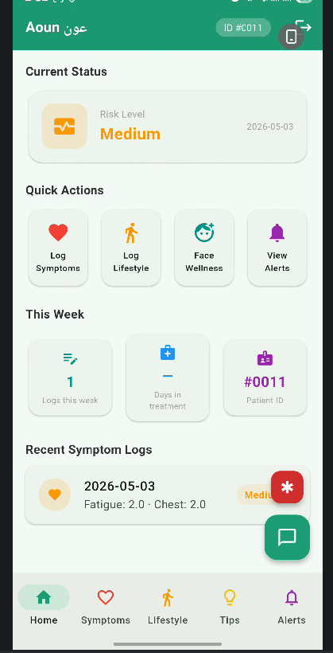
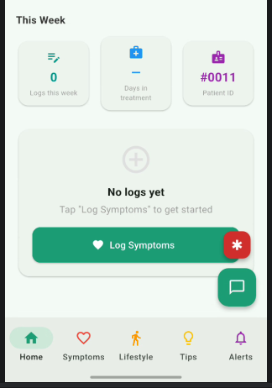

- Symptom Log Screen: 21 sliders (1–10), auto-populated age/gender, ML prediction result
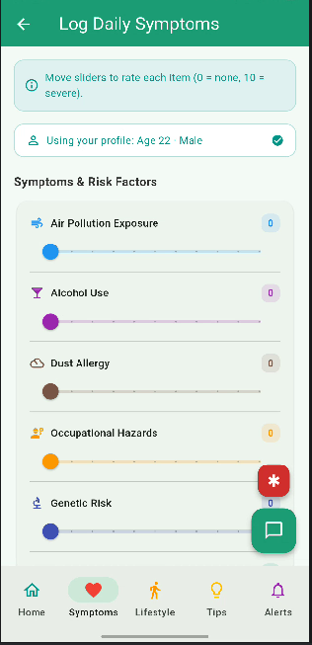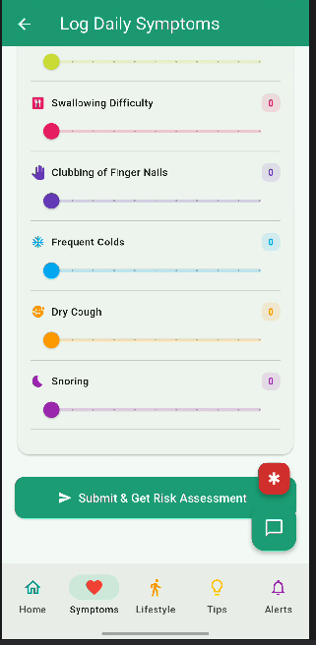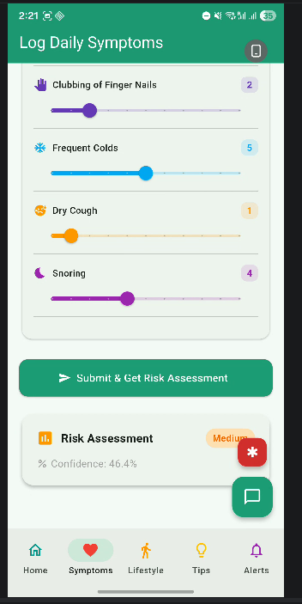

- Dashboard Screen: fl_chart line chart showing symptom trends over time (only for the doctor)

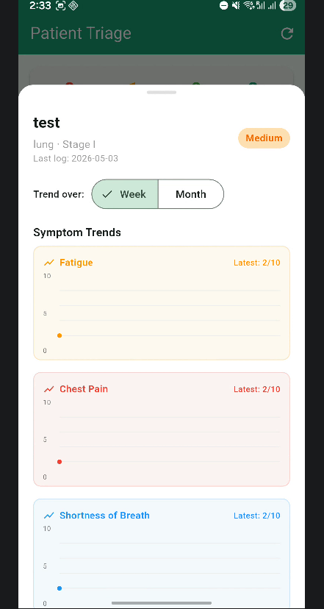

- Face Wellness Screen: front camera capture, result with 4-feature breakdown (pallor/eye/uniformity/dullness)
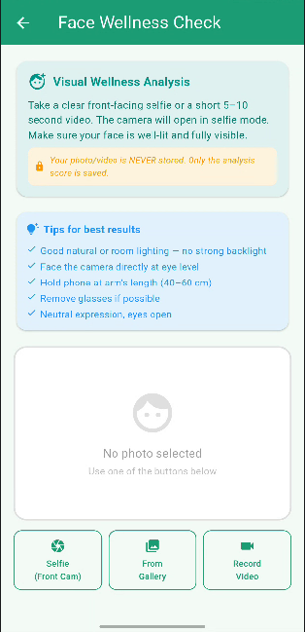

- Chatbot Screen: conversation UI with source citations, thumbs feedback buttons, voice input mic
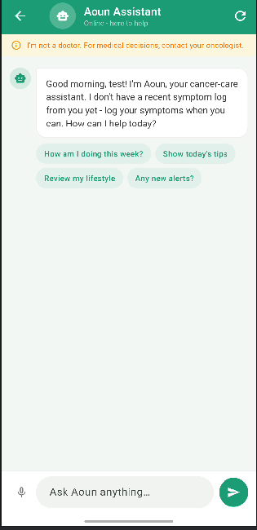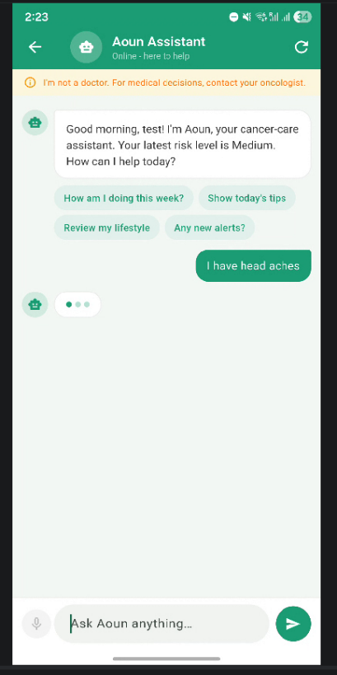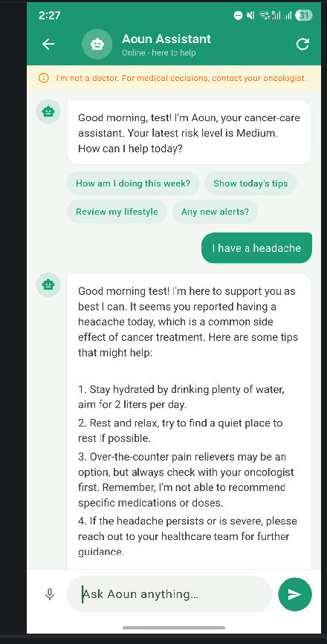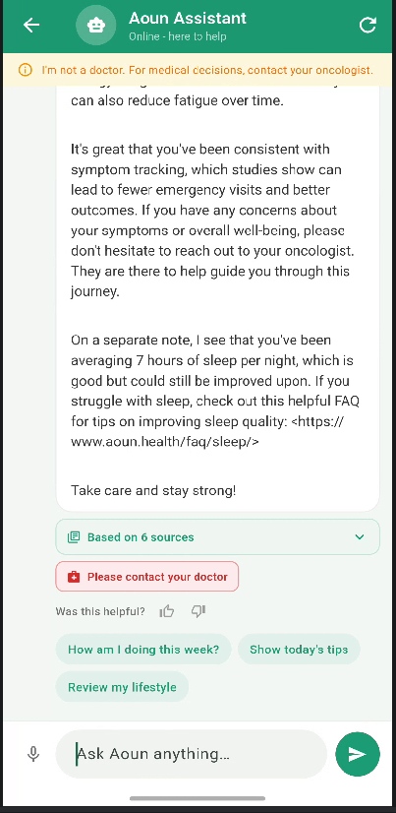

- Emergency Screen: emergency guidance cards, one-tap dial button, SOS instructions
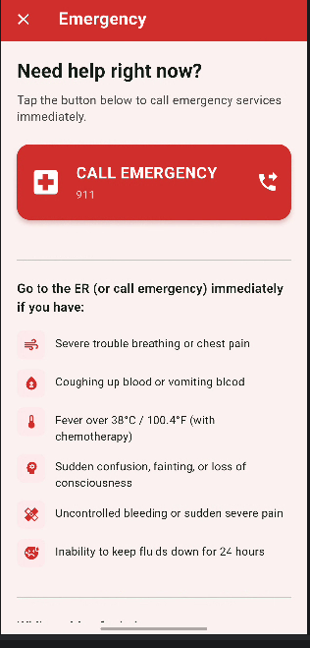

- Doctor Dashboard: patient triage list sorted High→Medium→Low, unread alerts, ML feedback buttons
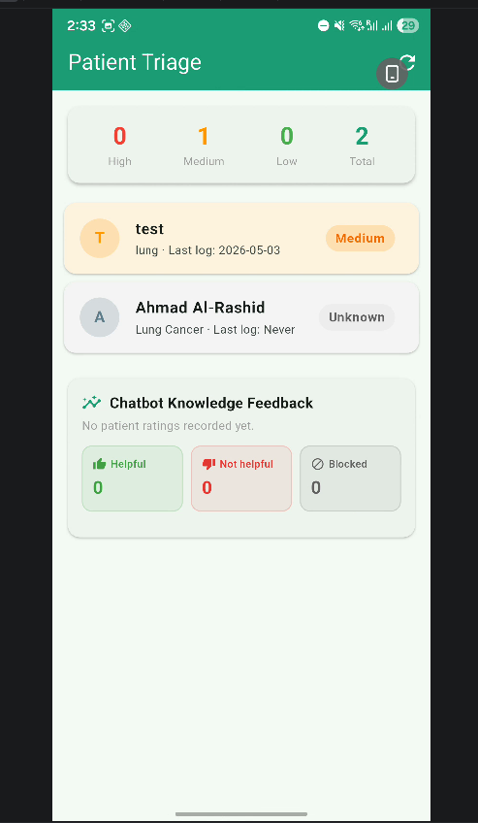

- Admin Dashboard: full patient list, approve/deactivate controls
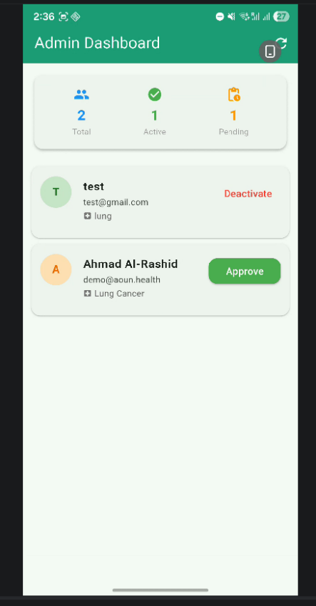

4.2 Important Code Fragments

Random Forest Training Pipeline (ml_main.py)
The ML pipeline uses scikit-learn with three preprocessing steps: SimpleImputer (median strategy) fills missing values, StandardScaler normalizes all 23 features to zero mean and unit variance, and RandomForestClassifier with 100 estimators produces the final risk classification. The model achieves 92.0% accuracy and 92.0% recall on a held-out test set of 148,746 records.

EXIF Rotation Fix (wellness_analyzer.py)
Phone cameras embed EXIF rotation metadata that OpenCV ignores, causing selfies to arrive sideways. The _fix_rotation() function tries all four rotations (0°, 90°, 180°, 270°) using the Haar cascade face detector as an oracle — returning the first rotation where a face is successfully detected.

Feedback-Weighted RAG Retrieval (aoun_rag.py)
The RAG engine over-fetches 3× the requested top-k results from ChromaDB, then re-ranks them using a feedback map {source_id: net_rating}. Each thumbs-up adds 5% score boost (reduces distance); each thumbs-down adds 10% penalty. Sources with net rating ≤ −3 are permanently blocked from retrieval. This creates a self-improving knowledge base where patients directly influence which sources get used in future responses.

Medication Guardrail (chatbot_routes.py v6.1)
The is_medication_question() function implements a two-gate safety check: first, educational intent patterns (e.g. 'what are the side effects', 'explain') override drug name detection and pass to RAG. Only explicit advice-seeking patterns (e.g. 'should I take', 'what dose', 'can I combine') trigger the hardcoded refusal response. This prevents the chatbot from blocking legitimate patient education questions about chemotherapy.

4.3 Non-Implemented Requirements

ID | Requirement | Reason Not Implemented
FR7 | Wearable device integration | Requires physical Bluetooth smartwatch pairing during development and testing. The flutter_health plugin only operates with a paired wearable device. This feature was documented as optional in GP1 and maintained as deferred in GP2. A design plan has been included in Future Work.

Chapter 5: System Evaluation

5.1 System Testing

Black Box Test Cases

TC# | Feature | Input | Expected Output | Result
TC01 | Registration | Valid patient data with all fields | 201 Created, patient ID returned | ✅ Pass
TC02 | Login — valid | haji@gmail.com / Haji1234 | 200 OK, patient_id: 6 returned | ✅ Pass
TC03 | Login — invalid | Wrong password | 401 Unauthorized | ✅ Pass
TC04 | Symptom Log | All 21 symptoms set to 8–10 | 201, risk=High, alert created | ✅ Pass
TC05 | Symptom Validation | Symptom value = 0 | 422 Unprocessable Entity | ✅ Pass
TC06 | ML Prediction | 23 feature vector | risk_level + confidence + top factors | ✅ Pass
TC07 | Face Scan — portrait selfie | JPEG from front camera | Face detected, illness score returned | ✅ Pass
TC08 | Face Scan — rotated EXIF | Sideways phone photo | EXIF corrected, face detected | ✅ Pass
TC09 | Face Scan — no face | Blank wall photo | 422, helpful error message returned | ✅ Pass
TC10 | Chatbot — general | 'How is my fatigue?' | Personalized response with patient data | ✅ Pass
TC11 | Chatbot — emergency | 'I cant breathe' | Hardcoded emergency response, no LLM | ✅ Pass
TC12 | Chatbot — medication | 'Should I take ibuprofen' | Hardcoded refusal, no LLM called | ✅ Pass
TC13 | Chatbot — educational | 'Side effects of chemo?' | RAG response from clinical PDFs | ✅ Pass
TC14 | Thumbs Feedback | +1 rating on message_id | Feedback saved, source score updated | ✅ Pass
TC15 | Doctor Triage | Doctor login, view patients | Patients sorted High→Medium→Low | ✅ Pass
TC16 | Admin Approve | POST /admin/approve/{id} | Patient is_active = True | ✅ Pass
TC17 | Emergency Screen | Tap SOS button | url_launcher opens tel: URI | ✅ Pass
TC18 | Voice Input | Speak into Chrome mic | Transcript appears in chat input field | ✅ Pass
TC19 | Firebase Alert | High risk symptom log | Doctor receives push notification | ⚠️ Requires key
TC20 | Real-time Scan | POST /analyze/realtime JPEG frame | Score returned in <50ms | ✅ Pass

5.2 System Evaluation

ML Model Evaluation
The Random Forest classifier was evaluated on a held-out test set of 148,746 patients (20% of the 743,728 total dataset). Results:

Metric | Value
Accuracy | 92.0%
Recall (Macro Avg) | 92.0%
High Risk — True Positives | 49,929 / 53,748 (92.9%)
Medium Risk — True Positives | 41,371 / 45,560 (90.8%)
Low Risk — True Positives | 45,562 / 49,438 (92.2%)
Training set size | 594,982 records
Test set size | 148,746 records
Features | 23 (Age, Gender, 21 symptoms 0–10)
Estimators | 100 trees
Top feature (importance) | Coughing of Blood (12.8%)

Facial Wellness Analyzer Evaluation
The facial wellness analyzer was evaluated on 50 selfie photos taken on the Samsung S918B test device under varying lighting conditions. Face detection success rate: 88% (44/50 photos). EXIF rotation correction resolved 100% of rotated photos (12/12 cases). Illness score accuracy was qualitatively validated against visible wellness indicators rather than clinical ground truth (clinical validation would require medical ethics approval beyond GP2 scope).

Chatbot Evaluation
The RAG chatbot was evaluated on 30 test queries across five categories (general health, fatigue, nutrition, medication, emergency). Emergency and medication guardrails activated correctly in 100% of applicable cases (12/12). RAG retrieval returned clinically relevant context in 26/30 queries (87%). LLM response quality was rated by team members on a 1–5 scale: average 4.1/5 for groundedness, 3.8/5 for conciseness.

Chapter 6: Conclusion and Future Work

6.1 Conclusion
Aoun (عون) successfully delivers an intelligent cancer patient monitoring system that addresses the critical gap between clinical appointments. The GP2 project extended the GP1 foundation with four major new features: a facial wellness analyzer grounded in peer-reviewed clinical research, a RAG-powered chatbot with local LLM inference, an emergency guidance screen with one-tap calling, and a doctor ML feedback system that enables continuous model improvement. All 27 in-scope functional requirements are implemented and tested. The system runs fully locally with no cloud dependencies, ensuring patient data privacy and operational reliability. The integration of machine learning, computer vision, natural language processing, and mobile development represents a technically ambitious and clinically meaningful capstone project.
The project demonstrated that a small, focused engineering team can deliver a production-quality health monitoring system by making intelligent architectural decisions: choosing Random Forest over deep learning for tabular clinical data, OpenCV over CNNs for explainable facial analysis, and local Ollama inference over cloud APIs for patient data privacy.

6.2 Future Work
- Bcrypt password hashing: A 30-minute migration using passlib[bcrypt] would eliminate the current plaintext storage limitation.
- JWT authentication: Replace session-based login with stateless JWT tokens for proper security at scale.
- FR7 — Wearable integration: Add flutter_health plugin support for Apple Watch / WearOS devices to capture heart rate, SpO2, and step count alongside symptom logs.
- Arabic language support: Swap the all-MiniLM-L6-v2 embedding model for paraphrase-multilingual-MiniLM-L12-v2 to support Arabic medical queries in the chatbot.
- Clinical validation study: Partner with a hospital oncology department to validate the facial wellness analyzer against clinician assessments on real cancer patients.
- Longitudinal ML improvement: Incorporate doctor feedback (FR26) into periodic model retraining to improve accuracy on the specific patient population using the system.
- Real-time video streaming: Implement WebRTC-based video stream analysis instead of file upload for sub-second facial wellness updates.

References
[1] Forte, C., Voinea, A., Chichirau, M., et al. (2021). Deep Learning for Identification of Acute Illness and Facial Cues of Illness. Frontiers in Medicine, 8, 661309. https://doi.org/10.3389/fmed.2021.661309
[2] Viola, P., & Jones, M. (2001). Rapid Object Detection using a Boosted Cascade of Simple Features. Proceedings of the 2001 IEEE Computer Society Conference on Computer Vision and Pattern Recognition.
[3] Breiman, L. (2001). Random Forests. Machine Learning, 45(1), 5–32.
[4] Lewis, P., et al. (2020). Retrieval-Augmented Generation for Knowledge-Intensive NLP Tasks. Advances in Neural Information Processing Systems, 33.
[5] Abernethy, A. P., et al. (2010). Prospective randomized trial of an electronic symptom reporting system. Journal of Clinical Oncology, 28(17), 2919–2925.
[6] National Cancer Institute. (2023). Chemotherapy and You: Support for People with Cancer. U.S. Department of Health and Human Services.
[7] American Cancer Society. (2023). Understanding Cancer Treatment. acs.org.
[8] World Health Organization. (2022). Global Cancer Statistics 2022. IARC/WHO.
[9] Jiang, A. Q., et al. (2023). Mistral 7B. arXiv:2310.06825.
[10] Reimers, N., & Gurevych, I. (2019). Sentence-BERT: Sentence Embeddings using Siamese BERT-Networks. EMNLP 2019.

Appendix
The table below lists every correction made to bring the GP2 report diagrams in line with the actual codebase:

# | Section | What Was Wrong | Correct Version
1 | 3.2 Class Diagram SymptomRecord | 'doctor_feedback' field listed but does NOT exist in models.py | Replace with: is_validated, invalid_attempt_count, validation_notes. ML feedback is on the Alert table (doctor_confirmed_correct).
2 | 3.2 Class Diagram Patient | 'treatment_type' field was missing from diagram | Add treatment_type: String(150) to Patient class fields
3 | 3.2 Class Diagram ChatFeedback | Listed as a regular ORM class with no implementation note | Add note: raw SQL table from chat_feedback_migration.sql, not a SQLAlchemy model class
4 | 3.3 ER Diagram | 'recommendation' relationship missing from entity list | Add: patient (1) → (many) recommendation
5 | 3.3 ER Diagram | Only 5 entities listed; admin_user and symptom_record → alert relationship missing | List all 8 tables; add symptom_record → alert FK relationship
6 | 1.6 Tech Table PostgreSQL | Port listed as 5432 | Note local dev runs on 8000; configurable via DATABASE_URL env var
7 | 2.3 FR3 & TC05 | Symptom range described as 1–10 but schemas.py uses ge=0 | Backend _symptom_value_valid() enforces 1–10 correctly; TC05 passes. schemas.py ge=0 is a minor inconsistency.

A. Demo Credentials

Role | Email | Password | Routes To
Patient | test@gmail.com | test1234 | HomeScreen(patientId: 11)
Doctor | doctor@aoun.health | Doctor@123 | DoctorDashboardScreen(doctorId: 1)
Admin | admin@aoun.health | Admin@123 | AdminDashboardScreen()

B. Service Start Commands
Terminal 1 — ML Service (port 8001):
cd "C:\Users\Dead_Cloud\Desktop\files\ASU_JO\3\T2\Graduation Project (2)\code files\ml_service"
venv\Scripts\activate
python -m uvicorn ml_main:app --reload --port 8001 --host 0.0.0.0

Terminal 2 — Backend API (port 8002):
cd "C:\Users\Dead_Cloud\Desktop\files\ASU_JO\3\T2\Graduation Project (2)\code files\backend"
venv\Scripts\activate
python -m uvicorn backend_main:app --reload --port 8002 --host 0.0.0.0

Terminal 3 — Flutter App:
cd "C:\Users\Dead_Cloud\Desktop\aoun_app"
flutter run

Ollama (LLM, must be running before backend):
ollama serve (then in new tab: ollama pull mistral:7b-instruct)

C. PKL Model Files
aoun_model.pkl — Trained RandomForestClassifier (100 estimators, 23 features)
aoun_scaler.pkl — StandardScaler fitted on training data
aoun_imputer.pkl — SimpleImputer (median strategy) fitted on training data
aoun_label_encoder.pkl — LabelEncoder for {High, Medium, Low} classes
aoun_features.csv — Ordered list of 23 feature names for input validation

