## Welcome!

Welcome to the Hog Bank Employee System Guide! This user guide will walk you through the various business processes that you will engage in during your time working in one of our branches. We will walk you through these processes:

1. Logging Into the System
2. Creating a New Customer
3. Viewing an Existing Customer’s General & Account Information
4. Creating A New Account for an Existing Customer
5. Depositing & Withdrawing Funds to/from an Account.

## Step 1: Logging Into the System

After opening the system, you will be prompted to enter an email and password. Please enter your credentials and click enter. You will then be greeted with a message welcoming you to the system. Please click OK to continue.

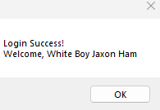

## Main Function Hub:

Upon successful completion of the login process, you will be directed to the Function Hub, with 5 large buttons, each with their own respective functions.

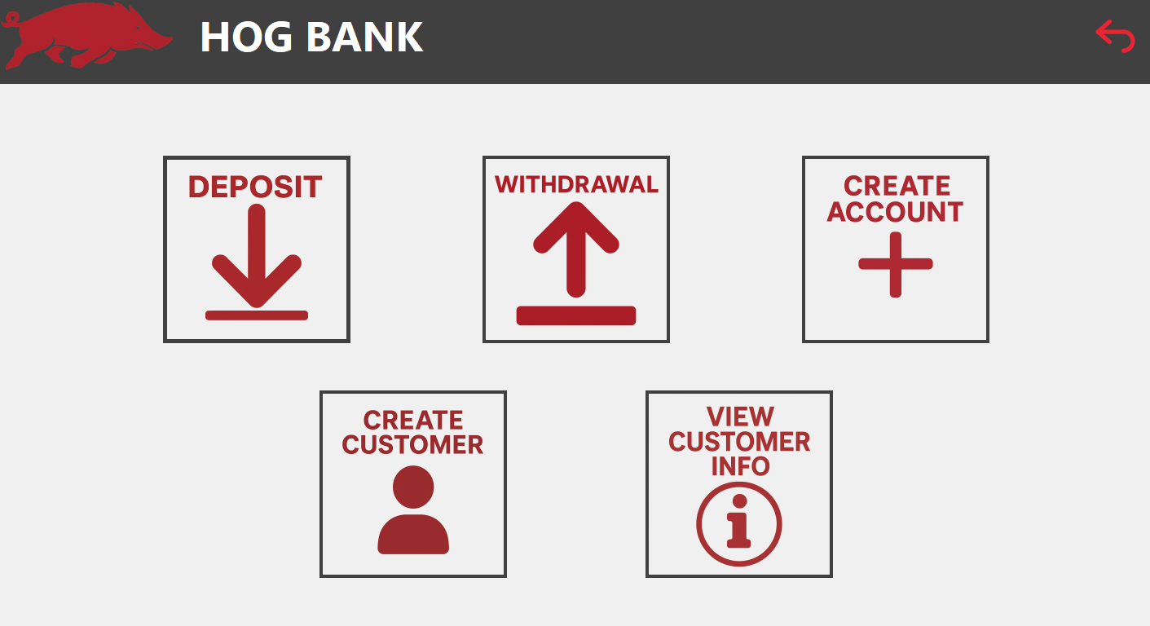

This is the main screen of the employee system, and all information/tasks will begin at this window.

At some points in this guide, you may want to return to this screen. To do so, please select the Back Arrow in the top right corner of another screen until you reach the Main Function Hub.

To Log Out, please select the Back Arrow in the top right corner of the Main Function Hub.

## Creating A New Customer:

To create a new customer, click the “Create Customer” button on the bottom left of the Main Function Hub screen. You will then be prompted to the “Create Customer Menu”:

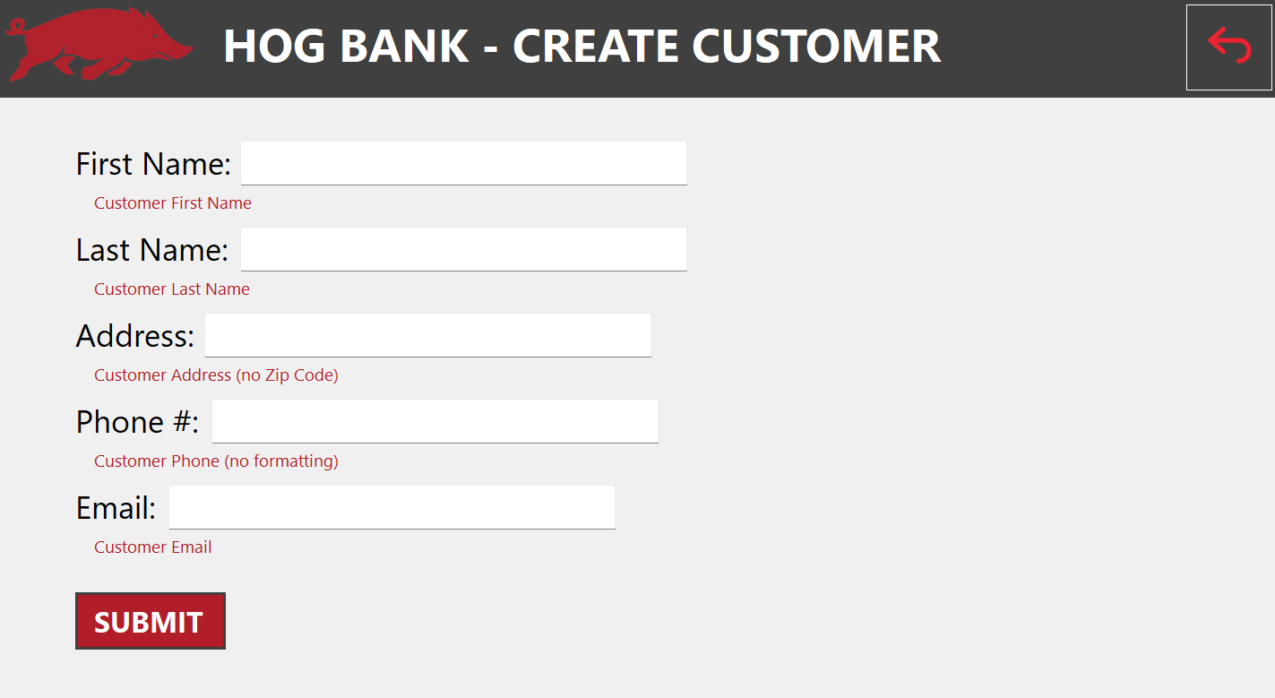Please enter the appropriate information into the fields within this menu.

Please Note that:

* the Address Field should not include ZIP codes (ex: 70 North East Avenue, Fayetteville, Arkansas)
* The Phone # Field should contain only numbers (ex: 1234567890)

After completing all fields, please click “Submit” to finish creating a new customer.

## Viewing an Existing Customer’s General and Account Information:

In the Main Function Hub, click the “View Customer Info” button in the bottom right corner. A menu should appear:

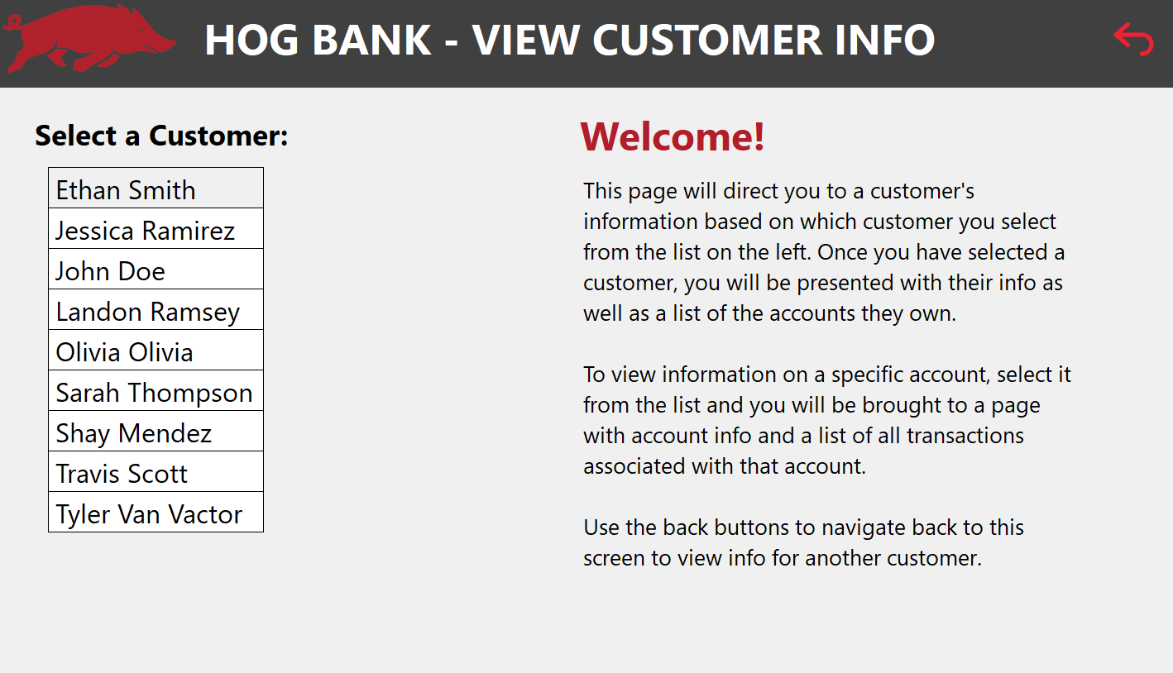On the left side of this screen is the list of customers, listed in alphabetical order. To view a specific customer’s information, please click on their name. After doing so, a new screen should appear:

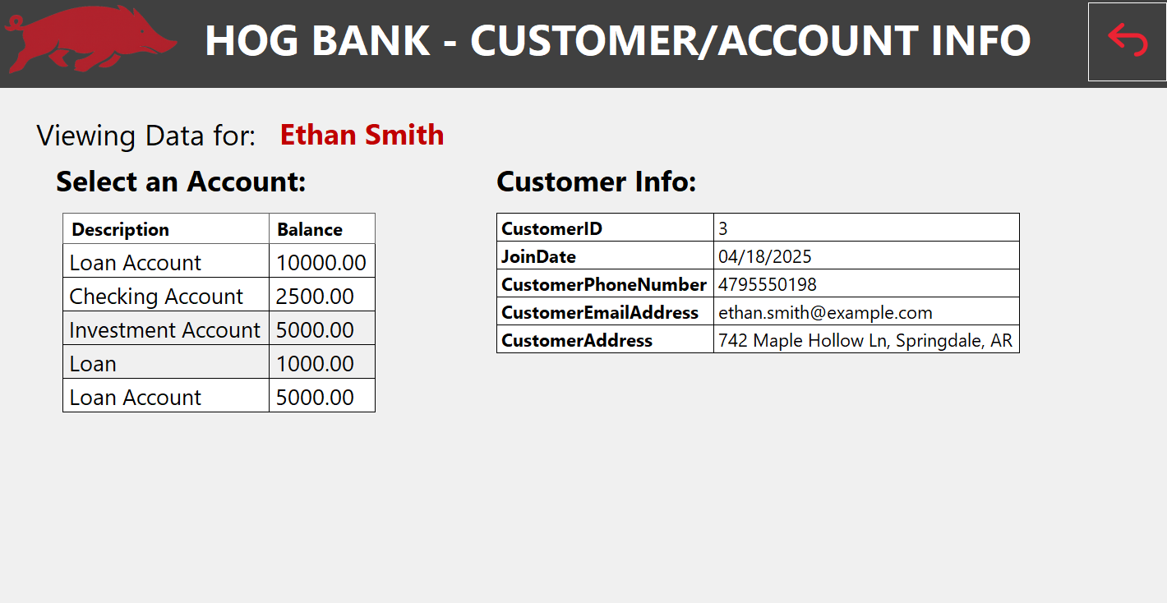

On the left side of the screen above is a list of accounts associated with a specific customer. On the right side, lists unique customer information. Please note the field “CustomerID” as it is important for creating accounts in the future.

Next, to view specific account information, please click on the Description or Balance associated with the account you with to view. A new screen should appear:

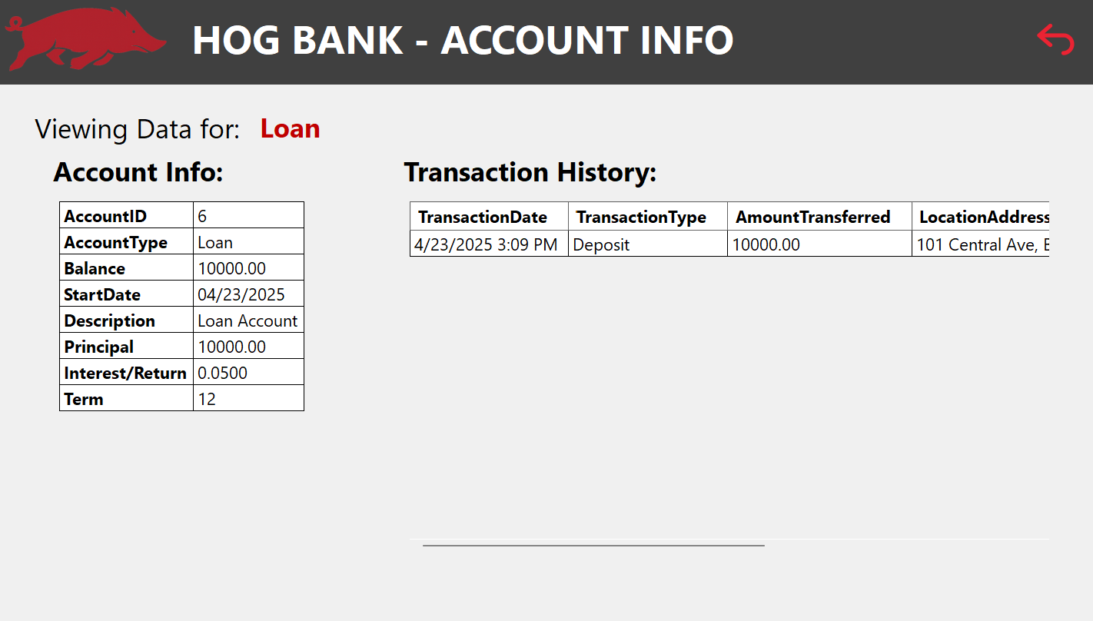

The above screen shows more information about a specific customer account.

Please note the “AccountID” field, as it is necessary to complete deposits and withdrawals later.

Also, note the scroll bar at the bottom of the page, which allows the rest of the transaction history information to be viewed.

## Creating A New Account:

To create a new account for a customer, please select the “Create Account” button in the top right corner of the Main Function Hub. You should see this screen appear:

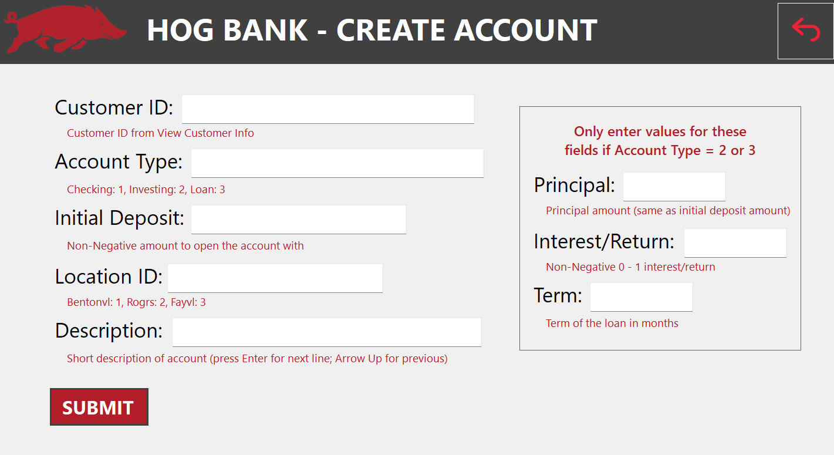

To create a new account, please fill in the fields accordingly. Please note that an Account cannot be created for a non-existent customer. After all necessary fields have been entered, please click ”Submit”.

## Deposits & Withdrawals:

To complete a deposit or withdrawal from an account, please select the “Deposit” or “Withdrawal” buttons in the top left/middle section of the Main Function Hub. One of the following two menus should appear accordingly:

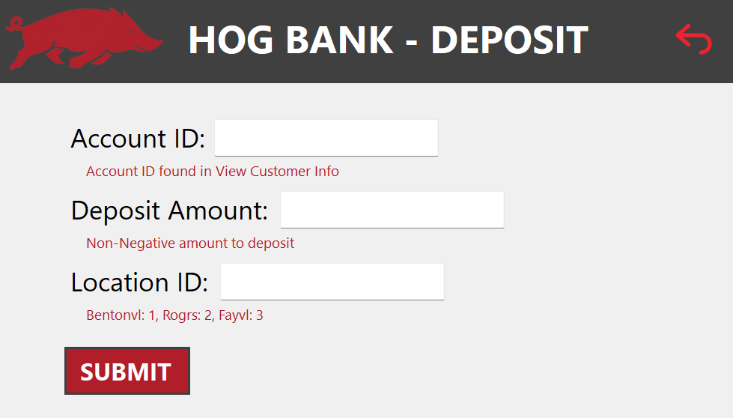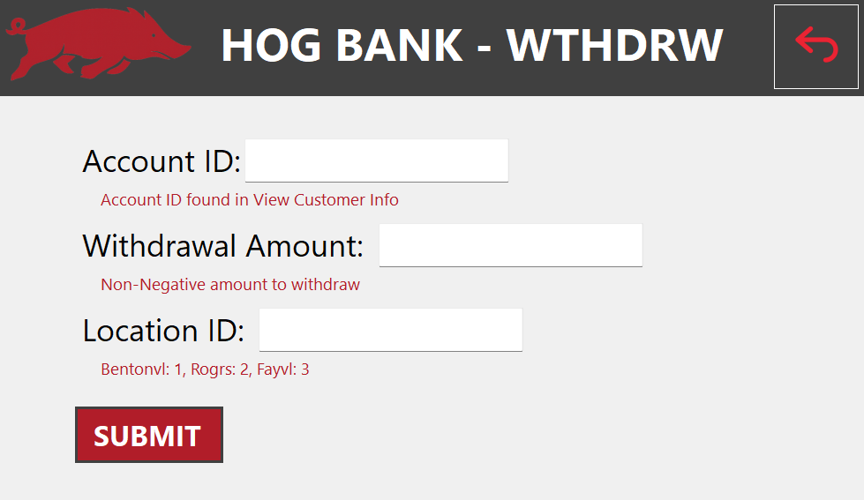

Please enter the appropriate information into the fields within either of these two windows to complete the transaction. Note: “Account ID” is found within the “View Customer Info” section. After completing all fields, please click the “Submit” button. This transaction should be updated in the Account information.