Project Report
Group 1 – Abe Archer, Ethan Ericson, Trevor Bolena
- We will use free student license of gorubi solver
- Capacity is now free + bikes because slots value is inconsistent with actual values
- We need to determine where trucks start in the system and how many bikes they start with at the beginning of the night
User Dissatisfaction Function (UDF)
- Constant mu and lambda for simpilicity. Don’t want to go the dynamic programming route as that’s going to eat up a bunch of time.
  - Maybe modify to add weighted averages for certain times of day?
- Overnight will be considered 10 pm to 7 am. (What the paper decided)
Poisson Streams
We will use the trip data records to estimate successful pickup and successful drop-off intensity parameters, u and lambda for two Poisson processes that will measure visits to a station. These parameters will be trained for every station and for every time interval from start of day to end of day, denoted as around 7:00 a.m. to 10:00 p.m.

UDF
Taking inspiration from Freund et al. (2020), the current plan for the data is to design a customer dissatisfaction function that will be used in a maximization objective that describes the per bike improvement in customer satisfaction. Here is the intended formula for the UDF:
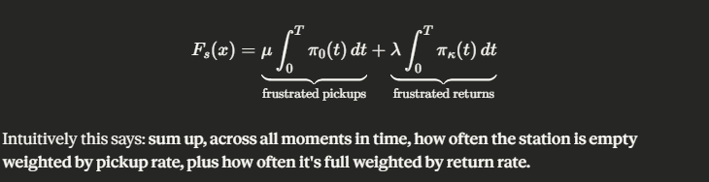
Mu and lambda will be constant. T is the total amount of minutes in the operating hours, while t is a specific minute that the probability of zero bikes or all bikes being present is evaluated at.
The function input flow will be as follows:
- Input a starting number of bikes x
  - This creates a probability distribution for the number of bikes at the station with probably 1 of x bikes at the station.
- Use Euler’s method to do ODE evolutions
  - This measures the increasing uncertainty of the number of bikes at a station as the day goes on.
- Evaluate the function on the results.
Synopsis
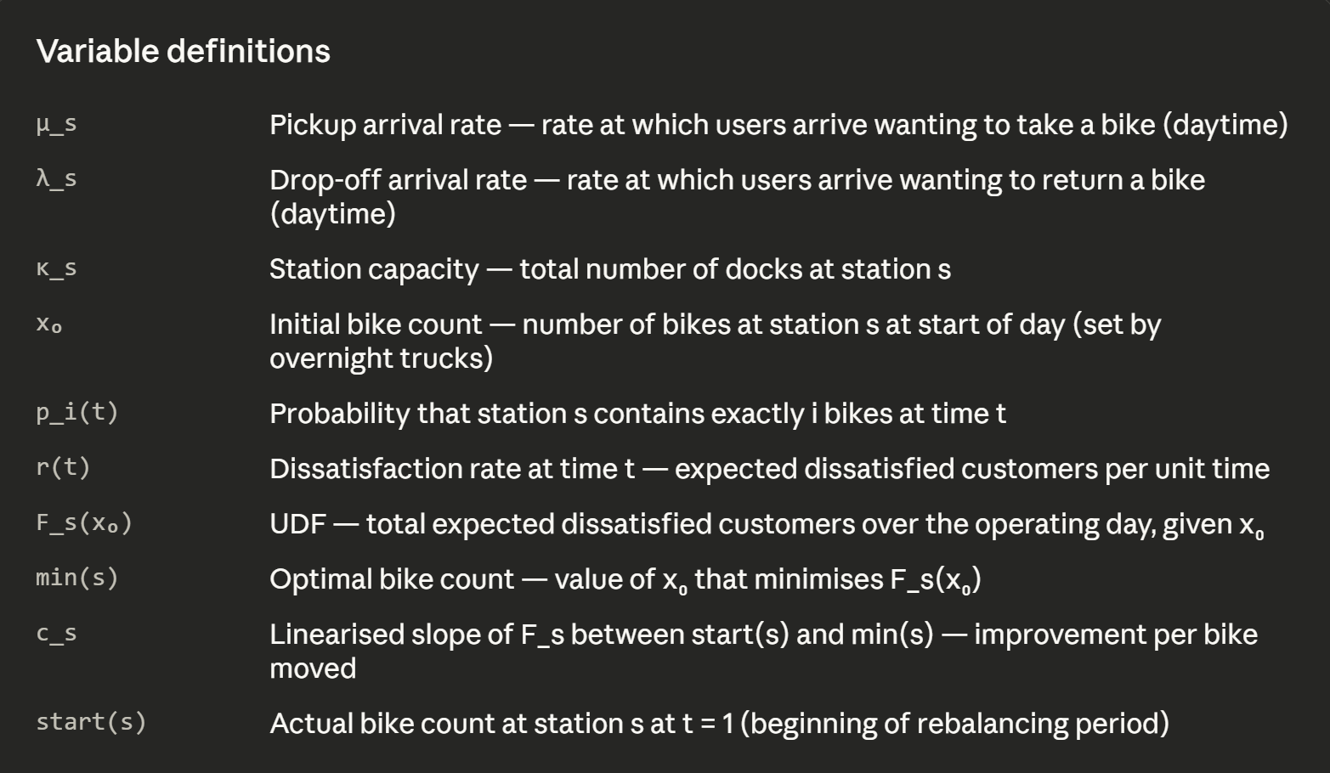
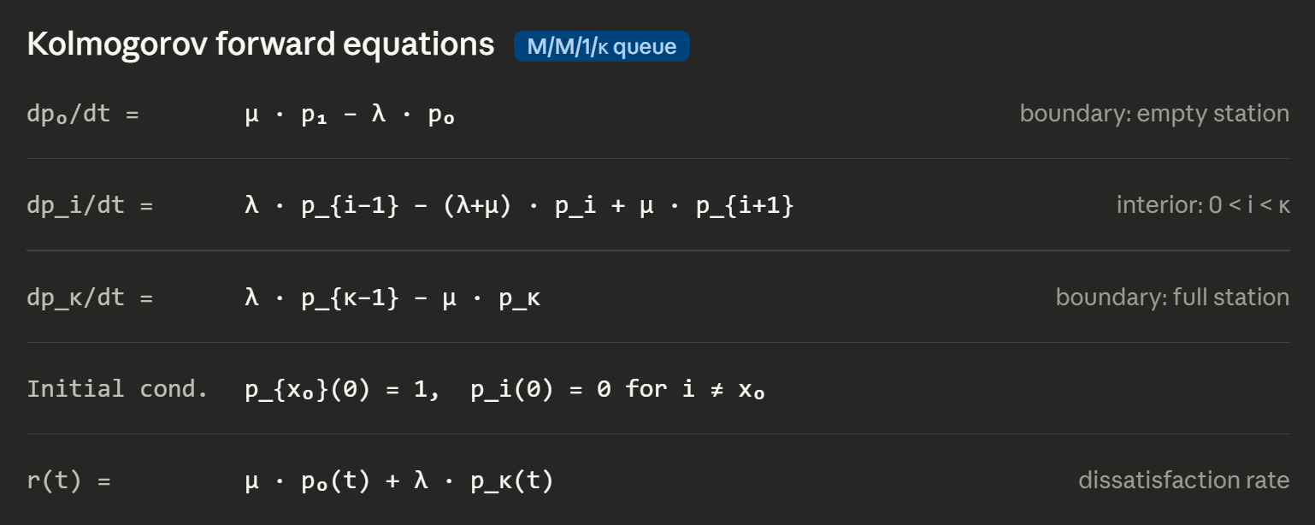
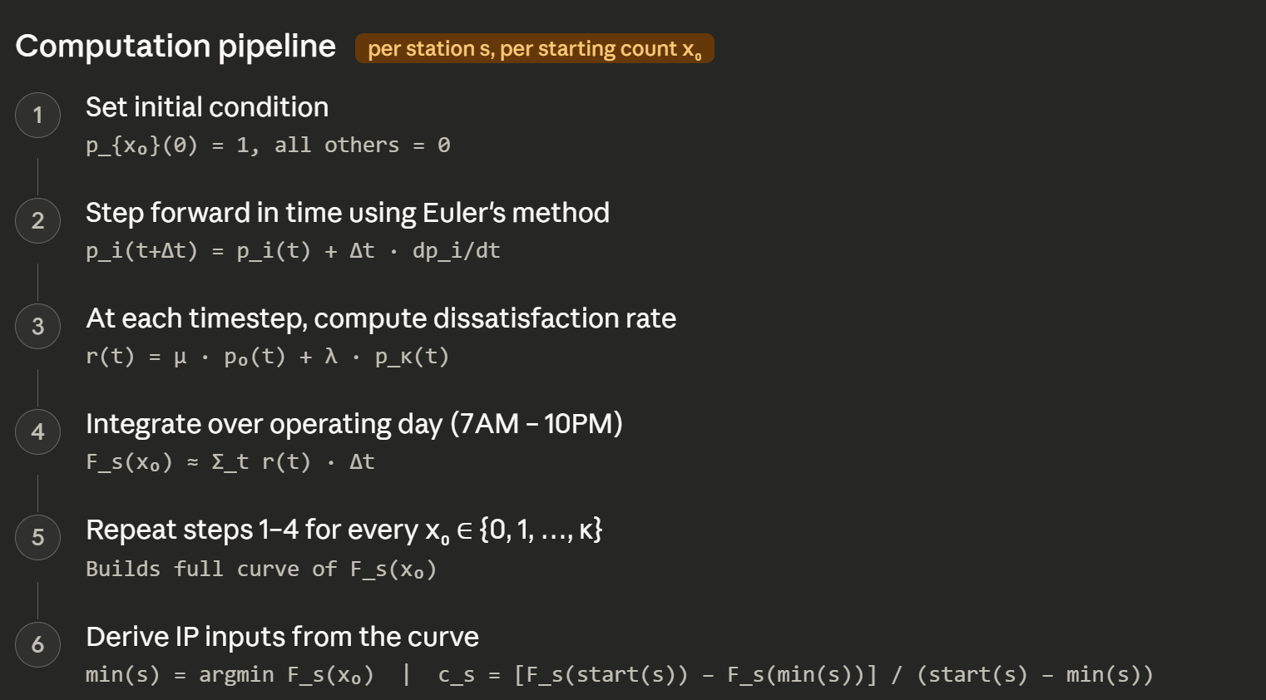
Integer Program
- So, we change the c_s formulation to remove the absolute value. We need sign information in objective, otherwise a net contribution to a station would result in a negative objective contribution since y_{stk} – y_{sTk} would be negative with an always positive c_s.
Time Intervals
Time intervals are each 6 minutes wide. This is based on NYCBS estimates of how long it takes to load/unload a set of 7 bikes. The time intervals cover the entire length of night rebalancing operations.
Indices
S = Set of stations
- This includes dummy stations that are each one 6-minute time interval apart. A 24-minute drive between two actual stations will have 3 dummy stations added. This is done to keep all operations on a consistent scale.
T = Set of time intervals
- Intervals range from start to end of the day
K = Set of trucks
Decision Variables
x_{stk} = A binary indicator of if truck k is at station s at time t.
y_{stk} = How many bikes accessible to truck k at station s at time t.
- Accessible to truck k is present to avoid double counting situations where two trucks are at the same station at the same time.
b_{tk} = The number of bikes in truck k at time t.
Parameters, Constants, and Subsets
N(s) = Set of stations (including dummies) directly adjacent to station s.
- We can get this using the longitude and latitude of the stations from the historical dataset
Y = Loading Rate (number of bikes that can be picked up or dropped off in one time set)
- Fixed at 7 per the NYCBS recommendation in Freund et al (2020).
start(s) = Initial bike count at station s at interval t = 1.
- We will use the historical data to grab the starting bike count.
min(s) = UDF Minimizer. This is the bike count at station s that minimizes the value of the UDF. This is the ideal target the rebalancing is trying to reach.
c_{s} = The per bike improvement value.
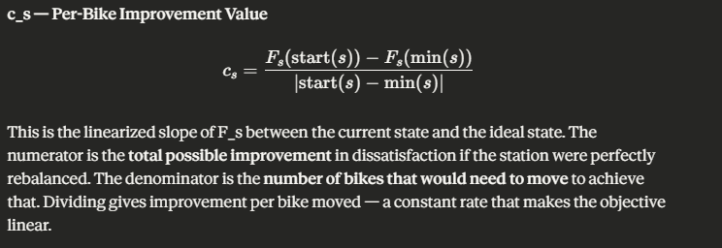
S⁺ = Set of stations that have more bikes than ideal. So, start(s) > min(s). These represent stations where bikes could be picked up.
S⁻ = Set of stations that have less bikes than ideal. So, start(s) < min(s). These represent stations where bikes could be dropped off.
Objective
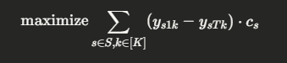
- The objective function seeks to maximize the total improvement value of the entire system of stations. The objective function sums the total net bike contribution of truck k to station s over the entire night (t = 1 to t = T) for every combination of station and truck. The total net bike contribution is multiplied by the per bike improvement value to give the customer dissatisfaction improvement value for that combination of truck and station.
Constraints
- Movement
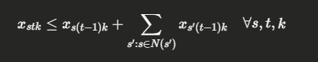
So x_{stk} can be 0 or 1. A value of 1 represents that truck k is at station s at time t, while a value of 0 represents that truck k is not at station s at time t. Thus, this constraint states that a truck k can only be at station s at time t if it was at that station in the previous time period (t – 1) or if it was in a station, s’, part of the set of stations adjacent to s, in the previous time period.

- One Location Per Truck
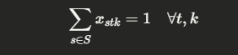
At every time t step and for every truck k, that specific truck can only be at one station at a time.

- Initialization
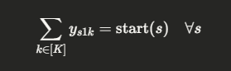
For every station s, the total bikes assigned across k trucks during time period 1 must be equal to the starting amount of bikes at that station.

- Pareto Constraint A
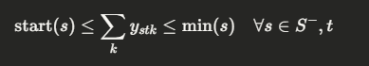
A pareto constraint is a constraint that enforces compromise between multiple directions of improvement. This part of the pareto constraint says that for stations that are below the optimal UDF input value, the number of bikes dropped off cannot exceed the optimal UDF input value. This keeps us from encroaching on the right side of the convex curve.

- Pareto Constraint B
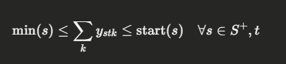
The second part of the pareto constraint handles stations that start off with more bikes than the optimal UDF value. It restricts the amount of bike picked up to not cross over to the left side of the convex curve.

- Conservation of Bikes
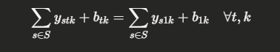
This constraint states that bikes can never be created or destroyed in the system. The number of total bikes assigned to a specific truck at a specific time across all stations must equal the number of bikes assigned to that truck across all stations at the beginning of the night.

- Loading Bikes only when present

This constraint enforces two things. First, when a truck is not at a station at a specific time interval, the change in bikes assigned to that truck at a station must be 0. Trucks cannot move bikes if not at that station.

Second, if a truck is at a station, the change in bikes can be no more than Y, which is fixed at 7.

- Move OR load, not both
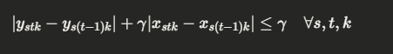
This constraint restricts the truck to either load/unload or to move, but not both. If there is a change in the number of bikes at a station assigned to a truck from one adjacent time period to the next, the truck must have loaded or unloaded. Since this term is > 0 in this case, the second term, representing a change in the location of a truck over the course of a time period change, must be 0, indicating the truck didn’t move.

Vice versa, if the truck did move, the constraint reaches its maximum from the second term alone, requiring the first term to be 0 to validate the constraint.

Data
All data below will be for the year 2025 (Maybe shrink down scope cuz that’s like a billion records)
Historical timestamps of bike availability at stations gathered from CityBikes (independent aggregator) at the Citibikes NYC (NYC LLC run by Lyft) endpoint. Encoded in General Bikeshare Feed Specification (GBFS).
Trip data records gathered from Citibikes NYC directly. Shows all trips with timestamps. It doesn’t record instances when a customer can’t find a bike or can’t deposit a bike at a station.

Citations
Main Article
Freund, D., Norouzi-Fard, A., Paul, A., Wang, C., Henderson, S., & Shmoys, D. (2020). Data-driven rebalancing methods for bike-share systems. https://people.orie.cornell.edu/shane/pubs/BSOvernight.pdf
De-censoring Technique
O’Mahony, E., & Shmoys, D. (2015). Data Analysis and Optimization for (Citi)Bike Sharing. Proceedings of the AAAI Conference on Artificial Intelligence, 29(1). https://doi.org/10.1609/aaai.v29i1.9245
Citi Bike Trip Data
New York City Bike Share. (2013). Citi Bike System Data | Citi Bike NYC. Citibikenyc.com. https://citibikenyc.com/system-data

Historical Bike Records from CityBikes
CityBikes. (2024). Data | Citybikes. Citybik.es. https://data.citybik.es/
Visualization
CityBikes. (2026). CityBikes: bike sharing networks around the world. Citybik.es. https://citybik.es/
Chat GPT
OpenAI. (2026, March 2). ChatGPT (GPT-5.2 Thinking) [Large language model]. https://chatgpt.com/
Claude
Anthropic. (2026, March 4). Claude (Sonnet 4.6 Extended) [Large language model]. https://claude.ai/new

