Question 2: Moving Average

Analysis of raw data:
Analysis of the raw data provided by the health monitoring agency of a developing country shows that the disease (XXX) has been damaging between the years 1950 to 1999. Approximately a 190,000 people suffered with the disease between 1955 and 1960 in two deadly attacks. Although it felt like it was settling down for 3-4 years after 1960, another 100,00 people suffered from it between 1964 and 1966. It came back again in 1974 causing huge damage just when the people and the authorities are thinking that the disease would not come back anymore after no incidences reported for at least 7-8 years between 1967 to 1974. However, the damage caused by the disease between 1983 to 1984 was a disaster as around 200,000 people suffered from the disease. 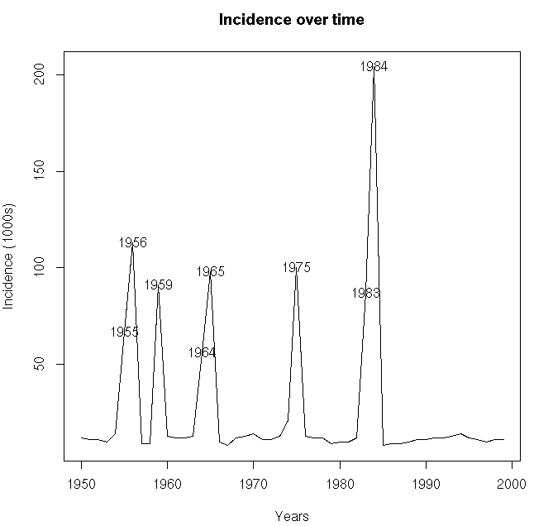
Graph shows the incidences over time and also tells when the disease was peaked during repeated intervals. However, it does not tell us if the disease is slowing down or is going to repeat after the health agency introduced the vaccine after 1984 disaster.

Performing Moving Average:
Although the health monitoring agency claims that the introduction of vaccine is a big success after 1984 disaster due to no incidences reported later on based on raw data analysis, performing moving average does not totally agree with their claim.

The graph below gives us a different look in to the situation.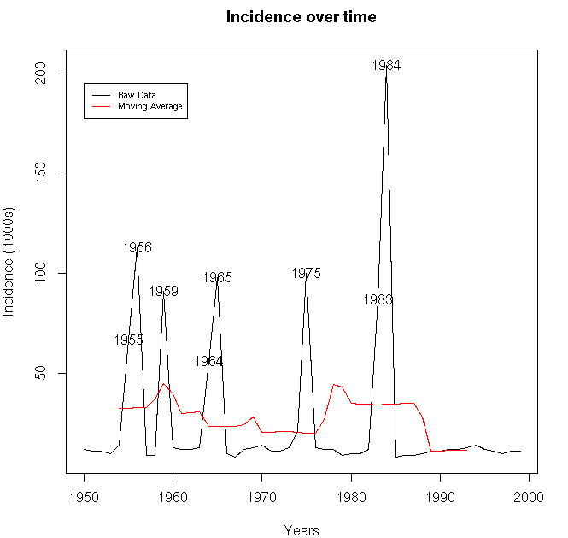
Raw data analysis says that there were no incidences reported after 1984 disaster.
But, after performing the moving average, it is clear that the incidences were actually reported until 1990 and they average up to almost the previous disasters. However, even moving average tells us that the incidences were reduced after 1990.

Conclusion:
As per the claims of the health monitoring agency that the incidences were reduced by 60%, I would agree. Because, the moving average of the incidences reported seems to be reduced compared to that of before vaccination. However, it could reoccur after a brief interval as we can notice few intervals of no incidences or no incidences at all between 1970-1976 and 1965-1970 as per the moving average. I cannot confirm from moving average analysis that the vaccination is a huge success as incidences need to be monitored for few more years before we come to any conclusion in this case to see if this is one of those intervals.

References:

- https://en.wikipedia.org/wiki/Moving_average
- https://www.rdocumentation.org/packages/pracma/versions/1.9.9/topics/movavg
- https://www.rdocumentation.org/packages/graphics/versions/3.5.1/topics/matplot
- https://www.rdocumentation.org/packages/graphics/versions/3.5.1/topics/legend
- https://stockcharts.com/school/doku.php?id=chart_school:technical_indicators:moving_averages
- https://www.rdocumentation.org/packages/graphics/versions/3.5.1/topics/text

Book:
- R programming for Bioinformatics by Robert Gentleman

Moving Average Code(R):

# Question - 2: Moving Average

rm(list=ls())
require(matlab)
# Activating matlab
source("movavg.r")
# Reading data
A <- read.table("vaccine.txt",header = FALSE)

###############################################
################ Step - a #####################
###############################################

# Plotting the Raw Data using matplot
x11()
matplot(A[,1], A[,2], type="l", xlab = "Years", ylab = "Incidence (1000s)", main = "Incidence over time", col = 1)
# Using which function to create threshold
A2 <- which(A[,2]>90)
A3 <- A[,2]>50
# Overlaying identified years on plot using 'text()' function
text(A[,1][A3],A[,2][A3],(1950:1999)[A3])

################################################
################# step - b #####################
################################################

# Performing moving average
wsize <- 11
movingavg <- movavg(A[,2], wsize)
window_half <- (wsize/2)
par(new = TRUE)
# Overlaying moving average on Raw data plot
matplot(A[(window_half):(length(A[,1])-window_half),1], movingavg, type = "l", xlab = "Years", ylab = "Incidence (1000s)", col= 2, xlim= c(1950,1999),ylim = c(8,204))
# Adding legend
legend(1950,195, legend = c("Raw Data","Moving Average"), col = c("black","red"),lty = 1, cex = 0.7)

