January 14, 2008

Applied Solutions
237 Pasteur Hall
Winona, MN

Milligander Geese Company
1400 Corporate Blvd
St. Paul, MN

Dear Mr. Milligan,

Thank you for requesting our services. I hope you are pleased with our analysis below.

Since the price of the ground corn oscillates regularly over the course of the year, the price, P(t), can be modeled using a cosine function, where t is the day of the year (1 for Jan 1, 2 for Jan 2, … 365 for Dec 31). Since the prices are between $5/lbs and $12/lbs, the center value is $8.50/lbs and the amplitude of the fluctuation is $3.50/lbs. In addition, since the period is one year and from the two prices you’ve supplied, we have been able to determine that

P(t) = 8.5 + 3.5 Cos(0.0172142 t – 5.56)

The amount of specially ground corn that you need to purchase can also be modeled using a cosine function. Again, since the fluctuation is between 70 and 100lbs and the period is a third of a year with a peak on March 1st, then the demand D(t) on day t as above is given by

D(t) = 85 + 15 Cos(0.0516426 t – 3.1)

Then, since the total cost (in dollars) of buying ground corn is given by the price (in dollars/lbs) multiplied by the quantity (in lbs), the total cost C(t) of specially ground corn on day t is determined by

C(t) = P(t)*D(t)

which is graphed below over the course of the year:

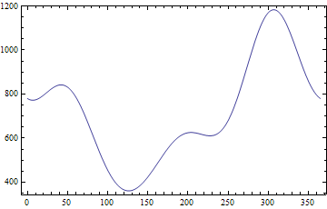
By analyzing this graph, we can see that the lowest expenses for ground corn occur around the 126th day of the year (i.e. May 7th) and will be about $360/day. The highest expenses will occur around the 307th day (i.e. November 3rd) and will be about $1183/day.

Good luck with your business and let me know if you have any further questions.

Sincerely,

Eric Errthum
Applied Solutions

