Department of Mathematics and Statistics Seminar

Time: 12:00 - 12:50 PM
Day: Wednesday, September 28
Place: Gildemeister 155

Summer Institute in  Biostatistics at NC State  Stacey Miertschin  _______________________________________  This past summer I spent six weeks at North Carolina State University for a Summer Institute in Biostatistics or SIBS. During this time, I went to daily class sessions that covered various topics in the field of biostatistics. I had many opportunities to interact with statisticians, cardiologists, and students who helped me to understand this area of study at the intersection of statistics and public health. Through this talk I hope to share more of my experiences and encourage others to seek out similar summer programs. |  | 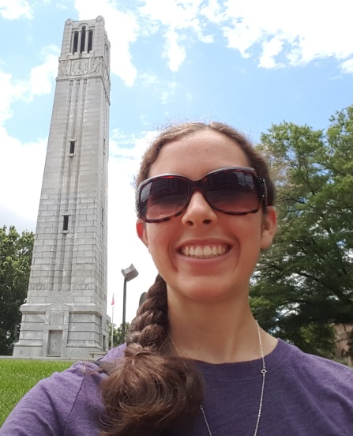
 | Investigating the Relationship between Personality and Satisfaction with College Major  Brandy Jaszewski  _______________________________________  Choosing a satisfying major and career path is an important decision that usually has a large impact on one’s life. In the current study, relationships between major satisfaction and personality traits were investigated. A survey was created which asked participants questions regarding their personality, in addition to assessing the level of satisfaction with their current (or intended) major and chosen career path. Correlations between satisfaction and personality traits, as well as several one-way analysis of variance analyses between the data collected were calculated. As hypothesized, certain personality traits have a higher degree of influence upon satisfaction, while others have nearly none. Those with the strongest relationship with major satisfaction were conscientiousness (being organized) and agreeableness. Study limitations and findings were discussed.

