**1. Killing Assay**

1-1. Set the ROI

Set the region of interest. ROI polygon should include only the entire chamber, because any high contrast objects within ROI can be counted as a worm and a worm out of it will be neglected. To set the ROI precisely, the vertices are added one by one, so that one can zoom in the target area before clicking to add a vertex.

>> CountWorms

Directory : **“data directory”\Sample**

Filename : **MKA**

…

[R]OI; Sa[V]e; [Q]uit ? **r**

Redefine ROI

[A]dd vertices; [U]se/[D]iscard this ROI ? **a**

Add more vertices

…

Add more vertices

[A]dd vertices; [U]se/[D]iscard this ROI ? **u**

The new ROI is defined.

Applying the new ROI...

…

[R]OI; Sa[V]e; [Q]uit ? **q**

Quit

CountData Saved.

Output: MKA.KACnt.mat

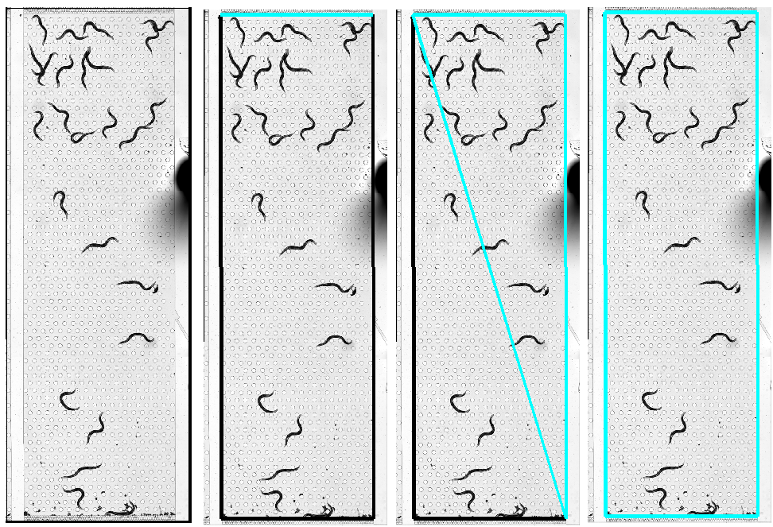

1-2. Find worm-domains (within the ROI)

At all frames, high-contrast objects within the ROI will be found and saved as worm-domains in .KACnt.mat (data) and .KACnt.png (bitmap image).

>> CountWormsBatch

Directory : **“data directory”\Sample**

Filename : **MKA**

Output: MKA.KACnt.mat, *.KACnt.png

1-3. Determine the number of worms for each worm-domain

Dead worms can be filtered out using the average brightness (Filter By Darkness).

>> InspectWorms

Directory : **“data directory”\Sample**

Filename : **MKA**

…

Filter By [A]rea/[D]arkness; Sa[V]e; [Q]uit? **d**

Filter By Darkness

Select ROI Polygon

44 Worms Selected

[A]uto Fix/Manual [C]heck ? **a**

Auto Fix

Selected Will be Discarded.



**Alive (Dark)**

**Dead (Light)**

Tiny objects which are not worms can be filtered out using the area of the domains (Filter By Area). Also, the number of worms in large worm-domains which likely correspond to multiple worms will be estimated using the area of single-worm domains.

…

Filter By [A]rea/[D]arkness; Sa[V]e; [Q]uit? **a**

Filter By Area

Select ROI Polygon

26 Worms Selected

[A]uto Fix/Manual [C]heck ? **a**

Auto Fix

Click for the Standard Size for a Single Worm

Filter By [A]rea/[D]arkness; Sa[V]e; [Q]uit? v

Save

CountData Saved.

Output: MKA.KACnt.mat



“Click for the Standard Size for a Single Worm”

Too small

Multi-Worms

1-4. Survival Curve

>> KillingCurve

Directory : **“data directory”\Sample**

[Q]uit ?



**2. Single-worm Masks**

2-1. Remove dead worms from the worm-domains

In this step, .Mask.png files are generated. They are the bitmap images of domains of worms alive and serve as the input in the following step.

>> MakeMask

Directory : **“data directory”\Sample**

Filename : **MKA**

FrameNo[1/10] 1.8 s...

FrameNo[2/10] 2.3 s...

FrameNo[3/10] 2.7 s...

FrameNo[4/10] 3.2 s...

FrameNo[5/10] 3.9 s...

FrameNo[6/10] 4.6 s...

FrameNo[7/10] 5.5 s...

FrameNo[8/10] 7.6 s...

FrameNo[9/10] 10.0 s...

FrameNo[10/10] 13.0 s...

Output: *.Mask.png

2-2. Make single-worm masks

Multi-worm-domains in .Mask.png will be separated into single-worm-domains saved as .SWMask.png.

>> MakeSWMask

Directory : **“data directory”\Sample**

Filename : **MKA**

[M]ake SW Mask; [G]o To; [Q]uit ? **m** % Make SW Mask for the selected frame(s)

Make SW Masks

Select Frames : **5**

…

[M]ake SW Mask; [G]o To; [Q]uit ? **g**

Go to

FrameNo [1-10] ? **5** % Go to the frame, and check the result

Output: *.SWMask.png

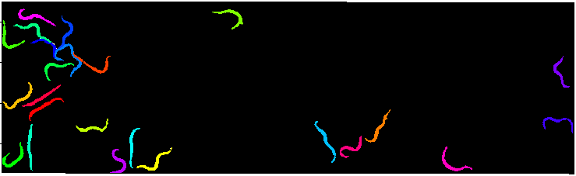

**Appendix. Data Format**

The sample data included here are the images of a HandKAChip device mounted on commercial Zeiss microscope. The images were originally recorded using ZEN 2012 software as .CZI files and then converted to TIFF files (MKA t*.tif) sorted into a custom directory structure, along with the metadata files (MKA.dat, MKA.tdata). Since the scripts introduced here assume that the input data follow this custom data format, here, we explain how to convert .CZI files from ZEN 2012 software.

A-1. Image Export (from ZEN software)

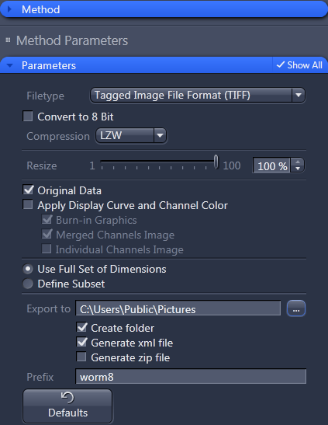

Output: *.tif,*.xml

A-2. Convert the exported to custom data format

>> SortZeissData

Directory : **“where the files were exported”**

Filename : **”CZI filename”**

>>