Introduction：

As a script murder game enthusiast living in Beijing, I found that there is no website or app containing professional summary and classification of script murder stores in the market that can fully cater to script murder culture because script murder is an emerging form of game. As a result, the old players always need to spend a lot of time to find a satisfactory store, and the new players who have just get in touch with this kind of game also tend to reject it because of the unpleasant experience at unsatisfied stores.

Therefore, I decide to build a Beijing script murder store guide website to summarize and classify the script murder stores in Beijing, and provide all valid and helpful information to help people find script murder stores that meet their needs.

Interview questions:

1. How often do you go to play script murder game?
2. How many stores have you gone to?
3. Are you satisfied with the stores you have visited before? With which aspects are you satisfied or unsatisfied?
4. Which aspects of the store do you think are the most important and determine whether you choose this store?
5. How do you usually find a store to visit? Can you please show the process to me?
6. What other information of the stores do you want to know?
7. What problem have you encountered when looking for the store and making appointment?
8. Do you like to engage in other entertainment activities after playing the script? What do you usually choose to do?
9. If there is a website that specializes in summarizing Beijing script murder game stores, what kind of information do you want it to provide?

Persona types：

1. A 24-year-old male postgraduate student, being an aficionado of script murder game who also owns a store
2. A 22-year old female KOL, being a fan of all kinds of script murder game
3. A 22-year-old female postgraduate student, being a fan of script murder game with performance
4. A 22-year-old female postgraduate student, being a fan of immersive script murder game
5. A 22-year-old female postgraduate student, being a primer player of script murder game

Among the 5 personas, I choose the first persona, that is, the 24-year-old male postgraduate student, being an aficionado of script murder game who also owns a store, because his frequency of going to the script murder store is very high so that there is a higher and more comprehensive demand for selecting and evaluating script murder stores.

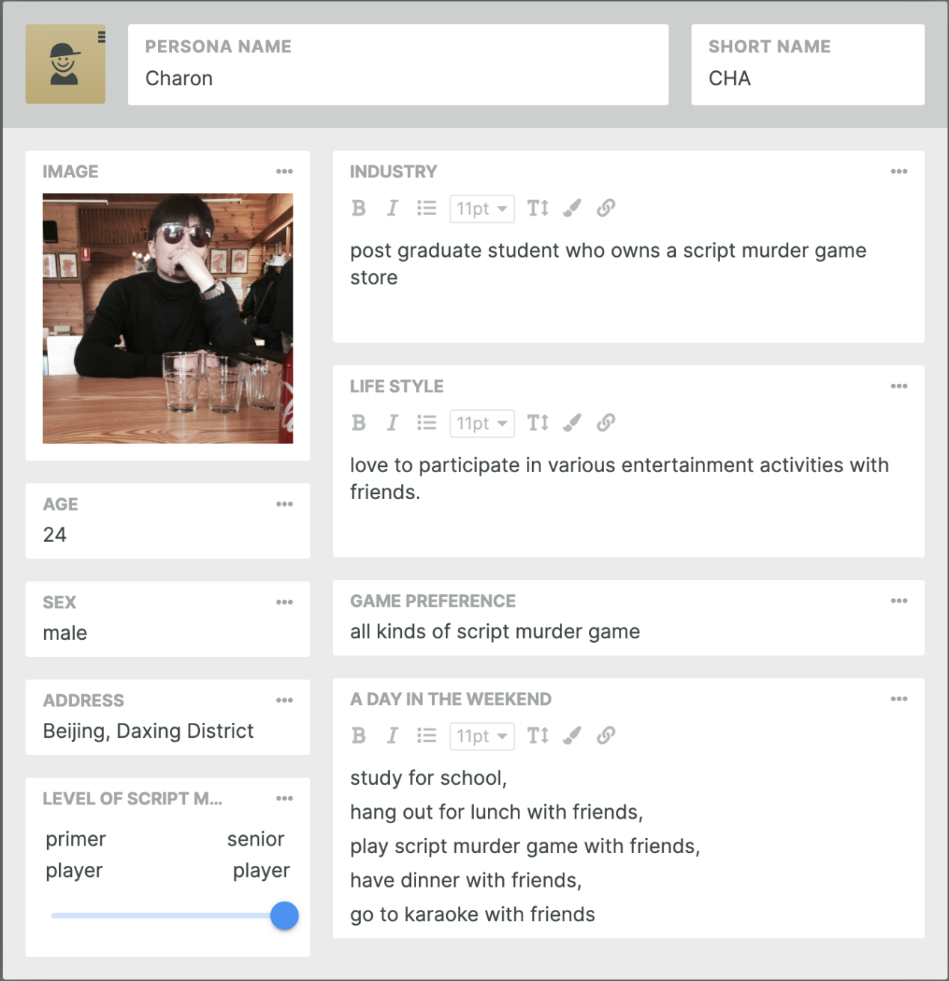

figure1: persona

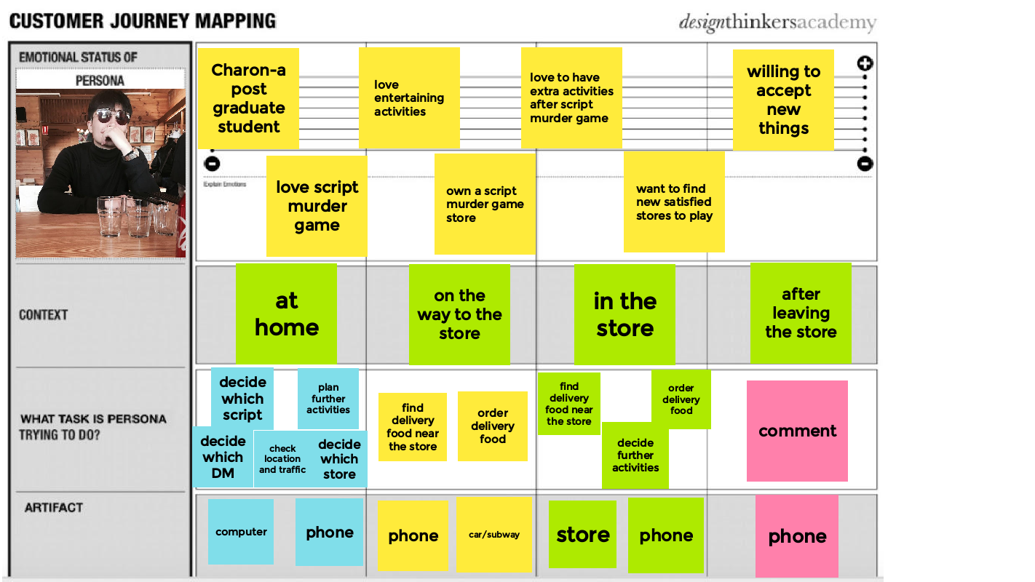

figure 2：journey map

Problem statement:

How might we make script murder game players address the problem of finding the script murder game stores that meed their needs to achieve the goal of having pleasant script murder game experience and enjoy convenient and pleasant extra entertaining activities.