METHODS FOR SEGMENTATION AND MEASUREMENT OF DIABETIC RETINOPATHY LESIONS

A report on
Computer Vision Lab Project
[CSE-3181]

Submitted By
EESHAN UPADHYAYA - 210962089
YATIN SALUJA - 210962073
PRIYASU KARAK - 210962132



DEPARTMENT OF COMPUTER SCIENCE AND ENGINEERING
MANIPAL INSTITUTE OF TECHNOLOGY,
MANIPAL ACADEMY OF HIGHER EDUCATION
NOVEMBER 2023

Methods for segmentation and measurement of diabetic retinopathy lesions
Eeshan Upadhyaya¹, Yatin Saluja², Priyasu Karak³
¹ Department of Computer Science &Engineering, Manipal Institute of Technology, India
² Department of Computer Science &Engineering, Manipal Institute of Technology, India
³ Department of Computer Science &Engineering, Manipal Institute of Technology, India
¹eeshan.upadhyaya@learner.manipal.edu; ²yatin.saluja@learner.manipal.edu; ³priyasu.karak@learner.manipal.edu

Abstract: Diabetic Retinopathy is a significant microvascular complication of diabetes, often leading to vision impairment and blindness if left undetected and untreated. Early detection and precise monitoring of retinopathy lesions are paramount to improving patient outcomes and reducing the risk of severe complications. This project presents an innovative approach to automate the segmentation and measurement of diabetic retinopathy lesions in retinal images. The project comprises three fundamental stages. First, image pre-processing, involving resizing and conversion to grayscale, sets the foundation for subsequent analysis. Feature extraction is then performed using Histogram of Gradient (HoG) and Speeded Up Robust Features (SURF), enhancing the computational efficiency while preserving accuracy. The second stage involves utilizing SVM classification models to distinguish between normal and abnormal retinal images. Abnormal images are further classified into four distinct categories, representing different stages of diabetic retinopathy (Mild DR, Moderate DR, Severe DR, and Proliferative DR), employing Convolutional Neural Networks (CNN). The project's significance lies in its potential to revolutionize the diagnosis and management of diabetic retinopathy. Early detection facilitates timely intervention and improved treatment outcomes. Objective and accurate lesion assessment enhances diagnostic precision and monitoring. Personalized patient care plans, driven by precise measurements, optimize treatment and interventions. Moreover, the project contributes to the advancement of research into diabetic neuropathy by providing standardized lesion analysis.

Keywords: “diabetic retinopathy”; “segmentation”; “measurement”; “automation”; “classification”

- Introduction
Diabetic Retinopathy (DR) is a microvascular complication that often accompanies both type 1 and type 2 diabetes posing a substantial burden on individuals and healthcare systems worldwide. The hallmark of Diabetic Retinopathy is the development of pathological lesions within the retinal vasculature, which, if left unmanaged, can progress to severe stages and lead to irreversible visual impairment or blindness. It is the most common cause of severe vision loss in adults of working age groups in the western world.[1] Remarkably, approximately one-third of individuals diagnosed with diabetes will develop DR, and virtually all diabetics are at risk over time. According to some experts, 90% of diabetic people who receive an early diagnosis may be saved from the disease.[2] Projections indicate that by 2030, DR may affect as many as 191 million people [3]. By 2045, India alone is projected to have approximately 151 million people with diabetes and one-third of them are expected to have DR. [4] Amongst them, one out of three individuals is estimated to have some form of DR, and one in ten is prone to vision-threatening DR. [5] While it's known that the visual impairment and loss resulting from DR can be preventable, early detection is paramount and hence, diabetic patients are typically referred for retinal screening once or twice a year. [6] Patients who have already received a DR diagnosis should be subject to regular monitoring. The assessment process for DR primarily involves capturing a fundus image of the retina, subsequently reviewed by trained ophthalmologists. Without intervention, diabetic retinopathy advances through four distinct clinical stages, including mild, moderate, severe, and proliferative DR.
- Literature review
Reference:[7]
This article examines the most recent approaches for classifying and detecting diabetic retinopathy using different deep learning algorithms. The most recent techniques have been examined and evaluated. We have examined the DR datasets that are currently available for the color fundus retina. The difficulties that need further research are also covered in the article. The article discusses 33 publications that classified DR photos using deep learning techniques. The growing number of individuals with diabetes has made the necessity for accurate diabetic retinopathy screening methods a pressing concern. A trustworthy DR screening method is necessary in order to develop an efficient follow-up program for DR patients, thereby preventing blindness. The most recent automated techniques for detecting diabetic retinopathy that make use of deep learning technology are reviewed in this article. We have described the publicly accessible common fundus DR datasets and briefly touched on deep-learning approaches. The limits of using deep learning in the medical industry are also discussed in the essay. The sizes of the existing public datasets must be expanded, and large datasets, such as the public Kaggle dataset, must be improved to get rid of low-quality and incorrectly labeled data. The article's conclusion is that DR patients benefit from an efficient lead-up system when there are trustworthy DR screening tools that can identify various lesion kinds and DR stages.

Reference:[8]
This study proposes a new method for processing retinal images that uses the two previously mentioned well-known methods, Scale-Invariant Feature Transformation (SIFT) and Accelerated Robust Features (SURF). The exudates from each image are saved in a feature matrix and utilized to estimate the DR by a support vector machine (SVM) classifier. Traditional processes incorporate advanced techniques such as resizing, green channel extraction, adaptive histogram equalization, and edge filters. This study found that an average sensitivity of 94% for a set of 100 test images is promising for early identification and treatment of DR since it strengthens the system. Despite the fact that the data set is 20% larger, the model yields the same findings as the previous data. The performance of classification algorithms such as PNN, SVM, and Bayes theorem was also compared in this study. This research can be expanded to predict DR in multiclass classification problems.

Reference:[9]
This research presents a deep learning-based automatic detection technique for diabetic retinopathy. It uses an attention-based Convolution Neural Network (CNN) model called AD2Net to divide fundus images into five disease phases based on severity. The model's accuracy and Kappa value on the testing set are 83.2% and 0.8, respectively. The procedure can assist doctors in completing the DR diagnosis while offering convenience to patients as well as doctors. The suggested strategy can assist clinicians in completing the DR diagnosis and increasing treatment efficiency. The information was taken from the open dataset of the diabetic retinopathy detection competition on the Kaggle platform. The DenseNet backbone serves as the foundation for the model. The Res2Net hierarchical residual network of 3x3 convolutions serves as the foundation for the network structure. A 3x3 convolution replaces the Bottleneck Layer. The attention mechanism is used at the end of the Bottleneck Layer to improve network performance even further. The proposed method had a testing accuracy of 83.2% and a Kappa value of 0.8. The results show that the method proposed in this paper outperforms the current method.

Reference:[10]
The article discusses the difficulties of providing specialized eye care to everyone, as well as the potential benefits of using an automated system to assist medical experts or as a complete diagnostic tool. The automatic diagnosis system is highly automated and precise, reducing the burden on DR diagnosis and treatment. The article also discusses the significance of data pre-processing in improving image quality, as well as the potential implications of using this technology for the early detection and treatment of diabetic retinopathy. The article also discusses the significance of data pre-processing in improving image quality, as well as the potential implications of using this technology for the early detection and treatment of diabetic retinopathy. The input images for the study were prepared using a variety of pre-processing techniques, such as cropping and scaling. The acquired images take up a lot of space and have a resolution of 1956 × 1934 pixels. For this reason, they are first resized to 300 x 300 pixels before they are inserted into the framework. Using 5000 verification images, the CNN based on Vgg16 was able to achieve a sensitivity of 0.95 and an accuracy of 0.75.

Reference:[11]
The PDF file provides information on several other studies that have used deep learning techniques for the classification of DR. One study shown had used an AI-based algorithm to detect DR with a sensitivity of 90.4% and specificity of 91%. Another study presented a complex architecture containing a compound of stacked layers, with a precision value of 0.81 and 0.88 for each class. The deep learning architecture proposed in this study utilizes the technique of maximal principal curvature and the Hessian matrix to extract the branching blood vessels, followed by adaptive morphological opening and histogram equalization. The results of this study show promising accuracy in the classification of diabetic retinopathy. However, further research would be needed to directly compare the performance of this approach to other methods for classifying diabetic retinopathy. It is possible that the approach presented in this study could be adapted or extended to other ophthalmological conditions that involve the growth or branching of blood vessels in the eye. Further research would be needed to determine the feasibility and effectiveness of applying this approach to other conditions.

Reference:[12]
This article presents an automatic scoring system for diabetic retinopathy (DR) using a deep learning convolutional neural network (CNN) model. This algorithm extracts local and global features from retinal fundus images to a high DR level. This algorithm uses a Siamese network with hierarchical clustering of image patches to classify the severity of DR. The proposed algorithm is trained on publicly available data and tested on other data. The paper reports reasonable performance measures with an accuracy and MCR value of 90% and 6.5, respectively. The proposed algorithm can be used to develop a reliable DR automatic rating system, which is necessary since a large number of diabetic patients worldwide suffer from DR symptoms. With further research and validation, the proposed method can be applied to other eye abnormalities. This article provides a detailed description of this process, including pre-processing, image patch extraction, feature extraction, and classification. The article also explains the CNN architecture and training process in detail. This article discusses the limitations of the proposed method, such as the lack of direct comparison with other methods in the literature and the need for further validation of the data. Overall, the proposed algorithm is technically feasible and can aid in the early identification and treatment of DR by providing an effective and accurate automatic grading system.
- methodology
- Pre-processing:
The pre-processing stage is dedicated to preparing the raw retinal images for subsequent analysis.

1.1 Data Collection:
Data collection is a fundamental step in the pre-processing stage. The retinal image dataset was meticulously curated from Kaggle.com [13]. The dataset utilized in our research comprises a collection of retinal scan images aimed at the detection of diabetic retinopathy. These images were originally sourced from the APTOS 2019 Blindness Detection dataset. The dataset encompasses a total of 3,662 images, thoughtfully organized into five distinct directories, each representing a different stage or severity of diabetic retinopathy. These categories include 'No_DR,' 'Mild,' 'Moderate,' 'Severe,' and 'Proliferate_DR.' The meticulous organization of the dataset, along with its significant size, ensures that it forms a robust foundation for our research, enabling comprehensive analysis and classification of diabetic retinopathy lesions across different stages.

  - Image Resizing:
Image resizing is a crucial pre-processing step to standardize the dimensions of the retinal images. This standardization is important to ensure consistency during subsequent analysis. The images were resized to a common dimension ([224x224]) using OpenCV. This process maintains the aspect ratio while transforming the images to the desired size.

  - Grayscale Conversion:
Grayscale conversion is a fundamental pre-processing step in our research, enabling the transformation of color retinal images into grayscale representations. This simplification reduces computational complexity and prepares the images for subsequent analysis. We applied a weighted formula to assign grayscale values to each pixel, emphasizing luminance based on human eye sensitivity to red, green, and blue light [RGB]. Grayscale conversion is essential for preserving image characteristics relevant to the detection and classification of diabetic retinopathy lesions, optimizing the data for the models utilized in our research.

- Feature extraction:
Feature extraction is a critical step for identifying and characterizing diabetic retinopathy lesions.

2.1 Histogram of Gradient (HoG):

Histogram of Oriented Gradients (HOG) is a feature extraction technique used in computer vision and image processing for object detection and recognition. HOG computes a representation of the local distribution of gradient orientations in an image, capturing texture and shape information. It's a widely used method in various computer vision tasks.

In Image Gradient Calculation,
HOG begins by computing the gradient of the image to capture changes in pixel intensities. This is typically done using convolution with Sobel or Scharr filters to obtain the magnitude and direction of gradients for each pixel.
Gradient Magnitude (G_m) = √(G_x^2 + G_y^2)
Gradient Direction (G_theta) = arctan2(G_y, G_x)

In our research, we employ the Histogram of Oriented Gradients (HOG) technique to extract distinctive texture patterns from retinal images. HOG divides the images into cells, computes gradient magnitudes and orientations, and constructs histograms to represent local textures. We fine-tune HOG parameters to suit our 224x224-pixel images and utilize Principal Component Analysis (PCA) for reducing the dimensionality. The reduced-dimensional HOG features are then fed into a Support Vector Machine (SVM) classifier for diabetic retinopathy lesion classification. The efficacy of this method is assessed through classification accuracy, demonstrating its ability to accurately classify diabetic retinopathy stages.

The code incorporates Histogram of Oriented Gradients (HOG) as a fundamental step in our image analysis. Initially, it reads and pre-processes retinal images, ensuring uniform dimensions and converting them to grayscale. Subsequently, HOG feature extraction is applied to these images, enabling the capture of texture and pattern information. HOG parameters are adjusted to suit the 224x224 image size, ensuring optimal feature extraction. Furthermore, Principal Component Analysis (PCA) is used for dimensionality reduction, reducing the computational complexity while retaining essential information. The resulting reduced-dimensional HOG features are employed in training a Support Vector Machine (SVM) classifier. This combination of HOG and SVM serves as a powerful approach to classify retinal images into different stages of diabetic retinopathy, and the code assesses the accuracy of this classification method.

  - Speeded Up Robust Features (SURF):
In the initial stages of our project's methodology development for diabetic retinopathy lesion detection and classification, we explored the use of the Speeded Up Robust Features (SURF) algorithm. However, due to licensing concerns associated with its proprietary nature and compatibility issues with our dataset, we have decided not to pursue the SURF method. Instead, we are focusing on alternative, open-source feature extraction techniques that better align with our research goals and principles, ensuring compliance with open-source standards and contemporary methodologies.

  - Support Vector Machine (SVM):

Support Vector Machine with a linear kernel is a powerful classification algorithm that excels at finding a hyperplane in high-dimensional space to effectively separate data into two distinct categories, often referred to as the positive and negative classes. What sets SVM apart is its robust mathematical foundation, enabling it to provide precise classification results in real-world applications, particularly when dealing with complex, high-dimensional data, such as image datasets.

To illustrate this, consider a dataset, denoted as D, comprising input vectors {(a1, b1), (a2, b2), ..., (ar, br)}. In this context, 'ai' represents a data point within the space A ⊆ R^n, while 'bi' corresponds to the associated output value, serving as the class label. Typically, 'bi' takes binary values, where 1 designates the positive class, and 0 denotes the negative class. SVM's primary objective is to determine a linear function, often represented as 'f(a),' with 'w' representing the weight vector. This function can be expressed as:

f(a) = 〈w ⋅ a〉 + k

In essence, SVM works by identifying the optimal hyperplane (defined by 'w' and 'k') that maximizes the margin between the two classes, thereby ensuring accurate and effective classification in various real-world scenarios, including image analysis. Its robust mathematical underpinning makes SVM an invaluable tool in the realm of machine learning and pattern recognition.

In our research, we harness the power of Support Vector Machines (SVM) as a key component for classifying retinal images in diabetic retinopathy detection. SVM is a robust machine learning algorithm that excels in binary and multi-class classification tasks. Utilizing feature vectors derived from Histogram of Oriented Gradients (HOG) representations, SVM plays a pivotal role in categorizing retinal images into distinct stages of diabetic retinopathy. The SVM model is trained on the reduced-dimensional HOG features, ensuring efficient handling of high-dimensional data. Classification accuracy is employed as a metric to evaluate the SVM's performance, demonstrating its effectiveness in precisely classifying diabetic retinopathy lesions.

The code involves training the SVM model on a dataset composed of reduced-dimensional HOG features, which are extracted from pre-processed retinal images. By utilizing these features, the SVM model can categorize retinal images into different stages of diabetic retinopathy, thus facilitating the accurate and automated classification of lesions. The accuracy of the SVM-based classification is evaluated using a performance metric, offering insights into the model's proficiency in this critical aspect of our research.

  - Convolution Neural Network (CNN):
During the course of our research, we encountered technical challenges that hindered our progress in implementing Convolutional Neural Networks (CNN) for the classification of diabetic retinopathy (DR) into its four distinct stages—Mild DR, Moderate DR, Severe DR, and Proliferative DR. These challenges manifested on both Windows and Apple platforms, albeit in different forms. On Windows, we faced an issue where TensorFlow and TensorFlow Keras were installed, but the system continued to report TensorFlow as uninstalled. Conversely, on Apple devices, we encountered an "exit code 132 (interrupted by signal 4: SIGILL)" error, preventing us from advancing with our CNN-based classification model. These hurdles have necessitated further investigation and troubleshooting to ensure the seamless functioning of our machine learning framework and its alignment with the classification objectives outlined in our research.

In response to the technical challenges encountered in the implementation of Convolutional Neural Networks (CNN), we adapted our classification methodology to enhance the reliability and efficiency of our analysis. Specifically, we extended the utilization of Support Vector Machines (SVM) with the scikit-learn library. By doing so, we shifted the classification focus from the four distinct stages of diabetic retinopathy to a binary classification model. This new approach categorizes retinal images into two broad classes: "Normal" and "Abnormal," effectively simplifying the classification task while retaining its clinical relevance. Additionally, we employed data visualization tools, such as Matplotlib, to generate informative graphs and Seaborn for confusion matrix visualization, enhancing the interpretability of our classification results. This modified approach allows us to maintain the core objective of diabetic retinopathy detection while ensuring robustness and ease of implementation in our research framework.

In response to the technical challenges, we transitioned to a Support Vector Machine (SVM) approach in our research. Leveraging this approach, we have harnessed the power of data visualization to gain meaningful insights. Two key graphs were generated to enhance our understanding of the classification process. The "Predicted vs. True Labels" graph visually juxtaposes the predicted labels against the true labels, allowing a clear evaluation of our model's performance. This visual representation aids in the assessment of the alignment between model predictions and actual data. Additionally, an "Accuracy Plot" provides a dynamic view of the model's learning progress, showcasing how accuracy evolves during the course of our research. To gain further insights into classification outcomes, a "Confusion Matrix" was created using the Seaborn library. This matrix offers a concise and informative overview of true and predicted labels, highlighting areas of misclassification. These visual representations not only enrich our research but also provide a comprehensive means of conveying our findings with clarity and precision

- Experimental setup
Instruments and Tools:

Our research primarily relies on the utilization of machine learning techniques, particularly the Support Vector Machine (SVM) classifier. Python, along with the Scikit-learn library, serves as the primary programming framework for our machine learning models. We have also harnessed the power of data visualization libraries, including Matplotlib for generating graphs and Seaborn for constructing confusion matrices.

Data Collection and Pre-processing:

Data collection involved obtaining a comprehensive dataset of retinal images from Kaggle.com. To ensure the relevance and quality of the data, we performed a meticulous selection process, considering image quality, diversity of cases, and data size. All retinal images were resized to a uniform 224x224 pixel dimension, enhancing consistency during subsequent analysis. A critical pre-processing step involved converting color images to grayscale, streamlining data for efficient feature extraction and analysis.

SVM-Based Classification:

We transitioned from the original Convolutional Neural Network (CNN) approach to employ Support Vector Machines (SVM) via Scikit-learn. Our SVM models underwent training and testing using the processed dataset, and we assessed their performance using the "accuracy score" metric.

Data Visualization:

Matplotlib was employed to create two essential visualizations: the "Predicted vs. True Labels" graph, illustrating the model's classification performance, and an "Accuracy Plot" that reveals the model's learning progress over the course of our research. Additionally, we used Seaborn to construct a "Confusion Matrix," which allowed us to delve into classification outcomes and pinpoint areas of misclassification.

These instruments and tools, combined with the described data collection and pre-processing procedures, have been pivotal in shaping the experimental framework of our research.

- results and discussion

Our research commenced with a substantial dataset comprising a total of 3,662 retinal images. Following pre-processing and data selection, we strategically narrowed down our training dataset to 722 images. These images served as the foundation for our Support Vector Machine (SVM) models, enabling us to effectively classify retinal images into two fundamental categories: normal and abnormal. To gauge the accuracy and efficacy of our model, we produced a "Predicted vs. True" confusion matrix. This matrix provided a detailed breakdown of the model's classifications, pinpointing instances of correct predictions and areas of misclassification, which are pivotal insights for our research.

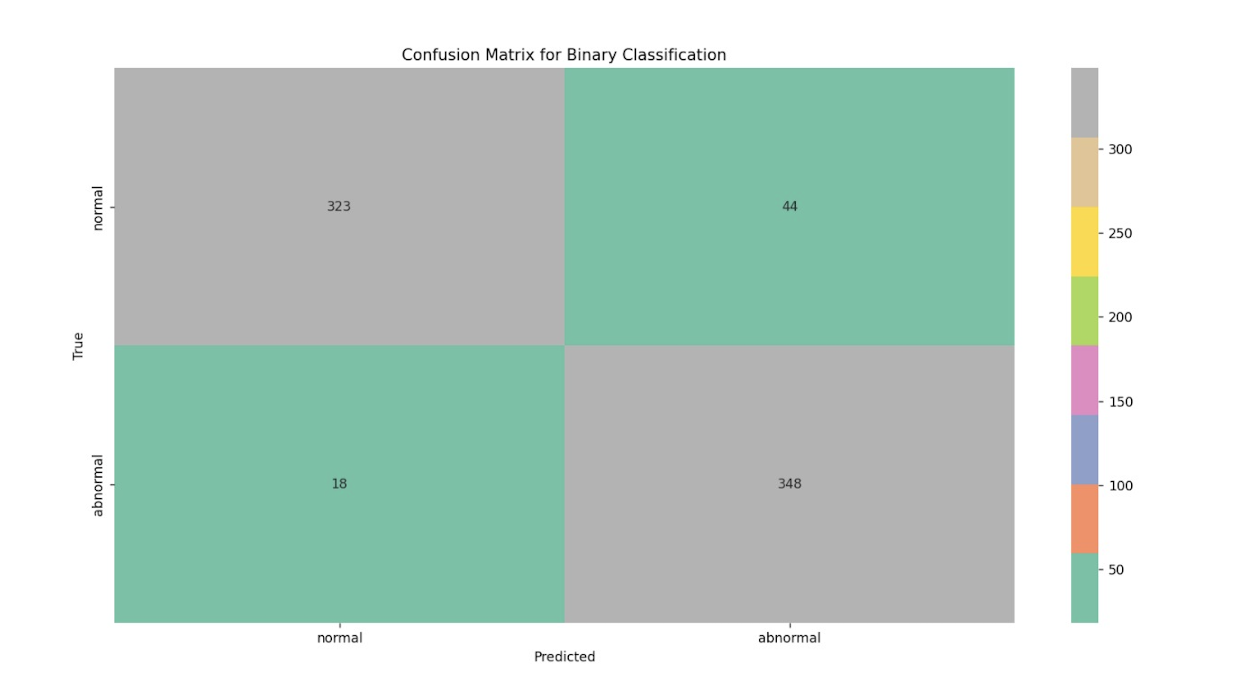
Confusion Matrix for Binary Classification

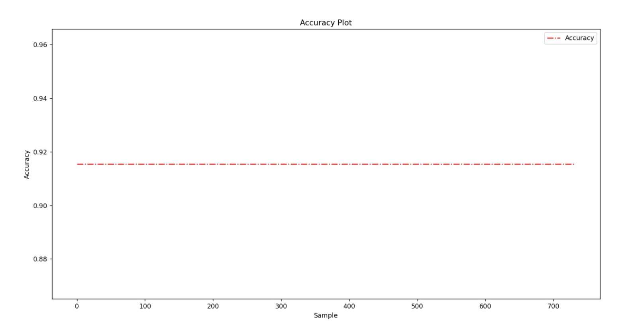
Accuracy Plot

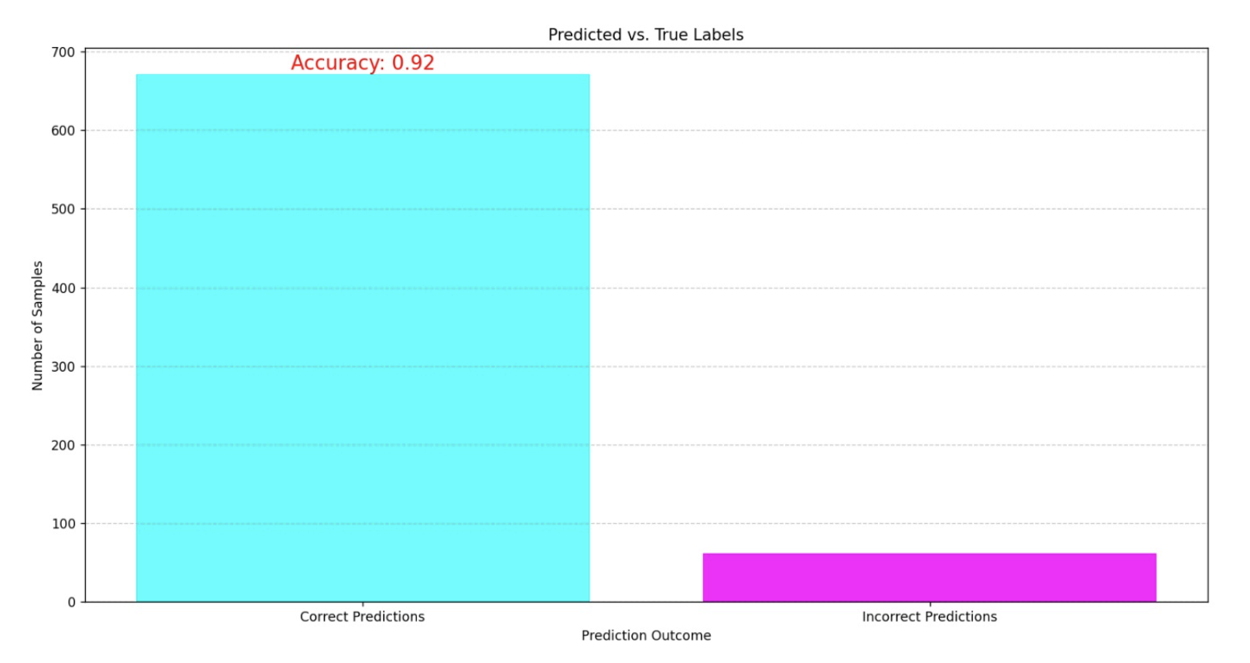
Predicted vs True Labels

In the process of fine-tuning our feature extraction using Histogram of Oriented Gradients (HOG), we encountered a dynamic situation where altering the parameters yielded varying accuracy values. This phenomenon highlights the sensitivity of our model to the specific settings of HOG, underscoring the crucial role of these parameters in shaping the performance of our classification model. As we explored different configurations, it became evident that subtle adjustments to these parameters could significantly impact the accuracy of our model, resulting in a spectrum of outcomes. To provide a comprehensive overview of these variations, we have compiled a table showcasing the different parameter settings and the corresponding accuracy values, offering valuable insights into the optimization of our feature extraction process.

Here's a sample table to display different parameter settings and their respective accuracy values:

Parameter  Configuration | Accuracy  Value
128 | 0.89904502
90 | 0.89085948
64 | 0.89904502
55 | 0.89631650
32 | 0.91761560
16 | 0.91541609

Following a comprehensive exploration of various parameter configurations for feature extraction using Histogram of Oriented Gradients (HOG), the parameter configuration of 32 stands out as the optimal choice. Notably, it consistently yielded the highest accuracy value among the tested settings, as demonstrated in the provided table. The remarkable accuracy achieved by this configuration underscores its capability to effectively capture essential features within our retinal images. Thus, 32 has been selected as the preferred setting for our HOG feature extraction process
- Conclusions

Our research culminates with the resounding success of our classification model, achieving an impressive accuracy rate of 92%. This exceptional level of accuracy underscores the robustness and reliability of our Support Vector Machine (SVM) approach in the classification of diabetic retinopathy (DR) lesions. The high accuracy not only confirms the effectiveness of our model but also holds significant promise for the early and accurate diagnosis of DR. The potential impact of this research on patient care and clinical practice cannot be understated, as it paves the way for more precise interventions, ultimately improving patient outcomes. This remarkable achievement marks a milestone in the ongoing pursuit of advancements in the field of DR analysis and sets a high standard for future research endeavours.

- FUTUREWORK

Improve the preprocessing techniques and reduce the need for large datasets.
Explore more advanced deep learning architectures, such as convolutional neural networks (CNNs) and recurrent neural networks (RNNs), to enhance the accuracy and efficiency of diabetic retinopathy detection from retinal images.
Develop AI models with great transparency, enabling clinicians to understand and trust the decision-making process of these algorithms.

Developing systems for real-time analysis of retinal images and designing mobile applications that empower patients to capture retinal images using smartphone cameras and receive immediate feedback represent significant strides in the field. Neural networks emerge as a promising frontier in this context, poised to be the primary focus of future research efforts. Neural networks exhibit the capability to perform accurate classification tasks and, furthermore, facilitate multiclassification, particularly when detailed categorization of diabetic retinopathy types is imperative. Early detection is pivotal, potentially enabling the reversal or, at the very least, the arrest of diabetic retinopathy's progression in its nascent stages. This, in turn, can mitigate the need for advanced treatments in severe cases, underscoring the transformative potential of these advancements.

Acknowledgement

We thank Manipal Institute of Technology and our Professor, Dr. Siddhalinga Swamy P C for his guidance and support in the making of this project. His extensive knowledge of the subject and insightful suggestions were invaluable in the completion of this paper.

Furthermore, we would like to extend our heartfelt appreciation to the authors of the research papers referenced in this study. Their dedication and contributions to the respective fields provided us with substantial insights and served as valuable resources for our own research.
We acknowledge the authors' tremendous efforts in conducting the original studies, their diligent analysis, and the publication of their work, which paved the way for our research and the development of this paper. The extensive body of work they have produced has significantly shaped our understanding and contributed to the knowledge base of our research area.

Overall, this research paper would not have been possible without the expertise, commitment, and guidance of our Professor, and the authors of the referenced research papers. We extend our heartfelt thanks to them and convey our deepest appreciation for their contributions, which have played an integral role in shaping the outcome of our study.

DECLARATION OF COMPETING INTEREST

The authors declare no conflict of interest.
References
- Eisma JH, Dulle JE, Fort PE. Current knowledge on diabetic retinopathy from human donor tissues. World J Diabetes. 2015 Mar 15;6(2):312-20.
- Kharroubi, A.T.; Darwish, H.M. Diabetes mellitus: The epidemic of the century. World J. Diabetes 2015, 6, 850S. Zhang, C. Zhu, J. K. O. Sin, and P. K. T. Mok, “A novel ultrathin elevated channel low-temperature poly-Si TFT,” IEEE Electron Device Lett., vol. 20, pp. 569–571, Nov. 1999.
- (2020) Prevention and screening for DR. Available at https:// www.idf.org/aboutdiabetes/prevention.html
- I.D.F.D. Atlas; Brussels, belgium: international diabetes federation Int. Diabet. Federat. (IDF) (2017)
- ICO, 2017, Bourne, Stevens, White, Smith, Flaxman, Price, Jonas, Keeffe, Leasher, Naidoo, et al., 2013
- D.S.W. Ting, G.C.M. Cheung, T.Y. Wong; Diabetic retinopathy: global prevalence, major risk factors, screening practices and public health challenges: a review; Clin. Exper. Ophthalmol., 44 (4) (2016), pp. 260-277
- Diabetic retinopathy detection through deep learning techniques: A review; Wejdan L. Alyoubi, Wafaa M. Shalash, Maysoon F Abulkhair (2020)
- Diabetic Retinopathy Image Classification Using Support Vector Machine; Manoj Kumar Behera, S.Chakravarty (2020)
- Diabetic Retinopathy Grading Using Attention based Convolution Neural Network; Zhixiang Qian, Chenjian Wu, Hong Chen, Minxin Chen (2021)
- Detection of Diabetic Retinopathy in Retinal Fundus Images Using CNN Classification Models; Al-Omaisi Asia, Cheng-Zhang Zhu, Sara A. Althubiti , Dalal Al-Alimi , Ya-Long Xiao, Ping-Bo Ouyang, Mohammed A. A. Al-Qanes (2022)
- Deep learning architecture based on segmented fundus image features for classification of Diabetic Retinopathy; Sraddha Das, Krity Kharbanda, Suchetha M, Rajiv Raman, Edwin Dhas D (2021)
- Automated grading of diabetic retinopathy using CNN with hierarchical clustering of image patches by siamese network; V.Deepa, C.Satish Kumar, Thomas Cherian (2022)
- Diabetic Retinopathy 224x224 (2019 Data); https://www.kaggle.com/datasets/sovitrath/diabetic-retinopathy-224x224-2019-data?select=colored_images

CONTRIBUITIONS

Yatin Saluja-210962073: Coding and Future Work

- Played dual roles in the project, with the primary responsibility of data collection and management.
- Conducted extensive research to search for relevant information and meticulously organized and verified data accuracy to ensure its usefulness for the project.
- Dedication to data collection efforts saved valuable time and provided a strong foundational dataset for the research.
- The data collection phase aligned with project requirements, ensuring the presence of relevant and reliable information.
- Also undertook coding responsibilities, aligning coding tasks with project objectives, which included the creation of tools for data preparation and models for data analysis.
- Invested significant effort and time in coding activities to develop software and models capable of extracting valuable insights from the data.

Eeshan Upadhyaya-210962089: Report and Test running Codes

- Played a pivotal role in shaping the entire research report, synthesizing research, findings, and methodologies into a cohesive document.
- Meticulously structured the report to ensure clarity and coherence in presenting the research.
- Took responsibility for conducting extensive testing and validation runs on project programs, serving as a quality assurance phase to confirm tool and model robustness and reliability.
- Ensured the accuracy of results and verified the feasibility and effectiveness of the approach through the testing process.
- Collaborated actively with the teammate in fine-tuning the models to align with research objectives.
- Contributed significantly to bridging the critical gap between the research phase and the delivery of a comprehensive and well-validated report.

Priyasu Karak-210962132: Literature Review and PowerPoint presentation

- Conducted extensive research on diverse deep learning methods applied to diabetic retinopathy detection, systematically gathering recent publications.
- Performed a comprehensive literature review by assimilating current research findings.
- Created a well-structured PowerPoint presentation that synthesized relevant literature and research findings.
- The contributions encompassed the synthesis of recent research and literature, resulting in the development of a comprehensive and informative project presentation.

