2D Game
Steps I took: set up my main tab (dontcrash), set size of screen. Added the void setup, void draw, void keyPressed. I added the background image using PImage. Made a new class for the astronaut which remains central, added the image using PImage, and adjusted the size to what was appropriate. Then I made a new class for the rockets (objects). I used imageMode(CORNER) to draw the star background image from axis (0,0)
Code snippets: The comments next to my code in the images describe/show my understanding of the code I wrote (code screen shots of key features). I annotated my code with these comments for this development report.
Bg image & astronaut displayed using pImage. The main tab has the void setup, void draw and void keypressed as well as the background pimage line of code.
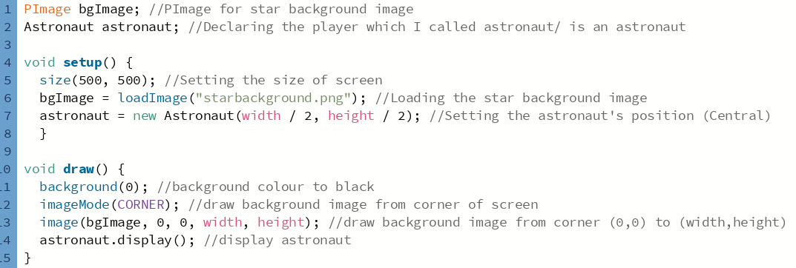
astronautClass tab shown below, int x, y are variables that store the x and y values which in this case is the astronauts positioning on the screen (central).
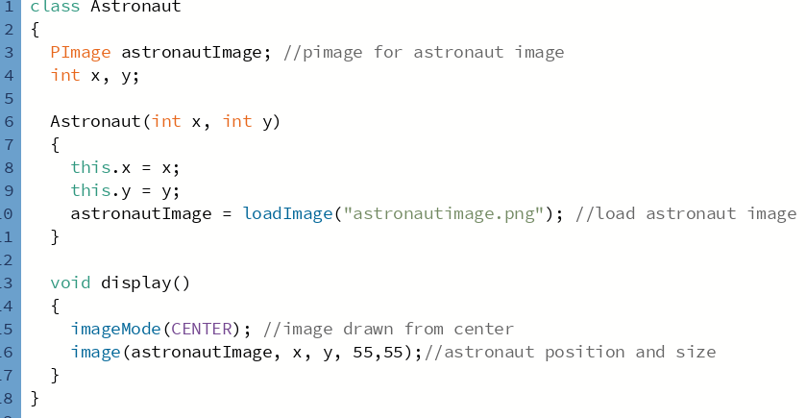
Made rocket class tab:
rocketClass tab shown below, int x, y are variables that store the x and y values and the int speedX and speedY store the speed in the x and y direction.
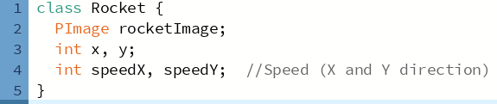
The if statement makes sure that if the speed of a rocket ever becomes zero then it gets changed to one, to keep it moving.
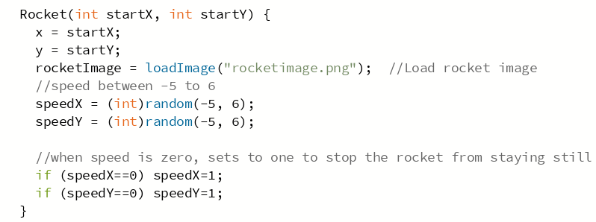
gameOver screen so when the collision takes place the screen pops up, with the text shown below (line 27):
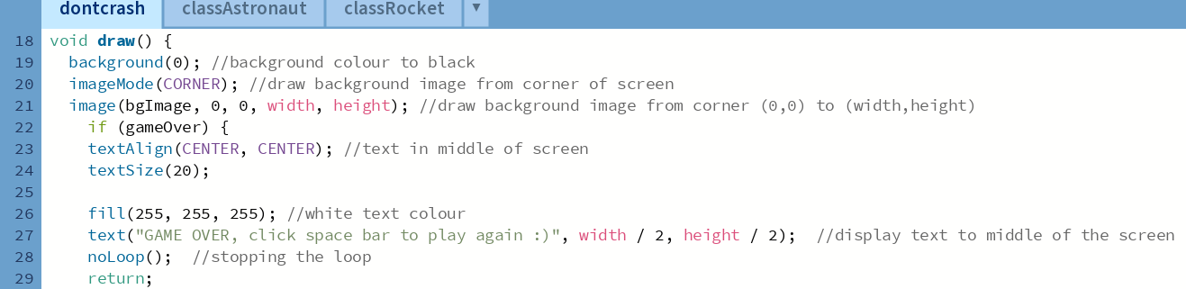
Boolean, so when rocket touches the astronaut then the gameOver is true hence screen pops up and the gaveOver is then true due to the collsion:
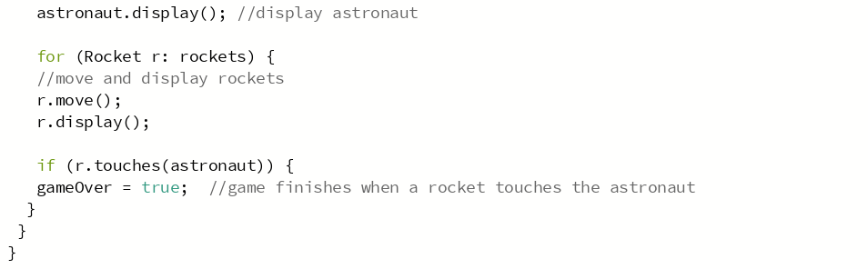
gameOver screen:
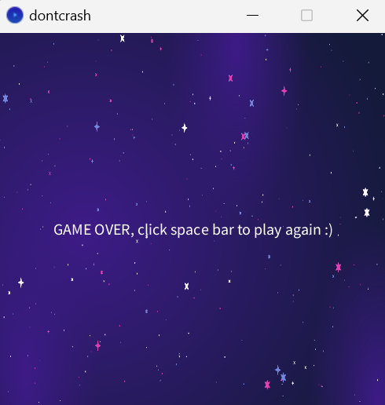
I added this piece of code because it detects when the astronaut and rocket ‘touch’/ ‘collide’ when d<20, this is In the classRocket tab:
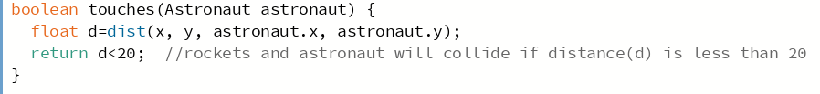
This part of my code resets the game after a collision so that the player can play again, the gameOver is now false:
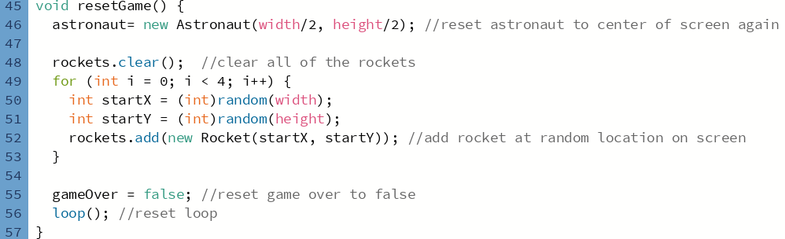
Void Keypressed feature, this is so that when the player clicks a key (in my game the keys are left, right, up, down and space bar) the rocket will move, and if spacebar is clicked then game will reset hence resetGame().’ Int dx=0, int dy=0;’ The rockets.get(i) gets each rocket from the list one after the other in the loop.

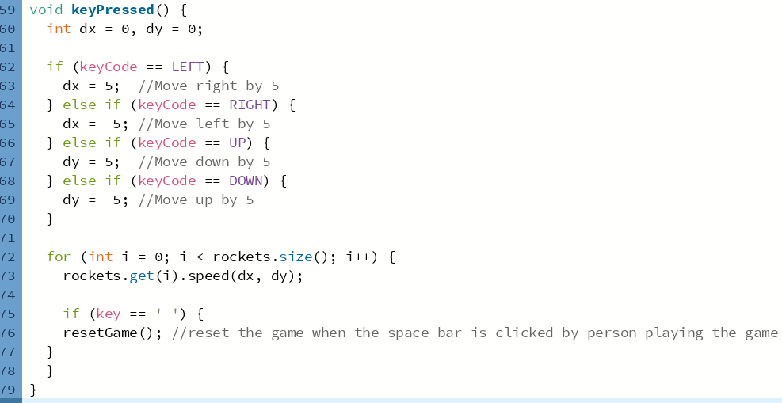

My game in action:
