CA-3 Vision-Based Application Task
Geometric Consistency Analysis for Detection of Synthetic Imagery
Vanishing-Point and Shadow-Based Cues Across Generator Generations

Course: Computer Vision | Assessment: CA-3 Project Report
Team members: <Name, PRN> | <Name, PRN> | <Name, PRN>
Department of <Department>, <Institute>
Academic Year 2026-27

1. Introduction

1.1 Background and Rationale
A photograph is the record of a physical process: light from a three-dimensional scene passes through a single optical centre and is recorded on a planar sensor. That process, the pinhole camera model, imposes constraints that no real photograph can violate. Lines that are parallel in three dimensions converge to a single vanishing point in the image; the three mutually perpendicular directions of a rectilinear building fix the camera's focal length and principal point; every cast shadow in a sunlit scene points away from one light source. These are not statistical regularities but consequences of projective geometry, and they hold for every camera ever built.
Modern text-to-image generators produce images that are photorealistic at the level of texture and colour, yet they possess no camera. A diffusion model learns the appearance statistics of photographs from data; nothing in its architecture represents an optical centre, a focal length or a principal point. Whether the resulting images nevertheless obey projective constraints is therefore an empirical question with a precise answer, and one that can be measured in interpretable physical units rather than in the abstract feature space of a learned classifier.
This project builds an instrument for that measurement. Every image is treated as an implicit claim that a single pinhole camera photographed the scene, and that claim is tested against a hierarchy of projective constraints. Each test returns a residual in degrees or in dimensionless ratios, so a failure is not merely detected but localised to a specific geometric rule.

1.2 Motivation
Three motivations drive the work. First, forensic: as generators improve, pixel-level and frequency-domain detectors degrade, whereas a geometric violation remains a violation regardless of how convincing the texture is. Second, scientific: the pattern of which constraints a generator satisfies and which it breaks is a probe of what the model has internalised about three-dimensional structure. Third, applied: monocular visual servoing, autonomous navigation and structure-from-motion all assume projective consistency, so synthetic imagery used to train or benchmark robot perception must be geometrically sound, and measuring that soundness is a prerequisite for using such data safely.

1.3 Recent Trends
Sarkar et al. (CVPR 2024) established that generated images violate projective geometry strongly enough for classifiers operating on geometric features alone, never on pixels, to distinguish them from photographs. Subsequent work has moved in two directions. On the generation side, systems that enforce consistent vanishing points during synthesis confirm that the community regards perspective inconsistency as a known weakness. On the analysis side, multi-view work reports that diffusion models violate epipolar constraints across generated viewpoints. In parallel, probing studies show that generative models encode depth, normals and intrinsic images locally, which sits in tension with the forensic finding of global geometric failure. Informal commentary in 2026 has begun to claim that the geometric tell has disappeared in current models; that claim is untested in the peer-reviewed literature and is precisely the kind of question this project is built to answer.

1.4 Significance of the Study
The contribution of this work is not another detector. It is a measurement methodology and a set of calibrated findings. Three aspects are significant. The residuals are interpretable, so a result states which constraint failed and by how many degrees. The comparison is calibrated against real photographs, including both a hand-curated dataset and an uncurated internet corpus, which turns out to be decisive: several apparently strong results reverse depending on which real reference is used. And the study defines an applicability criterion that decides, independently of the measurement itself, whether a given image can support the test at all, which prevents the systematic error that dominates naive applications of these constraints.

2. Review of Relevant Literature

2.1 Previous Research Work
Classical single-view geometry. Criminisi, Reid and Zisserman [7] established single-view metrology, recovering metric scene structure from vanishing points and the image of the absolute conic. Coughlan and Yuille [8] introduced the Manhattan-world assumption, that urban scenes are dominated by three mutually orthogonal directions. Hoiem, Efros and Hebert [9] linked horizon estimation to object scale. Denis, Elder and Estrada [10] published the York Urban Database, 102 calibrated images with hand-labelled line segments and ground-truth Manhattan vanishing points, which remains the standard benchmark for vanishing-point estimation. Grompone von Gioi et al. [11] contributed the Line Segment Detector, a parameterless sub-pixel line detector with false-detection control, which is the front end used throughout this project.
Image forensics from geometry. Kee, O'Brien and Farid [3] formulated cast-shadow consistency as a linear programming feasibility problem: each shadow-to-object correspondence, with its annotation uncertainty, constrains the image of the light source to a wedge, and a physically consistent scene requires all wedges to intersect. Farid [4, 5] applied vanishing-point, shadow and reflection analysis to early text-to-image outputs, establishing the approach but on small, manually analysed samples.
Learned geometric detection. Sarkar et al. [1] curated generated images that defeat pixel-based detectors, then trained classifiers on three derived geometric representations, namely line segments, perspective fields and object-shadow relations. Reported AUCs on the hardest subset were approximately 0.88 to 0.94 for lines, 0.86 to 0.92 for perspective fields and 0.77 to 0.79 for shadow cues.
Geometric awareness of generative models. Du et al. [12], Chen et al. [13] and El Banani et al. [14] show that intrinsic images, depth and surface normals can be linearly decoded from generative and foundation-model activations, indicating that geometry is represented locally. Jin et al. [15] and Veicht et al. [16] provide learned single-image calibration through perspective fields and geometric optimisation.

2.2 Key Findings from the Literature
- Generated images do violate projective geometry, strongly enough to support classification from geometric features alone (Sarkar et al., AUC 0.88-0.94 for line-based features).
- Cast-shadow consistency admits an exact, uncertainty-aware formulation as a linear program, avoiding arbitrary thresholds (Kee, O'Brien and Farid).
- Generative models encode local three-dimensional structure such as depth and normals, which can be recovered by linear probes.
- Perspective inconsistency is regarded as a known generation-side defect, to the point that methods now exist to constrain vanishing points during synthesis.

2.3 Research Gaps
Four gaps are identified; this project addresses the first three.
- Learned classifiers on geometric features report that a violation exists, but not which projective constraint failed, nor by how much. No published benchmark decomposes geometric failure constraint by constraint with calibrated statistical tests.
- Existing studies compare generated images against a single, usually hand-curated, real dataset. The dependence of the conclusion on the choice of real reference has not been examined, and this work finds that dependence to be decisive.
- The distinction between local and global geometric consistency has been stated informally but never quantified. In particular, no study separates whether a generator fails at scene orientation or at camera intrinsics.
- The applicability of the three-vanishing-point camera test to uncurated imagery has not been treated. Scenes that are not Manhattan worlds produce large residuals that carry no information about the camera.

3. Problem Statement and Objectives

3.1 Research Questions
- Do images produced by current diffusion models satisfy the projective constraints that a single pinhole camera imposes, when compared against real photographs under matched scene content and matched camera configuration?
- If violations exist, which constraint fails: the orthogonality of the scene's dominant directions, or the consistency of the implied camera intrinsics across the image?
- Does the violation diminish as generator capability increases, as would be expected if scale alone were sufficient to acquire an implicit camera model?
- Are explicit, interpretable geometric residuals competitive with learned classifiers on geometric features for the detection task?

3.2 Problem Statement
Given a single image, determine whether its geometric content is consistent with formation by one pinhole camera; express any inconsistency as an interpretable residual attributable to a specific projective constraint; calibrate that residual against the distribution obtained from real photographs under the same measurement pipeline; and use the resulting profile to compare generative models.

3.3 Objectives
- O1: Implement and validate a measurement pipeline for line-based projective constraints, specifically vanishing-point concurrency and single-camera coherence, with ground-truth validation.
- O2: Establish real-image null distributions for every residual, using both a curated benchmark and an uncurated internet corpus with diverse cameras.
- O3: Construct content-matched generated image sets from multiple diffusion models with fully logged generation parameters.
- O4: Define an applicability criterion, independent of the residual being measured, that determines whether an image can support the camera test, and validate it against ground truth.
- O5: Compare generators against real references under matched content and camera configuration, and evaluate standard classification algorithms on the resulting residual vectors.
- O6: Implement the shadow-consistency constraint as a linear program and validate it on synthetic scenes with a known light source.

3.4 Scope and Limitations
Scope. Single-image analysis only. Two line-based constraint levels are implemented and validated in full, namely vanishing-point concurrency and camera coherence, together with a regional camera-consistency analysis and the shadow constraint at the geometry level. Two locally generated models are evaluated, Stable Diffusion 1.5 and SDXL, against two real references.
Limitations. Closed frontier models such as Gemini and GPT-image are not yet included, as no API access was available; the prompt set and analysis are prepared so that such images can be added without modification. Multi-view constraints such as epipolar consistency do not apply to single images and are excluded by design. The shadow constraint is validated geometrically but is not yet deployed at scale, because automatic shadow-to-object association remains unsolved in this implementation. Constraint levels covering projective invariants, conics, reflections and cross-modal agreement are specified but not implemented.

4. Methodology

4.1 Overview of Methodology
The pipeline converts an image into a vector of interpretable geometric residuals in five stages: line-segment detection; unconstrained vanishing-point estimation; applicability assessment; residual computation for each constraint level; and statistical comparison against calibrated real-image null distributions. A deliberate design decision runs through the whole system: the vanishing-point estimator is never given a Manhattan or orthogonality prior, because the camera test asks precisely whether the recovered directions are mutually orthogonal, and an estimator that assumed this would make the test vacuous.
[FIGURE TO INSERT] System architecture flowchart. Draw a left-to-right block diagram: Image -> LSD line detection -> sequential RANSAC vanishing-point estimation (no Manhattan prior) -> applicability rule (decision diamond, with a rejected branch) -> residual computation (L2 concurrency, L3 camera coherence, Atlanta focal consistency, regional windows, L7 shadows) -> comparison against real-image null distributions -> failure profile.
Figure 4.1: Overall architecture of the geometric-consistency measurement pipeline.

4.2 Objective-wise Methodology
Objective | Method employed | Validation performed
O1 Pipeline implementation | LSD line detection; sequential RANSAC vanishing-point estimation with angular least-squares refinement on the unit sphere; closed-form and least-squares focal recovery | Synthetic scenes with known cameras; York Urban ground-truth vanishing points
O2 Real-image calibration | Full pipeline on York Urban (102 images) and a Wikimedia Commons corpus (358 images, 135 camera models) with EXIF focal lengths | Fitted focal length compared against EXIF-derived focal length
O3 Generated corpora | Local generation with Stable Diffusion 1.5 and SDXL; prompt strata mirroring the real content; seeds, steps, guidance scales and dates logged per image | Line-density and content matching verified statistically
O4 Applicability rule | Support, localisation, separation and spatial-spread criteria computed from evidence only | Agreement with York Urban ground truth; invariance under injected violations
O5 Comparison and classification | Matched-content and matched-field-of-view comparisons; six standard classifiers on residual vectors | Five-fold cross-validation; bootstrap confidence intervals
O6 Shadow constraint | Wedge constraints solved as a linear program minimising the largest violation | Synthetic scenes with a known sun direction and injected shadow rotations

Table 4.1: Mapping of objectives to methods and the validation performed for each.

4.3 Design: The Constraint Hierarchy
Each level of the hierarchy is one rule that a pinhole camera cannot break, paired with a residual in interpretable units. The levels implemented in this work are marked accordingly.
Level | Constraint | Residual | Status
L1 | Straight 3D edges project to straight image lines | Curvature (px) | Not implemented
L2 | 3D-parallel lines meet at a single vanishing point | Angular deviation (deg) | Implemented, validated
L3 | Three orthogonal directions fix one focal length and principal point | Deviation from 90 deg; focal spread | Implemented, validated
L3b | Every horizontal direction implies the same focal length with the vertical (Atlanta worlds) | Spread of log focal length | Implemented; primary statistic
L4-L6 | Horizon consistency; projective invariants; imaged circular points | Various | Specified, not implemented
L7 | All cast shadows are consistent with one light source | LP violation (px) | Geometry implemented and validated
L8-L9 | Reflection geometry; cross-modal normal agreement | Degrees | Specified, not implemented

Table 4.2: Constraint hierarchy, residual units and implementation status.

4.4 Materials and Methods

4.4.1 Hardware and software
Component | Specification
Compute | NVIDIA GeForce RTX 5060 Laptop GPU, 8 GB VRAM; Windows 11
Language and runtime | Python 3.14
Vision library | OpenCV 4.13 (Line Segment Detector, morphology, connected components)
Numerical and statistical | NumPy, SciPy (least squares, linear programming, statistical tests), scikit-learn, statsmodels, pandas
Generative models | PyTorch 2.14 with CUDA 13.0; diffusers 0.40; Stable Diffusion 1.5 and SDXL-base-1.0 with model CPU offload for the 8 GB budget
Project code | projgeo package: lines, vp, camera, selection, locality, regional, shadows, distortion, prompts, datasets

Table 4.3: Hardware and software environment.

4.4.2 Core algorithms
Line detection. The Line Segment Detector is applied to the greyscale image, followed by a length filter at two per cent of the image diagonal to suppress texture clutter. Standard refinement is used rather than advanced refinement, the latter having been measured to take up to fifty seconds on certain images with no benefit in segment quality.
Vanishing-point estimation. Segments are mapped to normalised coordinates. Vanishing points are found sequentially: pairs of segments are sampled with probability proportional to length, their intersection forms a candidate, and support is measured as the total inlier length within an angular threshold. The best candidate is refined by weighted angular least squares parameterised on the unit sphere, which handles vanishing points at infinity without special cases. Inliers are removed and the process repeats.
Camera coherence. With the principal point placed at the image centre, the focal length that best makes the back-projected vanishing-point rays mutually orthogonal is found by bounded one-dimensional optimisation, and the residual is the largest pairwise deviation from ninety degrees. For three finite vanishing points the principal point of a consistent camera must lie at the orthocentre of the vanishing-point triangle, and each pair yields a closed-form focal estimate; a negative value indicates a configuration no camera can produce.
Atlanta focal consistency. The vertical vanishing point is identified by its direction from the image centre alone, never by orthogonality. Each horizontal vanishing point must then imply the same focal length with it. This holds in Manhattan worlds and in Atlanta worlds, which contain several horizontal frames, and is therefore valid on uncurated photographs where the three-vanishing-point orthogonality test is not.
Uncertainty quantification. Each vanishing point's inlier set is resampled with replacement and re-refined, giving a bootstrap angular standard deviation in ray space. This distinguishes vanishing points that are genuinely well determined from those that slide along a family of nearly parallel lines.

4.4.3 The applicability rule
The three-vanishing-point camera test is defined only for scenes that actually exhibit three visible, well-separated, well-supported directions. An image is admitted if three vanishing-point families each carry at least eight per cent of the total detected line length, each is localised to better than one degree by the bootstrap, each pair is separated by at least ten degrees and by at least five times its own uncertainty, and each family's inliers span at least twelve per cent of the image diagonal. Real photographs additionally require a standard sensor aspect ratio, since cropping displaces the principal point. Orthogonality, focal length, the orthocentre and the shape of the vanishing-point triangle are deliberately excluded from the rule, because those quantities constitute the measurement.
Two validations confirm that the rule is sound. Against York Urban ground truth, admitted images have ninety per cent of their vanishing points within five degrees of the hand-labelled values, compared with fifty-seven per cent for rejected images. A unit test injects a controlled camera violation that leaves the line layout unchanged and asserts that the admission decision does not change, which establishes that the rule cannot be selecting real images for being consistent.

4.5 Data Acquisition
Dataset | Size | Role | Provenance and parameters
York Urban | 102 images, 640x480 | Curated real reference; ground-truth vanishing points and calibration | Elder Laboratory, York University; single camera, focal length 675 px
Wikimedia Commons | 358 images, 135 camera models | Uncurated real reference with diverse cameras | Commons API; filtered for EXIF camera model and focal length, landscape aspect, width at least 1024; CC licences with attribution recorded
SD 1.5 sets | 200 + 250 images, 640x480 | Older UNet diffusion baseline | 30 steps, guidance 6.0, seeds and prompts logged per image
SDXL sets | 200 + 250 + 120 + 80 images | Current-generation baseline | 30 steps, guidance 6.0, model CPU offload; 1024x768 plus 1:1 and 16:9 aspect variants
Synthetic scenes | Generated on demand | Ground-truth validation and violation injection | Known intrinsics and rotation; controlled violations of each constraint

Table 4.4: Datasets, their role in the study and acquisition parameters.
Prompt design. Generated content mirrors the real corpora. A first stratum covers building facades, streets, corridors, lecture halls and offices. A second stratum was introduced to guarantee three visible orthogonal directions by describing corners where two surfaces meet, and a third, refined stratum additionally requires repeating line-rich features such as tiled floors, shelving, window grids and brick courses, because the first attempt produced scenes that were structurally correct but too sparse in lines to be measurable. All generated images carry a metadata record with model identifier, prompt, negative prompt, seed, sampler, step count, guidance scale, resolution and generation date.

4.6 Implementation
The system is implemented as a Python package with a test suite of eighteen tests. Validation is layered. Synthetic scenes with known cameras verify that the estimators recover the truth, and controlled violation injectors verify that each residual responds to its own constraint and not to others: one injector perturbs line directions to break concurrency alone, one displaces a vanishing point so that concurrency is preserved but camera coherence is broken, one makes a vanishing point drift with image position, and one splits the image between two different cameras. Residuals are required to increase monotonically with the injected violation magnitude.
One implementation detail proved to matter for correctness. The inlier root-mean-square residual saturates once violations exceed the inlier threshold, because badly violating segments are simply excluded from the inlier set. A length-weighted capped mean over all segments, together with the fraction of line length that no vanishing point explains, was therefore introduced and verified to be monotone across the full range of injected violations.
[FIGURE TO INSERT] Screenshot of the per-image analysis output. Run: python scripts/analyze_image.py <image> --out outputs/ and insert the generated overlay PNG, which shows detected segments coloured by vanishing-point cluster, the vanishing points, and the orthocentre marked against the image centre.
Figure 4.2: Per-image analysis output showing line segments grouped by vanishing point.

5. Results and Discussion

5.1 Validation of the Instrument
Before any comparison between real and generated imagery, the measurement pipeline was validated against known ground truth. On synthetic scenes with known intrinsics, vanishing points are recovered to within 0.3 degrees and focal length to within one per cent. On the York Urban database the unconstrained estimator recovers 81 per cent of ground-truth vanishing points within two degrees and 94 per cent within five degrees, and the median ratio of fitted to true focal length is 1.02 with an interquartile range of 0.99 to 1.05. The camera-coherence machinery therefore recovers the real camera of real photographs, which is the necessary precondition for interpreting any residual measured on generated images.
Validation | Quantity | Result
Synthetic scenes | Vanishing-point direction error | Below 0.3 deg
Synthetic scenes | Focal length error | Below 1 per cent
York Urban | Ground-truth VPs recovered within 2 deg / 5 deg | 81 per cent / 94 per cent
York Urban | Fitted focal / true focal, median [IQR] | 1.02 [0.99, 1.05]
Commons (EXIF) | Fitted focal vs EXIF focal, well-conditioned images | Median ratio +6 per cent; 58 per cent within 20 per cent
Violation injection | Monotonicity of each residual in its own violation | Confirmed for all four injectors

Table 5.1: Validation of the measurement pipeline against ground truth.
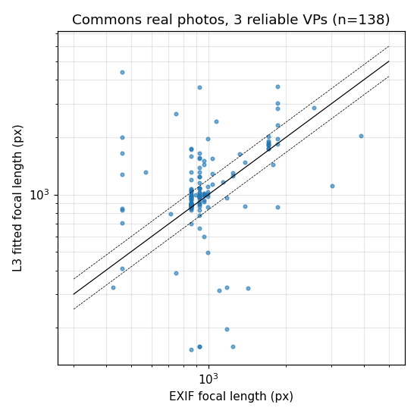
Figure 5.1: Fitted focal length against EXIF-derived focal length for real photographs from 135 different camera models. Dashed lines indicate a twenty per cent band.

5.2 Real-Image Null Distributions
Residual distributions were established on both real references. On York Urban the concurrency residual has a median of 1.31 degrees and a ninety-fifth percentile of 2.46 degrees; the camera-coherence residual has a median of 0.69 degrees. These values are not zero, and treating them as zero would be the single most common error in applying such tests. Two sources were identified and quantified: radial lens distortion, for which a per-image single-coefficient fit recovers a median value consistent with a dataset-wide fit, and the fact that real scenes are only approximately Manhattan.
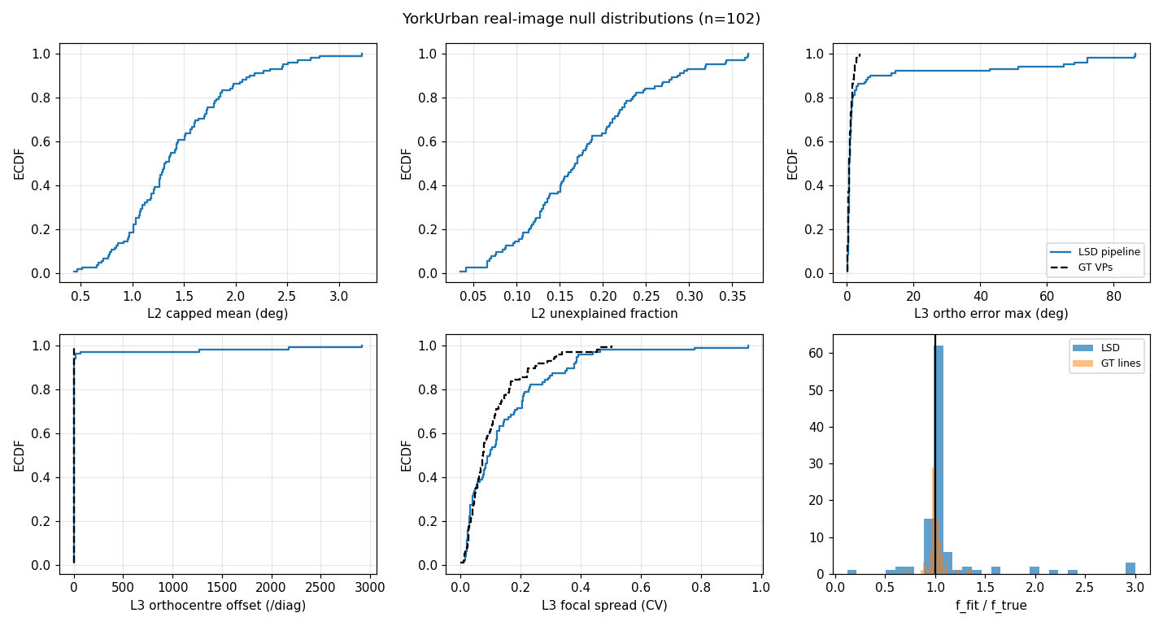
Figure 5.2: Empirical cumulative distributions of each residual on the curated real reference, with the estimator-only floor shown for comparison.

5.3 The Decisive Role of the Real Reference
The second real corpus, drawn from Wikimedia Commons with diverse cameras, produced the most consequential methodological finding of the study. Measured without an applicability criterion, uncurated real photographs score a median camera-coherence residual of 12.2 degrees, which is worse than Stable Diffusion 1.5 and far worse than SDXL. Taken at face value this would imply that generated images are more camera-consistent than photographs, which is not credible.
Inspection of the failing photographs explains the result. They are curved streets, adjacent building facades at oblique angles and near-frontal views: scenes that contain three well-supported, well-localised, clearly distinct vanishing-point families that are simply not mutually orthogonal. These are Atlanta worlds rather than Manhattan worlds, and the three-vanishing-point orthogonality test is not defined for them. The failure is one of applicability, not of photographic geometry, and no evidence-based filtering removes it: raising the support threshold makes the residual worse, and ninety-eight per cent of the affected images already have standard aspect ratios, which excludes cropping as the mechanism.
[FIGURE TO INSERT] Montage of selected uncurated real photographs spanning the residual range, available at results/commons_selected_montage.png. It shows that low and mid-range images are genuine three-direction scenes while the extreme tail consists of angled streets and near-frontal facades. Note: these are CC-licensed photographs; reproduce the author and licence from data/real/commons/metadata.jsonl if the montage is included.
Figure 5.3: Real photographs spanning the residual range, illustrating that the high-residual tail consists of non-Manhattan scenes.
Two corrections follow, and both are adopted in the results below. First, images are admitted only through the applicability rule of Section 4.4.3. Applying it reduces the uncurated real median from 12.2 degrees to 2.19 degrees. Second, the primary statistic is changed from three-vanishing-point orthogonality to Atlanta focal consistency, which is valid in both Manhattan and Atlanta worlds.

5.4 Primary Result: Camera Coherence
The primary comparison uses the Atlanta focal-consistency residual on images admitted by the applicability rule. The statistic is the spread of the logarithm of the focal length implied by each horizontal direction together with the vertical direction. A value of zero means every part of the scene agrees on how zoomed-in the camera is.
Quantity | York Urban (real) | Commons (real) | SD 1.5 | SDXL | Gemini | GPT-image
Images admitted by the rule | 72 | 121 | 92 | 112 | — | —
With at least two horizontal families | 72 | 120 | 87 | 109 | — | —
Log-focal spread, median [95% CI] | 0.142 [0.106, 0.221] | 0.152 [0.093, 0.220] | 0.465 [0.324, 0.709] | 0.355 [0.272, 0.529] | pending | pending
Images with an impossible pair | 28% [19, 39] | 44% [36, 53] | 68% [57, 77] | 58% [48, 66] | pending | pending
Manhattan orthogonality (secondary) | 0.65 deg | 2.82 deg | 2.93 deg | 1.94 deg | pending | pending

Table 5.2: Atlanta focal consistency on admitted images. Intervals are bootstrap intervals for medians and Wilson intervals for proportions. The two right-hand columns are reserved for closed frontier models (Section 5.4.1).

5.4.1 Reserved: frontier closed models
[FIGURE TO INSERT] Results for Gemini and GPT-image. These columns are reserved, not omitted: the same 200 prompts used for the local models are exported to data/generated/prompts.txt, so the images are content-matched by construction. Procedure: save the generated images as 0000.png, 0001.png ... (keeping the prompt index) into data/generated/gemini/ and data/generated/gptimage/, record the model version and date in a README.txt in each folder, then run python scripts/atlanta_compare.py --real data/real/commons --gen data/generated/sdxl_rich data/generated/sd15_rich data/generated/gemini data/generated/gptimage and copy the resulting medians and intervals into Table 5.2. Thirty to fifty images per model is sufficient for the median and its interval.
This is the single highest-value extension of the study. Stable Diffusion 1.5 and SDXL differ by roughly two years of model development, and the orientation residual improves across that gap while camera coherence does not. Whether a current frontier model has closed the camera-coherence gap is therefore the direct test of the claim, made informally in 2026 commentary, that the geometric tell has disappeared. The measurement pipeline is model-agnostic and requires no modification to accept these images.
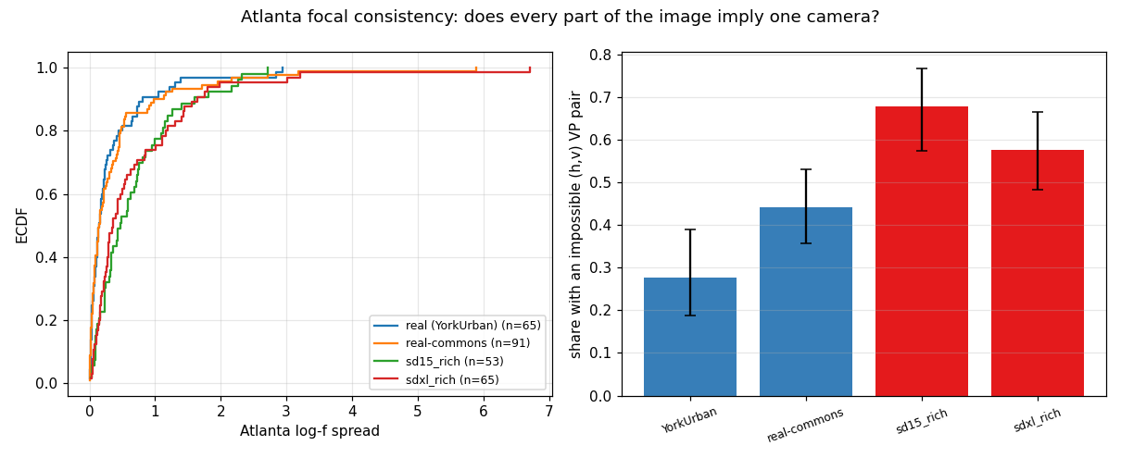
Figure 5.4: Distribution of the log-focal spread (left) and the share of images containing a vanishing-point pair for which no camera exists (right).
The two real references agree with one another to within their confidence intervals, at 0.142 and 0.152, while both generated sets lie clearly above them with non-overlapping intervals, at 0.355 and 0.465. Mann-Whitney tests give p of approximately three by ten to the minus five against either real reference. Expressed plainly: in a real photograph the horizontal directions agree on a single focal length to within about fifteen per cent, whereas in generated images they disagree by thirty-five to sixty per cent. The result holds against a hand-curated benchmark and against uncurated internet photographs alike, which is what makes it defensible.

5.5 Comparative Analysis Across Generators
Stable Diffusion 1.5 and SDXL were compared on identical prompts with matched field-of-view distributions and matched line density, using 250 generated images per model. The comparison separates two capabilities that are often conflated.
Measure | SD 1.5 | SDXL | p | Interpretation
Manhattan orthogonality | 2.93 deg | 1.94 deg | 0.0002 | Improves with model capability
Atlanta log-focal spread | 0.465 | 0.355 | 0.55 (n.s.) | Unchanged
Images with an impossible pair | 68% | 58% | 0.18 (n.s.) | Unchanged

Table 5.3: Scaling comparison on identical prompts, 87 and 109 usable images respectively. A frontier model added to this comparison would extend the capability axis by a further generation; see Section 5.4.1.
Scaling from Stable Diffusion 1.5 to SDXL improves the consistency of scene orientation significantly, while camera coherence is statistically unchanged and remains roughly two and a half to three times worse than either real reference. The honest reading is that orientation improves with model capability whereas camera coherence does not, which implies that scale alone is not on course to remove the deficit.

5.6 Where the Inconsistency Lives
Two further analyses locate the failure spatially. A regional analysis fits an independent camera inside each cell of an overlapping three-by-three grid and measures how much the cells disagree, reporting a consistency radius defined as the smallest deviation such that one global camera lies within that distance of every local camera. Generated images show substantially larger disagreement in implied focal length between regions than real photographs, and the gap widens as the analysis window grows, whereas real photographs converge towards a single camera at large windows.
A complementary analysis tests whether the inconsistency takes the form of a smooth spatial drift within a single family of parallel lines, using the spatial correlation of signed angular residuals. This statistic is indistinguishable between real and generated images for every set tested. The inconsistency is therefore not a gradual warping of the image; it is disagreement between distinct structures and regions.
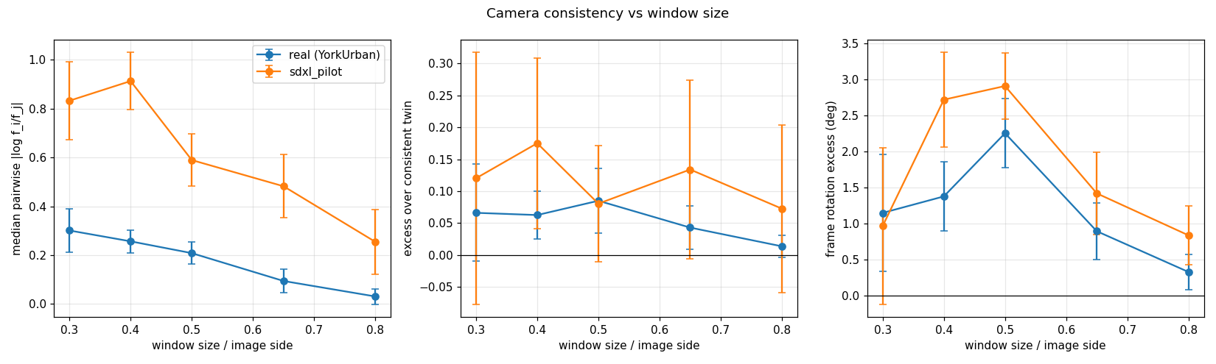
Figure 5.5: Disagreement in implied focal length between image regions as a function of window size, for real and generated images.

5.7 Classification from Geometric Residuals
To place the work beside the learned-classifier literature, six standard classification algorithms were trained on the per-image residual vector alone, never on pixels, and evaluated by five-fold stratified cross-validation. Feature groups were ablated so that camera-configuration and content descriptors could be excluded from the geometry-only condition.
Task | Best AUC, geometry only | Classifier
Curated real versus SDXL | 0.916 | Support vector machine
Curated real versus SD 1.5 | 0.916 | Support vector machine
Uncurated real versus SDXL | 0.824 | Random forest
All real versus all generated | 0.835 | Random forest
Field-of-view matched | 0.810 | Random forest

Table 5.4: Detection performance from interpretable geometric residuals, five-fold cross-validated.
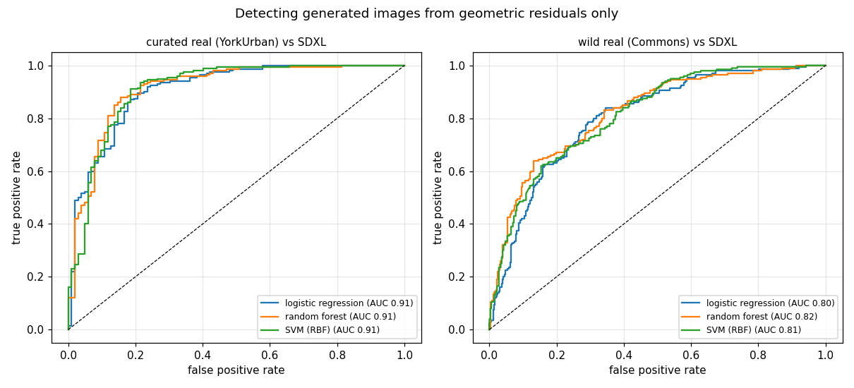
Figure 5.6: Receiver operating characteristic curves for detection from geometric residuals alone.
For reference, Sarkar et al. report approximately 0.88 to 0.94 AUC for a learned line-based classifier on their hardest subset. Explicit, unit-bearing residuals therefore reach a comparable band against a curated reference and retain 0.81 to 0.82 in the two most demanding conditions, namely uncurated real photographs and matched field of view. The purpose of this comparison is not to win on AUC but to show that interpretability is obtained at little cost in discriminative power.

5.8 Shadow Consistency
The shadow constraint was implemented following the wedge formulation. A shadow point together with the object region that may have cast it defines a wedge of admissible light positions, expressed as two half-planes, and a physically consistent scene requires all wedges to intersect. The problem is solved as a linear program that minimises the largest half-plane violation, so the output is a violation in pixels rather than a binary verdict. On synthetic scenes with a known sun the image of the light source is recovered exactly, the violation grows monotonically with injected shadow rotation, and wider annotation uncertainty is strictly more permissive, which is the property that makes the test safe to apply to hand-annotated data.
Shadow detection itself is implemented with the classical sequence of a grey-value transformation that exploits the fact that shadows are both darker and bluer, Otsu thresholding, morphological closing and opening with structuring elements scaled to the image diagonal, and connected-component analysis with an area filter.
[FIGURE TO INSERT] Shadow detection example, available at results/example_shadow_mask_works.png. Show the original sunlit image beside the detected shadow mask overlaid in colour.
Figure 5.7: Shadow detection by grey-value transformation, thresholding and morphology on a sunlit scene.
An attempt to avoid manual annotation, by testing whether the major axes of shadow regions converge at the sun's azimuth vanishing point, was evaluated and rejected. The real-photograph null for this statistic is fourteen degrees, and Stable Diffusion 1.5 scores better than real photographs, which shows that the statistic measures the detector rather than the light. Inspection confirms that the mask responds to dark glass, signage and shaded interiors as readily as to cast shadows. The shadow constraint therefore requires genuine shadow-to-object association, by instance shadow detection or manual annotation, before it can contribute to the comparison.

5.9 Interpretation of Results
Four independent lines of evidence converge on the same conclusion. The Atlanta focal-consistency comparison, the regional camera analysis, the classifier feature importances and the behaviour of the residuals under changes of scene structure all indicate that the deficit of current generators is specifically a failure to commit to one focal length and one principal point across an image, rather than a failure to represent the orientation structure of the scene.
This is a narrower and more precise claim than a naive comparison would support, and it is the claim that survives control of scene content, camera configuration and choice of real reference. It is also mechanistically plausible: the orientation of a dominant direction can be inferred from local evidence anywhere in the image, whereas the focal length depends on the separation between vanishing points and therefore requires the whole image to be integrated into one representation.

5.10 Significance of Findings
- A measurement methodology that reports which projective constraint failed and by how much, rather than a single opaque score.
- Evidence that the choice of real reference can reverse the direction of a published-style comparison, which is a methodological warning for the field.
- An applicability criterion with an explicit non-circularity guarantee, validated against ground truth, that makes the camera test usable on uncurated imagery.
- A powered, replicated result that generated images fail camera coherence by a factor of two and a half to three relative to real photographs, while matching them on scene orientation.
- Evidence that increasing model capability improves orientation but not camera coherence, indicating that scale alone will not close the gap.

5.11 Limitations
Frontier closed models are not yet evaluated, so the conclusions apply to locally reproducible open models; Table 5.2 reserves columns for them and Section 5.4.1 gives the procedure. The shadow constraint is not deployed at scale. Generated images are analysed after downsampling to the resolution of the curated real reference, and the effect of resampling on line detection has not been isolated, although the comparison against the uncurated corpus is resampling-matched and gives the same conclusion. Several constraint levels remain unimplemented.
Two claims made during the study were withdrawn after further testing, and are recorded here because the methodological lesson is part of the contribution. A statement that real photographs never contain an impossible vanishing-point pair was based on reading a median fraction rather than a proportion of images; the correct figures form a gradient rather than a categorical difference. A statement that camera coherence degrades with model scale was based on a focal-spread statistic computed over all vanishing-point pairs, including pairs that are not orthogonal, for which the focal formula is undefined; with a statistic restricted to pairs that are orthogonal by construction, and with four times the sample size, the difference disappears. The general rule adopted is that any focal-length statistic must be built only from vanishing-point pairs whose orthogonality is guaranteed by construction.

5.12 Summary of Results
Finding | Evidence
The instrument recovers real cameras | Focal length within 2 per cent on York Urban; vanishing points within 0.3 deg on synthetic scenes
Real-image residuals are not zero and must be calibrated | Concurrency median 1.31 deg; lens distortion and non-Manhattan structure quantified
The choice of real reference can reverse conclusions | Uncurated real photographs score worse than generated images on the orthogonality residual
Generated images fail camera coherence | Log-focal spread 0.355 and 0.465 versus 0.142 and 0.152 for real; p approximately 3e-5
Orientation is matched, intrinsics are not | Orthogonality comparable after control; focal coherence two and a half to three times worse
Scale improves orientation only | SD 1.5 to SDXL: orthogonality p = 0.0002; focal coherence p = 0.55
Interpretable residuals are competitive detectors | AUC 0.92 curated, 0.82 uncurated, versus 0.88 to 0.94 reported for learned geometric features

Table 5.5: Summary of principal results.

6. References
[1] A. Sarkar, H. Mai, A. Mahapatra, S. Lazebnik, D. A. Forsyth and A. Bhattad, “Shadows Don’t Lie and Lines Can’t Bend! Generative Models don’t know Projective Geometry…for now,” in Proc. IEEE/CVF Conf. Computer Vision and Pattern Recognition (CVPR), 2024.
[2] R. Hartley and A. Zisserman, Multiple View Geometry in Computer Vision, 2nd ed. Cambridge, U.K.: Cambridge Univ. Press, 2004.
[3] E. Kee, J. F. O’Brien and H. Farid, “Exposing photo manipulation with inconsistent shadows,” ACM Transactions on Graphics, vol. 32, no. 3, 2013.
[4] H. Farid, “Perspective (in)consistency of paint by text,” arXiv preprint, 2022.
[5] H. Farid, “Lighting (in)consistency of paint by text,” arXiv preprint, 2022.
[6] A. Desolneux, L. Moisan and J.-M. Morel, From Gestalt Theory to Image Analysis: A Probabilistic Approach. New York, NY, USA: Springer, 2008.
[7] A. Criminisi, I. Reid and A. Zisserman, “Single view metrology,” International Journal of Computer Vision, vol. 40, no. 2, pp. 123–148, 2000.
[8] J. M. Coughlan and A. L. Yuille, “Manhattan world: Compass direction from a single image by Bayesian inference,” in Proc. IEEE Int. Conf. Computer Vision (ICCV), 1999.
[9] D. Hoiem, A. A. Efros and M. Hebert, “Putting objects in perspective,” International Journal of Computer Vision, vol. 80, no. 1, pp. 3–15, 2008.
[10] P. Denis, J. H. Elder and F. J. Estrada, “Efficient edge-based methods for estimating Manhattan frames in urban imagery,” in Proc. European Conf. Computer Vision (ECCV), 2008.
[11] R. Grompone von Gioi, J. Jakubowicz, J.-M. Morel and G. Randall, “LSD: A fast line segment detector with a false detection control,” IEEE Trans. Pattern Analysis and Machine Intelligence, vol. 32, no. 4, pp. 722–732, 2010.
[12] X. Du et al., “Generative models: What do they know? Do they know things? Let’s find out!” in Advances in Neural Information Processing Systems (NeurIPS), 2023.
[13] Y. Chen, F. Viégas and M. Wattenberg, “Beyond surface statistics: Scene representations in a latent diffusion model,” arXiv preprint, 2023.
[14] M. El Banani et al., “Probing the 3D awareness of visual foundation models,” in Proc. CVPR, 2024.
[15] L. Jin et al., “Perspective fields for single image camera calibration,” in Proc. CVPR, 2023.
[16] A. Veicht et al., “GeoCalib: Learning single-image calibration with geometric optimization,” in Proc. ECCV, 2024.
[17] J. Lezama, R. Grompone von Gioi, G. Randall and J.-M. Morel, “Finding vanishing points via point alignments in image primal and dual domains,” in Proc. CVPR, 2014.
[18] M. Robinson, “Sheaves are the canonical data structure for sensor integration,” Information Fusion, vol. 36, pp. 208–224, 2017.
[19] D. Podell et al., “SDXL: Improving latent diffusion models for high-resolution image synthesis,” in Proc. Int. Conf. Learning Representations (ICLR), 2024.
[20] R. Rombach, A. Blattmann, D. Lorenz, P. Esser and B. Ommer, “High-resolution image synthesis with latent diffusion models,” in Proc. CVPR, 2022.
Note on sources: verify reference details against the publishers' records before final submission. Image credits for the Wikimedia Commons corpus, including author and licence for each photograph used in figures, are recorded in the project metadata file and must be reproduced if those images appear in the submitted report.

