CA-3 Vision-Based Application Task
Geometric Consistency Analysis for Detection of Synthetic Imagery
Vanishing-Point and Shadow-Based Cues Across Generator Generations

Course: Computer Vision | Assessment: CA-3 Project Report
Team members: <Name, PRN> | <Name, PRN> | <Name, PRN>
Department of <Department>, <Institute>
Academic Year 2026-27

1. Introduction

1.1 Background and Rationale
A real photograph is made by one camera. Light from the scene passes through one optical centre and lands on a flat sensor. This is called the pinhole camera model [1], and it puts hard rules on what a photo can look like. Lines that are parallel in the real world, like the edges of a corridor, meet at one point in the image called a vanishing point (VP). The vanishing points of a box-shaped building tell you the camera's focal length (how zoomed in it was) and its principal point (where the lens axis hits the sensor). Every shadow in a sunlit scene points away from the same sun. These rules are not habits of photographers. They come from geometry, so every real camera obeys them.
Modern text-to-image generators make pictures that look real in texture and colour, but there is no camera inside them. A diffusion model learns what photos look like from data. Nothing in it stores a focal length or a principal point. So whether its images still follow the camera rules is an open question, and it is one we can actually measure, in degrees and pixels, instead of asking a black-box classifier.
This project builds a tool to do that measurement. We treat every image as a claim that one pinhole camera took it, and we test that claim against a set of geometric rules. Each test gives back a residual (how badly the rule is broken) in degrees or as a ratio. So when an image fails, we can say which rule failed and by how much.

1.2 Motivation
There are three reasons for this work. Forensics: as generators get better, detectors that look at pixels or frequency patterns stop working, but a broken geometry rule stays broken no matter how good the texture is. Science: which rules a generator follows and which it breaks tells us what it has actually learned about 3D space. Applications: robot navigation, visual servoing and structure from motion all assume images obey projective geometry, so synthetic images used to train or test these systems need to be checked first.

1.3 Recent Trends
Sarkar et al. [2] showed in 2024 that generated images break projective geometry badly enough that a classifier using only geometric features, never pixels, can spot them. Since then, work has gone two ways. Some generation methods now force vanishing points to be consistent while the image is made, which shows the field sees perspective errors as a known weakness. Other work probes generators and finds they do store depth, surface normals and similar 3D information locally [3, 4, 5], which sits uneasily next to the forensic finding that the global geometry is wrong. In 2026, informal commentary started claiming that this geometric giveaway has disappeared in the newest models. Nobody had tested that claim properly, and this project does.

1.4 Significance of the Study
Our contribution is not just another detector. It is a measurement method plus a set of checked findings. Three things matter. First, the residuals are interpretable, so a result says which rule failed and by how many degrees. Second, everything is compared against real photographs, using both a hand-picked dataset and a set of ordinary internet photos. This turned out to be critical, because some results flip depending on which real photos you compare against. Third, we define an applicability rule that decides whether an image can be measured at all before looking at the answer. This stops a common mistake where the test is applied to images it was never meant for.

2. Review of Relevant Literature

2.1 Previous Research Work
Classical single-view geometry. Criminisi, Reid and Zisserman [6] showed how to measure real-world sizes from one image using vanishing points. Coughlan and Yuille [7] introduced the Manhattan world assumption: city scenes are mostly built from three directions at right angles to each other. Schindler and Dellaert [8] extended this to Atlanta worlds, where there is one vertical direction but several horizontal directions that need not be at right angles, like streets meeting at an angle. Hoiem, Efros and Hebert [9] linked the horizon line to object size. Denis, Elder and Estrada [10] released the York Urban Database: 102 calibrated photos with hand-labelled lines and true vanishing points, still the standard test set. Grompone von Gioi et al. [11] created the Line Segment Detector (LSD), built on the a-contrario approach of Desolneux, Moisan and Morel [12], which needs no tuning and controls false detections. We use LSD as our first step. Lezama et al. [13] detect vanishing points from point alignments, a different route to the same goal.
Image forensics from geometry. Kee, O'Brien and Farid [14] turned shadow consistency into a linear programming problem. Each shadow and the object that cast it limit where the light can be to a wedge-shaped region, and in a real scene all the wedges must overlap. Farid [15, 16] used vanishing points, shadows and reflections on early text-to-image outputs, but on small samples checked by hand.
Learned geometric detection. Sarkar et al. [2] collected generated images that fool pixel detectors, then trained classifiers on three geometric representations: line segments, perspective fields and object-shadow pairs. On their hardest subset they report AUC of about 0.88 to 0.94 for lines, 0.86 to 0.92 for perspective fields and 0.77 to 0.79 for shadows. AUC (area under the ROC curve) is 0.5 for guessing and 1.0 for perfect.
3D awareness of generators and learned calibration. Du et al. [3], Chen et al. [4] and El Banani et al. [5] show that depth, normals and intrinsic images can be read out of generator activations with simple linear probes. Jin et al. [17] and Veicht et al. [18] estimate camera calibration from a single image with learned models.

2.2 Key Findings from the Literature
- Generated images do break projective geometry, enough to be classified from geometric features alone (Sarkar et al., AUC 0.88 to 0.94 for line features).
- Shadow consistency can be written exactly as a linear program that allows for annotation error, so no arbitrary threshold is needed (Kee, O'Brien and Farid).
- Generators store local 3D structure such as depth and normals, which simple probes can recover.
- Perspective errors are seen as a known defect, to the point that new methods force vanishing points to agree during generation.

2.3 Research Gaps
We found four gaps. This project works on the first three.
- Learned classifiers say that an image is fake, but not which geometric rule failed or by how much. There is no published benchmark that breaks the failure down rule by rule with proper statistics.
- Past studies compare against one real dataset, usually a hand-picked one. Nobody has checked whether the conclusion changes with the choice of real photos. We found that it does.
- The difference between local and global consistency has been talked about but never measured. In particular, no study separates whether a generator gets scene orientation wrong or gets the camera itself wrong.
- The three-vanishing-point camera test has not been checked on ordinary photos. Scenes that are not Manhattan worlds give large residuals that say nothing about the camera.

3. Problem Statement and Objectives

3.1 Research Questions
- Do images from current diffusion models follow the rules of a single pinhole camera, when compared with real photos of similar scenes taken with similar camera settings?
- If they break the rules, which part fails: the right angles between the scene's main directions, or the camera's focal length and principal point agreeing across the image?
- Does the problem shrink as models get bigger, and do the newest closed models (Google Gemini and OpenAI's ChatGPT image model) still show it?
- Can simple, readable geometric residuals compete with learned classifiers at telling real from generated?

3.2 Problem Statement
Given one image, decide whether its geometry fits a single pinhole camera. Report any mismatch as a readable residual tied to a specific geometric rule. Compare that residual with what the same pipeline gives on real photos. Use the results to compare different generators.

3.3 Objectives
- O1: Build and validate a pipeline for line-based camera rules, namely vanishing-point concurrency and single-camera coherence, using ground truth.
- O2: Measure the normal range of every residual on real photos, using both a hand-picked benchmark and a set of ordinary internet photos from many cameras.
- O3: Build generated image sets with matched content from several models, two run locally with every setting logged and two closed frontier models.
- O4: Define an applicability rule that decides whether an image can be measured, without using the residual being measured, and validate it against ground truth.
- O5: Compare generators with real photos under matched content and camera settings, and test standard classifiers on the residuals.
- O6: Implement the shadow rule as a linear program and validate it on synthetic scenes with a known light source.

3.4 Scope and Limitations
Scope. One image at a time. Two line-based rule levels are built and validated in full (vanishing-point concurrency and camera coherence), plus a regional camera analysis and the shadow rule at the geometry level. Four generators are tested: Stable Diffusion 1.5 [19] and SDXL [20], run locally, and two closed frontier models, Google Gemini image generation ("nano banana") and OpenAI's image model in ChatGPT. They are compared against two real photo sets.
Limitations. The frontier models were used through their apps, so their internal settings are unknown and their sample sizes are smaller than the local models'. Rules that need several views of a scene, like epipolar geometry, do not apply to single images and are left out on purpose. The shadow rule is validated geometrically but not run at scale, because automatically matching each shadow to the object that cast it is not solved in this version. Rule levels for projective invariants, conics, reflections and agreement with depth networks are specified but not built.

4. Methodology

4.1 Overview of Methodology
The pipeline turns an image into a list of readable geometric residuals in five steps: detect line segments; find vanishing points without assuming right angles; decide whether the image can be measured; compute a residual for each rule; and compare against the normal range measured on real photos. One design choice runs through everything: the vanishing-point finder is never told to look for three directions at right angles (a Manhattan prior). The camera test asks exactly whether the directions are at right angles, so building that assumption into the finder would make the test meaningless.
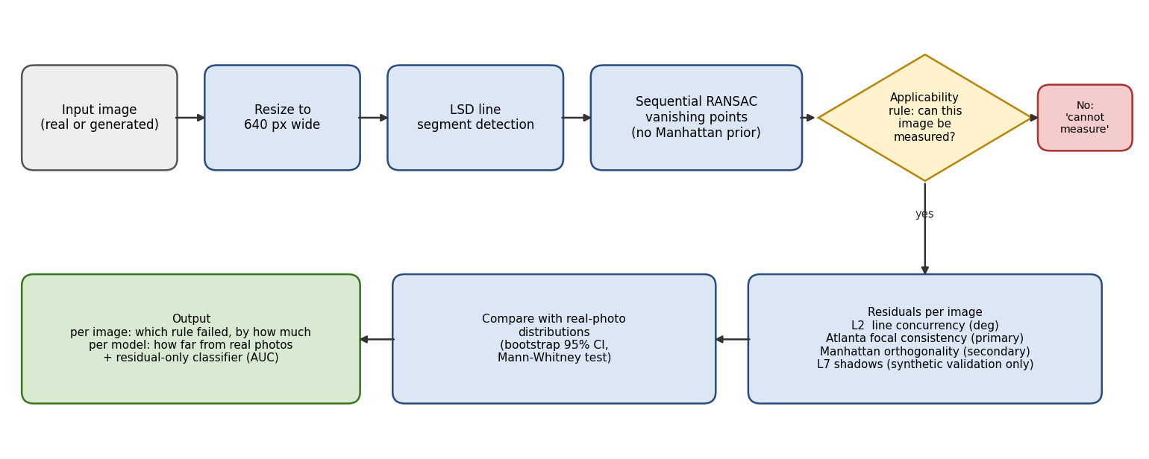
Figure 4.1: Overall architecture of the geometric-consistency measurement pipeline.

4.2 Objective-wise Methodology
Table 4.1: Each objective, the method used and the validation performed.
Objective | Method used | How it was validated
O1 Pipeline | LSD line detection; sequential RANSAC vanishing points refined by angular least squares on the unit sphere; closed-form and least-squares focal length | Synthetic scenes with known cameras; York Urban true vanishing points
O2 Real-photo baseline | Full pipeline on York Urban (102 photos) and Wikimedia Commons (358 photos, 135 camera models) with EXIF focal lengths | Fitted focal length compared with the EXIF focal length
O3 Generated sets | Stable Diffusion 1.5 and SDXL run locally with logged seeds and settings; Gemini and ChatGPT images from the same prompt list, numbered by prompt | Prompt sets checked image by image against metadata
O4 Applicability rule | Support, localisation, separation and spatial spread of each line family, from evidence only | Agreement with York Urban ground truth; unchanged decision under injected violations
O5 Comparison and classification | Matched-content and matched field-of-view comparisons; six standard classifiers on residuals | Five-fold cross-validation; bootstrap confidence intervals
O6 Shadow rule | Wedge constraints solved as a linear program that minimises the largest violation | Synthetic scenes with a known sun and injected shadow rotations

4.3 Design: The Constraint Hierarchy
Each level is one rule a pinhole camera cannot break, with a residual in readable units.
Table 4.2: The rule hierarchy, residual units and what was built.
Level | Rule | Residual | Status
L1 | Straight edges in 3D stay straight in the image | Curvature (px) | Not built
L2 | Lines parallel in 3D meet at one vanishing point | Angle (deg) | Built, validated
L3 | Three directions at right angles fix one focal length and principal point | Deviation from 90 deg | Built, validated (secondary)
L3b | Every horizontal direction gives the same focal length when paired with the vertical (Atlanta worlds) | Spread of log focal length | Built; primary measure
L4 to L6 | Horizon agreement; projective invariants; circles on planes | Various | Specified, not built
L7 | All shadows agree with one light source | LP violation (px) | Geometry built and validated
L8 to L9 | Reflections; agreement with depth and normal networks | Degrees | Specified, not built

4.4 Materials and Methods

4.4.1 Hardware and software
Table 4.3: Hardware and software used.
Component | Specification
Compute | NVIDIA GeForce RTX 5060 Laptop GPU, 8 GB VRAM; Windows 11
Language | Python 3.14
Vision library | OpenCV 4.13 (Line Segment Detector, morphology, connected components)
Maths and statistics | NumPy, SciPy (least squares, linear programming, statistical tests), scikit-learn [21], statsmodels, pandas
Generative models | PyTorch 2.14 with CUDA 13.0; diffusers 0.40; Stable Diffusion 1.5 and SDXL-base-1.0 with CPU offload to fit in 8 GB
Project code | projgeo package: lines, vp, camera, selection, explain, locality, regional, shadows, distortion, prompts, datasets; 20 automated tests

4.4.2 Core algorithms
Line detection. LSD runs on the greyscale image. Segments shorter than two per cent of the image diagonal are dropped to remove texture noise. We use standard refinement, because advanced refinement took up to fifty seconds on some images with no gain in quality.
Vanishing points. Segments are converted to normalised coordinates. Vanishing points are found one at a time with RANSAC: pick two segments at random (longer ones more likely), take their intersection as a candidate, and score it by the total length of segments that point at it within a small angle. The best candidate is refined by weighted least squares on the unit sphere, which also handles vanishing points at infinity (parallel lines in the image). Its segments are removed and the search repeats.
Camera coherence (Manhattan test). With the principal point at the image centre, we search for the one focal length that makes the three vanishing-point directions closest to 90 degrees apart. The residual is the worst deviation from 90 degrees. For three finite vanishing points, a real camera's principal point must sit at the orthocentre of the triangle they form [1], and the distance between the two is the orthocentre offset.
Atlanta focal consistency (primary measure). A real camera has one focal length f. For any two vanishing points v1 and v2 of directions at right angles, f squared equals minus the dot product (v1 minus p) times (v2 minus p), where p is the principal point. The vertical direction is at a right angle to every horizontal direction, even in an Atlanta world. So we find the vertical vanishing point (by its direction from the image centre only, never by checking right angles), pair it with each horizontal vanishing point, and get one focal length per pair. In a real photo these should all agree. Our statistic is the spread of log f across the pairs. Zero means perfect agreement. A spread of 0.14 means the largest and smallest focal lengths differ by about 15 per cent. If f squared comes out negative for a pair, no camera at all could produce it, and we call that an impossible pair.
Uncertainty. Each vanishing point's segments are resampled with replacement and the point is re-fitted (a bootstrap [22]), giving an angular spread. This separates well-pinned vanishing points from ones that slide along a family of nearly parallel lines.

4.4.3 The applicability rule
The camera test only makes sense for images that clearly show three well-separated, well-supported directions. An image is admitted only if three line families each hold at least eight per cent of the total line length, each vanishing point is pinned to better than one degree by the bootstrap, each pair is at least ten degrees apart and at least five times their uncertainty, and each family's lines spread over at least twelve per cent of the image diagonal. Real photos must also have a standard sensor aspect ratio, since cropping moves the principal point. The rule deliberately ignores right angles, focal length and the orthocentre, because those are what we are measuring.
We checked the rule two ways. On York Urban, admitted images have 90 per cent of their vanishing points within five degrees of the hand-labelled truth, against 57 per cent for rejected images. And a unit test injects a camera violation that leaves the lines' layout unchanged and confirms the admit or reject decision does not change. So the rule cannot be letting real images through just because they are consistent.

4.5 Data Acquisition
Table 4.4: Datasets, their role and how they were collected.
Dataset | Size | Role | Source and settings
York Urban [10] | 102 photos, 640x480 | Hand-picked real reference with true vanishing points | York University; one camera, focal length 675 px
Wikimedia Commons | 358 photos, 135 camera models | Ordinary real photos from many cameras | Commons API; EXIF camera and focal length, landscape, at least 1024 px wide; CC licences recorded
Stable Diffusion 1.5 | 200 + 250 images, 640x480 | Older open model | 30 steps, guidance 6.0; seed and prompt logged per image
SDXL | 200 + 250 + 120 + 80 images | Newer open model | 30 steps, guidance 6.0, CPU offload; 1024x768 plus 1:1 and 16:9 variants
Gemini ("nano banana") | 181 images (168 at 640x480, 13 larger) | Closed frontier model | Google Gemini image generation used through Antigravity, September 2026; first prompt set, numbered by prompt; internal settings not exposed
ChatGPT image model | 51 images, 1448x1086 | Closed frontier model | OpenAI image generation in ChatGPT, September 2026; first prompt set, numbered by prompt; internal settings not exposed
Synthetic scenes | Made on demand | Ground truth and violation injection | Known camera and rotation; controlled violations of each rule

Prompt design. The generated images copy the content of the real sets. The first prompt set covers building fronts, streets, corridors, lecture halls and offices. A second set asked for corners where two walls meet, to guarantee three visible directions. A third, line-rich set also asks for repeating straight features such as tiles, shelving, window grids and brick courses, because the second set gave scenes that were the right shape but had too few lines to measure. Every local image has a record of model, prompt, negative prompt, seed, sampler, steps, guidance, resolution and date. The frontier images were made from the first prompt set, so they are compared with the local images made from that same set. Comparing them with images from a different prompt set would mix up the effect of the model with the effect of the scene.

4.6 Implementation
The system is a Python package with 20 automated tests. Testing is layered. Synthetic scenes with known cameras check that the estimators find the truth. Violation injectors check that each residual reacts to its own rule and not to others: one bends line directions to break concurrency only, one moves a vanishing point so concurrency holds but the camera breaks, one makes a vanishing point drift across the image, and one splits the image between two cameras. Each residual must grow steadily as the injected violation grows.
One detail mattered for correctness. The usual inlier RMS residual stops growing once violations pass the inlier threshold, because badly broken segments just drop out of the inlier set. So we added a length-weighted capped mean over all segments, plus the share of line length that no vanishing point explains, and checked both grow steadily over the full range of violations.
The per-image output shows each line family in its own colour, with the focal length each horizontal direction implies. Figure 4.2 shows this for one real photo and one generated image. The same code drives the interactive demonstration.
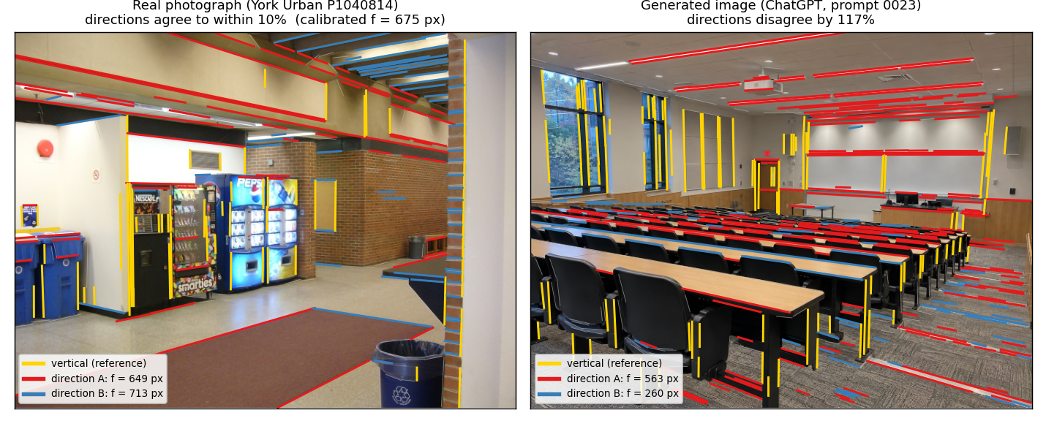
Figure 4.2: Per-image output. Yellow lines belong to the vertical vanishing point; each other colour is one horizontal direction, labelled with the focal length it implies. Left: a York Urban photo whose two directions give 649 and 713 px against a calibrated 675 px. Right: a ChatGPT image whose two directions give 563 and 260 px, more than a factor of two apart.

5. Results and Discussion

5.1 Validation of the Instrument
Before comparing anything, we checked the tool against known answers. On synthetic scenes, vanishing points come out within 0.3 degrees and focal length within one per cent. On York Urban, without being told about right angles, the finder recovers 81 per cent of the true vanishing points within two degrees and 94 per cent within five. The median ratio of fitted to true focal length is 1.02, with an interquartile range of 0.99 to 1.05. So the tool finds the real camera in real photos, which we need before trusting anything it says about generated images.
Table 5.1: Validation of the pipeline against ground truth.
Check | Quantity | Result
Synthetic scenes | Vanishing-point direction error | Below 0.3 deg
Synthetic scenes | Focal length error | Below 1 per cent
York Urban | True VPs recovered within 2 deg / 5 deg | 81 per cent / 94 per cent
York Urban | Fitted focal over true focal, median [IQR] | 1.02 [0.99, 1.05]
Commons (EXIF) | Fitted focal vs EXIF focal, well-conditioned photos | Median +6 per cent; 58 per cent within 20 per cent
Violation injection | Each residual grows with its own violation | Confirmed for all four

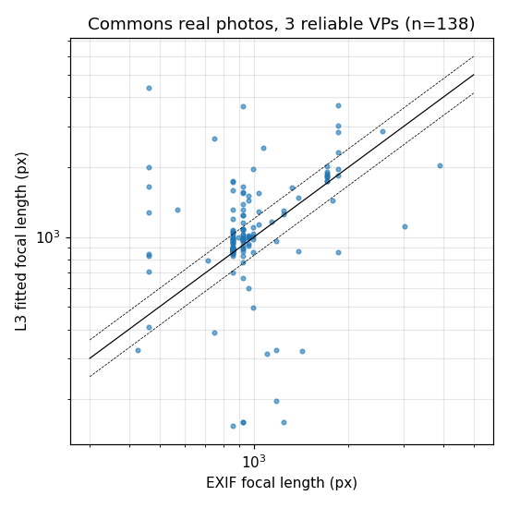
Figure 5.1: Fitted focal length against EXIF focal length for real photos from 135 camera models. Dashed lines mark a 20 per cent band.

5.2 Real-Image Null Distributions
We measured the normal range of each residual on real photos. On York Urban the concurrency residual has a median of 1.31 degrees and a 95th percentile of 2.46 degrees, and the Manhattan residual has a median of 0.69 degrees. These are not zero, and assuming they are zero is the most common mistake when using these tests. We found two causes: lens distortion (a per-image fit of one radial coefficient agrees with a fit over the whole dataset) and the fact that real buildings are only roughly box-shaped.
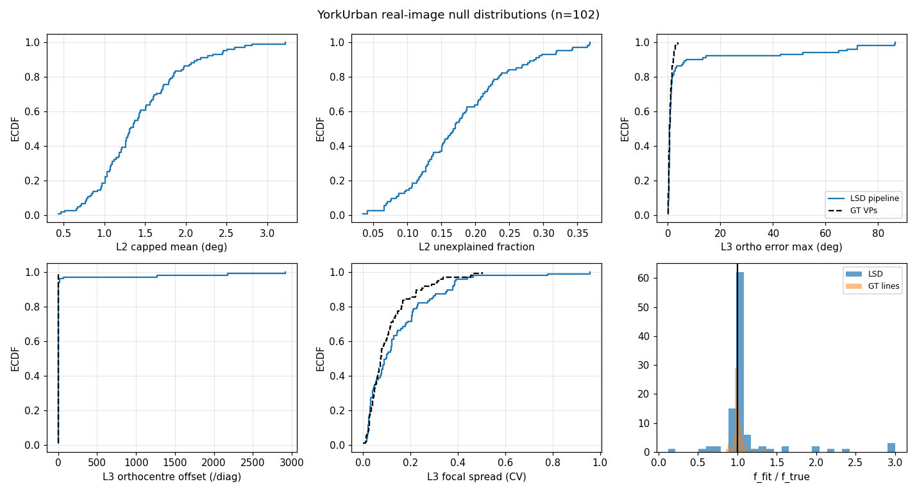
Figure 5.2: Cumulative distributions of each residual on the hand-picked real set, with the estimator-only floor for comparison.

5.3 The Decisive Role of the Real Reference
The Commons photos gave the most important method lesson of the project. With no applicability rule, ordinary real photos score a median Manhattan residual of 12.2 degrees. That is worse than Stable Diffusion 1.5 and much worse than SDXL. Taken at face value it would mean generated images are more camera-consistent than real photos, which cannot be right.
Looking at the worst photos explains it. They are angled streets, neighbouring buildings at odd angles, and fronts seen almost straight on. These scenes have three clear, well-supported directions that simply are not at right angles to each other. They are Atlanta worlds [8], not Manhattan worlds, and the three-direction right-angle test does not apply to them. The problem is with the test, not the photos. Filtering on evidence does not fix it: a stricter support threshold makes it worse, and 98 per cent of these photos already have standard aspect ratios, so cropping is not the cause. Figure 5.3 shows this. Photos (e) and (f) score 79 and 50 degrees on the Manhattan test, yet their directions agree on focal length to within 13 and 5 per cent on the Atlanta test.
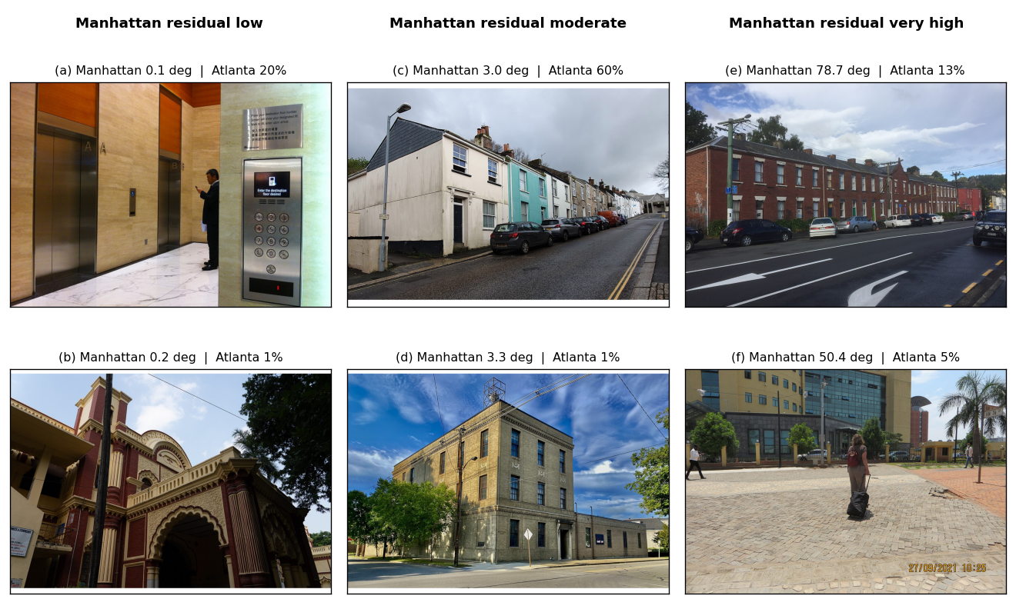
Figure 5.3: Real Commons photos admitted by the applicability rule, at low, moderate and very high Manhattan residual, with the Atlanta disagreement for each. Photos from Wikimedia Commons, resized: (a) Roamlohcs, CC BY-SA 3.0; (b) Amitabha Gupta, CC BY 4.0; (c) Mutney, CC0; (d) Andre Carrotflower, CC BY-SA 4.0; (e) DrThneed, CC BY-SA 4.0; (f) Gerard van de Bruinhorst, CC BY-SA 4.0.
We made two changes as a result, and both are used below. Images are only measured if they pass the applicability rule of Section 4.4.3; this brings the Commons median Manhattan residual down from 12.2 to 2.82 degrees. And the main measure is switched from the Manhattan test to Atlanta focal consistency, which works on both kinds of scene.

5.4 Primary Result: Camera Coherence
The main comparison uses Atlanta focal consistency on images that pass the applicability rule, with the line-rich prompt set for the generators. Medians come with bootstrap 95 per cent confidence intervals [22], proportions with Wilson intervals [23], and differences are tested with the Mann-Whitney test [24].
Table 5.2: Atlanta focal consistency on admitted images (line-rich prompt set for the generators). "Usable" counts images where at least two pairs give a real focal length.
Quantity | York Urban (real) | Commons (real) | SD 1.5 | SDXL
Images admitted by the rule | 72 | 121 | 92 | 112
With two or more horizontal directions | 72 | 120 | 87 | 109
Usable for log-focal spread | 65 | 91 | 53 | 65
Log-focal spread, median [95% CI] | 0.142 [0.106, 0.221] | 0.152 [0.093, 0.220] | 0.465 [0.324, 0.709] | 0.355 [0.272, 0.529]
Images with an impossible pair | 28% [19, 39] | 44% [36, 53] | 68% [57, 77] | 58% [48, 66]
Manhattan residual (secondary) | 0.65 deg | 2.82 deg | 2.93 deg | 1.94 deg

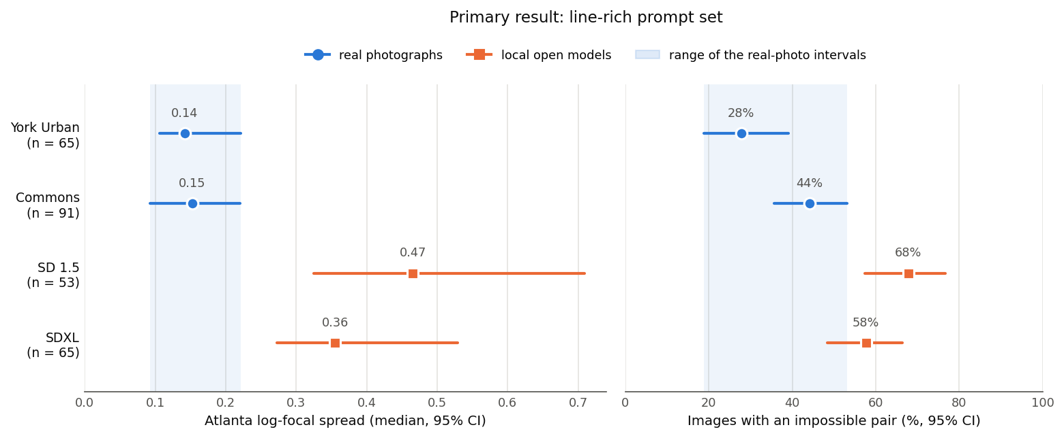
Figure 5.4: Median log-focal spread (left) and share of images with at least one pair no camera could produce (right), with 95 per cent intervals. The shaded band spans the two real sets' intervals. n is the number of images usable for the log-focal spread.
The two real sets agree with each other within their confidence intervals (0.142 and 0.152). Both generators sit clearly higher (0.355 and 0.465), and the intervals do not overlap. The Mann-Whitney test gives p of about 3 × 10⁻⁵ against either real set. In plain words: in a real photo, the horizontal directions agree on one focal length to within about 15 per cent. In a generated image they disagree by 35 to 60 per cent. This holds against the hand-picked set and against ordinary internet photos, which is what makes it believable.
The share of images with an impossible pair rises from 28 per cent (hand-picked real) to 44 per cent (ordinary real) to 58 and 68 per cent (generated). This is a steady rise, not a clean split, so the log-focal spread is the better statistic.

5.4.1 Robustness checks
We ran two checks on the main measure. Both came from looking closely at single images.
Check 1: picking the wrong vertical. The vertical vanishing point is chosen by its direction from the image centre. A vanishing point sitting near the centre, like the far end of a corridor seen head-on, can point in any direction and get picked by mistake. A real vertical vanishing point is only that close to the centre if the camera points steeply up or down. So we repeated the analysis requiring the vertical vanishing point to be at least one image height from the centre. This uses only its position, never the focal length, so it cannot bias the test. Only 0 to 5 per cent of images in any set were affected, and every result kept its size and significance.
Check 2: nearly level cameras. When a camera is held almost exactly level, vertical lines are almost parallel and their vanishing point is very far away. The focal-length formula then multiplies a tiny number by a huge one, so small errors are magnified. Generated images are level far more often than real photos: 76 to 80 per cent of SD 1.5 and SDXL images have their vertical vanishing point more than 20 image heights away, against 31 to 51 per cent of real photos. If that alone raised their scores, the main result would be an artefact. It does not. Within each set, levelness is only weakly related to the score (Spearman rho 0.0 to 0.3, mostly not significant). And keeping only clearly tilted cameras (vertical vanishing point within 50 image heights), generated images are still two to three times worse than real photos, with p of 0.008 or less.
Table 5.3: Median log-focal spread under two robustness checks, line-rich prompt set. Usable images in brackets. The last column is the largest Mann-Whitney p of either generator against either real set.
Condition | York Urban | Commons | SD 1.5 | SDXL | Largest p vs real
As published | 0.142 (65) | 0.152 (91) | 0.465 (53) | 0.355 (65) | 0.0001
Vertical VP at least 1 image height from centre | 0.142 (65) | 0.149 (88) | 0.465 (53) | 0.355 (65) | 0.0001
Clearly tilted cameras only (vertical VP within 50 image heights) | 0.135 (52) | 0.135 (74) | 0.423 (23) | 0.285 (27) | 0.008

The frontier models of Section 5.5.1 stay worse than real photos under both checks. Under check 1 nothing changes (p 0.014 to 0.020). On the tilted-only subset their samples shrink to 19 and 23 images and p rises to between 0.02 and 0.07, so that part needs the larger planned run.

5.5 Comparative Analysis Across Generators
Stable Diffusion 1.5 and SDXL were compared on the same 250 line-rich prompts, with matched field of view and line density. This separates two abilities that usually get lumped together.
Table 5.4: SD 1.5 against SDXL on identical prompts. 87 and 109 images have two or more horizontal directions; 53 and 65 of them give a usable log-focal spread.
Measure | SD 1.5 | SDXL | p | Reading
Manhattan residual | 2.93 deg | 1.94 deg | 0.0002 | Gets better with the bigger model
Atlanta log-focal spread | 0.465 | 0.355 | 0.55 (not significant) | No change
Images with an impossible pair | 68% | 58% | 0.18 (not significant) | No change

Going from SD 1.5 to SDXL makes the scene's right angles clearly better, but camera coherence does not change and stays about two and a half to three times worse than real photos. So orientation improves with a bigger model, and camera coherence does not. Size alone does not look like it will fix the problem.

5.5.1 Frontier models: Gemini and ChatGPT
To test the 2026 claim that the newest models no longer have this giveaway, we ran 181 prompts through Google Gemini image generation and 51 through OpenAI's image model in ChatGPT. All came from the first prompt set, so they are compared with the SD 1.5 and SDXL images made from that same set, image for image by prompt number.
Table 5.5: Frontier models against the real sets and against SD 1.5 and SDXL on the same prompts (first prompt set).
Quantity | York Urban | Commons | SDXL | SD 1.5 | Gemini | ChatGPT
Images admitted | 72 | 121 | 79 | 61 | 58 | 36
Usable for log-focal spread | 65 | 91 | 38 | 44 | 31 | 29
Log-focal spread, median | 0.142 | 0.152 | 0.593 | 0.592 | 0.338 | 0.491
95% CI | [0.106, 0.221] | [0.093, 0.220] | [0.355, 0.933] | [0.381, 0.841] | [0.182, 0.652] | [0.320, 0.634]
p vs York Urban / Commons |  |  | 7×10⁻⁵ / 1×10⁻⁴ | 3×10⁻⁵ / 2×10⁻⁵ | 0.016 / 0.018 | 0.014 / 0.015
Images with an impossible pair | 28% | 44% | 67% | 55% | 61% | 39%
Share of images admitted | 71% | 34% | 40% | 30% | 32% | 71%

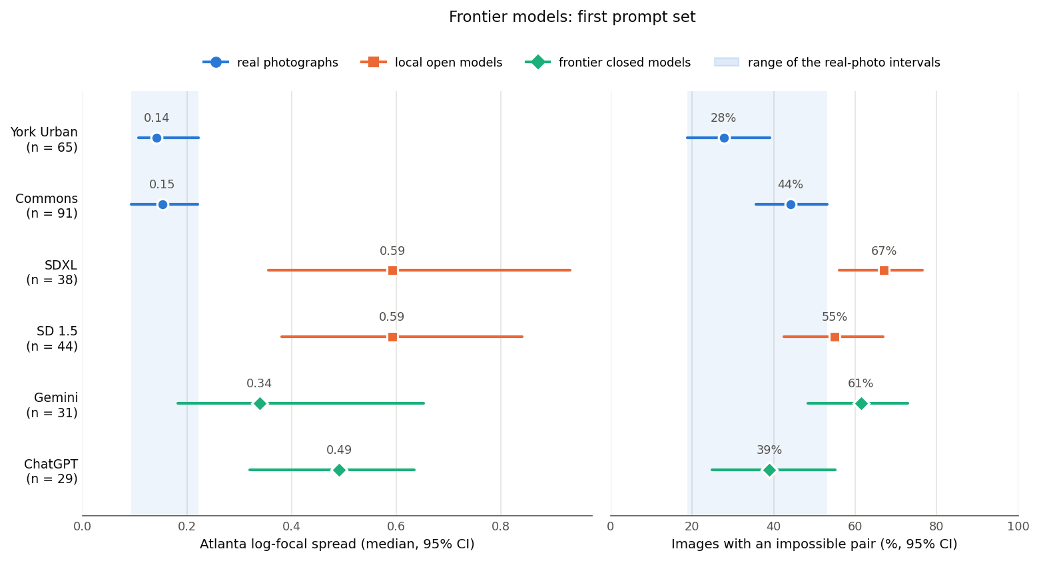
Figure 5.5: The frontier models beside both real sets and the local models on the same prompts. Same layout as Figure 5.4.
The giveaway has not gone away. Both frontier models are significantly worse than both real sets (p between 0.014 and 0.018). On this measure the newest models still do not commit to one camera.
We cannot say the frontier models are better than SD 1.5 and SDXL. Their medians are lower (0.338 and 0.491 against about 0.59), but none of the model-to-model differences is significant: Gemini against SDXL p = 0.26, against SD 1.5 p = 0.14; ChatGPT against SDXL p = 0.23, against SD 1.5 p = 0.15. With only 29 to 44 usable images per model the test does not have enough power. The evidence against the frontier models is also about a thousand times weaker than against the older models (p near 0.015 against p near 3 × 10⁻⁵). Part of that is real narrowing and part is the smaller sample.
Two side notes. ChatGPT's impossible-pair rate (39 per cent) falls between the two real sets, so on that statistic alone it looks like a real photo, but its focal spread is still high. And ChatGPT images were admitted twice as often as Gemini images (71 against 32 per cent). ChatGPT delivers 1448 px wide images that we shrink to 640 px, while most Gemini images arrived at 640 px. Larger originals give cleaner lines after shrinking, so this gap is probably about the measurement, not the model. Within Gemini, its 12 larger images were admitted 58 per cent of the time against 30 per cent for the small ones.

5.6 Where the Inconsistency Lives
Two more analyses look at where in the image the problem is. The regional analysis fits a separate camera inside each cell of an overlapping three by three grid and measures how much the cells disagree. It reports a consistency radius, the smallest distance such that one camera lies within that distance of every local camera, an idea taken from sheaf theory [25]. On the hand-picked real set against SDXL, generated images show much more disagreement in focal length between regions, and the gap grows with window size, while real photos settle on one camera.
This result comes with a caveat we found while preparing this report. Each local camera is fitted by choosing the focal length that makes all the cell's vanishing points as close to right angles as possible. That is the Manhattan assumption again. It holds for York Urban by design, but it has not been checked for generated images that may contain Atlanta-style angled directions, where it would make the local focal lengths wrong. So we report this result but do not count it as independent evidence until it is redone with an Atlanta-style local fit.
A second analysis tests whether the error is a smooth drift across the image within one line family, using the spatial correlation of signed angular residuals. This statistic is the same for real and generated images in every set. So the error is not a gradual warping of the picture. It is disagreement between separate structures and regions.
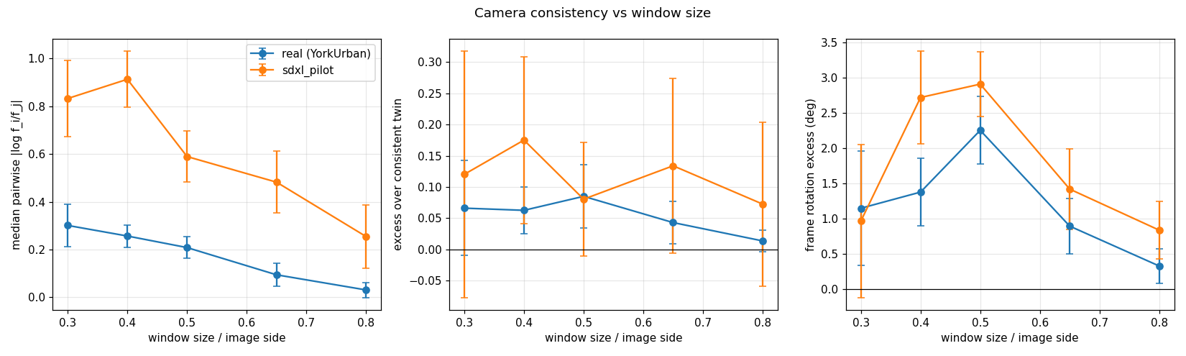
Figure 5.6: Disagreement in implied focal length between image regions as window size grows, York Urban against SDXL. Subject to the fitting caveat in the text.

5.7 Classification from Geometric Residuals
To compare with learned detectors, we trained six standard classifiers on the residual list alone, never on pixels, and scored them with five-fold stratified cross-validation using scikit-learn [21]. The geometry features are grouped as line concurrency (L2), Atlanta focal consistency, Manhattan right angles (including the orthocentre offset) and locality. Camera settings and content descriptors such as field of view and segment count are kept out of the geometry-only score.
We also removed every feature that turns a pair of vanishing points into a focal length without knowing the pair is at right angles (the old focal spread, its bootstrap version and the count of negative f squared), plus all regional features for the reason given in Section 5.6. Removing them lowered the best AUC by at most 0.04, so detection never depended on them.
Table 5.6: Best cross-validated AUC from geometry features only. The random forest [26] was best in every task.
Task | All images | Admitted images only
York Urban (real) vs SDXL | 0.875 | 0.903
York Urban (real) vs SD 1.5 | 0.919 | 0.926
Commons (real) vs SDXL | 0.807 | 0.808
All real vs all generated | 0.804 | 0.833
Field of view matched (40 to 60 deg) | 0.814 | 0.863

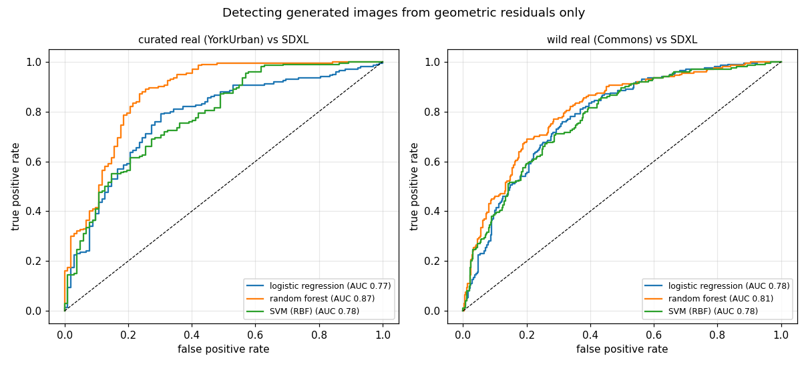
Figure 5.7: ROC curves for detection from geometric residuals alone, valid features only.
Sarkar et al. [2] report about 0.88 to 0.94 AUC for their learned line classifier. Our readable residuals reach 0.88 to 0.93 against the hand-picked set and about 0.81 to 0.86 in the two hardest cases, ordinary real photos and matched field of view. The point is not to win on AUC but to show that readable residuals cost little in accuracy.
Two cautions. On York Urban, camera and content features alone reach about 0.88 to 0.90, because every York Urban photo comes from one camera with one field of view. That is why the Commons and field-of-view matched numbers are the honest ones. And the most useful single feature is the orthocentre offset (it lowers AUC by 0.11 when shuffled; nothing else passes 0.01). That is about where the principal point sits, which fits our claim that the camera is wrong, but it points at the principal point rather than the focal length, and it is a Manhattan measure. On its own, the Atlanta measure is only a moderate per-image detector (AUC 0.61 to 0.74), even though it separates the groups very clearly. It is a strong population test and a weak single-image test.

5.8 Shadow Consistency
The shadow rule follows the wedge method of Kee, O'Brien and Farid [14]. A shadow point and the object area that could have cast it define a wedge of possible light positions, written as two half-planes. In a real scene all wedges must overlap. We solve it as a linear program that minimises the largest half-plane violation, so the answer is a violation in pixels rather than a yes or no. On synthetic scenes with a known sun, the light position is recovered exactly, the violation grows steadily as shadows are rotated, and allowing more annotation error always makes the test more lenient, which is what makes it safe to use with hand annotations.
Shadow detection uses classic steps: a grey-value transform that uses the fact that shadows are darker and bluer, Otsu thresholding, morphological closing and opening sized to the image diagonal, and connected components with an area filter.
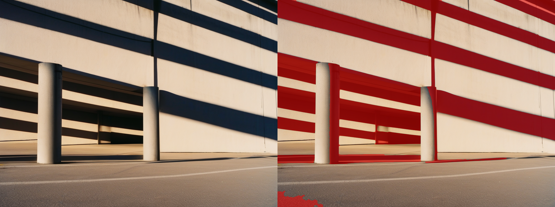
Figure 5.8: Shadow detection on a sunlit SDXL image. Cast shadows on the wall are found, but so is the dark garage interior, which shows why shadows must be matched to objects before the rule can be used.
We also tried to skip manual annotation by checking whether the long axes of shadow regions meet at the sun's vanishing point. We rejected this. Real photos already score 14 degrees on it, and SD 1.5 scores better than real photos, which means it measures the detector, not the light. The mask reacts to dark glass, signs and shaded rooms as much as to cast shadows (Figure 5.8). So the shadow rule needs real shadow-to-object matching, by instance shadow detection or by hand, before it can join the comparison.

5.9 Interpretation of Results
Two lines of evidence stand up cleanly. The Atlanta focal-consistency comparison shows generated images do not agree on one focal length, against two different real sets. And the SD 1.5 to SDXL comparison shows orientation improving while focal coherence does not. Together they say the weakness of current generators is not getting the scene's directions right, but committing to one camera across the whole image. A third line, the classifier, agrees that the camera is the problem but points at the principal point. A fourth, the regional analysis, agrees in direction but rests on an assumption we have not yet checked for generated images.
This is a narrower claim than a quick comparison would give, and it is the one that survives controlling for content, camera settings and choice of real photos. It also makes sense mechanically. The direction of a line family can be judged from any small patch of the image, but the focal length depends on how far apart the vanishing points are, so the whole image has to be combined into one consistent picture. A model that builds images out of locally convincing pieces would get the first right and the second wrong.

5.10 Significance of Findings
- A measurement method that says which camera rule failed and by how much, instead of one opaque score.
- Evidence that the choice of real photos can flip the direction of a comparison, which is a warning for the field.
- An applicability rule with a non-circularity test, validated against ground truth, that makes the camera test usable on ordinary photos.
- A replicated result that generated images are two and a half to three times worse than real photos at camera coherence while matching them on orientation.
- Evidence that the newest closed models, Gemini and ChatGPT, still fail this test against both real sets.
- Evidence that a bigger model fixes orientation but not camera coherence.

5.11 Limitations
The frontier samples are small (29 and 31 usable images), were made from the less line-rich prompt set, came at different resolutions, and were generated with settings we cannot see. A larger run of 250 line-rich prompts per model at full resolution is the next step. The shadow rule is not run at scale. Generated images are shrunk to 640 px to match York Urban, and the effect of this on line detection has not been isolated, although the Commons comparison is resolution-matched and agrees. The regional analysis needs an Atlanta-style local fit. Several rule levels are not built.
The Atlanta measure itself has two known weak spots. It treats every non-vertical direction as horizontal, so sloped structures such as staircases, ramps and pitched roofs give wrong pairs, in real photos as much as in generated ones; this probably explains part of the 28 to 44 per cent impossible-pair rate in real photos. And for a camera held almost exactly level, the focal length of a single image is poorly determined, so one image's number should be read with care even though the group comparison survives the tilt check of Section 5.4.1.
Three claims made during the project were withdrawn after more testing. We record them because the lesson is part of the contribution. First, we said real photos never contain an impossible vanishing-point pair. That came from reading a median fraction per image instead of the share of images; the correct figures form a steady rise, not a split. Second, we said camera coherence gets worse with model size. That used a focal spread computed over all vanishing-point pairs, including pairs not at right angles, where the focal formula does not apply; with the Atlanta measure and four times the data, the difference disappeared. Third, we said the classifier's most important features showed a focal-length problem; that relied on one of the same invalid features, and with valid features the classifier points at the principal point instead. The rule we now follow: build a focal-length statistic only from vanishing-point pairs that are at right angles by construction.

5.12 Summary of Results
Table 5.7: Summary of the main results.
Finding | Evidence
The tool recovers real cameras | Focal length within 2 per cent on York Urban; vanishing points within 0.3 deg on synthetic scenes
Real-photo residuals are not zero and must be measured | Concurrency median 1.31 deg; lens distortion and non-box-shaped scenes quantified
The choice of real photos can flip the conclusion | Ordinary real photos score worse than generated images on the Manhattan test
Generated images fail camera coherence | Log-focal spread 0.355 and 0.465 against 0.142 and 0.152 for real; p about 3 × 10⁻⁵
The main result is not an artefact | Unchanged when the vertical vanishing point must be away from the centre, and when only clearly tilted cameras are kept (p 0.008 or less)
Orientation matches, the camera does not | Manhattan residual comparable after the applicability rule; focal coherence 2.5 to 3 times worse
A bigger model improves orientation only | SD 1.5 to SDXL: Manhattan p = 0.0002; focal coherence p = 0.55
The newest models still fail | Gemini 0.338 and ChatGPT 0.491 against 0.142 and 0.152 for real; p about 0.015; not significantly different from SD 1.5 or SDXL yet
Readable residuals are competitive detectors | AUC 0.88 to 0.93 against the hand-picked set and 0.81 to 0.86 in the hardest cases, against 0.88 to 0.94 reported for learned geometric features

6. References
[1] R. Hartley and A. Zisserman, Multiple View Geometry in Computer Vision, 2nd ed. Cambridge, U.K.: Cambridge Univ. Press, 2004.
[2] A. Sarkar, H. Mai, A. Mahapatra, S. Lazebnik, D. A. Forsyth and A. Bhattad, “Shadows Don’t Lie and Lines Can’t Bend! Generative Models don’t know Projective Geometry…for now,” in Proc. IEEE/CVF Conf. Computer Vision and Pattern Recognition (CVPR), 2024.
[3] X. Du et al., “Generative models: What do they know? Do they know things? Let’s find out!” in Advances in Neural Information Processing Systems (NeurIPS), 2023.
[4] Y. Chen, F. Viégas and M. Wattenberg, “Beyond surface statistics: Scene representations in a latent diffusion model,” arXiv preprint, 2023.
[5] M. El Banani et al., “Probing the 3D awareness of visual foundation models,” in Proc. CVPR, 2024.
[6] A. Criminisi, I. Reid and A. Zisserman, “Single view metrology,” International Journal of Computer Vision, vol. 40, no. 2, pp. 123-148, 2000.
[7] J. M. Coughlan and A. L. Yuille, “Manhattan world: Compass direction from a single image by Bayesian inference,” in Proc. IEEE Int. Conf. Computer Vision (ICCV), 1999.
[8] G. Schindler and F. Dellaert, “Atlanta world: An expectation maximization framework for simultaneous low-level edge grouping and camera calibration in complex man-made environments,” in Proc. IEEE Conf. Computer Vision and Pattern Recognition (CVPR), 2004.
[9] D. Hoiem, A. A. Efros and M. Hebert, “Putting objects in perspective,” International Journal of Computer Vision, vol. 80, no. 1, pp. 3-15, 2008.
[10] P. Denis, J. H. Elder and F. J. Estrada, “Efficient edge-based methods for estimating Manhattan frames in urban imagery,” in Proc. European Conf. Computer Vision (ECCV), 2008.
[11] R. Grompone von Gioi, J. Jakubowicz, J.-M. Morel and G. Randall, “LSD: A fast line segment detector with a false detection control,” IEEE Trans. Pattern Analysis and Machine Intelligence, vol. 32, no. 4, pp. 722-732, 2010.
[12] A. Desolneux, L. Moisan and J.-M. Morel, From Gestalt Theory to Image Analysis: A Probabilistic Approach. New York, NY, USA: Springer, 2008.
[13] J. Lezama, R. Grompone von Gioi, G. Randall and J.-M. Morel, “Finding vanishing points via point alignments in image primal and dual domains,” in Proc. CVPR, 2014.
[14] E. Kee, J. F. O’Brien and H. Farid, “Exposing photo manipulation with inconsistent shadows,” ACM Transactions on Graphics, vol. 32, no. 3, 2013.
[15] H. Farid, “Perspective (in)consistency of paint by text,” arXiv preprint, 2022.
[16] H. Farid, “Lighting (in)consistency of paint by text,” arXiv preprint, 2022.
[17] L. Jin et al., “Perspective fields for single image camera calibration,” in Proc. CVPR, 2023.
[18] A. Veicht et al., “GeoCalib: Learning single-image calibration with geometric optimization,” in Proc. ECCV, 2024.
[19] R. Rombach, A. Blattmann, D. Lorenz, P. Esser and B. Ommer, “High-resolution image synthesis with latent diffusion models,” in Proc. CVPR, 2022.
[20] D. Podell et al., “SDXL: Improving latent diffusion models for high-resolution image synthesis,” in Proc. Int. Conf. Learning Representations (ICLR), 2024.
[21] F. Pedregosa et al., “Scikit-learn: Machine learning in Python,” Journal of Machine Learning Research, vol. 12, pp. 2825-2830, 2011.
[22] B. Efron and R. J. Tibshirani, An Introduction to the Bootstrap. New York, NY, USA: Chapman & Hall, 1993.
[23] E. B. Wilson, “Probable inference, the law of succession, and statistical inference,” Journal of the American Statistical Association, vol. 22, no. 158, pp. 209-212, 1927.
[24] H. B. Mann and D. R. Whitney, “On a test of whether one of two random variables is stochastically larger than the other,” Annals of Mathematical Statistics, vol. 18, no. 1, pp. 50-60, 1947.
[25] M. Robinson, “Sheaves are the canonical data structure for sensor integration,” Information Fusion, vol. 36, pp. 208-224, 2017.
[26] L. Breiman, “Random forests,” Machine Learning, vol. 45, no. 1, pp. 5-32, 2001.

