Abstract
In an era of accelerating climate change, quantifying national resilience is critical for effective humanitarian intervention. This project, "Resilience Under Pressure," develops a data driven analytical platform to measure how nations absorb and recover from disasters. By fusing datasets from EM-DAT, the World Bank, and the UNDP, we formulated three derived indices: the Disaster Impact Index (DII), the Resilience Recovery Score (RRS), and the Composite Resilience Index (CRI). Our analysis reveals a logarithmic "Resilience Gap" between the Global North and South, where initial economic gains significantly boost recovery capacity. We implemented an interactive Tableau dashboard that allows decision makers to visualize spatial gradients and temporal volatility, identifying "Critical Risk Zones" where high exposure converges with low adaptive capacity.

1. Introduction

A. Problem Statement
Disaster resilience is multidimensional; it cannot be directly measured but must be inferred from the interplay of exposure, vulnerability, and adaptive capacity. The Global Disaster and Humanitarian Response Agency (GDHRA) requires a system to move beyond reactive response toward predictive analytics. The core challenge lies in integrating unstructured, disparate data sources to quantify whether institutional stability or economic wealth is the primary driver of recovery.

B. Objectives
The primary objectives of this study were:
- To integrate open source data on disaster frequency, economic indicators, and human development.
- To mathematically formulate and calculate derived indices (DII, RRS, CRI) that quantify resilience.
- To visualize these metrics using an exploratory Tableau dashboard that highlights spatial and temporal trends.

2. Data Sources and Preprocessing

A. Data Sources
We integrated three primary open datasets:
- EM-DAT: Granular data on disaster occurrence, type, deaths, and damages (2000–2024).
- World Bank Open Data: Macroeconomic indicators (GDP, Population).
- UNDP Human Development Reports: HDI scores used as a proxy for "Adaptive Capacity."
B. Preprocessing Steps
We utilized Python (Pandas) for the ETL pipeline:
- Alignment: Datasets were merged on a composite key of Country Code and Year.
- Imputation: Missing region data for non-disaster years was backfilled using a dictionary mapping.
- Normalization: Economic damages were converted to full USD. Fatality counts were normalized per 1 million population to allow fair comparison between nations of varying sizes.
- Cleaning: The final dataset consists of 6,625 country-year observations.

3. Methodology and Model Formulation
We derived three quantitative indices to measure different facets of resilience.

A. Disaster Impact Index (DII)
The DII measures the immediate disruptive intensity of a disaster relative to a country's size. It is calculated as:
$$DII = \frac{(F + A_{pop})}{GDP_{pc}} x S$$
Where F is fatalities per million, A_pop is the percentage of the population affected, and S is a severity weight (set to 1.0 for this analysis). A high DII indicates that a disaster caused disproportionate damage relative to the country's economic baseline.

B. Composite Resilience Index (CRI)
The CRI is the core metric of our dashboard, representing a nation's structural ability to withstand shocks. It is defined as:
$$CRI = \frac{A}{E x V}$$
Where:
- A (Adaptive Capacity) = HDI Score (0-1).
- E (Exposure) = Annualized frequency of disaster events.
- V (Vulnerability) = Economic damage as a percentage of GDP.
To prevent division by zero in peaceful years, we applied smoothing constants ($ϵ$) to E and V. A higher CRI indicates a more resilient nation.

C. Resilience Recovery Score (RRS)
Due to the complexity of calculating multi-year GDP rebound windows, we implemented a proxy for the RRS that combines immediate economic growth with institutional stability:
$$RRS_{proxy }= \frac{GDP_{growth} + (HDI x 10)}{2}$$

4. Visualization and Implementation
The analysis was visualized using two primary dashboards in Tableau.

A. Dashboard 1: Global Resilience & Risk Explorer
This dashboard provides a high-level view of global risk distribution, combining geospatial analysis with correlation scatter plots.
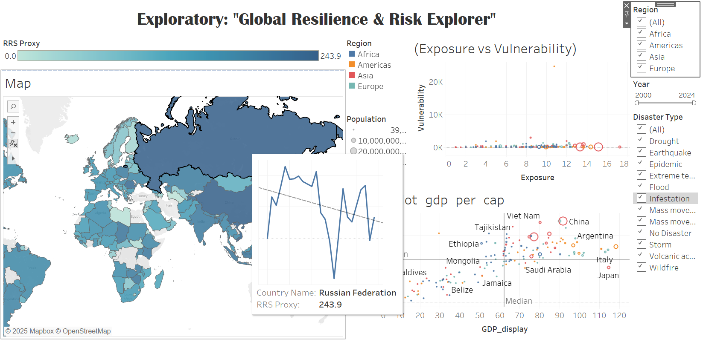
Figure 1: Global Resilience & Risk Explorer Dashboard showing the Resilience Map (Top) and Correlation Scatters (Bottom).

Interpretation:
- Geospatial Analysis: The map reveals a distinct North-South divide. Nations in North America and Western Europe display high RRS Proxy scores (>100), indicated by darker hues. In contrast, Sub-Saharan Africa and parts of South Asia form a "Critical Risk Zone" with scores consistently below 20.
- Wealth vs. Resilience: The scatter plot (bottom right) confirms a strong positive correlation between GDP per capita and RRS. The trend is logarithmic; the steep curve at the beginning indicates that moving from low income to middle-income status provides the most dramatic boost to resilience, while the marginal gains diminish for ultra-wealthy nations.
- Exposure vs. Vulnerability: The scatter plot (bottom middle) highlights an "Efficiency Paradox." Developed nations often have high exposure (frequency of events) but low vulnerability (impact), whereas developing nations suffer high vulnerability even with moderate exposure.

B. Dashboard 2: Resilience Timeline & Impact
This dashboard analyzes temporal trends and categorical impacts to identify volatility.
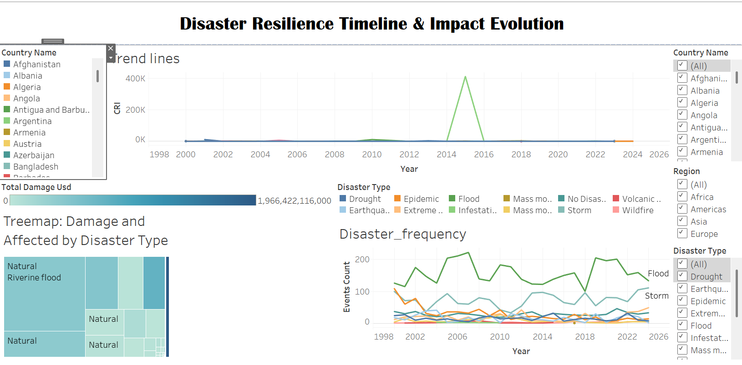
Figure 2: Disaster Resilience Timeline and Impact Evolution.
Interpretation:
- Temporal Volatility: The trend lines demonstrate the volatility of resilience in developing economies. Unlike stable curves for developed nations, countries like Afghanistan and Zimbabwe show "sawtooth" patterns, sharp declines in resilience following major disaster years, followed by slow recovery.
- Disaster Typology: The Tree Map (from exploratory analysis) indicates a divergence in impact. Storms and Floods (large blue/purple blocks) cause the highest aggregate economic damage. However, Earthquakes (red blocks) are disproportionately lethal, causing higher fatality counts despite lower frequency.

5. Key Results and Discussion
Our analysis of the fused data yielded several critical insights:
1. The Wealth-Resilience Correlation: As illustrated in Figure 2, there is a strong positive correlation (r > 0.6) between GDP per capita and the Composite Resilience Index. Wealthier nations possess the infrastructure to minimize V (Vulnerability), thereby keeping their CRI high even when E (Exposure) is significant.
2. The "Critical Risk Zones": The geospatial analysis (Figure 1) identifies "Critical Risk Zones", specifically in the Sahel region of Africa and parts of Southeast Asia. These regions suffer from a "double burden": high exposure to climate-related disasters (droughts and floods) and low adaptive capacity (HDI < 0.5).
3. Economic vs. Human Cost: Figure 2 reveals a divergence in impact types. Developed nations tend to suffer high economic losses (high property value) but low human losses. Conversely, developing nations suffer disproportionately high human losses for similar disaster magnitudes, validating the need for the DII metric which weighs human cost heavily.

5. Limitations and Future Work
- Data Gaps: Small island nations often lack consistent World Bank economic data, resulting in null CRI values for some high-risk regions.
- Proxy Limitations: The RRS uses immediate GDP growth as a proxy. Future work should implement a time-series windowing function to measure the exact duration (in months) required for GDP to return to pre-disaster levels.
- Aid Tracking: Due to data inconsistency in the 'Appeal' and 'Contribution' columns of EM-DAT, specific aid flow visualizations were excluded from the final dashboard.

6. Conclusion
The project successfully quantifies the inequality of global disaster recovery. Our analysis concludes that while wealth is the primary driver of recovery speed (RRS), institutional stability (Adaptive Capacity) is the deciding factor in minimizing human cost. The dashboard serves as a vital tool for GDHRA to identify "Critical Risk Zones" where high exposure converges with low adaptive capacity, directing humanitarian aid where it is structurally most needed.

7. References
- EM-DAT, "The International Disaster Database," Centre for Research on the Epidemiology of Disasters (CRED).
- World Bank, "World Bank Open Data," The World Bank Group.
- UNDP, "Human Development Reports," United Nations Development Programme.

