JSS Mahavidyapeetha

JSS SCIENCE AND TECHNOLOGY UNIVERSITY

Mysuru - 570 006



**“Handwriting Recognition”**

Project Report submitted in partial fulfillment of curriculum prescribed for Neural Network (CS620) for the award of the degree of

#### BACHELOR OF ENGINEERING

**IN**

**COMPUTER SCIENCE AND ENGINEERING**

*by*

Anirudh D Pai 01JST17CS019

Eeshaan Achar 01JST17CS052

Navneet Hosmane 01JST17CS097

Submitted to,  
Dr. Pushpalatha M P  
HEAD OF THE DEPARTMENT  
Dept. of CS&E, JSS S&TU MYSURU

**Abstract**

Character recognition is a classic pattern recognition problem for which researchers have worked since the early days of computer vision. With today's omnipresence of cameras, the applications of automatic character recognition are broader than ever.

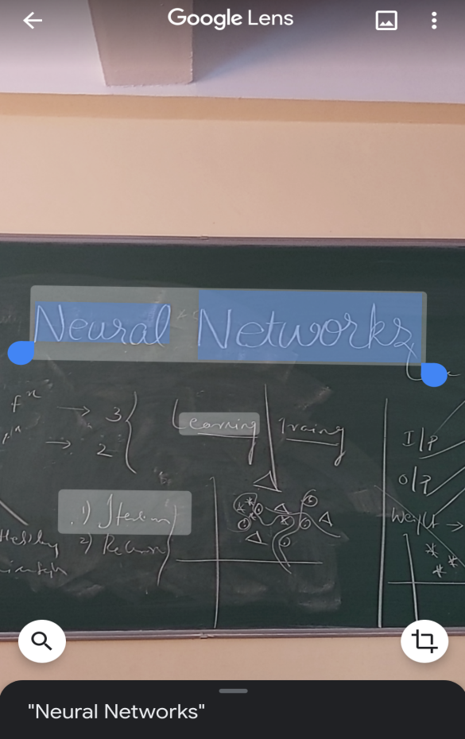

The inspiration for this project is Google Lens, which is an image recognition technology developed by Google, designed to bring up relevant information related to objects it identifies using visual analysis based on a neural network. When directing the phone's camera at an object, Google Lens will attempt to identify the object by reading barcodes, QR codes, labels and text, and show relevant search results and information.

In this project we are trying to achieve accurate recognition of handwritten characters. The text data will be fed as images and resized to smaller resolution. Each character will then be separated and the algorithm will be applied.

**Basic Block Diagram**

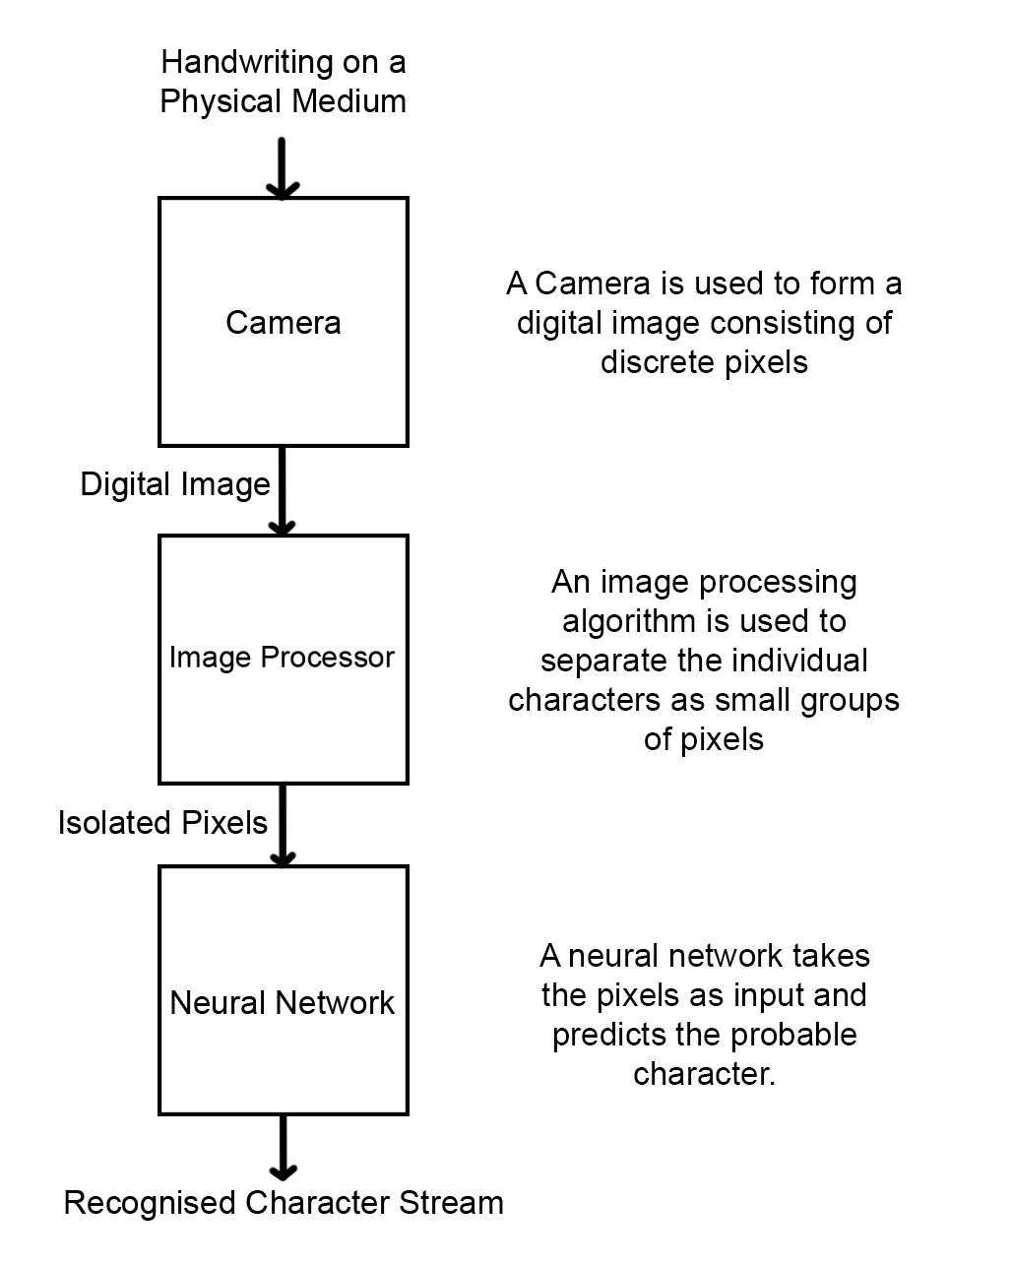

**Functional Requirements**

1. The system should process the input given by the user only if it is an image file (JPG, PNG, etc).

2. System shall show the error message to the user when the input given is not in the required format.

3. System should detect characters present in the image.

4. System should retrieve characters present in the image and display them to the user.

5. In case of overlapping handwriting, the system should be able to segregate them.

**The Dataset**

The dataset for the training and testing of the neural network wasdownloaded from

<http://www.ee.surrey.ac.uk/CVSSP/demos/chars74k/>

Our dataset consists of 3410 hand drawn characters using a tablet PC. There are a total of 64 classes (0-9, A-Z, a-z), each having 55 samples.

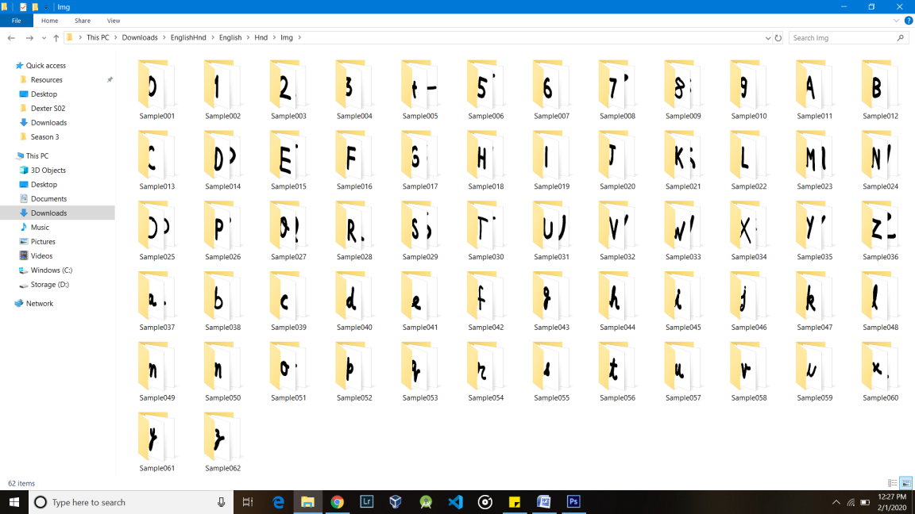

**Implementation Issues**

The expected implementations issues are

* **Segregation of the individual Characters**: As the handwriting image consists of continuous stream of characters, separating them into individual group of pixels, each having enough pixels to be fed into the Neural Network seems to be a huge overhead/complexity in implementation of the solution to the defined problem.
* **Complexity of the Network**: As there are 62 different classes of characters, the network as a whole might be very complex, especially given our lack of knowledge in the field as of today.
* **Recognizing bad / unconventional handwritings**: Even though we are training the sample with 55 samples for each class, our intuition tells us that we can still come across ‘bad handwritings’ which the neural network may fail in identifying.