Eesha Emaan
23i-2501
DS-5C
Data Visualization: Assignment 1
Visual EDA and Implementation of Studied Concepts

AIRBNB LISTINGS DATASET ANALYSIS REPORT
Hypothesis:
“Entire homes/apartments are more expensive than private or shared rooms, and within each room type, certain property types (like Apartments vs Houses vs Lofts) command higher prices.”
UNIVARIATE ANALYSIS:

Boxplot of Price:
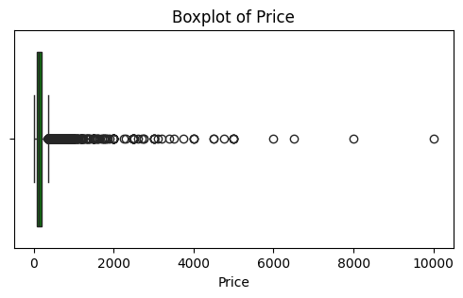
So first, here during my analysis of the dataset, I made a box plot for the price column, as it is numerical and going to be used in my further analysis. I got to know that it is too much spread with large prices, so I used the IQR technique to remove outliers and make the price column concentrated with a common, easy-to-analyze range.
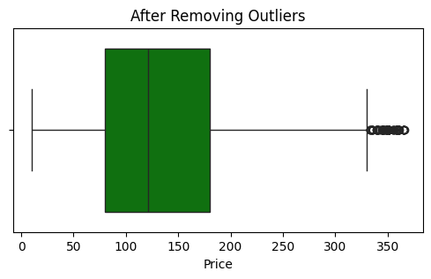
Now, after removing outliers, it is in the range 0 to 400, which shows the Price spread in a better way. This plot also identifies Median = 121.0, Q1 = 81.0 and Q3 = 195.0. Lower bound is -90.0 and upper bound is 366.0. Hence, it is evenly spread now.

Histogram of Price:
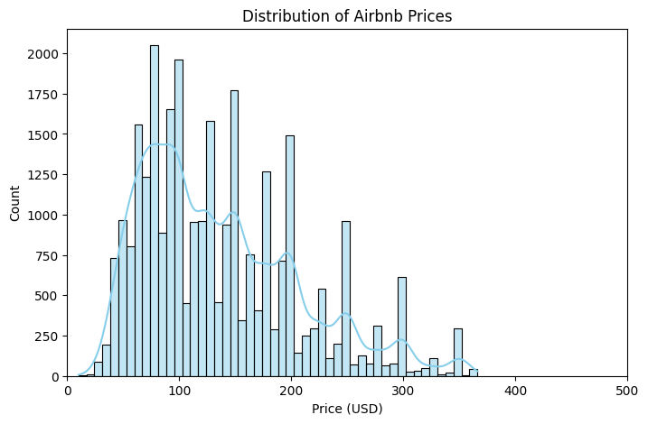
This plot shows that most Airbnb listings are priced below $300, with only a few high-priced listings. The distribution is right-skewed, showing that a small number of expensive listings exist. It confirms a wide variation in prices, useful for understanding how price behaves before comparing across room types.

Countplot of Room Type:
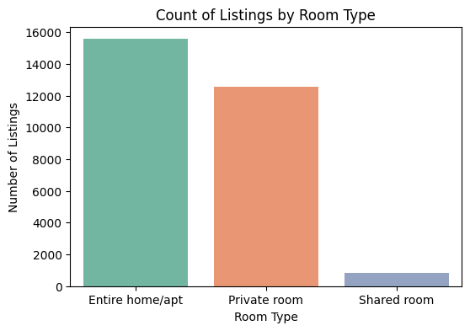
“Entire Home/Apartment” listings are the most common, followed by “Private Rooms.” “Shared Rooms” are rare, contributing very little to the overall data. This suggests that entire homes dominate the listings and are likely to have higher average prices, supporting the first part of the hypothesis.

Count of Listings by Property Type:
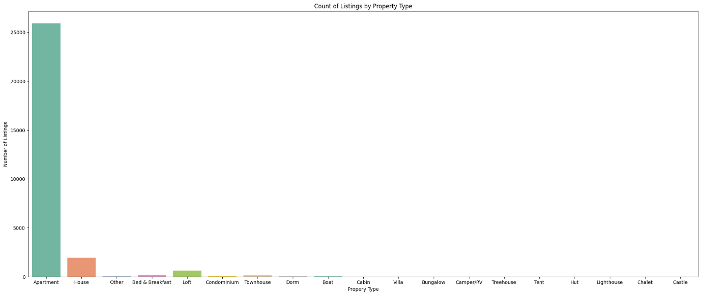
Apartments and houses dominate the listings, while property types such as lofts, bed & breakfasts, and townhouses appear much less frequently. This helps identify which property types most influence price differences, as the rare categories have minimal impact on the overall pattern.

BIVARIATE ANALYSIS:

Box Plot of Price by Room Type:
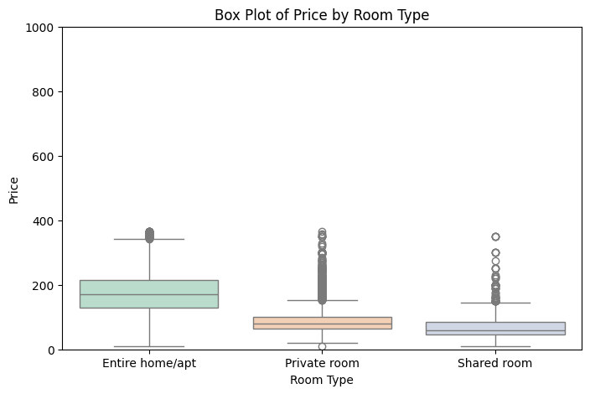
The boxplot shows that Entire Homes/Apartments have a much higher median and wider price range compared to Private or Shared Rooms. This strongly supports the hypothesis that entire units are generally more expensive.

Barplot showing average price by room type:
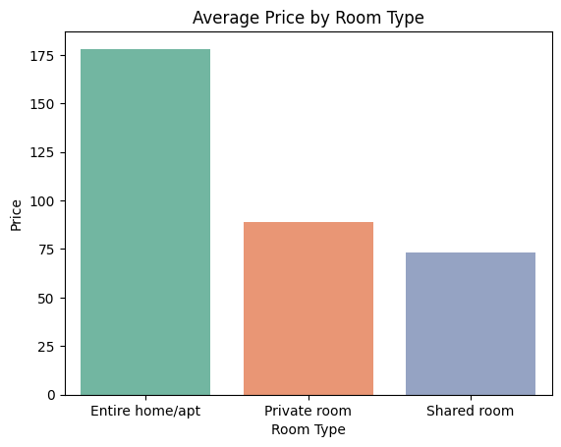
Average prices are highest for Entire Homes/Apartments, followed by Private Rooms, and lowest for Shared Rooms. The difference between entire homes and other room types is significant, confirming that room type has a strong influence on pricing. Whereas, private and shared rooms average prices are almost near.

MULTIVARIATE ANALYSIS:

Scatterplot showing Property Type vs Price by Room Type:
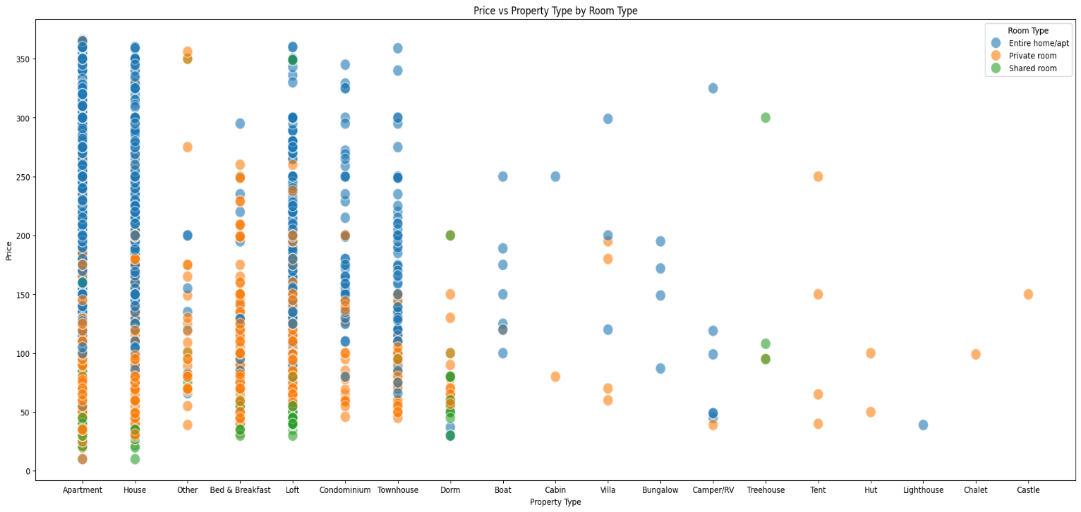
This scatterplot reveals that within each room type, certain property types such as apartments, houses, lofts, townhouses, and condominiums consistently show higher prices. It supports the second part of the hypothesis that property type also impacts pricing patterns within each room type.

Heatmap of Average Price by Room Type and Property Type:
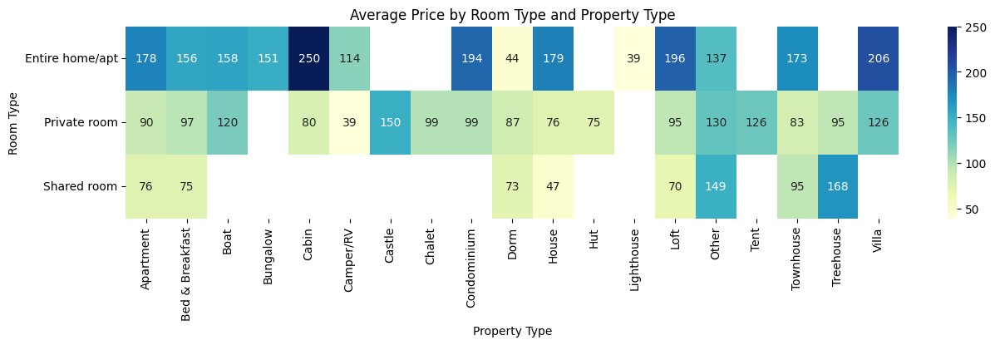
The heatmap highlights which combinations of room and property types are most expensive. For example, Entire Homes/Apartments that are Cabins, Villas, Lofts, or Condominiums have higher mean prices. In Private Rooms, Castles lead, while in Shared Rooms, Treehouses show higher averages. This confirms that both room and property type together determine pricing trends.

Barplot for average Price by Property Type and Room Type:
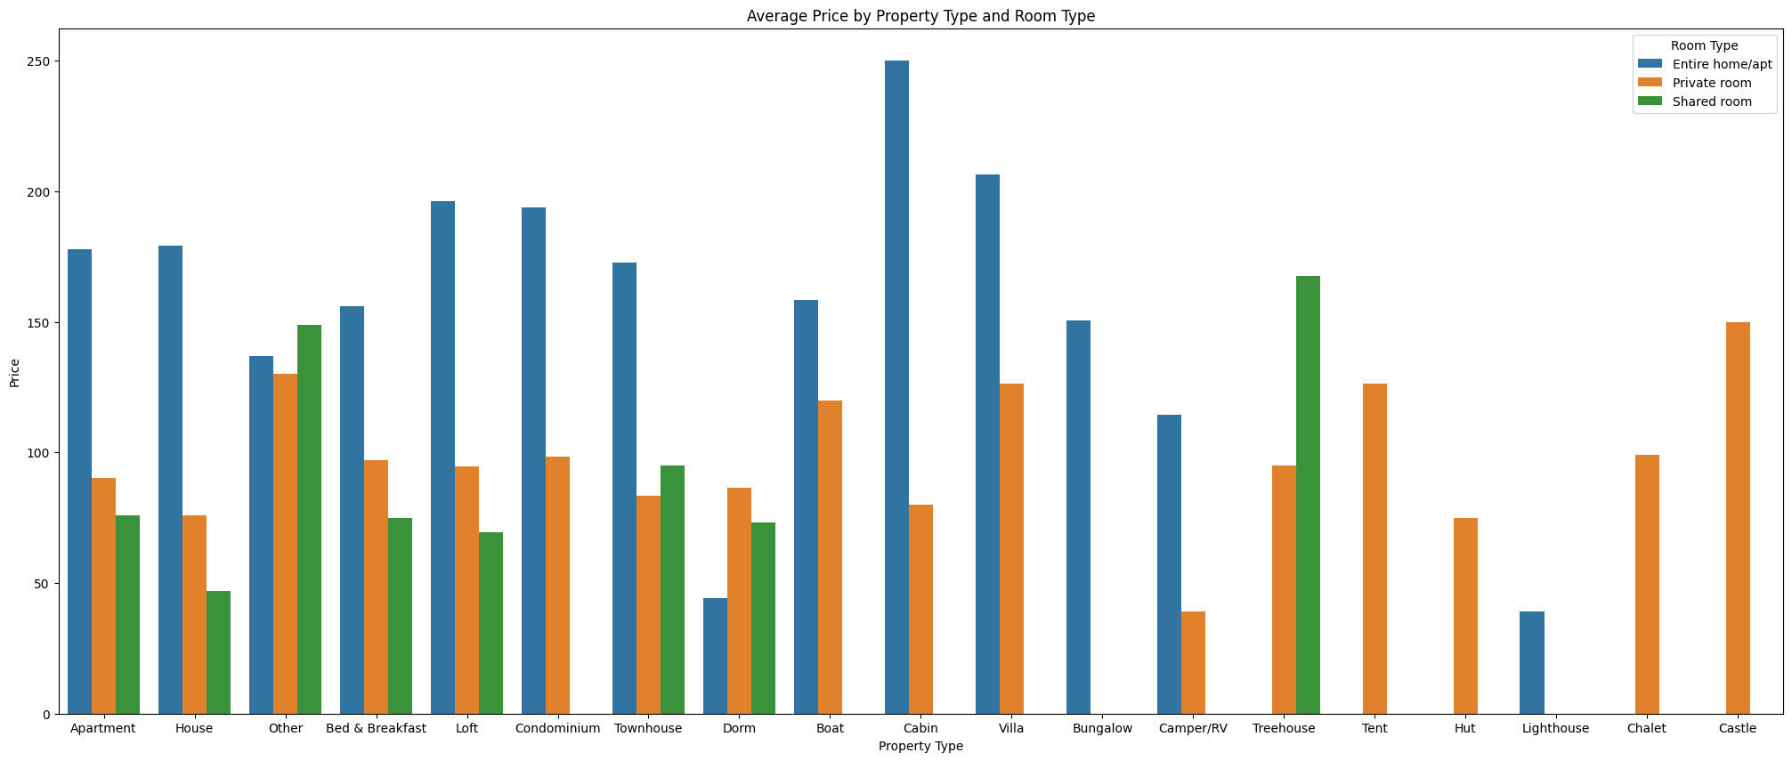
This plot provides a clear visual comparison showing that across nearly all property types, Entire Homes/Apartments have the highest prices. It reinforces the hypothesis and validates the trend observed in other visualizations.

INSIGHTS AND CONCLUSIONS:
- This plot provides a clear comparison showing that across property types, Entire Homes/Apartments almost always have the highest prices. It strengthens the conclusion that your hypothesis holds true.
- The visual analysis strongly supports the hypothesis that Entire Homes/Apartments are more expensive than Private or Shared Rooms.
- Room type is a major factor influencing Airbnb prices, with Entire Homes/Apartments having both the highest median and average prices.
- Within each room type, property type also affects price — luxury property types like Villas, Lofts, and Condominiums consistently command higher prices.
- The removal of outliers helped to clarify these relationships, ensuring that the analysis reflects typical market behavior instead of being distorted by luxury extremes.
- The results suggest a clear hierarchy in pricing: Entire Homes > Private Rooms > Shared Rooms.

RECOMMENDATIONS FOR FURTHER ANALYSIS:
- Include location-based variables (e.g., neighborhood) to see how geography influences price.
- Analyze host-related features, such as host since or number of reviews, to understand their impact on pricing.
- Future analysis could also use ratings to connect guest satisfaction with pricing levels.

FOOTBALL WORLDCUP MATCHES DATASET ANALYSIS REPORT
Hypothesis:
“Host nations were more likely to win or reach the semi-finals in the early decades of the World Cup than in the modern era, indicating a decline in home advantage over time.”

UNIVARIATE ANALYSIS:

Bar Plot showing overall Host Country Success:
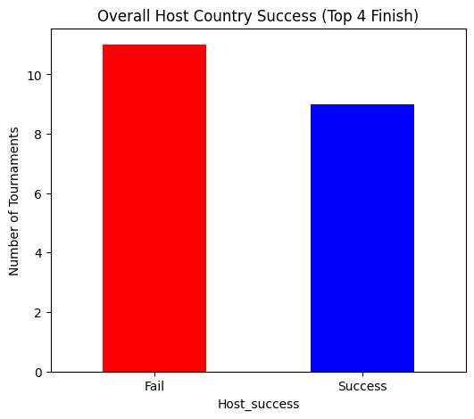
Shows the total number of times host countries succeeded (reached Top 4) vs failed (did not reach Top 4). Higher failure bars suggest that hosting does not guarantee success. This indicates that host advantage has varied over time and may have declined in modern tournaments.

BIVARIATE ANALYSIS:

Line Plot to show decline of Host Country Advantage Over Years:
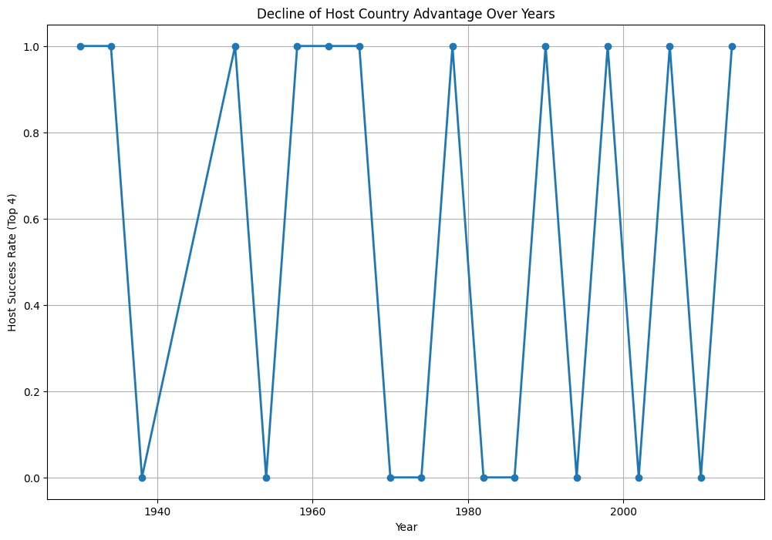

Tracks host success rate across individual World Cup years. Early tournaments show more frequent success for host nations. After 1980, success becomes less consistent, indicating that hosting alone no longer ensures reaching the Top 4.

Bar Plot showing Average Host Success by Decade:
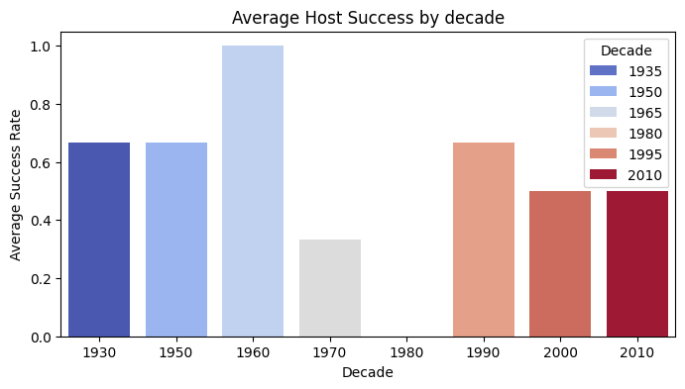
Compares average host success across decades. Early decades (first 40 years) show higher success ratios compared to later decades. Confirms that home advantage was stronger historically, supporting the hypothesis.

Line Plot showing Host Nation Success Over Decades:
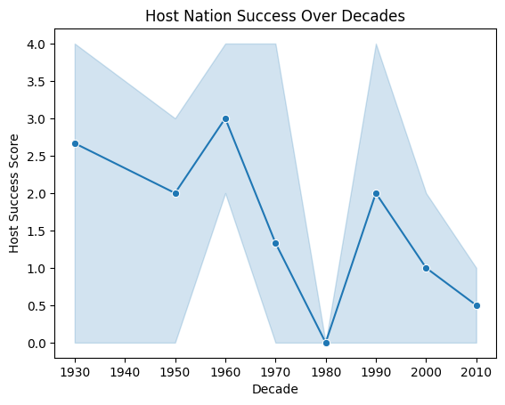
Host success scores (Winner=4, Runner-up=3, Third=2, Fourth=1, None=0), this plot shows overall host performance over decades. A clear decline in performance is visible after 1980, showing that host teams no longer benefit from home advantage.

MULTIVARIATE ANALYSIS:

Heatmap showing Host Performance by Decade:
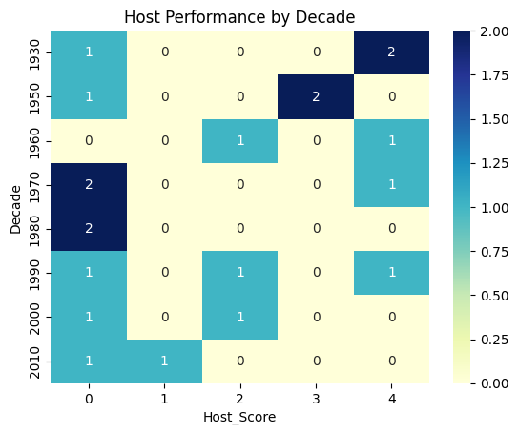
Shows the number of hosts reaching each stage (Winner, Runner-up, Third, Fourth) per decade. Early decades (1930–1980) show stronger host performance, with multiple hosts reaching Top 4. From 1990 onwards, we clearly see fewer hosts reach Top 4, indicating a reduction in the advantage of hosting.

Stacked Bar showing Proportion of Host Performance by Decade:
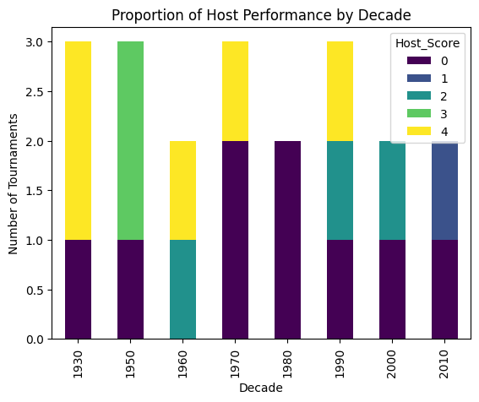
Visualizes the proportion of hosts reaching each stage(Winner, runner-up, third, fourth) per decade. Early decades are dominated by higher-stage performance (winner and runner-up), while modern decades mostly show lower-stage performance (third or fourth). Even overall heights of winning or coming in top 4 decreases too. Clearly confirms the decline of home advantage over time, supporting the hypothesis.

INSIGHTS & CONCLUSIONS:
- During early tournaments -> Hosting significantly improved chances of reaching Top 4 or winning.
- During modern tournaments -> Home advantage has decreased; hosting alone no longer guarantees high performance or success chances.
- The line and bar plots show a clear downward trend in host success over decades.
- Multivariate plots (heatmap and stacked bar) illustrate that early decades were dominated by strong host performances, while modern decades are more balanced and not biased.
- Overall, the visual analysis supports the hypothesis that home advantage has declined over time.

RECOMMENDATIONS FOR FURTHER ANALYSIS:
- Examine whether host nations tend to score more goals compared to other teams in tournaments they host.
- Study the relationship between QualifiedTeams and host success to see if tournament size affects the host’s chance of reaching the Top 4.
- Investigate if the number of “MatchesPlayed” has an influence on host performance.
- Explore whether higher Attendance for host matches correlates with better host performance, as crowd support may contribute to home advantage.
Create a Graph and network diagram for all football matches of the 2014 world cup via utilization of provided data.
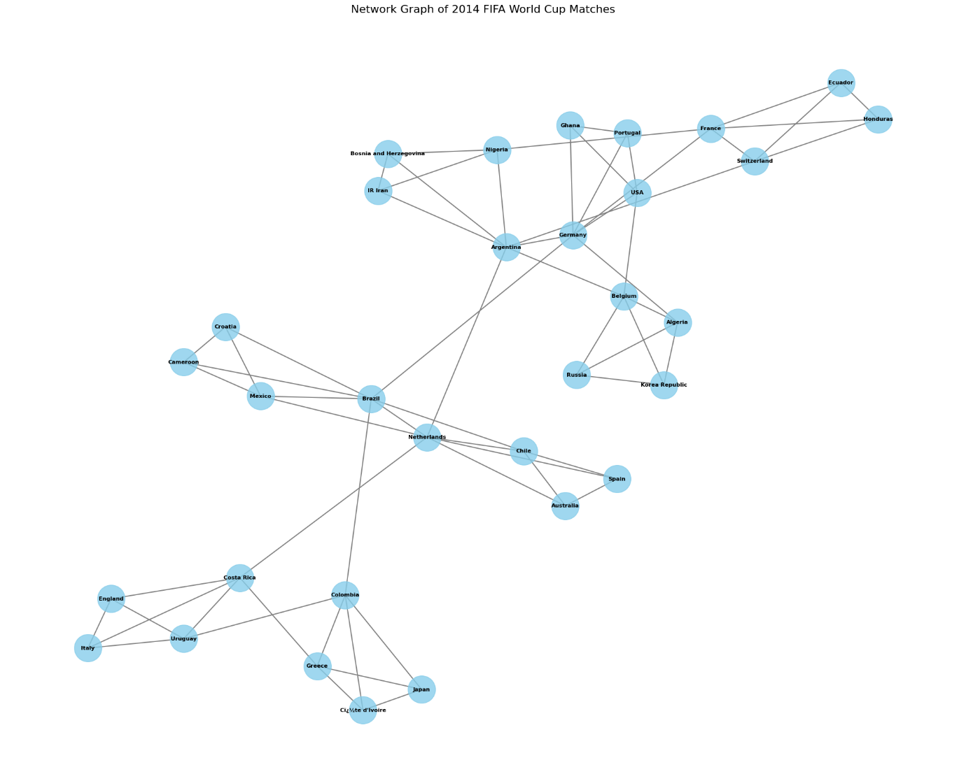
Description of Graph:
- Each node represents a team that participated in the 2014 FIFA World Cup.
- Each edge represents a match played between two teams.
- Since the graph is undirected, the edge only shows a connection between two teams, without indicating who won or lost.
- Gray edges with moderate thickness were used for visibility.
- spring_layout positions nodes based on a force-directed algorithm, meaning teams with more matches (more connections) are pulled towards the center, while less-connected teams appear on the periphery.
- Set k=0.35 and iterations=50 to make spacing visually balanced.
- Team names are displayed as labels for clarity using nx.draw_networkx_labels.
- Large figure size, clear node colors, edge colors, and bold labels make the network easy to interpret.

Interpretation of Graph:
- Teams in the center of the network likely played more matches.
- Teams on the edges had fewer matches, often those eliminated in the group stage.
- Nodes closer together indicate teams that faced each other more frequently or participated in the same group.

