University of Washington

Department of Electrical Engineering

EE 472, Spring 2015

**Report for Lab 3:**

**Interrupts**

Report by:

Denny Ly

Eeshan Londhe

Ruchira Kulkarni

# Introduction

The purpose of this lab is to understand how to use hardware interrupts and implement the distance sensor for the RoboTank system. After gaining a further understanding of how interrupts work, the goal is to enable key presses using interrupts. Then, modify the code from the previous lab to run my efficiently by removing polling with interrupt driven software. Our group created “Guess the Height” (GTH) game that allows the user to play a game with the distance sensor. Overall, through the process of doing the lab objectives and creating the game, our group gained a strong understanding of how interrupts work. We referenced the LM3S8962 manual to learn how to initialize interrupts for timers and GPIO ports.

# Control Flow Diagram

This chart shows the flow of our code throughout the GTH game. The game begins when the user presses the select button and goes to the main menu. The menu toggles through three modes of play for the GTH game. Once the user decides on a game to play, the code will start the game and go through a countdown. After the countdown finishes, the game will begin at the level you selected. The game will go on until you guess 9 heights within the time limit. After the game in complete, the user will have the option of playing the level again or going back to the main menu to choose a different level.

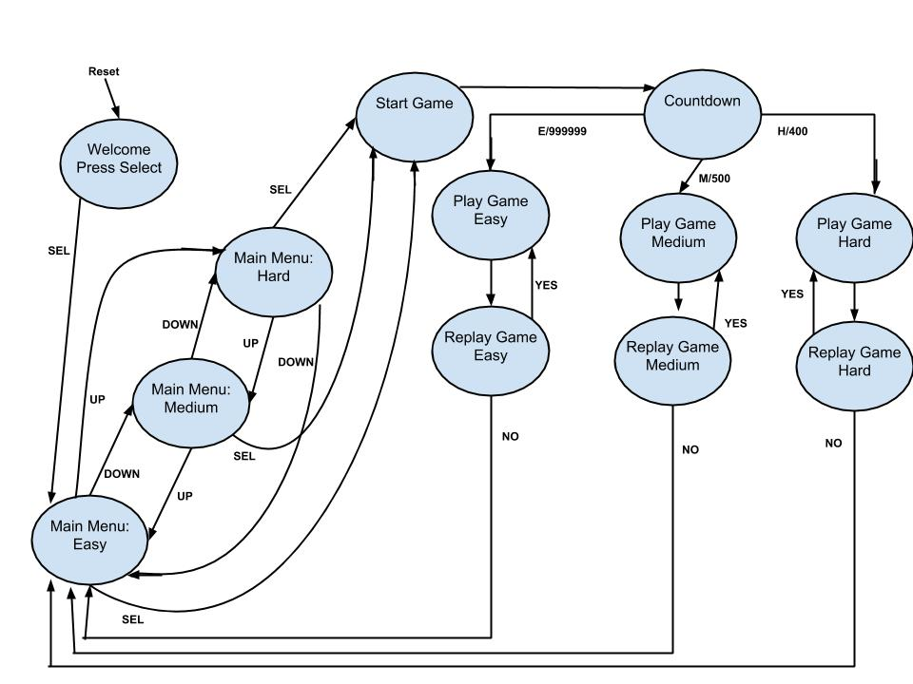

# Hardware Schematic

The microcontroller takes in five inputs from the keypad. The microcontroller outputs 7 data bits to the LCD. There are also three control bits being outputted that controls the read or write, enable and reset of the LCD. One data bit of the LCD is just being grounded. The LCD’s power supply is coming from the +5V port on the controller and the potentiometer to determine the brightness on the LCD.

The control/data wire is connected to the ADC0 port of the Stellaris board. The power is given to the sensor with a 5V pin on the board, and ground is connected to ground on the board as well.

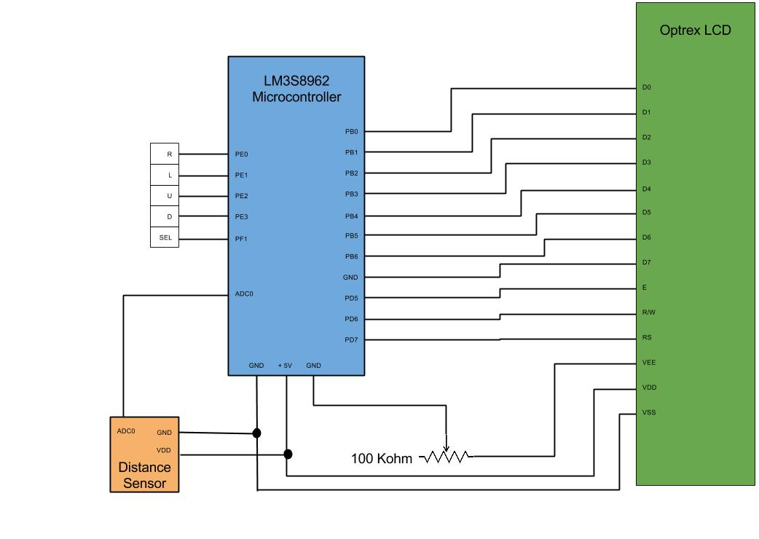

**Memory Diagram**

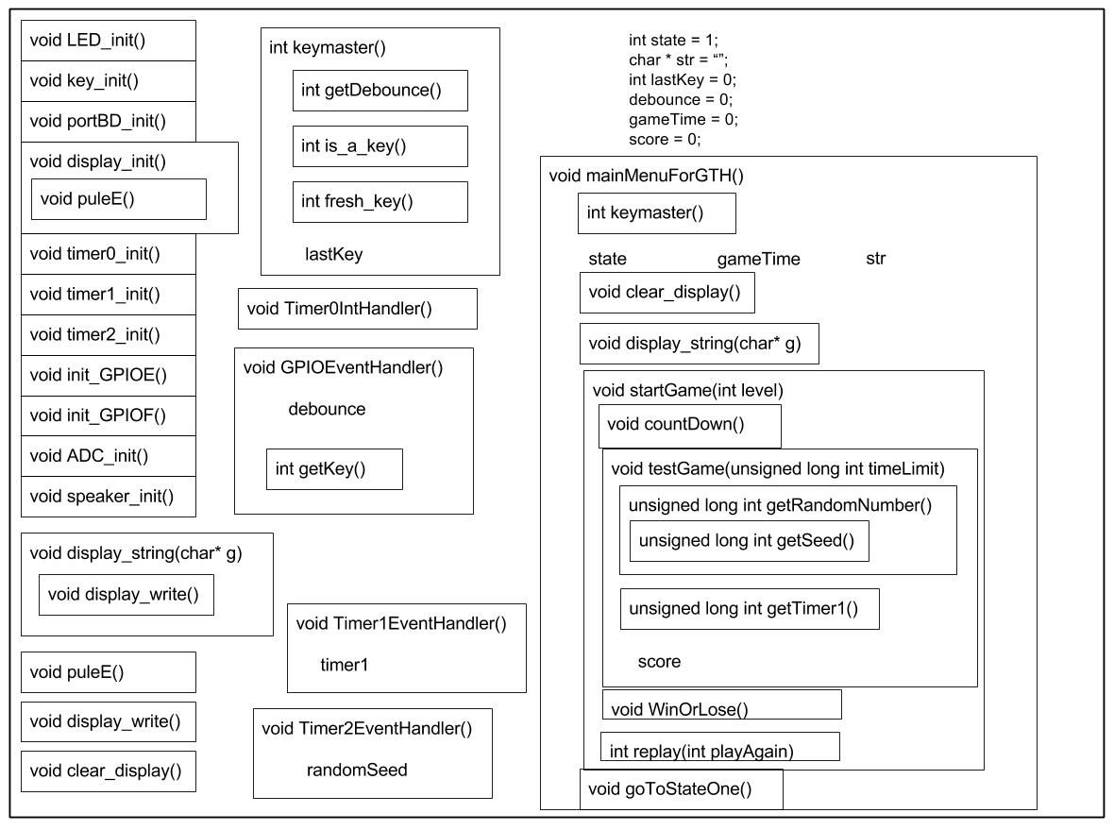This memory diagram shows how all of the functions relate to each other. It displays the hierarchy Top-Down to explain how and when a function would be called. The global variables are also displayed and this shows how the functions interact with the global variables to get/set their values.

game

**Conclusion**

The lab helped us understand more about the GPIO ports and how to use other peripheral devices like sensors with the LM3S8962 microcontroller. There were a couple of challenges that we came across while developing our lab. One of our problems was initializing the interrupts for the GPIO PORTS E and F. Initially; we had set the interrupt so it would read the posedge instead of the negedge value of the key press. However, we realized that when reading values of key presses, the posedge corresponded to when the key was not being pressed and the negedge corresponded to the button being pressed. Another challenge we came across was on assuming that the value of the register TAIL_R was changing as time went on, but it was actually a constant value. So, to get around this problem we created a global variable that decreased every time the interrupt occurred and we used that as a timer. Overall, we learned a lot about using different peripherals on the board and are excited to use this newfound knowledge in future labs.