University of Washington

Department of Electrical Engineering

EE 472, Spring 2015

**Report for Lab 2:**

**I/O and Peripherals**

Report by:

Denny Ly

Eeshan Londhe

Ruchira Kulkarni

# Introduction

The purpose of this lab is to learn how to use the GPIO pins to configure an LCD display. Once configured, the goal was to create some sort of menu to display understanding of how the display works. Our group created a main menu for a DDR game as well as creating the game itself. The game allows the player to input a sequence of arrows that show up on the screen. Overall, through the process of creating the game, our group gained a strong understanding of how GPIO pins and peripherals work. We referenced the LM3S8962 manual to find what bits on which Ports are needed for the LCD display. We also referenced the Stellaris manual to find which Ports the keypad buttons were on. Also, we used the Optrex manual to configure the LCD Display.

# Control Flow Diagram

This chart shows the flow of our code throughout the DDR game. The game begins when the user presses the select button and goes to the main menu. The menu toggles through three modes of play for the DDR game. Once the user decides on a game to play, the code will start the game and go through a countdown. After the countdown finishes, the game will begin at the level you selected. The game will go on until there are nine correct in a row or the user gets one of the arrows incorrect. After the game in complete, the user will have the option of playing the level again or going back to the main menu to choose a different level.

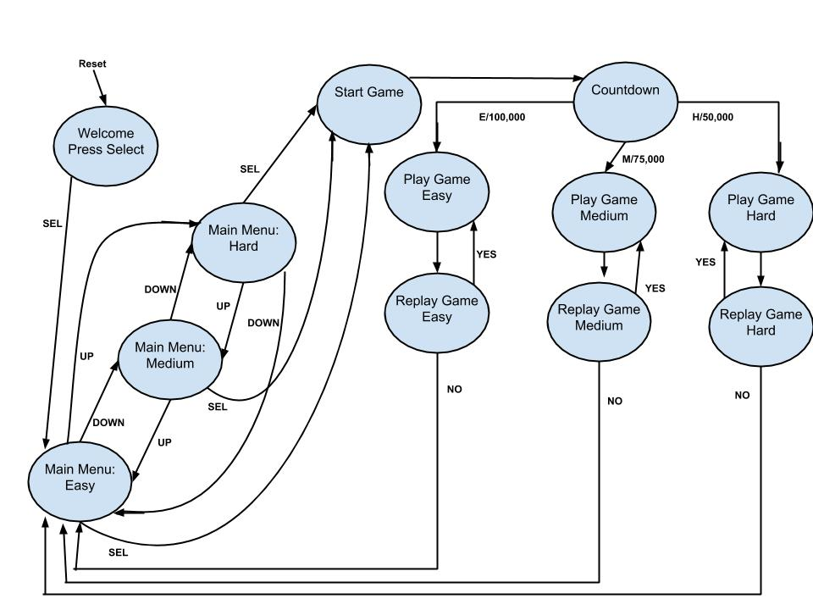

# Hardware Schematic

The microcontroller takes in five inputs from the keypad. The microcontroller outputs 7 data bits to the LCD. There are also three control bits being outputted that controls the read or write, enable and reset of the LCD. One data bit of the LCD is just being grounded. The LCD’s power supply is coming from the +5V port on the controller and the potentiometer to determine the brightness on the LCD.

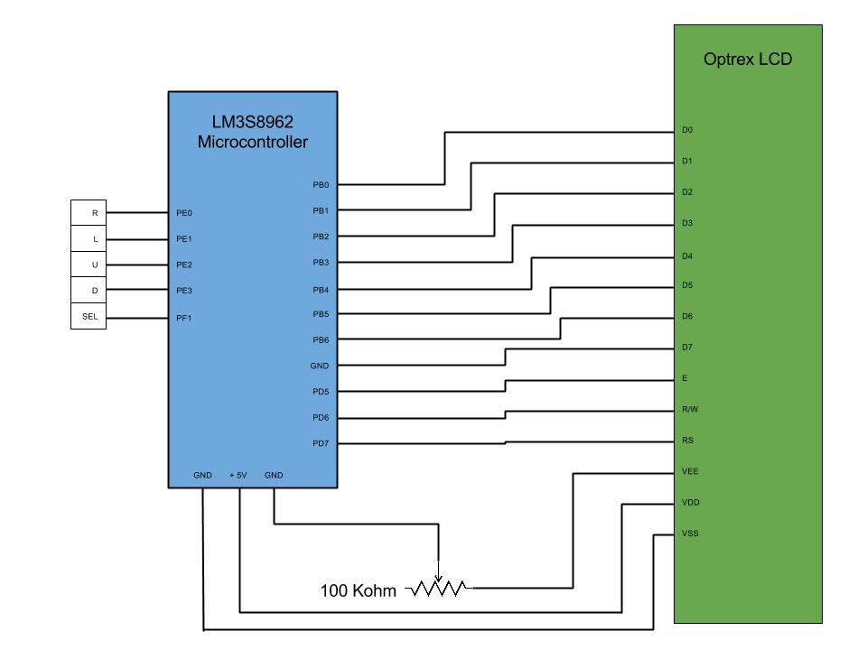

**Conclusion**

The lab helped us understand more about the GPIO ports and how to use other peripheral devices with the LM3S8962 microcontroller. There were a couple of challenges that we came across while developing our lab. One of our problems is printing things on the second line. We figured out each line on the LCD can hold up to 41 characters before we can begin displaying characters on the second line. Another problem that we came across was learning the bitwise operations. The operations was an essential technique for initializing the GPIO ports to be used throughout the lab. Overall, we learned a lot about using different peripherals on the board and are excited to use this newfound knowledge in future labs.