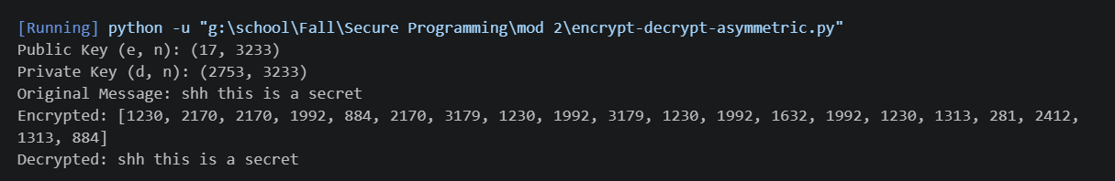
This is the input/output showing the asymmetric encryption both encrypts and decrypts properly. This is a proof of concept directly using the RSA formula for encrypting. In practice it would be asymmetric because the private key would never actually be shared with anyone.

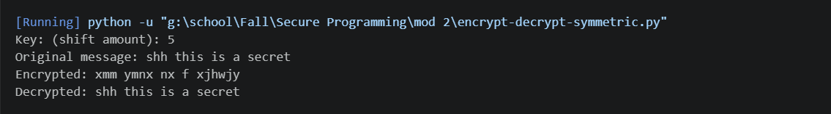

This is the input/output, showing how a Caesar Cipher is able to create ciphertext in the use of symmetrical encryption. As long as both parties are familiar with how the key is shifting the message they will both be able to read and send encrypted messages. In order for this method to actually be secure, the key would need to be shared securely.

