Documentation for RBA Authentication Mini Application
For now, there is no form input, and roles are hardcoded, where:
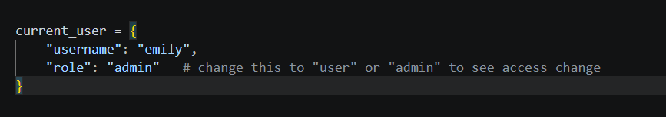
outputs:
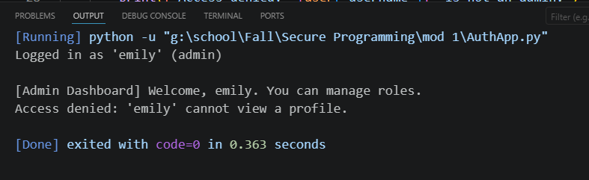
And where:
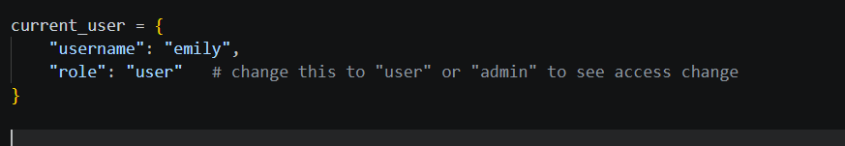
outputs:
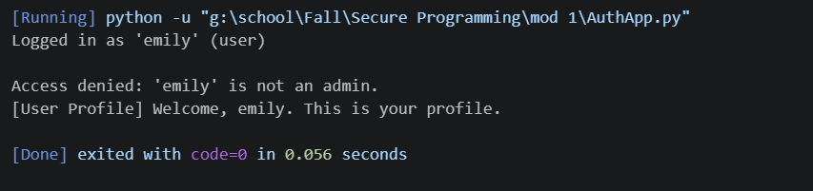

This system is an example of the first portion of CIA Triad in that Confidentiality is where neither user can access the other user’s account profile. Confidentiality being defined by how secrets and authentication are managed, and confidentiality would be compromised if multiple users could have access to the information related to authentication for accounts they are not meant to have access to.

