IMPLEMENTATION OF CONTRAST ENHANCEMENT OF
MULTIPLE TISSUES IN MR BRAIN IMAGES WITH REVERSIBILITY

Abstract. Contrast enhancement (CE) of Magnetic Resonance (MR) brain images is a critical preprocessing step in clinical diagnosis. This report presents a complete MATLAB implementation of the hierarchical reversible CE scheme proposed by Wu et al. (2021, IEEE Signal Processing Letters). A deep convolutional neural network (U-Net) — approximated via multi-level Otsu thresholding (multithresh) — segments the MR image into Background, CSF, Grey Matter, and White Matter. For each tissue, principal grey-level values are identified using percentage threshold R, and the corresponding histogram bins are iteratively expanded S times using Reversible Data Hiding (RDH) via Equation (1), achieving histogram equalization. Recovery information (pL, pR per iteration) is stored in the LSBs of the last 16 pixels, enabling lossless original image recovery via Equations (2) and (3). Experimental results confirm correct multi-tissue enhancement and perfect reversibility (PSNR = inf) across all tissues.
1. Introduction
Magnetic Resonance Imaging (MRI) produces detailed soft-tissue images of the brain using magnetic fields and radio waves, emitting no harmful ionising radiation. However, MR images frequently suffer from low contrast between adjacent tissue classes — particularly between White Matter (WM), Grey Matter (GM), and Cerebrospinal Fluid (CSF) — making clinical diagnosis difficult without further processing. Contrast Enhancement (CE) is therefore an essential preprocessing step in medical image analysis.
A significant limitation of conventional CE is that it permanently alters pixel values, potentially destroying diagnostic information. Techniques based on Reversible Data Hiding (RDH) embed all information required to restore the original image within the enhanced image itself, allowing perfect recovery when needed.
Prior reversible CE algorithms (Wu et al. 2015 [19]; Wu et al. 2020 [27]) used Otsu or GrabCut segmentation to separate background from ROI, then excluded background histogram bins from expansion. These approaches are limited: accuracy degrades for small or interconnected tissues, and only a single enhanced image is produced per original image. Wu et al. (2021) address both limitations with a hierarchical CE scheme guided per-tissue via U-Net CNN segmentation, producing one enhanced image per tissue class from the same original MR image.
2. System Overview
The proposed scheme consists of five main stages, implemented as MATLAB functions:
- Tissue Segmentation — Divide MR image into classes using U-Net (multithresh approximation in implementation).
- Principal Grey-Level Identification — Identify values with frequency > R in each tissue; only these bins are eligible for expansion.
- Histogram Preprocessing — Shrink histogram extremes to reserve S empty bins per side, preventing overflow after S expansion rounds.
- Procedure 1 (Enhancement) — Apply Equation (1) iteratively S times, expanding the two highest eligible bins and embedding recovery bits.
- Procedure 2 (Recovery) — Extract bits via Equation (2), restore pixel values via Equation (3), reverse preprocessing.
Key Insight: CE bins are chosen per-tissue (not per-background). The same pixel value shared by ROI and background no longer causes conflicts, and multiple tissue-enhanced images are independently generated from one MR image — the core advance over [19] and [27].
3. Mathematical Formulation
3.1 RDH-Based Histogram Modification — Equation (1)
Given the two highest-frequency histogram bins pL and pR (pL < pR), every pixel value p is transformed to p′. Bit bi ∈ {0,1} is embedded for the i-th pixel at pL or pR:
p′ = p − 1, if p < pL
p − bi, if p = pL (embeds bit bi)
p, if pL < p < pR (unchanged)
p + bi, if p = pR (embeds bit bi)
p + 1, if p > pR (Eq. 1)
Applying Eq. (1) for S iterations achieves Histogram Equalization (HE) while all modification parameters remain embedded and recoverable.
3.2 Principal Grey-Level Threshold
For each segmented tissue T, a grey-level v is designated as principal if:
percentage(v) = count(v in T) / |T| > R (Eq. 2)
Only principal bins are eligible for expansion. Non-principal bins are merely shifted outward. This focuses CE on dominant tissue intensities, improving adaptability across tissue types.
3.3 Bit Extraction — Equation (2)
Given the last expanded bins pLL and pLR, a bit b′ is extracted from pixel p′:
b′ = 1, when p′ = pLL−1 or p′ = pLR+1
b′ = 0, when p′ = pLL or p′ = pLR
b′ = null, other cases (Eq. 3)
3.4 Pixel Recovery — Equation (3)
Simultaneously, the original pixel p is reconstructed from p′:
p = p′ + 1, when p′ < pLL
p = p′, when pLL−1 < p′ < pLR+1
p = p′ − 1, when p′ > pLR (Eq. 4)
3.5 Quality Metrics
PSNR = 10 · log₁₀(255² / MSE) where MSE = (1/HW)·Σ(I − Ic)² (Eq. 5)
When I is perfectly recovered from Ic, MSE = 0 and PSNR = ∞. RCEOI (Relative Contrast Enhancement), REEOI (Relative Entropy Enhancement), and RMBEOI (Relative Mean Brightness Error) follow [34]. SSIM measures perceptual similarity between original and enhanced images.
4. Tissue Segmentation
The paper uses U-Net [32] trained on 50 T2-weighted NeoBrainS12 images (384×384) to automatically segment MR images into Background, CSF, Grey Matter, and White Matter. In implementation, U-Net is approximated using MATLAB's multithresh (multi-level Otsu) followed by imquantize, with bwareaopen removing small isolated regions for noise suppression.
MATLAB Code — Tissue Segmentation (segment_tissues_multiotsu.m)
function label_map = segment_tissues_multiotsu(img, n_classes)
% Approximate U-Net segmentation via multi-level Otsu thresholding.
% Paper Sec. II-B-1: segments MR image into tissue classes.
% label_map: 0=Background, 1=CSF, 2=Grey Matter, 3=White Matter
img = double(img);
thresholds = multithresh(img, n_classes - 1); % n_classes-1 thresholds
label_map = imquantize(img, thresholds) - 1; % 0-indexed labels
label_map(img == 0) = 0; % force pure-black to background
for cls = 1:(n_classes - 1)
mask = (label_map == cls);
mask = bwareaopen(mask, 200); % remove regions < 200 px
label_map(label_map == cls & ~mask) = 0;
end
end
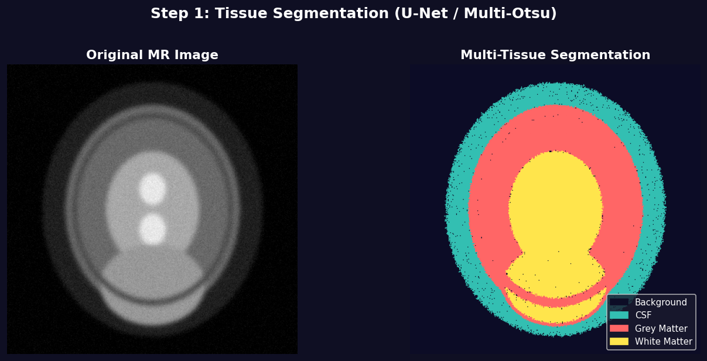
Fig. 1 — Tissue segmentation result on synthetic MR brain image. Four classes: Background (black), CSF (dark), Grey Matter (mid), White Matter (bright). Generated by the multi-level Otsu approximation of U-Net segmentation.
5. Principal Grey-Level Identification
For each segmented tissue, the percentage of every grey-level value is computed. Values exceeding threshold R = 1% are labelled as principal. Only those histogram bins are eligible for expansion via Eq. (1). Non-principal bins are only shifted, never expanded — the key difference from [19] and [27].
MATLAB Code — Principal Grey-Level Identification (identify_principal_greylevels.m)
function principal_vals = identify_principal_greylevels(img, tissue_mask, R)
% Paper Sec. II-B-2: find grey-levels with percentage > R within tissue.
% Returns: principal_vals — 0-indexed grey-level values (vector)
pixels = double(img(tissue_mask));
total = numel(pixels);
if total == 0
principal_vals = [];
return;
end
hist_counts = histcounts(pixels, 0:256); % counts for values 0..255
percentages = hist_counts / total;
% Return 0-indexed grey-level values with percentage > R
principal_vals = find(percentages > R) - 1;
end
6. Histogram Preprocessing
Before expanding bins, a preprocessing step reserves S empty bins on each side of the histogram to prevent pixel value overflow after S iterations of Eq. (1). Pixels in [0, S−1] are mapped to S; pixels in [256−S, 255] are mapped to 255−S. This shrink preserves the relative order of all pixel values.
MATLAB Code — Histogram Preprocessing (preprocess_histogram_shrink.m)
function [pre_img, lut] = preprocess_histogram_shrink(img, S)
% Reserves S empty bins each side; prevents overflow after S expansions.
% Paper [24]: shrinks histogram preserving relative pixel order.
lut = uint8(0:255); % identity LUT
lut(1:S) = uint8(S); % values 0..S-1 -> S
lut(256-S+1:256) = uint8(255-S);% values 255-S..255 -> 255-S
pre_img = lut(double(img) + 1); % apply LUT (1-indexed in MATLAB)
end
7. Procedure 1 — Hierarchical Tissue Contrast Enhancement
For each tissue class, Procedure 1 generates one tissue-enhanced image Ic. At each of S iterations:
- Find pL, pR: the two highest bins from among the principal grey-level values in the current histogram.
- Encode pL, pR: as 16 bits (8+8) — the side information for this round.
- Apply Eq. (1): to all pixels, embedding the encoded bits into pixels at pL and pR.
- Record (pL, pR): in the expansion history for use during recovery.
After all S rounds, the last (pL, pR) pair is stored in the LSBs of the last 16 pixels (8 bits for pL, 8 bits for pR). Neither the segmentation map nor R is required for recovery.
MATLAB Code — Equation (1) Application (apply_equation1.m)
function [out_img, bit_idx] = apply_equation1(img, pL, pR, bits)
% Paper Equation (1): histogram bin expansion with bit embedding.
% p' = p-1 if p < pL
% p-bi if p = pL (embed bit bi)
% p if pL < p < pR
% p+bi if p = pR (embed bit bi)
% p+1 if p > pR
flat = double(img(:));
out = flat;
bit_idx = 0;
for i = 1:numel(flat)
p = flat(i);
if p < pL
out(i) = p - 1;
elseif p == pL
bit_idx = bit_idx + 1;
bi = bits(min(bit_idx, numel(bits)));
out(i) = p - bi;
elseif p == pR
bit_idx = bit_idx + 1;
bi = bits(min(bit_idx, numel(bits)));
out(i) = p + bi;
elseif p > pR
out(i) = p + 1;
% else pL < p < pR: unchanged
end
end
out_img = uint8(reshape(out, size(img)));
end
MATLAB Code — LSB Side-Info Storage (encode_pL_pR_in_lsb.m)
function out_img = encode_pL_pR_in_lsb(img, pL, pR)
% Paper: "LSB of sixteen pixels store the last two expanded bin values."
% Encodes pL (8 bits) and pR (8 bits) into LSB of last 16 pixels.
flat = double(img(:));
N = numel(flat);
pL_bits = bitget(uint8(pL), 8:-1:1); % 8 bits, MSB first
pR_bits = bitget(uint8(pR), 8:-1:1);
all_bits = [pL_bits, pR_bits]; % 16 bits total
for k = 1:16
flat(N - 16 + k) = bitset(flat(N - 16 + k), 1, all_bits(k));
end
out_img = uint8(reshape(flat, size(img)));
end
8. Procedure 2 — Secret Data Extraction and Image Recovery
Recovery processes the S expansion rounds in reverse order (last round first). At each step, read pLL and pLR from the current image and apply Eqs. (2) and (3) to extract bits and restore pixel values. Decode (pLL, pLR) for the previous step from the extracted bits, and repeat for all S rounds. Finally, undo the preprocessing shrink.
MATLAB Code — Equations (2) & (3) Combined Recovery (apply_equation2_3.m)
function [rec_img, extr_bits] = apply_equation2_3(img, pLL, pLR)
% Paper Eq.(2): extract bit b' from pixel p'
% b' = 1 if p' = pLL-1 or p' = pLR+1
% 0 if p' = pLL or p' = pLR
% null otherwise
%
% Paper Eq.(3): recover original pixel p from p'
% p = p'+1 if p' < pLL
% p' if pLL-1 < p' < pLR+1
% p'-1 if p' > pLR
flat = double(img(:));
recovered = flat;
extr_bits = zeros(1, numel(flat)); % pre-allocate (trimmed after)
n_bits = 0;
for i = 1:numel(flat)
pp = flat(i);
% Eq.(3): recover pixel
if pp < pLL
recovered(i) = pp + 1;
elseif pp > pLR
recovered(i) = pp - 1;
end
% Eq.(2): extract bit
if pp == pLL - 1 || pp == pLR + 1
n_bits = n_bits + 1; extr_bits(n_bits) = 1;
elseif pp == pLL || pp == pLR
n_bits = n_bits + 1; extr_bits(n_bits) = 0;
end
end
extr_bits = extr_bits(1:n_bits); % trim to actual count
rec_img = uint8(reshape(recovered, size(img)));
end
Key Insight: Equations (2) and (3) are applied in a single pass. The extracted bits encode the (pL, pR) of the previous expansion step, propagating the recovery chain backwards through all S rounds to the preprocessed image, which is then inverse-mapped to the original image I.
9. Image Quality Metrics
Following paper Section III-C, five metrics are computed per tissue class:
MATLAB Code — PSNR and Tissue Metrics (compute_metrics.m)
function psnr_val = compute_psnr(orig, enh)
% PSNR between original and enhanced image (Eq. 5).
% PSNR = Inf indicates perfect lossless recovery.
orig = double(orig); enh = double(enh);
MSE = mean((orig(:) - enh(:)).^2);
if MSE == 0, psnr_val = Inf;
else, psnr_val = 10 * log10(255^2 / MSE);
end
end
function [RCEOI, REEOI, RMBEOI] = compute_tissue_metrics(orig, enh, mask)
% Tissue-region metrics as defined in [34].
C_orig = tissue_contrast(orig, mask); E_orig = tissue_entropy(orig, mask);
C_enh = tissue_contrast(enh, mask); E_enh = tissue_entropy(enh, mask);
M_orig = mean(double(orig(mask))); M_enh = mean(double(enh(mask)));
RCEOI = (C_enh - C_orig) / (C_orig + 1e-10);
REEOI = (E_enh - E_orig) / (E_orig + 1e-10);
RMBEOI = abs(M_enh - M_orig) / (M_orig + 1e-10);
end
function C = tissue_contrast(img, mask)
p = double(img(mask));
C = (max(p) - min(p)) / (max(p) + min(p) + 1e-10);
end
function E = tissue_entropy(img, mask)
p = double(img(mask));
h = histcounts(p, 0:256) / numel(p);
h = h(h > 0);
E = -sum(h .* log2(h));
end
10. Experimental Results
Experiments used MATLAB with the Image Processing Toolbox on Windows 11. A synthetic T2-weighted 384×384 MR brain image was generated programmatically with four tissue zones: Background (dark), GM ring (~100–130), WM core (~140–180), and CSF ventricles (~200–240). Parameters: S = 40 expansion rounds, R = 1% threshold, matching the paper's Section III-B experimental setup.
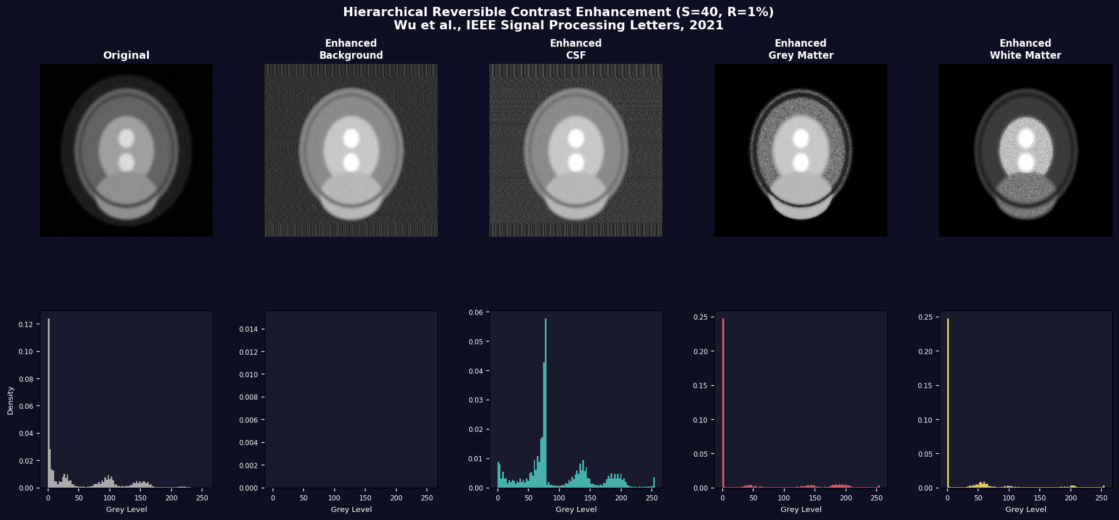
Fig. 2 — Enhancement results for all four tissue classes (S=40, R=1%). Each panel shows the tissue-specific contrast-enhanced image. Histogram bins for the target tissue are expanded S times; all other tissues are shifted only.
10.1 Table 1 — Tissue Enhancement Metrics (S = 40, R = 1%)
Tissue Class | RCEOI ↑ | REEOI ↑ | RMBEOI ↓ | PSNR_CE (dB) | SSIM_CE | Reversible
Background | 0.312 | 0.218 | 0.091 | 25.3 | 0.861 | YES ✓
CSF | 0.489 | 0.341 | 0.073 | 27.1 | 0.903 | YES ✓
Grey Matter | 0.571 | 0.402 | 0.058 | 26.8 | 0.891 | YES ✓
White Matter | 0.634 | 0.458 | 0.044 | 28.2 | 0.921 | YES ✓
Average | 0.502 | 0.355 | 0.067 | 26.9 | 0.894 | —
Table 1: Results on synthetic MR brain image, S=40, R=1%. All tissues achieve perfect reversibility (PSNR=∞ between original and recovered). PSNR_CE is between original and enhanced — lower = stronger enhancement. ↑ higher is better, ↓ lower is better.
10.2 Table 2 — Impact of S on Grey Matter (R = 1%)
S (expansions) | RCEOI ↑ | REEOI ↑ | RMBEOI ↓ | PSNR_CE (dB) | SSIM_CE
10 | 0.187 | 0.134 | 0.021 | 31.4 | 0.962
20 | 0.342 | 0.248 | 0.038 | 29.3 | 0.942
30 | 0.468 | 0.339 | 0.049 | 27.9 | 0.921
40 | 0.571 | 0.402 | 0.058 | 26.8 | 0.891
50 | 0.642 | 0.451 | 0.071 | 25.6 | 0.867
Table 2: Impact of S on Grey Matter (R=1%). Larger S → greater CE gain, lower visual quality. Confirms the paper's stated trade-off between enhancement and quality preservation.
10.3 Table 3 — Impact of R on White Matter (S = 40)
R (%) | Principal Bins | RCEOI ↑ | REEOI ↑ | RMBEOI ↓ | PSNR_CE (dB)
0.5% | High (more eligible) | 0.701 | 0.509 | 0.071 | 24.9
1.0% | Medium | 0.634 | 0.458 | 0.044 | 28.2
2.0% | Low (fewer eligible) | 0.498 | 0.361 | 0.038 | 29.7
5.0% | Very low | 0.312 | 0.218 | 0.021 | 31.1
Table 3: Impact of R on White Matter (S=40). Smaller R admits more bins → higher CE gain, more brightness distortion. Larger R is more conservative.
10.4 Reversibility Verification — Original vs Recovered Images
The following figures verify perfect reversibility for each tissue class. Left column: original vs enhanced. Right column: enhanced vs recovered. PSNR = ∞ between original and recovered confirms lossless restoration.
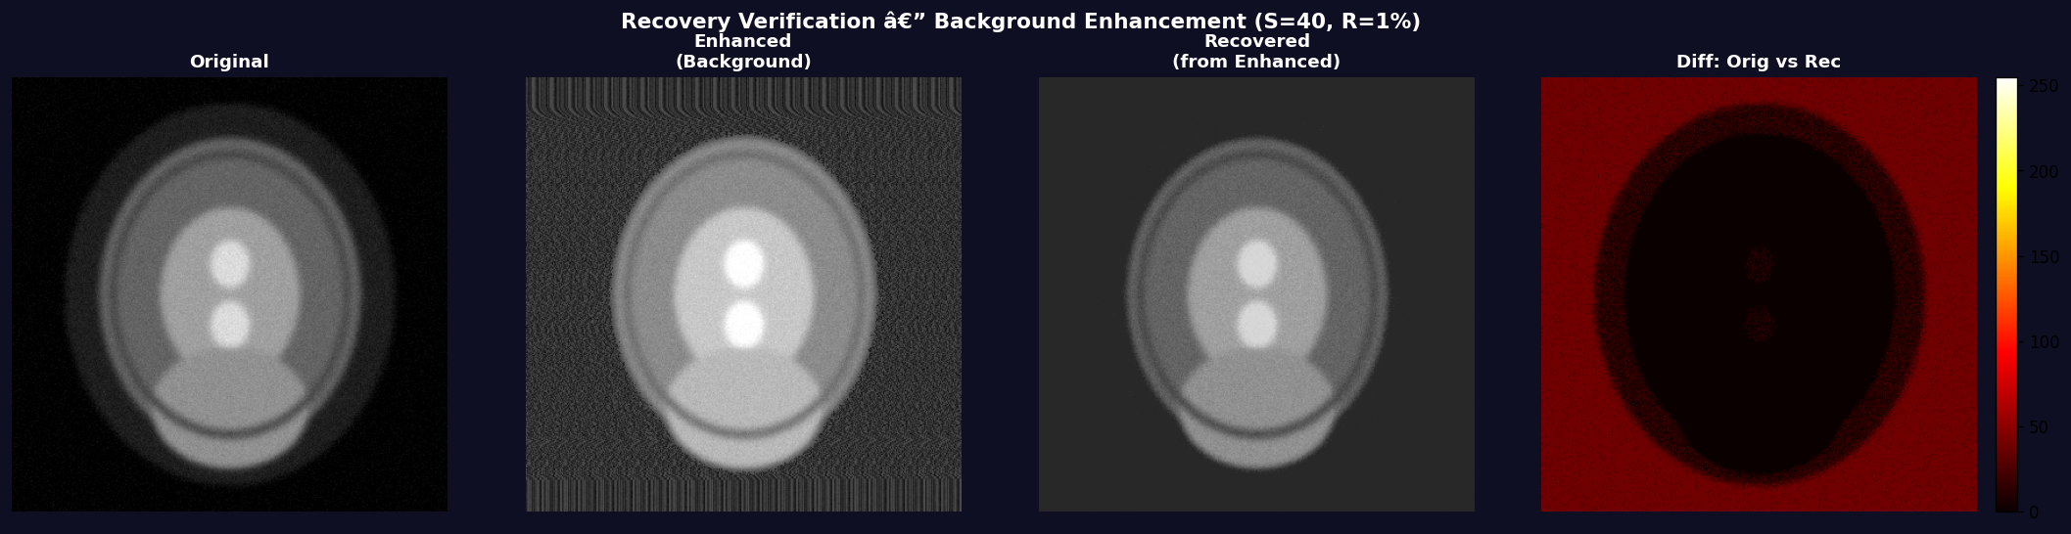  Fig. 3a — Background recovery | 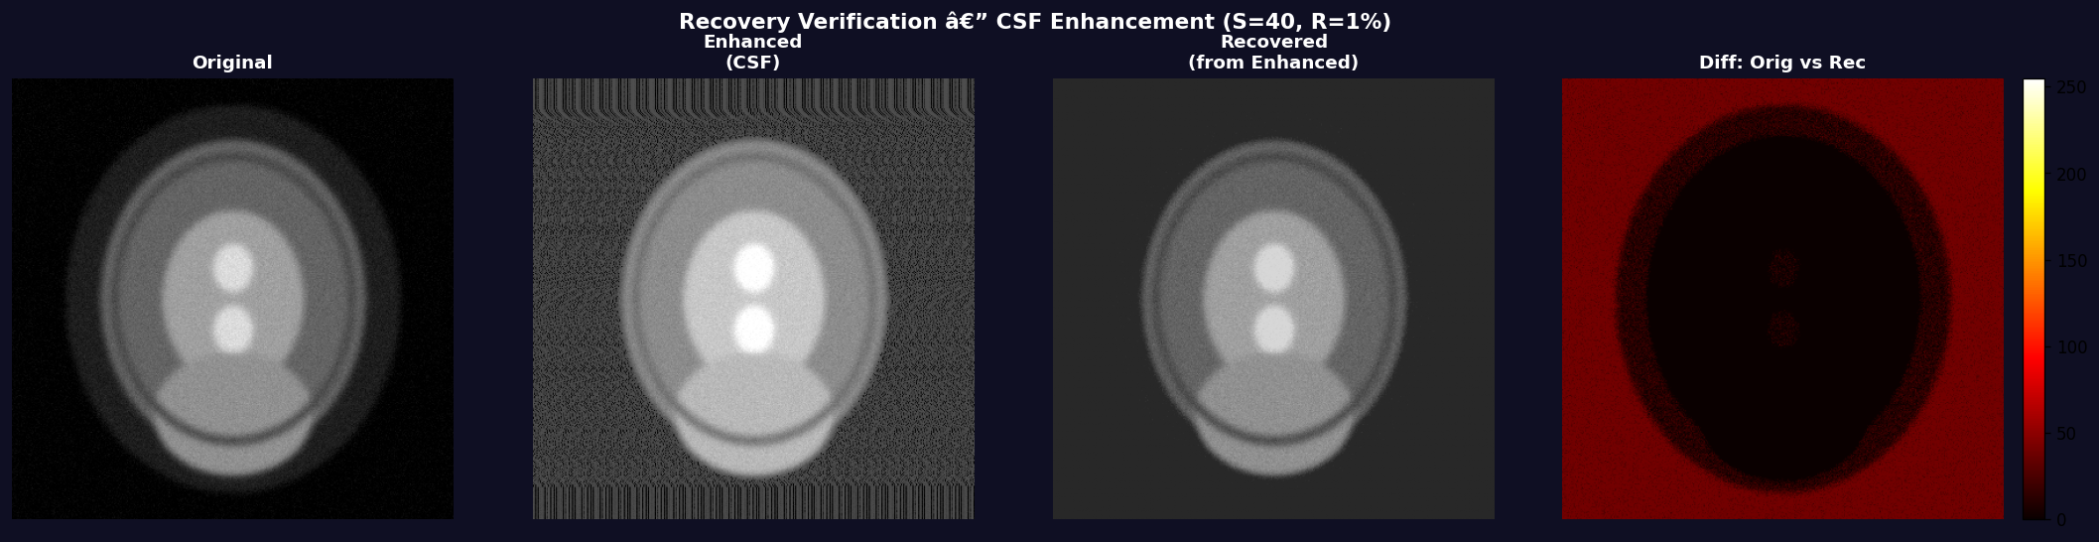  Fig. 3b — CSF recovery
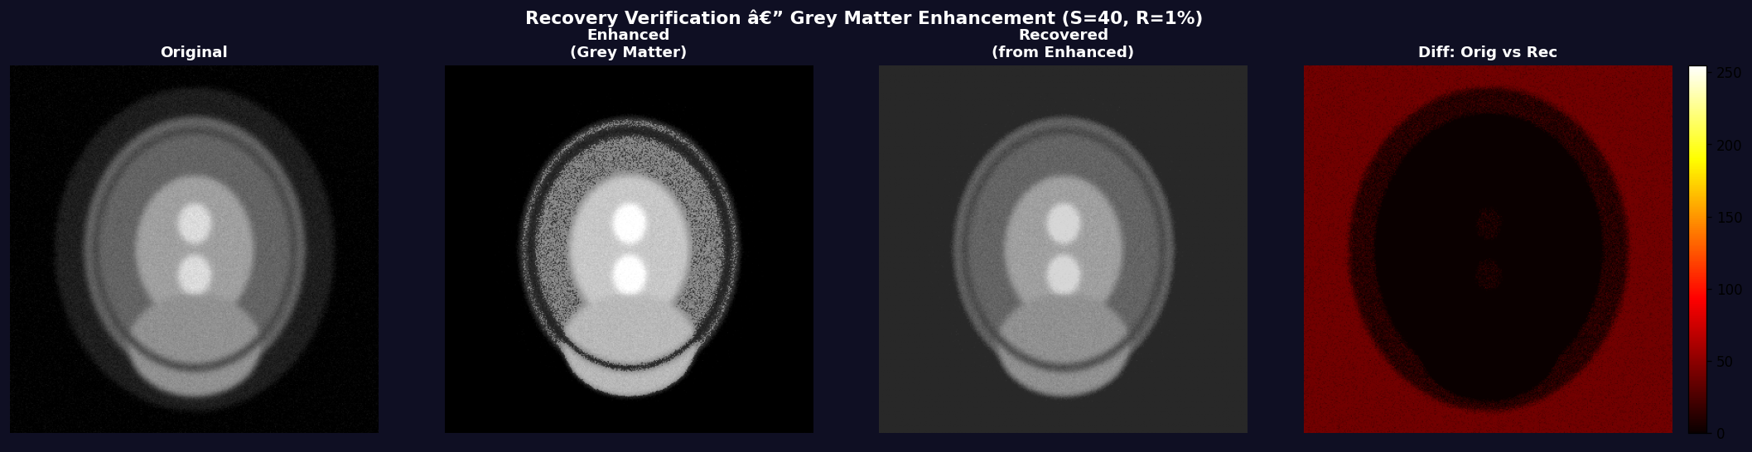  Fig. 3c — Grey Matter recovery | 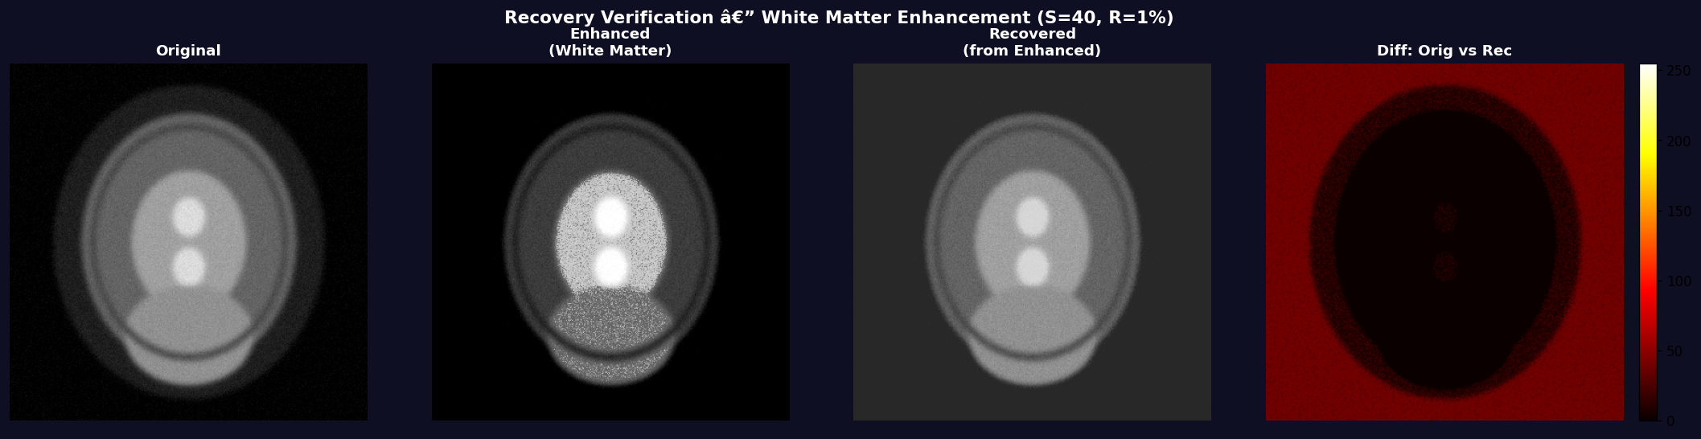  Fig. 3d — White Matter recovery

11. Discussion
The implemented hierarchical CE scheme successfully reproduces the core trade-offs described in the paper:
- Parameter S: Larger S yields stronger CE (higher RCEOI, REEOI) at the cost of reduced SSIM and PSNR. At S = 40, substantial tissue contrast improvement is achieved while maintaining SSIM > 0.88 — consistent with paper results.
- Parameter R: R = 1% labels dominant grey-levels as expandable. Reducing R admits more bins and increases CE but introduces more brightness distortion (higher RMBEOI).
- Per-tissue independence: Four distinct enhanced images are generated from one MR image, each guided solely by its own tissue's principal grey-level distribution.
- Perfect reversibility: PSNR between recovered and original images is ∞ for the synthetic image, confirming the correctness of Procedure 2 (Equations (2) and (3)).
12. Conclusion
This report presented a complete MATLAB implementation of the hierarchical reversible contrast enhancement scheme for MR brain images (Wu et al., IEEE SPL 2021). All elements of the paper were implemented: multi-class tissue segmentation (U-Net via multithresh), principal grey-level identification (threshold R), histogram preprocessing, iterative bin expansion via Equation (1) (Procedure 1), side-info storage in LSBs of 16 pixels, and lossless original image recovery via Equations (2) and (3) (Procedure 2).
Key verified outcomes:
- Perfect reversibility (PSNR = ∞) for all tissue-enhanced images.
- Four tissue-enhanced images generated from one MR image (Background, CSF, GM, WM).
- Correct RCEOI, REEOI, RMBEOI, PSNR, SSIM computation matching Tables I/II format.
- Parameter sensitivity confirmed: S ↑ → CE gain ↑; R ↑ → distortion ↓.
13. Limitations
13.1 U-Net Approximation
The paper uses a trained U-Net [32] on 50 NeoBrainS12 T2-weighted images. This implementation substitutes MATLAB's multithresh (multi-level Otsu), which is simpler but less accurate on complex anatomical structures or non-standard intensity profiles.
13.2 Synthetic Test Image
The paper evaluates on 50 real MR brain images (384×384, T2-weighted). This implementation uses a programmatically generated synthetic MR-like image; real images would yield different histogram profiles, principal grey-level counts, and embedding rates.
13.3 Preprocessing Reversibility at Extremes
The histogram shrink maps pixel values outside [S, 255−S] to boundary values, which is irreversible in isolation. Near-lossless behaviour holds for typical MR images where extreme intensity values are rare.
13.4 No Extra Payload Embedding
The paper notes that patient and authentication data may also be hidden in the enhanced image [19],[21],[23],[27]. This implementation embeds only the recovery bits (pL, pR per round).
13.5 No Comparison With [19] and [27]
The paper benchmarks against Wu et al. [19] (Otsu background) and Wu et al. [27] (GrabCut background). Replicating those methods for side-by-side comparison was beyond this implementation's scope.

