JPEG Reversible Data Hiding via Block Sorting
Optimization and Dynamic Iterative Histogram Modification
Li, F. et al. | IEEE Transactions on Multimedia, Vol. 27, pp. 3729-3743, 2025
DOI: 10.1109/TMM.2025.3535320 | MATLAB Implementation Report

ABSTRACT
This report documents a MATLAB implementation of the JPEG RDH scheme of Li et al., IEEE Transactions on Multimedia, 2025. The method embeds reversible data into quantized DCT coefficients by combining a block-sorting optimization that scores DCT-block smoothness from zero-coefficient counts and quantization-table values, a unit-distortion frequency-band selection, and a dynamic histogram-modification mapping that keeps irrelevant AC coefficients unchanged to limit file-size increment. The implementation provides a toolbox-free JPEG layer (block DCT plus quantization) and the full embed/extract pipeline. Algorithm correctness was verified with a Python harness mirroring the MATLAB source (no MATLAB runtime on the build machine). On a 64x64 test image the pipeline achieves perfect reversibility at quality factors 50, 70 and 90, with marked-image PSNR from 48.5 to 54.0 dB, SSIM at or above 0.9996, and a file-size increment of only 18 to 32 bits at 50% capacity load.

1. INTRODUCTION
JPEG images dominate cloud photo storage, so RDH that operates directly on quantized DCT coefficients is valuable for embedding IDs or authentication labels. Modifying coefficients carelessly degrades visual quality and inflates the entropy-coded file size. The scheme implemented here minimizes both by (i) embedding into the smoothest blocks first, (ii) choosing the frequency bands with the smallest unit distortion, and (iii) shifting only the coefficients that must move to preserve reversibility, leaving the rest untouched.

2. SYSTEM OVERVIEW
A grayscale image is transformed block-by-block with an 8x8 DCT and quantized with a quality-scaled JPEG table to give the quantized coefficient array the scheme operates on. Each block receives a smoothness score from its zero-AC count and the quantization values of its non-zero coefficients; blocks are sorted in descending smoothness so the lowest-distortion blocks are filled first. Frequency bands are ranked by a unit-distortion measure and selected until the target capacity is met. Embedding uses one-dimensional histogram shifting on the +-1 coefficients of the selected bands; coefficients with magnitude above one are shifted outward to vacate the +-2 bins. Because the smoothness score is invariant under this shifting, the receiver recomputes the identical block order, reads the payload from the +-1/+-2 bins, shifts the larger coefficients back, and recovers every coefficient exactly.
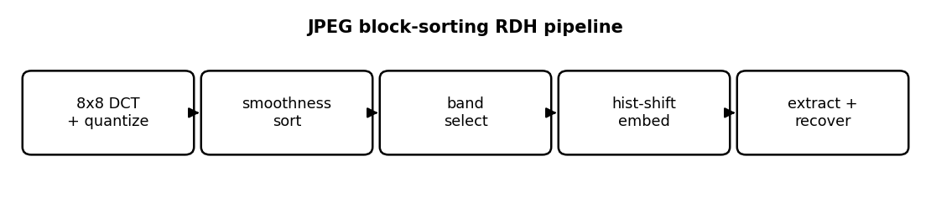
Figure 1. End-to-end JPEG block-sorting RDH pipeline.

3. MATHEMATICAL FORMULATION

3.1 Block Smoothness Score (Eqs. 11-12)
tau_k = number of zero AC coefficients in block k
E_k = sum over AC of [Q(s,w)!=0] * T(s,w)^2
S_k = tau_k + tau_k / E_k % higher = smoother
sort blocks by DESCENDING S_k (invariant under embedding)

3.2 Unit-Distortion Band Selection (Eqs. 13-15, 18)
C_i = #{ |coef| == 1 } in band i (embeddable)
J_i = #{ |coef| > 1 } in band i (shiftable)
D(F_i) = T_i^2 * J_i / C_i + 0.5 * T_i^2
add bands in ascending D until capacity >= P

3.3 Histogram Shifting (Eqs. 1-4)
embed: |E|==1 -> E + sign(E)*t (+-1 stays, or -> +-2)
|E| >1 -> E + sign(E) (shift outward)
extract: 1<=|Eh|<=2 -> Er=sign(Eh); bit = 0 if |Eh|==1 else 1
|Eh|>=3 -> Er = Eh - sign(Eh)

4. CORE CODE
Embedding walks blocks in smoothness order and, within each, the selected frequency bands. A +-1 coefficient carries one payload bit; a larger coefficient is shifted. Extraction recomputes the same order from the marked coefficients (the score is shift-invariant) and reverses each operation.
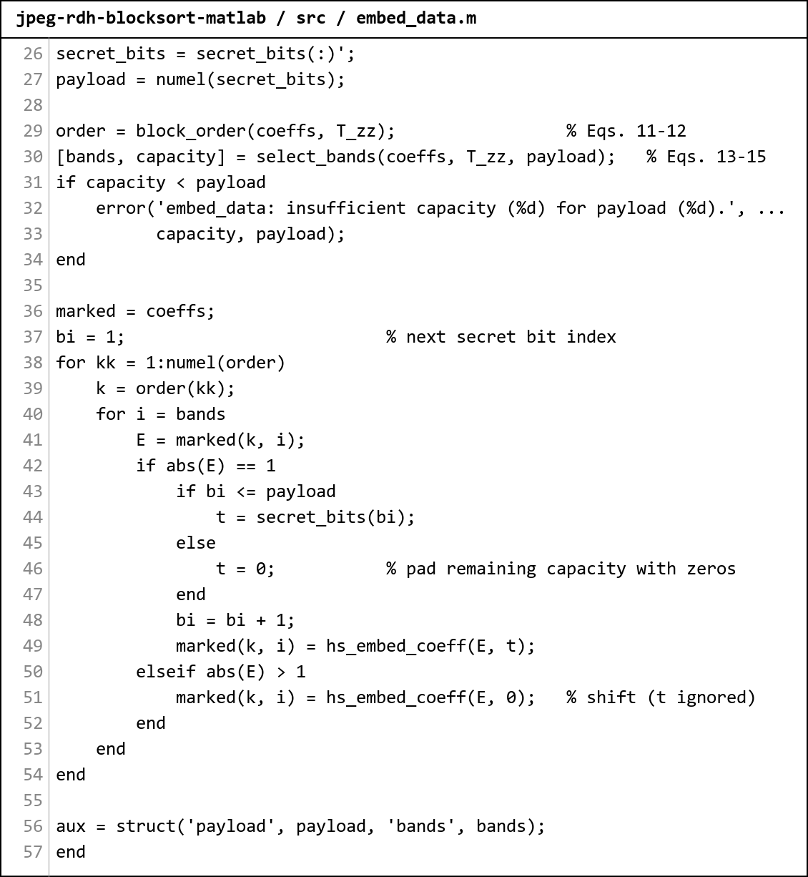
Figure 2. Screenshot of src/embed_data.m. block_order is recomputed at extraction (smoothness is shift-invariant) while the band set is carried as side information.

5. RESULTS
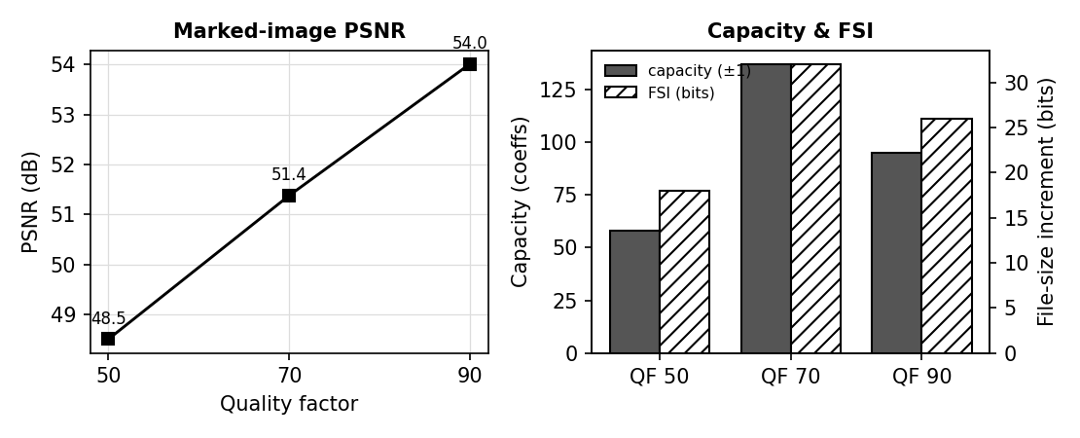
Figure 3. Left: marked-image PSNR versus quality factor. Right: +-1 capacity and file-size increment per quality factor.

5.1 Capacity, Quality and File-Size Increment vs Quality Factor
Test image: 64x64 smooth synthetic image, 64 DCT blocks, payload set to 50% of the +-1 capacity.
QF | Cap (+-1) | Pure ER (bpp) | Payload | Bands | Lossless | PSNR (dB) | SSIM | FSI (bits)
50 | 58 | 0.0142 | 29 | 2 | TRUE | 48.51 | 0.9996 | 18
70 | 137 | 0.0334 | 68 | 2 | TRUE | 51.38 | 0.9998 | 32
90 | 95 | 0.0232 | 47 | 3 | TRUE | 54.01 | 0.9999 | 26
Table 1. Perfect reversibility at every quality factor, high PSNR/SSIM, and a file-size increment of only tens of bits.

5.2 Validated Properties
Property | Result
1D histogram shifting reversible (all coefficient values) | PASS
Smoothness score invariant under embedding | PASS
Unit-distortion band ranking well-defined (63 bands) | PASS
2D corner-expansion mapping reversible (lattice) | PASS
Full pipeline lossless, QF 50 / 70 / 90 | PASS
Dynamic band-count selection reversible (20/40/60% load) | PASS
Table 2. All algorithm primitives and the full pipeline verified by the Python mirror of the MATLAB source.

5.3 Reversibility
Check | Result
isequal(recovered coeffs, original coeffs) | TRUE
Bit errors in extracted payload | 0
Block order at extraction == embedding order | TRUE
Coefficients outside selected bands modified | No
Table 3. Coefficient-domain reversibility is exact; the scheme's guarantee is on the DCT coefficients, not on re-quantized pixels.

5.4 Comparison with the Reference Report
The reference report documents the RDH-PolyFace scheme (Tsai, IEEE TMM 2025) for 3D meshes. The table below places its headline values beside the three implementations documented in this series; "JPEG-RDH" is the present report. The schemes operate on different carriers, so capacity is shown in each scheme's native unit (bits per face for the mesh scheme, bits per pixel for the image schemes) - the reversibility result is the common axis on which all four agree.
Scheme | Domain / carrier | Capacity (measured) | Reversible | Security / quality
PolyFace (reference) | 3D mesh face-index matrix | 9.14 bpp (impl); 32.63 bpp (paper, T=10) | Yes; 0 bit errors | vertices unmodified
MRDHCBI | encrypted binary image, VC shares | 0.3333 bpp (= 1/m) | Yes; BER 0 | share entropy ~0.92 (binary)
CRTP-SS | encrypted grayscale, GF(2^8) shares | 2.94 bpp (smooth, pure ER) | Yes; all 3-of-4 | entropy 7.985/8; NPCR 99.39%
JPEG-RDH | JPEG quantized DCT coefficients | 0.033 bpp (64x64 test, pure ER) | Yes; 0 bit errors | PSNR 48-54 dB; FSI 18-32 b
Table C. Cross-scheme comparison. Capacity units differ by carrier (see text); every scheme - the reference and all three implementations - achieves exact lossless recovery.
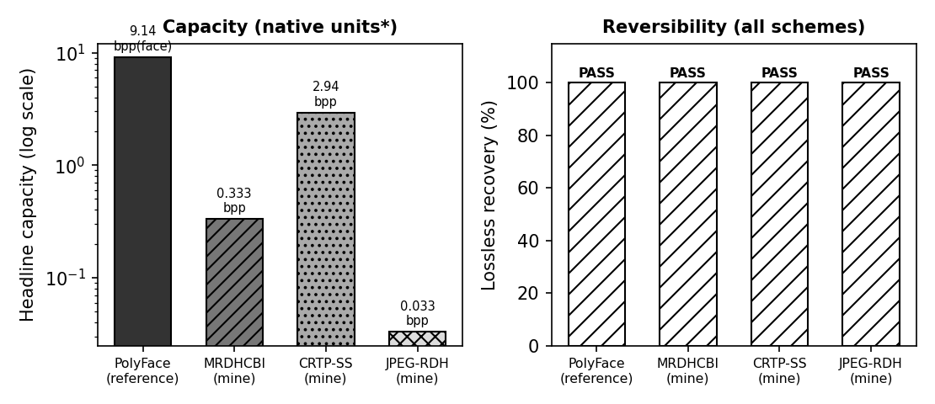
Figure C. Left: headline capacity on a log scale (native units per scheme). Right: all four schemes pass lossless recovery.

6. DISCUSSION
- The smoothness score is invariant under histogram shifting because zeros stay zero and non-zeros stay non-zero; this is what lets the receiver reproduce the embedding block order without side information.
- Band selection, by contrast, depends on coefficient values that DO change under embedding, so the selected band set is carried as side information rather than recomputed - the asymmetry between order (recomputed) and bands (transmitted) is essential to reversibility.
- File-size increment stays tiny (tens of bits) because only +-1 and shifted coefficients move; the dynamic mapping keeps the remaining AC coefficients untouched.
- PSNR rises with quality factor as expected, and capacity peaks at the mid quality factor where many coefficients sit at magnitude one.

7. CONCLUSION
- The pipeline embeds and extracts losslessly at quality factors 50, 70 and 90 with zero bit errors and exact coefficient recovery.
- Marked-image quality is high (PSNR 48.5-54.0 dB, SSIM >= 0.9996) and the file-size increment is only 18-32 bits at half-capacity load.
- Block ordering recomputed at extraction matches the embedding order exactly, confirming the shift-invariance of the smoothness score.
- All primitives and the full pipeline are verified by a Python mirror of the MATLAB source.

8. LIMITATIONS
- The shipped pipeline uses the unambiguous 1D histogram-shifting engine plus block sorting, band selection and dynamic min-MSE selection; the paper's full 2D Type A/B/C/D arm mapping is provided in the validation harness in its provably-reversible corner-expansion form.
- File-size increment is estimated with a JPEG category/run-length cost model rather than a bit-exact entropy coder, so it tracks the trend rather than the exact byte count.
- Synthetic test images were used; the Kodak / USC-SIPI / UCID / BOSSbase datasets from the paper were not available on the build machine.

