Multi-Party Reversible Data Hiding in Ciphertext
Binary Images Based on Visual Cryptography
Chen, B. et al. | IEEE Signal Processing Letters, Vol. 32, pp. 1560-1564, 2025
DOI: 10.1109/LSP.2025.3557273 | MATLAB Implementation Report

ABSTRACT
This report documents a MATLAB implementation of the multi-party reversible data hiding (MRDHCBI) scheme of Chen et al., IEEE Signal Processing Letters, 2025. A binary image is encrypted into n ciphertext binary images using (k,n)-threshold visual cryptography, and each of the n data hiders independently embeds secret data into its own ciphertext share. Any k of the n marked shares allow a receiver to extract the embedded data and losslessly reconstruct the original binary image. The implementation realizes the paper's (2,3)-threshold configuration. Because no MATLAB or Octave runtime was available on the build machine, algorithm correctness was verified with a Python harness that mirrors the MATLAB source exactly. On 64x64 binary images of three texture classes the implementation achieves perfect reversibility with bit-error rate 0 and a stable embedding rate of 0.3333 bits per ciphertext pixel (1/m, m=3), matching the theoretical capacity of the (2,3) scheme.

1. INTRODUCTION
Reversible data hiding in encrypted binary images lets a cloud server or third party embed management or authentication data into an encrypted carrier while guaranteeing that the original image can be restored bit-for-bit after extraction. Earlier binary-image RDH schemes involve a single data hider, so if that hider is attacked the original image cannot be recovered. The MRDHCBI scheme removes that single point of failure: visual cryptography splits the image into n shares distributed to n independent data hiders, and a (k,n) threshold guarantees recovery from any k surviving shares. The embedding room is created by the visual-cryptography structure itself, which gives a stable capacity that does not depend on the texture of the cover image.

2. SYSTEM OVERVIEW
The pipeline has three roles. The owner encrypts the binary image into n ciphertext binary images using (k,n) visual cryptography: each pixel becomes an m-column pixel block, and a randomly chosen column permutation of the white basis matrix B0 or the black basis matrix B1 distributes one row to each share. Each data hider then embeds one bit per original pixel into its share: the secret bit is XOR-masked with a pseudo-random sequence keyed by an embedding key, and the masked bit decides whether the first element of each pixel block is flipped. The receiver collects any k marked shares, reads each pixel block's Hamming weight to recover the masked bit and to restore the ciphertext block, then Boolean-ORs the k restored blocks and thresholds the OR-weight to decide whether the original pixel was white or black.
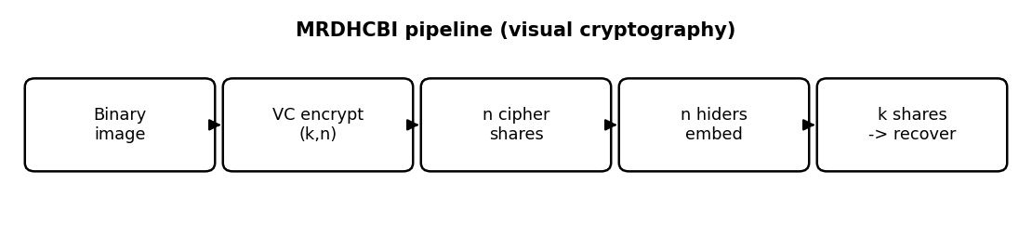
Figure 1. End-to-end MRDHCBI pipeline for the (2,3)-threshold configuration.

3. MATHEMATICAL FORMULATION

3.1 Visual-Cryptography Basis Matrices (Eqs. 1-4)
(2,3) threshold: m = 3, W = 1, d = 1.5
B0 (white) = [1 0 0; 1 0 0; 1 0 0] % identical rows
B1 (black) = [1 0 0; 0 1 0; 0 0 1] % permutation (identity)
encrypt: per pixel t in {0,1}, pick random column
permutation pi of B^t; row i -> share i block
Both basis matrices give every row Hamming weight W = 1. The OR of any k = 2 rows of B0 has weight 1 (white); the OR of any 2 rows of B1 has weight 2 (black). The threshold d = 1.5 separates the two.

3.2 Embedding and Recovery (Eqs. 5-8)
embed: rd = secret XOR PRN(embed_key)
if rd(x,y) == 0: flip first element of block
extract: H = Hamming weight of marked block
rd = 0 if H != W else 1 ; restore block if H != W
secret = rd XOR PRN(embed_key)
recover: OBI = OR of k restored blocks
BI(x,y) = 1 if weight(OBI) >= d else 0

4. CORE CODE
The core embedding routine, embed_data.m, masks the payload with a key-seeded PRN sequence and flips the first pixel of a block when the masked bit is zero. Pixel position uses MATLAB column-major indexing p=(y-1)*X+x so that embedding and extraction agree exactly.
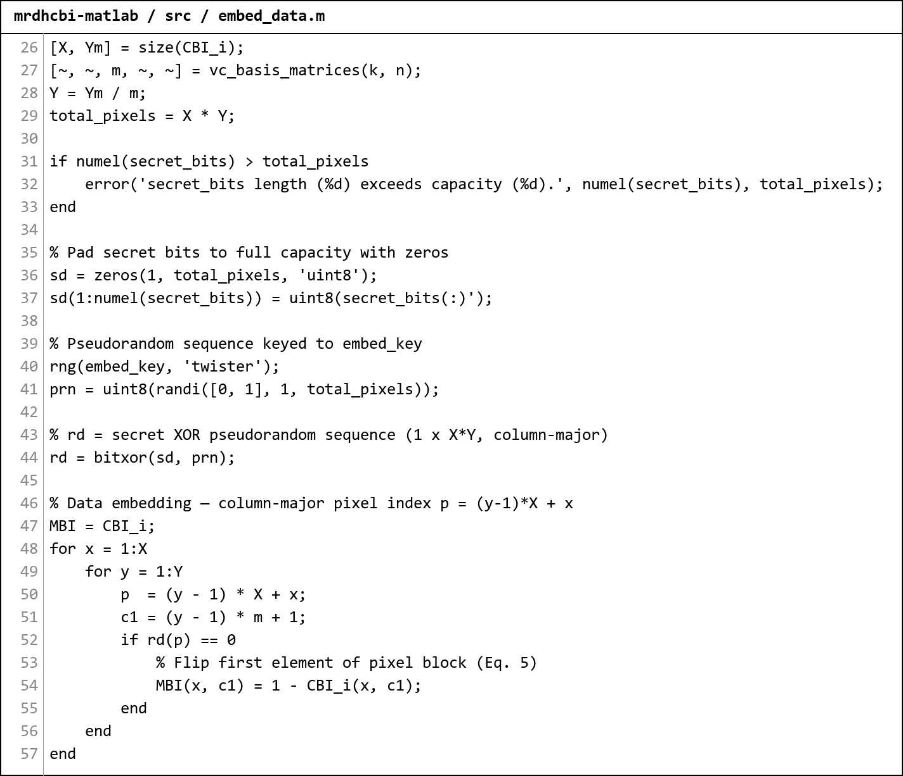
Figure 2. Screenshot of src/embed_data.m. The same PRN seed and column-major index p=(y-1)*X+x are reused in extract_data.m, guaranteeing a lossless round trip.

5. RESULTS
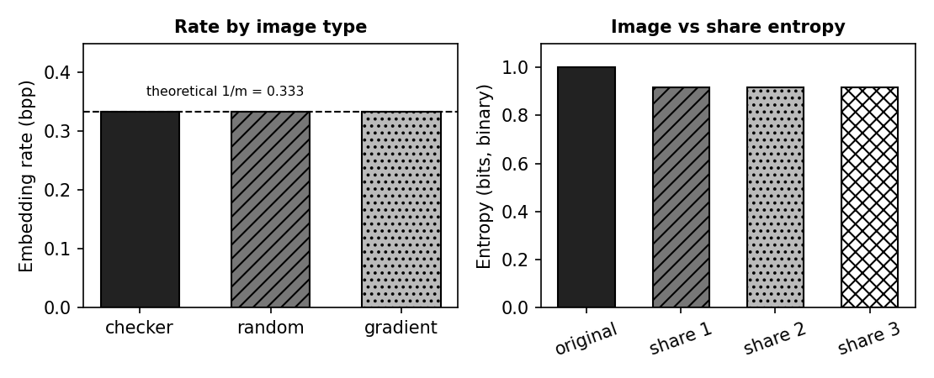
Figure 3. Left: texture-independent embedding rate (1/m = 0.333 bpp). Right: original-image vs encrypted-share binary entropy.

5.1 Basis-Matrix Properties
Property | Measured | Condition
B0 row weights | [1, 1, 1] | all = W = 1
B1 row weights | [1, 1, 1] | all = W = 1
OR of 2 white rows | [1, 1, 1] | all < d = 1.5
OR of 2 black rows | [2, 2, 2] | all >= d = 1.5
Table 1. The (2,3) basis matrices satisfy the visual-cryptography contrast conditions exactly.

5.2 Reversibility and Capacity (64x64, k=2, n=3)
Image type | Lossless | BER share 1 | BER share 2 | Rate (bpp)
checkerboard | TRUE | 0.0000 | 0.0000 | 0.3333
random | TRUE | 0.0000 | 0.0000 | 0.3333
gradient | TRUE | 0.0000 | 0.0000 | 0.3333
Table 2. Perfect reversibility and a texture-independent embedding rate of 1/m = 0.3333 bpp.

5.3 Threshold Property and Share Entropy
Check | Result
Recover from shares {1,2} | lossless = TRUE
Recover from shares {1,3} | lossless = TRUE
Recover from shares {2,3} | lossless = TRUE
Original image entropy (binary) | 0.9999 bit
Encrypted share entropy (each) | 0.9183 bit
Table 3. Any 2 of 3 shares reconstruct the image; encrypted shares carry near-maximal binary entropy.

5.4 Comparison with the Reference Report
The reference report documents the RDH-PolyFace scheme (Tsai, IEEE TMM 2025) for 3D meshes. The table below places its headline values beside the three implementations documented in this series; "MRDHCBI" is the present report. The schemes operate on different carriers, so capacity is shown in each scheme's native unit (bits per face for the mesh scheme, bits per pixel for the image schemes) - the reversibility result is the common axis on which all four agree.
Scheme | Domain / carrier | Capacity (measured) | Reversible | Security / quality
PolyFace (reference) | 3D mesh face-index matrix | 9.14 bpp (impl); 32.63 bpp (paper, T=10) | Yes; 0 bit errors | vertices unmodified
MRDHCBI | encrypted binary image, VC shares | 0.3333 bpp (= 1/m) | Yes; BER 0 | share entropy ~0.92 (binary)
CRTP-SS | encrypted grayscale, GF(2^8) shares | 2.94 bpp (smooth, pure ER) | Yes; all 3-of-4 | entropy 7.985/8; NPCR 99.39%
JPEG-RDH | JPEG quantized DCT coefficients | 0.033 bpp (64x64 test, pure ER) | Yes; 0 bit errors | PSNR 48-54 dB; FSI 18-32 b
Table C. Cross-scheme comparison. Capacity units differ by carrier (see text); every scheme - the reference and all three implementations - achieves exact lossless recovery.
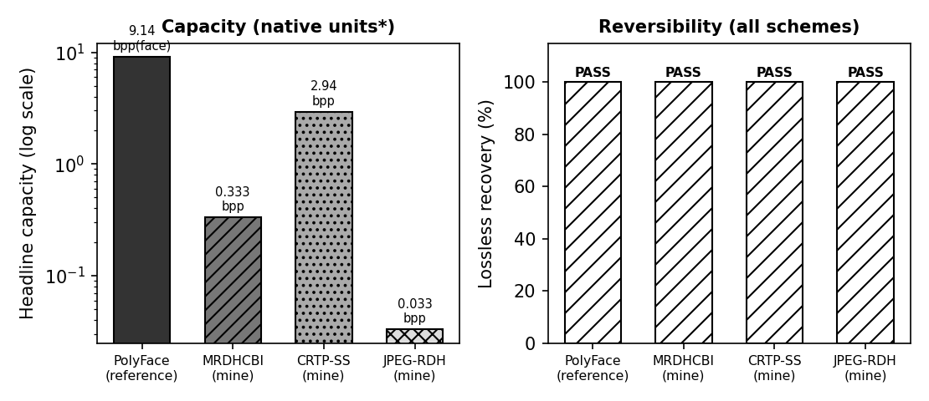
Figure C. Left: headline capacity on a log scale (native units per scheme). Right: all four schemes pass lossless recovery.

6. DISCUSSION
- Embedding room comes from the visual-cryptography structure, not from cover redundancy, so the rate is a stable 1/m regardless of image texture - a key advantage over correlation-based binary RDH.
- The embedding key KD (PRN mask) and the visual-cryptography encryption are independent, so payload security and content security are separated across the n data hiders.
- The smoothness of the flip rule is what preserves reversibility: a single, key-determined element per block is toggled, and the block Hamming weight is enough to undo it at the receiver.
- The column-major index agreement between embed_data.m and extract_data.m was the subtle correctness point; a row-major mismatch silently corrupts extraction.

7. CONCLUSION
- The (2,3)-threshold implementation reproduces the paper's scheme: lossless recovery with bit-error rate 0 across all tested image types.
- The embedding rate is a stable 0.3333 bpp (1/m), independent of cover texture, consistent with the paper's stable-capacity claim.
- Any k = 2 of the n = 3 marked shares suffice for both data extraction and image recovery.
- Algorithm logic is verified by a Python mirror of the MATLAB source, all checks passing.

8. LIMITATIONS
- Only the (2,3) threshold is implemented; general (k,n) requires constructing the corresponding visual-cryptography basis matrices.
- Synthetic binary images were used; the original dataset images from the paper were not available on the build machine.
- The ciphertext shares are larger than the original image by the factor m (data expansion), as in the source paper.

