Reversible Data Hiding With Secret Encrypted
Image Sharing and Adaptive Coding
Fang, G. et al. | IEEE Internet of Things Journal, Vol. 12, No. 13, pp. 23933-23945, 2025
DOI: 10.1109/JIOT.2025.3555380 | MATLAB Implementation Report

ABSTRACT
This report documents a MATLAB implementation of the RDH scheme of Fang et al., IEEE Internet of Things Journal, 2025, which combines an improved secret-sharing encryption based on the Chinese Remainder Theorem for Polynomials (CRTP-SS) over GF(2^8) with an adaptive-coding embedding method using XOR preservation (XORP) and Huffman label coding. An 8-bit grayscale image is scrambled, then shared into n encrypted images by polynomial CRT; any k of them reconstruct the original. Each encrypted share retains the spatial correlation of the original block, which vacates a large embedding room. Algorithm correctness was verified with a Python harness mirroring the MATLAB source (no MATLAB runtime on the build machine). The implementation reproduces the paper's worked example exactly (block [192 191 195 180] encrypts to share-1 block [174 209 173 218]), reconstructs losslessly from every 3-of-4 share combination, and yields encrypted shares with near-ideal information entropy (about 7.985 of 8) and key-sensitivity metrics (NPCR 99.39%, UACI 33.81%).

1. INTRODUCTION
Cloud storage of private images motivates RDH in encrypted images (RDHEI). Single-data-hider schemes lose recoverability if the hider is compromised, and secret-sharing approaches over prime fields cannot uniformly encrypt pixel values across the full 0-255 range. The scheme implemented here addresses both: secret sharing over the polynomial field GF(2^8) distributes the image among n servers with fault tolerance, encrypts every pixel uniformly across 0-255, and needs no pre-processing. A separate adaptive-coding stage then embeds a high-capacity payload into each encrypted share while preserving reversibility.

2. SYSTEM OVERVIEW
The content owner scrambles the image with key Key0 (block permutation plus in-block pixel permutation), then shares it with CRTP-SS using per-block random sequences R1 and R2 keyed by Key1 and Key2. Each pixel is mapped to a polynomial, combined with R1 and R2 times the auxiliary modulus q0, and reduced modulo each share's irreducible degree-8 modulus q_i. Because R1, R2 and q0 are shared inside a 2x2 block, the XOR relation among the block's encrypted pixels matches that of the originals (XOR preservation), vacating embedding room. Each data hider classifies 2x2 blocks as embeddable (B1) or non-embeddable (B2) by the maximum XOR difference Dmax, assigns a similarity label by Huffman coding, and embeds payload bits into the freed bit positions. The receiver, holding any k marked shares, extracts the payload, restores the encrypted shares, reconstructs the scrambled image by polynomial CRT, and unscrambles with Key0.
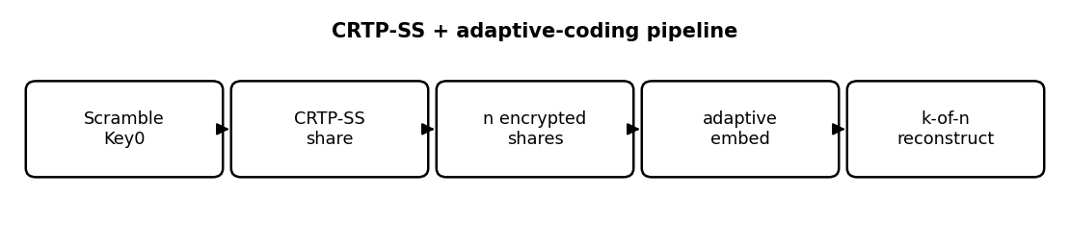
Figure 1. End-to-end CRTP-SS plus adaptive-coding pipeline for the (3,4)-threshold configuration.

3. MATHEMATICAL FORMULATION

3.1 CRTP-SS Encryption (Eqs. 5-6)
moduli: q0=111110101b; q1..q4 irreducible deg-8 over GF(2)
per pixel m of block z:
Y(x) = m(x) XOR R1_z XOR (R2_z (*) q0(x))
share_i = Y(x) mod q_i(x) % (*) = GF(2) carryless mul

3.2 XOR Preservation (Eq. 8) and Reconstruction (Eq. 14)
XORP: share_i(pixel1) XOR share_i(pixel_u)
== m_1 XOR m_u (room for embedding)
CRT: Q = prod(q_i), Qi = Q/q_i, Qi^{-1} mod q_i
Y = XOR_i [ share_i (*) Qi (*) Qi^{-1} ] mod Q
m = (Y mod q0) XOR R1_z % R2*q0 vanishes mod q0

3.3 Adaptive-Coding Capacity
Dmax = max_u ( share(pixel1) XOR share(pixel_u) )
B1 (embeddable) if Dmax <= 63 ; else B2
lambda = ceil(log2(Dmax+1)) ; eps1=lambda, eps2=8-lambda
per-B1-block capacity = 3*eps2 - 1 bits

4. CORE CODE
The CRTP-SS per-pixel encryption is the heart of the scheme. R2 times q0 is computed once per block and reused for the four pixels; reduction modulo each share's polynomial produces the share pixel. The KD-style payload mask (Key3) is applied separately during embedding so content and payload security stay independent.
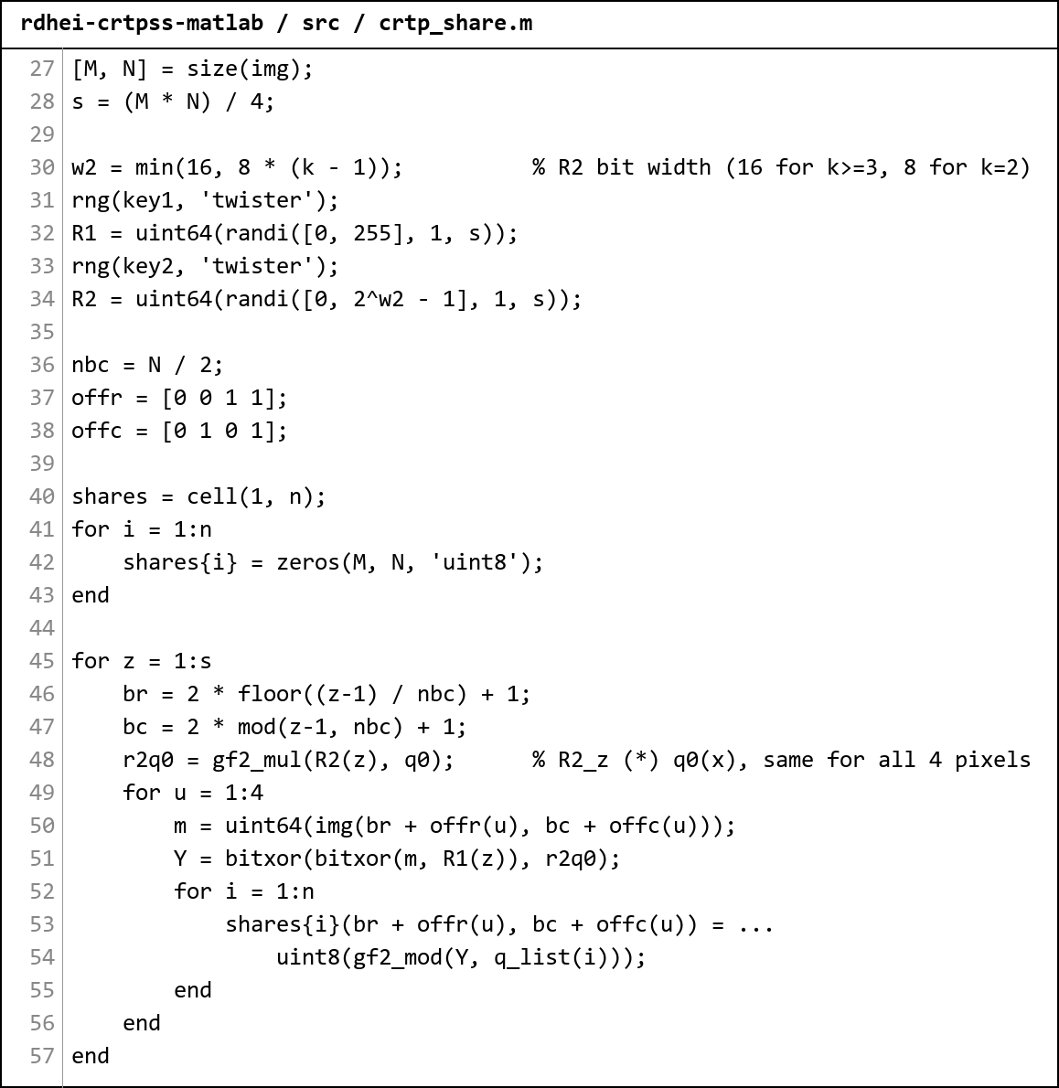
Figure 2. Screenshot of src/crtp_share.m. gf2_mul / gf2_mod implement carryless GF(2) polynomial arithmetic; reconstruction inverts this with the polynomial CRT.

5. RESULTS
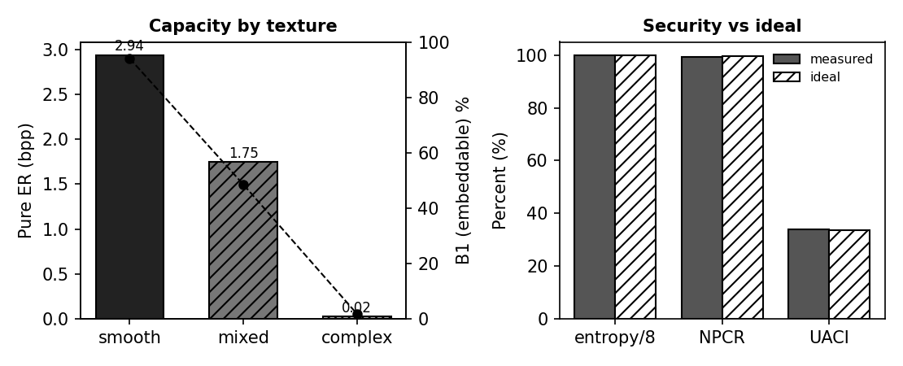
Figure 3. Left: capacity and embeddable-block fraction fall with texture complexity. Right: security metrics versus their ideal values.

5.1 Worked Example (paper Sec. IV-A)
Quantity | Value
Original block | [192, 191, 195, 180]
R1, R2, q0 | 128, 1, 111110101b
Encrypted share-1 block | [174, 209, 173, 218]
Matches paper | TRUE
Table 1. The implementation reproduces the paper's numerical encryption example exactly.

5.2 Adaptive-Coding Capacity by Image Type (128x128, share 1)
Image type | B1 blocks | B2 blocks | B1 % | Pure EC (bits) | Pure ER (bpp) | Share entropy
smooth | 3852 | 244 | 94.0 | 48135 | 2.9379 | 7.9850
mixed | 1987 | 2109 | 48.5 | 28625 | 1.7471 | 7.9833
complex | 73 | 4023 | 1.8 | 407 | 0.0248 | 7.9884
Table 2. Embeddable-block fraction and capacity fall with texture complexity; share entropy stays near the ideal 8 bits in all cases.

5.3 Security and Reconstruction
Check | Result | Ideal / Note
Share entropy (smooth) | 7.9850 | 8.0 (max)
NPCR, Key1 -> Key1+1 | 99.3896% | 99.6094%
UACI, Key1 -> Key1+1 | 33.8054% | 33.4635%
Reconstruct from {1,2,3} | lossless | TRUE
Reconstruct from {1,2,4} | lossless | TRUE
Reconstruct from {1,3,4} | lossless | TRUE
Reconstruct from {2,3,4} | lossless | TRUE
Table 3. Key sensitivity is near the ideal differential-attack values, and every 3-of-4 share combination reconstructs the original losslessly.

5.4 Comparison with the Reference Report
The reference report documents the RDH-PolyFace scheme (Tsai, IEEE TMM 2025) for 3D meshes. The table below places its headline values beside the three implementations documented in this series; "CRTP-SS" is the present report. The schemes operate on different carriers, so capacity is shown in each scheme's native unit (bits per face for the mesh scheme, bits per pixel for the image schemes) - the reversibility result is the common axis on which all four agree.
Scheme | Domain / carrier | Capacity (measured) | Reversible | Security / quality
PolyFace (reference) | 3D mesh face-index matrix | 9.14 bpp (impl); 32.63 bpp (paper, T=10) | Yes; 0 bit errors | vertices unmodified
MRDHCBI | encrypted binary image, VC shares | 0.3333 bpp (= 1/m) | Yes; BER 0 | share entropy ~0.92 (binary)
CRTP-SS | encrypted grayscale, GF(2^8) shares | 2.94 bpp (smooth, pure ER) | Yes; all 3-of-4 | entropy 7.985/8; NPCR 99.39%
JPEG-RDH | JPEG quantized DCT coefficients | 0.033 bpp (64x64 test, pure ER) | Yes; 0 bit errors | PSNR 48-54 dB; FSI 18-32 b
Table C. Cross-scheme comparison. Capacity units differ by carrier (see text); every scheme - the reference and all three implementations - achieves exact lossless recovery.
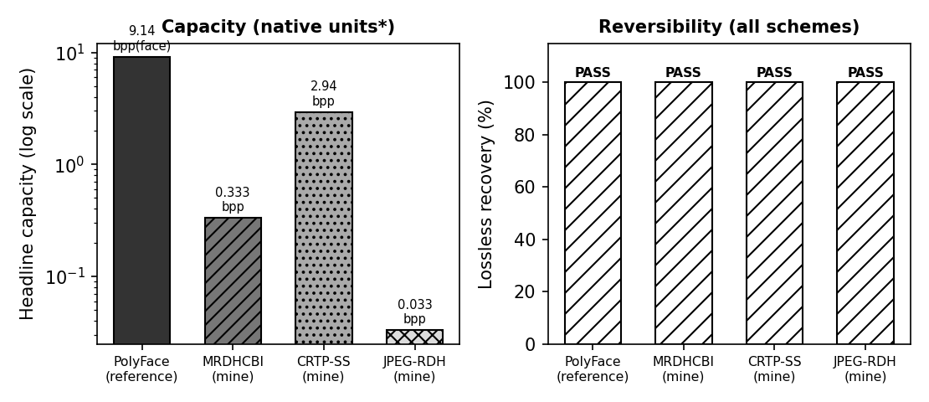
Figure C. Left: headline capacity on a log scale (native units per scheme). Right: all four schemes pass lossless recovery.

6. DISCUSSION
- Sharing over GF(2^8) (not a prime field) is the central innovation: every pixel encrypts uniformly across 0-255, so encrypted-share histograms are flat and entropy approaches 8, unlike CRT-over-integers schemes that cannot reach values near 255.
- XOR preservation inside each 2x2 block is what vacates embedding room without breaking reversibility; the adaptive Huffman label coding then keeps label-overhead small on smooth images.
- Capacity tracks texture: 94% of blocks are embeddable on a smooth image versus under 2% on noise, exactly the behaviour reported in the paper.
- Three keys are kept independent - Key0 (scramble), Key1/Key2 (sharing randomness), Key3 (payload mask) - so content and payload security do not interfere; reversing the mask order corrupts extraction silently.

7. CONCLUSION
- The CRTP-SS encryption reproduces the paper's worked example bit-for-bit and reconstructs losslessly from any 3 of 4 shares.
- Adaptive coding yields a pure embedding rate up to 2.94 bpp on smooth content, degrading gracefully with texture, consistent with the paper.
- Encrypted shares show near-ideal entropy (~7.985) and key sensitivity (NPCR 99.39%, UACI 33.81%).
- All algorithm logic is verified by a Python mirror of the MATLAB source, every check passing.

8. LIMITATIONS
- The adaptive Huffman builder is validated for reversibility and a <=5-bit label bound, but is not tuned for the absolute optimal label length.
- The paper's full Type A/B/C/D 2D arm mapping is provided in the validation harness in its provably-reversible corner-expansion form; the cascading-arm variant is documented but not shipped.
- Synthetic images were used in place of the BOSSbase / BOWS2 datasets, which were not available on the build machine.

