


Loop

Description
This Action is used to execute a specific part of the Flow in a loop. The Action should be placed at the beginning of the part of the Flow that will be executed in a loop and is entered at the Start input, and at the end of that part of the Flow it should be returned to this Action, but now through the Next input. Each time the Flow passes through this Action, the value of the set variable will change from the From to the To value with the Step value. Flow execution will go through (From - To + 1) / Math.abs(step) times before the iteration completes, and passes through the Done output. If we want to stop the iteration before the To value is reached, then we simply don't need to return to the Next input. Also, it is possible to use SetVariable to change the variable by which it is iterated, and thus skip one or more steps.
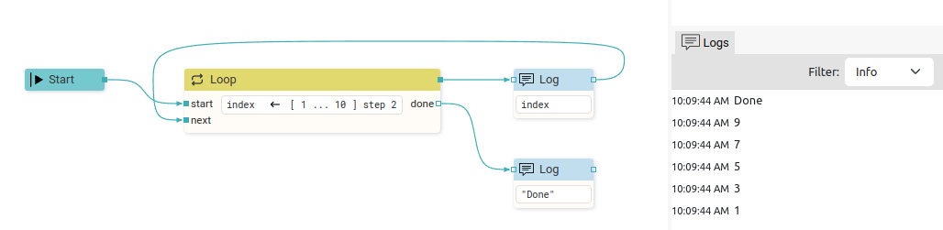

Properties

Specific

Variable ASSIGNABLE EXPRESSION (integer)
A variable that determines the number of passes through the loop and whose value will be changed and tested to see if a new iteration is needed.

From EXPRESSION (integer)
The initial value of the variable.

To EXPRESSION (integer)
The final value of the variable.

Step EXPRESSION (integer)
The value by which the variable is changed on each pass. It can be a positive or negative number.

General

Description String
This is the description of the Action component. Description is displayed below the component in the Project editor/viewer. In the main toolbar, it is possible to hide or display descriptions of all components with one click.

Flow

Inputs Array
Additional component inputs that the user can add as desired in order to use them to receive additional data needed when evaluating expressions in properties. Each input is given a name and type. Name is used when referencing an input within an expression. A type is used to project Check to check whether a data line that transmits data of that type is connected to the input or not.

Outputs Array
Additional component outputs that the user can add to send data through. Each output is assigned a name and type. An example of using this output is e.g. in the Loop component, where we can put the output name for the Variable property instead of e.g. variable name. In that case, the Loop component will not change the content of the variable in each step, but will send the current value through that output.

Catch error Boolean
If this checkbox is enabled then an @Error output will be added to the component and if an error occurs in this component during the execution of the Flow, the Flow will continue through that output. The data that will be passed through that output is the textual description of the error.

Position and size

Align and distribute Any
Alignment icons and component distribution. Alignment icons appear when two or more components are selected, and distribution icons appear when three or more components are selected.


Inputs

start SEQ | MANDATORY
When this input is passed, the variable is set to the From value and Flow execution continues through seqout.

next SEQ | MANDATORY
When this input is passed, the variable is changed by the Step value. It is tested whether it is less than or equal to To value if Step is positive, or whether it is greater than or equal to if Step is negative.
If the variable has not exceeded the To value, then Flow execution continues through seqout, otherwise it continues through Done output.

Outputs

seqout SEQ | MANDATORY
Flow execution continues through this output for the duration of the iteration.

done SEQ | OPTIONAL
Flow execution continues through this output when the iteration is complete.

Examples

- Loop

