


TestAndSet

Description
It tests the boolean variable and if it is false then it is set to true and output to the sequential output (seqout), and if it is true then it is put back into the Flow execution queue, i.e. this action waits until the variable becomes false.This testing and setup is done as a single atomic (non-interruptable) operation, so this Action is suitable for the case when you want to make sure that at some point you only go through a certain part of the Flow once. In that case, this Action should be set before entering that part of the Flow, and at the exit from the Flow, the variable should be set to false again with the SetVariable Action.
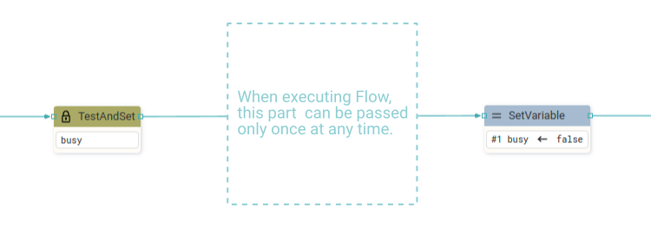

Properties

Specific

Variable ASSIGNABLE EXPRESSION (boolean)
The variable to be tested and set.

General

Description String
This is the description of the Action component. Description is displayed below the component in the Project editor/viewer. In the main toolbar, it is possible to hide or display descriptions of all components with one click.

Flow

Inputs Array
Additional component inputs that the user can add as desired in order to use them to receive additional data needed when evaluating expressions in properties. Each input is given a name and type. Name is used when referencing an input within an expression. A type is used to project Check to check whether a data line that transmits data of that type is connected to the input or not.

Outputs Array
Additional component outputs that the user can add to send data through. Each output is assigned a name and type. An example of using this output is e.g. in the Loop component, where we can put the output name for the Variable property instead of e.g. variable name. In that case, the Loop component will not change the content of the variable in each step, but will send the current value through that output.

Catch error Boolean
If this checkbox is enabled then an @Error output will be added to the component and if an error occurs in this component during the execution of the Flow, the Flow will continue through that output. The data that will be passed through that output is the textual description of the error.

Position and size

Align and distribute Any
Alignment icons and component distribution. Alignment icons appear when two or more components are selected, and distribution icons appear when three or more components are selected.


Inputs

seqin SEQ | OPTIONAL
A standard sequential input.

Outputs

seqout SEQ | OPTIONAL
Flow execution continues through this sequential output when the variable becomes false.

Examples

- Tetris In the do_action User action, which is called when it is detected that some key on the keyboard is pressed, the TestAndSet action on the busy variable is used at the beginning, and before the exit the busy variable is set to false. In this way, it is ensured that two Actions are not executed simultaneously.

