
AddToInstrumentHistory

Description

It is used to add a new item to the History view of the instrument. Currently, only adding chart items is supported.
For example in the Rigol Waveform Data example we have this Action:
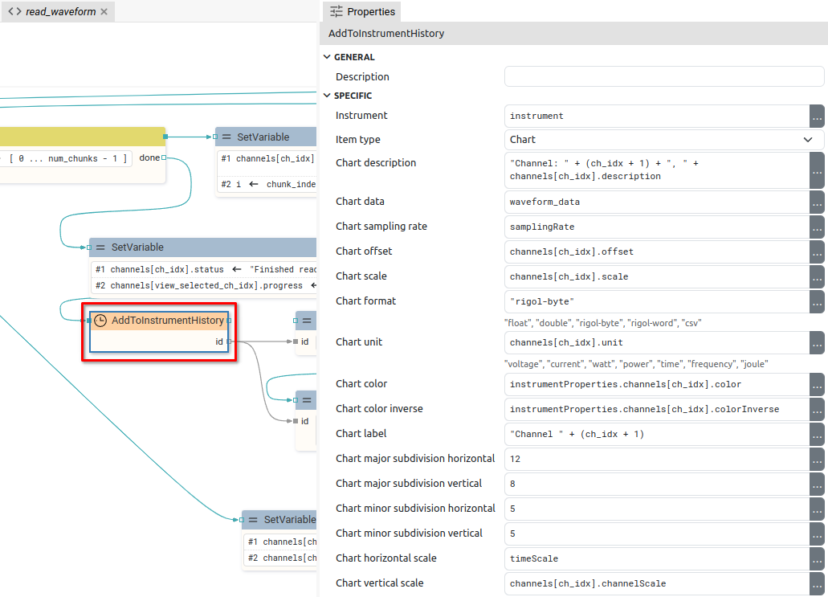
It is used to add a chart which, after successful addition, will be displayed as follows (example of test signal acquisition):
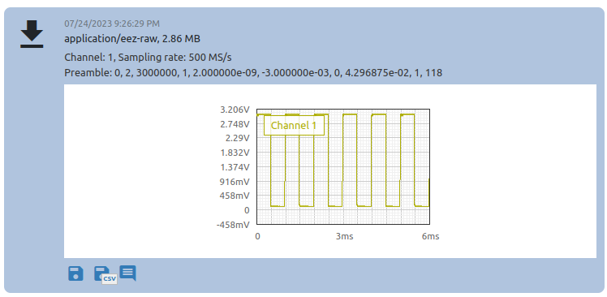

Properties

Specific

Instrument EXPRESSION (object:Instrument)
An instrument in whose History an item will be added.

Item type Enum
Item type to be added, currently it can only be "Chart".

Chart description EXPRESSION (string)
Description of the chart displayed in the instrument History:
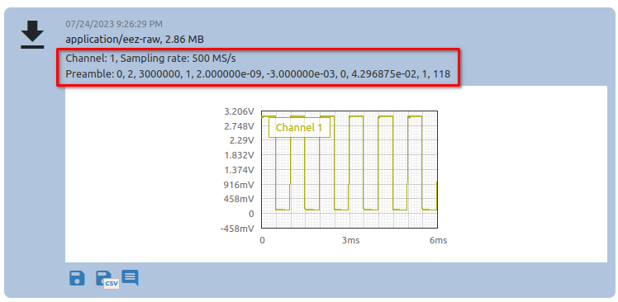

Chart data EXPRESSION (blob)
A string or blob containing the samples that will be displayed in the chart.

Chart sampling rate EXPRESSION (float)
Sampling rate or number of samples per second (SPS).

Chart offset EXPRESSION (double)
Offset value used in formula offset + sample_value * scale which transforms sample value to sample position on y axis in the chart.

Chart scale EXPRESSION (double)
When displaying samples, the formula offset + sample_value * scale is used.

Chart format EXPRESSION (string)
Format from Chart data. Possible values:
- "float": "Chart data" must be a blob containing 32-bit, little-endian float numbers
- "double": "Chart data" must be a blob containing 64-bit, little-endian float numbers
- "rigol-byte": "Chart data" must be a blob containing 8-bit unsigned integer numbers
- "rigol-word": "Chart data" must be a blob containing 16-bit unsigned integer numbers
- "csv": "Chart data" must be a CSV string, the first column is taken

Chart unit EXPRESSION (integer)
The unit displayed on the Y-axis. The X-axis is always time.

Chart color EXPRESSION (string)
The color of the line in the chart if a dark background is selected.

Chart color inverse EXPRESSION (string)
The color of the line in the chart if the light background is selected.

Chart label EXPRESSION (string)
Chart label:
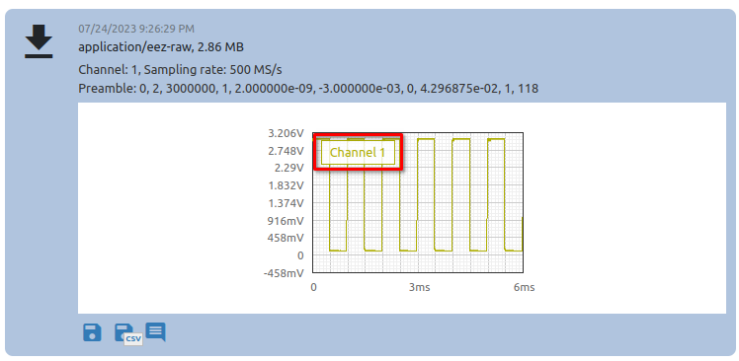

Chart major subdivision horizontal EXPRESSION (integer)
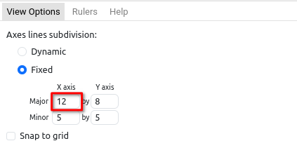

Chart major subdivision vertical EXPRESSION (integer)
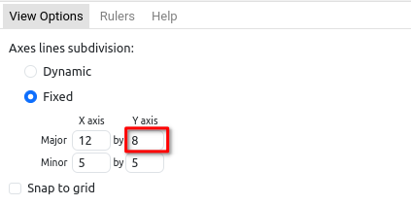

Chart minor subdivision horizontal EXPRESSION (integer)
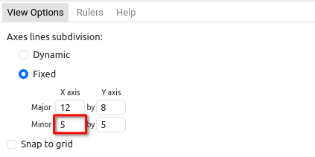

Chart minor subdivision vertical EXPRESSION (integer)
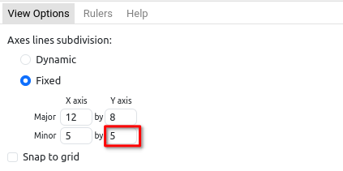

Chart horizontal scale EXPRESSION (double)
The number that defines the X-axis zoom factor in the default chart view.

Chart vertical scale EXPRESSION (double)
The number that defines the Y-axis zoom factor in the default chart view.

General

Description String
This is the description of the Action component. Description is displayed below the component in the Project editor/viewer. In the main toolbar, it is possible to hide or display descriptions of all components with one click.

Flow

Inputs Array
Additional component inputs that the user can add as desired in order to use them to receive additional data needed when evaluating expressions in properties. Each input is given a name and type. Name is used when referencing an input within an expression. A type is used to project Check to check whether a data line that transmits data of that type is connected to the input or not.

Outputs Array
Additional component outputs that the user can add to send data through. Each output is assigned a name and type. An example of using this output is e.g. in the Loop component, where we can put the output name for the Variable property instead of e.g. variable name. In that case, the Loop component will not change the content of the variable in each step, but will send the current value through that output.

Catch error Boolean
If this checkbox is enabled then an @Error output will be added to the component and if an error occurs in this component during the execution of the Flow, the Flow will continue through that output. The data that will be passed through that output is the textual description of the error.

Position and size

Align and distribute Any
Alignment icons and component distribution. Alignment icons appear when two or more components are selected, and distribution icons appear when three or more components are selected.


Inputs

seqin SEQ | MANDATORY
A standard sequence input.

Outputs

seqout SEQ | OPTIONAL
A standard sequence output.

id DATA(string) | OPTIONAL
ID of the added history item. We can, for example, use this data in the Chart Widget to display the chart history item inside the dashboard.

Examples

- Rigol Waveform Data

