

Grid

Description

Use this Widget when you want to display the same Widget multiple times inside the grid. This Widget has one Child widget under it, and the number of times it will be displayed depends on the Data property.
Multiplied Widgets depending on the Grid flow property can be displayed by filling the rows first:
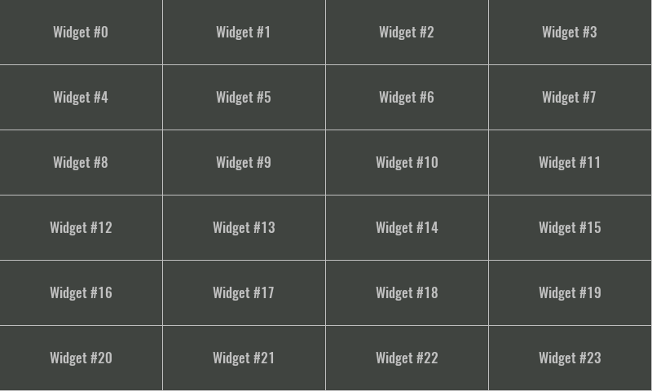
... or columns:
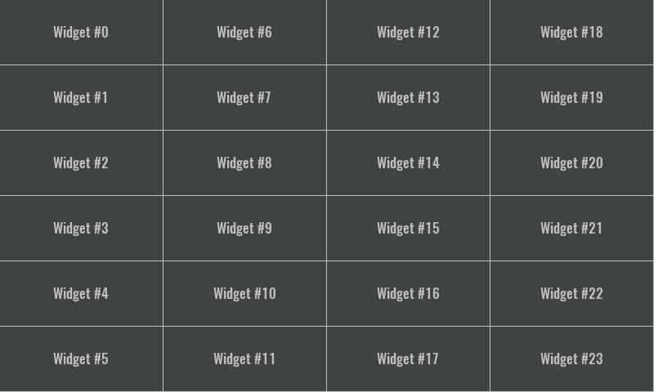
It wouldn't be very useful if multiplied Widgets always had the same content, that's why there is a system variable $index that tells us in which order the Widget is rendered. That variable is zero based, that means when its value is 0 then the first Widget is rendered, when its value is 1 then the second Widget is rendered and so on. That $index can then be used within the expression of the property of the Child widget, and in this way it is achieved that each rendered Widget has different content (e.g. the contents shown above were created in such a way that we defined for the Text widget that the displayed text is calculated from the following expression: "Widget #" + $index).

Properties

Specific

Data EXPRESSION (any)
Determines how many times the Child widget will be multiplied, i.e. the number of elements in the grid. The value of this property can be an integer and then it is the number of elements, and if the value of this property is an array, then the number of elements in the list is equal to the number of elements in that array.
In the case of EEZ-GUI projects, the value of this property can also be struct:$ScrollbarState. The same structure is used for the ScrollBar Widget, which can then be connected to the Grid Widget via the struct:$ScrollbarState variable and thus enable scrolling of the list in case the total number of list elements is greater than the number of elements that fit within the Grid Widget.
More about the struct:$ScrollbarState system structure can be found in the ScrollBar Widget documentation.

Grid flow Enum
Defines the grid filling method. We need to select Row if we want it to be filled row by row. We will select Column if we want it to be filled column by column.

Visible EXPRESSION (boolean)
If the calculated expression is true then the Widget is visible, and if it is false then the Widget is hidden. It can be left blank, in which case the Widget is always visible.

Position and size

Resizing Any
If the page where this Widget is located has the "Scale to fit" option enabled, then this option can be used to control how the position and size of the widget will be calculated when scaling the page:

With the Pin to edge option we can fix the top, right, bottom and left edge of the Widget in relation to the page when it changes its original dimension because the Scale to fit option is selected. E.g. if we selected Pin to top edge then the distance between the top edge of the page and the top edge of the Widget will always be the same, in other words the Top position does not change the value. If Pin to top edge is not selected, then the Top position will scale proportionally as the page height scales.
Using the Fix size option, we can fix the width/height of the Widget, i.e. if this option is selected the width/height will always be the same, and if not selected the width/height will scale proportionally as the page height scales.
Note: If Pin to left edge and Pin to right edge are selected, then the Fix width option will be disabled, and conversely if Fix width is selected, then both Pin to left edge and Pin to right edge cannot be selected, because both cannot be satisfied. The same applies to Pin to top edge and Pin to bottom edge and Fix width.

Hide "Widget is outside of its parent" warning Boolean
Check when we want to hide "Widget is outside of its parent" warning message(s).

Align and distribute Any
Alignment icons and component distribution. Alignment icons appear when two or more components are selected, and distribution icons appear when three or more components are selected.


Center widget Any
Icons for horizontal and vertical centering of widgets within a page or parent widget.


Left Number
X position of the component in relation to the page or parent widget. It is set in pixels.
Hint: when setting the value of this property (as well as the Top, Width and Height properties), simple mathematical expressions can be used. When we enter an expression and press enter, the expression will be evaluated and the result set as the value of this property. It is allowed to use +, -, * and / operators in expressions. Brackets can also be used.
Examples of such mathematical expressions: 18 + 36, 50 + 32 * 6, (100 - 32) / 2.

Top Number
Y position of the component in relation to the page or parent widget. It is set in pixels.

Width Number
The width of the component. It is set in pixels.

Height Number
The height of the component. It is set in pixels.

Absolute position String
The absolute position of the component in relation to the page. This property is read-only.

Style

Default Object
Style used when rendering the background of the Widget.

Events

Event handlers Array
List of event handler definitions. During execution, the widget can generate certain events (e.g. the CLICKED event is generated when the touchscreen is pressed and released within the Widget) and through this list we can specify the method of event processing. We must define these properties for each event handler:
- Event – Event that is processed, e.g. CLICKED.
- Handler type – There are two options: Flow or Action. If Flow is selected, a flow output will be added through which the event is processed, and if Action is selected, then it is necessary to specify which User action will be performed during event processing.
- Action - If the Handler type is set to Action, then here we need to enter the name of the User action that will be performed during the processing of the selected event.

Flow

Inputs Array
Additional component inputs that the user can add as desired in order to use them to receive additional data needed when evaluating expressions in properties. Each input is given a name and type. Name is used when referencing an input within an expression. A type is used to project Check to check whether a data line that transmits data of that type is connected to the input or not.

Outputs Array
Additional component outputs that the user can add to send data through. Each output is assigned a name and type. An example of using this output is e.g. in the Loop component, where we can put the output name for the Variable property instead of e.g. variable name. In that case, the Loop component will not change the content of the variable in each step, but will send the current value through that output.

Catch error Boolean
If this checkbox is enabled then an @Error output will be added to the component and if an error occurs in this component during the execution of the Flow, the Flow will continue through that output. The data that will be passed through that output is the textual description of the error.

Examples

- eez-gui-widgets-demo
- Tetris

