Ellie Ezzell

Research Question and Data Sources

**Research question**

How did the metering policy implemented in May 2018 in the Laredo Field Office affect where family units and unaccompanied minors requested asylum, at a port of entry or in between a port of entry?

**Data Sources**

**Source 1**

**Title:** Southwest Border Inadmissibles Fiscal Year 2017 - By Month

**Link:** [**https://www.cbp.gov/newsroom/stats/ofo-sw-border-inadmissibles-fy2017**](https://www.cbp.gov/newsroom/stats/ofo-sw-border-inadmissibles-fy2017)

**Description:** This link contains the data for the number of individuals in a family unit (FMUA), and unaccompanied minors (UAC) who presented themselves at an official port entry for the months of October-December of 2016, and January-September of 2017. This data was added to the “At POE” variable.

**Access:** to find the data, click the link, and scroll down to the section which looks like the screenshot below. 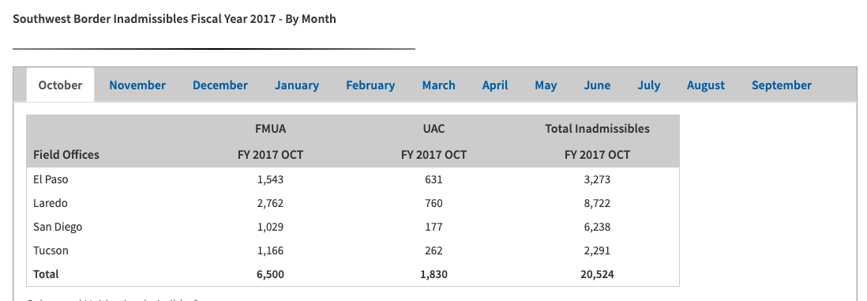

**Source 2**

**Title:** Southwest Border Inadmissibles Fiscal Year 2018 - By Month

**Link:** [**https://www.cbp.gov/newsroom/stats/ofo-sw-border-inadmissibles**](https://www.cbp.gov/newsroom/stats/ofo-sw-border-inadmissibles)

**Description:** This link contains the data for the number of individuals in a family unit (FMUA), and unaccompanied minors (UAC) who presented themselves at an official port entry for the months of October-December of 2017, and January-September of 2018. This data was added to the “At POE” variable.

**Access:** to find the data, click the link, and scroll down to the section which looks like the screenshot below.

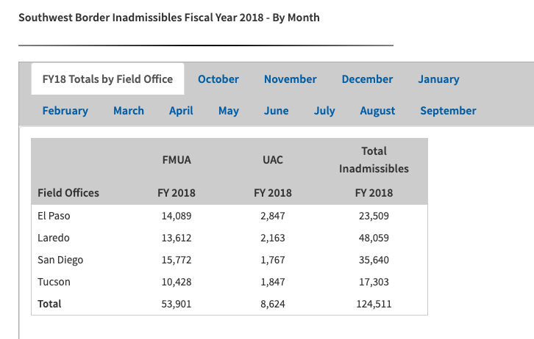

**Source 3**

**Title:** Office of Field Operations Southwest Border Inadmissibles FY 2019

**Link:** <https://www.cbp.gov/newsroom/stats/sw-border-migration/ofo-sw-border-inadmissibles>

**Description:** This link contains the data for the number of individuals in a family unit (FMUA), and unaccompanied minors (UAC) who presented themselves at an official port entry for the months of October-December of 2018, and January-February of 2019. This data was added to the “At POE” variable.

**Access:** to find the data, click the link, and scroll down to the section which looks like the screenshot below.

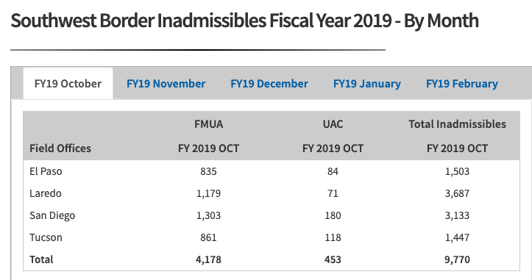

**Source 4**

**Title:** United States Border Patrol Southwest Family Unit Subject and Unaccompanied Alien Children Apprehensions Fiscal Year 2016 - By Month

**Link:** <https://www.cbp.gov/newsroom/stats/southwest-border-unaccompanied-children/fy-2016>

**Description:** This link contains the data for the number of individuals in a family unit (FMUA), and unaccompanied minors (UAC) who presented themselves in between an official port entry for the months of October-December of 2015, and January-September of 2016. This data was added to the “In Between POE” variable.

**Access:** to find the data, click the link, and scroll down to the section which looks like the screenshot below. 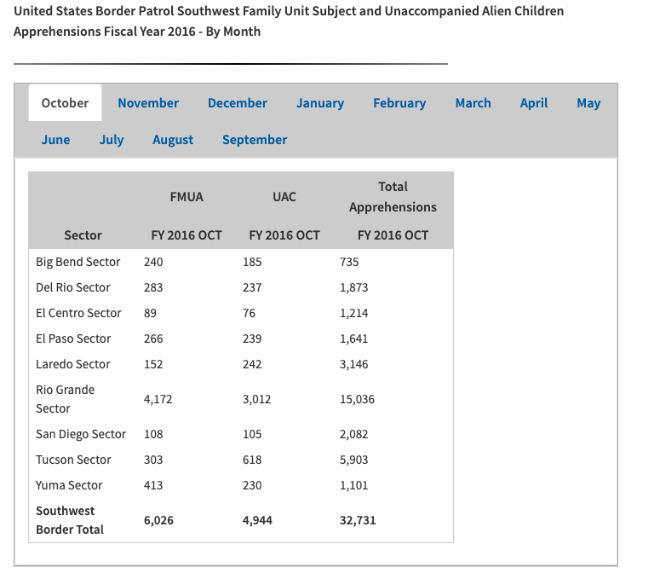

**Source 5**

**Title:** Southwest Family Unit Subject and Unaccompanied Alien Children Apprehensions Fiscal Year 2017 - By Month

**Link:**  <https://www.cbp.gov/newsroom/stats/usbp-sw-border-apprehensions-fy2017>

**Description:** This link contains the data for the number of individuals in a family unit (FMUA), and unaccompanied minors (UAC) who presented themselves in between an official port entry for the months of October-December of 2016, and January-September of 2017. This data was added to the “In Between POE” variable.

**Access:** to find the data, click the link, and scroll down to the section which looks like the screenshot below.

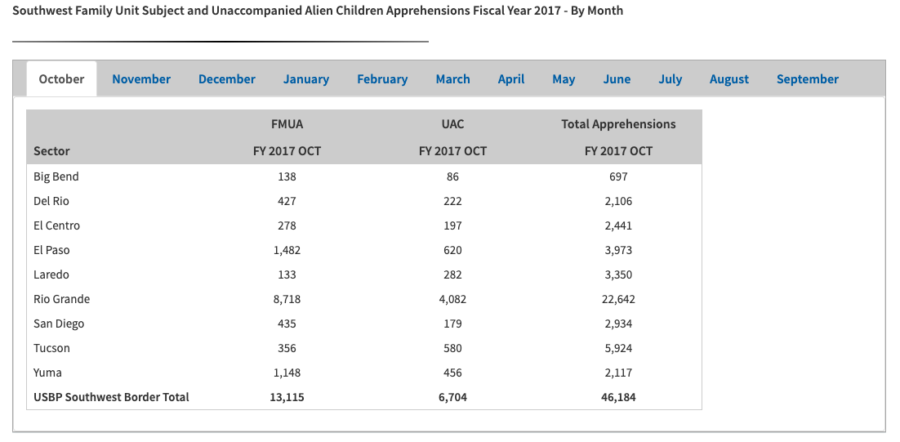

**Source 6**

**Title:** Southwest Family Unit Subject and Unaccompanied Alien Children Apprehensions Fiscal Year 2018 - By Month

**Link:** [**https://www.cbp.gov/newsroom/stats/usbp-sw-border-apprehensions**](https://www.cbp.gov/newsroom/stats/usbp-sw-border-apprehensions)

**Description:** This link contains the data for the number of individuals in a family unit (FMUA), and unaccompanied minors (UAC) who presented themselves in between an official port entry for the months of October-December of 2017, and January-September of 2018. This data was added to the “In Between POE” variable.

**Access:** to find the data, click the link, and scroll down to the section which looks like the screenshot below.

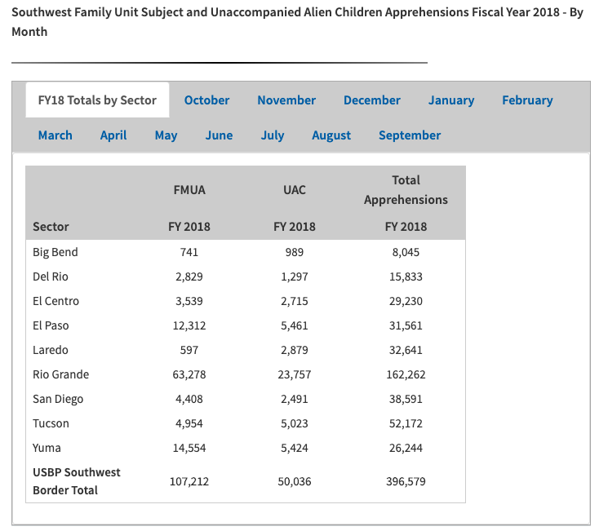

**Source 7**

**Title:** Southwest Family Unit Subject and Unaccompanied Alien Children Apprehensions Fiscal Year 2019 - By Month

**Link:** [**https://www.cbp.gov/newsroom/stats/sw-border-migration/usbp-sw-border-apprehensions**](https://www.cbp.gov/newsroom/stats/sw-border-migration/usbp-sw-border-apprehensions)

**Description:** This link contains the data for the number of individuals in a family unit (FMUA), and unaccompanied minors (UAC) who presented themselves in between an official port entry for the months of October-December of 2018, and January-February of 2019. This data was added to the “In Between POE” variable.

**Access:** to find the data, click the link, and scroll down to the section which looks like the screenshot below.

