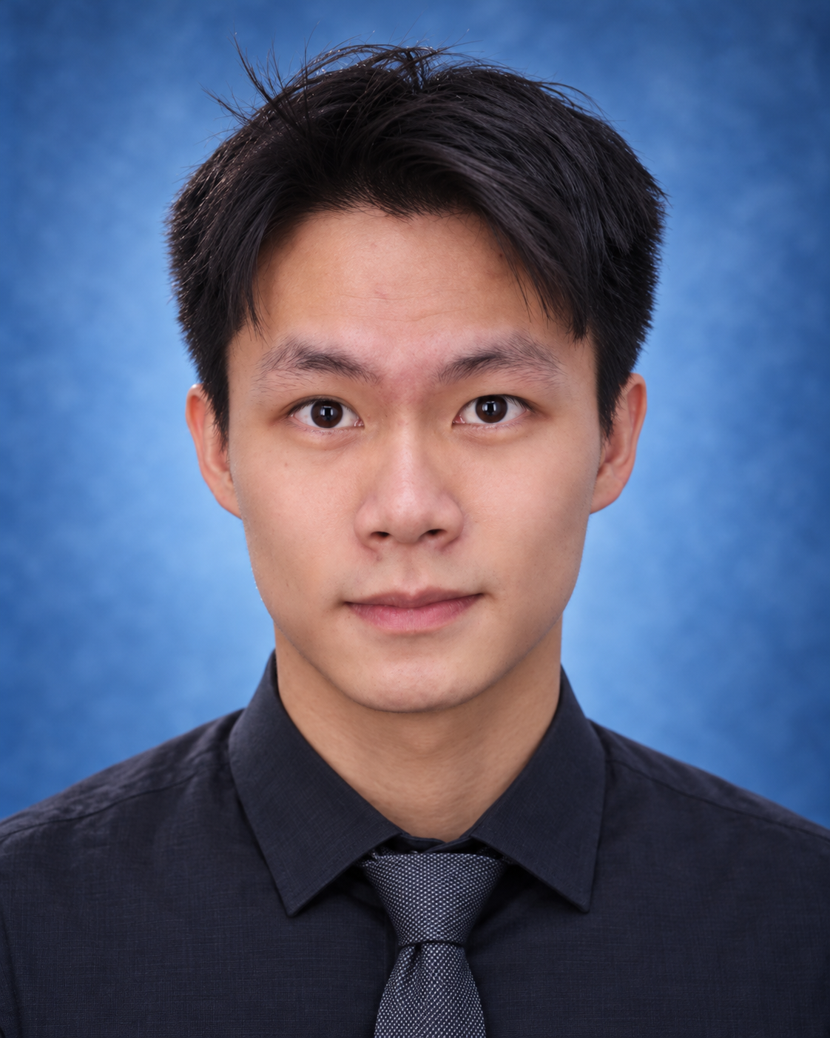
Yue Chen
cheny2639@mail2.sysu.edu.cn | github.com/ef1026
Seeking: Algorithm Research Internship
Document Intelligence / Multimodal Learning / RAG

Education
Sun Yat-sen University 2024–2028
Microelectronics Science and Engineering · Undergraduate

Research and Algorithm Projects
ProSA | Structural Robustness Auditing for Document Parsing 2026
Accepted at EMNLP 2026 Main Conference · First Author
arXiv: arxiv.org/abs/2605.19309 | GitHub: github.com/ef1026/ProSA
• Led the development of ProSA, an auditing framework requiring no access to parser internals. To address Footprint Bias in measuring parsing damage by perturbation area, designed the block-level structural loss rate B-SLR to jointly assess block locations and text preservation.
• Led the research direction, experimental design and core validation; evaluated MinerU and PP-StructureV3 and analyzed how structural errors propagate to downstream question answering and retrieval.
• Across 1,000 document pages and 29 fixed perturbation configurations, B-SLR achieved fitted R² values of 0.727 / 0.916 against changes in OCR character error rate, exceeding 0.384 / 0.110 for the area-based metric.
SAE | Sprint Video Analysis and Evidence-Augmented Reports 2026
Under review at Biology of Sport · Co-first author (second-listed author)
• Contributed to the SEE–ASSESS–EXPLAIN framework, combining pose estimation from single-view video, phase-specific rule assessment, literature retrieval and LLM explanations to generate technique analysis reports with cited evidence.
• Contributed to expert agreement, retrieval and evidence comparison evaluations. Across 1,008 fixed phase-specific rule assessments from 112 sprint trials, rule judgments agreed with the majority judgment of three experts in 93.2% of cases.
Physical Belief | Multimodal Physical State Estimation for Robots 2026–Present
Multimodal Fusion · Temporal Modeling
• Fuse RGB-derived poses, robot states and interaction history using an MLP + GRU to estimate object mass, friction and center of mass, building a physical state representation continuously updated through interaction.
• Conduct training under multiple conditions, temporal ablations and generalization evaluations. In completed in-domain tests, full history reduced friction estimation MAE by approximately 65% relative to a short-history baseline.

Other Projects
Personalized Education RAG System
Undergraduate Innovation and Entrepreneurship Training Program · Project Lead
• Lead the technical roadmap and project execution; designed a personalized education system combining course knowledge bases, user information, retrieval and generation.

Honors and Awards
• National Scholarship and First-Class Outstanding Student Scholarship, Sun Yat-sen University (2024–2025)
• Third-Class Outstanding Student Scholarship, Sun Yat-sen University (2025–2026)
• First Prize, Guangdong Provincial Mathematics Competition for College Students (2024)
• Second Prize, China Undergraduate Mathematical Contest in Modeling, Guangdong Division (2026)

Skills
Programming and Tools: Python, PyTorch, MuJoCo
Research and Practice: Document Intelligence / DLA, RAG / Agents, Temporal Deep Learning, Multimodal Fusion, Model Evaluation
English: College English Test Band 6 (CET-6): 579

