AI Demo Ideas for Robot Education: Chips and Boards Without Wi-Fi
This document lists AI demo ideas for robot education and matches each one to chips or boards that have no Wi-Fi, with their AI speed (TOPS) and price as of October 2026. The demos are grouped by how much AI computing they need: from gesture spells on a $5 microcontroller up to an offline talking robot that needs a 20 to 40 TOPS accelerator. After the four tier tables, a section shows how the demos combine on one two-wheel self-balancing robot with a camera.

At a glance
The 28 demo ideas fall into four tiers by how much AI computing they need. Each tier lists its demos and the no-Wi-Fi chips that run them.
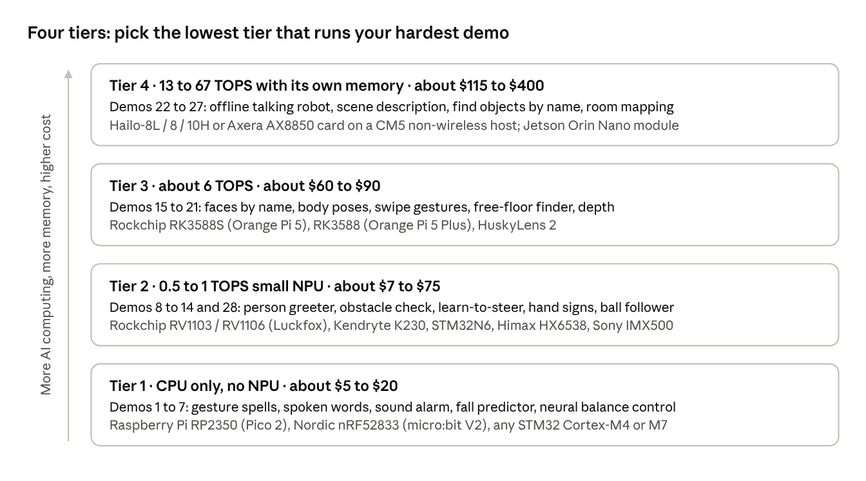
AI demo tiers · 28 demos, 4 compute levels, no-Wi-Fi chips
Read from the bottom up: each step adds AI power and cost. A robot for younger students can stop at Tier 1 or 2; a robot that must talk back or describe what it sees needs Tier 4. Exact chips, TOPS and prices for every demo are in the tier tables below.

How to read the recommendations
Each demo table lists a recommended chip or board, its AI speed, its price, and notes. A few terms explain how to compare them.
TOPS and GOPS. An NPU (neural processing unit) is a part of a chip built only to run neural networks. Its speed is given in TOPS: trillions of simple maths operations per second. GOPS is the same in billions, so 600 GOPS = 0.6 TOPS. More TOPS lets you run bigger models or more frames per second. TOPS is only a rough guide, though. Real speed also depends on memory bandwidth, the software tools, and whether the model's layers are supported by that NPU.
INT8 vs INT4. Makers quote TOPS at a number precision. INT8 means each number in the model is stored in 8 bits; INT4 uses 4 bits, which doubles the headline TOPS but is mainly useful for language models. To compare fairly, compare INT8 figures. This document gives INT8 where the maker publishes it. For example, the Hailo-10H is "40 TOPS" at INT4 but 20 TOPS at INT8.
Microcontroller, Linux processor, or accelerator. There are three kinds of part:
- Microcontroller (MCU): a small chip that runs one program with no operating system. It reacts within microseconds, which is what motor control and balancing need. Newer ones (STM32N6, Himax HX6538) add a small NPU.
- Linux processor (MPU or SoC): runs Linux, Python and camera software. Many have an NPU built in (Rockchip RV1106, RK3588, Kendryte K230). It is slower to react than an MCU, so robots usually pair one with an MCU.
- Accelerator: a separate AI chip on an M.2 card (like a small SSD) that plugs into a Linux board over PCIe (Hailo, Axera AX8850). It does no general computing on its own.
Chip vs board price. Prices here are for development boards or modules you can buy in single units. If you design your own robot board, the bare chip costs less, but you add memory, power circuits and design effort.
What "no Wi-Fi" means here. Every recommended part has no Wi-Fi radio on the board. A few have Bluetooth or a simple radio, and the tables say so. Some boards come in two versions (for example Luckfox Pico Ultra and Ultra W); the tables name the version without Wi-Fi.
Prices. US dollar prices as of October 2026 unless marked. Prices in other currencies are shown as listed, with a rough dollar figure marked "approx.". Memory-heavy boards (Raspberry Pi, Jetson, RK3588 boards) have risen several times in 2026 because of a memory chip shortage, so check before buying in bulk.

Tier 1 demos: motion and sound AI on microcontrollers (no NPU needed)
These demos use motion sensors (an IMU: accelerometer plus gyroscope) or a microphone, not a camera. The models are tiny, a few thousand numbers, so an ordinary microcontroller runs them in about a millisecond without any NPU. That makes this the cheapest tier, and the best place to teach the basic idea: collect examples, label them, train, test on new people.
# | Demo idea | What students see and learn | Model behind it | Recommended chip or board (no Wi-Fi) | AI speed | Price (USD)
1 | Magic-wand gesture spells | Three arm or robot movements trigger three reactions. Learn training data, labels, and why a model trained on one person fails on another | Small neural network on motion data (micro:bit CreateAI or TensorFlow Lite Micro) | BBC micro:bit V2 (Bluetooth LE radio only), or Raspberry Pi Pico 2 (RP2350) + IMU | CPU only | ~18 to 20 / ~5 (approx.)
2 | Spoken commands: "go", "stop", "left", "right" | The robot obeys words with no internet. Learn how sound becomes a picture (a spectrogram) that a small image network reads | Keyword-spotting CNN | Grove Vision AI V2 (Himax HX6538, built-in microphone), or Pico 2 + I2S microphone | Arm Ethos-U55 NPU at 400 MHz (TOPS not published) / CPU | 15.99 (maker list) / ~5 + mic
3 | Sound alarm: clap, whistle, knock | The robot turns toward a sound and names it. Learn classifying non-speech audio | Small CNN on audio | micro:bit V2 (built-in microphone), or Grove Vision AI V2 | CPU / Ethos-U55 | ~18 to 20 / 15.99
4 | "Am I about to fall?" predictor | The robot predicts a fall a fraction of a second early and brakes. Learn predicting from a time series (a moving window of sensor readings) | Small 1-D CNN or LSTM on IMU data | Pico 2 (RP2350), or any STM32 with Cortex-M4/M7 | CPU only | ~5
5 | Motor-health checker | Detects a loose wheel or worn gear from vibration. Learn anomaly detection: the model learns what "normal" looks like and flags anything unusual | Tiny autoencoder | Pico 2, or STM32 | CPU only | ~5
6 | Neural-network balance controller | A small network learns to copy a working PID balance controller, then drives the robot itself. Learn imitation learning, and why a safety fallback is needed | Small multilayer network (a few dozen neurons) run 200 to 500 times per second | Pico 2 (dual Cortex-M33 with floating point), or STM32G4 / H7 | CPU only | ~5
7 | "What is happening to me?" robot state | The robot tells driving, idle, picked up, and bumped apart. Learn multi-class classification and confusion between similar classes | Small neural network on IMU features | micro:bit V2, or Pico 2 | CPU only | ~18 to 20 / ~5
Why no NPU is needed: a model with 5,000 weights needs about 10,000 operations per guess. A 150 MHz microcontroller does that in well under a millisecond. An NPU only starts to matter once a camera is involved, because one image holds hundreds of thousands of numbers.

Tier 2 demos: camera AI on small NPUs (0.1 to 1 TOPS)
This is the most cost-effective tier for camera demos. One small NPU runs a compact image model at a usable speed (roughly 10 to 30 frames per second at low resolution) for under $60, and several options cost under $20. The models here are "mobile-sized": MobileNet classifiers and small YOLO detectors with a few million weights.
# | Demo idea | What students see and learn | Model behind it | Recommended chip or board (no Wi-Fi) | AI speed (INT8) | Price (USD)
8 | Person and face greeter | The robot notices a person, turns to face them and says hello. Learn object detection (a box plus a label) and how it differs from classification (a label only) | Small face or person detector | STM32N6 Nucleo-N657X0-Q (MCU with NPU and camera input), or Grove Vision AI V2 + OV5647 camera | 0.6 TOPS (600 GOPS) / Ethos-U55 | 56.25 launch, 74.23 at DigiKey / 15.99 + camera
9 | Camera obstacle check: "path clear" or "blocked" | The robot stops or turns using only its camera. Learn to collect your own dataset of floor photos and train a two-class classifier | MobileNet classifier | Luckfox Pico Max (Rockchip RV1106G3, 256 MB, Linux) | 1 TOPS | 14.99
10 | Learn-to-steer line follower | Drive the robot by hand while it records camera frames and your steering; a network learns to steer like you. Learn "behaviour cloning" and why more varied driving makes a better driver | Small CNN that outputs a steering value | Luckfox Pico Max (RV1106G3), or Luckfox Pico Mini (RV1103, 64 MB) for the cheapest build | 1 TOPS / 0.5 TOPS | 14.99 / 6.99
11 | Hand-sign commands (fist = stop, palm = come, two fingers = turn) | Students design their own sign set and dataset. Learn class balance and lighting problems | Small classifier or detector | CanMV-K230 (Kendryte K230, Ethernet, no Wi-Fi on the original board), or Luckfox Pico Max | K230: no single TOPS figure published; YOLOv5s at 38+ fps and MobileNetV2 at 670+ fps (maker figures) | ~50 to 62 / 14.99
12 | Ball or toy follower | The robot finds a chosen object and keeps it centred as it moves. Learn to turn a detector's box position into a steering command | YOLO detector + simple controller | HuskyLens 2 (smart sensor, no built-in Wi-Fi; Wi-Fi only via an optional plug-in), or CanMV-K230 | 6 TOPS / see above | ~75 to 90 / ~50 to 62
13 | Sign-reading navigation | The robot reads arrow cards, handwritten digits or AprilTags and follows them through a maze. Learn the classic digit-recognition network, then extend it | Small CNN (MNIST-style) + AprilTag detector | STM32N6 Nucleo, or Grove Vision AI V2 | 0.6 TOPS / Ethos-U55 | 56.25 to 74.23 / 15.99
14 | Smart camera that keeps the robot's main computer free | Any of demos 8 to 13, but the model runs inside the image sensor itself and only sends results | Small detector (for example MobileNet SSD) | Raspberry Pi AI Camera (Sony IMX500). Needs a Raspberry Pi host; for no Wi-Fi, pair it with a Compute Module 5 "non-wireless" version | On-sensor AI (no TOPS figure published) | 70 at launch
Two notes. First, the STM32N6 is a microcontroller, so it can also do real-time motor control; that makes it a candidate for a one-chip robot (see the robot section below). Second, the Luckfox boards run Linux on a single small core with very little memory (64 to 256 MB), so keep models small and expect simple command-line tools rather than a desktop.

Tier 3 demos: richer vision on 3 to 6 TOPS chips
At around 6 TOPS a robot can run medium-sized vision models, and often two or three at once. That unlocks demos where the model finds points (body joints, finger tips), labels every pixel, or recognises who someone is rather than just that someone is there. The chips here run full Linux with gigabytes of memory, so students can use Python and OpenCV.
# | Demo idea | What students see and learn | Model behind it | Recommended chip or board (no Wi-Fi) | AI speed (INT8) | Price (USD)
15 | Face recognition with names ("Hello, Maria") | The robot greets registered students by name. Learn "embeddings": the network turns a face into a list of numbers, and the same person gives nearby numbers. A good moment to discuss consent and privacy | Face detector + face-embedding network | HuskyLens 2 (built-in face recognition), or Orange Pi 5 (Rockchip RK3588S; no onboard Wi-Fi, only an optional M.2 module) | 6 TOPS / 6 TOPS | ~75 to 90 / launched at 60 (4 GB), 2026 price not checked
16 | Swipe and wave gesture control | Wave to call the robot, swipe left or right to turn it. Learn keypoints (21 points per hand) and recognising a movement over time, not a single picture | Hand-keypoint model + small sequence model | Orange Pi 5 (RK3588S), or Orange Pi 5 Plus (RK3588, no onboard Wi-Fi) | 6 TOPS | ~60+ / about 175 to 220 EUR
17 | "Simon says" pose game | The robot calls a pose; the camera checks if each student copies it. Learn body-pose estimation (17 body joints per person) | Pose network (for example YOLO-pose) | Orange Pi 5 (RK3588S), or Raspberry Pi Compute Module 5 non-wireless + Hailo-8L M.2 | 6 TOPS / 13 TOPS | ~60+ / CM5 from 45 at launch + Hailo-8L 115 EUR
18 | Free-floor finder | The robot colours every pixel as floor or not-floor and steers toward open floor. Learn segmentation, and compare it with the simple yes/no obstacle check in demo 9 | Segmentation network | Orange Pi 5 (RK3588S), or CM5 non-wireless + Hailo-8L | 6 / 13 TOPS | as above
19 | "How far is that?" with one camera | The robot estimates distance to objects from a single image and slows down near them. Learn how a network guesses depth from clues like size and texture, and where it fails (glass, mirrors) | Small monocular depth network | CM5 non-wireless + Hailo-8L, or Orange Pi 5 (slower) | 13 / 6 TOPS | as above
20 | Emotion-reactive robot face | The robot's screen shows a matching face when a student smiles or frowns. Learn expression classification, and discuss how often such models are wrong | Face detector + expression classifier | CanMV-K230, or Orange Pi 5 | see Tier 2 / 6 TOPS | ~50 to 62 / ~60+
21 | Three models at once | Detect a person, recognise their face, and read their hand sign in one pipeline. Learn time budgets: each model takes milliseconds, and they must all fit in one frame | Detector + face embedding + gesture model | Orange Pi 5 (RK3588S has three NPU cores), or HuskyLens 2 (runs several models in series or parallel) | 6 TOPS | ~60+ / ~75 to 90
Why RK3588S here: it is the most common 6 TOPS chip with good open software (Rockchip's RKNN tools), and the basic Orange Pi 5 leaves Wi-Fi off the board. Some other 6 TOPS boards (for example the Radxa ROCK 4D with RK3576) build Wi-Fi in, so they are left out.

Tier 4 demos: speech, language and vision-language models (13 to 67 TOPS)
Language models and vision-language models are far bigger than image detectors: hundreds of millions to a few billion weights. Two things matter more than TOPS here. First, memory: the whole model must fit, so accelerators with their own 4 to 8 GB of memory (Hailo-10H, Axera AX8850) are the practical choice. Second, the host board: the accelerator cards below plug into an M.2 PCIe slot. To keep the whole robot free of Wi-Fi, use a host without it, such as a Raspberry Pi Compute Module 5 "non-wireless" version on an IO board with an M.2 slot.
# | Demo idea | What students see and learn | Model behind it | Recommended chip or board (no Wi-Fi) | AI speed | Price (USD)
22 | Offline talking robot | Ask the robot a question out loud; it answers out loud with no internet. Learn that a voice assistant is three models in a chain (speech-to-text, a language model, text-to-speech) and where the delay comes from | Speech-to-text (for example Whisper small) + small language model (1 to 3 billion weights) + text-to-speech | Hailo-10H M.2 card with 8 GB (for example ASUS UGEN300), or M5Stack LLM-8850 card (Axera AX8850, 4 or 8 GB), on a CM5 non-wireless host | 20 TOPS INT8 / 40 INT4 / 24 TOPS INT8 | 259 list / ¥37,345 (4 GB) to ¥43,395 (8 GB) in Japan, roughly 250 to 290 (approx.)
23 | "What do you see?" robot | Students ask "what is on the table?" and the robot describes the scene. Learn vision-language models, and test where they invent things that are not there | Small vision-language model | Hailo-10H 8 GB on CM5 non-wireless, or NVIDIA Jetson Orin Nano 8 GB module on a carrier board without Wi-Fi | 20 TOPS INT8 / 40 TOPS (67 in "Super" mode) | 259 / 399 module + carrier
24 | "Find the red cup" by name | Type or say any object name; the robot searches for it with no training. Learn open-vocabulary detection, which links words and images | YOLO-World or similar | Hailo-8 M.2 on CM5 non-wireless, or Jetson Orin Nano module | 26 TOPS / 40 to 67 TOPS | 195 EUR / 399 + carrier
25 | Map the room, then "go to the door" | The robot builds a map with its camera and drives to a named place. Learn visual SLAM (building a map while tracking your own position) and the ROS 2 robot software framework | Visual SLAM + navigation stack (for example NVIDIA Isaac ROS) | Jetson Orin Nano 8 GB module | 40 to 67 TOPS | 399 + carrier
26 | Follow-me robot that remembers you | The robot follows one student through a crowd, even after they pass behind someone. Learn tracking and "re-identification" (matching a person's appearance across frames) | Detector + tracker + re-identification network | Hailo-8 on CM5 non-wireless, or Orange Pi 5 (slower) | 26 / 6 TOPS | 195 EUR / ~60+
27 | Robot that explains itself | Ask "why did you stop?" and it answers "a chair was in my path". A language model reads the detector results and sensor log. Learn how language models can summarise data, and why their answers must be checked | Detector + small language model | Hailo-10H or AX8850 card on CM5 non-wireless | 20 / 24 TOPS INT8 | 259 / ~250 to 290 (approx.)
Two cautions. The Jetson developer kit ships with a Wi-Fi card, so for a no-Wi-Fi build buy the bare module and a carrier board without wireless, or remove the card. And Raspberry Pi raised CM5 prices during 2026 along with the Pi 5 (CM5 launched at $45 for the 2 GB, no-wireless, no-storage version), so check current prices.

Putting it together: a two-wheel self-balancing robot with a camera
A two-wheel self-balancing robot that avoids obstacles, takes voice commands and recognises faces and gestures should be built with two processors: a microcontroller that keeps it upright, and an AI chip that decides where to go. This section explains why, which demos run where, and four ways to build it without Wi-Fi.
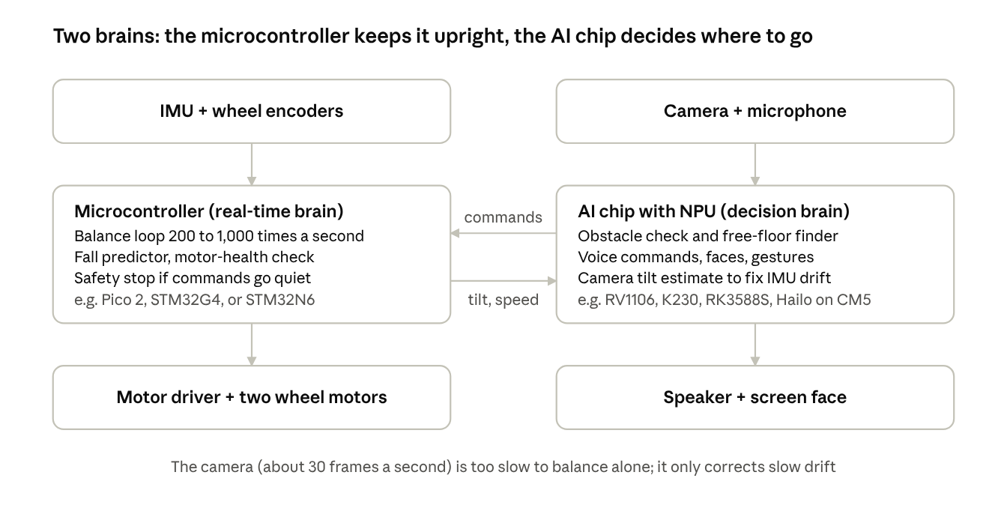
self-balancing robot architecture · two processors linked by a serial line
Why two brains. A self-balancing robot is an inverted pendulum: like balancing a broom on your hand, it starts to fall the moment the wheels stop correcting. The control loop must read the tilt and adjust the motors hundreds of times a second, and every cycle must arrive on time. A microcontroller does this reliably because it runs nothing else. A Linux AI chip cannot promise that: one camera frame takes 30 to 100 milliseconds to process, and Linux may pause a program at any moment. So the AI chip sends short commands over a serial line (UART), such as "turn left 20 degrees" or "stop, person ahead", and the microcontroller blends them into its balance loop. If commands stop arriving, the microcontroller brings the robot to a safe stand-still on its own.
Can the camera help balance? Not on its own: at about 30 frames a second it gives a new reading every 33 milliseconds, with extra delay for processing, while the IMU gives one every millisecond. But it can help in a slower role. The IMU's tilt estimate slowly drifts; the camera can see the horizon or floor lines and correct that drift a few times a second. It can also learn the robot's new balance point when it carries a load. That gives one more demo:
- Demo 28: camera tilt estimator vs IMU. Train a small network to guess the robot's tilt from camera images, then plot its guess against the IMU. Students see the camera is accurate but slow, the IMU fast but drifting, and why robots combine both (sensor fusion). Runs on any Tier 2 chip.
Which demos run where
Robot feature | Demo numbers | Runs on | How often (typical)
Balancing | 6 (neural controller, optional), 4 (fall predictor) | Microcontroller | 200 to 1,000 times a second
Camera-assisted balance | 28 | AI chip, result sent to microcontroller | A few to 30 times a second
Obstacle avoidance | 9 (clear or blocked), 18 (free floor), 19 (distance) | AI chip | 10 to 30 times a second
Voice commands | 2 | AI chip, or a small vision/audio module with its own microphone | Always listening
Face recognition | 8 (find faces), 15 (recognise who) | AI chip | 5 to 15 times a second
Gesture recognition | 11 (hand signs), 16 (swipe and wave) | AI chip | 10 to 30 times a second
Four ways to build it (all without Wi-Fi)
Build | Microcontroller | AI chip | Demos it covers well | Approximate cost of these two parts (USD)
A. Lowest cost | Pico 2 (RP2350) | Luckfox Pico Max (RV1106G3, 1 TOPS) + I2S microphone | 2, 4, 5, 6, 8, 9, 10, 11, 28. Face recognition is possible but slow | ~20
B. One chip | STM32N6 does both balancing and vision | (same chip, 0.6 TOPS NPU) | 2, 4, 6, 8, 9, 11, 13, 28. Simplest wiring, but only 4.2 MB of on-chip memory limits model size | 56 to 74 (dev board)
C. Full vision | Pico 2 or STM32G4 | Orange Pi 5 (RK3588S, 6 TOPS) | All of A plus 15 to 21: names, poses, swipe gestures, free-floor segmentation | ~65+ (Orange Pi 5 2026 price not checked)
D. Talking robot | Pico 2 or STM32G4 | CM5 non-wireless + IO board + Hailo-10H 8 GB | All of C plus 22 to 27: offline conversation, scene description, "find the red cup" | roughly 45 + IO board + 259, before 2026 CM5 price rises
A practical path for an education robot is to design the main board around build A or C, and leave an M.2 slot or connector free so the same robot can be upgraded to build D for advanced classes.

Chip and board reference (all without Wi-Fi)
Every part recommended above, sorted from least to most AI computing. "Demos" refers to the numbered ideas in the tier tables.
Part | Type | Main chip | AI engine (INT8 unless noted) | CPU | Memory | Wireless | Price (USD) | Demos
Raspberry Pi Pico 2 | Microcontroller board | RP2350 | None (CPU only) | 2 x Cortex-M33, 150 MHz | 520 KB | None | ~5 (approx.) | 1, 2, 4, 5, 6, 7
BBC micro:bit V2 | Microcontroller board | nRF52833 | None (CPU only) | Cortex-M4, 64 MHz | 128 KB | Bluetooth LE + micro:bit radio, no Wi-Fi | ~18 to 20 (approx.) | 1, 3, 7
Grove Vision AI V2 | Microcontroller vision module (camera sold separately) | Himax WiseEye2 HX6538 | Arm Ethos-U55 at 400 MHz (TOPS not published) | 2 x Cortex-M55, 400 / 150 MHz | Up to 2.4 MB | None | 15.99 (maker list) | 2, 3, 8, 13
STM32N6 Nucleo-N657X0-Q | Microcontroller board | STM32N657 | ST Neural-ART, 0.6 TOPS | Cortex-M55, 800 MHz | 4.2 MB on chip | None | 56.25 launch, 74.23 DigiKey | 8, 13, one-chip robot
Raspberry Pi AI Camera | Smart camera module | Sony IMX500 + RP2040 | On-sensor AI (TOPS not published) | — | — | None (needs a Pi host) | 70 at launch | 14
Luckfox Pico Mini | Small Linux board | Rockchip RV1103 | 0.5 TOPS | Cortex-A7, 1.2 GHz | 64 MB | None | 6.99 | 10
Luckfox Pico Max | Small Linux board | Rockchip RV1106G3 | 1 TOPS | Cortex-A7, 1.2 GHz | 256 MB | None | 14.99 | 9, 10, 11
CanMV-K230 | Linux board | Kendryte K230 | KPU (no single TOPS figure; YOLOv5s 38+ fps) | 2 x RISC-V C908, up to 1.6 GHz | not checked | None on the original board (Ethernet); some other K230 boards add Wi-Fi | ~50 to 62 | 11, 12, 20
HuskyLens 2 | Smart vision sensor | not published | 6 TOPS | Dual-core 1.6 GHz | — | None built in (optional plug-in Wi-Fi module) | ~75 to 90 | 12, 15, 21
Orange Pi 5 | Linux board | Rockchip RK3588S | 6 TOPS (3 NPU cores) | 4 x Cortex-A76 + 4 x Cortex-A55 | 4 to 16 GB | None on board (optional M.2 module) | launched at 60 (4 GB); 2026 price not checked | 15 to 21, 26
Orange Pi 5 Plus | Linux board | Rockchip RK3588 | 6 TOPS | 4 x Cortex-A76 + 4 x Cortex-A55 | 8 to 16 GB | None on board | about 175 to 220 EUR | 16
Raspberry Pi CM5, non-wireless | Linux module (needs an IO or carrier board) | Broadcom BCM2712 | None (host for accelerators) | 4 x Cortex-A76, 2.4 GHz | 2 to 16 GB | None | launched at 45 (2 GB, no storage); raised in 2026 | host for 14, 17 to 19, 22 to 24, 26, 27
Hailo-8L M.2 | Accelerator card | Hailo-8L | 13 TOPS | — | — | None | 115 EUR | 17, 18, 19
Hailo-8 M.2 | Accelerator card | Hailo-8 | 26 TOPS | — | — | None | 195 EUR | 24, 26
Hailo-10H M.2, 8 GB | Accelerator card | Hailo-10H | 20 TOPS (40 at INT4) | — | 8 GB on card | None | 259 list (ASUS UGEN300) | 22, 23, 27
M5Stack LLM-8850 | Accelerator card | Axera AX8850 | 24 TOPS | 8 x Cortex-A55, 1.7 GHz on the card | 4 or 8 GB on card | None | ¥37,345 to ¥43,395, roughly 250 to 290 (approx.) | 22, 27
Jetson Orin Nano 8 GB module | GPU module (needs a carrier board) | NVIDIA Orin | 40 TOPS, 67 in "Super" mode | 6 x Cortex-A78AE | 8 GB | None on the module | 399 (1,000-unit list) + carrier | 23, 24, 25
A note on the Jetson's TOPS: NVIDIA's figures assume a "sparse" model (one where many weights are zero), so real dense INT8 speed is lower than the headline. Even so, it is the most capable and best-supported option here.

How to choose
Pick the hardest demo you must show, then buy the cheapest part that runs it. Extra TOPS you never use only adds cost, heat and battery drain.
- Only motion or sound demos (1 to 7)? A microcontroller is enough: Pico 2 or micro:bit V2. No NPU needed.
- Simple camera demos (8 to 14)? A 0.5 to 1 TOPS part: Luckfox Pico Max for the lowest cost, STM32N6 if you also want real-time motor control on the same chip, CanMV-K230 for a friendlier MicroPython setup.
- Faces by name, poses, gestures over time, segmentation (15 to 21)? About 6 TOPS: Orange Pi 5 (RK3588S), or HuskyLens 2 if students should not touch the model code.
- Talking, describing scenes, open-vocabulary search, mapping (22 to 27)? 13 to 67 TOPS with its own memory: a Hailo or AX8850 card on a CM5 non-wireless host, or a Jetson Orin Nano module.
- Then check four practical things: the software tools for converting models (Rockchip RKNN, ST Edge AI, Hailo Dataflow Compiler, NVIDIA TensorRT), power draw on a battery, camera connector type (MIPI CSI or USB), and whether the board's "no Wi-Fi" version is the one in stock.

Sources
- Microcontrollers and vision modules: DigiKey: STM32N6 series · CNX: STM32N6 launch and board prices · Switch Science: Grove Vision AI V2 · TechCrunch: Raspberry Pi AI Camera
- Small Linux AI boards: Waveshare: Luckfox Pico Pro/Max · Waveshare: Luckfox Pico Mini · CNX: CanMV-K230 · Hackster: K230 benchmarks · Stemfinity: HuskyLens 2 · Core Electronics: HuskyLens 2 Wi-Fi module
- 6 TOPS boards: CNX: Orange Pi 5 launch · Liliputing: Orange Pi 5 wireless · raspberry.tips: 2026 SBC comparison · Ameridroid: Radxa ROCK 4D (has Wi-Fi)
- Hosts and accelerators: Core Electronics: CM5 non-wireless range · NeoTeo: CM5 launch prices · buyzero: Hailo-8 / 8L M.2 prices · Electromaker: Hailo-8 vs 8L vs 10H · SHI: ASUS UGEN300 Hailo-10H · Switch Science: M5Stack LLM-8850 4 GB
- Jetson: Think Robotics: Orin Nano module review · CNX: July 2026 Jetson price increase
- Classroom tools: micro:bit: First lessons with CreateAI · PCWorld: Raspberry Pi 2026 prices

