Recommendation for a smart home device: voice commands, face recognition and gestures
Best pick: Sipeed MaixCAM Lite, about $45 plus a microSD card. It is the only board under $50 that has a camera, a microphone and Wi-Fi built in, and ready-made, documented examples for all three of your tasks. Runner-up: Seeed's Grove Vision AI V2 kit with a XIAO ESP32-S3 if you prefer to split voice and vision across two small chips. For battery power: MAX78000FTHR ($34).
Your two conditions make a cheap board realistic. A short, fixed list of voice commands needs a far smaller model than full speech-to-text. And because results do not need to be instant, the board can check one or a few camera frames per second instead of 30, which a 1 TOPS chip handles comfortably.

How each task works on a small board
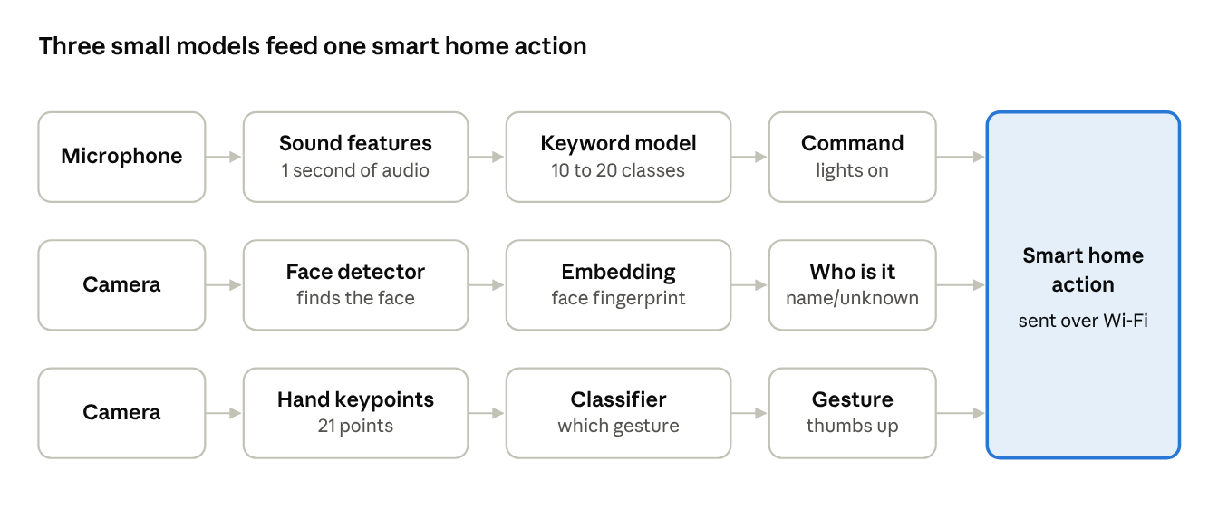
the three tasks as small model pipelines on one board
Each task is a short chain of small models; none of them needs a large chip. The board turns any of the three results into one action, such as switching a light.
- Voice commands (keyword spotting). The board does not transcribe speech. It listens to about one second of audio at a time and asks a small model: "is this one of my 10 to 20 known commands, or nothing?" That is a classification task, the same kind of problem as recognizing a cat in a photo, so it needs very little computing power.
- Face recognition (who is it). This happens in three steps. First a detector finds the face in the image. Then a second model turns the face into a list of numbers, a kind of "face fingerprint" called an embedding. Finally the board compares that fingerprint with the fingerprints of household members you saved earlier; if the closest one is similar enough, it reports that person's name, otherwise "unknown". Adding a new person only means saving a new fingerprint, with no retraining.
- Gesture recognition. A model finds 21 key points on the hand (fingertips, knuckles, wrist). A very small second step looks at the positions of those points and decides which gesture it is, such as open palm, fist, thumbs up or pointing.

The candidates compared for this job
Board | Full setup cost | Voice commands | Face recognition | Gestures | Wi-Fi | Effort
Sipeed MaixCAM Lite | about $45 + microSD card; camera, mic included | Ready: built-in mic and a keyword recognition example | Ready: face recognizer app, enroll people on the device | Ready: gesture classifier with 4 or 14 gestures | Built in (Wi-Fi 6) | Low
Grove Vision AI V2 + XIAO ESP32 | kits from $28.88 (camera + XIAO ESP32-C3); choose the ESP32-S3 version for voice | Ready on ESP32-S3: Espressif's MultiNet, up to 200 commands you type in, no training | Face detection ready; recognizing who needs a small custom model | Ready: pretrained gesture detection model | Through the XIAO ESP32 | Medium
MAX78000FTHR | about $34; camera, mic included | Ready: 20 fixed words preloaded (zero to nine, go, stop, on, off, up, down, left, right); new words need retraining | Demo available (FaceID); adding people needs a rebuild | No ready demo; train your own | None; add an ESP32 | High
Luckfox Pico Max | about $15 + camera + microphone | Build it yourself on the CPU | Example available (RetinaFace + MobileFaceNet), but memory is tight | Build it yourself | None on this model (Ethernet) | High

Why MaixCAM Lite comes first
- All three tasks are already written. Sipeed's MaixPy Python library includes face recognition (detect, align, compare with saved faces), a hand gesture classifier (4 simple or 14 full gestures) and keyword recognition, each with documentation and example code (MaixPy docs).
- The hardware is complete. A 1 TOPS NPU, a camera, a built-in microphone, a speaker amplifier and Wi-Fi 6 are on the board (probots). Wi-Fi lets it send commands to a smart home hub, for example over MQTT to Home Assistant.
- Things to know. "Lite" means no screen and no case; Sipeed itself recommends the screened MaixCAM or MaixCAM Pro for beginners, which cost more (the Pro is about $65 to $75). The chip is the same Sophgo SG2002 as the LicheeRV Nano, but MaixPy runs on its RISC-V core rather than its ARM core. Memory is 256 MB, so run one vision model at a time: for example, run face recognition only after a gesture or voice command triggers it.

Why the Grove + ESP32-S3 split is a good alternative
- Voice is the strongest part. Espressif's free ESP-SR library includes MultiNet, which recognizes up to 200 English or Chinese commands such as "turn on the bedroom light". You add commands by typing them in, with no model training (Espressif docs). That suits a limited command list perfectly.
- Vision runs on the Grove module's Arm Cortex-M55 and Ethos-U55. Gesture detection is a ready model in SenseCraft AI; face detection is too. To tell household members apart, train a small classifier in SenseCraft from photos of each person.
- Trade-off: two chips and two programs to coordinate, connected by I2C or UART.

Tips that make it work reliably
- Use a trigger. Keep the microphone listening, and only run face or gesture recognition after a voice command or when motion is detected. This saves memory and power and reduces false triggers.
- Enroll faces in the real spot. Save each person's face with the same camera, lighting and distance the device will see daily. Enroll several photos per person.
- Tune the match threshold. A stricter threshold means fewer strangers mistaken for family but more "unknown" results for family members. For a door lock, lean strict; for greeting people, lean relaxed.
- Pick distinct command words. Commands that sound different ("lights on", "fan off") are recognized far more reliably than similar ones. A short wake word before each command also cuts false triggers.
- Privacy is a built-in benefit. Everything runs on the board, so no audio or face images need to leave the house.

More deep learning applications for the smart home
The same boards can do much more than voice, faces and gestures. Most home AI ideas fall into three groups depending on the sensor: camera, microphone, or other sensors such as vibration, current or water flow. The diagram groups them; the table below gives the details and the recommended board for each.
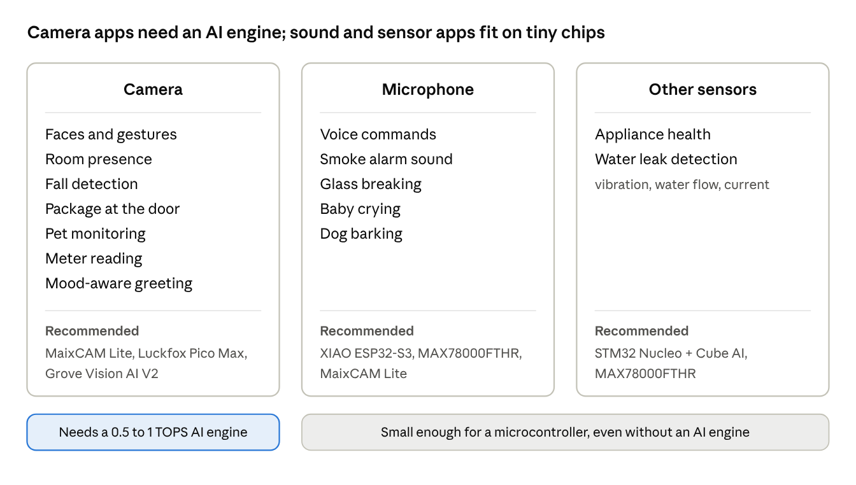
smart home AI applications by sensor · boards from this document
Images are large, so camera applications need a board with an AI engine; sound clips and sensor readings are small enough for a plain microcontroller.

Applications and recommended boards
Application | What the model does | Sensor | Recommended board (under $50) | Ready starting point | Difficulty
Room presence for lights and heating | Detects whether a person is in the room, not who | Camera | Grove Vision AI V2 (low power) or MaixCAM Lite | Pretrained person detection in SenseCraft AI (Hackster) | Easy
Fall detection for older family members | Finds body key points and flags a person lying on the floor | Camera | MaixCAM Lite | MaixPy human key point detection and pose classifier (MaixPy) | Medium
Package at the door | Detects a parcel left on the doorstep and sends an alert | Camera | Luckfox Pico Max or MaixCAM Lite | Edge Impulse "Delivered Package Detection" project; YOLO examples on both boards (Edge Impulse projects) | Medium
Pet monitoring | Spots the cat or dog, for example on the kitchen counter or at the door | Camera | MAX78000FTHR or MaixCAM Lite | Cat/dog detector demo for the MAX78000 (Elektor) | Easy
Meter reading | Reads the digits on a water, gas or electricity meter from a photo | Camera | MaixCAM Lite | MaixPy OCR; Edge Impulse meter-reading project | Medium
Sound alerts | Recognizes a smoke alarm, glass breaking, a baby crying or a dog barking | Microphone | MAX78000FTHR or XIAO ESP32-S3 | Audio classification projects in Edge Impulse; train with your own recordings | Medium
Appliance health | Learns the normal sound or vibration of a washer, fridge or pump and flags anything unusual | Vibration sensor or microphone | STM32 Nucleo with Cube AI, or MAX78000FTHR | Anomaly detection projects in Edge Impulse | Medium
Water leak detection | Learns normal water-flow patterns and flags a leak or a running toilet | Flow meter | STM32 Nucleo with Cube AI | Edge Impulse "Fluid Leak Detection" project | Medium
Mood-aware greeting or lighting | Estimates facial expression (happy, neutral, sad) | Camera | MaixCAM Lite | MaixPy face emotion example | Easy

How to think about these
- Camera applications need an AI engine. Presence, falls, packages, pets and meters all work on the 0.5 to 1 TOPS boards because they only need a few checks per second.
- Sound and sensor applications are much smaller. A one-second sound clip or a few seconds of vibration data is tiny compared with an image, so even boards with no AI engine (an STM32 with Cube AI) can run them.
- Combine them on one device. A MaixCAM Lite on the hallway wall could handle voice commands, face recognition, gestures, presence and fall detection, running one model at a time and switching as needed.
- Mind privacy and reliability. Keep processing on the board, avoid cameras in bathrooms and bedrooms, and treat safety uses (falls, smoke alarms) as a helpful extra, never a replacement for certified alarms.

Background: how a $15 to $45 board can hear commands and recognize faces and hands
Every board in this document pairs a small main processor with a small AI engine, called an NPU (neural processing unit). The main processor runs your program, the camera, the microphone and Wi-Fi. The AI engine does the heavy math inside the neural networks.
That math is mostly one operation repeated millions of times: multiply two numbers and add the result to a running total. A main processor does a handful of these at a time; an NPU does hundreds or thousands side by side. That is why a $15 board with an NPU can recognize a face, while the same board without one would be far too slow.
The diagram below shows how a model gets from your computer onto the board. For your device, the "network" box is the keyword model, the face models or the hand model.
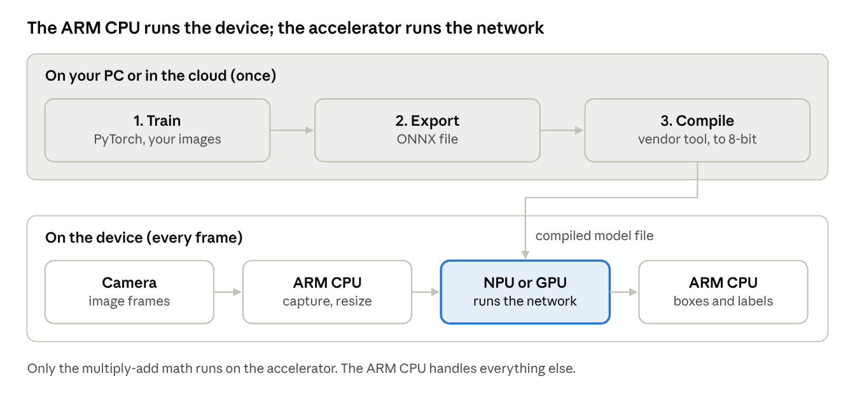
how a model reaches an ARM device · 3 steps once, 4 steps per frame
The top row happens once on your computer. The bottom row repeats for every audio clip or camera frame the device checks.

What the AI performance figures mean for your device
- TOPS means trillions of operations per second. The boards here offer roughly 0.5 to 1 TOPS. That is plenty for keyword spotting, face recognition and hand gestures when you check one or a few frames per second, which suits your device because it does not need instant results.
- Vendor figures can be inflated. Some quote 4-bit numbers, which are about double the 8-bit figure on the same chip. Compare boards on what they actually run, not on the headline.
- Memory is often the real limit. Several boards have only 256 MB. Running face, gesture and voice models at the same time may not fit, so plan to run them one at a time (see the tips in the recommendation).

Converting models to 8-bit (quantization)
Models are trained with 32-bit decimal numbers, but these AI engines run 8-bit whole numbers. Each vendor's tool converts the model using a few hundred sample inputs to learn the range of values. Accuracy usually drops slightly, so test the converted model with your own household's faces, hands and voices before relying on it.

Every candidate board, judged for the home device
The boards below all cost $50 or less for a working setup. Prices are single-board prices in US dollars as of October 2026.

Two kinds of hardware live in this price range
- Tiny Linux camera boards (0.5 to 1 TOPS). A small ARM application processor runs Linux, and a small NPU next to it runs the network. They have a proper camera input and run a small detector (for example a "nano" YOLO model) on live video. Their weakness is memory: often only 128 to 256 MB, so the model and the program must be small.
- AI microcontrollers (well under 1 TOPS). An ARM Cortex-M microcontroller with a tiny neural engine. No Linux: you write firmware in C, or use a no-code tool. They boot instantly, use very little power and can run on a battery, but only handle very small models at low resolution.
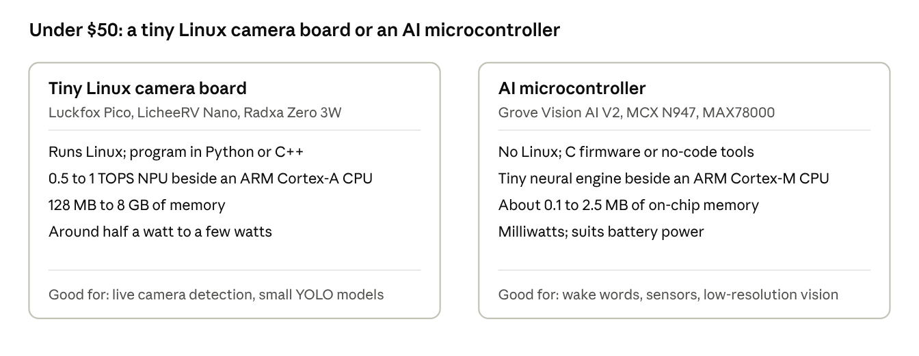
two classes of sub-$50 AI hardware · board examples from the tables below
If your project needs a live camera feed and Linux software, start on the left; if it must run on a battery or cost a few dollars per unit, start on the right.

What each board brings to the three tasks
Board | Price | AI engine | Camera | Microphone | Wi-Fi | Best home role | Software
Sipeed MaixCAM Lite | about $45 + microSD | Sophgo SG2002, 1 TOPS | Included | Built in | Wi-Fi 6 | All three tasks, ready examples | MaixPy (Python)
Sipeed LicheeRV Nano (W version) | $9 to $14 + $8.90 camera | Sophgo SG2002, 1 TOPS | Add-on | Add one | W and WE versions | Same chip as MaixCAM for less money, but more DIY: MaixPy officially supports only MaixCAM boards | TPU-MLIR converter
Grove Vision AI V2 + XIAO ESP32-S3 | kits from $28.88 (C3 version) | Arm Ethos-U55 + ESP32-S3 vector instructions | In kit | Built in | Through the XIAO | Gestures and faces on the Grove module, voice on the ESP32-S3 | SenseCraft AI, Espressif ESP-SR
MAX78000FTHR | about $34 | CNN accelerator next to an Arm Cortex-M4F | Included | Included | None | Battery-powered device; 20 voice words and face ID demos | ADI ai8x tools
Luckfox Pico Max | about $15 + camera | Rockchip RV1106, 1 TOPS | Add-on | Add one (the chip has an audio input) | None (Ethernet) | Face recognition from Rockchip examples; voice and gestures are DIY | RKNN-Toolkit2
Radxa Zero 3W | about $26+ | Rockchip RK3566, 0.8 TOPS | Add-on (camera connector) | Add one | Wi-Fi 6 | 1 to 8 GB of memory, enough to keep all three models loaded | RKNN-Toolkit2
STM32 Nucleo boards | roughly $15 to $30 | None (main processor only) | None | Add one | None | Voice commands only | STM32Cube AI Studio

What these boards can and cannot do in a home
- They can: recognize a short list of spoken commands, tell apart the handful of people who live in the house, and recognize a few distinct hand gestures, at a few checks per second. Seeed measures 33 ms per frame for a small detector on the Grove Vision AI V2, so even microcontroller boards are fast enough.
- They cannot: understand free-form sentences like a smart speaker, recognize faces reliably in a dark room without good lighting or infrared, or identify large numbers of people.
- Accuracy depends on placement. A camera at face height, facing the spot where people stand, with steady lighting, matters more than which board you pick.

If you design your own product: bare chip prices
The boards above are development tools. The chips inside are cheaper:
- Rockchip RV1106G3 (inside the Luckfox Pico Max): about $4.60 each at 100 pieces, $6.32 for one (LCSC).
- Analog Devices MAX78000: from $10.60 each in 1,000-piece lots (Analog Devices).

The STM32 route for voice commands: Cube AI (STM32Cube.AI)
If you want to build the voice-command part on an STM32 microcontroller, Cube AI is the tool you would use. It is STMicroelectronics' free software that converts a trained neural network into optimized C code for STM32 chips (ARM Cortex-M microcontrollers). A keyword model for 10 to 20 commands is small enough to run on an STM32's main processor, so a $15 to $30 Nucleo board can handle voice. Faces and gestures need more power than these boards offer under $50; ST's boards with a built-in AI engine (STM32N6) cost more.

The names changed in 2026
ST's naming is confusing, so here is how the pieces fit:
- ST Edge AI Core is the engine underneath. It is a command-line program that analyzes, optimizes and compiles models for ST chips (ST wiki).
- X-CUBE-AI was the original user-facing tool: a plug-in for ST's STM32CubeMX setup program. ST has stopped updating it (ST community).
- STM32Cube AI Studio, released in February 2026, replaces X-CUBE-AI. It is a free standalone desktop app built on ST Edge AI Core (ST data brief). New projects should start here.
- ST Edge AI Suite is ST's umbrella name for all of these, plus the STM32 model zoo and an online board farm where you can test your model on real chips before buying a board.
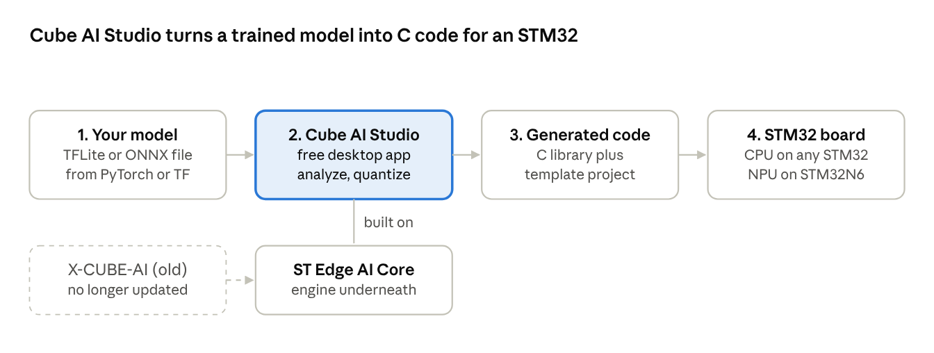
ST's Cube AI toolchain as of 2026 · 4 steps
You only work in Cube AI Studio; it calls ST Edge AI Core for you. The old X-CUBE-AI plug-in used the same engine but is no longer updated.

What it does for you, step by step
- Import a trained model, for example a TensorFlow Lite or ONNX file exported from your training code.
- Analyze it: the tool reports how much flash and RAM the model needs and how many multiply-add operations one inference takes. This tells you immediately whether it fits on your chosen chip.
- Optimize it: quantize to 8-bit and arrange memory so the model fits in a microcontroller's small RAM.
- Validate it: compare the converted model's outputs against the original, on your PC and on the real board.
- Generate C code and a template application. ST's template runs your model on test input and prints the output over a serial cable, a quick way to confirm everything works (ST community).
For TensorFlow Lite models, you can choose ST's own runtime or the standard TensorFlow Lite for Microcontrollers runtime (ST).

STM32 boards under $50 that work with Cube AI
Board | Chip | AI engine | Price | Best for
Standard STM32 Nucleo boards (STM32H7, STM32U5 and others) | Arm Cortex-M7 or M33 | None: the model runs on the CPU | roughly $15 to $30 (approximate) | Sensor data, keyword spotting, tiny image models
- STM32 boards with ST's neural engine (the STM32N6 Nucleo, about $56 to $80, and the STM32N6 Discovery Kit, $185) are left out because they cost more than $50.
- For your device: an STM32 board could serve as the always-listening voice unit, sending commands to a separate vision board. If you want one board for everything, the MaixCAM Lite or the Grove + ESP32-S3 pair is simpler.

Other microcontroller AI routes
- Arm Ethos-U NPUs. Arm licenses this neural engine to chip makers to pair with Cortex-M cores; the Grove Vision AI V2 uses one. The newest, Ethos-U85, scales from 256 GOPS to 4 TOPS. Models are prepared with Arm's open-source Vela compiler.
- Plain Cortex-M (no NPU). LiteRT for Microcontrollers and Edge Impulse run very small models on common microcontrollers using Arm's CMSIS-NN math library.

How to choose for your home device
Start from which task matters most and how the device is powered. The table matches common priorities to a first pick and a backup.
Your priority | First pick | Approx. cost | Backup pick | Why
All three tasks on one board, fastest start | MaixCAM Lite | about $45 + microSD | Grove Vision AI V2 + XIAO ESP32-S3 | Camera, mic, Wi-Fi and examples for every task included
Best voice commands | XIAO ESP32-S3 with Espressif MultiNet | part of the Grove kit | MaixCAM Lite | Up to 200 commands you type in, no training
Best face recognition | MaixCAM Lite | about $45 + microSD | Luckfox Pico Max | Enroll family members on the device; no retraining to add people
Best gesture control | MaixCAM Lite | about $45 + microSD | Grove Vision AI V2 | Ready gesture classifier (4 or 14 gestures) built on hand keypoints
Runs on a battery | MAX78000FTHR | about $34 | Grove Vision AI V2 | Microjoule inferences; camera and microphone included
Lowest possible cost | LicheeRV Nano W + camera | about $23 to $28 | Luckfox Pico Max | Same chip as MaixCAM; more setup work

Four questions that settle the choice
- Mains power or battery? Mains power allows any board here. A battery points to the MAX78000FTHR or the Grove Vision AI V2, which use far less power than Linux boards.
- One board or two? One board (MaixCAM Lite) means one program to write. Two chips (Grove for vision, ESP32-S3 for voice) gives each task its best tool but needs them to talk to each other.
- How will it control your home? If it must talk to a hub such as Home Assistant, pick a board with Wi-Fi (MaixCAM, LicheeRV Nano W, Radxa Zero 3W, or a XIAO ESP32 alongside the Grove module).
- Prototype or product? For a prototype, pick the best examples and tools. For a product, look at the bare chip price; the Rockchip RV1106 costs about $5 and the MAX78000 about $11 in volume.

A safe way to build it
- Run the vendor's ready examples first (MaixPy face recognition, gesture classifier and keyword recognition; or SenseCraft and ESP-SR) to confirm the hardware works in the room where it will live.
- Enroll your household: save several face photos per person, and choose distinct command words.
- Test in real conditions: morning and evening light, people at different distances, background noise from a TV or kitchen.
- Only if the ready models fall short, train your own (for example a custom gesture set) and convert it with the vendor's tool, checking accuracy before and after conversion.
- Connect the results to your home, for example by sending MQTT messages over Wi-Fi to Home Assistant.

Sources
- ST: X-CUBE-AI product page and ST wiki: ST Edge AI Core documentation
- ST: STM32Cube AI Studio data brief (February 2026)
- ST community: Introducing STM32Cube AI Studio and STM32N6 NPU and Cube AI thread
- CNX Software: STM32N6 launch and kit prices
Boards:
- CNX Software: Sipeed LicheeRV Nano (SG2002)
- Waveshare: Luckfox Pico Pro / Max
- RobotShop: Grove Vision AI V2 performance figures
- CNX Software: Radxa Zero 3W
- DigiKey: MAX78000FTHR and Analog Devices: MAX78000
- LCSC: Rockchip RV1106G3 pricing
- Espressif: ESP-SR (AI instructions on ESP32-S3)
Smart home recommendation:
- Sipeed MaixPy: face recognition and MaixPy project list (gesture classifier, speech)
- SpotPear: MaixCAM Lite price and Sipeed: MaixPy quick start (versions)
- Espressif: ESP-SR MultiNet command recognition
- CNX Software: Grove Vision AI V2 kits
- Elektor: MAX78000FTHR keyword demo and Analog Devices: MAX78000 keyword spotting
- Luckfox RetinaFace example

