Two-Wheel Balancing Educational Robot — Design Guide

1. Overview
Build the robot with two brains. A small microcontroller keeps the robot upright using a motion sensor (an IMU), checking and correcting hundreds of times per second. A main computer uses the camera and microphones to decide where to go and how to react, and sends the microcontroller simple orders like "move forward slowly" or "turn left".
Your idea of balancing from the camera is worth keeping, but in a changed form: the camera is too slow to be the main balance sensor (section 3 explains why with numbers), but it can help the balance by keeping the robot in place and correcting slow sensor drift.
Planned features:
- Self-balancing on two wheels
- Obstacle avoidance using the camera, with small distance sensors as a safety backup
- Camera-assisted balance: holding a spot without drifting, correcting the tilt sensor
- Voice commands
- Face recognition
- Gesture recognition
- More ideas in section 8 (person following, block programming, auto-docking, and others)
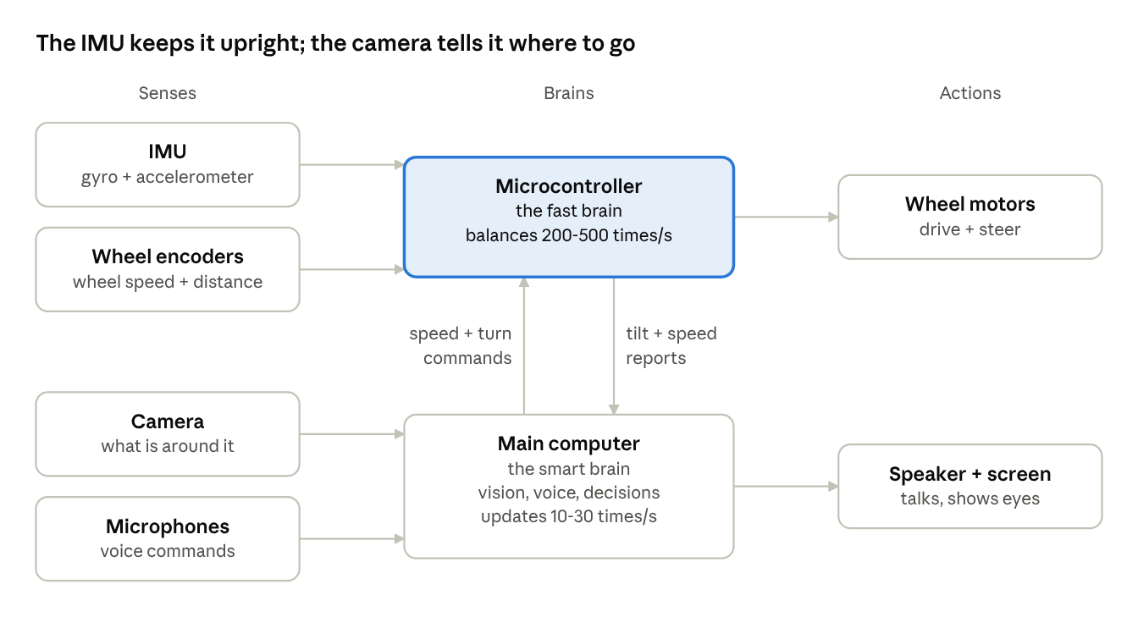
system overview · senses, two brains, actions
Read it left to right: sensors feed the two brains, and the brains drive the motors, speaker and screen. The fast brain (highlighted) is the only part that must never be late, so it is kept small and simple.

2. How balancing works
The robot is an inverted pendulum: like a broom balanced on your hand, it stays up only by constantly moving its wheels under its falling body. It is never truly still; it makes many tiny corrections every second.
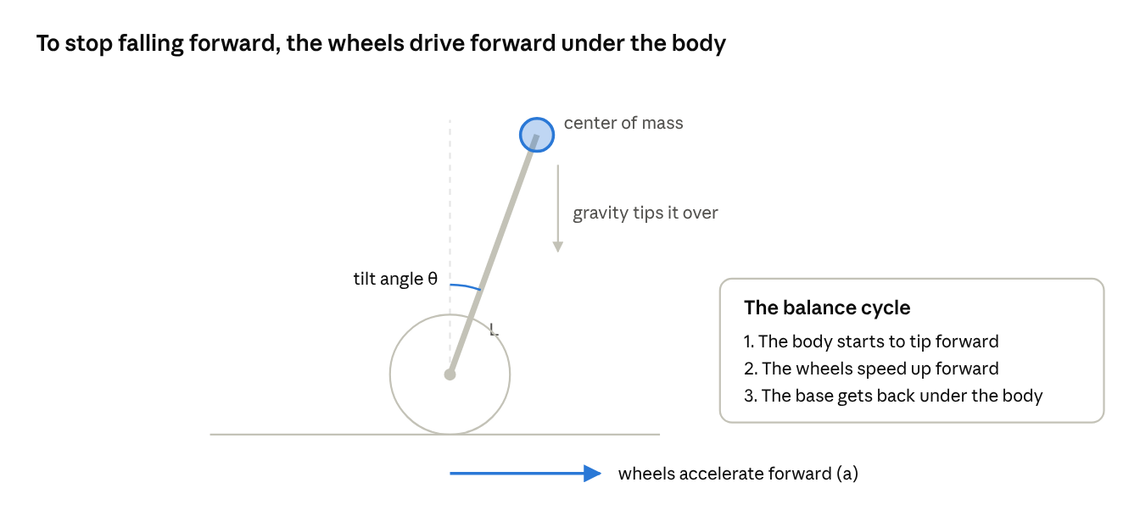
inverted pendulum · tilt, gravity and wheel push
When the body leans, gravity pulls it further over. The only thing the robot can do is accelerate its wheels in the same direction as the lean, which drives the base back under the center of mass.

The one equation worth knowing
For small tilts, the physics of the robot comes down to this:
θ̈ = (g / L) · θ − a / L
In plain words: how fast the tilt speeds up equals a gravity part minus a wheel part.
- θ is the tilt angle (in radians, 0 = perfectly upright).
- g / L × θ is the gravity part. The more it leans, the faster it falls. g is 9.81 m/s² and L is the height of the center of mass above the wheel axle.
- a / L is the wheel part. Accelerating the wheels by a (in m/s²) pushes the base under the body and cancels the fall.

How much time does the robot have?
If nothing corrects it, the tilt grows exponentially, multiplying by about 2.7 every τ seconds, where:
τ = √(L / g)
Example: with the center of mass 15 cm above the axle, τ = √(0.15 / 9.81) ≈ 0.12 s. That means a 1° lean becomes a 10° lean in about 0.29 s. This single number drives most design choices:
- The tilt sensor must be fast. It must report tilt many times within those 0.12 s. This is why an IMU at 200 to 1000 readings per second is used, and why the camera alone is not enough (next section).
- Taller robots are easier to balance. A higher center of mass makes τ bigger, so the robot falls more slowly and the controller has more time. Mounting the battery high is a common trick. The cost is that the motors need more torque to recover.
- Motors must respond quickly and without slack. Gears with play (backlash) add delay and cause a constant small wobble.

A surprising effect students love
To drive forward steadily, the robot must lean slightly forward. To stop, it must first lean backward, and the only way to lean back is to briefly speed up even more so the base gets ahead of the body. So the robot speeds up a little before it can slow down. Engineers call this "non-minimum phase" behavior, and it explains why the speed controller in section 5 looks backward at first.

3. Can the camera do the balancing?
No, not as the main sensor: a camera sees too late and too rarely to catch a fall that doubles every tenth of a second. Use the IMU for the fast balance loop and let the camera make the balance better on a slower time scale.

Why the camera is too slow
From section 2, a robot with its center of mass 15 cm high has τ ≈ 0.12 s. A common rule of thumb is that the total delay in the balance loop should be under about one tenth of τ, so roughly 10 ms.
Now follow one camera picture from light to motor command:
- Wait for the next frame: up to 33 ms at 30 frames per second.
- Exposure: the sensor collects light for several milliseconds.
- Transfer and image processing: typically tens of milliseconds more.
That totals roughly 50 to 100 ms. By the time the robot reacts, a small lean has already grown 1.6 to 2.2 times bigger (e raised to 0.06/0.12 and 0.1/0.12). The controller is always correcting an old picture, so it overshoots, wobbles harder, and falls.
There are also practical problems:
- Motion blur and rolling shutter. The robot wobbles constantly, which smears and bends the image exactly when you need it.
- The scene must cooperate. The camera can only judge tilt from visible straight lines, the floor, or the horizon. A blank wall, darkness, or a person walking past breaks it.
- Heavy computing. The main computer would need to process every frame in a few milliseconds, leaving nothing for face or gesture recognition.
 | IMU (gyro + accelerometer) | Camera
Readings per second | 200 to 1000+ | 30 to 60 typical
Delay | under 1 ms | about 50 to 100 ms
Works in the dark | yes | no
Weakness | slowly drifts over time | slow, depends on the scene
Best job | fast balance loop | slow corrections and seeing the world
The two are a good match: the IMU is fast but drifts, and the camera is slow but does not drift. Combining them gives the best of both.

How the IMU measures tilt
The gyroscope measures how fast the robot is rotating. Adding up (integrating) that rate gives the angle, but small errors pile up, so the angle slowly drifts. The accelerometer senses which way gravity points, giving an absolute angle, but it is noisy and gets confused when the robot accelerates. A complementary filter blends them, trusting the gyro for quick changes and the accelerometer for the long-term average:
θₖ = α · (θₖ₋₁ + ωₖ · Δt) + (1 − α) · θacc,ₖ
- ω is the gyro rotation rate, Δt is the time between readings (for example 0.005 s at 200 Hz), and θacc is the tilt computed from the accelerometer.
- α is the trust in the gyro, typically about 0.98. Higher means smoother but slower to fix drift.
Later, students can replace this with a Kalman filter, which chooses the blending automatically from the noise levels of each sensor.

Four ways the camera does help balance
- Correcting tilt drift. When the camera sees reliable vertical lines (door frames, shelf edges) or the floor, it can compute an absolute tilt a few times per second. Use it to slowly correct the IMU estimate: keep a small correction value b, and each time the camera gives a trusted tilt θcam, nudge b by a small step toward (θ − θcam). The balance loop then uses θ − b. Because the nudge is small, a bad camera frame cannot knock the robot over.
- Holding its spot. Wheel encoders slip, so a "standing still" robot slowly wanders. The camera can track the floor or a printed marker (an AprilTag) to measure real movement and correct position. This feeds the outer position loop (section 5), not the fast tilt loop.
- Seeing slopes and bumps ahead. On a ramp the upright balance angle changes. If the camera sees a ramp or bump coming, the robot can slow down and pre-lean instead of being surprised.
- Speed decisions. The camera sees obstacles and people, and sets how fast the robot should go. The balance loop then works out how to lean to reach that speed.

A great classroom experiment
In simulation, or on the real robot with a safety tether, add an artificial delay to the IMU readings: 5 ms, 20 ms, 50 ms, 100 ms. Students see the robot get wobblier and finally fall, and discover for themselves why camera-only balance fails. It turns your original idea into a strong lesson about delay in control systems.
A stretch research project for advanced students: a high-speed global-shutter camera (120+ frames per second) tracking a simple high-contrast target can hold a tall, slow-falling robot upright in a lab demo. Keep the IMU running underneath as the safety net.

4. Hardware
A computer with no wireless hardware plus an AI accelerator, and a separate microcontroller for balance, covers every feature in this guide. Every board recommended here has no Wi-Fi or Bluetooth chip; prices are in section 11. The parts below are proven families; check current versions and prices before buying, since this list was written from general knowledge, not a fresh market check.
Part | Suggested choice | Why
Main computer | Raspberry Pi Compute Module 5, non-wireless version, on the CM5 IO Board with a Hailo M.2 module; or an NVIDIA Jetson Orin Nano Super with its Wi-Fi card removed | Runs vision, voice and decisions. The AI accelerator lets face, gesture and obstacle models run at camera speed. Jetson is stronger and supports CUDA; Pi is cheaper with a huge education community.
Microcontroller | STM32 Nucleo-F446RE, Raspberry Pi Pico 2 (not the Pico 2 W), or Teensy 4.1, all without wireless | Runs the balance loop on a strict clock with no operating-system hiccups. If the main computer freezes, the robot still balances and can stop safely.
IMU | ICM-42688-P, BMI088, or LSM6DSO | Modern, low-noise gyro + accelerometer. The old MPU-6050 works for a first prototype but is noisier. Mount it rigidly near the wheel axle, with foam under the board to damp motor vibration.
Motors | DC gear motors with quadrature encoders (beginner), or brushless gimbal motors with FOC drivers (advanced) | Encoders are required for the speed loop. Pick low-backlash gears. Brushless motors with field-oriented control are smooth, quiet and precise, and a great advanced topic, but harder to set up.
Motor driver | DRV8874 or TB6612FNG class for DC; SimpleFOC-compatible driver for brushless | Must handle motor stall current. Use current sensing if available so software can limit force.
Camera | Raspberry Pi Camera Module 3 Wide, or a global-shutter camera | Wide view helps obstacle avoidance and seeing people. Global shutter avoids the bent, wobbly image caused by the robot's constant motion.
Close-range safety sensors | 1 to 3 small time-of-flight sensors (VL53L1X, or VL53L5CX 8×8 zones), plus 1 to 2 pointing down at the floor | Back up the camera at very short range and in the dark. The downward sensors detect table edges and stairs, which is essential for a classroom robot used on desks.
Microphones | 4-microphone USB array such as the ReSpeaker XVF3800 (pick the version without the XIAO ESP32S3 board, which adds Wi-Fi) | Several microphones allow noise reduction and direction finding, important because motors are noisy.
Speaker + screen | Small speaker with amplifier; small round or rectangular LCD | The screen can show animated eyes, which makes the robot feel alive and shows its state (listening, thinking, scared of an obstacle).
Battery | 3S lithium-ion pack (about 11.1 V) with a protection board (BMS) | Separate 5 V regulator for the computer, rated at least 5 A for a Pi 5 under load. Motor current spikes must not brown out the computer.
Safety | Physical power switch, emergency stop button, kickstand or training wheels | A kickstand lets the robot rest when off and during development, and can later become a self-righting arm (section 8).

Mechanical tips
- Keep the frame stiff. Flex and wobble in the body look like tilt to the IMU.
- Put the wheels as far apart as practical for stable turning, and use wheels with good grip (rubber tires).
- A taller body with weight higher up falls more slowly (section 2), which makes tuning more forgiving for students.
- Leave room for the camera at the top, angled slightly downward so it sees the floor in front as well as faces.

5. Control software
Use three loops nested inside each other: a fast tilt loop keeps the robot upright, a medium speed loop decides how much to lean, and a slow navigation loop decides where to go. Each outer loop only gives a target to the loop inside it.
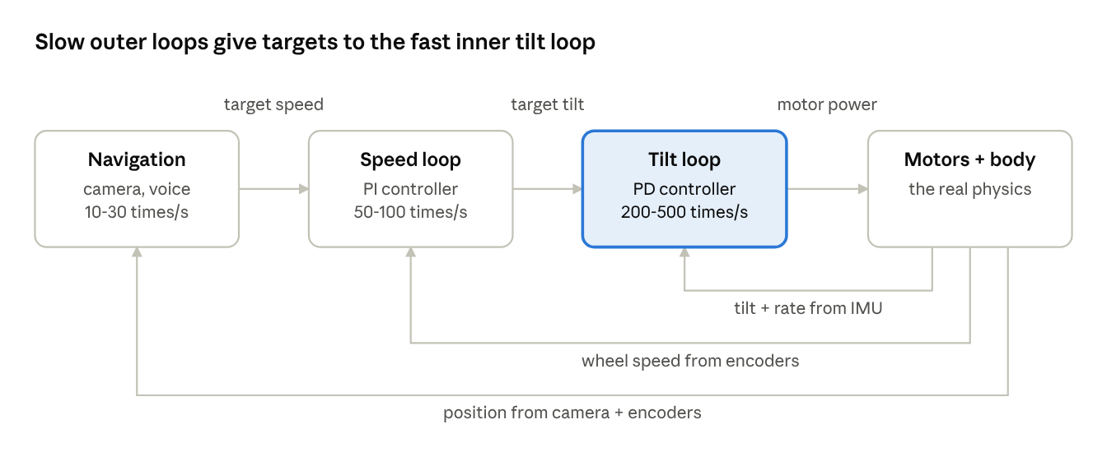
cascaded control · three nested loops
The tilt and speed loops run on the microcontroller. Navigation runs on the main computer and sends a target speed and turn rate over a serial cable.
Sign convention used below: tilt θ is positive when leaning forward, and speed v is positive when moving forward.

Tilt loop (innermost, fastest)
This is a PD controller. It computes how hard to drive the wheels:
u = Kp · (θ − θtarget) + Kd · θ̇
- The P part (Kp) pushes harder the more the robot leans away from the target angle, like a spring.
- The D part (Kd) uses the gyro rate θ̇, which says how fast the robot is falling. It reacts before the lean gets big and acts like a shock absorber that stops the wobble.
- Run it from a timer interrupt at a fixed rate (for example every 5 ms). An uneven rate makes tuning very hard.

Speed loop (middle)
The robot cannot drive its wheels directly to a speed, because that would make it fall. Instead, the speed loop chooses a lean angle, and the tilt loop makes the robot lean that way:
θtarget = Kpv · (vtarget − v) + Kiv · ∫ (vtarget − v) dt
Follow it step by step for "going too fast":
- v is above the target, so θtarget becomes negative (lean back).
- The tilt loop sees the robot is more forward than the target, so it drives the wheels forward harder.
- The base moves ahead of the body, so the body tilts back.
- Now leaning back, the tilt loop slows the wheels, and the robot decelerates.
This is the "speed up to slow down" effect from section 2. Always limit θtarget to a few degrees (for example ±6°) so the speed loop can never ask for a dangerous lean. The integral part (Kiv) removes slow drift, for example from a badly measured balance point.

Turning
Turning does not affect balance much. Add a steering amount s to one wheel and subtract it from the other: left motor = u + s, right motor = u − s. Compute s with a small PI controller that compares the target turn rate to the gyro's vertical-axis rate.

Navigation loop (outermost, slowest)
This loop lives on the main computer. It turns everything the robot sees and hears (obstacles, voice commands, a gesture, a face to follow) into two numbers: target speed and target turn rate. Sections 6, 7 and 9 describe how.

Advanced option: LQR
Instead of tuning two separate loops, advanced students can use a Linear Quadratic Regulator (LQR). It treats position, speed, tilt and tilt rate as one state and computes all four gains at once from a physics model:
u = −K · [ x, ẋ, θ, θ̇ ]ᵀ
The gain K is computed on a laptop (for example with the python-control library) by stating how much you care about tilt error versus motor effort. It is an excellent bridge between the physics model in section 2 and real code.

Tuning step by step
- Check signs first. With wheels off the ground, tilt the robot forward by hand. The wheels must spin forward. If not, flip the sign before anything else.
- Find the true balance angle. Few robots are balanced at exactly 0°. Hold it where it feels weightless and record that IMU angle as the zero.
- Speed loop off, Kd = 0. Raise Kp until the robot stands but shakes quickly back and forth.
- Add Kd until the shaking dies away. The robot now stands but slowly drifts away.
- Turn on the speed loop with small gains and increase slowly until it stays in place.
- Add turning, then connect the navigation commands.
- Safety rules, always on: cut the motors if the tilt passes about 40° (it has fallen), and set target speed to zero if no command arrives from the main computer for half a second.
Stream tilt, speed and motor power to a laptop and plot them live. Seeing the curves is the fastest way to tune, and it is a great teaching tool.

6. Obstacle avoidance with the camera
Turn each camera frame into a simple "how far can I go in each direction" list, steer toward the most open direction, and slow down as things get close. Small distance sensors catch what the camera misses.

Step 1: Find the free floor
The most reliable idea for an indoor robot is to find the floor, not the obstacles. Anything that is not floor is in the way.
- Run a small segmentation model that labels each pixel as floor or not floor. For a classroom, a model fine-tuned on a few hundred photos of your own floors works very well. For a first version, students can even use simple color matching on a plain floor.
- For each column of the image, scan upward from the bottom and find the first pixel that is not floor. That is where the nearest obstacle touches the ground in that direction.
- Convert that pixel row to a real distance (Step 2). The result looks like a laser scanner: one distance per direction across the camera's view.

Step 2: Turn a pixel row into a distance
Because the camera is at a known height and looks down at a known angle, a point on the floor further away appears higher in the image. Simple trigonometry gives the distance:
d = h / tan(φ + β), where β = arctan((v − cy) / f)
- h is the camera height above the floor, for example 0.30 m.
- φ is how far the camera points down from horizontal.
- v is the pixel row of the obstacle's bottom edge, cy is the image's center row, and f is the focal length in pixels (found by a one-time camera calibration with a checkerboard).
- β is the extra angle of that pixel below the image center.
Example: with h = 0.30 m and φ = 20°, a point at the image center is 0.30 / tan(20°) ≈ 0.82 m away.
Important for a balancing robot: the camera tilts whenever the robot leans, so φ changes all the time. Add the IMU tilt to the mounting angle (φ = mount angle + θ) in every frame. This is a nice example of two sensors working together, and without it distances jump around as the robot wobbles.

Step 3: Decide where to go
- Split the distance list into sectors, for example 7 sectors across the view.
- Pick the open sector closest to where the robot wants to go (the goal from a voice command, the person it follows, or straight ahead).
- Set the turn rate toward that sector and the speed from the clearance straight ahead: target speed = k × (front distance − stop distance), capped at a maximum.
- If every sector is blocked, stop and rotate in place until a sector opens.
Advanced students can upgrade this to a vector field histogram (VFH) or to a local planner that also remembers obstacles that have left the camera's view.

Remember: it cannot stop instantly
A balancing robot must lean back before it can brake (section 2), so it needs more stopping distance than a normal car-like robot. Roughly:
dstop ≈ v · treact + v² / (2 · amax)
With v = 0.5 m/s, a reaction time of 0.2 s and a comfortable braking of 1.5 m/s², that is about 0.10 + 0.08 = 0.18 m. Measure the real values on your robot and add a safety margin.

Other useful tools
- Object detection (a small YOLO-style model) tells the robot what an obstacle is. A wall is avoided, but a person can be greeted, and a pet can make the robot slow right down.
- Monocular depth models (for example Depth Anything) estimate depth for every pixel from one image. Their scale is only relative, but you can fix it using the floor distances from Step 2. Useful for obstacles that hang above the floor, like a table edge at camera height.
- Time-of-flight sensors measure distance with light. They catch glass doors, dark scenes and things very close to the robot, and are the last line of defense.
- Cliff sensors pointing down stop the robot at a table edge or a stair. On an educational robot used on desks, treat this as required, not optional.

7. Voice commands, face recognition, gesture recognition
All three can run on the robot itself without internet, using small open-source models. Each one ends the same way: it produces an event like "command: turn left" or "saw: Maria" or "gesture: stop", and the behavior manager (section 9) decides what to do.

Voice commands
Voice works in four stages:
- Wake word. A tiny always-on model listens only for the robot's name (for example "Hey Robo"). Options: openWakeWord (open source) or Porcupine. This saves power and avoids false commands from classroom chatter.
- Speech to text. After the wake word, record a few seconds and turn it into text. For a fixed command list, Vosk with a limited vocabulary is fast and very accurate. For free-form speech, a small Whisper model (through whisper.cpp) understands much more but is slower.
- Understanding (intent). Match the text to a command: "go forward", "turn left", "stop", "come here", "follow me", "dance", "what do you see?". Start with simple keyword matching; later, a small language model can handle any phrasing.
- Talking back. Piper is a good offline text-to-speech engine. Short spoken replies ("Okay, following you") make the robot feel responsive.
Practical tips:
- Motors and wheels are noisy. A microphone array with noise suppression and beamforming (listening in one direction) helps a lot. Mount microphones away from the motors.
- "Stop" must be special. Give it the shortest, fastest path: recognize it locally, skip any language model, and send zero speed immediately.
- Use the microphone array's direction estimate so the robot turns to face whoever is speaking.

Face recognition
Face recognition is two separate jobs:
- Face detection finds where faces are in the image (a box around each face). Good small detectors: YuNet (built into OpenCV) or MediaPipe Face Detector.
- Face recognition decides who it is. A model such as ArcFace or SFace turns a face into an embedding, a list of about 128 to 512 numbers. Two photos of the same person give similar lists, so the robot compares the new embedding to stored ones and picks the closest. If no stored face is close enough, the person is "unknown".
To enroll a student, take 5 to 10 photos from slightly different angles and lighting, and store the average embedding with the name.
Useful behaviors: greet people by name, turn to keep a face in the center of the view (by rotating the robot, or with a small tilt servo for the camera), and remember a "favorite person" to follow.
Privacy matters with children. Get consent from students and parents before enrolling faces. Store only embeddings, not photos, and keep them on the robot, never in the cloud. Give an easy way to delete a person. Check the rules that apply to schools in your region.

Gesture recognition
MediaPipe Hands finds 21 points on each hand (wrist, knuckles, fingertips) in every frame. Gestures are then recognized from the positions of these points:
- Static gestures are hand shapes: open palm = stop, thumbs up = yes, fist = come here, pointing = go that way (use the direction of the index finger). The MediaPipe Gesture Recognizer includes several of these, and you can train your own with a few hundred examples.
- Dynamic gestures are movements over time: a wave (hand moving side to side), a circle (dance), a swipe. Track the wrist point over about one second and classify the path.
- Body pose (MediaPipe Pose) tracks shoulders, hips and arms. It is great for "follow me", because it keeps working when the hand is too small to see.
Avoid false triggers by requiring the same gesture in several frames in a row (for example 5 frames, about 0.2 s), and only acting on gestures from a person facing the robot.

Sharing the computer between features
Running every model on every frame will overload the main computer. Run them only when useful:
- Run person or face detection all the time, but at a low rate.
- Start face recognition only when a new face appears, not on every frame.
- Start hand tracking only when a person is close and facing the robot.
- Put the heaviest models (segmentation, detection) on the AI accelerator, and keep voice on the CPU.

8. Extra feature ideas
For an educational robot, the most valuable additions are the ones that let students see inside the robot and change its behavior themselves: a live tuning dashboard, block programming, and a simulator. The rest add fun and teach new topics. Sorted from easiest to hardest:
Feature | What it does | What students learn | Difficulty
Expressive eyes | Animated eyes on the screen show mood and state: happy, curious, scared, listening | State machines, user experience design | Easy
Wired remote control | Drive the robot from a laptop web page over an Ethernet cable, or with a USB game controller, with live camera view | Networking, web basics | Easy
Live tuning dashboard | Web page with live graphs of tilt, speed and motor power, and sliders to change PID gains while it runs | Control theory, seeing feedback with their own eyes | Easy to medium
Block programming | Students write behaviors with Scratch- or Blockly-style blocks ("when you see a face, say hello and spin"), then switch to Python | Programming from beginner to real code | Medium
Line following | Follow a tape line on the floor using the camera | Image processing, a classic first vision task | Medium
Person following | Follow a chosen person around the room, keeping a set distance | Tracking, control, combining vision and motion | Medium
Ball games | Track a colored ball and push it into a goal, or play fetch-style games | Object tracking, simple planning | Medium
AprilTag navigation and auto-docking | Printed markers on walls tell the robot exactly where it is; it can drive back to a charging dock by itself | Camera geometry, localization | Medium to hard
Room mapping (visual SLAM) | Builds a map of the room while driving, then goes to named places ("go to the door") | Mapping, localization, path planning | Hard
Self-righting arm | A servo arm pushes the robot back up after it falls, and doubles as the kickstand | Mechanical design, motion sequences | Hard
AI conversation | Connect a language model so the robot can answer questions, tell stories, or quiz students on a topic | Large language models, prompt design, AI safety | Medium, needs internet unless run on a strong computer
Learning to balance | Train a balance controller with reinforcement learning in simulation, then compare it to the PID | Machine learning, simulation-to-reality gap | Hard
Multi-robot dance | Several robots move in sync to music, started together by a sound cue or linked by Ethernet cable | Communication, timing | Medium

Add a simulator early
A digital twin of the robot in a simulator (Webots, Gazebo, MuJoCo, or PyBullet) lets every student experiment without breaking hardware: tune PID gains, test the camera delay experiment from section 3, and train learning-based controllers. It also lets a class of 30 work at the same time with only a few physical robots.
One feature to treat with care: guessing emotions from faces. The science behind it is disputed and it raises privacy concerns, so if you include it, present it to students as an experiment to question, not as a reliable fact about people.

9. Software architecture
Split the software into small independent programs that each do one job, and let a single behavior manager decide what the robot actually does. Only the behavior manager may send speed and turn commands to the microcontroller.
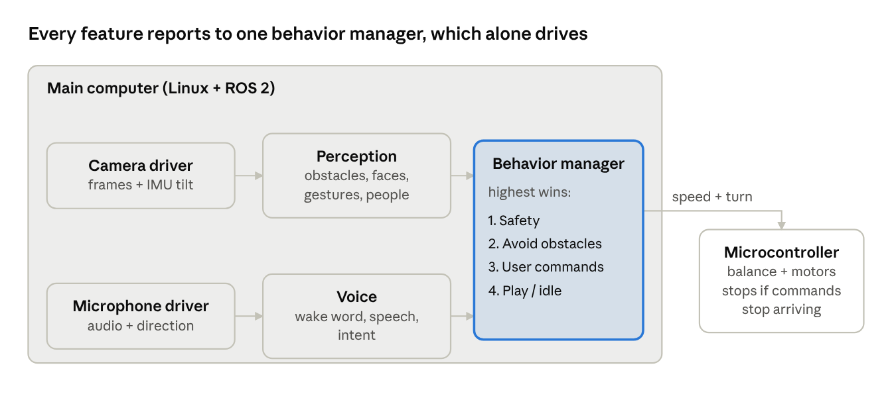
software architecture · features feed one behavior manager
Read it left to right: drivers capture camera and sound, perception and voice turn them into events, the behavior manager picks one action, and the microcontroller carries it out while keeping balance.

Why one behavior manager?
Without it, the voice module says "go forward" while obstacle avoidance says "turn" and gesture says "stop", and the robot jerks between them. The behavior manager uses a fixed priority order, and the highest active one wins:
- Safety: fallen over, cliff ahead, battery low, emergency stop. Always wins.
- Avoid obstacles: changes or limits whatever the robot was about to do.
- User commands: voice, gestures, phone remote, block programs.
- Play / idle: look around, track faces, show eyes, small "breathing" movements.
Write it as a state machine (states such as Idle, Following, Driving to goal, Avoiding, Fallen) so students can draw it on paper and change it. Behavior trees are a good upgrade later.

Framework choice
- ROS 2 (Robot Operating System) is the standard in robotics research and industry. Each box in the diagram becomes a ROS node, and nodes talk through named topics such as /obstacles, /faces, /voice_command, /cmd_vel. It also gives you recording and replay of sensor data, and visualization tools. Learning it is a valuable skill for students who go further. Use the current long-term-support release.
- Plain Python with a message queue is simpler for younger students. You can start this way and move to ROS 2 later if the module boundaries stay the same.

Link between main computer and microcontroller
Use a serial link (UART) with a small, fixed message format, for example:
- Main computer to microcontroller, about 50 times per second: target speed, target turn rate, mode, and a message counter.
- Microcontroller to main computer, about 100 times per second: tilt, tilt rate, wheel speeds, battery voltage, status flags.
- Add a checksum to every message so corrupted bytes are thrown away.
The microcontroller treats the message counter as a heartbeat: if no fresh command arrives for 0.5 s, it sets the target speed to zero and keeps balancing in place. This way a crash on the main computer never makes the robot run away. (micro-ROS is an alternative that puts the microcontroller directly on ROS topics.)

10. Safety, build roadmap and lessons
Get the robot balancing reliably first, with safety rules built into the microcontroller, then add one feature at a time. Each new feature should be tested on top of a robot that already balances well.

Safety checklist
- ☐ Motors cut off when tilt passes about 40° (fallen)
- ☐ Robot stops driving if commands from the main computer stop for 0.5 s
- ☐ Physical emergency stop button that cuts motor power directly
- ☐ Motor current limit so wheels cannot pinch fingers hard
- ☐ Downward cliff sensors to stop at table edges
- ☐ Classroom speed limit (for example 0.5 m/s) that students cannot override
- ☐ Battery with protection board; charge only under supervision, in a fire-safe charging bag
- ☐ Wheels and gears covered so fingers and hair cannot get caught
- ☐ Face data: consent collected, stored only on the robot, easy to delete

Build roadmap
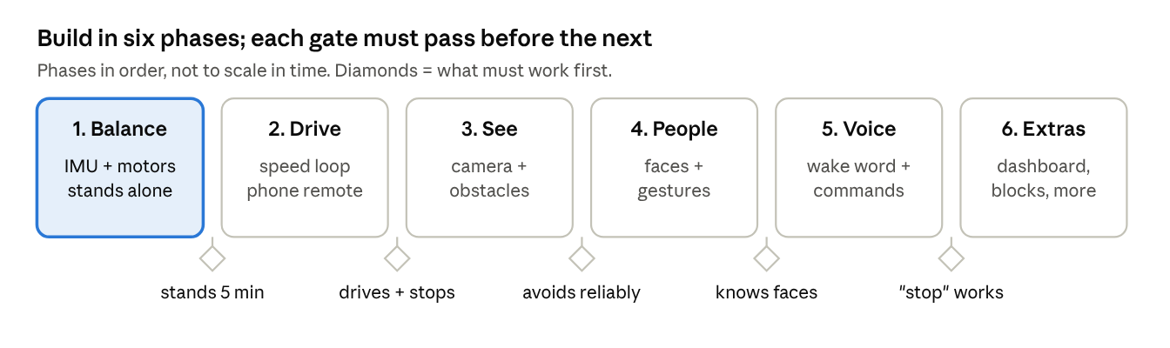
build roadmap · six phases with gates
Phase 1 (highlighted) is the foundation and usually takes the longest. Do not move to the camera until the robot can stand for 5 minutes and recover from a gentle push.

Lesson ideas by level
Beginner
- Balance a broom on your hand, then compare a short and a long broom. Connect it to τ = √(L / g).
- Program behaviors with blocks: "when you see a thumbs up, spin and say yay".
- Look through the robot's eyes: show the camera view with detected faces and floor drawn on top.
Intermediate
- PID tuning lab with the live dashboard: each group finds gains and explains what P and D do.
- The delay experiment from section 3: why camera-only balance fails.
- Line following and person following in Python.
- Face enrollment, followed by a class discussion on privacy and fairness in face recognition.
Advanced
- Replace the complementary filter with a Kalman filter, and fuse camera tilt for drift correction.
- Derive the physics model and design an LQR controller; compare it with PID on the real robot.
- Train a balance controller with reinforcement learning in simulation, then test it on hardware.
- Build a room map with visual SLAM and add "go to the door" voice commands.

Open questions to settle
- Which age group will use it? This decides block programming versus Python first, and how strict the safety limits are.
- Budget per robot and number of robots? This decides Raspberry Pi versus Jetson, and DC versus brushless motors.
- Must it work fully offline? This decides whether a cloud language model for conversation is allowed.

11. Wi-Fi-free parts and prices
A complete Wi-Fi-free robot costs roughly $650 to $950, depending on how much AI power you want. The main computer is the biggest choice, so the parts are grouped into three computer tiers plus parts every robot needs. Prices were checked in October 2026; memory shortages have pushed prices up several times this year, so recheck before ordering.

Why these boards
- Raspberry Pi 5 has Wi-Fi built in, and the official Raspberry Pi AI HAT+ boards only fit Raspberry Pi 5. So this guide uses the Compute Module 5 (CM5) in its non-wireless version instead: the same processor as a Pi 5, with no radio chip. It plugs into the CM5 IO Board, and an AI accelerator goes into the IO Board's M.2 slot.
- Jetson Orin Nano Super has no radio on the module itself. The developer kit ships with a Wi-Fi card plugged into an M.2 slot; unplug it and the board is wireless-free.
- Microcontrollers: choose versions without wireless. Avoid ESP32 boards and the Pico 2 W.
- If hardware-free is not strictly required, a normal Raspberry Pi 5 with Wi-Fi switched off in software is a cheaper option, but the radio is still physically on the board.

Computer tiers
Tier | Board combination | Computer cost | Whole robot, roughly
A. Basic (CPU only) | CM5 4 GB non-wireless + 16 GB eMMC ($120–125) + CM5 IO Board (~$41) | ~$165 | ~$660
B. Vision (recommended) | CM5 8 GB non-wireless ($190, estimate) + IO Board ($41) + Hailo-8L 13 TOPS M.2 (€115) | ~$365 | ~$870
B+. Heavy vision | As tier B, but Hailo-8 26 TOPS M.2 (€195) instead of Hailo-8L | ~$460 | ~$960
C. Generative AI | Jetson Orin Nano Super Developer Kit ($399), Wi-Fi card removed, plus an NVMe drive (~$30, estimate) | ~$430 | ~$930
Euro prices are from a European shop and are converted roughly to dollars in the totals. Another wireless-free option is the Radxa ROCK 5B (no onboard Wi-Fi, built-in 6 TOPS NPU) at about €265, but its AI software is less beginner-friendly than Hailo or Jetson.

Parts every robot needs
Part | Wireless-free pick | Price | Checked?
Microcontroller | STM32 Nucleo-F446RE (built-in debugger) | ~$18 | Checked
Microcontroller, alternatives | Raspberry Pi Pico 2 (not Pico 2 W); Teensy 4.1 | $5; from ~$30 | List prices, Teensy figure from 2024
IMU | LSM6DSOX breakout | ~$15–25 (£11–20 in UK shops) | Checked
Camera | Raspberry Pi Camera Module 3 Wide | ~$35 | Checked
Camera, alternative | Raspberry Pi Global Shutter Camera (lens extra) | ~$50–55 | Checked
Front distance sensor | VL53L5CX 8×8 time-of-flight breakout | ~$19–31 | Checked
Motors (×2) | Pololu 37D 12 V gearmotor with 64 CPR encoder | ~$61 each, ~$122 pair | Checked
Microphones | ReSpeaker XVF3800 USB 4-mic array, version without XIAO board | ~$50–60 | Checked
Motor drivers | Two single-channel drivers rated for the motors' stall current | ~$20–40 | Estimate
Battery | 3S Li-ion pack with protection board, plus charger | ~$40–70 | Estimate
Power regulator | 5 V, 5 A step-down for the computer | ~$10–20 | Estimate
Cliff sensors (×2) | Small downward time-of-flight sensors | ~$20–40 | Estimate
Speaker + amplifier | Small 3 W speaker with amplifier board | ~$10–15 | Estimate
Screen | Small round or rectangular LCD for the eyes | ~$15–30 | Estimate
Mechanics | Wheels, hubs, brackets, frame, fasteners | ~$40–90 | Estimate
These parts total about $500 per robot: roughly $275 of checked prices and $225 of estimates.
One warning on the IMU: ICM-42688-P breakout boards now sell for about $53 to $88 because of a chip shortage, so the LSM6DSOX is the better buy today. For a classroom set, ask distributors for quantity pricing; motors and computers usually get cheaper at 10+ units.

12. Board and price for each AI demo
Tier B (CM5 8 GB + Hailo-8L, about $365 for the computer) runs every demo except room mapping and on-robot language models, so it is the best single choice for a classroom. Pick tier A to save money if you only want the simpler demos, and tier C if conversation or "describe what you see" matters to you.
The "minimum" column is the cheapest tier that runs the demo acceptably; the "recommended" column is where it runs smoothly alongside the other features. Computer prices are from section 11.
AI demo | Minimum tier | Recommended tier | Why
Self-balancing, camera-delay experiment | Microcontroller only (~$18) | Microcontroller only | Pure control; no AI computer needed
Learning to balance (reinforcement learning) | Microcontroller only | Microcontroller only | Training happens on a lab PC in simulation; the trained controller then runs on the microcontroller
Line following | A (~$165) | A | Classic image processing with OpenCV runs easily on the CPU
AprilTag navigation and auto-docking | A | A | Tag detection is lightweight CPU work
Colored ball tracking and ball games | A | A | Color filtering on the CPU is enough
Voice commands (wake word, fixed commands, spoken replies) | A | A | Vosk, openWakeWord and Piper are designed for small CPUs; voice stays on the CPU in every tier
Face detection and recognition | A | B (~$365) | Works on the CPU at a modest frame rate; the accelerator keeps it smooth while other features run
Gesture recognition (hands, body pose) | A | B | MediaPipe runs on the CPU but uses a lot of it; pose models on the accelerator free the CPU
Obstacle avoidance with floor segmentation | B | B | Segmentation on every frame needs the accelerator
Object detection (people, pets, chairs) | B | B | YOLO-style detectors are what Hailo accelerators are built for
Person following | B | B | Needs detection or pose plus tracking at the same time
Monocular depth estimation | B | B+ ($460) or C ($430) | Depth models are large; the 26 TOPS Hailo-8 or the Jetson GPU runs them comfortably
Several vision models at once (obstacles + faces + gestures) | B+ | B+ or C | The 13 TOPS Hailo-8L is happiest running one network at a time
Room mapping (visual SLAM) | C | C | SLAM runs on the CPU and GPU, not on a Hailo accelerator; Jetson has the best-supported tools
AI conversation with a local language model | C | C | A Wi-Fi-free robot cannot use cloud AI, so the model must run on the robot; the Jetson's 8 GB and GPU can run small language models
"What do you see?" (vision-language model) | C | C | Same reason; needs a GPU and memory for an image-plus-text model
A practical classroom plan: build most robots at tier B, plus one or two tier C robots for the generative-AI and mapping lessons. All tiers use the same microcontroller, motors and sensors, so students' balance code works on every robot.

13. More AI demo ideas from around the world
The most successful student AI projects worldwide share three traits: students train or change the AI themselves, they see the result move in the real world within minutes, and there is a game or challenge to win. The ideas below come from well-known school programs, competitions and university courses, adapted to a balancing robot. The tier column refers to section 12.

Train-it-yourself demos
Demo | Inspired by | What students learn | Tier
Train the robot in 5 minutes: show it objects or hand signs, then link each class to an action ("red card = spin") | Google Teachable Machine, widely used in schools | Data collection, training, testing, why more varied examples help | A (train on a laptop, run on the robot)
Drive it, then let it drive itself: record a student driving around a track, train a small neural network to copy them | Donkey Car, a popular open-source self-driving car community | Imitation learning, how bad training data leads to bad driving | B
Sound commands without words: claps, whistles, a bell | Edge Impulse-style audio projects common in school maker labs | Turning sound into pictures (spectrograms) and classifying them | A
Sign language alphabet reader: the robot spells words signed to it | Popular science-fair project using MediaPipe hand points | Feature engineering from hand landmarks; inclusive design | A, smoother on B
Recycling helper: the robot identifies litter type and says which bin it goes in | Common environmental AI project in schools | Image classification, class imbalance, real-world impact | B

Challenge and competition demos
Demo | Inspired by | What students learn | Tier
Mini self-driving town: lanes, intersections, traffic signs, toy pedestrians | Duckietown, a self-driving course started at MIT and used by universities worldwide | Lane detection, sign recognition, rules of the road as code | B
Traffic pillar challenge: pass red pillars on one side and green on the other, then park | World Robot Olympiad, Future Engineers category | Color detection, planning, reliability under time pressure | A
Rescue mission: follow a line, avoid obstacles, find "victims" (colored balls or markers) and report them | RoboCup Junior Rescue Line, an international student competition | Combining several skills into one reliable program | A
Robot soccer: push a ball into a goal, one or two robots | RoboCup Junior Soccer | Ball tracking, simple strategy, teamwork between robots | A
Autonomous time trial: fastest lap around a taped track | AWS DeepRacer leagues and F1TENTH university racing | Reinforcement learning in simulation, then racing the real robot | B (training on a lab PC)
Maze explorer: find the exit and remember the map for a faster second run | Micromouse competitions | Search algorithms, mapping, memory | A for markers; C for camera mapping

Interaction and storytelling demos
Demo | Inspired by | What students learn | Tier
Rock-paper-scissors and Simon Says with gestures | Classic gesture-recognition demos popular in classrooms everywhere | Real-time recognition, game logic, fairness and timing | A
Robot tour guide: greets visitors, leads them to stations, explains each one | Guide and reception robots common in museums and schools in Japan and Korea | Combining faces, speech, navigation and a script | B; C for free conversation
Dance to the music: finds the beat and dances, or follows a student "conductor" | Music-and-robotics shows at robotics festivals | Audio beat detection, synchronizing motion to time | A
Find my object: "find the red cup" and the robot searches the room and stops in front of it | Open-vocabulary detection and vision-language model demos from recent AI research | How models link words to images, and where they fail | C
Robot storyteller: describes what it sees as a story for younger children | Vision-language model demos | Generative AI, prompts, checking AI output for mistakes | C

AI ethics and "how AI fails" demos
These are some of the most memorable lessons, because students catch the AI making mistakes:
- Fool the detector: students print patterns or change lighting and angles to see when person or object detection stops working. This teaches that AI sees patterns, not meaning.
- Fairness check: test face detection across lighting, skin tones, glasses and masks using consenting volunteers or public test images, then discuss why training data matters.
- Privacy by design: compare a robot that stores face photos with one that stores only embeddings on the robot, and debate which a school should allow. Your Wi-Fi-free design is a great real example of privacy by design.
- Cloud versus on-robot AI: measure the response time and discuss what data leaves the robot in each case.
These map well to the widely used AI4K12 "Five Big Ideas in AI" framework for schools: perception, representation and reasoning, learning, natural interaction, and societal impact. Every idea in this section covers at least one of them, which helps when presenting the robot to teachers.
One note on the Wi-Fi-free design: competitions and multi-robot demos normally use wireless links. Use Ethernet cables, USB connections or start signals such as a sound cue instead, and train reinforcement learning models on a lab PC, then copy them to the robot with a USB drive or cable.

Sources
Prices checked October 2026. Rows marked "Estimate" in section 11 were not looked up.
- CM5 non-wireless variants (Core Electronics)
- CM5 4 GB non-wireless prices (PiShop US)
- CM5 8 GB wireless prices, used for the 8 GB estimate (PiShop US)
- Raspberry Pi memory-driven price rises (Raspberry Pi)
- CM5 IO Board (RobotShop)
- Hailo-8 and Hailo-8L M.2 modules (buyzero)
- Raspberry Pi AI HAT+, Raspberry Pi 5 only (The Pi Hut)
- Jetson price increase to $399 (CNX Software)
- Jetson Orin Nano Super kit contents, including Wi-Fi card (RS)
- Radxa ROCK 5B price and wireless (raspberry.tips)
- NUCLEO-F446RE (Future Electronics)
- Raspberry Pi Pico 2 price (eeNews Europe)
- Teensy 4.1 price (PCBONLINE, 2024)
- LSM6DSOX breakout (Cool Components)
- ICM-42688-P breakout shortage pricing (Elecrow)
- Camera Module 3 and Global Shutter list prices (Raspberry Pi)
- Raspberry Pi cameras (PiShop US)
- VL53L5CX-SATEL budgetary price (ST)
- Pololu 37D gearmotor with encoder (RobotShop)
- ReSpeaker XVF3800 USB array (The Pi Hut)
- reSpeaker Flex XVF3800 Linear-4 (RobotShop)

