Infrared (IR) LED diodes are
semiconductor devices that emit light in the infrared spectrum (wavelengths typically above 700 nm), which is invisible to the human eye. They are commonly used in conjunction with IR receivers for applications such as remote controls, security systems, and various sensing technologies.
Common Wavelengths and Applications
IR LEDs are available in a variety of wavelengths tailored to specific applications and the sensitivity of the corresponding detectors.
- 850 nm: Often preferred for night vision cameras, CCTV monitoring systems, and digital photography applications where the slight visible red glow is acceptable or desired.
- 940 nm: Ideal for remote controls (TVs, climate control systems) and biometric devices because the emission is completely invisible to the human eye.
- Other wavelengths: Include 808 nm for medical treatments, and 1310 nm or 1550 nm for fiber optic communication systems.
Key Specifications
When selecting an IR LED, key specifications to consider include:
- Peak Wavelength (𝜆𝑝): The specific wavelength in nanometers (nm) where the diode's emission is strongest.
- Forward Voltage (𝑉𝑓): The typical voltage drop across the diode when current flows (e.g., ~1.2–1.7 V for many IR LEDs).
- Forward Current (𝐼𝑓): The amount of current the diode is designed to handle, which affects its output power.
- Beam Angle / Angle of Half Intensity: Determines the spread of the infrared light. Narrower angles are better for longer distances (like remote controls), while wider angles are for broader illumination.
- Package Type: Common types include through-hole (5mm, 3mm) and surface-mount device (SMD) packages.
Product Examples
Specific IR LED diodes are available from various manufacturers and retailers.
- TSAL6400 Vishay 5mm (T-1 3/4) Through Hole package: A common and popular 940 nm IR transmitter.
- Chanzon 5mm Infrared Ray IR 940nm Emitter LED Diode Lights: Available in bulk packs, suitable for DIY electronics projects.
- ams OSRAM SFH 4795BS-EA1FA1-11: An infrared emitter with 940 nm wavelength in a SMD package, available from distributors like Mouser Electronics.
- Kingbright L-7104F3C 3mm Infrared LED: A 940 nm emitter with a 34° viewing angle, a standard option for general use.

High-power 810nm and 850nm IR LEDs in 3W, 5W, and 10W power ratings are available from various manufacturers like
OSRAM and through retailers and B2B platforms, with pricing largely dependent on order volume and specific product features.
Popular Products
Many high-power IR LEDs are sold as bare chips or integrated into standard packages like 3535 SMD or COB (Chip on Board) arrays, often requiring external heat sinks for proper operation. Specific models often come from major manufacturers such as OSRAM, though the items listed on general retail sites are often generic or "Epistar Chip Inside" components.
- OSRAM Oslon Black Series (e.g., SFH 4715AS, SFH 4727AS): These are popular and highly regarded for security and night vision applications due to their efficiency and performance around the 850nm wavelength.
- Chanzon High Power LED Chips: A common brand found on online marketplaces, offering 3W, 5W, and 10W options in various wavelengths including 810nm and 850nm, often on a star PCB base.
- GMKJ LED 3535 SMD: Products from manufacturers like GMKJ offer 3W and 5W options in 810nm and 850nm wavelengths, with various beam angles for different applications.
Pricing Information
Pricing for these components varies widely based on quantity ordered (single units vs. bulk), manufacturer, and quality. The prices listed below are general ranges sourced from high-volume online marketplaces and are subject to change.
Power Rating | Approximate Price Range (per unit) | Notes
3W | $0.35 - $3.50 | Prices are often much lower when purchased in bulk quantities (e.g., 100+ units).
5W | $0.50 - $5.00 | Bulk pricing can go as low as $0.09 per piece for very large orders.
10W | $3.00 - $7.00 | Specialized, high-quality 10W LEDs can be more expensive, while generic options are cheaper.
Wavelength Considerations
- 810 nm: This wavelength provides strong output and good compatibility with silicon-based image sensors, making it a reliable choice for monitoring and medical treatment applications. It offers a balance between visibility and camera sensitivity.
- 850 nm: Widely used in security cameras because most CCD/CMOS sensors have peak sensitivity around this wavelength. It emits a faint red glow, which can aid in alignment but makes it less "covert" than 940 nm LEDs.
810nm ir led, chinese, 3w consumption
You can find
810nm 3W IR LEDs from a variety of Chinese manufacturers, with common packages including the SMD 3535 form factor. These LEDs are widely available from suppliers on major B2B platforms like Alibaba and Made-in-China.com.
Product Specifications Overview
Chinese manufacturers like Guangzhou Tuoran Photoelectric Technology Co., Ltd., Dongguan Houke Electronic Co., Ltd., and Guangzhou Yingsheng Lighting Co., Ltd. offer 810nm 3W IR LEDs with a range of specifications.
Specification | Details
Wavelength | 800nm to 810nm, or specifically 810nm.
Power Consumption | 3W (also available in 1W, 5W, etc.).
Package Type | Common in 3535 SMD ceramic package.
Forward Current | Typically around 700mA for 3W power.
Forward Voltage | Ranges from 3.2V to 3.6V according to Tuoran. Other options may be available.
Beam Angle | Usually 120° or 160°±5°.
Chip Brand | Often utilize chips from manufacturers like Epileds or Sanan.
Base Material | Ceramic base is common for high power applications.
Important Considerations
- Heat Management: For a 3W LED, using a suitable heat sink system and a constant current LED driver is strongly recommended to maintain performance and lifespan.
- Applications: These LEDs are frequently used in security cameras (CCTV/night vision), distance measurement, photoelectric sensors, and medical devices due to their penetration capabilities.
Where to Find Specific Products
Since you are looking for these LEDs, here are a few examples of products from Chinese suppliers:
- SMD3535 810nm 3W Infrared High Power LED: This specific product is available for applications like security camera illumination.
- TR-3535IR-3W: Guangzhou Tuoran Photoelectric Technology Co., Ltd. lists a 3W, 810nm LED chip with a ceramic base and Sanan chips.
- High Power 3535 SMD LED Chip Lamp Beads 1-3W: Shenzhen Chuhong Trading Co., Ltd. offers a general 1-3W high power option with an aluminum base for heat dissipation, and customization is available.
- Wholesale 3W IR 800-810nm High Power LED Diode: Guangzhou Yingsheng Lighting Co., Ltd. provides a 3W deep IR diode in a 3535 package, often with an added PCB for ease of use.
AI responses may include mistakes. Learn more


19 sites
- Ir Illuminator 10Pcs 3W Infrared LED Chips - 810nm 3535 ...
- About This Product. Working temperature should be less than 60 Degrees Celsius / (140 Fahrenheit) with a Heat Sink System. SMD3535...
- SensorHaus
- 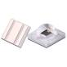
- Products - Made-in-China.com
- China 810nm Ir Led, 810nm Ir Led Wholesale, Manufacturers, Price | Made-in-China.com. Inquiry Basket. High Power LED 760nm 810nm 8...
- Made-in-China.com
- 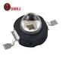
- 3W 5W 10W High Power 3535 Infrared SMD LED 740nm 750nm ...
- Basic Info. * Model NO. TR-3535IR-3W. * 120° * White. * IP Rating. IP33. * Base Material. Ceramic. * LED Chips. Sanan. * Power. 3W...
- Guangzhou Tuoran Photoelectric Technology Co., Ltd.
- 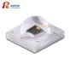
Show all
810nm ir led, chinese, 5w consumption
Numerous Chinese manufacturers produce
810nm IR LEDs with 5W consumption in various high-power packages, such as SMD 5050 and 3535, which are readily available from major suppliers.
Product Specifications Overview
Chinese manufacturers like Dongguan Houke Electronic Co., Ltd., Shenzhen Guangmai Electronics Co., Ltd., and Lumixtar offer 810nm 5W IR LEDs with typical specifications:
Specification | Details
Wavelength | 805nm to 815nm (peak at 810nm).
Power Consumption | 5W.
Package Type | Common in SMD 5050 ceramic or 3535 SMD packages.
Forward Current | Typically around 1000mA.
Forward Voltage | Ranges from 1.4V to 1.7V or 30V-34V depending on configuration (series/parallel).
Beam Angle | Usually 60° or 120°.
Chip Brand | Often utilize chips from manufacturers like Epileds or Epistar.
Base Material | Ceramic or copper base for better heat dissipation.
Important Considerations
- Heat Management: A 5W LED generates significant heat. According to experts from Lumixtar, a suitable heat sink system and a constant current LED driver are critical for performance and longevity.
- Applications: These high-power LEDs are commonly used in medical and scientific instruments, iris and face recognition systems, security cameras (CCTV/night vision), and industrial automation.
Where to Find Specific Products
Here are examples of specific products and manufacturers found on B2B platforms like Alibaba and Made-in-China.com:
- High Power 5 Watt 810nm IR LED (Houkem Brand): Dongguan Houke Electronic Co., Ltd. offers a 5W IR LED in various power options with a long lifespan.
- 810nm 5W SMD5050 IR High Power LED (Lumixtar): This product is available as an emitter or mounted on a Star PCB, ideal for medical applications.
- Customized High Power Ceramic 5050 IR LED (Ningbo Lightkey Electronic Technology Co., Ltd.): This supplier offers a 5W ceramic 5050 package, suitable for high-intensity infrared applications.
- High Power LED Chip IR Infrared 3W 5W 680nm 740nm... (Shenzhen Guangmai Electronics Co., Ltd.): This manufacturer provides general 5W high-power IR chips for various uses, including flashlights.
AI responses may include mistakes. Learn more


17 sites
- 5W IR 810nm High Power LED - Lumixtar
- Features: * 99.99% gold wire bonding, 1.2mil. * Red copper substrate. * Silicone Lens. * Epileds, 4pcs * 42mil Chips. * Meet CE, R...
- Lumixtar
- 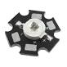
- 810nm 5W 10W SMD5050 IR High Power LED - Lumixtar
- Features: * 99.99% gold wire bonding, 1.2mil. * Ceramic Substrate. * Silicone Lens. * Epileds, 4pcs * 42mil Chips. * Meet CE, ROHS...
- Lumixtar
- 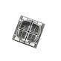
- High Power 5W IR LED 810nm | 805nm-808nm - Alibaba
- Dongguan Houke Electronic Co.,Ltd. Established in 2003, Houkem has over 20 years professional manufacturer experience, development...
- Alibaba
- 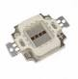
Show all
810nm ir led, chinese, 10w consumption
You can find
810nm 10W IR LEDs from various Chinese manufacturers and suppliers on B2B platforms, typically available in integrated packages like the SMD 5050 or COB form factors.
Product Specifications Overview
Chinese manufacturers like Dongguan Houke Electronic Co., Ltd., Shenzhen Guangmai Electronics Co., Ltd., and others offer 810nm 10W IR LEDs with a range of specifications.
Specification | Details
Wavelength | 800nm to 810nm (peak wavelength).
Power Consumption | 10W.
Package Type | Common in integrated multi-chip packages such as SMD 5050, COB, or high-power 3535.
Forward Current | Typically around 900-1050mA.
Forward Voltage | Ranges from 4.5V to 5.5V, depending on the chip configuration.
Beam Angle | Usually 60°, 120°, or 160°±5°.
Base Material | Red copper or ceramic base is often used for superior heat dissipation.
Lifespan | A long lifespan of up to 50,000 hours is common.
Important Considerations
- Heat Management: For a 10W LED, a robust heat sink system is essential to dissipate the significant heat generated and prevent overheating.
- Power Supply: A constant current LED driver is recommended to power these LEDs at the specified forward current and voltage for stable operation.
- Applications: These high-power LEDs are commonly used in medical treatment devices, surveillance cameras (night vision), virtual reality (VR/AR) products, and laser technology applications.
Where to Find Specific Products
Since you are looking for these LEDs, here are a few examples of products from Chinese suppliers:
- HOKEM-HP10W-810 (Dongguan Houke Electronic Co., Ltd.): This product is a high-power 10W IR LED available for various applications, including medical and security systems.
- High Power 10W IR LED 805-810nm (e.g., from Klgeivb brand): These are often available on platforms like eBay, designed with a red copper base and a wide viewing angle for diverse uses.
- COB High Power Integrated LED Bead Light (805-810nm): Available in 10W and higher options, these integrated COB chips are designed for high radiant flux in surveillance and medical applications.
AI responses may include mistakes. Learn more

11 sites
- 10W 45mil High Power IR LED beads 760nm 810nm 970nm ...
- Price details. Was. $26.99. (5% off) -$1.35. $25.64. FREE. $25.64* You save: $1.35. Free shipping. Includes import fees. New. Wave...
- eBay
- 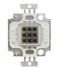
- 10w Ir Led 800nm 805nm 808nm 810nm 808 nm High Power Ir Led
- Jan 1, 2026 — Dongguan Houke Electronic Co.,Ltd * Established in 2003, Houkem has over 20 years professional manufacturer experience,
- Alibaba.com
- 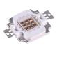
- 10W IR LED 810nm for Laser Technology | RoHS Certified ...
- Model Number (1) HOKEM-HP10W-810. Ship to. Key attributes. 810nm. Color Temperature(CCT) 100. Luminous Efficacy(lm/w) No. Support ...
- Alibaba.com·
- 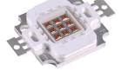
- 0:30
Show all
850nm ir led, chinese, 3w consumption
Chinese manufacturers offer a wide variety of
850nm 3W IR LEDs, primarily in the compact and heat-efficient SMD 3535 ceramic package, which are widely used for security and night vision applications.
Product Specifications Overview
Chinese suppliers such as Shenzhen Guangmai Electronics Co., Ltd. (GMKJ) and Guangdong Juhong Optoelectronics Co., Ltd. provide 850nm 3W IR LEDs with a common set of specifications:
Specification | Details
Wavelength | 840nm to 850nm.
Power Consumption | 3W.
Package Type | Common in 3535 SMD ceramic package; also available in COB form factors.
Forward Current | Typically 700mA. Some variants can operate up to 1000mA or 1500mA.
Forward Voltage | Ranges from 1.4V to 1.8V (for single chip configurations) or 2.8V-3.4V depending on specific internal chip arrangements.
Beam Angle | Usually available in 60°, 120°, or 135°.
Chip Brand | Often utilize chips from manufacturers like Epileds or Epistar.
Base Material | Red copper or ceramic base is commonly used for efficient heat dissipation.
Important Considerations
- Heat Management: For a 3W LED, proper heat dissipation is crucial. Using a suitable heat sink system is strongly recommended to maintain performance and a lifespan of up to 50,000 hours.
- Visible Glow: 850nm LEDs have a slight glow that is faintly visible to the human eye, unlike 940nm LEDs which are completely invisible. This makes them effective for surveillance without being completely covert.
- Constant Current: These LEDs are designed to be run with a constant current LED driver to ensure stable operation and prevent damage.
Where to Find Specific Products
Here are a few examples of products from Chinese suppliers:
- GMKJ 3w 3535 850nm Deep Infrared LED: Shenzhen Guangmai Electronics Co., Ltd. (GMKJ) offers a 3W 850nm LED chip in the 3535 ceramic package with branded Epileds chips.
- SMD3535 850nm 3W Infrared High Power LED: Lumixtar provides a 3W 850nm SMD3535 LED with various beam angle options (30°, 60°, 120°) for surveillance and inspection systems.
- JH-3535IR12G42-T8A-850: Guangdong Juhong Optoelectronics Co., Ltd. offers a 3535 SMD 3W 850nm LED with a 120-degree viewing angle.
AI responses may include mistakes. Learn more
19 sites
- 5Pcs 850nm IR High Power Tiny LED Chip 3535 SMD COB ...
- Table_title: Product specifications Table_content: header: | Light Type | LED | row: | Light Type: Additional Features | LED: Ener...
- Amazon.com
- 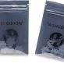
- CE RoHS 3W IR 850nm High Power LED/Gold Wire Welding ...
- Guangdong Juhong Optoelectronics Co., Ltd. What's your impression of this company?
- Made-in-China.com
- 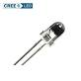
- China GMKJ 3w 3535 800nm Deep Infrared 810nm 850nm ...
- Located in Shenzhen, China, Guangmai Technology Co., Ltd. is a professional LED chips package manufacturer. We mainly produce 2835...
- Alibaba·
- 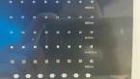
- 0:15
Show all
850nm ir led, chinese, 5w consumption
Numerous Chinese manufacturers produce
850nm IR LEDs with 5W consumption, which are commonly available in high-power integrated packages such as the SMD 5050 and 3535 form factors. These LEDs are used extensively in security cameras and biometric systems.
Product Specifications Overview
Chinese suppliers like Chanzon, Moonleds, and Shenzhen Guangmai Electronics Co., Ltd. (GMKJ) offer 850nm 5W IR LEDs with a common set of specifications:
Specification | Details
Wavelength | 840nm to 850nm (peak wavelength).
Power Consumption | 5W.
Package Type | Common in SMD 5050 ceramic or 3535 SMD packages.
Forward Current | Typically around 1200mA to 1400mA.
Forward Voltage | Ranges from 1.4V to 1.8V, depending on chip configuration.
Beam Angle | Usually available in 60°, 120°, or 140°.
Chip Brand | Often utilize chips from manufacturers like Epileds or Epistar.
Base Material | Ceramic or copper base for better heat dissipation.
Important Considerations
- Heat Management: A 5W LED generates significant heat, so a suitable heat sink system and a constant current LED driver are critical for performance and longevity, as recommended by manufacturers like Chanzon.
- Visible Glow: 850nm LEDs produce a faint red glow that is slightly visible to the human eye, which should be considered depending on the application (e.g., covert surveillance may prefer 940nm).
- Applications: These high-power LEDs are commonly used in security cameras (CCTV/night vision), iris/face recognition systems, medical instruments, and industrial automation.
Where to Find Specific Products
Here are a few examples of products from Chinese suppliers available on B2B platforms:
- Chanzon High Power Led Chip 5W Infrared (IR 850nm): This integrated COB LED panel is a popular option featuring Epistar chips and a copper frame, available with or without an aluminum PCB base.
- Moonleds MN-S5050IR8501400D: This is a 5W 850nm SMD 5050 LED series, known for its high-thermal conductivity aluminum nitride ceramic substrate.
- GMKJ 5W 3535 IR LED Diode: Shenzhen Guangmai Electronics Co., Ltd. (GMKJ) offers a high-power 5W IR LED diode in the 3535 package with a 60-degree beam angle.
AI responses may include mistakes. Learn more

14 sites
- 5050 5W 850nm IR SMD LED - Moonleds
- Moonleds 5050 high power 5w IR SMD LED series includes 730-740nm, 850nm, 940nm, featured by branded Epileds chip inside, tight 505...
- Moonleds
- 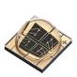
- CHANZON 5 pcs High Power Led Chip 5W Infrared (IR 850nm ...
- About this Item. 5Watt / Infra Red / 850nm / 45mil chips / 120 - 140 degree Light Emitting Angle Lightbulbs. Integrated Chanzon Hi...
- Amazon.com·
- 
- 850nm 5W 10W SMD5050 IR High Power LED - Lumixtar
- Features: 99.99% gold wire bonding, 1.2mil. Ceramic substrate. Silicone Lens. Bridgelux, 4pcs * 45mil Chips. Meet CE, ROHS Complia...
- Lumixtar
Show all
850nm ir led, chinese, 10w consumption
Chinese manufacturers offer a wide selection of
850nm 10W IR LEDs, typically in robust COB (Chip on Board) or integrated SMD packages (like the 5050 form factor), widely available from various suppliers.
Product Specifications Overview
Suppliers like Chanzon, Dongguan Houke Electronic Co., Ltd., and Shenzhen Guangmai Electronics Co., Ltd. offer 850nm 10W IR LEDs with typical specifications:
Specification | Details
Wavelength | 840nm to 850nm (peak wavelength).
Power Consumption | 10W.
Package Type | Common in integrated multi-chip packages such as COB or SMD 5050.
Forward Current | Typically around 900mA to 1050mA.
Forward Voltage | Ranges from 5V to 6V (for certain Chanzon COB chips) or 4V-5V depending on chip configuration.
Beam Angle | Usually available in 120° to 140°.
Base Material | Red copper or ceramic base is commonly used for efficient heat dissipation.
Lifespan | A long lifespan of up to 50,000 hours is common.
Important Considerations
- Heat Management: A 10W LED generates significant heat. According to manufacturers, a robust heat sink system is essential to keep the working temperature below 60°C (140°F) to ensure performance and longevity.
- Visible Glow: 850nm LEDs produce a faint red glow at the source, unlike 940nm LEDs which are nearly invisible to the human eye. This is an important consideration for covert applications.
- Power Supply: These LEDs are designed to be run with a constant current LED driver for stable and safe operation.
Where to Find Specific Products
Here are a few examples of products from Chinese suppliers available on B2B platforms:
- Chanzon High Power Led Chip 10W Infrared (IR 850nm): This integrated COB LED panel features Epistar chips, a copper frame, and double golden wires, ideal for security systems and night vision.
- HOKEM-10W-850 (Dongguan Houke Electronic Co., Ltd.): This product is a high-power 10W IR LED available for various applications, including medical and inspection systems.
- GMKJ Factory Supply 5050 IR SMD 10W: Shenzhen Guangmai Electronics Co., Ltd. offers a 10W IR LED diode in the 5050 package with a 120-degree beam angle, designed for high power applications.
- Lumixtar 10W IR 850nm High Power LED: Lumixtar provides a 10W IR LED with a red copper substrate and Epileds/Epistar chips, suitable for surveillance systems and machine vision.

Finding a 2.5-inch or smaller LCD with a 7-cable analog interface is challenging, as modern small displays primarily use simpler digital interfaces or standard composite video (RCA) with fewer wires for the video signal itself. Dedicated 7-cable analog video interfaces for this size are not a common, current product.
Available Options
- NTSC/PAL Composite Video Displays: Displays of around 2.5 inches (or slightly larger, e.g., 3.5") are available that accept a single composite video signal, which is an analog standard.
  - Wiring: These typically only require a few wires: power (2 wires, e.g., red/black for 6-12V DC) and the composite video signal (usually a yellow wire and a ground wire). This does not match your specific 7-cable requirement, but it is an analog option for a small screen.
  - Examples: Products like the NTSC/PAL (Television) TFT Display - 2.5" Diagonal from retailers like The Pi Hut are examples of this type.
- VGA Interface (Analog): VGA is an analog interface that uses multiple signal lines (for Red, Green, Blue, horizontal sync, vertical sync, and grounds). However, displays using VGA are typically 7 inches and larger (e.g., the Xenarc 7" VGA small monitor). It is highly unlikely to find a 2.5-inch VGA display.
- Hobbyist/Industrial Panels: Some raw LCD panels use a TTL signal interface with many pins (e.g., 40 or 50 pins in a flat cable), which includes parallel RGB signals. These require a separate driver board to interface with common video sources and typically do not use individual "7 analog cables".
- Legacy Devices: Your requirement might refer to a specific, perhaps proprietary, interface on an older piece of equipment (like a legacy camcorder or an industrial control panel). In this case, you would need to identify the exact device and seek a replacement screen or custom solution from the original manufacturer or specialized suppliers.
Due to the specifics of your request, it is highly likely you are looking for a composite video solution with fewer cables, or a legacy/specialty item. Generic new products do not commonly use 7 individual analog cables for a 2.5-inch display.

For a 2.5-inch or smaller LCD with analog inputs, available products typically use a composite video interface (NTSC/PAL standard) which has fewer cables than your specified seven. These are common in hobbyist electronics and small camera monitoring applications.
Composite Video Displays
The most common analog displays of this size accept a single composite video input.
- NTSC/PAL (Television) TFT Display - 2.5" Diagonal (from The Pi Hut/Adafruit)
  - Description: This is a small, easy-to-use color TFT display panel with a driver board that accepts standard analog NTSC/PAL video signals. It is widely used for DIY projects, FPV (First-Person View) drones, or as a small CCTV monitor.
  - Wiring: The wiring is very simple, typically using only four wires:
    - Red wire: 6-12V DC power input.
    - Black wire: Ground connection (for power and signal).
    - Yellow wire: Composite video signal input.
    - An optional small button for adjusting backlight brightness may have additional wires.
  - Price: The price is approximately £43.20 (around $55 USD) from The Pi Hut.
  - 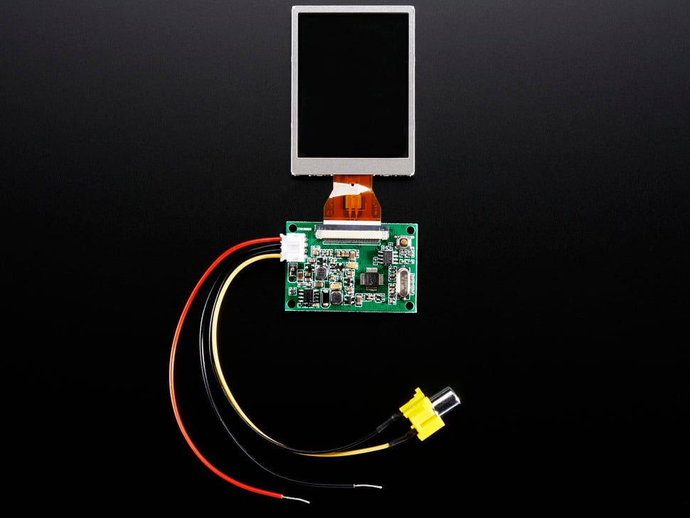
- NTSC/PAL (Television) TFT Display - 2.0" Diagonal (from Adafruit)
  - Description: A slightly smaller version of the above, with the same NTSC/PAL analog driver board and features.
  - Wiring: Same simple 4-wire setup as the 2.5" version.
  - Price: The price is approximately $39.95.
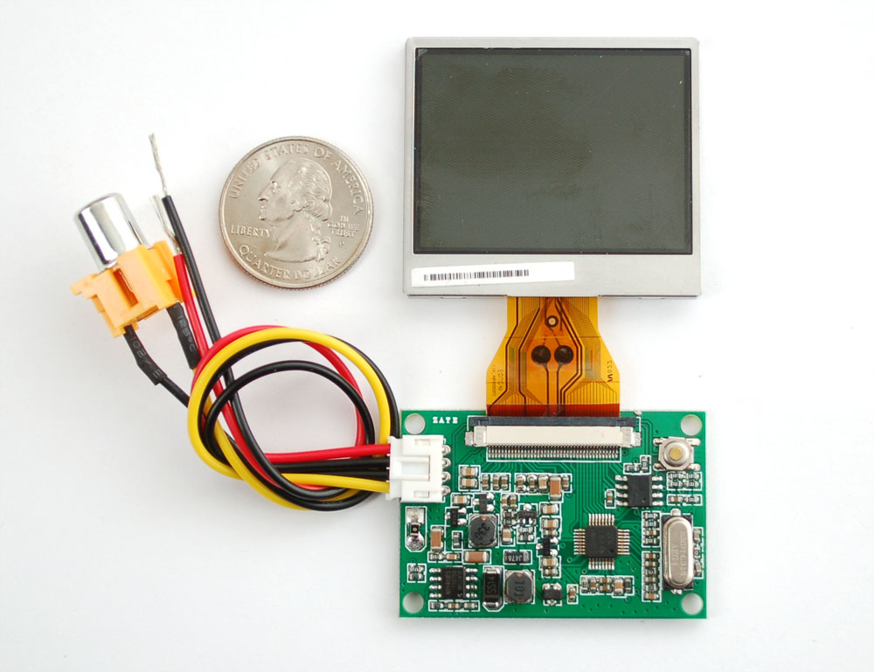
Legacy/Specialty Analog Interfaces
Your requirement for "7 analog cables" may refer to a specific legacy or industrial interface. Generic consumer/hobbyist products do not use this wiring scheme.
- VGA Interface: The VGA interface uses separate analog signals for Red, Green, Blue, Horizontal Sync, Vertical Sync, and multiple ground lines (potentially more than 7 wires in total), but displays are typically 7 inches or larger, not 2.5 inches.
- Raw LCD Panels with TTL/RGB Interface: Some raw industrial 2.5" LCD panels use a flat flexible cable (FFC) with many pins (e.g., 40 or 50 pins), which can carry 18-bit or 24-bit RGB data along with sync signals and power. This requires a specialized driver board to function and does not use individual "7 analog cables".
For a 2.5-inch display, the composite video option is the most common and practical analog solution.
Numerous Chinese manufacturers produce OLED display modules in the 1-2.5 inch range, with specific products available from suppliers who focus on small to medium-sized displays for various applications.
Notable Manufacturers and Suppliers
- BOE: Recognized as the top OLED manufacturer in China, BOE focuses on small-sized OLED screens primarily for smartphones and related applications.
- Visionox: Specializes in small and medium-sized OLED displays, including flexible and transparent options, often used in wearables and other electronic devices.
- Tianma: A high-tech enterprise that specializes in both LCD and OLED panels and modules.
- EverDisplay Optronics (EDO): Another significant player in the Chinese OLED market, focusing on developing and manufacturing OLED panels.
- Shenzhen Saef Technology Ltd. and Huaxin Technology Co. Ltd.: These suppliers, found on global trade platforms, offer a variety of specific small OLED modules (e.g., 0.96", 1.5", 2.23", 2.42") through online marketplaces, which are suitable for industrial and consumer electronics projects.
Available Products
Specific Chinese-made OLED display modules can be found from suppliers like those on Made-in-China.com and Alibaba.com, often with a range of technical specifications:
- 0.96-inch OLED Display Module: Typically 128x64 resolution, these are widely available and often support SPI or IIC interfaces, making them popular for hobbyist and small device integration.
- 1.5-inch OLED Display Panel Module Unit: These modules may have a 128x128 pixel resolution and support I2C interfaces.
- 2.23-inch OLED Module: Available in resolutions such as 128x32 or 128x64 pixels, these modules can feature SPI interfaces.
- 2.42-inch OLED Display Module: These are offered in resolutions like 128x64, sometimes with yellow graphics, and can have SPI/IIC interfaces.
- 1.77-inch Full Color OLED Display Module: Some suppliers offer full-color options with resolutions like 160RGB×128 pixels.
These displays are ideal for applications in smart wearable devices, industrial meters, point-of-sale machines, and other portable devices due to their compact size, high contrast ratios, and low power consumption.
Chinese-made OLED display modules in the 1 to 2.5 inch range generally cost between $1.50 and $15.00 per unit, with exact pricing depending heavily on the screen size, resolution, color (monochrome vs. full color), interface, and order quantity. Bulk orders typically result in significantly lower per-unit costs compared to single-piece purchases.
Typical Price Ranges by Size
- 0.96-inch to 1.1-inch modules: These are among the most common and affordable, with prices ranging from approximately $1.20 to $4.50 per unit in bulk (e.g., 1000+ pieces). Single units for hobbyist use might cost slightly more, around $7 to $10.
- 1.3-inch to 1.5-inch modules: These modules often cost between $3.00 and $9.50 per unit when purchased in larger quantities. Full color modules will be on the higher end of this range.
- 2.0-inch to 2.5-inch modules: For these larger displays, prices typically range from $6.00 to $16.00 per unit for quantity orders. Specialized, high-resolution micro-OLEDs in this size range can be considerably more expensive, potentially exceeding $200 per unit, depending on specifications like 4K resolution.
Key Factors Affecting Price
- Order Quantity: Prices drop substantially when ordering in bulk. For example, a 0.96-inch display might cost $2.40 for one piece but $1.20 each for 20 million pieces.
- Display Type: Monochrome displays (single color like white, blue, or yellow) are the most cost-effective. Full-color AMOLED or PMOLED displays are more expensive.
- Resolution and Features: Standard resolutions like 128x64 or 128x128 are common and competitively priced. Higher resolutions or added features like touch panels increase the cost.
- Supplier: Prices vary between different Chinese manufacturers and distributors on platforms like Alibaba.com and Made-in-China.com.

