TECHNICAL BRIEFING
Dereverberation:
Theory, Android Projects,
and the Literature
Everything in one place: how room echo works and how it is removed, which open source projects you can actually use on an Android device, and thirty papers worth reading.
Prepared 3 September 2026

What is inside
- Part I — Dereverberation, sections 1 to 9. What room echo is, why it damages speech, the four families of methods, a step-by-step explanation of WPE, how to measure results, and what to avoid.
- Part II — Open source projects for dereverberation on Android, sections 10 to 18. Which repositories exist, which are drop-in, which need porting, and three concrete paths through them.
- Part III — Notable papers, entries 1 to 30, grouped by line of thinking, each with a plain-language summary written for this document rather than copied from the published abstract.
- Appendix A — The Android Open Source Project, sections 19 to 28. Only relevant if you are building your own device and control the audio hardware; see section 18 for why it is here rather than in the main text.
- Appendix B — Four papers from the Android security literature.

Part I — Dereverberation

1. What reverberation actually is
When someone speaks in a room, the microphone does not receive one sound. It receives many copies of the same sound, arriving at different moments. One copy travels in a straight line. Every other copy bounces off a wall, the ceiling, the floor, a desk or a window first, and so travels farther, arrives later, and arrives quieter. In an ordinary office there are thousands of such copies.
We group them into three parts, and the distinction between them is the single most important idea in this whole subject:
Part | When it arrives | Effect on the sound
Direct sound | immediately | The clean signal we actually want.
Early reflections | roughly 1–50 ms later | Adds body and loudness. Mostly helpful — our ears use it to judge the size of the room. Keep it.
Late reverberation | roughly 50 ms onward | A dense, decaying tail. This is the part that destroys intelligibility. Remove it.

The complete pattern — what comes out of the room when a single click goes in — is called the room impulse response, or RIR. The standard way to summarise a room in one number is RT60: the time it takes for the tail to fall by 60 decibels, meaning to one millionth of its energy. A treated studio is around 0.2 seconds. A living room is around 0.4. A lecture hall or a church can be 1 to 3 seconds.
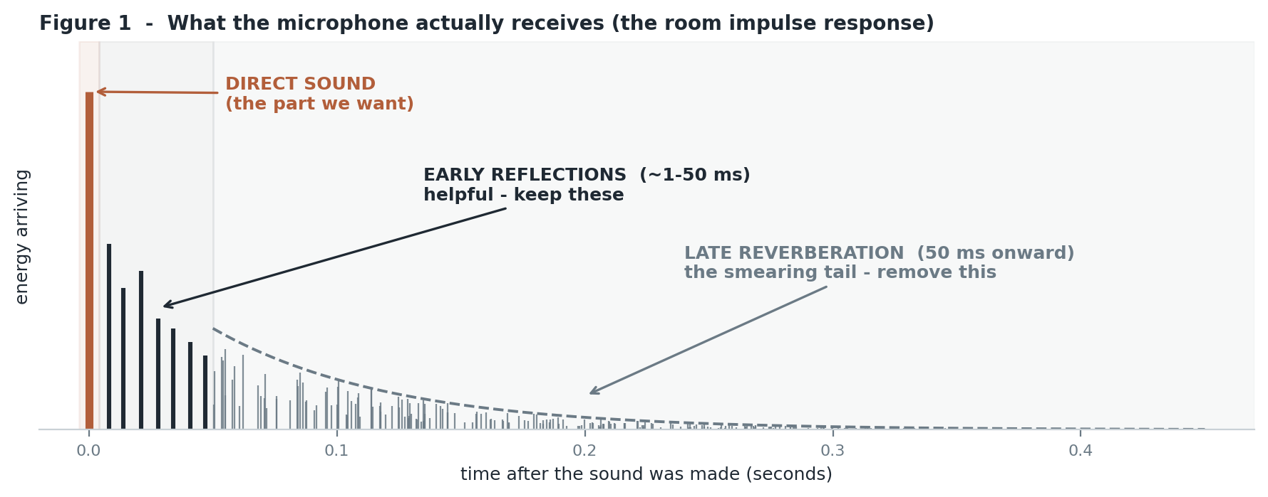
Figure 1 — The three parts of what the microphone receives. Removing the grey tail while keeping the first 50 ms is the whole objective.

2. Why the late tail is the damaging part
Speech changes fast. A syllable lasts roughly 80 milliseconds. If the room tail runs for 400 milliseconds, then the energy of a vowel you spoke five syllables ago is still lying on top of the consonant you are speaking now. This is called temporal smearing: on a picture of frequency against time, everything gets dragged to the right and the silences between sounds fill in.
CLEAN SPEECH REVERBERANT SPEECH
freq freq
| ## ### ## | ##=- ###==- ##=-
| ### # #### | ###==-#=-####==--
| # ##### # | #=-#####==--#==--
+--------------> time +--------------> time
clear gaps between sounds gaps filled with smeared energy
The practical consequences:
- Consonants are brief and quiet, so they get buried under the tail of the loud vowel before them. Words stop being distinguishable.
- Speech recognisers degrade badly. In a strongly reverberant room the word error rate can double or worse.
- Speaker identification, wake-word spotting and speaker diarisation all suffer for the same underlying reason.
The framing that matters
Reverberation is not noise. Noise is unrelated sound added on top of yours. Reverberation is your own signal, delayed and made quieter. That difference is exactly why ordinary noise-suppression techniques do not transfer to this problem without modification.

3. The problem stated properly, and why it is hard
The physics is a convolution. If s is the clean speech and h is the room impulse response, then what the microphone hears is:
y(t) = h(t) * s(t) + noise
---- -------------
what the the room smearing
mic hears the clean speech
Dereverberation means recovering s from y. But normally we do not know h either. Recovering two unknown things from one known thing is called blind deconvolution, and it is fundamentally ill-posed: infinitely many pairs of (h, s) would produce exactly the same y. Every method in existence works by adding an extra assumption that rules out most of those pairs. Four specific difficulties explain the design of every method in the next section.

a. You cannot simply invert the room
The obvious idea is to build a filter that is the mathematical inverse of h and run the recording through it. Room responses are almost always non-minimum-phase, which in plain terms means their exact inverse is unstable — it grows without bound instead of settling. Approximate inverses can be constructed, but they are extraordinarily sensitive: an inverse designed for one microphone position becomes actively harmful once the microphone or the talker moves a few centimetres.

b. The room does not hold still
People move. Doors open. A human body absorbs sound. So h is not a fixed thing, and anything estimated from the signal has to be re-estimated continuously rather than measured once.

c. Early and late must be treated differently
You want the late tail gone and the early reflections kept. Strip the early reflections too and the speech becomes thin, distant and unnatural, without becoming any more intelligible. Any method that treats all reflections the same is throwing away something useful.

d. Suppression creates its own damage
Aggressive suppression produces musical noise — random warbling tones where cells were zeroed inconsistently — and hollow, robotic timbres. These artifacts can hurt a downstream recogniser more than the reverberation did, which is a genuinely common outcome and the reason mild processing often beats strong processing.

4. The four families of methods
DEREVERBERATION
|
+----------------------+----------------------+
| | |
SPATIAL SIGNAL-MODEL LEARNED
(needs 2+ mics) (1 or more mics) (needs training data)
| | |
delay-and-sum WPE (linear masking / mapping /
MVDR, GEV prediction), generative models
beamforming spectral suppression

4.1 Beamforming — exploit the direction the voice comes from
With several microphones you can use geometry. The direct sound arrives from one particular direction; the late reverberation arrives from every direction at once. A beamformer combines the microphone signals so that sound from the talker direction reinforces itself while sound from other directions cancels out.
- Delay-and-sum: time-align the microphones to the talker, then average. Simple, extremely robust, modest improvement.
- MVDR or GEV: statistically optimal versions that suppress everything except the target direction as hard as the statistics allow.
Strengths: essentially no artifacts, very robust. Limits: needs multiple microphones, and cannot remove reverberation that happens to arrive from the same direction as the talker.

4.2 Spectral suppression — estimate the tail and subtract it
Estimate how much of the energy in each time–frequency cell is late reverberation, then turn that cell down. This is the same logic as a noise suppressor, except the "noise" is estimated from the signal own recent past together with an assumed decay rate derived from RT60. Strengths: cheap, works with a single microphone. Limits: prone to musical noise, and it only handles magnitudes, leaving the phase smeared.

4.3 WPE — the classical workhorse
Important enough to deserve its own section; see section 5.

4.4 Neural network methods
The dominant approach today, in three flavours:
- Masking — the network predicts a gain between 0 and 1 for every time–frequency cell and multiplies down the cells dominated by reverberation. Safe, stable, hard to make things worse.
- Mapping — the network outputs the clean spectrogram or the clean waveform directly. More powerful, but it must invent the parts of the signal the room destroyed, so it can hallucinate.
- Generative — diffusion models, GANs and flow matching, which treat the task as "generate plausible clean speech consistent with this reverberant observation". Currently the best-sounding results, especially in strong reverberation, at high compute cost and with some risk of altering what was actually said.
Training data is made by taking clean speech and convolving it with impulse responses, either measured ones from public datasets or simulated ones. The standard simulation trick is the image-source method, which models a rectangular room by placing mirrored virtual sources outside the walls; the pyroomacoustics library does this in a handful of lines.

4.5 The combination that actually wins
In real systems these are stacked rather than chosen between:
multi-mic input --> WPE --> beamformer --> neural enhancement --> ASR
^ ^ ^
removes the isolates the cleans up
late tail talker what remains
(no artifacts) direction
WPE goes first on purpose. It is nearly artifact-free, so it makes the job easier for everything downstream without damaging any of the cues those later stages depend on.

5. How WPE works, step by step
WPE stands for Weighted Prediction Error. It deserves a careful walkthrough, both because it is the most widely used classical method and because its central idea is genuinely clever.

The core observation
Late reverberation at this instant is a filtered copy of the signal from a moment ago. That means it is predictable from the recent past. Clean speech, by contrast, is largely unpredictable from a few tens of milliseconds earlier, because it changes too quickly. So the strategy is: predict the present from the past; whatever you can predict is reverberation; subtract it; what remains is the clean signal.

The prediction delay is the crucial trick
If you predicted from the immediate past you would also cancel the natural short-term structure of speech — the pitch periods and the vocal tract resonances — leaving something whitened and buzzy. So WPE deliberately leaves a gap. It uses a prediction delay of typically two or three frames, around 30 to 50 milliseconds, and predicts only from what came before that gap. That gap is precisely the mechanism that removes late reverberation while leaving the direct sound and the early reflections untouched.
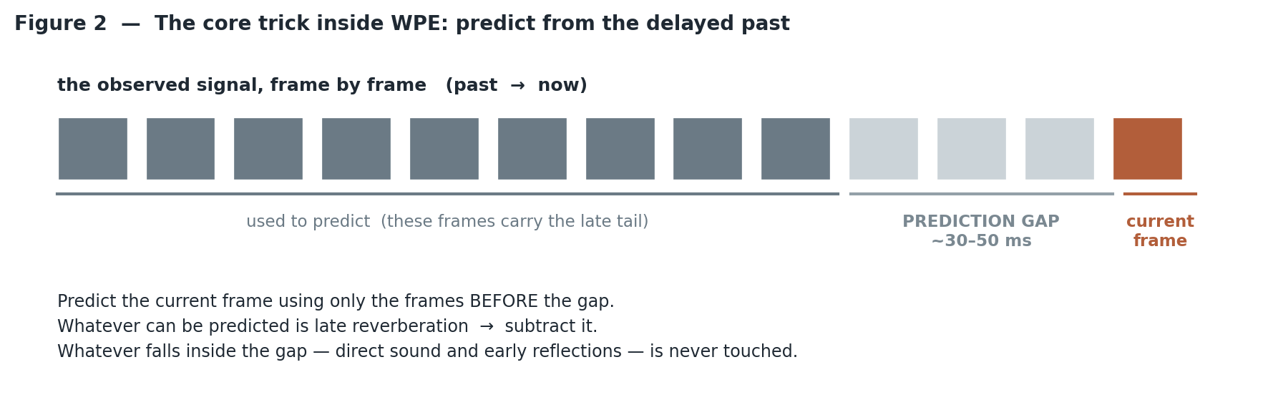
Figure 2 — The prediction delay. Everything inside the gap is protected; everything before it is treated as the source of the late tail.

The "weighted" part, and why it is needed
Speech power swings enormously — a vowel can be a thousand times louder than a pause. If you fitted the prediction filter by ordinary least squares, the loud vowels would dominate the fit completely and the filter would be a poor description of the room. WPE instead divides each frame error by an estimate of the clean speech power in that frame, so a quiet frame counts as much as a loud one. That is what the word weighted refers to, and it is what makes the filter estimate accurate.

The circularity, and how it is resolved
The weights need the clean speech power, but the clean speech is exactly what we are trying to compute. WPE resolves this by iterating:
- Assume the clean power is roughly the observed power. This is the starting guess.
- Estimate the prediction filters using those weights.
- Subtract the prediction from the observation to get an estimated clean signal.
- Recompute the clean power from the result of step 3.
- Return to step 2. Three passes are usually enough; it converges quickly.

Properties and settings
WPE works per frequency band in the short-time Fourier domain, requires no training data at all, and handles one microphone or many — the multi-microphone version is noticeably stronger. Because it is a linear filter, it introduces essentially no artifacts. It does not remove all the reverberation, but what it does remove, it removes cleanly.
Typical settings for 16 kHz speech with a 32 ms window and 8 ms hop: prediction delay of 3 frames, filter length of 10 to 15 taps in a small room and 30 to 40 in a large one, and 3 iterations. The reference implementation is nara_wpe in Python, with both offline and streaming versions; it is also built into the ESPnet, SpeechBrain and Asteroid pipelines.

6. Measuring whether it worked
Do not trust your ears alone, and do not trust any single number.
Metric | Needs a clean reference? | What it tells you
SRMR | No | Reverberation-specific quality. Usable on real recordings where no clean version exists.
PESQ | Yes | Predicted perceived quality, on a scale of roughly 0.5 to 4.5.
STOI / ESTOI | Yes | Predicted intelligibility, 0 to 1.
Cepstral distance | Yes | Spectral distortion. Sensitive to processing artifacts.
DRR | Needs the RIR | Direct-to-reverberant energy ratio.
C50 | Needs the RIR | Energy before 50 ms against energy after. The closest of these to intelligibility.
Word error rate | Needs transcripts | The only number that matters if the output feeds a recogniser.

The trap to know about
A method can improve PESQ while making word error rate worse. It smooths the signal in ways a quality metric rewards but which destroy the fine cues an acoustic model relies on. If the consumer of your audio is a machine, evaluate on the machine task, not on a listening score.

7. Choosing a method
Your situation | Start with
Microphone array, output feeds a recogniser | WPE followed by an MVDR beamformer. This is the standard baseline and it is strong.
Single microphone, real-time, tight compute | A lightweight neural mask (small recurrent or convolutional-recurrent net); spectral suppression if compute is very tight.
Single microphone, offline, quality is everything | A diffusion-based generative enhancer.
Very strong reverberation (RT60 above 0.8 s) | Generative model — masking approaches run out of headroom.
A human will listen to the result | Process mildly. Artifacts annoy people more than moderate reverberation does.
You have no training data | WPE. It needs none.

8. Practical pitfalls
- Over-processing. Removing the early reflections along with the tail makes speech thin and distant. Protect the first 50 ms.
- Training and deployment mismatch. A model trained only on simulated rectangular rooms generalises poorly to real ones. Mix measured impulse responses into training — BUT ReverbDB, ACE, the MIT survey, dEchorate.
- Ignoring noise. Real rooms have reverberation and noise together. A dereverberator on its own often makes the remaining noise more audible; plan a joint approach.
- Fixed inverse filters. Anything precomputed for one geometry breaks the moment someone moves. Re-estimate continuously.
- Metric tunnel vision. Optimise for the actual downstream task, not for whichever score is easiest to move.
- Discarding phase. Magnitude-only methods leave the phase smeared and cap the quality you can reach. Complex-domain or waveform-domain methods do better.

9. Tools worth knowing
Tool | What it is for
nara_wpe | Reference WPE implementation, in NumPy and TensorFlow; offline, block-online and frame-online variants.
pyroomacoustics | Simulate rooms and generate impulse responses for building training data.
SpeechBrain, Asteroid, ESPnet-SE | Pretrained enhancement models and reproducible training recipes.
ESPnet (enh module) | A PyTorch DNN-WPE implementation you can train with and export to ONNX.
pesq, pystoi, pysepm | Evaluation metrics.
REVERB Challenge, WHAMR! | Standard benchmark datasets, so results can be compared fairly.

Part II — Open source projects for dereverberation on Android

10. The honest starting point
There is no mature open source project whose purpose is dereverberation on Android. Nothing on the platform is the equivalent of what RNNoise is for noise. This is worth stating plainly at the outset, because searching for one will waste your time.
What does exist splits into two groups that do not overlap:
- Projects that ship as working Android libraries. Almost all of them are noise suppressors. They reduce reverberation somewhat as a side effect, because their models were trained on data that included reverberant speech, but that is not what they were built to do and they will not remove a strong room tail.
- Projects that genuinely do dereverberation. These are Python or desktop C++ research code. None of them ships an Android build. Getting one onto a phone is a porting job you do yourself.
So the practical question is not "which Android dereverberation library should I use" but "how much reverberation reduction can I get from something that already runs, and is the gap worth the porting work". The rest of this document answers that.
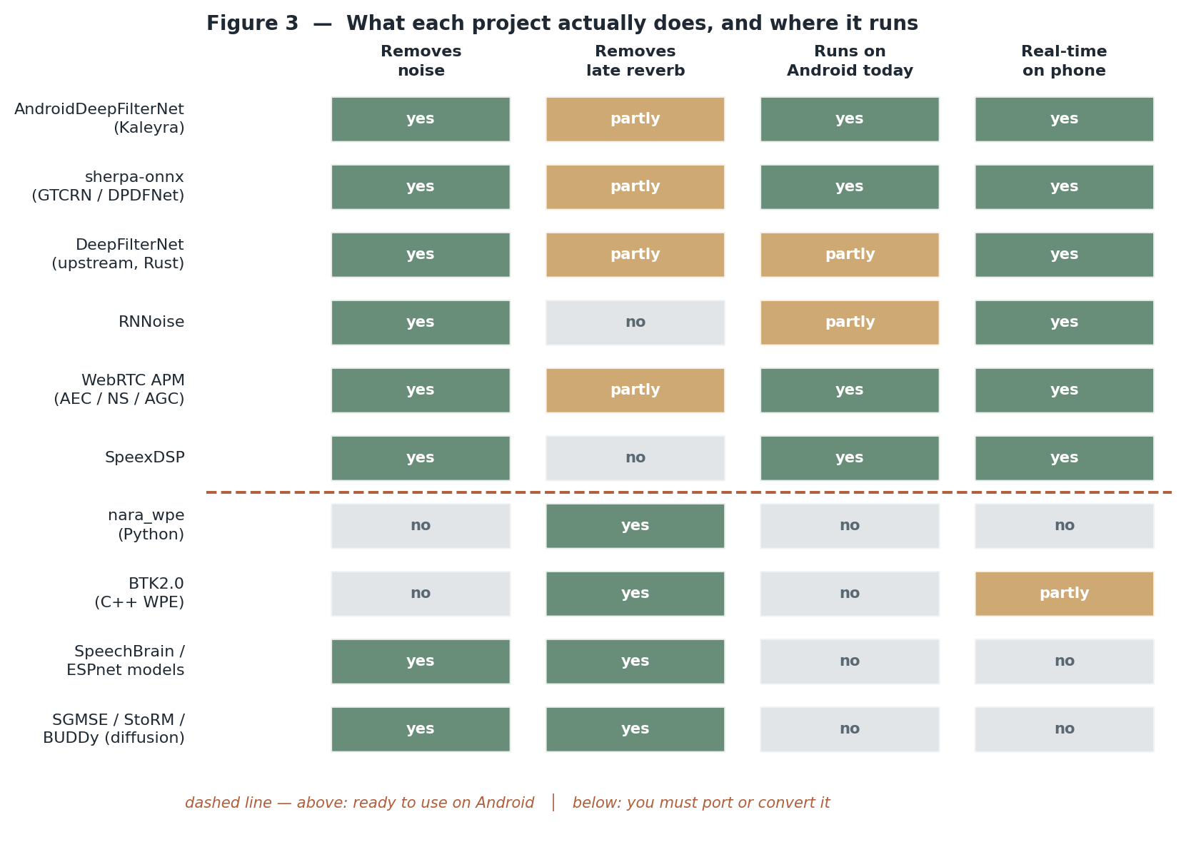
Figure 3 — The landscape. Note that the two useful columns rarely line up in the same row.

11. Why a denoiser helps with reverberation at all
It is fair to ask why a noise suppressor does anything to an echo. The reason is in how these models were trained. Modern speech enhancement datasets are built by convolving clean speech with room impulse responses and then adding noise, so the network learns to output something close to the direct-path speech given an input that is both noisy and reverberant. Reverberation reduction is therefore in the training objective even when the project describes itself as noise suppression.
What you get in practice from that side effect:
Room condition | What a good denoiser gives you
Dry room, RT60 under 0.3 s | Noise gone, and the small amount of reverberation present is largely cleaned up. This is usually sufficient.
Typical office or living room, 0.3 to 0.5 s | Noise gone, speech noticeably clearer, but the tail is still audible and a recogniser will still lose accuracy.
Hall, church, large hard-surfaced room, over 0.8 s | Little help. The model was not built for this and the tail dominates. You need real dereverberation.

The single most useful test before you build anything
Record ten seconds in your actual target room, run it through one of the ready-made libraries in section 12, and listen. If the result is good enough, stop there — you have saved yourself weeks. The porting work in section 13 is only justified when this test fails.

12. Ready to use on Android today
These have working Android builds or bindings. Listed in the order I would try them.
AndroidDeepFilterNet
github.com/KaleyraVideo/AndroidDeepFilterNet — Android library with JNI bindings around DeepFilterNet.
This is the closest thing to a drop-in answer. It wraps the DeepFilterNet neural noise suppressor with JNI bindings for efficient integration with native Android code, and it is packaged for Gradle. It supports Android API level 21 and above, and it works on 48 kHz mono 16-bit PCM. You can either bundle the model inside the library, which makes the app self-contained but larger, or have the model downloaded on demand at initialisation to keep the initial app size down.
Getting it onto Android: Add the Maven coordinate to your app build.gradle and pick the bundled or on-demand variant. There is nothing to compile yourself.
Watch out for: It is a noise suppressor. Expect meaningful improvement in a normal room and disappointment in a hall. Also note the fixed 48 kHz mono format — if your pipeline is 16 kHz you will be resampling in both directions.
sherpa-onnx
github.com/k2-fsa/sherpa-onnx — offline speech toolkit with a prebuilt Android AAR.
A broad on-device speech toolkit built on ONNX Runtime, covering speech-to-text, text-to-speech, VAD, source separation and speech enhancement, with no internet connection required. For our purposes the relevant part is its speech enhancement support, which offers two model families, GTCRN and DPDFNet, through both an offline API for a complete recording and an online API for streaming chunks. Android is a first-class supported platform alongside iOS, Raspberry Pi and several NPU targets.
Getting it onto Android: Use the published Android AAR, then download a model such as gtcrn_simple.onnx from the project speech-enhancement-models release. The offline call takes a float sample buffer and a sample rate and hands back denoised samples; the streaming call processes a chunk at a time with a flush at the end.
Watch out for: Again these are denoisers rather than dereverberators. The upside over the previous entry is that you get streaming and offline in one library, plus VAD and ASR if you need them, which usually you do.
DeepFilterNet (upstream)
github.com/Rikorose/DeepFilterNet — the original Rust and Python implementation.
The project the Android wrapper above is built on. It predicts a short filter applied across neighbouring time-frequency bins rather than predicting clean speech directly, which is why it runs in real time at full 48 kHz bandwidth on modest hardware. The repository contains the training framework, pretrained weights, a Rust core library, a command-line tool and a LADSPA plugin.
Getting it onto Android: Only worth going to directly if you need a newer model than the wrapper ships, or want to retrain. You would build the Rust core for the Android NDK targets yourself.
Watch out for: The upstream project targets desktop and PipeWire use. Nothing here is Android-specific, so you inherit the whole cross-compilation problem that the Kaleyra wrapper already solved.
WebRTC audio processing (APM)
The audio processing module from WebRTC — present in the AOSP tree under external/webrtc, and packaged standalone as webrtc-audio-processing.
Acoustic echo cancellation, noise suppression, automatic gain control and voice activity detection, in well-tested C++ that has run on billions of devices. The echo canceller in particular models a decaying tail, so it is not naive about reverberation, but its job is removing the far-end signal, not the near-end talker room.
Getting it onto Android: Build the standalone library for the NDK, or use one of the existing Android ports. This is the lowest-risk, lowest-compute option.
Watch out for: It will not dereverberate the talker. Treat it as the hygiene layer beneath whatever else you do, not as a solution.
RNNoise
github.com/xiph/rnnoise — a very small recurrent noise suppressor in C.
A tiny hybrid of classical signal processing and a small recurrent network, operating at 48 kHz. It is fast enough to be almost free, and it is trivially portable because it is plain C with no dependencies.
Getting it onto Android: Drop the C sources into your NDK build. There is no model file to manage.
Watch out for: It does noise only. It has no dereverberation behaviour worth speaking of, so include it only as a cheap baseline or as a first stage before something else.
DPDFNet and GTCRN (the model repositories)
The upstream repositories behind the sherpa-onnx enhancement models. DPDFNet extends DeepFilterNet2 with dual-path recurrent blocks for stronger long-range temporal and cross-band modelling, and publishes PyTorch code, checkpoints, ONNX and TFLite models with inference code, and a real-time demo.
Relevant if you would rather run the model yourself through ONNX Runtime or LiteRT than take the whole sherpa-onnx dependency, or if you want to fine-tune on your own reverberant data.
Getting it onto Android: Take the exported ONNX or TFLite file and load it with ONNX Runtime Android or LiteRT. Check which sample rate variant you are using — there are separate 16 kHz and 48 kHz models.
Watch out for: You are now responsible for the framing, buffering and state handling that sherpa-onnx would have done for you. Budget more integration time than you expect.
System-wide modules for rooted devices
Several Magisk / KernelSU / APatch modules exist that install RNNoise, DTLN or DeepFilterNet as a system audio pre-processing effect, with a web interface for configuration.
These apply enhancement to the microphone path for every app on the device rather than inside one app. Useful for improving calls and recordings generally.
Getting it onto Android: Flash the module on a rooted device.
Watch out for: Requires root, which rules it out for anything you intend to ship. Treat it as a way to experiment, not as a product path.

13. Real dereverberation — but you must port it
These do the thing you actually asked about. None of them runs on Android as published.
nara_wpe
github.com/fgnt/nara_wpe — the reference implementation of Weighted Prediction Error dereverberation.
The one to know. It implements the WPE family described in Yoshioka and Nakatani 2012: iterative offline WPE, block-online WPE and recursive frame-online WPE. The algorithms are implemented in NumPy and in TensorFlow. It needs no training data at all, works with one microphone or several, and because it is a linear filter it introduces essentially no artifacts.
Getting it onto Android: Two realistic routes. Either run it off-device — on a server or in a Python worker — and send audio to it, which is what most people should do. Or port the core prediction loop to C++ for the NDK; it is a few hundred lines of linear algebra over STFT frames, so this is genuinely feasible, and the C++ implementation in BTK2.0 below is a better starting point than the Python.
Watch out for: The published online variant was reported by users to be far too slow for real-time use, so do not assume the streaming mode is deployable as-is. Also note it is NumPy and TensorFlow, not PyTorch — if you saw otherwise in my earlier document, that was wrong.
BTK2.0 (Beamforming Toolkit)
distantspeechrecognition.sourceforge.io — the distant speech recognition toolkit.
Implements single-channel and multi-channel WPE in the subband domain, and it explicitly differs from nara_wpe in two ways that matter here: it offers a proper multi-rate filter bank as an alternative to plain overlap-add STFT, and the core WPE processing is implemented in C++ rather than Python, which makes it substantially faster.
Getting it onto Android: The C++ core is the most realistic base for an NDK port of WPE. Extract the dereverberation module rather than trying to build the whole toolkit.
Watch out for: The project is old and its build system shows it. Expect to spend time on dependencies before you get to the audio.
jhu-neural-wpe
github.com/sas91/jhu-neural-wpe — neural network based spectrum estimation for online WPE.
An open implementation of the Kinoshita 2017 method, in which a small network predicts the power spectrum that WPE needs for its weights, replacing the iterative estimate and making the method causal. The WPE filtering code is derived from nara_wpe.
Getting it onto Android: Reference material rather than a deployment target — it uses Chainer, which is no longer maintained. Reimplement the idea against your own runtime.
Watch out for: Do not plan to run this framework on a device. Read it, take the design, rewrite it.
ESPnet and SpeechBrain
The two main open speech toolkits. ESPnet contains a PyTorch DNN-WPE implementation inside its enhancement module; SpeechBrain publishes pretrained enhancement models on Hugging Face, for example speechbrain/mtl-mimic-voicebank, a 16 kHz single-channel enhancement model that can be used on its own or as an ASR front end.
This is where you go if you want to train or fine-tune a model specifically for dereverberation rather than accept a general denoiser. Both toolkits have recipes, and both can export to ONNX.
Getting it onto Android: Train or fine-tune on reverberant data — WHAMR! or the REVERB Challenge set — export to ONNX, then run with ONNX Runtime Android. This is the only realistic path to a genuine on-device dereverberator today.
Watch out for: The published SpeechBrain enhancement checkpoints were trained on Voicebank and DEMAND, which is a noise corpus. Using them as dereverberators without retraining on reverberant data will disappoint you.

14. Excellent research code that will not run on a phone
The diffusion-based methods — SGMSE, StoRM, BUDDy and their relatives from the Hamburg group — produce the best dereverberation results currently available, and their code and audio examples are public. They are also completely impractical on a device: each output requires many passes of a neural network rather than one, so you are looking at seconds of compute per second of audio even on a desktop GPU.
Use them as a quality ceiling to compare against, or run them server-side for offline processing where latency does not matter. Do not plan a mobile product around them.

15. Supporting pieces you will need either way
Component | Why you need it
Oboe | Google open source low-latency audio library wrapping AAudio and OpenSL ES. Use it for capture instead of the Java APIs, or your latency budget is gone before you start.
ONNX Runtime for Android | Ships as an AAR with NNAPI and XNNPACK execution providers. The path of least resistance for running any exported model.
LiteRT (formerly TensorFlow Lite) | The alternative runtime, worth using if your model is already a .tflite file — DPDFNet, for instance, publishes one.
pyroomacoustics | Simulates rooms and generates impulse responses using the image-source method. This is how you build reverberant training data if you go the training route.
Measured RIR datasets | BUT ReverbDB, the ACE Challenge set, the MIT survey and dEchorate. Mix real impulse responses into training or your model will only work in simulated rectangular rooms.
REVERB Challenge and WHAMR! | Standard evaluation sets, so your numbers mean something to someone else.

16. Three concrete paths
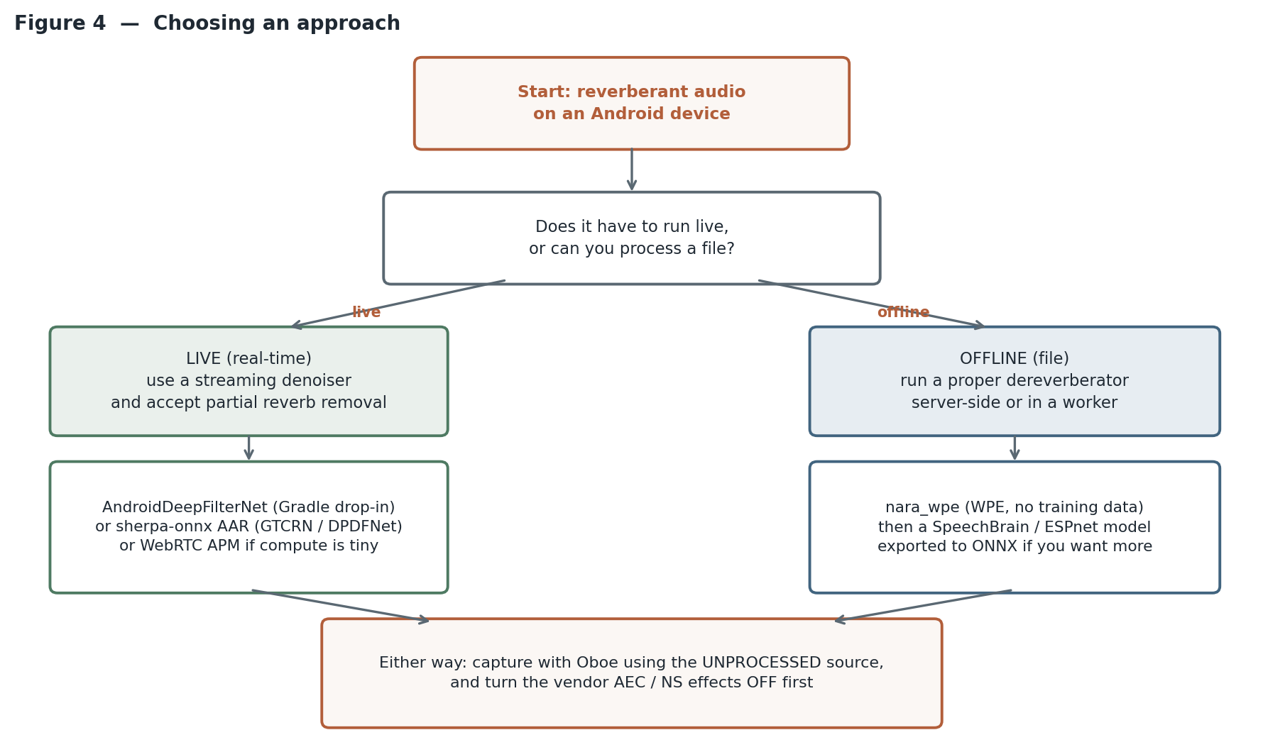
Figure 4 — The decision that actually determines your architecture is live versus offline, not which library is best.

Path A — Live audio, ship this week
- Capture with Oboe at the rate your model wants, using the UNPROCESSED audio source if the device reports supporting it.
- Disable the vendor AcousticEchoCanceler and NoiseSuppressor effects on the capture session so they are not fighting your processing.
- Run AndroidDeepFilterNet, or sherpa-onnx streaming enhancement if you also want VAD and ASR from the same library.
- Measure with SRMR on real recordings from your target rooms, since you will have no clean reference.
Expect: noise essentially gone, reverberation reduced but present. Good enough for most consumer applications in ordinary rooms.

Path B — Recordings you process afterwards
- Capture raw and unprocessed on the device. Do no enhancement there at all.
- Run nara_wpe on a server or in a Python worker. It needs no training data, adds no artifacts, and is the strongest thing you can deploy without a model.
- If quality still matters after that, follow WPE with a trained enhancement model, or with a diffusion model if you can afford the compute.
Expect: this is the best quality available to you, and by a wide margin. If your product can tolerate processing after the fact rather than during, take this path.

Path C — A genuine on-device dereverberator
- Generate training data: clean speech convolved with a mix of simulated impulse responses from pyroomacoustics and measured ones from the datasets above.
- Train a small masking or deep-filtering model in SpeechBrain or ESPnet. Use a reverberation-time-shortening target rather than a fully anechoic one — it is an easier target to learn and produces fewer artifacts.
- Export to ONNX, quantise, and run through ONNX Runtime Android with NNAPI or XNNPACK.
- Validate on WHAMR! or REVERB so your results are comparable, and on your own room recordings so they are relevant.
Expect: weeks of work, and a result that a general-purpose denoiser will not match in strong reverberation. This is the only route to something that genuinely dereverberates on the device, and there is no shortcut around it because nobody has published the artifact you would otherwise download.

17. Platform constraints that will bite you
- You usually cannot get the individual microphone signals. Android hands your app a processed mono or stereo stream that the vendor layer has already beamformed and cleaned. The strongest dereverberation methods are multi-microphone, so on a stock phone they are simply unavailable to you.
- Vendor pre-processing varies by device and fights yours. The android.media.audiofx effects are interfaces whose implementations come from the vendor HAL, so the same code behaves differently on different handsets. Query and disable what you can.
- Sample rate mismatches are a real cost. DeepFilterNet-derived models want 48 kHz; GTCRN and most ASR front ends want 16 kHz. Resampling twice per pipeline stage adds latency and can add artifacts.
- Latency accumulates quietly. STFT framing costs you the window length, any prediction delay costs more, and model lookahead costs more again. For transcription this rarely matters; for a live call it decides whether the product is usable.
- Thermal throttling is the constraint nobody benchmarks. A model that runs comfortably for thirty seconds may not after ten minutes of a video call.

If you control the hardware
Everything in constraint 1 disappears if you are building your own device and own the audio HAL, because then you decide how the microphone channels are exposed. That — and only that — is where the AOSP material in Appendix A becomes relevant. On a stock consumer phone it is not.

18. Why the AOSP material is in an appendix
An earlier draft of this briefing treated the phrase "open source Android" as meaning the Android Open Source Project, and covered its licensing, its build process and the distributions derived from it. That was the wrong subject for this problem. For anyone writing an app, AOSP is not a lever you can pull: you get the audio stream the platform gives you, and the projects in this part are what you have to work with.
It is kept as Appendix A because of the one case where it does matter, described in the callout above. If you are building your own hardware and own the audio HAL, you decide how the microphone channels are exposed, and multi-microphone dereverberation becomes available to you. In that situation the appendix stops being background and becomes the plan.

Part III — Notable papers
Thirty papers that shaped the field, grouped by the line of thinking they belong to. The summaries below are written in plain language for this document; they are not the published abstracts. They are meant to tell you whether a paper is worth your time and what idea you would take from it. Read the original for the details, and treat any specific number reported in a paper as belonging to that paper test conditions rather than as a general fact.
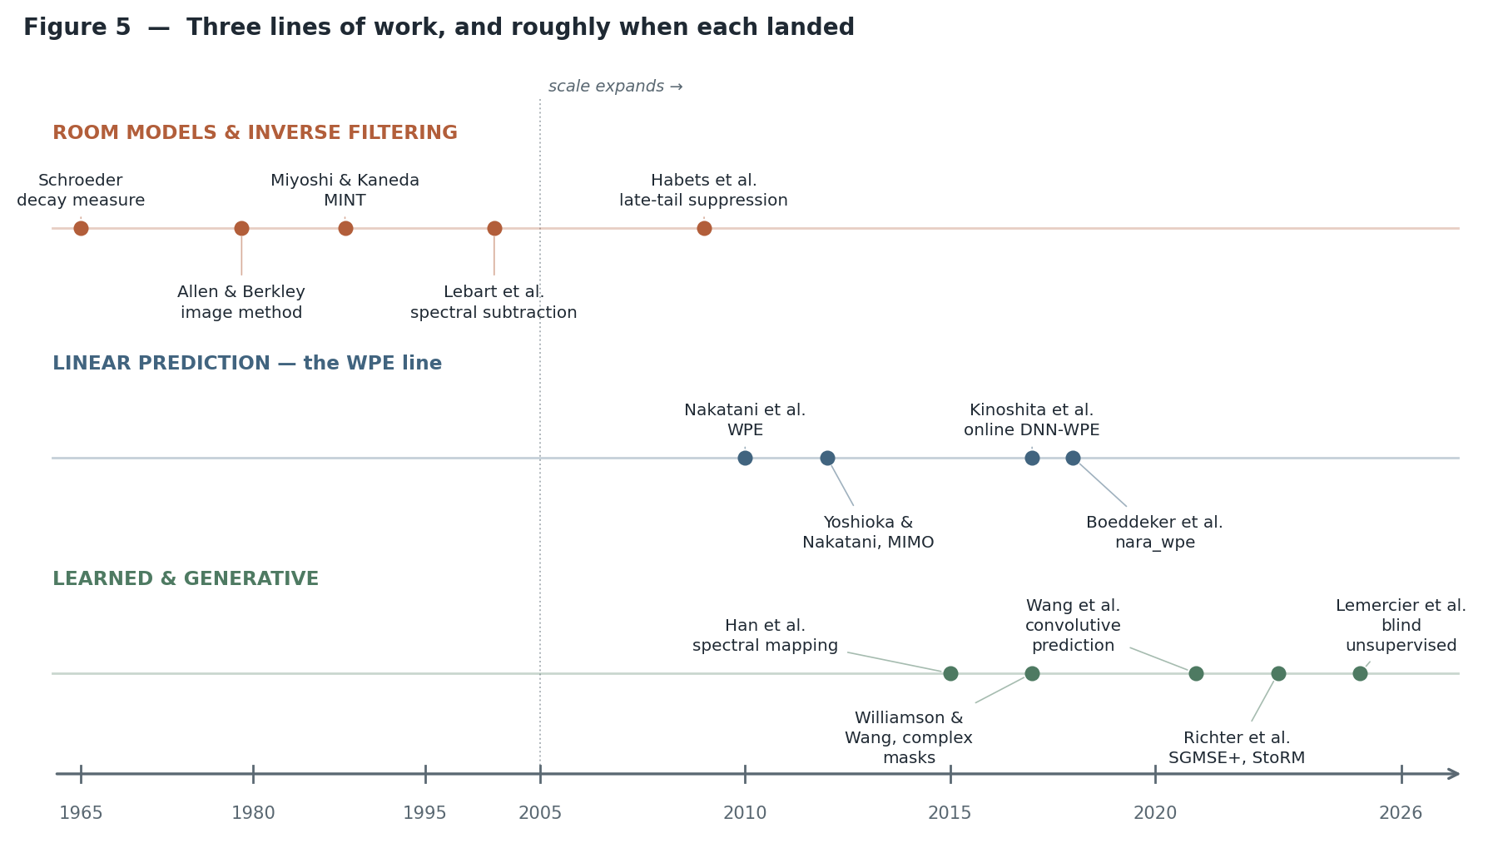
Figure 5 — The three research lines. They overlap in time rather than replacing one another; the best current systems combine all three.

How to use this list
The field has three distinct lines of thinking, and they did not replace each other. The oldest line models the room and tries to undo it. The second line gives up on knowing the room and exploits the statistical predictability of the reverberant tail. The third learns what clean speech looks like from data. Modern systems stack all three, so it is worth reading at least one paper from each line rather than only the newest ones.
If you read only five, read these:
- Nakatani et al. 2010 (entry 6) — the WPE method, still the strongest thing you can run without training data.
- Allen & Berkley 1979 (entry 2) — the image method, which is how essentially all training data gets simulated.
- Kinoshita et al. 2016 (entry 14) — the REVERB Challenge summary, which defines how the field measures itself.
- Richter et al. 2023 (entry 22) — the diffusion-based generative approach, the current quality ceiling.
- Haeb-Umbach et al. 2024 (entry 30) — a recent overview that explains how the classical and learned halves are being combined.

A. Foundations: modelling the room and trying to undo it
1. New Method of Measuring Reverberation Time
M. R. Schroeder. Journal of the Acoustical Society of America, 1965. Related: "Complementarity of Sound Buildup and Decay", JASA 1966.
Why it matters: Every RT60 number you will ever quote is measured this way.
Before this, reverberation time was measured by firing a noise burst and watching the decay, which is noisy and needs averaging over many trials. Schroeder showed that integrating the impulse response backwards in time gives the ensemble-average decay curve directly, from a single measurement. The resulting "Schroeder curve" is what every room-acoustics tool plots, and fitting a line to it is how RT60 is obtained.
2. Image Method for Efficiently Simulating Small-Room Acoustics
J. B. Allen and D. A. Berkley. Journal of the Acoustical Society of America, 65(4), 1979.
Why it matters: This is how almost all reverberant training data is generated, to this day.
The paper gives a simple way to compute the impulse response of a rectangular room: instead of tracing reflections, place mirror-image copies of the source outside each wall, then again outside those, and sum their direct paths with an attenuation for each wall bounce. It is fast, it is easy to implement, and it is exactly what pyroomacoustics and every other room simulator does under the hood. Its known weakness — that real rooms are not rectangular and real walls are not frequency-flat — is precisely why models trained only on simulated rooms generalise poorly.
3. Inverse Filtering of Room Acoustics
M. Miyoshi and Y. Kaneda. IEEE Transactions on Acoustics, Speech and Signal Processing, 36(2), 1988. Known as MINT (Multiple-input/output INverse Theorem).
Why it matters: The formal answer to "can you just invert the room?" — and the conditions under which you can.
A single room response usually cannot be inverted stably, because it is non-minimum-phase. Miyoshi and Kaneda proved that with several microphones, the responses can be jointly inverted exactly, provided they share no common zeros. This is a genuinely important theoretical result, and it also explains the practical disappointment: the exact inverse depends on knowing the responses precisely, and it collapses when the geometry changes even slightly. Nearly all later work can be read as a response to this fragility.
4. A New Method Based on Spectral Subtraction for Speech Dereverberation
K. Lebart, J. M. Boucher and P. N. Denbigh. Acta Acustica united with Acustica, 87, 2001.
Why it matters: The first practical single-microphone method, and the ancestor of every suppression-based approach.
Rather than trying to identify the room, this treats the late tail as a kind of self-generated noise whose power can be predicted from the signal own recent past using a statistical model of exponential decay. You estimate that power, then subtract it in the spectral domain exactly as a noise suppressor would. It needs only RT60 as a parameter and one microphone, which made it deployable long before anything else was. It also introduced the characteristic failure mode of the family: musical noise.
5. Late Reverberant Spectral Variance Estimation and Suppression of Reverberant Speech
E. A. P. Habets, S. Gannot and I. Cohen. IEEE Transactions on Audio, Speech and Language Processing, 17(6), 2009.
Why it matters: Made the suppression family properly rigorous, and formalised the early-versus-late split.
Habets and colleagues put the Lebart-style idea on a firmer statistical footing, deriving better estimators of the late reverberant power that account for the direct-to-reverberant ratio and do not assume the talker distance is fixed. Just as importantly, this line of work made explicit the distinction between early reflections, which should be preserved, and the late tail, which should be suppressed — the idea that underpins the prediction delay in WPE and the training targets used in modern neural systems.
6. Speech Dereverberation (book)
P. A. Naylor and N. D. Gaubitch (editors). Springer, 2010.
Why it matters: The standard reference for everything before the deep-learning era.
A collected volume covering room acoustics models, measurement and evaluation, inverse filtering, spectral suppression and multichannel methods, written by the people who developed them. If you want one place to understand the pre-2012 landscape properly rather than through later papers’ summaries of it, this is it. The chapter on models, measurement and evaluation is still the clearest treatment of what the various metrics actually measure.

B. Linear prediction: the WPE line
7. Speech Dereverberation Based on Variance-Normalized Delayed Linear Prediction
T. Nakatani, T. Yoshioka, K. Kinoshita, M. Miyoshi and B.-H. Juang. IEEE Transactions on Audio, Speech and Language Processing, 18(7), pp. 1717–1731, 2010. This is the WPE paper.
Why it matters: The single most important classical method, and still a live component of state-of-the-art systems.
The insight is that the late tail is predictable from the observed signal a few frames earlier, while the direct sound is not. So you fit a prediction filter, skip a deliberate delay so the early reflections are protected, and subtract what the filter predicts. The "variance-normalized" part is the second contribution: weighting each frame by the inverse of the estimated clean speech power stops loud vowels from dominating the fit, which is what makes the estimate accurate. It needs no training data, adds essentially no artifacts because it is linear, and works with one microphone or many.
8. Generalization of Multi-Channel Linear Prediction Methods for Blind MIMO Impulse Response Shortening
T. Yoshioka and T. Nakatani. IEEE Transactions on Audio, Speech and Language Processing, 20(10), 2012.
Why it matters: The theoretical tidy-up that explains why the WPE family works and how far it extends.
This paper puts several multichannel linear prediction methods into one framework and shows what they are really doing: shortening the effective impulse response rather than inverting it. That reframing matters, because impulse-response shortening is a well-posed goal where exact inversion is not. It also covers the multiple-input multiple-output case, which is the setting for microphone arrays and for joint dereverberation and separation.
9. Neural Network-Based Spectrum Estimation for Online WPE Dereverberation
K. Kinoshita, M. Delcroix, H. Kwon, T. Mori and T. Nakatani. Interspeech, 2017. See also J. Heymann et al., "Frame-Online DNN-WPE Dereverberation", IWAENC 2018, and their joint-training work at ICASSP 2019.
Why it matters: The bridge between the classical and neural halves of the field.
WPE needs an estimate of the clean speech power spectrum to compute its weights, and traditionally gets it by iterating. This work replaces that iteration with a small neural network that predicts the power spectrum directly, which both improves the estimate and makes the method run causally in a streaming setting. The follow-up work trains that network jointly with the downstream acoustic model, so the dereverberation stage is optimised for recognition accuracy rather than for signal quality. This hybrid pattern — a classical filter with a learned parameter estimator — is now everywhere.
10. NARA-WPE: A Python Package for Weighted Prediction Error Dereverberation
C. Boeddeker, L. Drude, J. Heitkaemper, J. Heymann and R. Haeb-Umbach. ITG Conference on Speech Communication, 2018.
Why it matters: The reference implementation. If you are going to run WPE, you will probably run this.
Not a new algorithm but an open-source, carefully validated implementation of the WPE family in NumPy and PyTorch, with both offline and streaming variants and reproduction of the original results. Its practical value is hard to overstate: it turned WPE from a method described in a paper into a component people actually deploy, and it is embedded in ESPnet, Asteroid and several challenge baselines.
11. Convolutive Prediction for Monaural Speech Dereverberation and Reverberant Speaker Separation
Z.-Q. Wang, G. Wichern and J. Le Roux. WASPAA 2021 and IEEE/ACM TASLP, 2021.
Why it matters: Brings the linear-prediction idea inside a neural system, rather than bolting it on in front.
The idea is to have a network produce an initial estimate of the direct-path speech, then use linear prediction against that estimate to model and cancel the reverberation, then feed the result back. Because the prediction is computed against a learned target rather than the raw mixture, it sidesteps the weighting problem WPE solves by iteration. This works for single-microphone input, which is where classical multichannel prediction cannot help, and it extends naturally to separating several reverberant talkers.

C. Benchmarks, datasets and evaluation
12. A Summary of the REVERB Challenge: State-of-the-Art and Remaining Challenges
K. Kinoshita, M. Delcroix, S. Gannot, E. A. P. Habets, R. Haeb-Umbach, W. Kellermann, V. Leutnant, R. Maas, T. Nakatani, B. Raj, A. Sehr and T. Yoshioka. EURASIP Journal on Advances in Signal Processing, 2016.
Why it matters: The benchmark that made results in this field comparable at all.
REVERB provided a common dataset with both simulated and real recordings, defined the evaluation conditions, and reported what a large number of submitted systems actually achieved on both signal quality and speech recognition. Its most useful contribution to a newcomer is the honest analysis of the gap between the two: systems that improved perceptual scores did not reliably improve recognition, and the paper says so plainly. Read it before designing your own evaluation.
13. Estimation of Room Acoustic Parameters: The ACE Challenge
J. Eaton, N. D. Gaubitch, A. H. Moore and P. A. Naylor. IEEE/ACM TASLP, 24(10), pp. 1681–1693, 2016.
Why it matters: Defines the sub-problem of estimating RT60 and direct-to-reverberant ratio blindly, which many methods depend on.
Several dereverberation methods need to know the reverberation time or the direct-to-reverberant ratio, and in deployment nobody hands you those. ACE benchmarked blind estimation of both from the reverberant signal alone, across a set of measured impulse responses and noise conditions. The dataset is also widely reused as a source of real impulse responses for building training data.
14. A Non-Intrusive Quality and Intelligibility Measure of Reverberant and Dereverberated Speech
T. H. Falk, C. Zheng and W.-Y. Chan. IEEE TASLP, 18(7), 2010. This is the SRMR measure.
Why it matters: The metric you use when you have no clean reference — which is the case for all real recordings.
SRMR works from the modulation spectrum: clean speech has strong energy at the modulation rates corresponding to syllables, and reverberation fills in the higher modulation frequencies. The ratio between the two bands gives a quality score without needing a clean version of the same utterance. It is imperfect and can be gamed by heavy smoothing, but it is the standard non-intrusive measure and it is the only option on genuinely real data.
15. EARS: An Anechoic Full-Band Speech Dataset Benchmarked for Speech Enhancement and Dereverberation
J. Richter, Y.-C. Wu, S. Krenn, S. Welker, B. Lay, S. Watanabe, A. Richard and T. Gerkmann. Interspeech, 2024.
Why it matters: A modern, genuinely anechoic, full-bandwidth dataset — which the older benchmarks are not.
Most reverberant training data is built by convolving speech that was itself recorded in a room, so the "clean" target is not actually clean, and most datasets are limited to 16 kHz. EARS provides anechoic recordings at full bandwidth from many speakers, with benchmarks for both enhancement and dereverberation. If you are training a generative model, where the quality of the target directly caps what you can produce, this matters a great deal.
16. The Interspeech 2025 URGENT Speech Enhancement Challenge
K. Saijo, W. Zhang, S. Cornell, R. Scheibler, C. Li, Z. Ni, A. Kumar, M. Sach, Y. Fu, W. Wang, T. Fingscheidt and S. Watanabe. Interspeech, 2025.
Why it matters: The current benchmark, and it deliberately treats dereverberation as one distortion among many.
URGENT evaluates systems that must handle noise, reverberation, bandwidth limitation, clipping and codec artifacts together, across languages and sampling rates, rather than one degradation at a time. That is much closer to real deployment. It is also where a live methodological argument is playing out: the challenge uses early-reflected speech as the clean reference, while several strong recent systems train against time-shifted anechoic speech, and the mismatch between those two definitions of "clean" measurably affects the scores.

D. The deep-learning era
17. Learning Spectral Mapping for Speech Dereverberation and Denoising
K. Han, Y. Wang, D. Wang, W. S. Woods, I. Merks and T. Zhang. IEEE/ACM TASLP, 23(6), 2015.
Why it matters: The paper that established the basic supervised recipe the whole field then built on.
Train a network on pairs of reverberant and clean spectrograms and have it output the clean magnitude directly. That framing seems obvious now, but it was the demonstration that a learned mapping could outperform carefully designed statistical suppressors, and it set the template for training data generation by convolution with simulated impulse responses. Its limitation — that it predicts magnitudes only and reuses the reverberant phase — is what the next entry addresses.
18. Time-Frequency Masking in the Complex Domain for Speech Dereverberation and Denoising
D. S. Williamson and D. Wang. IEEE/ACM TASLP, 25(7), 2017.
Why it matters: Showed that phase matters, and gave a practical way to estimate it.
Magnitude-only methods leave the phase smeared by the room, which puts a ceiling on achievable quality. This work predicts a complex ratio mask — real and imaginary parts — so the network corrects magnitude and phase together. The gain is consistent and the change is cheap, and complex-domain output is now the default rather than the exception. It also quantifies how much of the remaining error in magnitude-only systems was phase all along.
19. A Reverberation-Time-Aware Approach to Speech Dereverberation Based on Deep Neural Networks
B. Wu, K. Li, M. Yang and C.-H. Lee. IEEE/ACM TASLP, 25(1), pp. 102–111, 2017.
Why it matters: Makes the point that one model for all rooms is a compromise, and does something about it.
A network trained across all reverberation times learns an average behaviour that is too aggressive for dry rooms and too timid for wet ones. This work conditions the model on an estimate of the reverberation time, effectively selecting the right behaviour per room. The idea recurs constantly in later work under different names — conditioning on acoustic parameters, adaptive target control — and it is one of the cheapest reliable improvements available.
20. Speech Dereverberation with a Reverberation Time Shortening Target
R. Zhou, W. Zhu and X. Li. ICASSP 2023 (arXiv 2022).
Why it matters: Argues that the training target has been wrong, which is a more consequential claim than it sounds.
Most systems are trained to output either fully anechoic speech or direct-plus-early-reflections. Both are hard: the first asks the network to invent information the room destroyed, the second is ambiguous about where "early" ends. This paper proposes targeting a shortened reverberation time instead — keep the room, just make it drier. The task becomes easier to learn, the artifacts reduce, and downstream recognition improves. Target design is now recognised as being as important as architecture, and this is the clearest statement of why.
21. TF-GridNet: Integrating Full- and Sub-Band Modeling for Speech Separation
Z.-Q. Wang, S. Cornell, S. Choi, Y. Lee, B.-Y. Kim and S. Watanabe. IEEE/ACM TASLP, 31, pp. 3221–3236, 2023.
Why it matters: The architecture that became the default strong backbone for reverberant speech tasks.
Nominally a separation model, but it is the backbone many dereverberation and enhancement systems now use. It alternates modelling along frequency within a time frame and along time within a frequency band, which lets it capture both the harmonic structure of speech and the long temporal decay of reverberation without an unmanageable parameter count. When a recent paper reports a strong discriminative baseline, this is often what it is.
22. Deep Filtering and Efficient Real-Time Dereverberation on Edge Devices
Representative of the DeepFilterNet line: H. Schröter et al., DeepFilterNet (ICASSP 2022 and follow-ups), with recent efficiency-focused variants published through 2025.
Why it matters: The practical answer when the model has to run on a phone rather than a server.
Instead of predicting the clean signal directly, these systems predict a short linear filter applied across neighbouring time-frequency bins. That is a much smaller thing to learn, it handles the temporal spreading of reverberation naturally, and it runs in real time on modest hardware. If you are building the on-device pipeline in Part III, this family is the realistic starting point rather than anything diffusion-based.

E. Generative models: the current frontier
23. Speech Enhancement and Dereverberation with Diffusion-Based Generative Models
J. Richter, S. Welker, J.-M. Lemercier, B. Lay and T. Gerkmann. IEEE/ACM TASLP, 31, pp. 2351–2364, 2023. Known as SGMSE+; builds on Welker et al., Interspeech 2022.
Why it matters: The paper that made diffusion models a serious option here, and the current quality reference point.
The method runs a diffusion process in the complex short-time Fourier domain. The important design choice is that the reverse process does not start from pure noise: it starts from a mixture of the degraded observation and noise, with a drift term pulling toward clean speech, which is what makes a small number of steps sufficient. The authors report strong results across datasets and, notably, better behaviour than discriminative models when tested on a corpus different from the training one — generalisation being the usual weakness of learned enhancement.
24. StoRM: A Diffusion-Based Stochastic Regeneration Model for Speech Enhancement and Dereverberation
J.-M. Lemercier, J. Richter, S. Welker and T. Gerkmann. IEEE/ACM TASLP, 31, pp. 2724–2737, 2023.
Why it matters: A clean answer to the two complementary failure modes of generative and discriminative models.
Generative models can invent breathing and vocalisation artifacts in hard conditions; discriminative models do not hallucinate but distort the speech instead. StoRM runs a discriminative model first and uses its output to guide the diffusion process, so the generative stage is repairing a reasonable estimate rather than constructing from scratch. This reduces both artifact types and cuts the number of diffusion steps needed. The "predict first, then refine generatively" pattern has been widely adopted since.
25. Diffusion Posterior Sampling for Informed Single-Channel Dereverberation
J.-M. Lemercier, S. Welker and T. Gerkmann. WASPAA, 2023.
Why it matters: Reframes dereverberation as a classical inverse problem with a learned prior, which is a genuinely different way in.
Rather than training a network on reverberant-clean pairs, this uses a diffusion model trained only on clean speech as a prior, and solves for the clean signal that is consistent with the observed reverberant recording given a known impulse response. The advantage is that the prior does not need to have seen your room, or any room. The limitation, addressed by the next two entries, is that it assumes the impulse response is available.
26. BUDDy: Single-Channel Blind Unsupervised Dereverberation with Diffusion Models
E. Moliner, J.-M. Lemercier, S. Welker, T. Gerkmann and V. Välimäki. IWAENC, 2024.
Why it matters: Removes the requirement to know the room, and the requirement for paired training data.
BUDDy jointly estimates the clean speech and a parametric model of the room response at inference time, alternating between refining the speech under a clean-speech diffusion prior and refining the room parameters to explain the observation. Nothing about the room is known in advance and no reverberant training data is used. This is a meaningful step because paired data is exactly what is hardest to obtain for real rooms.
27. Unsupervised Blind Joint Dereverberation and Room Acoustics Estimation with Diffusion Models
J.-M. Lemercier, E. Moliner, S. Welker, V. Välimäki and T. Gerkmann. IEEE Transactions on Audio, Speech and Language Processing, 33, pp. 2244–2258, 2025.
Why it matters: The journal-length development of the blind unsupervised approach, and a good snapshot of where the frontier sits.
This extends the BUDDy line with a fuller treatment: the method returns not only dereverberated speech but an estimate of the room acoustics themselves, which is useful in its own right for applications that need RT60 or a response for rendering. It also examines where the approach breaks down, which is the part worth reading closely if you are considering deploying anything in this family.
28. RVAE-EM: Generative Speech Dereverberation Based on Recurrent Variational Autoencoder and Convolutive Transfer Function
P. Wang and X. Li. ICASSP, 2024.
Why it matters: A non-diffusion generative alternative, and considerably cheaper to run.
This combines a recurrent variational autoencoder as the speech prior with an explicit convolutive transfer function model of the room, fitted by expectation-maximisation at inference time. It sits between the classical model-based methods and the diffusion approaches: there is a real acoustic model being estimated, but the speech prior is learned. Worth knowing about because diffusion is not the only generative option and the compute difference is substantial.
29. MetricGAN-U: Unsupervised Speech Enhancement and Dereverberation Based Only on Noisy or Reverberated Speech
S.-W. Fu, C. Yu, K.-H. Hung, M. Ravanelli and Y. Tsao. ICASSP, 2022.
Why it matters: Trains without any clean reference at all, by optimising a non-intrusive metric directly.
Instead of comparing against clean targets, the model is trained adversarially against a learned approximation of a non-intrusive quality measure such as SRMR — a score that can be computed on degraded audio alone. This makes training on real, unpaired recordings possible. The obvious risk is that you get whatever the metric rewards rather than what a listener wants, and the paper is reasonably candid about that trade-off.

F. Overviews worth reading before anything else
30. Microphone Array Signal Processing and Deep Learning for Speech Enhancement: Combining Model-Based and Data-Driven Approaches to Parameter Estimation and Filtering
R. Haeb-Umbach, T. Nakatani, M. Delcroix, C. Boeddeker and T. Ochiai. IEEE Signal Processing Magazine, 41(6), pp. 12–23, 2024.
Why it matters: The best single recent explanation of how the classical and learned halves fit together.
Written by several of the people responsible for the WPE line, this argues against treating classical array processing and neural networks as competing options. The productive structure, they argue, is a model-based filter whose parameters are estimated by a network — which is exactly what neural-WPE and mask-based beamforming are. If you only have time for one modern survey before choosing an architecture, choose this one.

Where to find these
Almost everything from 2015 onward is on arXiv, and the Gerkmann group at Hamburg (SGMSE, StoRM, BUDDy, EARS) publishes code and audio examples alongside their papers, which is by far the fastest way to hear what each method actually sounds like. The older IEEE journal papers are usually available through an institutional subscription; several of the authors also host preprints on their own pages.

Appendix A — The Android Open Source Project
Included for the case described in section 18: you are building your own device rather than an app, and therefore control the audio hardware abstraction layer. If that is not your situation, this appendix is background reading rather than anything actionable.

19. What AOSP is, in plain terms
The Android Open Source Project, universally shortened to AOSP, is the publicly released source code for the Android operating system. It is a complete, working operating system: it boots a phone, draws a screen, makes calls, runs apps, manages power and enforces security. Google develops it and publishes it, and anyone may take it, modify it, ship it on hardware and sell it without paying a fee and without being obliged to publish their own changes.
The reason it exists is deliberate. Google has stated that the project was created so there would always be an open platform available to carriers, manufacturers and developers, and so that no single company could restrict or control the innovation of any other. That framing matters, because it explains both the licence chosen and the tensions described further below.

20. What is inside it, and what is deliberately left out
This is the single most misunderstood point about Android. AOSP is the operating system. It is not the Google experience. The Play Store, Google Play Services, Gmail, Maps, YouTube, the Google app and the associated APIs are collectively called Google Mobile Services, or GMS. They are proprietary, they are not in AOSP, and they are licensed separately to manufacturers who meet Google conditions.
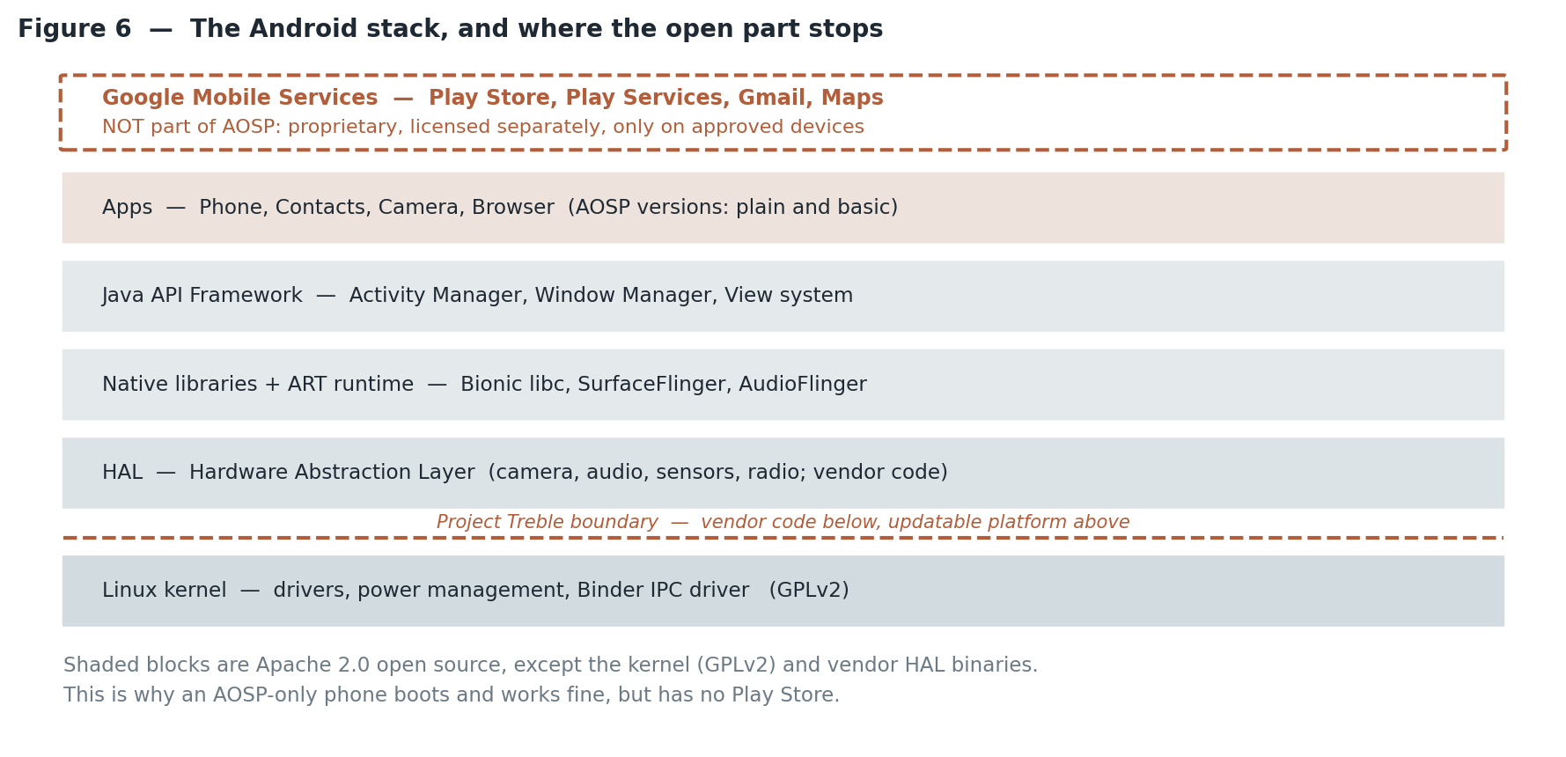
Figure 6 — The Android stack. Everything shaded is in AOSP; the dashed box on top is not.
Reading the stack from the bottom:
- Linux kernel — drivers, memory and power management, and the Binder driver that carries almost all inter-process communication on Android. Licensed GPLv2, because it is Linux.
- Hardware Abstraction Layer (HAL) — a defined set of interfaces the platform calls to reach the camera, audio path, sensors, radio and so on. Manufacturers and chip vendors supply the implementations, and these are frequently closed-source binaries.
- Native libraries and the ART runtime — Bionic (Android own C library), SurfaceFlinger for compositing the screen, AudioFlinger for mixing audio, the media framework, SQLite, and ART, which compiles and runs application code.
- Java API framework — the services applications talk to: Activity Manager, Window Manager, the View system, notifications, content providers, permissions.
- Apps — AOSP ships plain versions of Phone, Contacts, Camera, Messaging, Settings, a basic browser. They work, and they are deliberately unremarkable.
The practical consequence
An AOSP-only phone is a real, functioning phone. It just has no Play Store, no Google account integration, and no Play Services, so apps that depend on Google APIs for push notifications, maps or location fusion will misbehave. This gap is the central design problem for every de-Googled Android distribution.

21. Licensing, and why Apache 2.0 was chosen
Component | Licence | What it obliges you to do
Almost all of the platform | Apache 2.0 | Keep the notices. You may modify and ship without publishing your changes.
The Linux kernel | GPLv2 | Publish your kernel source changes when you distribute the binary.
Assorted third-party code | BSD, MIT, others | Varies; attribution at minimum.
Google Mobile Services | Proprietary | Requires a licence agreement with Google and passing compatibility testing.

The choice of Apache 2.0 for the userspace was strategic rather than incidental. A copyleft licence such as the GPL would have forced every manufacturer to publish their modifications, which would have made hardware partners far more reluctant to adopt the platform. Apache 2.0 lets a manufacturer differentiate privately. The visible result is that manufacturer skins — One UI, MIUI/HyperOS, ColorOS — contain large amounts of code the public never sees, while the kernel source, which is GPLv2, must be released and generally is.

22. How the code is organised and obtained
AOSP is not one Git repository. It is several hundred of them, held together by a tool called repo, which reads an XML manifest listing every repository and the branch each should be checked out at. Code review happens in Gerrit; anyone may submit a patch, and a Google reviewer must approve it before it merges.
# install the repo tool, then:
mkdir aosp && cd aosp
repo init -u https://android.googlesource.com/platform/manifest \
-b android-latest-release
repo sync -c -j8

# then build:
source build/envsetup.sh
lunch aosp_cf_x86_64_phone-trunk_staging-userdebug # a Cuttlefish virtual device
m -j$(nproc)
The branch name matters. Google recommends android-latest-release rather than the fast-moving aosp-main; that manifest branch always points at the most recent release that has actually been pushed to AOSP, which as of mid-2026 is the android17-release branch.
What the build costs you
A full AOSP checkout is well over 100 GB, and a complete build needs roughly 400 GB of disk, as much RAM as you can supply (64 GB is comfortable, 32 GB is painful), and a few hours on a strong machine. Cuttlefish, the virtual reference device, lets you boot and test the result without any physical hardware, which is how most people should start.

23. How development actually happens in 2026
This is where the honest picture differs from the marketing picture, and it has changed recently enough to be worth stating carefully.
Historically, Android had two parallel tracks: a public AOSP branch and an internal branch used by Google and its closest partners. The two drifted apart over the years, with the public branch increasingly lagging. In 2025 Google consolidated development onto the internal branch, stopping real-time public commits; the company maintained that Android remains open source, since the source is still published — just after the internal work is complete rather than during it.
At the start of January 2026 Google went further and changed the publication cadence. Source drops now happen twice a year, in the second and fourth quarters, instead of once per quarter. Google frames this as aligning with its trunk-stable development model, in which engineers work on a single continuously shippable main branch with new features hidden behind feature flags until they are ready.
What follows from that, stated plainly:
- Monthly security bulletins and patches continue as before, on a separate security branch. Security is not on the slower cadence.
- Large manufacturers with private early access — Samsung and others — are essentially unaffected, because they never depended on the public drops.
- Community distributions such as LineageOS and GrapheneOS wait longer for platform code, which slows feature work and support for older devices. They are the parties who actually bear the cost.
- External contributions still go through Gerrit; if a change is accepted, Google cherry-picks it into the internal branch and it surfaces publicly at the next drop.
Whether you call this "open source but not open development" or something less charitable is a judgement call, and commentators have gone both ways. The factual position is that the licence has not changed, the code is still published, and the window between internal work and public availability has widened.

24. Subsystems worth knowing by name
Name | What it does and why it matters
Binder | The inter-process communication mechanism nearly everything on Android uses. Understanding Binder is the key to understanding how the framework is wired.
Bionic | Android C library, written instead of glibc partly for size and partly for licensing reasons.
ART | The runtime that executes app code, with ahead-of-time and just-in-time compilation and its own garbage collector.
Project Treble | Splits the vendor implementation from the platform through stable HAL interfaces, so the platform can be updated without rebuilding vendor code. This is what made faster upgrades feasible at all.
GKI (Generic Kernel Image) | A common kernel core with vendor code confined to loadable modules, reducing kernel fragmentation.
Mainline modules | Selected system components shipped as updatable packages through Google Play system updates, bypassing the manufacturer for those parts.
SELinux | Mandatory access control enforced across the whole system, with per-process policy domains.
Verified Boot / AVB | Cryptographic verification of every boot stage. Central to why unlocking a bootloader has consequences.

25. Compatibility: why a fork cannot simply add the Play Store
Three things sit between AOSP and a Google-blessed device:
- The Compatibility Definition Document (CDD) — a written specification of what a device must and must not do to be called Android compatible.
- The Compatibility Test Suite (CTS) — an automated test suite, itself open source, that checks the device against the CDD. Anyone can run it, and running it on your own build is genuinely useful.
- The GMS licence agreement — a commercial contract. Passing CTS makes you eligible; it does not entitle you to anything. Google decides.
This structure is what keeps forks compatible at the API level while keeping the Google services layer under Google control. It has been the subject of significant antitrust attention in several jurisdictions, with the bundling terms being the usual point of contention.

26. What is built on AOSP
Distribution | Character
LineageOS | The largest community distribution, descended from CyanogenMod. Broad device support, close to stock AOSP, GMS optional and installed by the user.
GrapheneOS | Security and privacy hardened, Pixel-only because it depends on the hardware security features and on relockable verified boot. Runs Play Services in a sandbox rather than privileged.
CalyxOS | Privacy-focused with a gentler usability trade-off, using microG as a Play Services substitute.
/e/OS | De-Googled with an integrated cloud and app store, aimed at non-technical users.
Fire OS (Amazon) | A commercial fork with no GMS at all — the clearest proof that a full AOSP-derived product is viable without Google services.
One UI, HyperOS, ColorOS | Manufacturer distributions: AOSP underneath, with large proprietary layers and GMS on top.
Automotive, TV, Wear OS | Google-maintained variants of the same platform for other form factors, each with its own AOSP components.

27. What open source does and does not get you here
An honest summary, because this is where expectations most often break:
You do get | You do not get
Full platform source under a permissive licence, and the right to ship modified builds commercially. | Drivers. Most hardware needs closed vendor binaries, which is the main reason community builds are limited to particular devices.
The ability to audit the platform, remove telemetry, and change security policy. | Play Services. Apps that depend on Google push, Maps or location APIs need GMS or a substitute such as microG.
A working phone with no Google account required. | Guaranteed app compatibility. Play Integrity checks cause some banking, payment and media apps to refuse to run on unlocked or custom builds.
Long-term support for hardware the manufacturer abandoned. | A short path in. Bootloader unlocking is required, is irreversible on some devices, wipes the device, and is blocked outright by some manufacturers and carriers.

28. A sensible way to start
- Read source.android.com — it is the authoritative documentation and it is thorough.
- Build for Cuttlefish, the virtual reference device, before touching real hardware. You get the full experience without bricking anything.
- Make a small, self-contained change in the framework, rebuild, and watch it take effect. This teaches more than reading does.
- Run CTS against your build to see what compatibility actually means in practice.
- Only then move to a physical device, and pick one with a well-documented unlock path and existing community support.

Appendix B — Papers from the Android security literature
Appendix A has no comparable research literature: AOSP is an engineering project documented at source.android.com, not a field with a canonical paper trail. There is, however, a real academic literature on Android security and the platform openness, and these four are the ones most often cited.
Paper | What it established
Felt, Chin, Hanna, Song, Wagner, "Android Permissions Demystified", ACM CCS 2011 | Mapped the Android API to its permissions and showed that a large share of apps request more than they use. Shaped the later move to runtime permissions.
Smalley and Craig, "Security Enhanced (SE) Android: Bringing Flexible MAC to Android", NDSS 2013 | The design and rationale for SELinux on Android — how mandatory access control was made workable on a mobile platform. Explains a large part of how AOSP is hardened today.
Enck et al., "TaintDroid: An Information-Flow Tracking System for Realtime Privacy Monitoring on Smartphones", OSDI 2010 | Demonstrated system-wide tracking of sensitive data through apps, and produced concrete evidence of undisclosed data transmission. Heavily influential on the privacy debate.
Gamba, Rashed, Razaghpanah, Tapiador, Vallina-Rodriguez, "An Analysis of Pre-installed Android Software", IEEE Symposium on Security and Privacy 2020 | Large-scale study of manufacturer and partner software shipped on devices, and the privileged access it holds. The strongest empirical case for why an AOSP-based build is not merely an ideological preference.

For the platform itself, the authoritative sources remain the Compatibility Definition Document, the Android Security Bulletins and the Android Source documentation, none of which are papers but all of which are more current than any paper would be.

