Hawk 100R
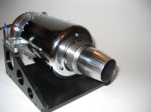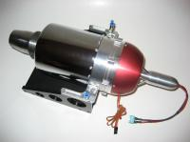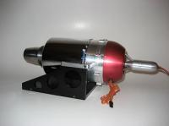
The Hawk 100R set includes:
Engine with temp probe, RPM sensor, Mounting lugs, Glow plug,
ECU, RX cable, Cable set for glow plug, Fuel pump with cable set,
HDT, Transport casing, Manual fuel valve, O-ring spare part for starter, Fuel & Propane valve, Hose for Kerosene, Hose for propane,
Engine users manual, Warranty paper,
Three years warranty.

Technical spec.
Hawk 100R technical figures

Example of typical data:

Thrust range 0.6 - 11.0 kg / 1.3 - 24.4 lbs +/- 10%

Pressure ratio 1.2 - 3.8

Rpm 60 000 - 175 000 rpm

EGT 390 - 760° (max 800) Celsius

Fuel consumption 30 - 260g / minute

Fuel Kerosene, Jet A1 or Diesel (EN590) with 1.5% oil

Oil quality Two stroke outboard oil

Engine controll Fadec full auto start

Starting gas Propane butane mixture

Battery LiPo 7.4, 2000mAh (Not incl.)

Mounting Lugs with fuel / propane connectors

Compressor Radial, transonic in-house design

Turbine Radial

Combustor Reverse flow type

Engine weight 1650 gram (engine and starter)

Airborne Install weight Aprox. 2000 gram

All data in ISA conditions.

Unique features for the Hawk 100R
- Unique rotor damping system
- Milled in house designed compressor
- Mounting lugs of solid aluminium with fuel connectors
- Lowest fuel consumption on the market (2,1 liters will last for 10 minutes flying in normal sport / scale aircraft)
- Fast spool times
- Three years warranty

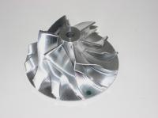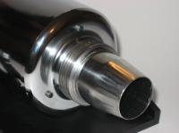

Fuel figures
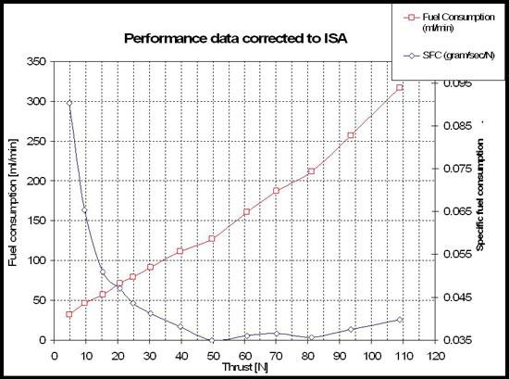
Already when passing 15N we have the best SFC on the market.

Performance
The Hawk 100R has, what we believe, the fastest spool time on the market. Factory settings for the Hawk 100R is around 4 seconds from idle to max power. However you have the possibility to change the setting for times down to around 2,5 seconds. This gives you the spool time from half throttle (aprox 50N of thrust) to maximum throttle in around half a second. This is a result due to very high combined turbine and compressor efficiency.

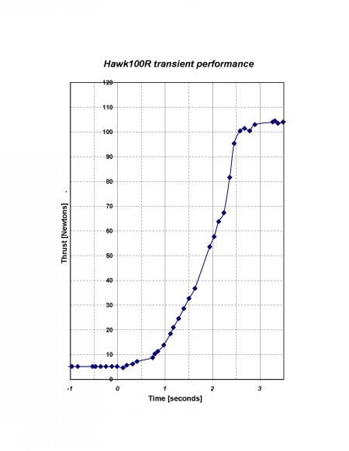

Dimensions
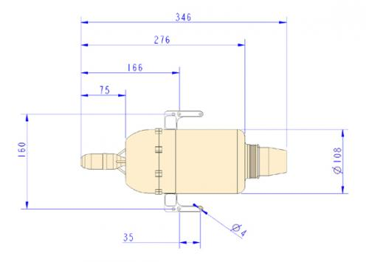

Hawk 240R
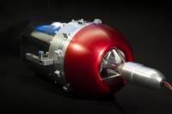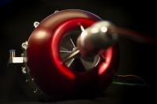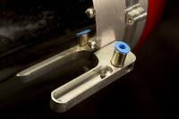

The Hawk 240R set includes:
Engine with temp probe, RPM sensor, Mounting lugs, Glow plug,
ECU, RX cable, Cable set for glow plug, Fuel pump with cable set,
HDT, Manual fuel valve, O-ring spare part for starter,
Fuel & Propane valve, Hose for Kerosene, Hose for propane,
On a USB memory:Engine users manual, Warranty paper,
Three years warranty.

Technical spec.
Hawk 240R technical figures

Example of typical data:

Thrust range 0.8 - 24.0 kg / 1.8 - 52,9 lbs +/- 10%

Pressure ratio 1.2 - 4,6

Rpm 39 000 - 132 000 rpm

EGT 400 - 760° ( max 800) Celsius

Fuel consumption 65 - 515g / minute

Fuel Kerosene, Jet A1 or Diesel (EN590) with 1.5% oil

Oil quality Two stroke outboard oil

Engine controll Fadec full auto start

Starting gas Propane butane mixture

Battery LiPo 7.4, 2000mAh (Not incl.)

Mounting Lugs with fuel / propane connectors

Compressor Radial, transonic in-house design

Turbine Radial

Combustor Reverse flow type

Engine weight 2800 gram (engine and starter)

Airborne Install weight Aprox. 3100 gram

All data in ISA conditions.

Unique features for the Hawk 240R
- Unique rotor damping system
- Milled in house designed compressor
- Mounting lugs of solid aluminium with fuel connectors
- Lowest fuel consumption on the market (4,5 liters will last for 10 minutes flying in normal sport / scale aircraft)
- Fast spool times
- Three years warranty

Fuel Figures
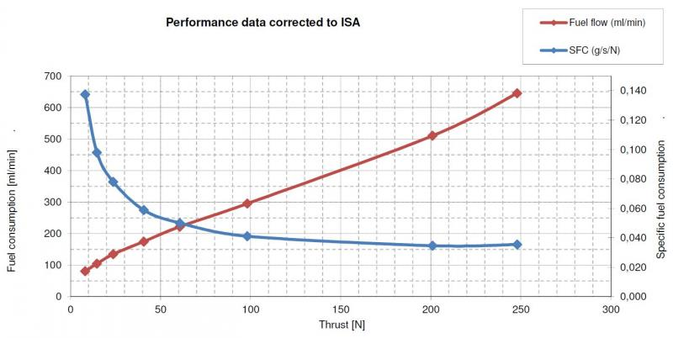

Dimensions
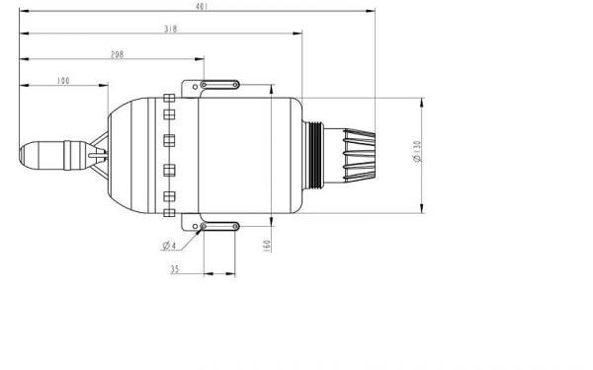

Hawk 190R
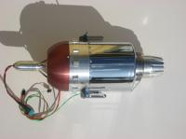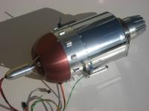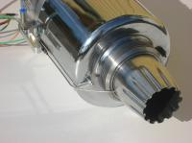

The Hawk 190R set includes:
Engine with temp probe, RPM sensor, Mounting lugs, Glow plug,
ECU, RX cable, Cable set for glow plug, Fuel pump with cable set,
HDT, LiPo battery, Manual fuel valve, O-ring spare part for starter,
Fuel & Propane valve, Hose for Kerosene, Hose for propane,
Engine users manual, Warranty paper,
Three years warranty.

technic spec.
Hawk 190R technical figures

Example of typical data:

Thrust range 0.5 - 19.0 kg / 1.3 - 41.9 lbs +/- 10%

Pressure ratio 1.2 - 3.9

Rpm 39 000 - 130 000 rpm

EGT 390 - 760° ( max 800) Celsius

Fuel consumption 50 - 390g / minute

Fuel Kerosene, Jet A1 or Diesel (EN590) with 1.5% oil

Oil quality Two stroke outboard oil

Engine controll Fadec full auto start

Starting gas Propane butane mixture

Battery LiPo 7.4, 2000mAh (Not incl.)

Mounting Lugs with fuel / propane connectors

Compressor Radial, transonic in-house design

Turbine Radial

Combustor Reverse flow type

Engine weight 2800 gram (engine and starter)

Airborne Install weight Aprox. 3100 gram

All data in ISA conditions.

Unique features for the Hawk 190R
- Unique rotor damping system
- Milled in house designed compressor
- Mounting lugs of solid aluminium with fuel connectors
- Lowest fuel consumption on the market (3,2 liters will last for 10 minutes flying in normal sport / scale aircraft)
- Fast spool times
- Three years warranty

fuel figures_

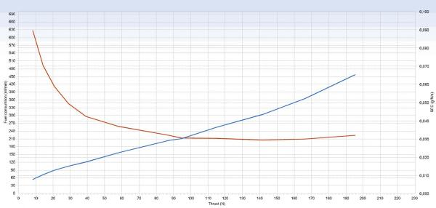

Dimensions_
Hawk 190R



Hawk 290R


The Hawk 290R set includes:
Engine with temp probe, RPM sensor, Mounting lugs, Glow plug,
ECU, RX cable, Cable set for glow plug, Fuel pump with cable set,
HDT, Manual fuel valve, O-ring spare part for starter,
Fuel & Propane valve, Hose for Kerosene, Hose for propane,
On a USB memory:Engine users manual, Warranty paper,
Three years warranty.

Technical spec 290R
Hawk 290R technical figures

Example of typical data:

Thrust range 0.8 - 29.0 kg / 1.8 - 52.9 lbs +/- 10%

Pressure ratio 1.2 - 4,7

Rpm 39 000 - 132 000 rpm

EGT 400 - 780° ( max 800) Celsius

Fuel consumption 84 - 659g / minute

Fuel Kerosene, Jet A1 or Diesel (EN590) with 1.5% oil

Oil quality Two stroke outboard oil

Engine controll Fadec full auto start

Starting gas Propane butane mixture

Battery LiPo 7.4, 2000mAh (Not incl.)

Mounting Lugs with fuel / propane connectors

Compressor Radial, transonic in-house design

Turbine Radial

Combustor Reverse flow type

Engine weight 2800 gram (engine and starter)

Airborne Install weight Aprox. 3100 gram

All data in ISA conditions.

Dimensions 290R


