A dual-WAN router has two Wide Area Network (WAN) ports, allowing it to connect to two different internet service providers (ISPs) simultaneously for enhanced reliability, speed, and performance through features like failover (automatic switch to backup if primary fails) and load balancing (sharing traffic across both connections). This setup prevents downtime, boosts throughput, and is ideal for homes or businesses needing continuous, robust internet, using various connection types like cable, DSL, cellular, or satellite.
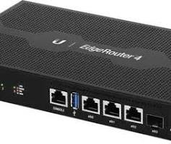
Key Benefits
- Failover/Redundancy: If one ISP connection goes down, the router automatically switches to the other, ensuring uninterrupted internet access.
- Load Balancing: Distributes network traffic across both connections, maximizing available bandwidth and preventing bottlenecks for better overall speed.
- Increased Performance: Combines bandwidth for some applications or dedicates connections to specific devices or services.
- Flexibility: Can combine different types of connections (e.g., fiber and 4G/5G) for a versatile setup.
How It Works
- Multiple Connections: Connect two different modems or internet sources to the router's WAN ports.
- Primary/Secondary Setup: Designate one connection as primary and the other as secondary.
- Traffic Management: Configure settings for failover (switch on failure) or load balancing (share traffic).
- Device Routing (Optional): Some advanced routers allow you to route specific devices (e.g., gaming console) through one WAN and others (e.g., streaming) through the other.
Common Uses
- Businesses: Ensure mission-critical applications stay online.
- Remote Workers: Maintain stable home internet for video calls and cloud access.
- Home Users: Get reliable internet in areas with unreliable single providers.
The ClearlyIP Failover Gateway provides business continuity for voice communications by automatically switching to a 4G wireless backup during internet or SIP provider outages, ensuring calls (including emergency 911) keep flowing, and replacing costly analog POTS lines with SIP while supporting legacy equipment like alarms and elevator phones, often with optional battery backup for power loss resilience. It acts as a "Swiss Army knife," bridging VoIP and analog systems and offering a local PBX failover for up to 250 endpoints, making it a cost-effective insurance policy for voice services.

Network redundancy protocols create backup paths and devices for uninterrupted data flow, preventing downtime from failures like cable breaks or hardware issues, with common examples including Spanning Tree Protocols (STP/RSTP) for Layer 2 loops, First Hop Redundancy Protocols (HSRP, VRRP, CARP) for default gateways, and industrial protocols like MRP, PRP, and HSR for zero-downtime scenarios in critical applications, all ensuring fault tolerance and high availability.
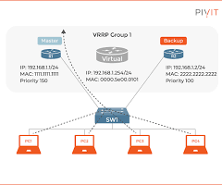
Layer 2 (Data Link Layer) Protocols
- Spanning Tree Protocol (STP) / Rapid Spanning Tree Protocol (RSTP): Prevents Layer 2 loops by logically blocking redundant paths while keeping them active as backups, allowing for fast failover.
- Media Redundancy Protocol (MRP): Used in ring topologies (IEC 62439-2), it detects faults and resends data on an alternative path, allowing for minor disruption (around 200ms).
- Parallel Redundancy Protocol (PRP): Sends duplicate frames simultaneously over two separate networks (LAN A & B) and accepts the first one received, offering zero downtime for single failures (IEC 62439-3).
- High-availability Seamless Redundancy (HSR): Similar to PRP, it duplicates frames but uses a single network ring for redundancy, also offering zero recovery time (IEC 62439-3).
Layer 3 (Network Layer) Protocols (First Hop Redundancy)
- Hot Standby Router Protocol (HSRP) (Cisco proprietary): Allows multiple routers to act as a single virtual router, with one active and others on standby, sharing a virtual IP address.
- Virtual Router Redundancy Protocol (VRRP): An open standard similar to HSRP, allowing multiple routers to share a virtual IP and offer backup for the default gateway.
- Common Address Redundancy Protocol (CARP): Provides failover for firewalls and routers, enabling multiple hosts to share a set of IP addresses, often used in BSD systems.
Key Benefits
- Fault Tolerance: Ensures continued operation despite hardware or link failures.
- High Availability: Minimizes downtime by automatically rerouting traffic.
- Load Balancing: Some protocols can share traffic across redundant links.

SIP Trunk Failover is a redundancy feature that automatically reroutes calls from a primary, failed SIP trunk to a backup, ensuring call continuity by switching to an alternate internet connection or carrier using techniques like DNS SRV records, heartbeat monitoring, or pre-configured route lists. This process prevents downtime by detecting primary failures (often via ping or SIP OPTIONS) and seamlessly activating a secondary path, which could be another trunk, a mobile number, or a different gateway.
How it Works (Key Methods)
- Heartbeat/Pinging: Devices constantly send pings or SIP OPTIONS messages to the primary trunk/gateway; if responses stop (e.g., three failed pings), failover is triggered.
- DNS SRV Records: Standby systems listen for SIP registrations and use DNS to find the highest-priority active trunk, automatically registering with the next available when the primary fails.
- Route Lists/Groups: IP PBX systems (like CUCM) group trunks and use algorithms (e.g., top-down) to try them in order, moving to the next when one goes down.
- Call Forwarding: Manually or automatically forwarding calls to a mobile number or different SIP trunk if the primary fails.
Common Failover Scenarios
- Primary Internet Outage: A firewall detects the primary ISP link is down and switches traffic to a secondary ISP connection.
- Primary SIP Gateway Failure: The PBX detects its main connection to the service provider is down and registers with a secondary gateway.
- Provider Server Failure: Systems like 3CX can switch between different servers from the same provider if one becomes unresponsive.
Key Components
- Session Border Controllers (SBCs): Often used to manage SIP traffic and provide redundancy features.
- IP PBXs: Systems like Cisco Unified Communications Manager (CUCM) or 3CX manage trunk groups and failover logic.
- Dual Internet Connections: Essential for true network redundancy.
Benefits
- Business Continuity: Maintains voice communications during outages.
- Reduced Downtime: Minimizes interruptions for users.
- Enhanced Reliability: Critical for businesses where continuous connectivity is essential.
A PBX (Private Branch Exchange) server functions as a business's internal phone system, managing calls between employees (using free internal extensions) and sharing a limited number of external lines, offering features like auto-attendants, call routing, voicemail, conferencing, and call recording to boost professionalism and efficiency, using either traditional analog lines or modern VoIP technology.
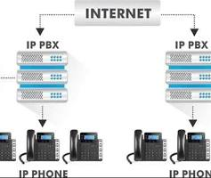
Core Functionality
- Internal & External Calls: Connects internal users (extensions) and routes external calls through shared lines, reducing costs.
- Call Management: Directs, transfers, forwards, and queues calls, using features like hold music and custom greetings.
- Employee Extensions: Assigns unique numbers (extensions) to employees, allowing direct internal calls.
Key Features
- Auto-Attendant (IVR): Automated greetings and menus (e.g., "Press 1 for Sales").
- Voicemail: Voicemail boxes for individuals, often with voicemail-to-email.
- Call Conferencing: Allows multiple parties to join a single call.
- Call Recording: Records calls for training, quality, or legal purposes.
- Caller ID & Call Logging: Shows who's calling and provides detailed call records.
- Business Hours: Sets specific call handling rules for day/night/holidays.
Types of PBX
- Traditional PBX: Hardware-based, using physical copper lines (PSTN).
- IP PBX (On-Premise): Software-based, uses your computer network (LAN) and the internet (VoIP).
- Cloud/Virtual PBX (Hosted): Hosted by a provider, uses the internet, reducing hardware costs and increasing flexibility.
- Hybrid PBX: Combines elements of traditional and IP systems.
Benefits
- Professionalism: Gives a business a sophisticated, multi-line presence.
- Cost Savings: Reduces call costs, especially with VoIP, and lowers initial capital expenditure for cloud systems.
- Productivity: Streamlines communication and supports remote work.

Building a marine VoIP system for 150 phones with physical cable redundancy in 2026 requires a structured approach focusing on DNV-GL approved hardware and specific network protocols.
1. System Architecture
To handle 150 extensions with failover, you need a high-availability server setup and a redundant network ring.
- Dual PBX Servers: Use two servers (e.g., Xorcom Marine PBX or Yeastar P-Series) in a Hot Standby configuration. If the primary server fails, the secondary takes over all 150 phones automatically.
- Redundant Network Ring: Connect your switches in a "ring" topology using Rapid Spanning Tree Protocol (RSTP). This allows for a backup path if any single cable between switches is cut.
2. Required Components & Installation
- IP PBX: Xorcom TwinStar Plus CXTS3000 or Yeastar P570. These support up to 300+ users and include redundant power supplies.
- Industrial Managed Switches: For 150 phones, use several 24-port or 48-port DNV-certified switches (e.g., Korenix JetNet 5900 series or Hatteland Technology switches).
  - Note: Ensure the switches support PoE (Power over Ethernet) to power the phones through the network cable.
- Marine IP Phones: Use FHF FernTel IP150 or Norphonic Offshore phones for high-exposure areas. For cabins, use DNV-approved Innovaphone IP111.
3. Step-by-Step Build Guide
- Configure the PBX: Set up the primary and secondary PBX servers with mirrored configurations and a shared virtual IP address for 150 extensions.
- Enable RSTP on Switches:
  - Access the switch management console.
  - Enable RSTP mode globally on all switches.
  - Designate one switch as the Root Bridge.
- Physical Wiring for Failover:
  - Run two separate Ethernet cables to each "zone" or deck.
  - Connect phones with dual LAN ports (like the FHF IP150) to the network.
  - Crucial: If the phone itself does not support RSTP, you should connect it to a single wall jack that is part of an RSTP-protected switch branch. Connecting two cables directly into a non-RSTP phone will cause a loop.
- Power Redundancy: Connect all switches and PBX servers to a Marine Uninterruptible Power Supply (UPS) to ensure the system stays online during power fluctuations.
Summary of Redundancy Levels
Level | Redundancy Method | Component
Server | Hot Standby / Dual PBX | Xorcom/Yeastar Servers
Network Path | RSTP Ring Topology | Managed Marine Switches
Physical Cable | Dual Uplinks to Switches | Redundant Cabling per Deck
Power | Dual Power Supplies / UPS | Marine-Grade UPS Systems
The following tutorial demonstrates how to enable Rapid Spanning Tree Protocol (RSTP) on a managed switch, which is the foundational technology for physical cable failover in your marine network:
FHF FernTel IP / IP150

Xorcom TwinStar Plus CXTS3000
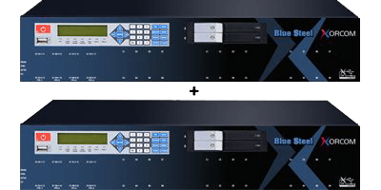
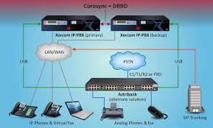

Yeastar P570
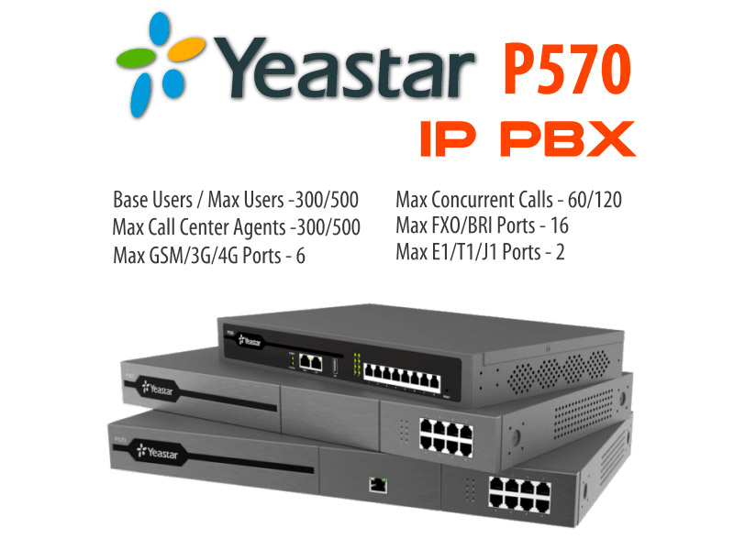
Marine-Grade Phones & Mounting
The mounting solutions for these phones ensure they remain fixed and withstand vibration, impact, and high humidity.
- FHF FernTel IP / IP150
  - Mounting: This versatile phone can be easily converted from a desk phone to a wall-mounted device using its included hardware. The installation involves fastening a mount with screws; for wall mounting, the phone is placed in upper latches and swings down to engage lower latches, and can be further secured with locking screws to maintain its IP65 rating.
  - Features: IP65 ingress protection, dual LAN ports, robust polycarbonate housing resistant to acids, alkalis, and lubricants.
- Norphonic Offshore SIP-based Telephone
  - Mounting: The Norphonic telephone is designed for secure, fixed installation. A specific mounting plate is available (often included or an optional accessory) for wall installation without needing rear access. They also offer a unique panel-mounting system (for through-wall/cabinet installation) using a patent-pending wedge system that doesn't require screws, ensuring an IP65 rating.
  - Features: IP65/IP66 weatherproof rating, impact/shock/vibration proof, hookswitch with no moving parts, suitable for extreme temperatures.
- J&R Technology Limited JR101-FK-VoIP
  - Mounting: These phones are typically housed in cast aluminum enclosures with robust, pre-drilled fixing points for direct and secure wall mounting using security screws to prevent tampering.
  - Features: IP67 waterproof rating, corrosion-resistant, armored handset cord for durability.
Mounting Details
- Method: Installation generally involves screw-based mounting for maximum stability on bulkheads or walls.
- Hardware: The phones usually come with the necessary screws, anchors, or brackets.
- Stability: The fixed nature of the installation helps ensure the devices are safe and secure, preventing them from moving even in rough seas.
These technical guides describe mounting options for fixed marine VoIP phones on walls and desks:

Marine IP Phones from Norphonic Offshore

DNV-approved Innovaphone IP111
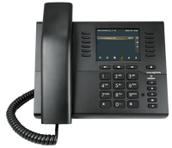
J&R Technology Limited JR101-FK-VoIP
