#### 三. 数据处理

**原始数据**

| 样品1 基本参数 | 频率 | R1 欧 | R2 千欧 | C 微法 |
| --- | --- | --- | --- | --- |
|  | 40Hz | 10.9 | 50 | 4.8 |

饱和磁滞回线

| UX mV | 760 | 473 | 300 | 227 | 153 | 107 | 66.7 | 0 | -46.7 | -107 | -267 | -433 | -753 | 333 | 387 | 760 | 300 | 80 | 0 | -60 | -100 | -160 | -213 | -273 | -327 | -453 | -573 | -753 | 120 | 200 |
| --- | --- | --- | --- | --- | --- | --- | --- | --- | --- | --- | --- | --- | --- | --- | --- | --- | --- | --- | --- | --- | --- | --- | --- | --- | --- | --- | --- | --- | --- | --- |
| UY mV | 23.6 | 20 | 14 | 10 | 4 | 0 | -4.8 | -10 | -12.8 | -15.6 | -20 | -22 | -24.4 | 15.6 | 17.6 | 23.6 | 20 | 14 | 10 | 4 | 0 | -4.8 | -10 | -12.8 | -15.6 | -20 | -22 | -24.4 | 15.6 | 17.6 |

基本磁化曲线

| UX mV | 760 | 607 | 467 | 367 | 293 | 227 | 167 | 120 | 53.3 | 33.3 |
| --- | --- | --- | --- | --- | --- | --- | --- | --- | --- | --- |
| UY mV | 23.6 | 22 | 19.6 | 16.4 | 13.2 | 10.4 | 6.8 | 4.4 | 1.6 | 0.8 |

| 样品2 基本参数 | 频率 | R1 欧 | R2 千欧 | C 微法 |
| --- | --- | --- | --- | --- |
|  | 40Hz | 10.9 | 50 | 4.8 |

饱和磁滞回线

| UX mV | 3390 | 2520 | 1850 | 1390 | 1320 | 1120 | 920 | 787 | 720 | 520 | 387 | 86.7 | -80 | -413 | -1080 | -3380 | 3390 | 1890 | 687 | 53.3 | -46.7 | -280 | -480 | -613 | -680 | -913 | -1050 | -1280 | -1410 | -1580 | -2080 | -3380 |
| --- | --- | --- | --- | --- | --- | --- | --- | --- | --- | --- | --- | --- | --- | --- | --- | --- | --- | --- | --- | --- | --- | --- | --- | --- | --- | --- | --- | --- | --- | --- | --- | --- |
| UY mV | 76 | 68 | 58 | 46 | 42 | 34 | 20 | 8 | 0 | -22 | -30 | -42 | -48 | -54 | -62 | -74 | 76 | 68 | 58 | 46 | 42 | 34 | 20 | 8 | 0 | -22 | -30 | -42 | -48 | -54 | -62 | -74 |

基本磁化曲线

| UX mV | 3390 | 3150 | 2850 | 2290 | 1920 | 1620 | 1320 | 1090 | 853 | 653 | 587 | 420 | 320 | 253 | 107 | 50.7 |
| --- | --- | --- | --- | --- | --- | --- | --- | --- | --- | --- | --- | --- | --- | --- | --- | --- |
| UY mV | 76 | 74 | 72 | 68 | 64 | 58 | 52 | 46 | 38 | 30 | 22 | 14 | 8 | 4 | 1.2 | 0.4 |

| 样品2 基本参数 | 频率 | R1 欧 | R2 千欧 | C 微法 |
| --- | --- | --- | --- | --- |
|  | 100Hz | 4.9 | 44 | 2.4 |

饱和磁滞回线

| UX mV | 461 | 428 | 455 | 448 | 435 | 421 | 408 | 375 | 348 | 308 | 301 | 255 | 208 | 161 | 121 | 21.3 | -92 | -145 | -265 | -432 | 261 | 428 | 148 | 28 | -58.7 | -119 | -159 | -219 | -259 | -299 | -305 | -345 | -385 | -405 | -425 | -445 | -452 | -459 | -452 | -432 |
| --- | --- | --- | --- | --- | --- | --- | --- | --- | --- | --- | --- | --- | --- | --- | --- | --- | --- | --- | --- | --- | --- | --- | --- | --- | --- | --- | --- | --- | --- | --- | --- | --- | --- | --- | --- | --- | --- | --- | --- | --- |
| UY mV | 86 | 92 | 82 | 72 | 62 | 54 | 46 | 32 | 20 | 2 | 0 | -20 | -32 | -46 | -54 | -66 | -76 | -82 | -88 | -92 | 86 | 92 | 82 | 72 | 62 | 54 | 46 | 32 | 20 | 2 | 0 | -20 | -32 | -46 | -54 | -66 | -76 | -82 | -88 | -92 |

基本磁化曲线

| UX mV | 428 | 421 | 401 | 381 | 335 | 315 | 275 | 235 | 188 | 141 | 101 | 54.7 |
| --- | --- | --- | --- | --- | --- | --- | --- | --- | --- | --- | --- | --- |
| UY mV | 92 | 84 | 80 | 70 | 62 | 52 | 46 | 36 | 24 | 14 | 8 | 4 |

经过测量得到样品1(40Hz)和样品2(40Hz和100Hz)的 $U_{X}$ 和 $U_{Y}$，由公式

$H=\frac{U_{X}N_{1}}{LR_{1}}$

$B=\frac{U_{Y}CR_{2}}{SN_{2}}$

计算得作图数据

| H A/m | 80.45 | 50.07 | 31.76 | 24.03 | 16.20 | 11.33 | 7.06 | 0.00 | -4.94 | -11.33 | -28.26 | -45.84 | -79.71 | 35.25 | 40.97 | 80.45 | 31.76 | 8.47 | 0.00 | -6.35 | -10.59 | -16.94 | -22.55 | -28.90 | -34.62 | -47.95 | -60.66 | -79.71 | 12.70 | 21.17 |
| --- | --- | --- | --- | --- | --- | --- | --- | --- | --- | --- | --- | --- | --- | --- | --- | --- | --- | --- | --- | --- | --- | --- | --- | --- | --- | --- | --- | --- | --- | --- |
| B T | 0.30 | 0.26 | 0.18 | 0.13 | 0.05 | 0.00 | -0.06 | -0.13 | -0.17 | -0.20 | -0.26 | -0.28 | -0.31 | 0.20 | 0.23 | 0.30 | 0.26 | 0.18 | 0.13 | 0.05 | 0.00 | -0.06 | -0.13 | -0.17 | -0.20 | -0.26 | -0.28 | -0.31 | 0.20 | 0.23 |

| H A/m | 80.45 | 64.26 | 49.44 | 38.85 | 31.02 | 24.03 | 17.68 | 12.70 | 5.64 | 3.53 |
| --- | --- | --- | --- | --- | --- | --- | --- | --- | --- | --- |
| B T | 0.30 | 0.28 | 0.25 | 0.21 | 0.17 | 0.13 | 0.09 | 0.06 | 0.02 | 0.01 |

| H A/m | 358.86 | 266.76 | 195.84 | 147.14 | 139.73 | 118.56 | 97.39 | 83.31 | 76.22 | 55.05 | 40.97 | 9.18 | -8.47 | -43.72 | -114.33 | -357.80 | 358.86 | 200.07 | 72.72 | 5.64 | -4.94 | -29.64 | -50.81 | -64.89 | -71.98 | -96.65 | -111.15 | -135.50 | -149.26 | -167.25 | -220.18 | -357.80 |
| --- | --- | --- | --- | --- | --- | --- | --- | --- | --- | --- | --- | --- | --- | --- | --- | --- | --- | --- | --- | --- | --- | --- | --- | --- | --- | --- | --- | --- | --- | --- | --- | --- |
| B T | 0.98 | 0.88 | 0.75 | 0.59 | 0.54 | 0.44 | 0.26 | 0.10 | 0.00 | -0.28 | -0.39 | -0.54 | -0.62 | -0.70 | -0.80 | -0.95 | 0.98 | 0.88 | 0.75 | 0.59 | 0.54 | 0.44 | 0.26 | 0.10 | 0.00 | -0.28 | -0.39 | -0.54 | -0.62 | -0.70 | -0.80 | -0.95 |

| H A/m | 358.86 | 333.45 | 301.69 | 242.41 | 203.25 | 171.49 | 139.73 | 115.38 | 90.30 | 69.12 | 62.14 | 44.46 | 33.87 | 26.78 | 11.33 | 5.37 |
| --- | --- | --- | --- | --- | --- | --- | --- | --- | --- | --- | --- | --- | --- | --- | --- | --- |
| B T | 0.98 | 0.95 | 0.93 | 0.88 | 0.83 | 0.75 | 0.67 | 0.59 | 0.49 | 0.39 | 0.28 | 0.18 | 0.10 | 0.05 | 0.02 | 0.01 |

| H A/m | 108.56 | 100.78 | 107.14 | 105.49 | 102.43 | 99.14 | 96.08 | 88.30 | 81.95 | 72.53 | 70.88 | 60.05 | 48.98 | 37.91 | 28.49 | 5.02 | -21.66 | -34.14 | -62.40 | -101.73 | 61.46 | 100.78 | 34.85 | 6.59 | -13.82 | -28.02 | -37.44 | -51.57 | -60.99 | -70.41 | -71.82 | -81.24 | -90.66 | -95.37 | -100.08 | -104.79 | -106.44 | -108.08 | -106.44 | -101.73 |
| --- | --- | --- | --- | --- | --- | --- | --- | --- | --- | --- | --- | --- | --- | --- | --- | --- | --- | --- | --- | --- | --- | --- | --- | --- | --- | --- | --- | --- | --- | --- | --- | --- | --- | --- | --- | --- | --- | --- | --- | --- |
| B T | 0.49 | 0.52 | 0.47 | 0.41 | 0.35 | 0.31 | 0.26 | 0.18 | 0.11 | 0.01 | 0.00 | -0.11 | -0.18 | -0.26 | -0.31 | -0.37 | -0.43 | -0.47 | -0.50 | -0.52 | 0.49 | 0.52 | 0.47 | 0.41 | 0.35 | 0.31 | 0.26 | 0.18 | 0.11 | 0.01 | 0.00 | -0.11 | -0.18 | -0.26 | -0.31 | -0.37 | -0.43 | -0.47 | -0.50 | -0.52 |

| H A/m | 100.78 | 99.14 | 94.43 | 89.72 | 78.89 | 74.18 | 64.76 | 55.34 | 44.27 | 33.20 | 23.78 | 12.88 |
| --- | --- | --- | --- | --- | --- | --- | --- | --- | --- | --- | --- | --- |
| B T | 0.52 | 0.48 | 0.45 | 0.40 | 0.35 | 0.30 | 0.26 | 0.20 | 0.14 | 0.08 | 0.05 | 0.02 |

作图如下

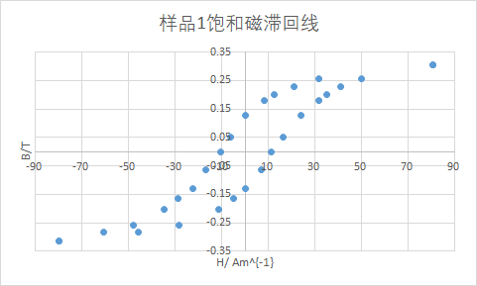

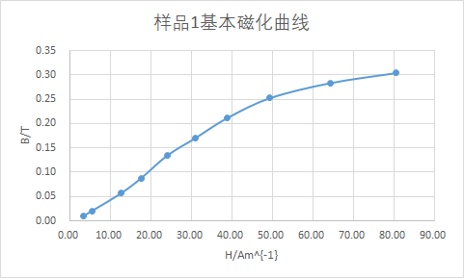

**样品1剩磁为0.13T，矫顽力为10.96 A/m**

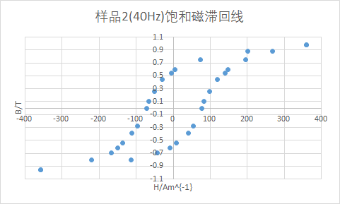

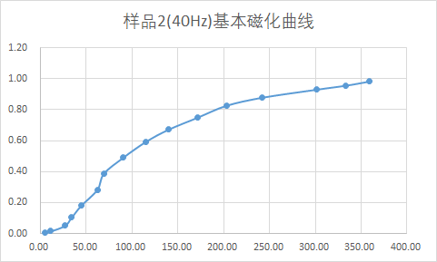

**样品2(40Hz)剩磁为0.6T，矫顽力为74.10 A/m**

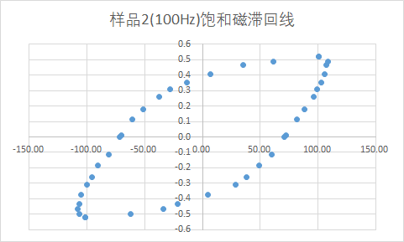

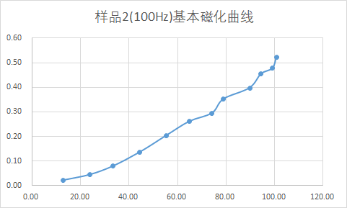

**样品2(100Hz)剩磁为0.4T，矫顽力为71.35 A/m**

#### 四. 实验结论及现象分析

由实验结果可知，我们的样品1是软磁材料，其磁滞回线为瘦窄形状，样品2是硬磁材料，磁滞回线为胖宽形。

随着交流信号频率增加，同一样品磁滞回线由相对细长变为椭圆形。

#### 五. 讨论问题

1. 某两种材料的磁滞回线，一个很宽一个很窄，它们各属于哪类磁性材料？分别可以应用于什么场合？

* 答：磁滞回线较宽的是硬磁，较窄的是软磁。磁滞回线宽肥，磁化后可长久保持很强磁性，适于制成磁电式电表中的永磁铁、耳机中的永久磁铁、永磁扬声器。软磁材料适用于继电器、电机、以及各种高频电磁元件的磁芯、磁棒。

1. 一钢制部件不慎被磁化，请设计一种退磁方案。

* 答：沿着被磁化的方向施加逆向的磁场直到部件不再显示磁性。或者可以使用高温加热、剧烈撞击来使磁性消失。