Name of student: Evelyn Fagbola, Gipsy Gonzalez, Hanane Larbi and Katarzyna Pastuszka

Panel data econometrics homework: replication

To be uploaded on the EPI at the due date

- The original paper in pdf
- The database that you use (possibly updated with respect to the paper), possibly in Excel format.
- The database formatted for the software you used (Python, Stata, R)
- The code of your preferred software (e.g. Python), in a format so that anyone can run your code immediately.
- The code translated in Stata and R with the help of LLM, with comments mentioning difficulties for running these versions.
- A Word or TEX and pdf version of your answers according to the guidelines starting next page (using this word file or copied in TEX).
- A Word and then a PDF file with copy and paste of all your LLM prompts and answers for doing this homework, including code (no problem if it is 300 pages).
- A “To-do-list” of steps of panel data for the next time you will use panel data.

You may add a commented HTML file of the code and output of your software, but it is NOT accepted to be a substitute of the written version of answers.

Some panel data estimates (in particular, GMM, with xtabond2, Hausman Taylor) are coded in STATA.
A book with R code for panel data is in the folder BOOKS.

Remark: If ever you estimate an autoregressive parameter (or the sum of the auto-regressive parameters) which is larger than one, the series of the long run coefficients are infinite and the formula with 1/(1-rho) is not valid. One can compute the impulse response for the first periods, but they explode.

Remark: Pay attention: is your work readable? Copy and paste patchy answers from LLM is not enough for readability. The reader at the end may not grasp anything of what you did not yourself understood. The aim of statistics is to extract signal from noise and explain it clearly. You may have a perfect “to do list” proposed by LLM which contradicts what you have written.

Homework Panel data: Partial replication

Name of the student: Evelyn Fagbola, Gipsy Gonzalez, Hanane Larbi and Katarzyna Pastuszka

APA Reference of the replicated paper using Google Scholar and check:
(authors, title, journal, pages)
Lofaro, A., & Di Bucchianico, S. (2025). Impact of monetary policy on functional income distribution: A panel vector autoregressive analysis. Economic Modelling, 151, 107227. https://doi.org/10.1016/j.econmod.2025.107227

Link to the paper (possibly with DOI):
Impact of monetary policy on functional income distribution: A panel vector autoregressive analysis - ScienceDirect
DOI: https://doi.org/10.1016/j.econmod.2025.107227

Table 1: Key correlation of the paper
Dependent variables denoted Y in what follows | Key preferred explanatory variables denoted X in what follows
WR (Real wages per employee): This variable measures real wages , computed as nominal compensation per employee. The variable is deflated by the GDP deflator.  Source: AMECO database: https://economy-finance.ec.europa.eu/economic-research-and-databases/economic-databases/ameco-database_en | i (Short-term interest rate): This is the monetary policy variable, which is usually the central bank policy rate or a similar short-term market rate depending on availability in the country.  Sources:  - Source: AMECO database: https://economy-finance.ec.europa.eu/economic-research-and-databases/economic-databases/ameco-database_en  - OECD short-term interest rates: https://www.oecd.org/en/data/indicators/short-term-interest-rates.html  - Jordà-Schularick-Taylor Macrohistory Database: https://www.nber.org/research/data/jorda-schularick-taylor-macrohistory
LS (Adjusted labor share): This variable measures labor compensation as a share of GDP, adjusted for self-employed workers and other non-wage labor components.

Source: AMECO database: https://economy-finance.ec.europa.eu/economic-research-and-databases/economic-databases/ameco-database_en

The level of observation is country-year. The project will use panel data where the individuals are 15 advanced economies and the time dimension is annual data from 1970 to 2019.

Link to the data set: Replication folder ECMODE-D-24-01693 - Mendeley Data

Links to the data set sources:
AMECO database: https://economy-finance.ec.europa.eu/economic-research-and-databases/economic-databases/ameco-database_en
OECD short-term interest rates: https://www.oecd.org/en/data/indicators/short-term-interest-rates.html
OECD GDP and national accounts: https://www.oecd.org/en/data/datasets/gdp-and-non-financial-accounts.html
OECD Economic Outlook: https://www.oecd.org/economic-outlook/
World Bank commodity price data: https://www.worldbank.org/en/research/commodity-markets
Jordà-Schularick-Taylor Macrohistory Database: https://www.nber.org/research/data/jorda-schularick-taylor-macrohistory
Bruegel real effective exchange rates: https://www.bruegel.org/publications/datasets/real-effective-exchange-rates-for-178-countries-a-new-database
Wu-Xia shadow rates: https://sites.google.com/view/jingcynthiawu/shadow-rates

Abstract (100 words) of what you have done.

This partial replication studies Lofaro and Di Bucchianico (2025), who examine the impact of monetary policy on functional income distribution. Using their panel dataset for 15 advanced economies from 1970 to 2019, we analyze the relationship between short-term interest rates, real wages, and labor share. We first check the panel structure, missing observations, variable classifications, and transformations. We then compare between, within, first-difference, and two-way fixed-effects results. Our main finding is that the relationship is highly sensitive to the transformation used, with stronger evidence of a negative relationship for real wages than for labor share.

- Introduction (1 page): summarize in 3 paragraphs what you find which was not seen in the paper (to do at the end of your partial replication)

The original paper by Lofaro and Di Bucchianico studies the effect of monetary policy on functional income distribution using a panel VAR framework. In our partial replication, we use the authors’ dataset for 15 advanced economies over the period 1970–2019 and focus on three central variables: the short-term interest rate, real wages, and the adjusted labor share. One finding that becomes clear from our data exploration is that the panel is not perfectly balanced for the two main dependent variables. Although the dataset contains 15 countries and 50 years, Japan has missing observations for real wages and the labor share before 1980. As a result, the panel includes 14 countries from 1970 to 1979 and 15 countries from 1980 onwards. This does not lead to major sample loss, since all countries satisfy the requirement of at least three consecutive observations, but it matters for the construction and interpretation of panel transformations.
A second finding is that the descriptive relationship between monetary policy and income distribution is highly sensitive to the type of panel variation used. In the between-country comparison, countries with higher average short-term interest rates also tend to have higher average real wages. However, once country averages are removed, the within-country relationship between interest rates and real wages becomes weakly negative. For the labor share, the sign of the relationship also changes across transformations, depending on whether the analysis uses between variation, within variation, first differences, or two-way fixed effects. This shows that simple correlations are not stable across specifications and should not be interpreted as causal evidence. The distinction between between-country variation and within-country time variation is therefore central to the replication exercise.
A third finding is that the results reveal substantial country heterogeneity and sensitivity to model specification. The relationship between the short-term interest rate and the labor-income variables is not uniform across economies: some countries display positive correlations, others negative correlations, and some only weak relationships. In the panel estimates, the coefficient on the interest rate also changes in sign and significance depending on the estimator used. For real wages, fixed-effects and first-difference specifications produce negative and statistically significant coefficients, which is consistent with the idea that tighter monetary policy may reduce real wages. However, when two-way fixed effects are included, the relationship often becomes insignificant, suggesting that common time shocks play an important role. Overall, our partial replication indicates that the estimated effect of monetary policy on income distribution is sensitive to the chosen transformation, the inclusion of time effects, and cross-country heterogeneity.

Table 2: Key items found by order of interest of this partial replication
1 | The results are very sensitive to the panel transformation used as between, fixed effects, first differences and two-way fixed effects give different signs and significance levels for the interest rate coefficient.
2 | The evidence is stronger for real wages than for labor share. Fixed effects and first differences provide a negative and significant relationship between short term interest rates and real wages, but labor share results are less robust.
3 | The two way fixed effects remove much of the apparent relationship showing the importance of common time shocks. So this means that international monetary regimes, inflation episodes or crisis periods may explain part of the relationship.
4 | The dataset is slightly unbalanced for the main dependent variables because Japan has missing observations for WR and LS before 1980.
5 | There is large country level heterogeneity. Some countries show positive relationships between interest rates and labor-income variables, while others show negative or weak relationships. So pooled estimates may hide different national responses.

- Database update

We use the original dataset without extending it beyond 2019. The paper stops before the COVID-19 period, and we keep the same choice because the pandemic involved exceptional volatility, zero lower bound episodes, and unconventional monetary policy interventions that would be difficult to compare with the rest of the sample.

Table 3: Data characteristics
Maximal time span | Frequency | Number of individuals | Maximal number  of time observations for an individual | Balanced or unbalanced panel
1970-2019 | Annual | Ntotal=15 | Tmax=  50 years, e.g. Australia | Balanced country-year structure, but slightly unbalanced for WR and LS because Japan starts in 1980.
Update:
Not done

- Panel data sample selection

Table: Sample selection for dynamic panel data: at least 3 consecutive observations of the DEPENDENT variable for each individual.

Panel data sample selection
Individuals excluded from the panel data selection | Individuals with at least THREE consecutive observations for the dependent variable: these are the individuals kept in all the next questions
Number: N1=0 | Ntotal-N1=N = 15 countries
 | Maximal time span for an individual: 1970-2019 yearly. For Japan, WR and LS are available from 1980 to 2019 but Japan is still kept as it has 40 consecutive observations.
List: None | List: Australia, Belgium, Canada, Finland, France, Germany, Italy, Japan, Netherlands, Norway, Portugal, Spain, Sweden, UK, USA

No country is dropped: all 15 have at least three consecutive observations for the relevant dependent variables, which is the minimum required for the estimations that follow. Since no country is dropped from the original sample, there is no additional sample selection at this stage. It should be noted, however, that the original paper itself restricts the analysis to advanced economies. From now on, all statistics are computed on the selected sample, restricting observations to those where the dependent variable is not missing.

- Sample selection within an unbalanced panel

Data availability often implies sample selection leading to unbalanced panel (missing time observations for some individuals).

Table: number of individuals per date
Date | 1970-1979 | 1980-2019
N | 14 | 15

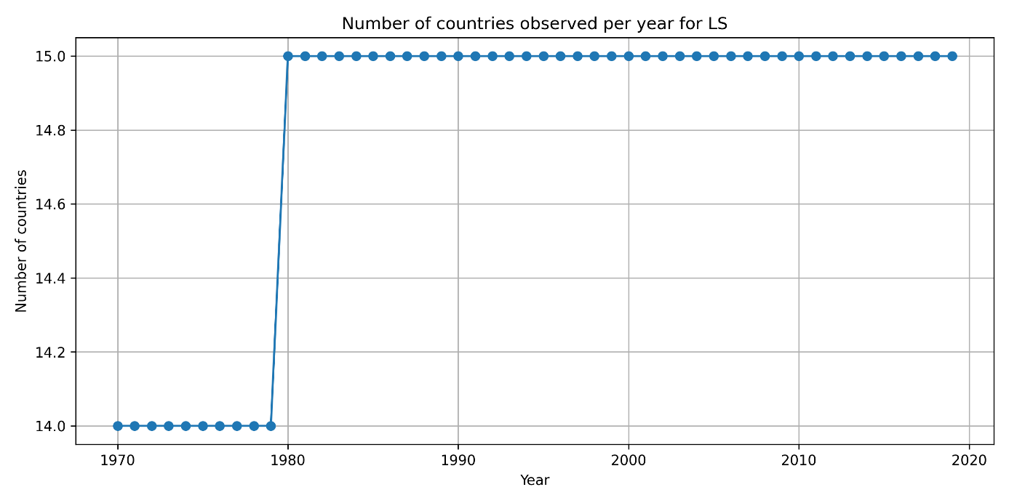
Figure 1. Number of countries observed per year for the labor share variable. The same pattern is obtained for real wages.
The figure shows that the number of countries observed for the dependent variables is 14 from 1970 to 1979 and 15 from 1980 to 2019. This pattern is due to Japan, whose observations for WR and LS are available only from 1980 onward. Therefore, the panel is slightly unbalanced at the beginning of the period, but there is no attrition at the end of the sample, since all 15 countries are observed every year from 1980 to 2019.

Table: Number of countries by number of annual observations
Observations  By individuals | Tmax = 50 | 40
Number of individuals in this case | 14 | 1

14 countries have the maximum number of observations with 50 annual observations from 1970 to 2019. One country, Japan, has 40 annual observations.
There are no holes inside country-specific time periods for the dependent variables LS and WR. Thus, the unbalanced structure is not due to random missing years inside the panel but it is due to Japan entering later than other countries.

- Panel data variables classification

Table 4: Variable classification by categories
List of variables varying with two indices (time and individuals). | List of time invariant variables  (share of between variance 100%), wiped out by individual dummies | List of individual invariant variables.  (time series invariant for all individuals), wiped out by time dummies
Number: K= 12  P, W, SH, i, WR, REER, LS, UN, LONGUN, GDP, SHORTUN, LF | K1= 0  None | K2= 1  PCOM

Table 5: Time varying variables (0%<%within variance< 100%), the variables should by sorted by their percentage of within variance (from the highest within variance down to the lowest). Dependent variables first.
Variable (in words) | N | NT | NT/N | Overall  variance | Between  variance | Within  Variance | % within variance/  Total  Sorted by this column
Dependent variable: Real wages, WR | 15 | 740 | 49.33 | 395.57 | 92.80 | 312.53 | 79.01%
Dependent variable: Labor share, LS | 15 | 740 | 49.33 | 29.32 | 12.07 | 18.05 | 61.56%
GDP deflator / price level, P | 15 | 750 | 50.00 | 872.43 | 55.04 | 820.91 | 94.10%
Nominal compensation per employee, W | 15 | 740 | 49.33 | 263.65 | 17.18 | 247.42 | 93.84%
Shadow interest rate, SH | 15 | 750 | 50.00 | 30.75 | 2.19 | 28.70 | 93.35%
Short-term interest rate, i | 15 | 750 | 50.00 | 23.49 | 1.83 | 21.77 | 92.70%
Real effective exchange rate, REER | 15 | 750 | 50.00 | 164.69 | 55.36 | 112.95 | 68.58%
Unemployment rate, UN | 15 | 741 | 49.40 | 15.69 | 7.47 | 8.64 | 55.03%
Long-term unemployment, LONGUN | 15 | 588 | 39.20 | 778,002.40 | 542,980.90 | 284,644.30 | 36.60%
Real GDP, GDP | 15 | 750 | 50.00 | 9.54e+12 | 8.54e+12 | 1.56e+12 | 16.37%
Short-term unemployment, SHORTUN | 15 | 588 | 39.20 | 2,840,238.00 | 2,358,683.00 | 153,043.20 | 5.39%
Labor force, LF | 15 | 741 | 49.40 | 1.08e+09 | 1.10e+09 | 46,619,488.00 | 4.30%

Most variables vary across both countries and years, which means that they can be used in standard panel transformations. No variable is purely time invariant within countries, so no variable is mechanically eliminated only by country fixed effects. PCOM is the only individual invariant variable: it varies over time but is common across countries, so it would be absorbed by year fixed effects in a two-way fixed effects specification.

The dependent variables have substantial within-country variation. Real wages, WR, have a within-variance share of 79.01%, indicating that most of their variation comes from changes over time within countries rather than from permanent differences between countries. LS has a lower within share of 61.56%, but this is still substantial. The short-term interest rate stands out with a within share of 92.70%, among the highest in the sample; its level across countries barely varies compared to how much it moves within each country over time. Other variables such as the GDP deflator P, nominal compensation per employee W, and the shadow interest rate SH also have very high within shares, above 90%, meaning they move with the business cycle within each country. However, real GDP, GDP, short-term unemployment, SHORTUN, and labor force, LF, have low within shares, meaning that much of their variation comes from persistent differences between countries rather than changes over time within countries. Importantly, high within shares should be interpreted carefully because they may also reflect a few high-leverage observations after the within transformation. This is especially relevant for variables such as WR, which has a high maximum value in the descriptive statistics, and for interest rates, which spike during disinflation episodes.

- Between plus One-Way Within decomposition: univariate bivariate descriptive statistics after variable transformations

REAL WAGES, WR
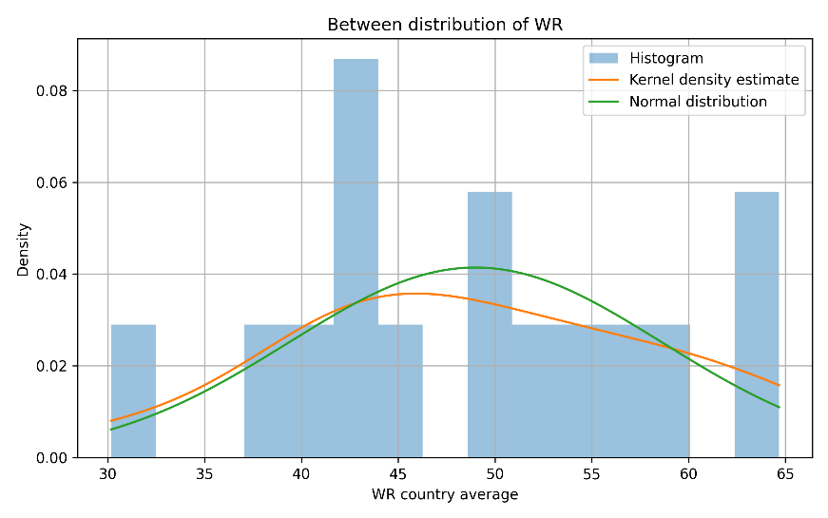
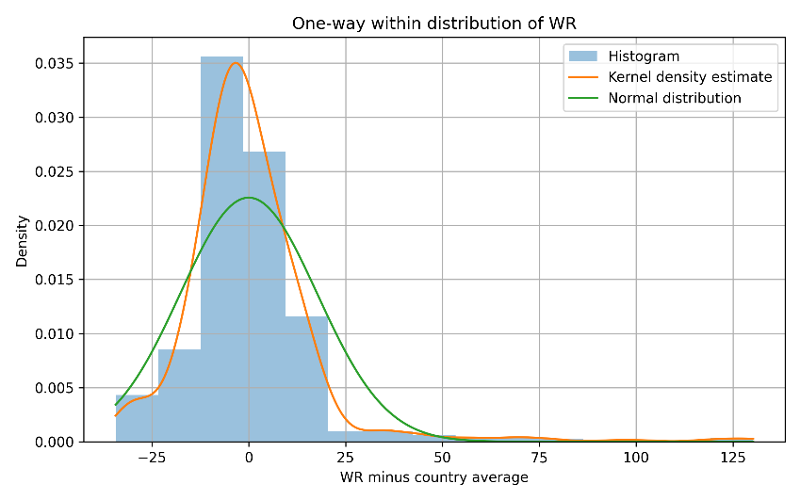

The one-way within distribution of WR is centred around zero. However, it has a long right tail that points to positive skewness, high kurtosis, and likely influential observations. These observations are important because they may strongly influence fixed-effects estimates.
The right tail in the within distribution of WR is important for the rest of the analysis, because it will reappear in the TWFE boxplots. Portugal in particular deserves attention as a potential source of high-leverage observations.
The between distribution of WR shows clear cross-country differences in average real wages.
Country averages are spread over a wide interval, from around 30 to above 60. The histogram and KDE do not perfectly follow the normal curve, though with only 15 points the histogram is hard to read. However, because the between distribution only contains one observation per country, the interpretation should be cautious.
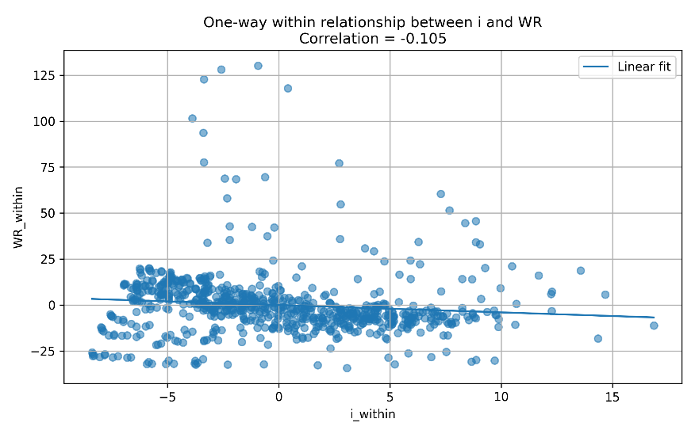
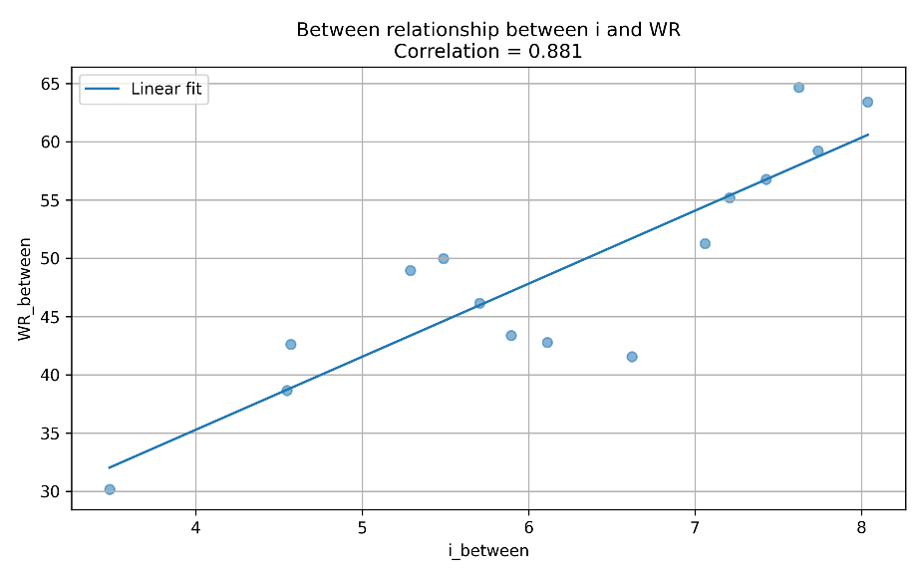

The bivariate graphs show that the relationship between WR and i changes after transformation. The between correlation is strongly positive, 0.881, meaning that countries with higher average short-term interest rates also tend to have higher average real wages. However, the within correlation is weakly negative, -0.105. The negative sign is more consistent with the idea that tighter monetary policy may reduce real wages, but the simple correlation is weak and should not be interpreted causally.

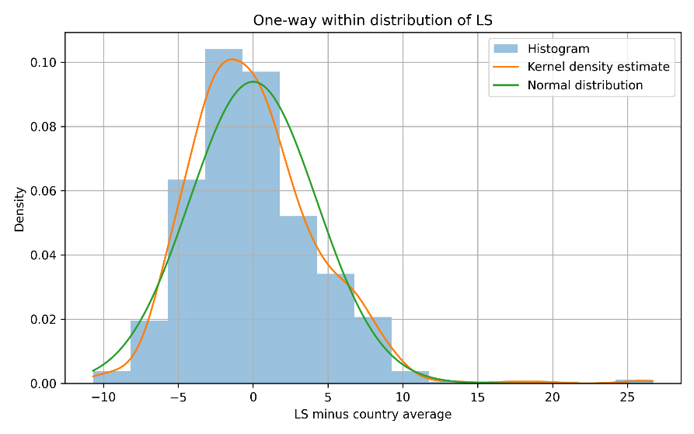
LABOR SHARE, LS
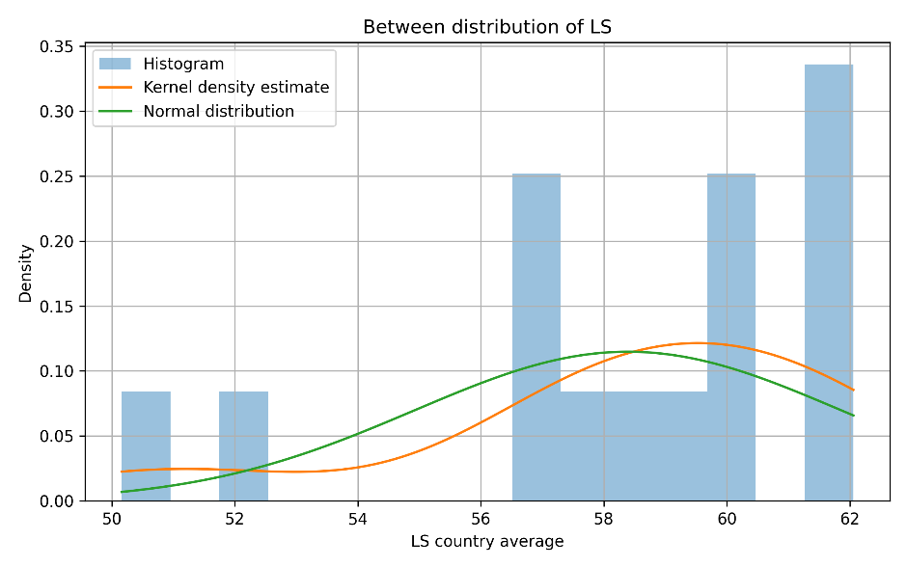

The one-way within distribution of LS is also centered around zero, but it is less extreme than the within distribution of WR. Most deviations are concentrated in a relatively narrow range around zero, although a few large positive observations stand out. The tails are therefore less pronounced than for WR, but the distribution is still not perfectly normal. This suggests that labor share has meaningful within-country variation over time, while being less affected by extreme observations than real wages.
The more concentrated within distribution of LS suggests that pooled panel estimates may be more stable for this variable than for WR, although the presence of some outliers still requires caution.
The between distribution of LS is more concentrated than the between distribution of WR. Most country averages are located around the high 50s and low 60s, although a few countries have lower averages around 50–52. This creates some left-skewness. The KDE does not perfectly match the normal curve, suggesting that the between distribution of labor share is not exactly normal.

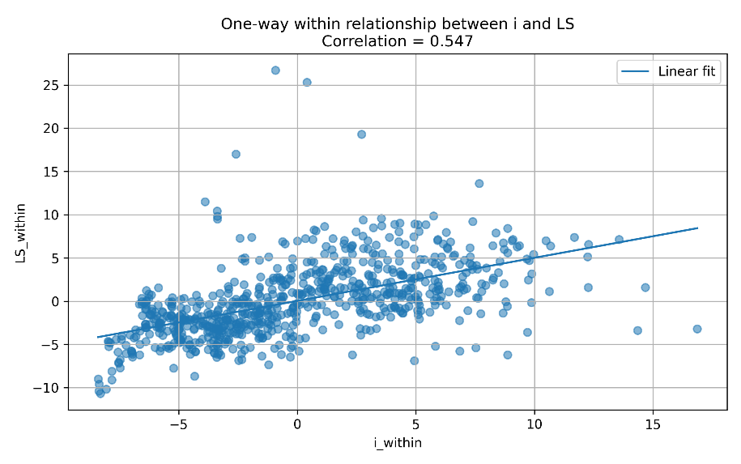
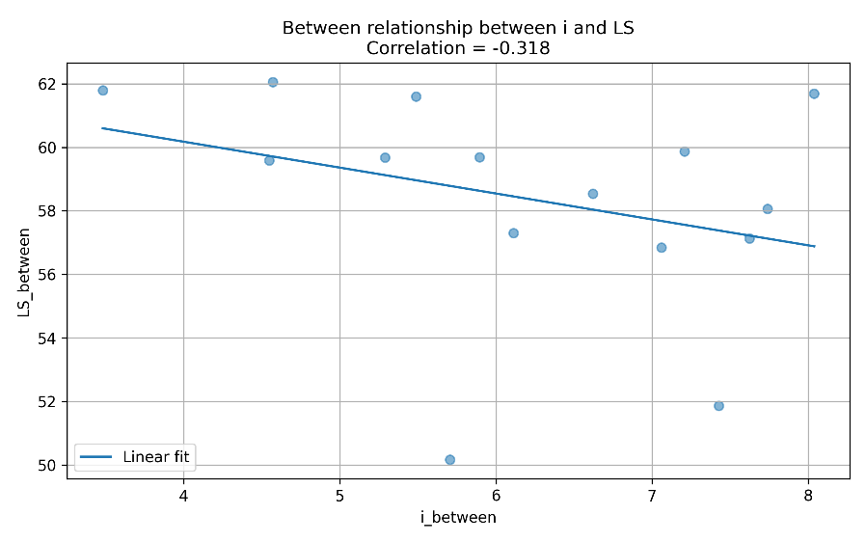

The bivariate graphs again show that the between and within relationships differ. The between correlation between i and LS is negative, -0.318, meaning that countries with higher average interest rates tend to have lower average labor shares. Within countries over time, the correlation turns positive (0.547), this means that, in the simple within-transformed data, higher-than-average interest rates are associated with higher-than-average labor shares.The positive within correlation contradicts the negative PVAR effects in the paper, a sign that dynamics and controls matter.

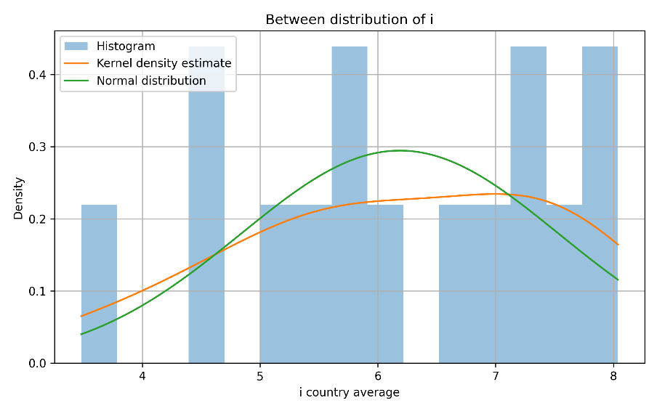
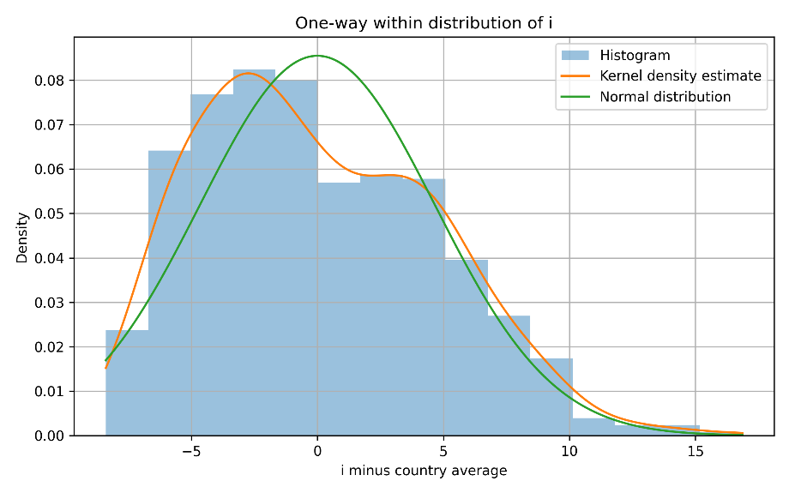
SHORT TERM INTEREST RATE, i

The within distribution of i is centred near zero but is slightly asymmetric. Most deviations fall in the [−8, +8] range, with a few spikes above 10 in high-inflation episodes. This confirms that the short-term interest rate has substantial within-country time variation. The non-normality is expected because monetary policy changed sharply in some periods.
Country averages span roughly 4 to 8, a narrower band than the within variation. The KDE is flatter than the normal curve, consistent with the different monetary regimes across countries over this period.
The concentration of within variation in the short-term interest rate suggests that monetary policy movements are not evenly distributed over the sample. This motivates checking time-period heterogeneity later in the analysis, especially around episodes such as the early 1980s and the post-2008 low-rate period.

Overall

The between and within transformations tell two different stories about the data. The between transformation captures persistent differences across countries, while the within transformation captures changes over time within countries. The graphs show that the distributions are not perfectly normal, especially for WR, which has a long right tail in the within distribution. This suggests possible high-leverage observations. The bivariate graphs also show that the relationship between the interest rate and the dependent variables depends strongly on the transformation used.

- First differences versus two-way fixed effects univariate and bivariate descriptive statistics after variable transformations (they eliminate deterministic trends).

First differences were computed within each country as x(i,t) minus x(i,t − 1). The variables transformed in the first differences are LS, WR and i, generating d_LS, d_WR and d_i. Formally, for a generic variable x:
$d_{x}(i,t) = x(i,t) − x(i,t − 1)$
Since the data are sorted by country and year, the first observation of each country must have a missing value for the first difference. This avoids computing an incorrect difference between the last observation of one country and the first observation of the next country. Specifically, for country i at its first observed year t = t1:
$d_{x}(i,t_{1}) = . (missing)$
First difference boundary check around changes of country
Country | Year | LS | d_LS | WR | d_WR | i | d_i
Australia | 1970 | 59.70 | . | 76.12 | . | 7.11 | .
Australia | 1971 | 60.40 | 0.70 | 77.07 | 0.95 | 7.01 | -0.10
Australia | 2019 | 53.40 | 1.10 | 55.53 | -1.43 | 1.34 | -0.60
Belgium | 1970 | 55.40 | . | 26.48 | . | 7.81 | .
Belgium | 1971 | 57.50 | 2.10 | 28.44 | 1.97 | 5.00 | -2.80
Belgium | 2019 | 58.90 | -0.20 | 70.04 | 0.18 | -0.36 | -0.03
Canada | 1970 | 59.90 | . | 42.42 | . | 7.45 | .
Canada | 1971 | 60.10 | 0.20 | 42.93 | 0.51 | 4.57 | -2.88
Canada | 2019 | 55.60 | 0.30 | 48.32 | -1.35 | 1.89 | 0.10
Finland | 1970 | 62.20 | . | 38.80 | . | 10.61 | .
Finland | 1971 | 64.50 | 2.30 | 40.09 | 1.28 | 8.09 | -2.53
The table checks the first rows around changes of country in the stacked panel. As expected, d_LS, d_WR and d_i are all missing at each country's first observation.
We now describe the distributions of the first difference transformed variables.
Variable | Observations | Mean | Standard deviation | Min | Max
d_LS | 725 | -0.144 | 1.311 | -6.00 | 9.70
d_WR | 725 | -0.041 | 3.359 | -40.69 | 45.18
d_i | 735 | -0.150 | 1.869 | -7.64 | 7.90

The first difference distributions describe yearly changes in the main variables. For d_LS, d_WR and d_i, we plot the histogram, the kernel density estimate and the corresponding normal distribution with the same mean and standard deviation.
The three distributions are centered close to zero, which is expected because first differences remove country specific levels and focus on year to year changes. Both correlations stay close to zero in absolute terms (0.009 and −0.097). Real wages display the largest dispersion, with a standard deviation of 3.359 and values ranging from -40.69 to 45.18. A standard deviation of 3.36 and a range of nearly 86 points suggest Portugal or other high-inflation episodes are driving the extremes. Labor share is more concentrated, with a standard deviation of 1.311, while the short term interest rate also shows substantial yearly variation, with a standard deviation of 1.869.
The first-differenced variables preserve enough time variation to be useful, but the large range of d_WR from −40.69 to 45.18 warrants closer inspection before any regression.
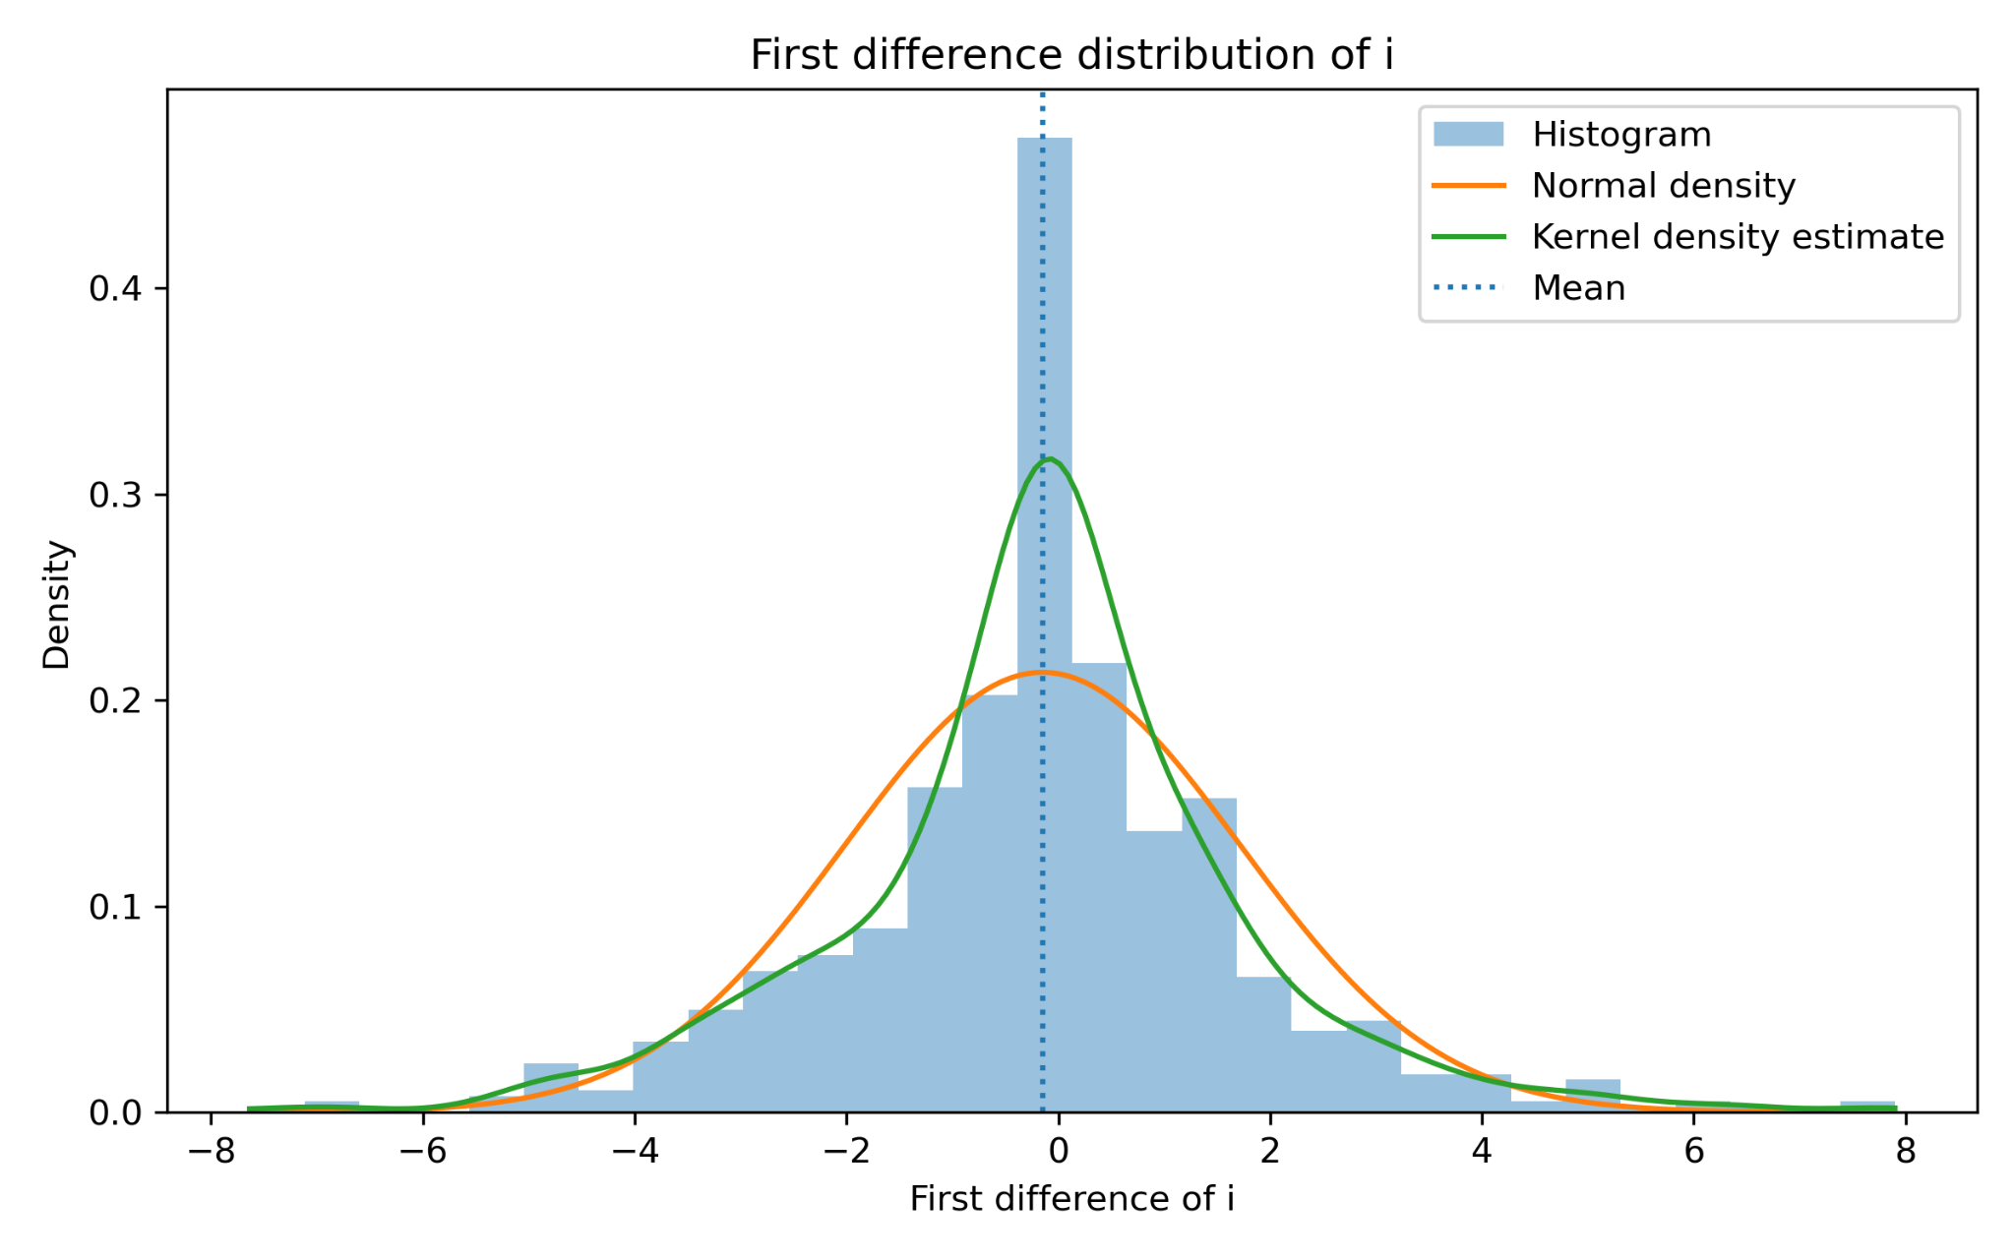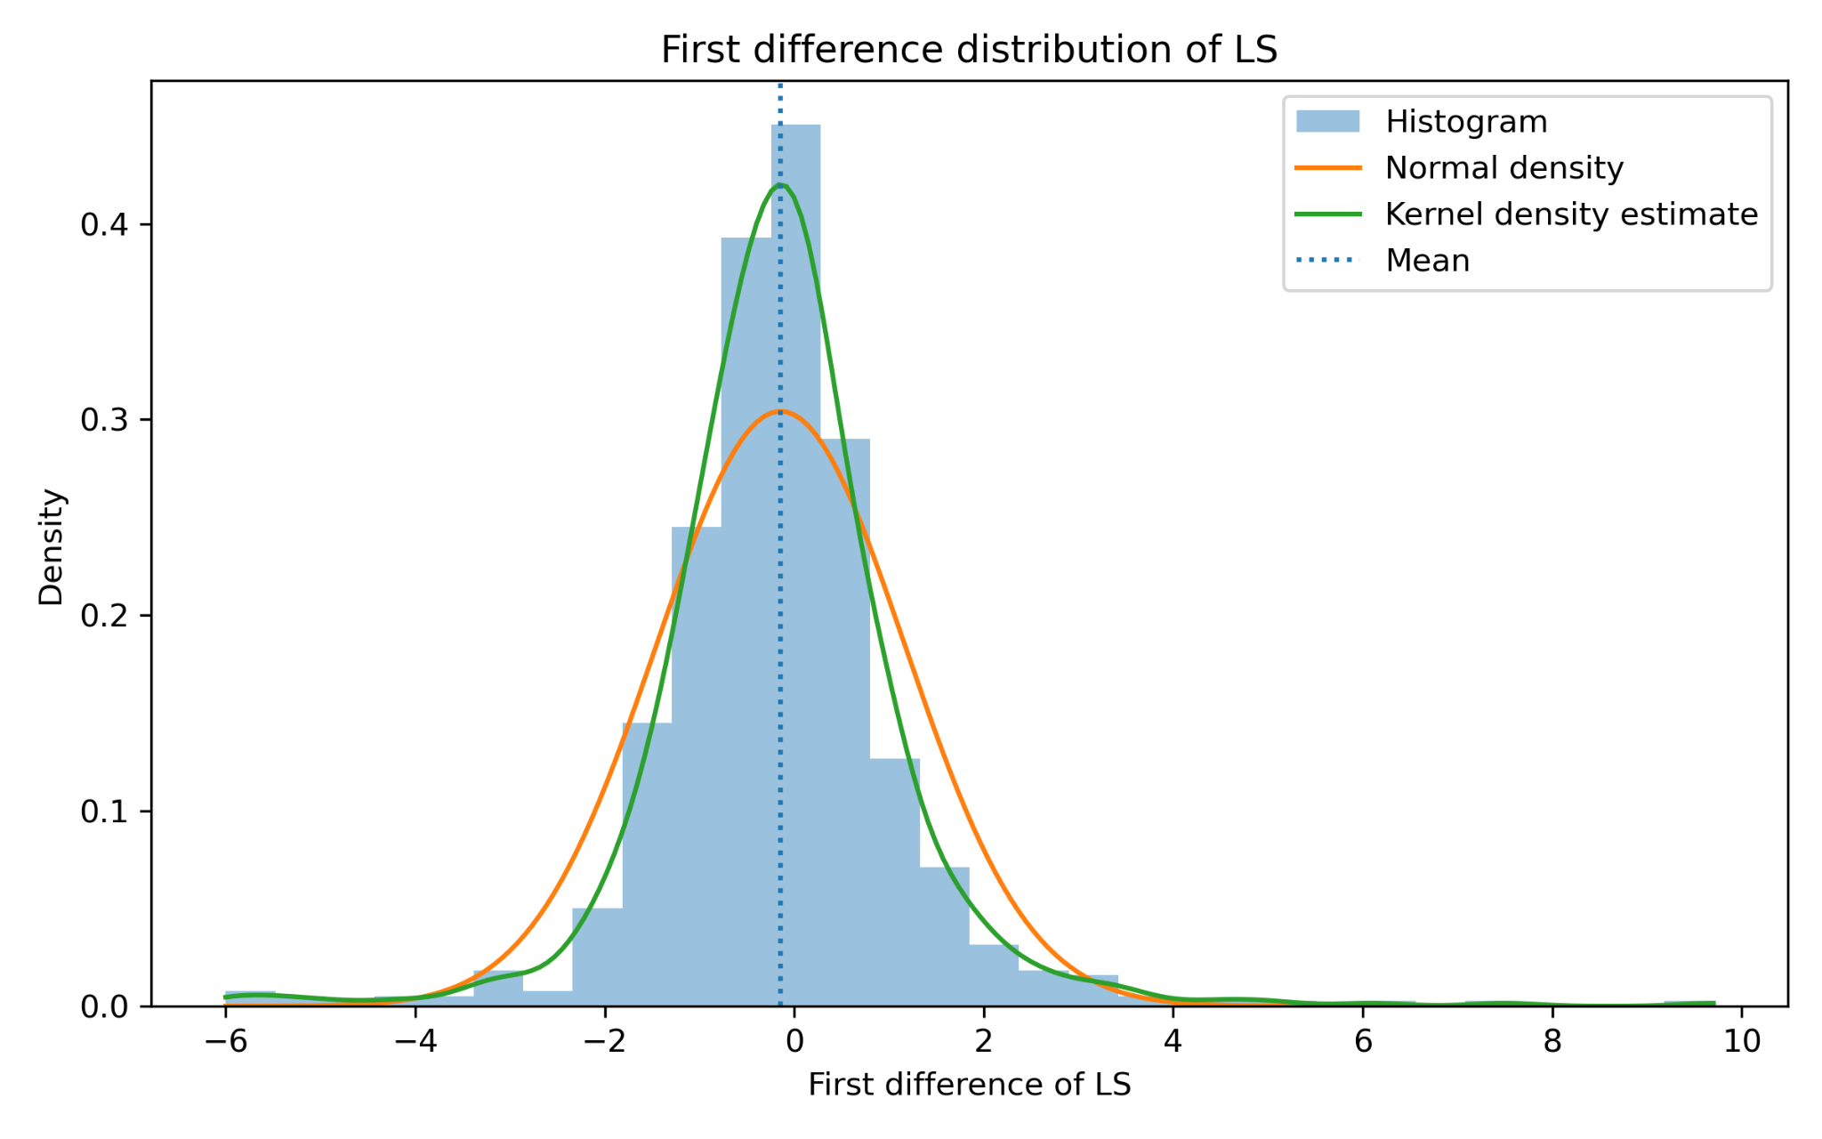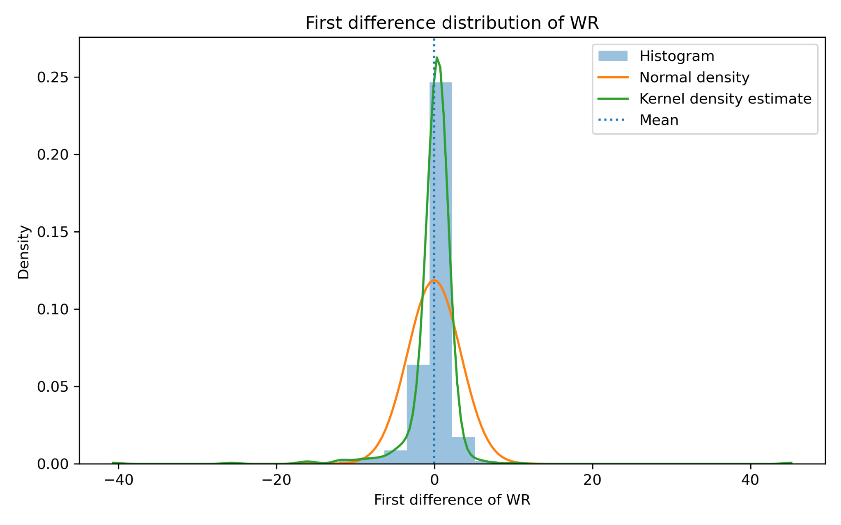
We next examine the simple bivariate relationship between the first difference transformed monetary policy variable and the first difference transformed dependent variables. The scatter plots report the cloud of points, a fitted regression line, the marginal distributions and the simple correlation coefficient.
The first-difference correlation between d_i and d_LS is 0.009, for practical purposes, no bivariate relationship
The simple first difference correlation between d_i and d_WR is -0.097. This relationship is still weak, but it is slightly more negative than for labor share. Therefore, yearly increases in the interest rate are weakly associated with lower yearly changes in real wages.
Like the one-way within transformation, first differences rely on within-country variation over time rather than persistent cross-country differences. The difference is that first differences focus on year-to-year changes, while the within transformation focuses on deviations from each country's average. In our case, the first difference correlations remain small in absolute value, suggesting that the bivariate relationship between monetary policy and the distribution variables is weak before moving to richer panel specifications.

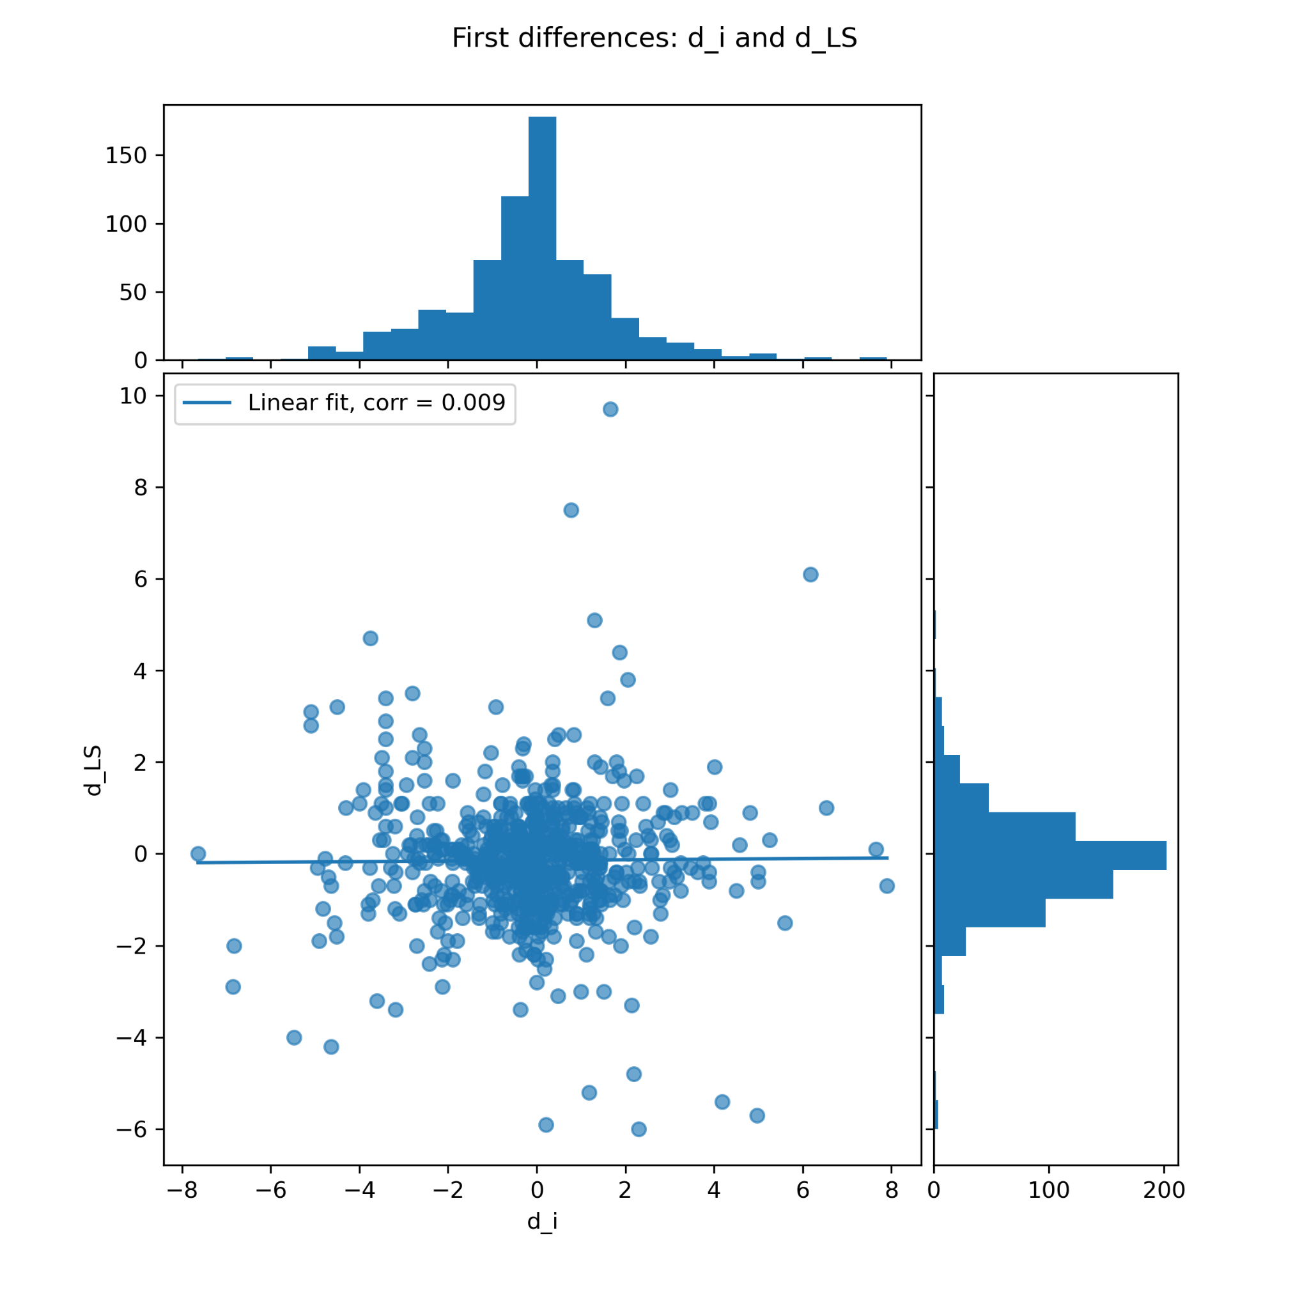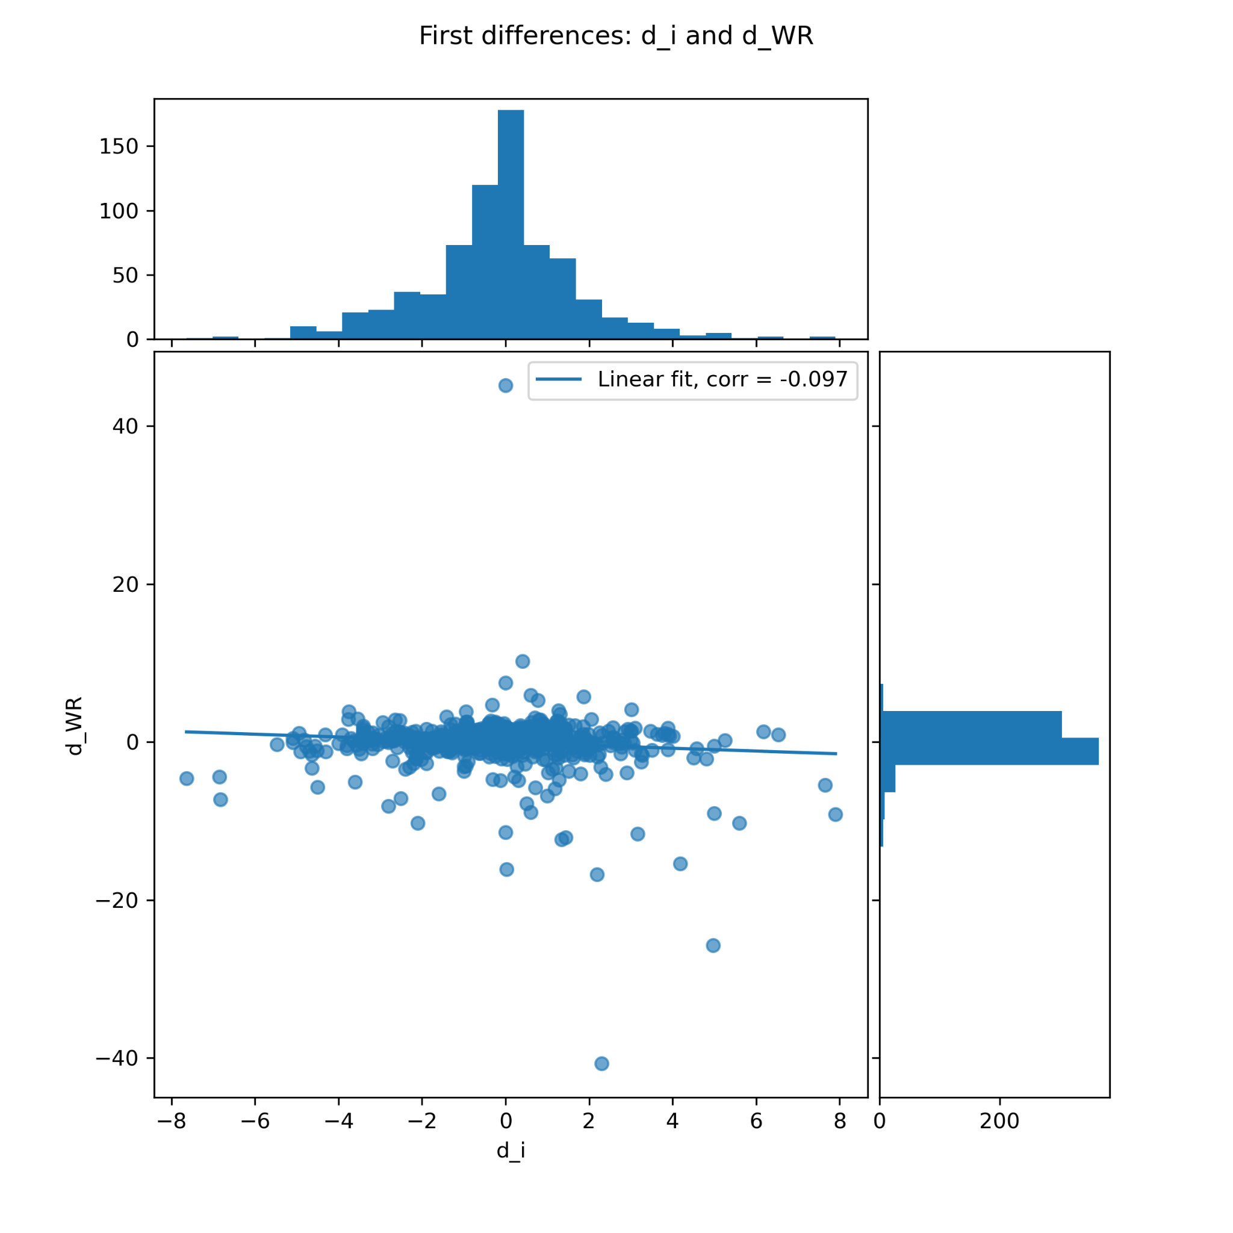
For the balanced two way fixed effects transformation, we restrict the sample to the countries observed over the longest common time span. The balanced sample contains 14 countries observed over 50 years, from 1970 to 2019, giving 700 observations.
Table. Balanced sample used for the two way fixed effects transformation
Item | Value
Number of countries | 14
Number of years | 50
Period | 1970 to 2019
Total observations | 700
Excluded country | Japan
Reason for exclusion | WR and LS start in 1980
TWFE formula | $x(i,t) − x(i.) − x(.t) + x(..)$

The two-way fixed effects (TWFE) transformation is computed as:
$x̃(i,t) = x(i,t) − x̅(i.) − x̅(.t) + x̅(..)$
In this notation, $x̅(i.)$ is the country average, $x̅(.t)$ is the year average and $x̅(..)$ is the grand mean. Therefore, this transformation removes both country-specific average levels and common yearly shocks.
Before computing the full TWFE transformed variables, the time component removed by the transformation is computed as:
$− x̅(.t) + x̅(..)$
This component shows the common yearly movement that is removed from all countries in the balanced sample. For the short-term interest rate, this is important because monetary policy conditions may share common international movements over time, especially during inflationary or disinflationary periods.
Table. Summary of the common yearly component removed from i by the TWFE transformation
Statistic | Value
Number of years | 50
Period | 1970 to 2019
Minimum value | -8.37
Year of minimum | 1981
Maximum value | 6.24
Year of maximum | 2017
First year value, 1970 | -1.19
Last year value, 2019 | 6.06
Figure. Common yearly component removed from i by the TWFE transformation
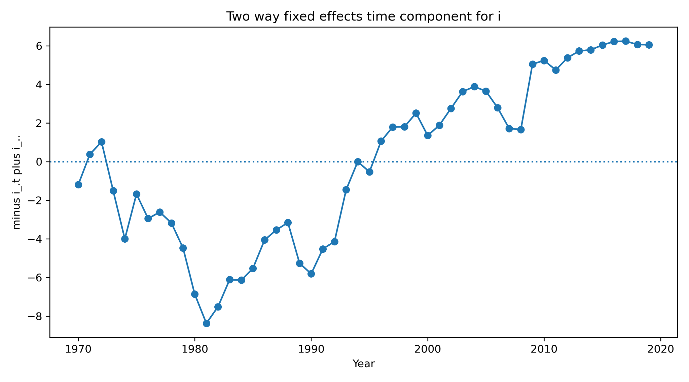
The figure shows that the time component is not constant over the sample. The time component varies strongly over the sample, with an extreme value in 1981 and another extreme value in 2017. These dates are consistent with major international monetary-policy regimes, including the high-interest-rate disinflation period of the early 1980s and the post-crisis low-rate environment. This confirms that common year effects are important.
After computing the full two way fixed effects transformation, we compute descriptive statistics for the transformed variables LS, WR and i. The TWFE transformed variables are centered around zero by construction, since the transformation removes both country averages and year averages.
Variable | Observations | Mean | Standard deviation | Min | Max
twfe_LS | 700 | 0.000 | 2.573 | -9.44 | 19.21
twfe_WR | 700 | 0.000 | 16.766 | -33.78 | 117.01
twfe_i | 700 | 0.000 | 1.943 | -6.59 | 10.73
The dispersion differs sharply across variables: WR's standard deviation of 16.77 is nearly nine times that of i and values ranging from minus 33.78 to 117.01. Labor share is much more concentrated, with a standard deviation of 2.573. The short term interest rate has a standard deviation of 1.943, with values ranging from minus 6.59 to 10.73.
The boxplots by country are ordered by the variance of each transformed variable, from the smallest to the largest. They show that the TWFE transformation removes deterministic country and time components, but it does not eliminate country heterogeneity in dispersion. For the short term interest rate, Portugal, Spain and Germany appear among the most dispersed countries. For labor share, Portugal and Belgium show the largest dispersion. For real wages, Portugal is clearly the most extreme case, followed by Italy and Belgium. Therefore, some countries may contribute more strongly to the variance of the transformed variables even after removing country and year averages.
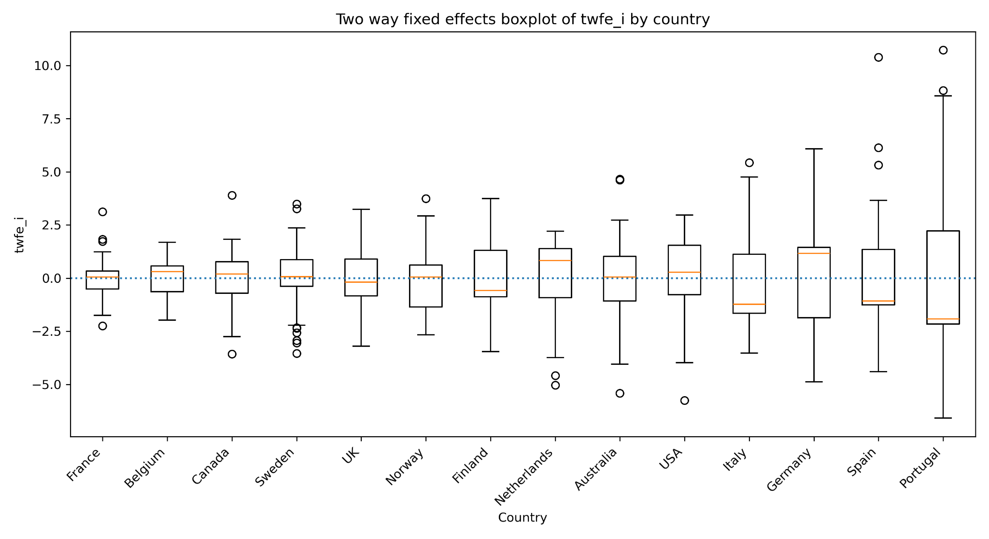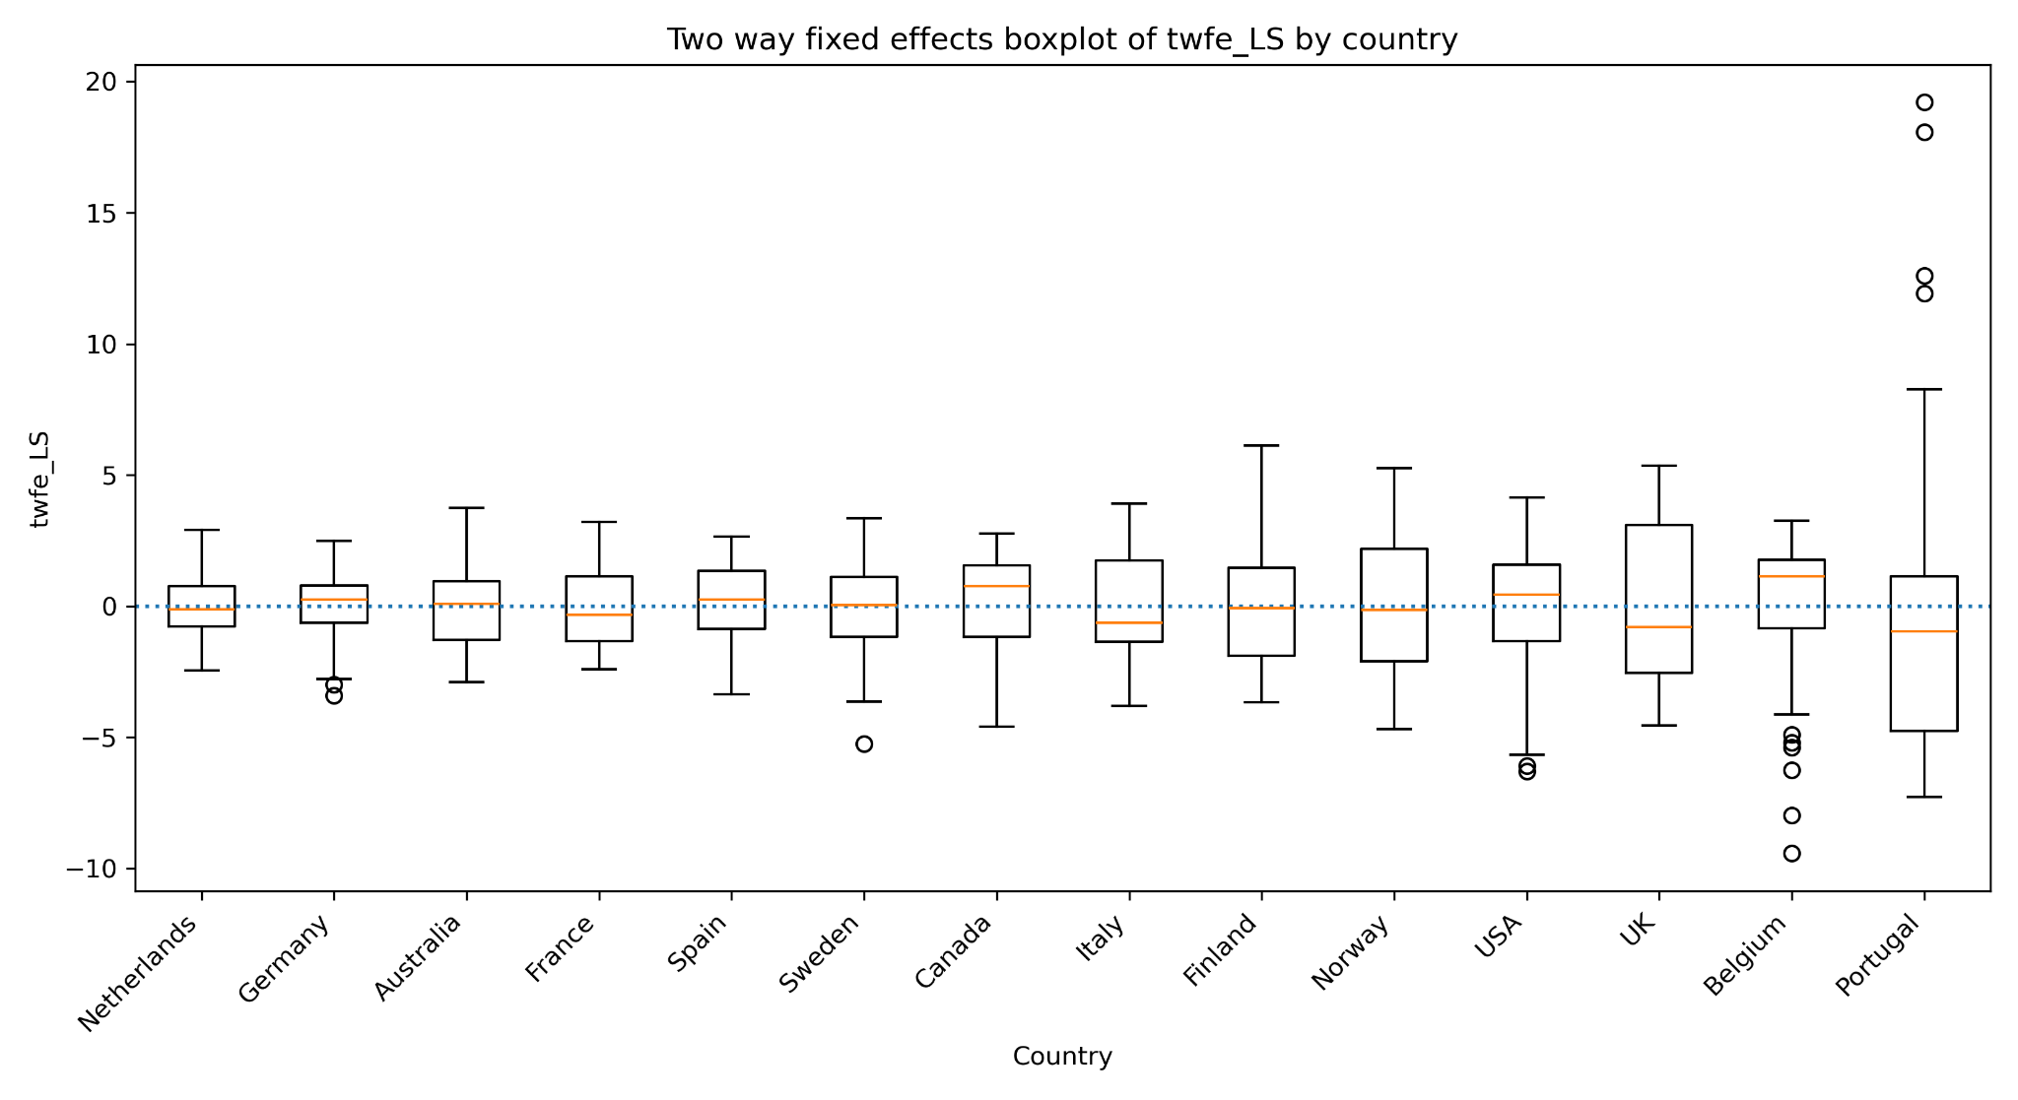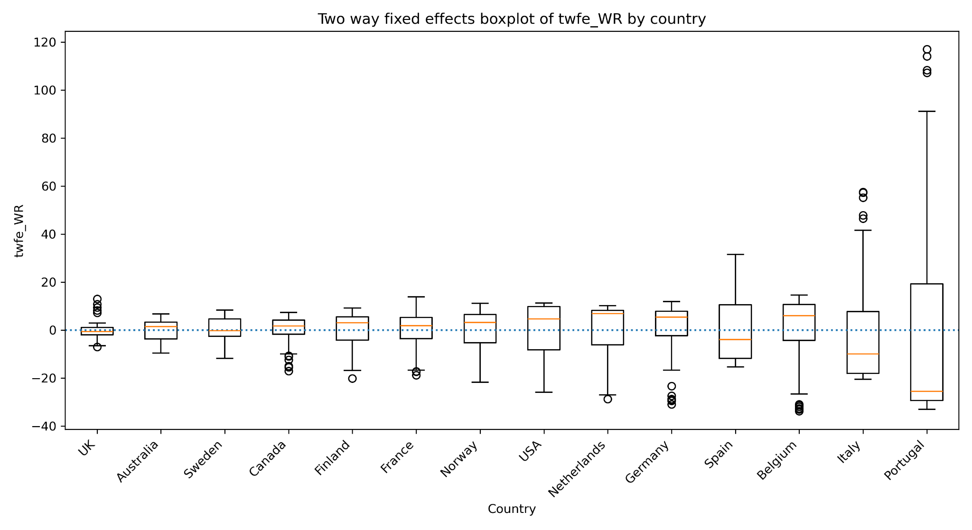

We finally compute country specific simple correlations between the TWFE transformed interest rate and each TWFE transformed dependent variable. In the notation of the template, the dependent variable Y corresponds here to LS or WR, while the preferred explanatory variable X corresponds to the short term interest rate i.
For each country, the table reports the number of observations, the simple correlation coefficient, the standard deviation of the TWFE transformed dependent variable, the standard deviation of the TWFE transformed interest rate, and the implied simple regression slope. The slope is computed as the correlation coefficient multiplied by the ratio of the standard deviation of Y to the standard deviation of i.
Table. Country specific TWFE correlations between i and LS

Country | N | Correlation | Std. dev. of LS | Std. dev. of i | Simple slope
Finland | 50 | 0.584 | 2.318 | 1.618 | 0.837
Italy | 50 | 0.480 | 2.172 | 2.180 | 0.478
Norway | 50 | 0.415 | 2.430 | 1.522 | 0.663
Spain | 50 | 0.369 | 1.668 | 2.538 | 0.242
USA | 50 | 0.236 | 2.441 | 1.974 | 0.292
Germany | 50 | 0.186 | 1.279 | 2.431 | 0.098
Sweden | 50 | 0.178 | 1.833 | 1.464 | 0.222
UK | 50 | 0.125 | 2.921 | 1.466 | 0.249
Belgium | 50 | 0.118 | 2.938 | 0.968 | 0.357
Australia | 50 | 0.065 | 1.437 | 1.905 | 0.049
Canada | 50 | -0.021 | 2.010 | 1.264 | -0.034
France | 50 | -0.119 | 1.470 | 0.924 | -0.190
Portugal | 50 | -0.282 | 6.152 | 3.616 | -0.479
Netherlands | 50 | -0.474 | 1.208 | 1.884 | -0.304

Table. Country specific TWFE correlations between i and WR

Country | N | Correlation | Std. dev. of WR | Std. dev. of i | Simple slope
Italy | 50 | 0.304 | 23.841 | 2.180 | 3.324
Sweden | 50 | 0.223 | 5.037 | 1.464 | 0.766
UK | 50 | 0.214 | 4.100 | 1.466 | 0.598
Netherlands | 50 | 0.191 | 12.667 | 1.884 | 1.288
USA | 50 | 0.139 | 12.463 | 1.974 | 0.875
Spain | 50 | 0.115 | 14.112 | 2.538 | 0.638
Belgium | 50 | 0.059 | 15.170 | 0.968 | 0.918
Germany | 50 | -0.061 | 12.972 | 2.431 | -0.325
Canada | 50 | -0.109 | 6.294 | 1.264 | -0.541
Portugal | 50 | -0.184 | 46.880 | 3.616 | -2.391
Norway | 50 | -0.205 | 9.445 | 1.522 | -1.271
Australia | 50 | -0.262 | 4.736 | 1.905 | -0.650
France | 50 | -0.337 | 8.598 | 0.924 | -3.133
Finland | 50 | -0.402 | 7.933 | 1.618 | -1.971

The country specific correlations reveal substantial heterogeneity. For LS, the largest positive correlations are found in Finland, Italy and Norway, while the most negative correlation appears in the Netherlands. For WR, Italy, Sweden and the UK show positive correlations, while Finland and France show the most negative correlations.
The simple slopes also show that the magnitude of the bivariate relationship depends not only on the correlation, but also on the relative dispersion of the dependent variable and the interest rate. For example, Italy has the largest positive WR slope, while France has the largest negative WR slope. Portugal also has a large negative slope for WR, partly because the TWFE transformed real wage variable is very volatile in Portugal.
Aggregate TWFE correlations mask a wide range of country-level signs from +0.584 in Finland to −0.474 in the Netherlands for LS alone. Finland and Norway with positive LS correlations, Netherlands and Portugal with negative ones directly motivate testing whether a pooled estimator is appropriate, or whether the sample should be split before interpreting aggregate results.
We also compute the TWFE transformation on the unbalanced panel. This step keeps all available countries, including Japan, instead of restricting the sample to the 14 countries observed over the full 1970 to 2019 period. No country has only one observation, so no country is removed for this reason.

For the unbalanced panel, we do not use directly the balanced formula$x(i,t) − x̅(i.) − x̅(.t) + x̅(..)$
Instead, we follow the residualization approach. First, we compute one way within transformed variables by subtracting country averages. Second, we remove year effects from these within transformed variables by subtracting their yearly averages. This is equivalent to regressing the within transformed dependent variables and the within transformed preferred explanatory variable on year dummies and collecting the residuals.

Table. Unbalanced TWFE sample summary

Item | Value
Number of countries | 15
Minimum number of years by country | 40
Maximum number of years by country | 50
First year | 1970
Last year | 2019
Number of observations | 740
Countries removed because of one observation | None

This approach keeps the interpretation of two way fixed effects clear while using all available observations. The transformed variables capture deviations that are not explained by country averages or common year effects.
We finally plot the distributions of the unbalanced TWFE transformed variables for the two dependent variables, LS and WR, and for the preferred explanatory variable, i. As before, each figure reports the histogram, the kernel density estimate and the corresponding normal distribution with the same mean and standard deviation.
The unbalanced TWFE transformed variables are centered close to zero. Interest rates cluster near zero after transformation, with isolated large positives likely corresponding to the early 1980s for specific countries. The labor share distribution is also centered around zero, but it displays visible tails and a few extreme observations. Real wages show the strongest departure from normality, with a very long right tail and several large outliers.
Compared with the one way within distributions, the unbalanced TWFE transformation removes an additional component of variation, namely the common yearly effect. This makes the transformed variables more directly focused on deviations that are not explained by either country average levels or common time shocks. Compared with the between distributions, the unbalanced TWFE distributions no longer represent persistent cross country differences in average levels. They instead describe the remaining country year variation after both dimensions of fixed effects have been removed.
Adding Japan to the sample does not shift the main findings. The extreme values in WR persist, confirming that the non-normality is not driven by Japan's shorter time series but by a few specific country-year observations common to both samples.

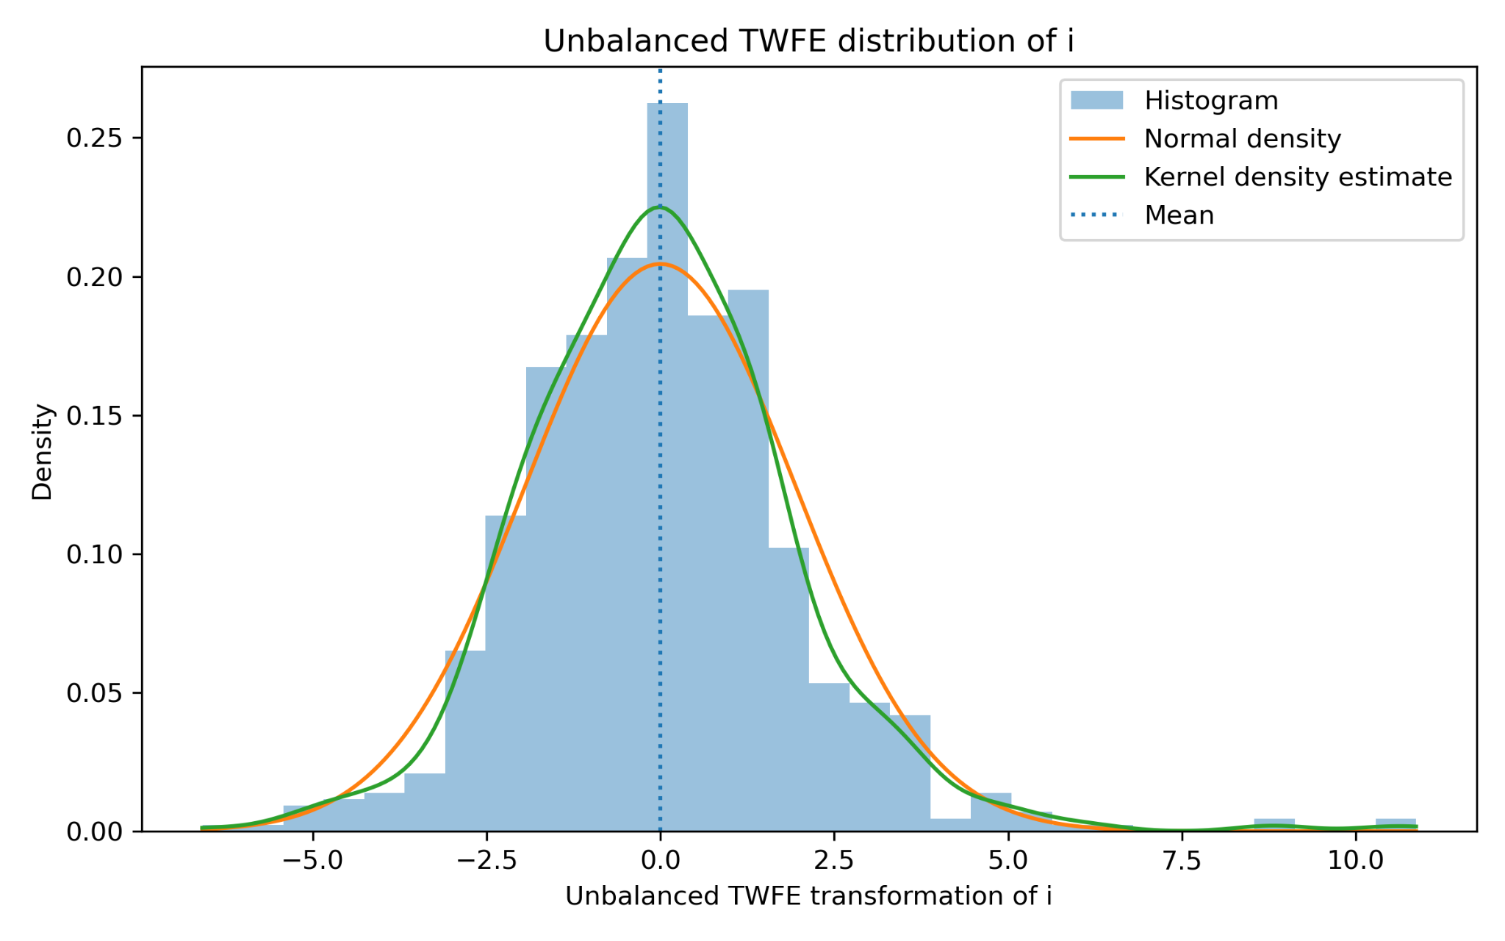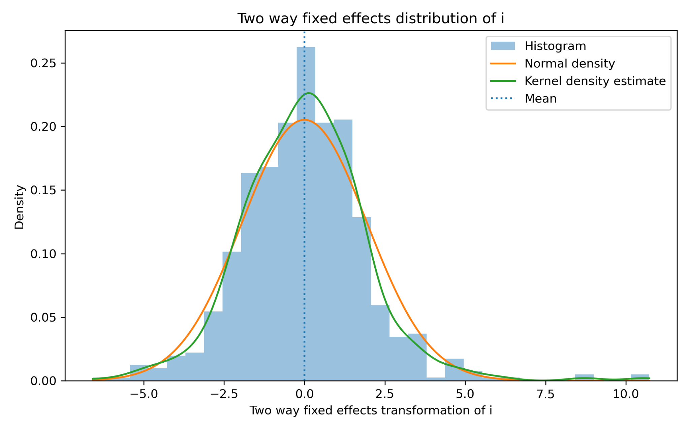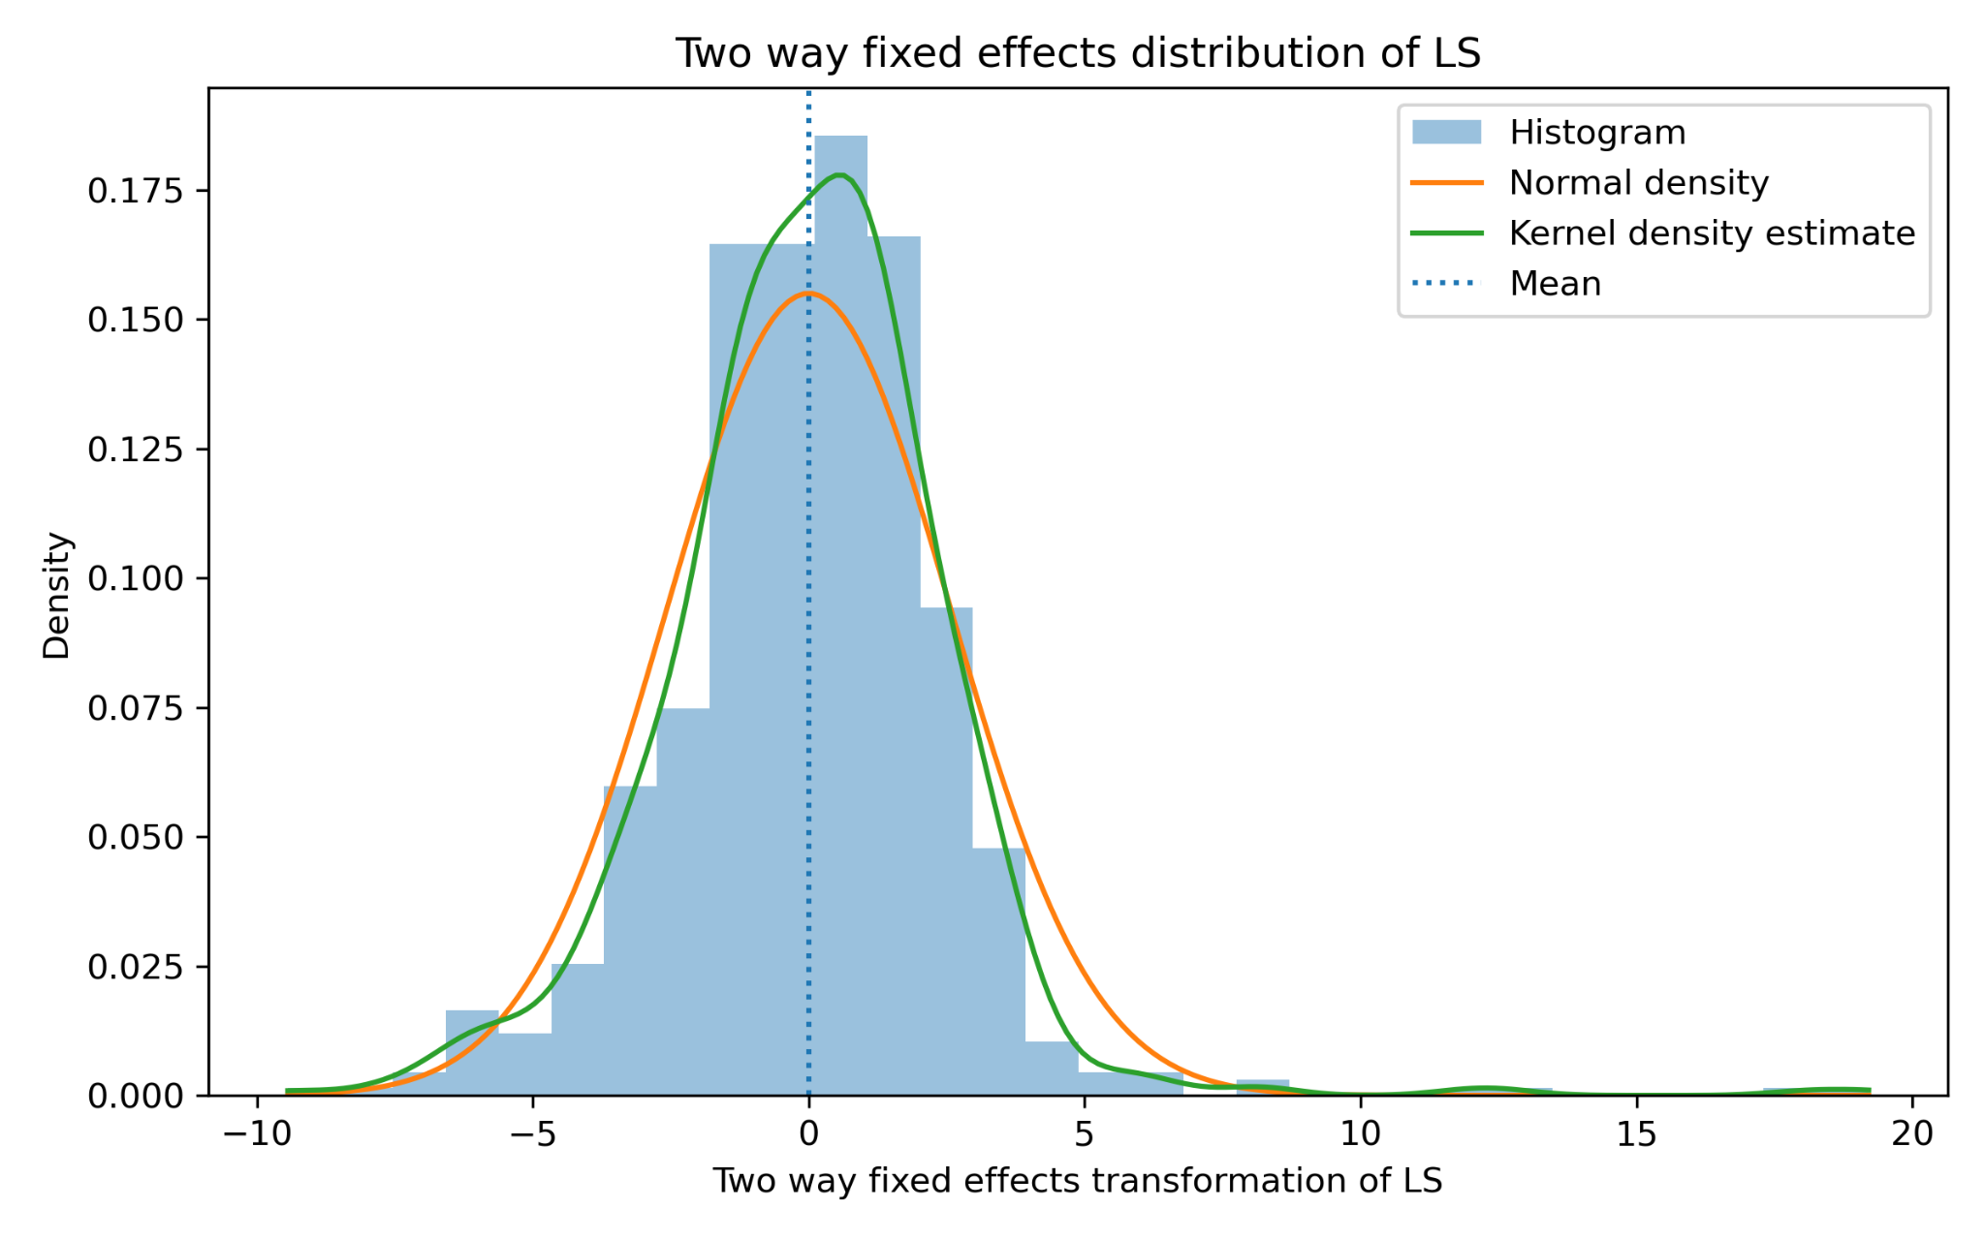

- Comparisons of the four transformed variables (Between, one-way within, two-way within, first differences).

This section compares the four transformed versions of the main variables: the between transformation, the one-way within transformation, the first-difference transformation and the two-way fixed effects transformation. The comparison is carried out for the two dependent variables, real wages (WR) and labor share (LS), and for the preferred explanatory variable, the short-term interest rate (i).

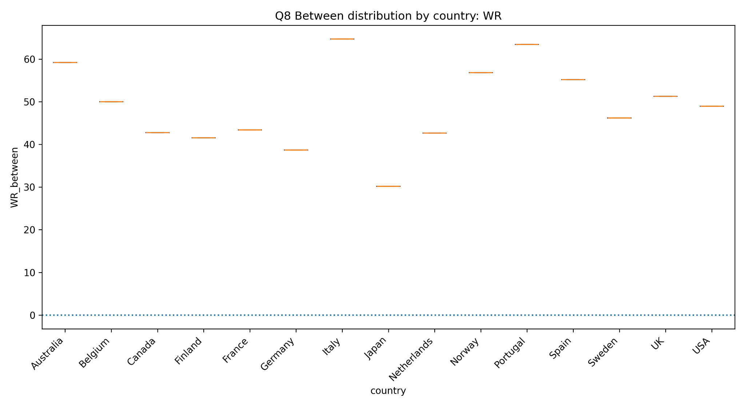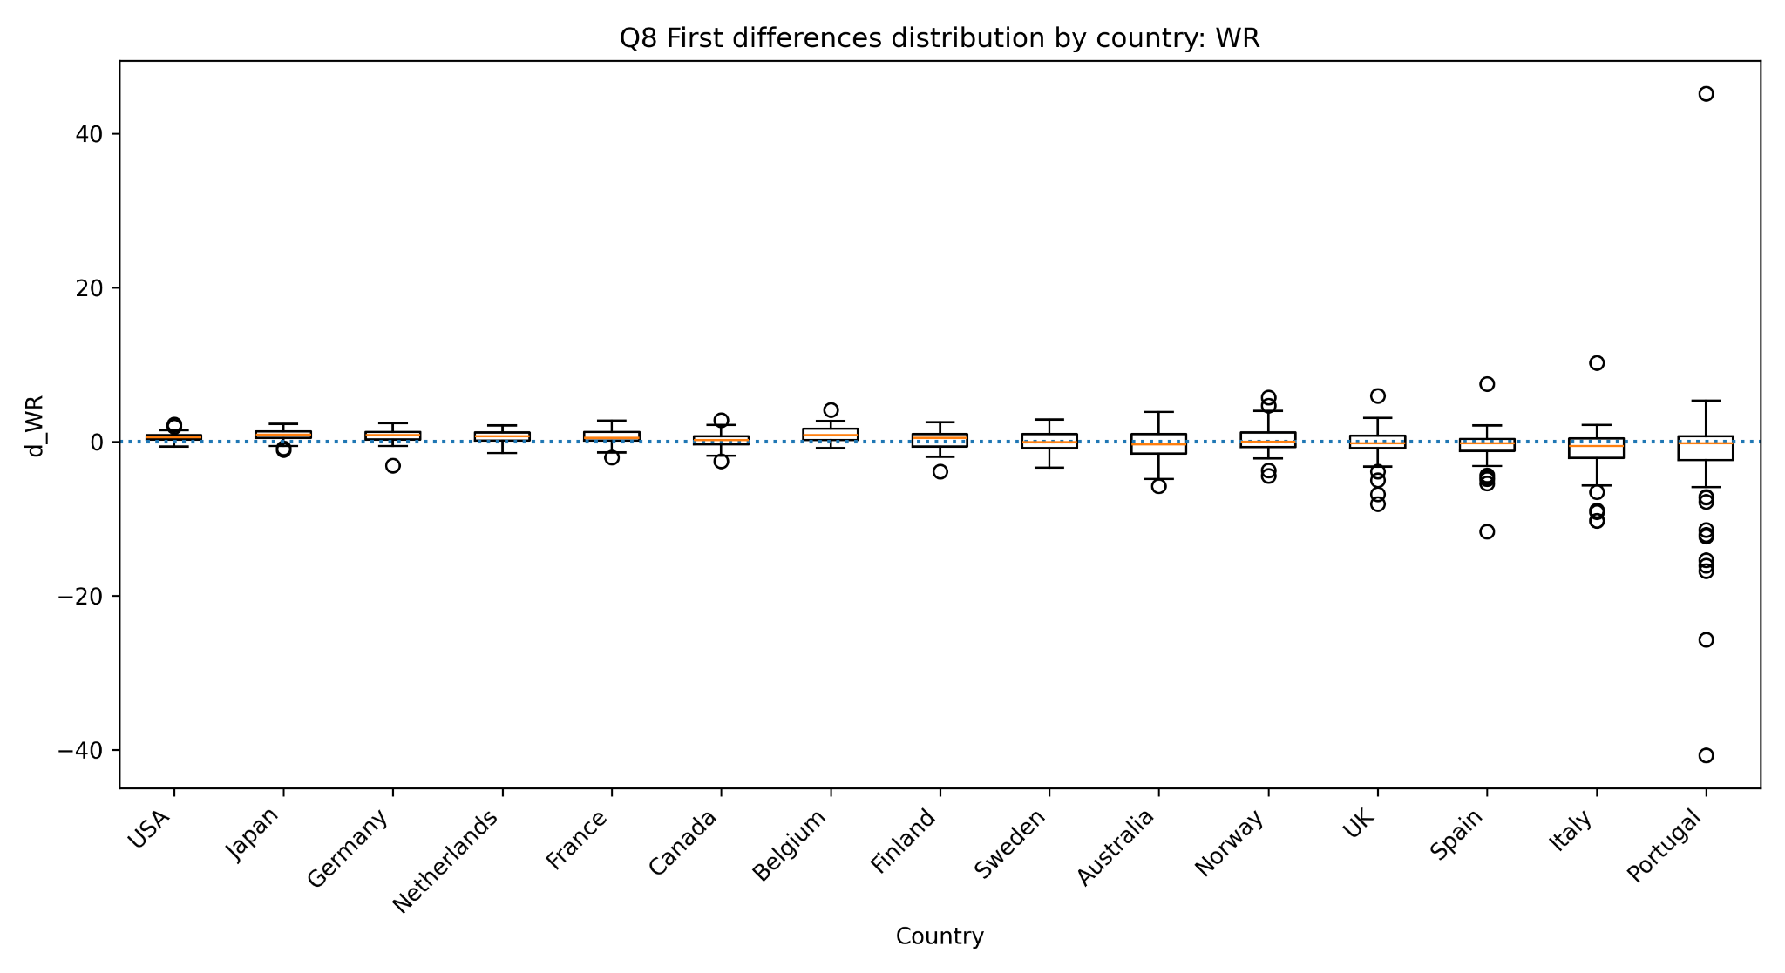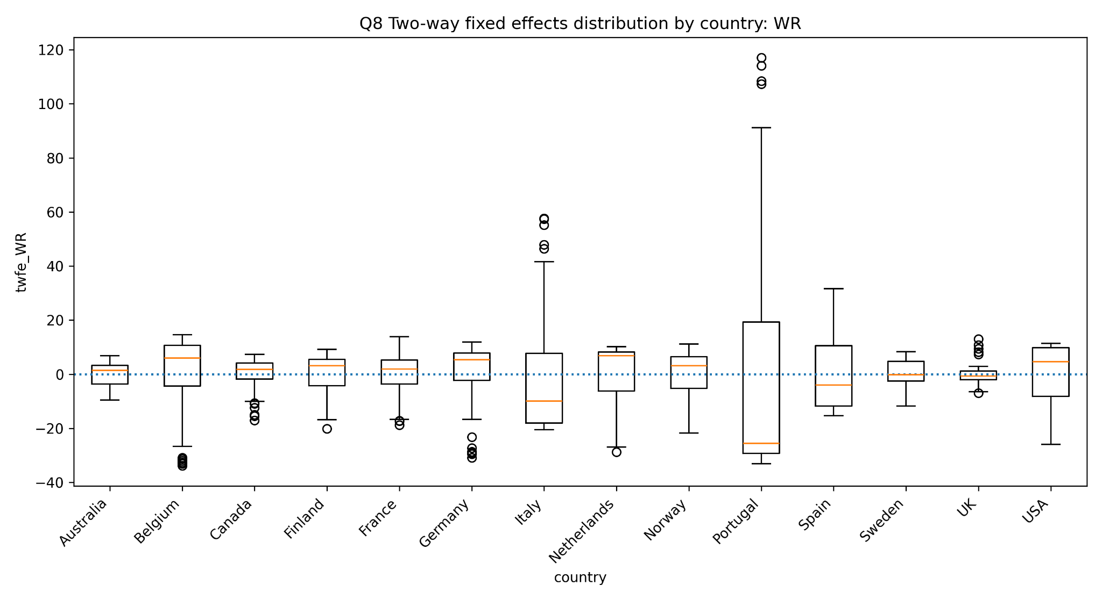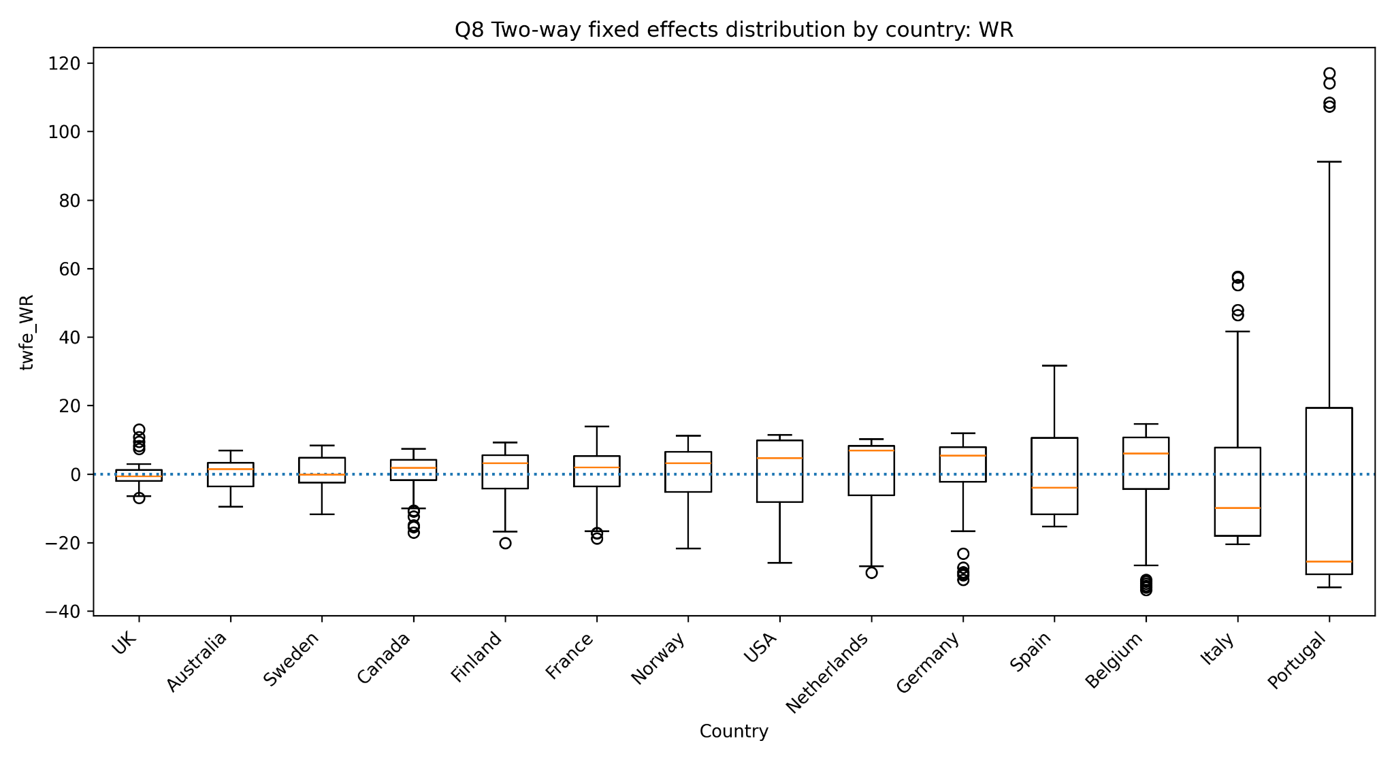

The between transformation captures cross-country differences in average levels. Since it contains one average value per country, it is mainly useful for comparing persistent differences across countries rather than within-country variation. The boxplots show clear differences in average real wages and labor shares across countries. This is consistent with the findings in Question 5, where real wages and labor share had substantial between-country variation, although most of the variation in WR and i came from within-country changes.

The one-way within transformation subtracts country-specific averages and therefore centres each variable around zero. The boxplots show that most countries have distributions concentrated around zero, but the dispersion is not identical across countries. Portugal and Italy remain more volatile for real wages, while labor share is more concentrated. This confirms that removing country effects does not remove all heterogeneity: some countries still have larger deviations from their own long-run averages.

The first-difference transformation focuses on year-to-year changes. These distributions are also centred close to zero, as expected, because they remove persistent country-specific levels. First differences are generally more concentrated than the two-way fixed effects transformation, but they reveal large short-run outliers, especially for real wages. This suggests that annual changes in WR include some extreme country-year movements, which may affect later regression estimates.

The two-way fixed effects transformation removes both country-specific averages and common time effects. The transformed variables are again centred around zero, but the boxplots still show substantial heterogeneity in dispersion across countries. Portugal remains the most extreme case for real wages, with Italy and Belgium also showing relatively large variation. This means that even after removing both country and year effects, some countries contribute disproportionately to the remaining variation.

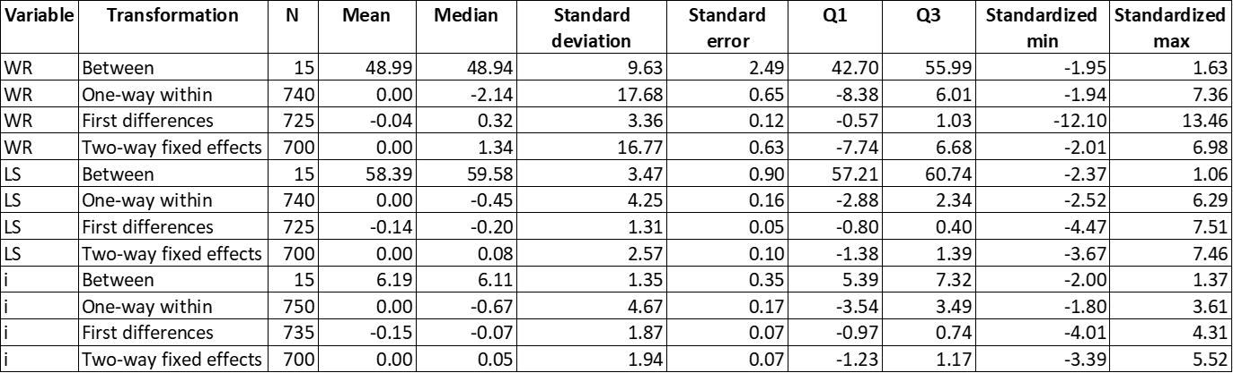

The univariate descriptive statistics confirm the visual evidence from the boxplots. The means of the within and two-way fixed effects transformed variables are very close to zero by construction. The first-difference means are also close to zero, because most annual changes fluctuate around stable long-run paths. The medians are generally close to the means, but the standardized minimum and maximum values show that real wages contain more extreme observations than labor share or interest rates. The standardized extremes are therefore important because they reveal influential observations that are not visible from the mean alone.

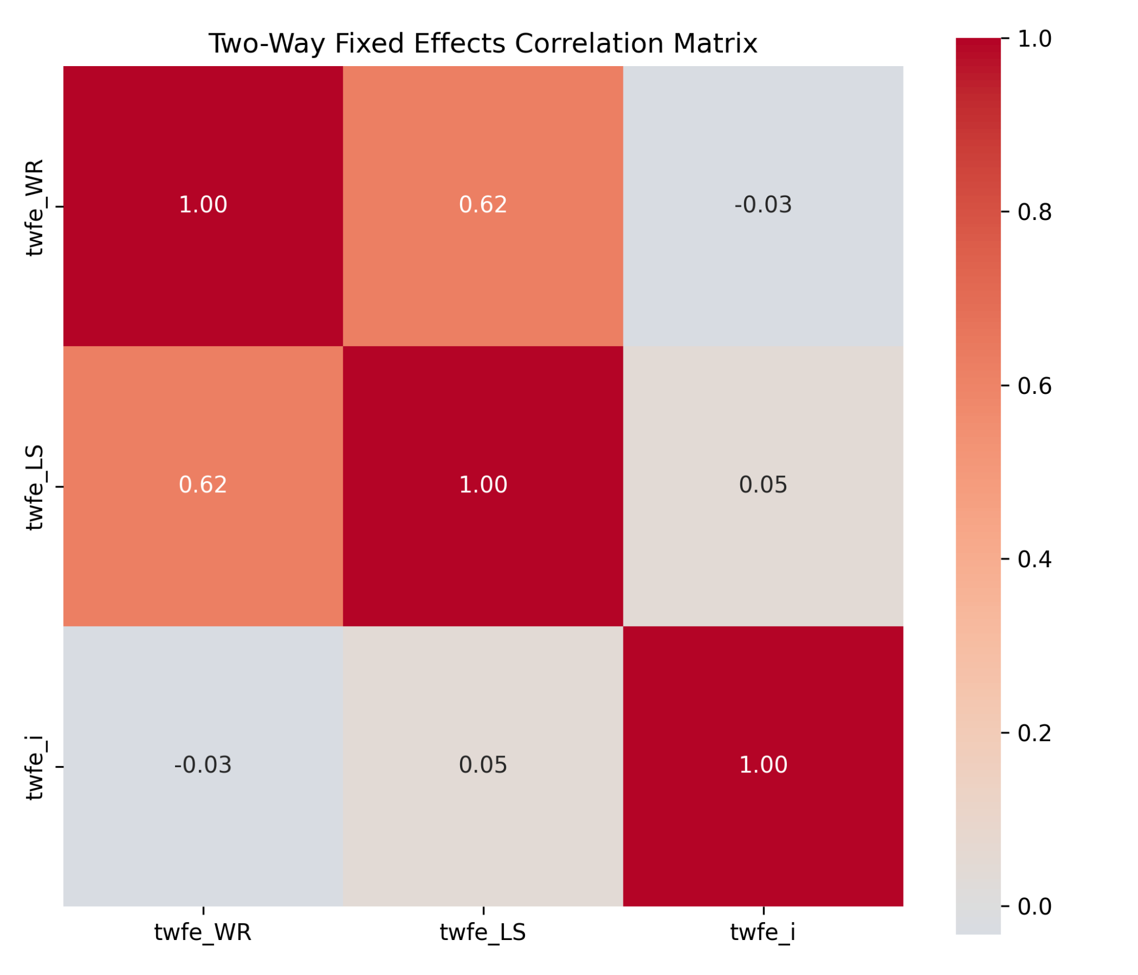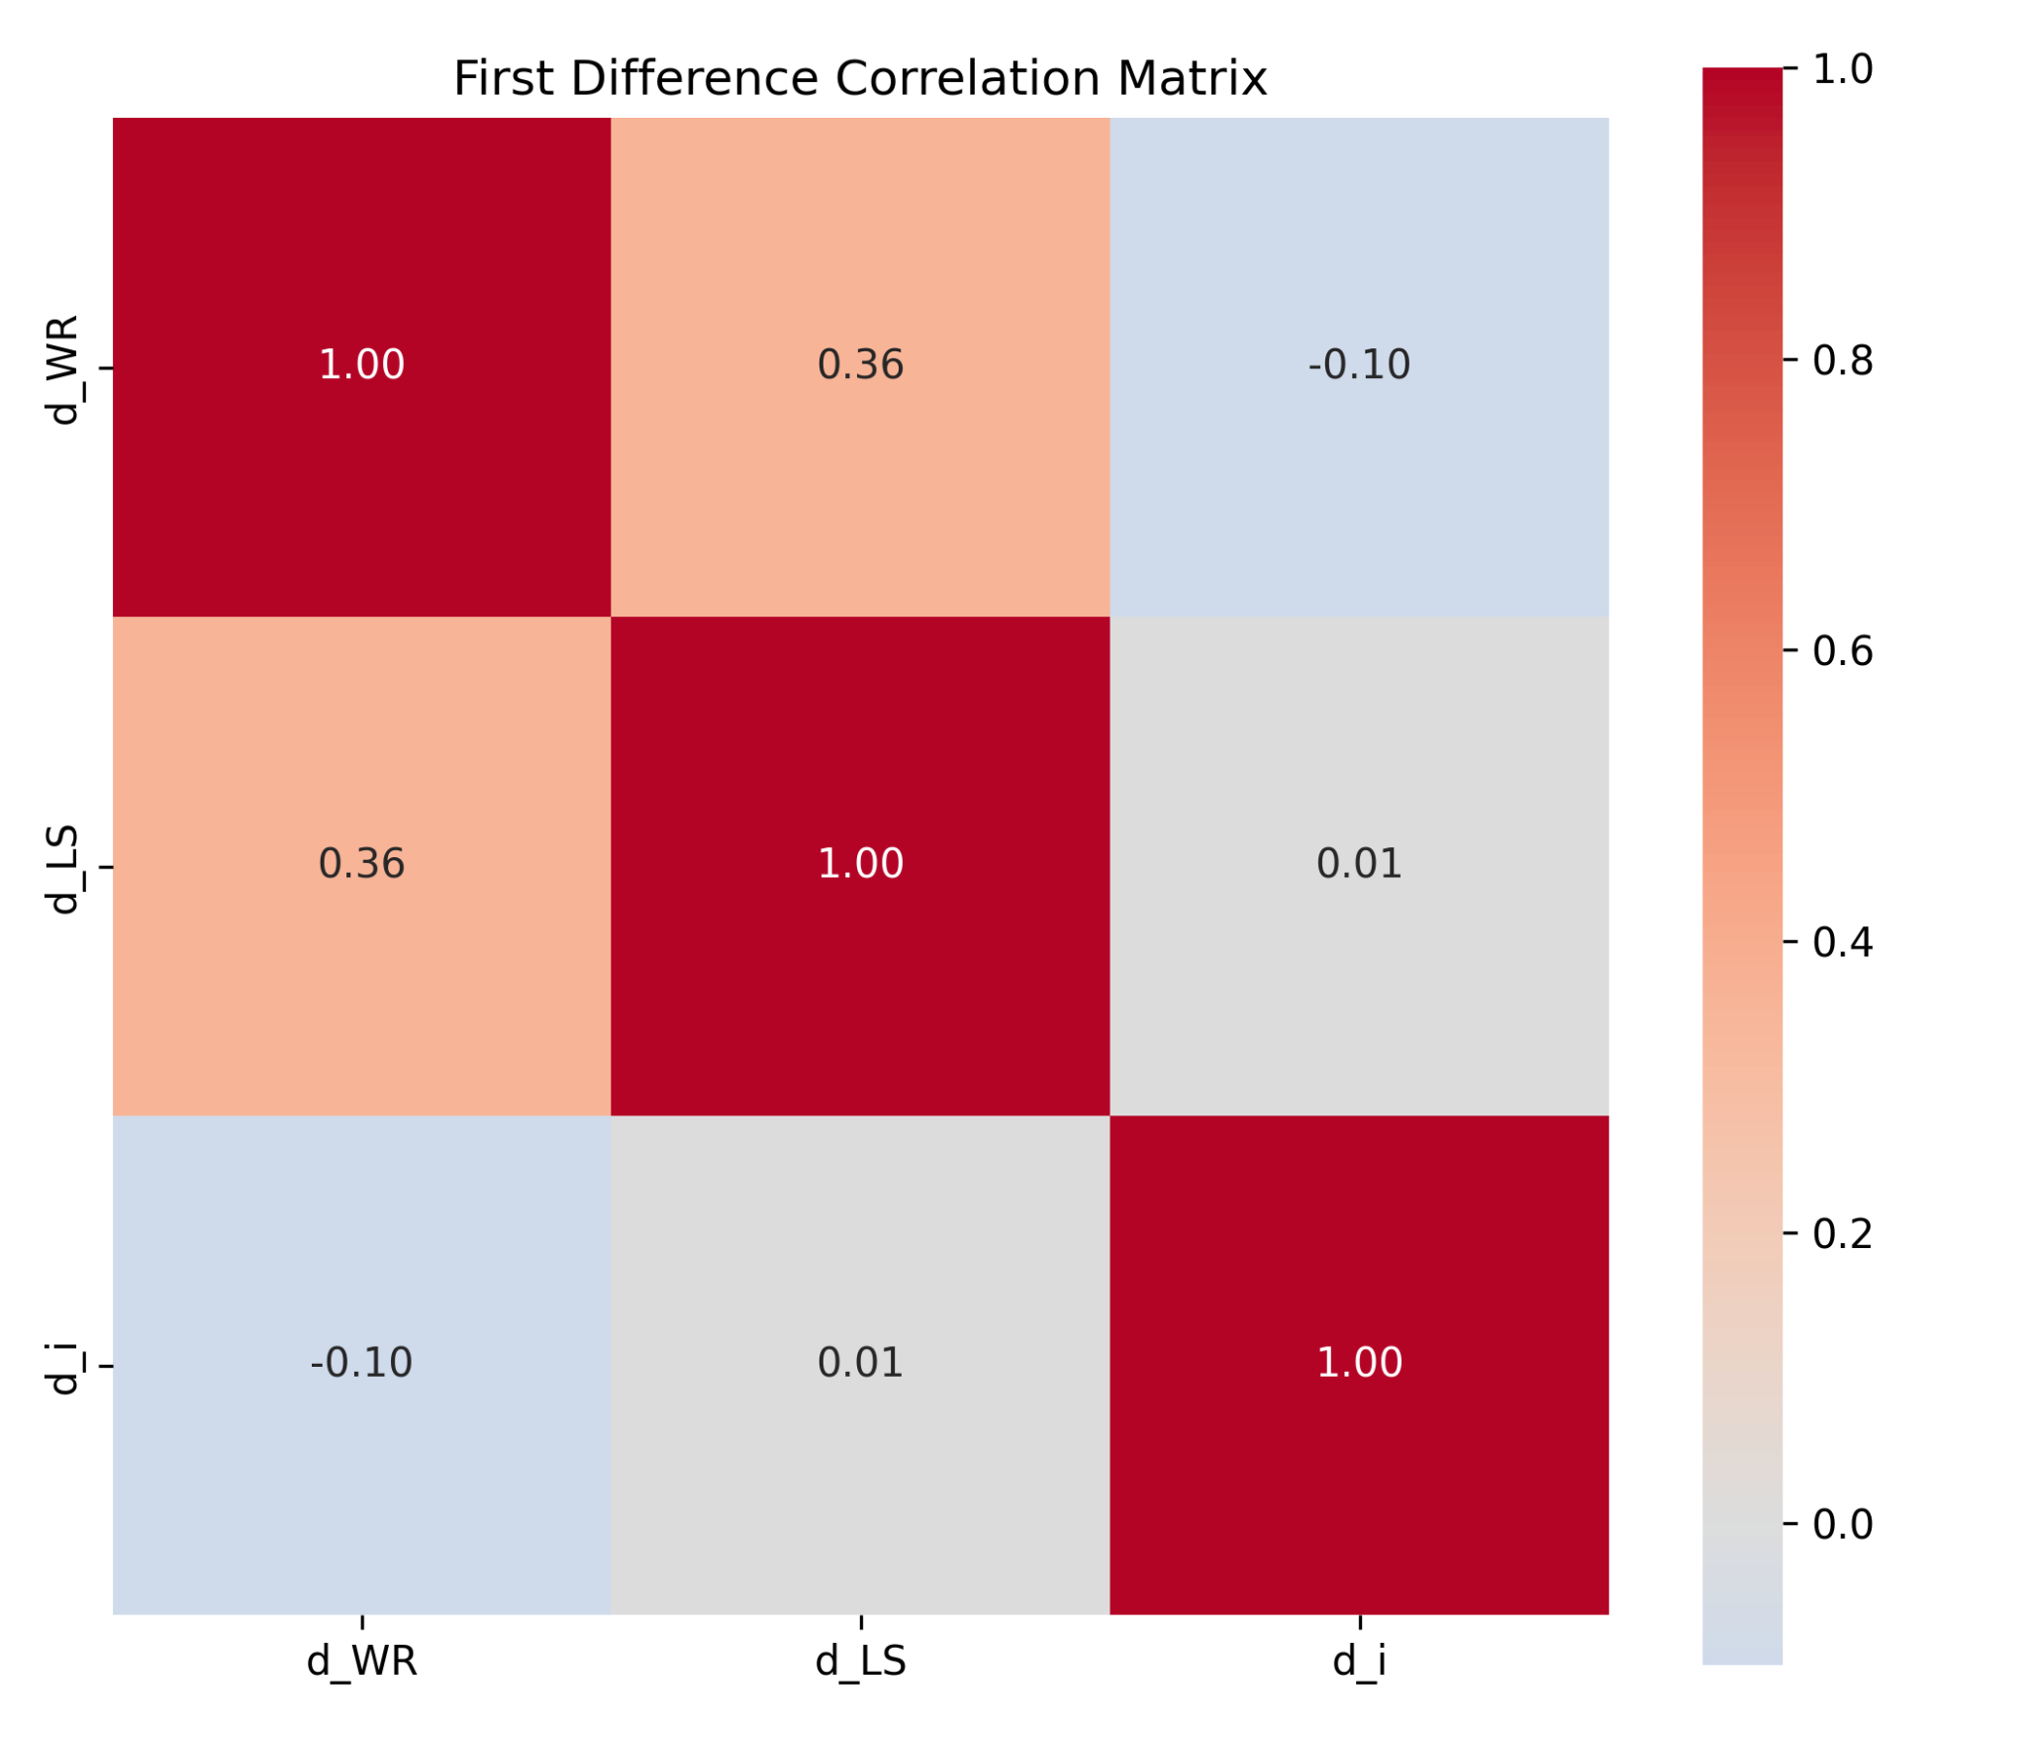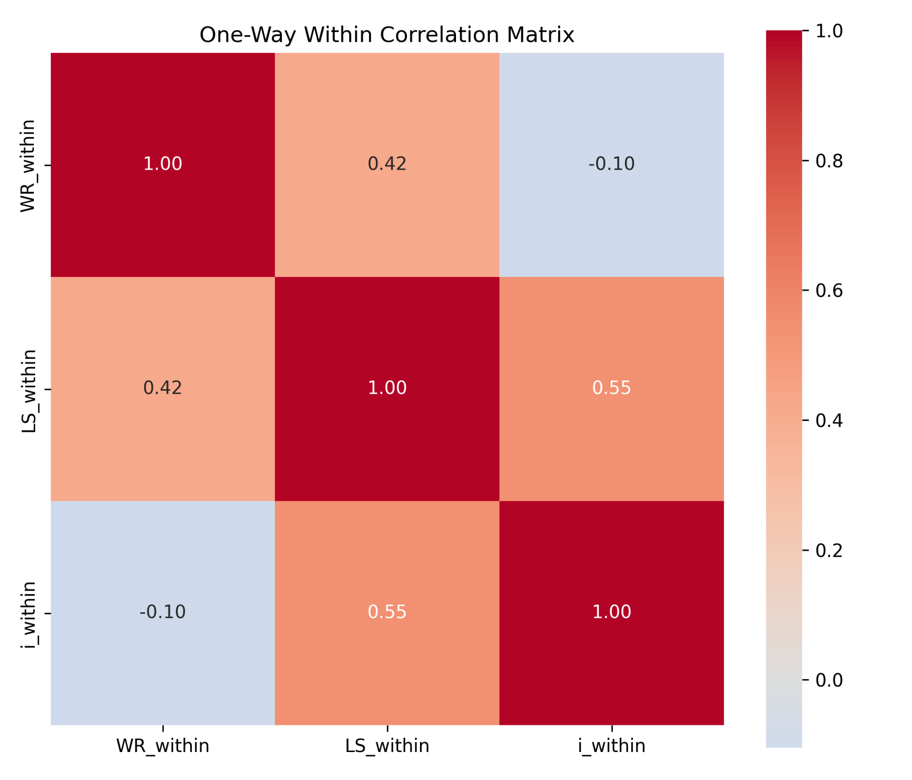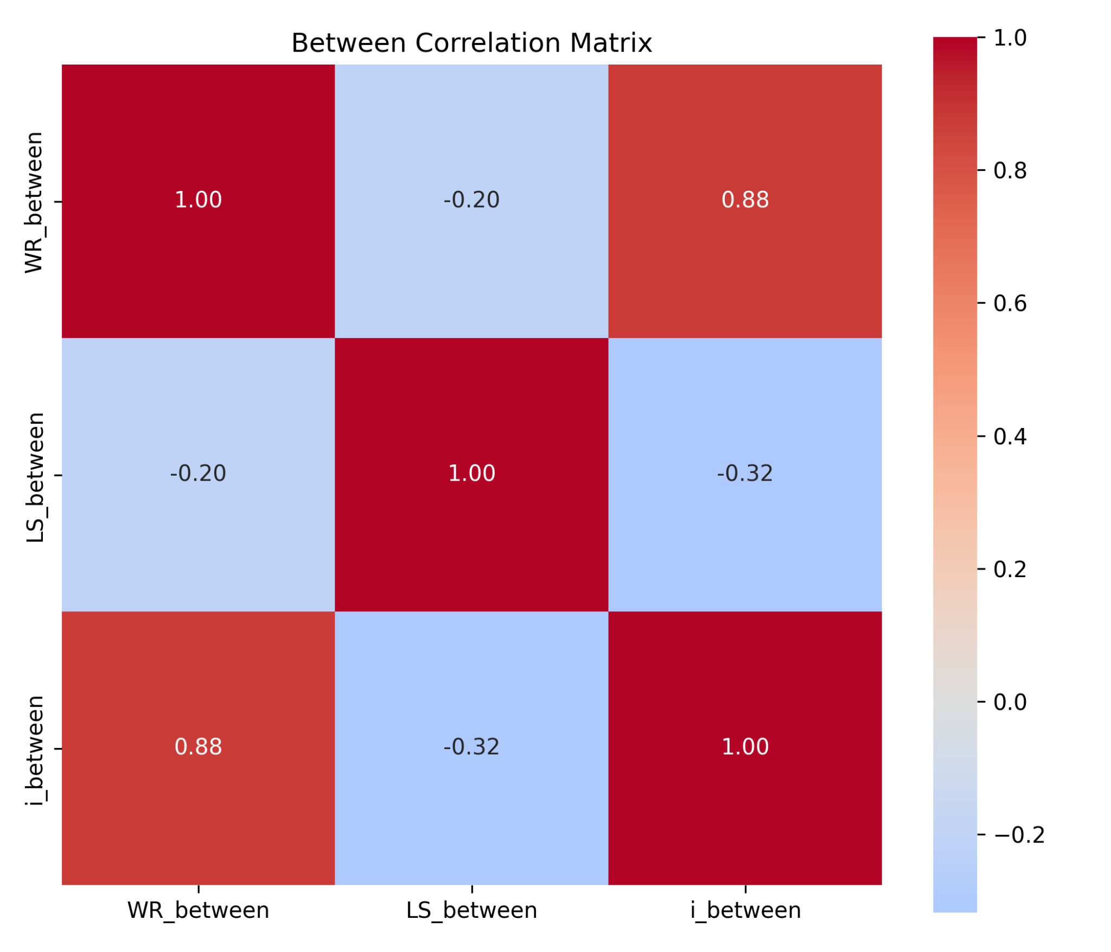
The correlation matrices show that the simple bivariate relationships depend strongly on the transformation used. The between correlation matrix captures long-run cross-country differences, while the within matrix captures deviations from country-specific averages. For the key relationship between the short-term interest rate and real wages, the within correlation is weakly negative. For labor share, the sign and strength of the relationship differ across transformations. This confirms that simple correlations should not be interpreted causally, because they are sensitive to whether the variation is cross-sectional, within-country, first-differenced or net of time effects.

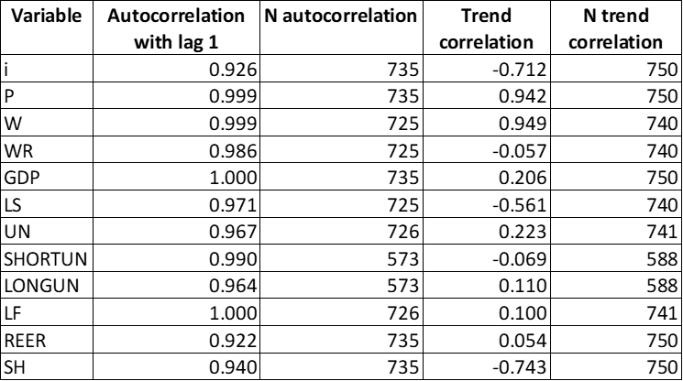

The autocorrelation and trend-correlation results in the table above show that several variables are persistent over time, especially macroeconomic level variables. This matters because persistent variables can produce misleading bivariate correlations if trends are not removed. The first-difference and two-way fixed effects transformations help address this issue by removing deterministic trends or common time movements. The first 30 observations of the first-difference variables and their lags confirm that the first observation of each country has missing first differences, so the code does not mistakenly subtract the last observation of one country from the first observation of the next country.

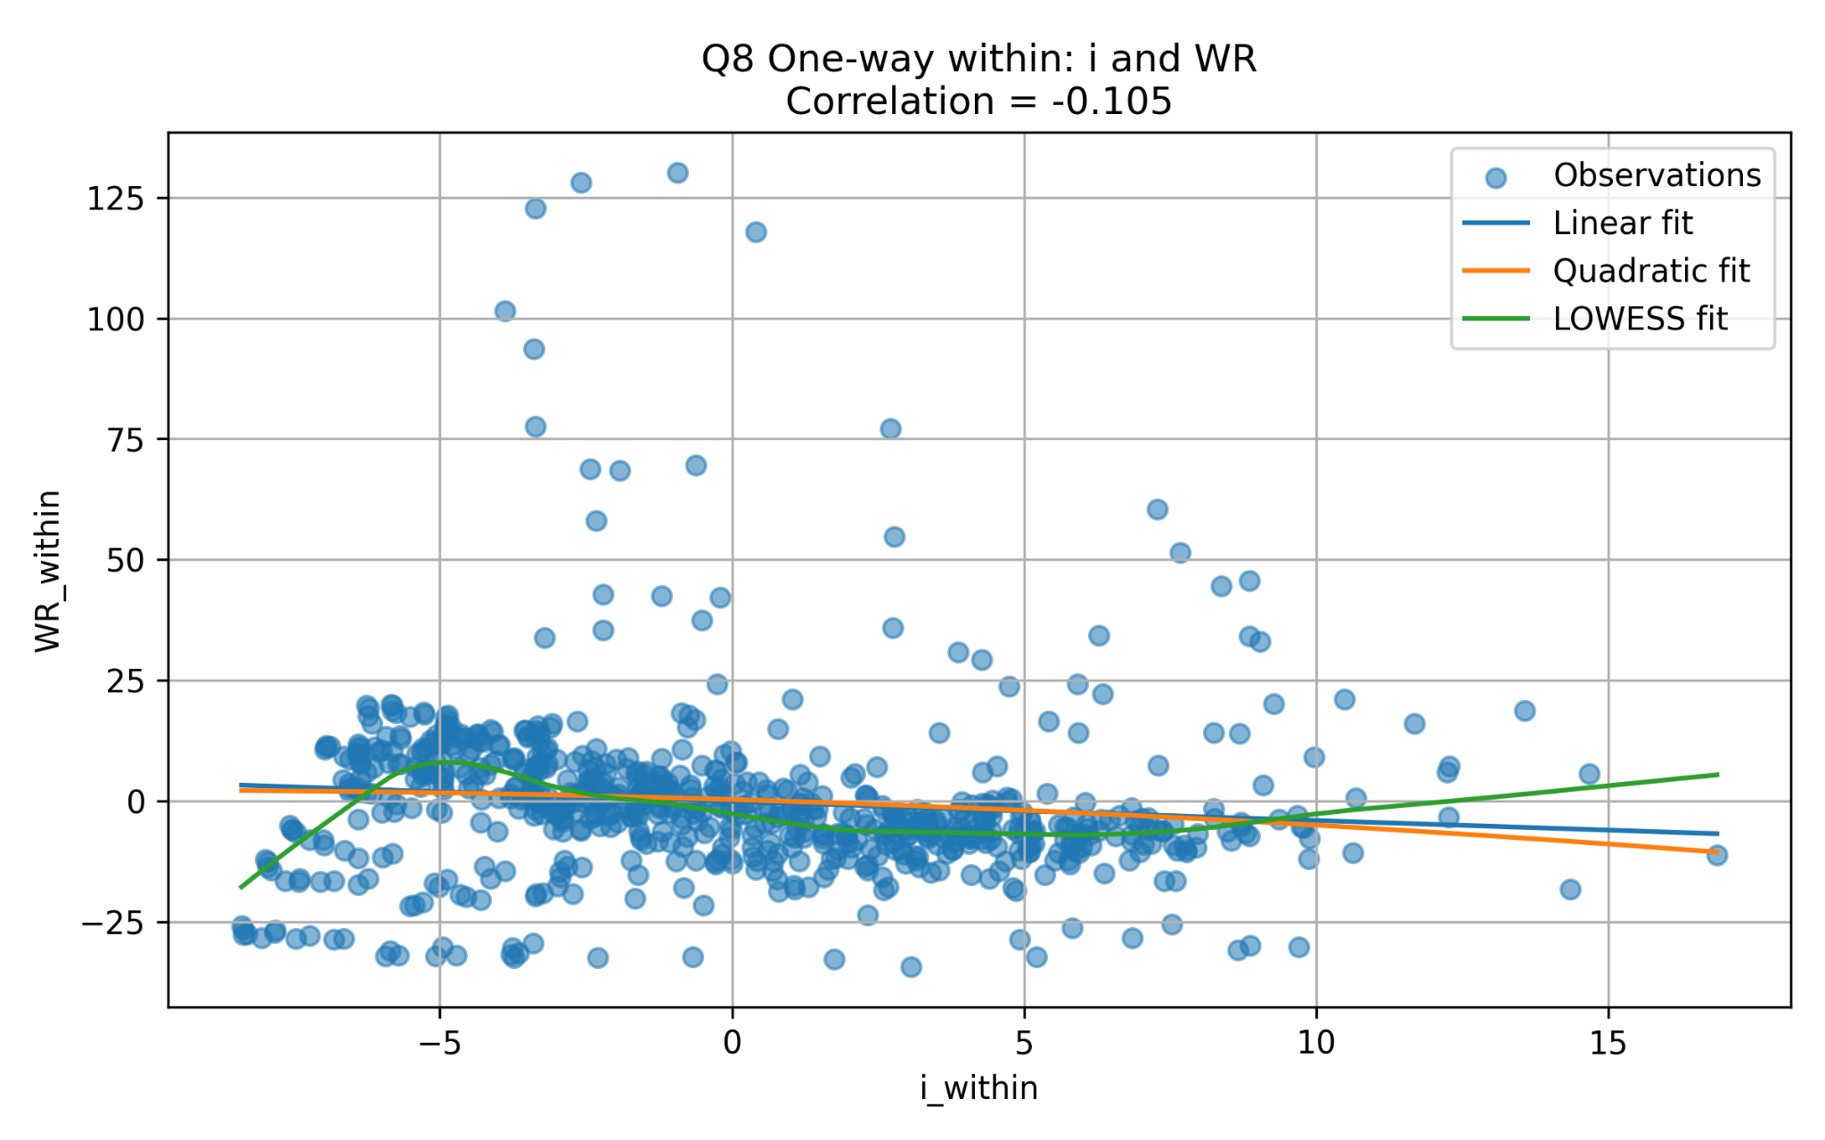

Finally, the bivariate graphs with linear, quadratic and LOWESS fits show that the relationship between the interest rate and the dependent variables is generally weak and sometimes nonlinear. The within-transformed relationship between i and WR is slightly negative, while the other transformations produce different patterns. The LOWESS curves suggest that some of the relationship may be driven by extreme observations rather than a stable linear association across the whole sample. Overall, the evidence from Question 8 supports the same conclusion as Question 5: the choice of transformation is not neutral, and the interpretation of the relationship between monetary policy and functional income distribution depends heavily on whether the analysis uses between-country variation, within-country deviations, first differences or two-way fixed effects.

9. Investigating bivariate heterogeneity by individuals for TWFE and FD

Diagnosis (First Differences) (Table in the Appendix)

The heterogeneity analysis reveals substantial variation across countries. For labor share, six countries belong to the positive-correlation group (correlation above 0.08), six countries belong to the negative-correlation group (correlation below -0.08), and three countries exhibit weak correlations. Australia displays the strongest positive correlation, while the Netherlands exhibits the strongest negative correlation.

For real wages, five countries belong to the positive-correlation group, six countries belong to the negative-correlation group, and four countries display weak correlations. The existence of positive, negative and weak groups indicates that the relationship between changes in interest rates and changes in functional income distribution is highly heterogeneous across countries.

These results suggest that pooled panel estimators may conceal important country-specific responses and motivate the investigation of subgroup regressions.

Diagnosis (Two-Way Fixed Effects)

The two-way fixed effects heterogeneity analysis confirms that the relationship between the short-term interest rate and the dependent variables differs substantially across countries. For labor share, nine countries exhibit positive correlations, three countries exhibit negative correlations and two countries display weak correlations. The predominance of positive correlations suggests that common time effects play an important role in the relationship between monetary policy and labor share.

For real wages, six countries exhibit positive correlations, six countries exhibit negative correlations and two countries display weak correlations. The distribution is therefore balanced between positive and negative responses, indicating that there is no single common effect across all countries.

The persistence of heterogeneity after removing both country and year effects suggests that institutional, structural and macroeconomic differences continue to influence how monetary policy affects labor share and real wages. Consequently, pooled panel estimates should be interpreted with caution, as they may conceal substantial country-specific variation.

10. Panel Data Estimates
In this section, we estimate several panel-data specifications in order to assess the relationship between monetary policy and functional income distribution. The dependent variables are the adjusted labor share (LS) and real wages per employee (WR). The main explanatory variable is the short-term interest rate, denoted (i). We also include GDP, unemployment (UN), and the real effective exchange rate (REER) as control variables.
We report five estimators: the Between estimator, the one-way Fixed Effects estimator, the Two-Way Fixed Effects estimator, the First Differences estimator, and the Mundlak correlated random effects specification.

Table 10.1. Panel data estimates: coefficient of the short-term interest rate

Dependent variable | Estimator | Coefficient of i | P-value | Interpretation
LS | Between | 0.782 | 0.378 | Not significant
LS | Fixed Effects | 0.455 | 0.000 | Significant at 1%
LS | Two-Way Fixed Effects | -0.025 | 0.627 | Not significant
LS | First Differences | 0.029 | 0.292 | Not significant
LS | Mundlak / CRE | 0.455 | 0.000 | Significant at 1%
WR | Between | 5.474 | 0.000 | Significant at 1%
WR | Fixed Effects | -0.270 | 0.036 | Significant at 5%
WR | Two-Way Fixed Effects | 0.011 | 0.970 | Not significant
WR | First Differences | -0.256 | 0.000 | Significant at 1%
WR | Mundlak / CRE | -0.270 | 0.036 | Significant at 5%
The results show that the estimated effect of the short-term interest rate depends strongly on the panel transformation used.
For the labor share (LS), the Between estimator gives a positive but statistically insignificant coefficient. This means that, when only cross-country average differences are considered, countries with higher average interest rates do not have a statistically different average labor share. The Fixed Effects estimator gives a positive and highly significant coefficient of approximately 0.455. However, when year fixed effects are added in the Two-Way Fixed Effects specification, the coefficient becomes negative and statistically insignificant. The First Differences estimator also gives a small and insignificant coefficient.
This suggests that the apparent positive relationship between interest rates and labor share in the one-way Fixed Effects model is not robust once common time shocks are controlled for. In other words, the relationship may partly reflect common macroeconomic episodes affecting all countries, rather than a stable within-country effect of monetary policy on labor share.
The Mundlak specification gives a coefficient close to the Fixed Effects estimator. This is expected because the Mundlak model includes the country means of the explanatory variables in order to account for correlation between country-specific effects and the regressors. The fact that the Mundlak estimates are close to the Fixed Effects estimates suggests that unobserved country heterogeneity is relevant and that simple pooled or standard random effects estimates would be inappropriate.
For real wages (WR), the results are even more contrasted. The Between estimator gives a large positive and statistically significant coefficient. This means that countries with higher average interest rates also tend to have higher average real wages. However, this cross-country relationship should not be interpreted causally, because it may reflect structural differences between countries.
Once country fixed effects are introduced, the coefficient becomes negative and statistically significant. The Fixed Effects coefficient is approximately -0.270, and the First Differences coefficient is also negative and highly significant, around -0.256. This suggests that, within countries over time, increases in the short-term interest rate are associated with lower real wages.
However, in the Two-Way Fixed Effects specification, the coefficient becomes almost zero and statistically insignificant. This means that once we control both for country fixed effects and common year shocks, the direct relationship between interest rates and real wages disappears. This result is important because it suggests that common macroeconomic shocks and international monetary conditions play a major role in the observed relationship.
Overall, the results confirm the importance of using several panel-data estimators. The Between estimator captures persistent cross-country differences, while the Fixed Effects and First Differences estimators focus on within-country changes over time. The Two-Way Fixed Effects estimator additionally removes common time shocks. Since the coefficient of the interest rate changes sign and significance across estimators, the relationship between monetary policy and functional income distribution should be interpreted with caution.
The main conclusion is that controlling for unobserved heterogeneity matters. For WR, the negative coefficients obtained with Fixed Effects and First Differences are consistent with the idea that tighter monetary policy may reduce real wages. For LS, the results are less robust, since the coefficient becomes insignificant under Two-Way Fixed Effects and First Differences. Therefore, the evidence is stronger for real wages than for labor share.

11. Hausman-Taylor Estimator

The Hausman-Taylor estimator was not implemented because the dataset does not contain any country-specific time-invariant variable.
According to the variable classification performed in the previous questions, the number of country-specific time-invariant variables is equal to zero (K1 = 0). As a result, the identification conditions required for the Hausman-Taylor estimator are not satisfied.
Consequently, the Hausman-Taylor specification is not applicable to the present dataset and cannot be estimated.
This limitation is directly related to the structure of the dataset. All explanatory variables either vary across countries, over time, or both. Therefore, there is no suitable time-invariant country characteristic that could be instrumented within the Hausman-Taylor framework.

12. Additional Estimation: The Impact of the Global Financial Crisis
As an additional estimation, we examine whether the relationship between monetary policy and functional income distribution differs before and after the Global Financial Crisis. We estimate the two-way fixed effects model separately for the pre-crisis period, 1970–2007, and the post-crisis period, 2008–2019. The dependent variables are the adjusted labor share, LS, and real wages, WR. The explanatory variables are the short-term interest rate, i, GDP, unemployment, and the real effective exchange rate. Country and year fixed effects are included in all specifications, and standard errors are clustered at the country level.
For the labor share, the coefficient of the short-term interest rate is close to zero before 2008, at -0.025, and statistically insignificant. In the post-2008 period, the coefficient becomes more negative, at -0.366, but it is also statistically insignificant once standard errors are clustered by country. Therefore, there is no strong statistical evidence that the effect of interest rates on the labor share differs before and after the crisis, although the post-crisis coefficient is economically larger in magnitude.
For real wages, the estimated coefficient is negative in both sub-periods. Before 2008, the coefficient is -0.718, while after 2008 it is -0.425. This suggests that higher interest rates are associated with lower real wages in both periods. However, neither coefficient is statistically significant with clustered standard errors. Therefore, the split-sample results are consistent in sign with the idea that tighter monetary policy may reduce real wages, but the estimates are too imprecise to provide strong evidence.
Overall, the split-sample analysis suggests that the relationship between monetary policy and labor-income indicators may differ across macroeconomic regimes, but the evidence is not statistically strong after clustering standard errors by country. The main conclusion is therefore more cautious: the coefficients are generally negative, especially for real wages, but the post-2008 sample is short and the clustered standard errors are large. This means that the results should be interpreted as exploratory robustness evidence rather than firm proof of a structural change after the Global Financial Crisis.

Table 12.1. Split-sample TWFE estimates before and after the 2008 crisis
Dependent Variable | Period | Coefficient of i | P-value | Interpretation
LS | 1970–2007 | -0.025 | 0.897 | Not significant
LS | 2008–2019 | -0.366 | 0.219 | Not significant
WR | 1970–2007 | -0.718 | 0.136 | Not significant
WR | 2008–2019 | -0.425 | 0.192 | Not significant

List of references cited in the text.
Bruegel. (2026). Real effective exchange rates for 178 countries: A new database. https://www.bruegel.org/publications/datasets/real-effective-exchange-rates-for-178-countries-a-new-database
European Commission. (2026). AMECO database. Directorate-General for Economic and Financial Affairs. https://economy-finance.ec.europa.eu/economic-research-and-databases/economic-databases/ameco-database_en
Jordà, Ò., Schularick, M., & Taylor, A. M. (2017). Macrofinancial history and the new business cycle facts. NBER Macroeconomics Annual, 31(1), 213–263. https://doi.org/10.1086/690241
Lofaro, A., & Di Bucchianico, S. (2025). Impact of monetary policy on functional income distribution: A panel vector autoregressive analysis. Economic Modelling, 151, 107227. https://doi.org/10.1016/j.econmod.2025.107227
Lofaro, A., & Di Bucchianico, S. (2025). Replication folder ECMODE-D-24-01693 [Data set]. Mendeley Data. https://data.mendeley.com/datasets/dbfjwwwzgf/1
Organisation for Economic Co-operation and Development. (2026). GDP and non-financial accounts. https://www.oecd.org/en/data/datasets/gdp-and-non-financial-accounts.html
Organisation for Economic Co-operation and Development. (2026). OECD Economic Outlook. https://www.oecd.org/economic-outlook/
Organisation for Economic Co-operation and Development. (2026). Short-term interest rates. https://www.oecd.org/en/data/indicators/short-term-interest-rates.html
World Bank. (2026). Commodity markets. https://www.worldbank.org/en/research/commodity-markets
Wu, J. C., & Xia, F. D. (2016). Measuring the macroeconomic impact of monetary policy at the zero lower bound. Journal of Money, Credit and Banking, 48(2–3), 253–291. https://doi.org/10.1111/jmcb.12300

Appendix:

To do list.

Tick | Items
 | Clearly identify the panel unit and time variable before starting the analysis.
 | Check whether the panel is balanced or unbalanced, and report missing years or missing countries.
 | Check for duplicate individual-time observations before estimating any model.
 | Verify that each dependent variable has enough consecutive observations for dynamic panel methods.
 | Classify variables as time-varying, time-invariant, or individual-invariant.
 | Produce summary statistics for the raw variables before transformations.
 | Plot the main dependent and explanatory variables over time.
 | Check missing values separately for each dependent variable and control variable.
 | Create transformed variables carefully, including logs, lags, first differences, and fixed-effects transformations.
 | Check that lags and first differences are computed within each country, not across country boundaries.
 | Compare between, within, first-difference, and two-way fixed-effects transformations before interpreting results.
 | Check for outliers and high-leverage country-year observations.
 | Estimate several models instead of relying on only one estimator.
 | Compare Between, Fixed Effects, Two-Way Fixed Effects, First Differences, and Mundlak/CRE results.
 | Cluster standard errors at the country level when using panel data.
 | Test whether common year effects matter by comparing one-way FE and two-way FE results.
 | Check whether results are driven by specific countries or time periods.
 | Run robustness checks, such as pre-crisis versus post-crisis samples.
 | Clearly distinguish descriptive correlations from causal estimates.
 | Keep a replication log recording data sources, code changes, errors, and outputs.
 | Save the final dataset, code, outputs, and documentation so another person can reproduce the results.

