Introduction and Overview
This paper describes the construction and execution of a Hierarchical State Machine or HSM. HSM's are a specialization and expansion of the common finite state machine. The HSM shares the same concepts of state, state pointer, edge, and transition with the previous art, but introduces several new concepts and restrictions. The eight components of the HSM available to the designer are described first; these are building blocks which must be arranged into a static configuration prior to execution of the HSM. The dynamic behavior of the HSM during execution is described next. Two techniques to introduce multi-threading are introduced. An example HSM is presented for illustration.
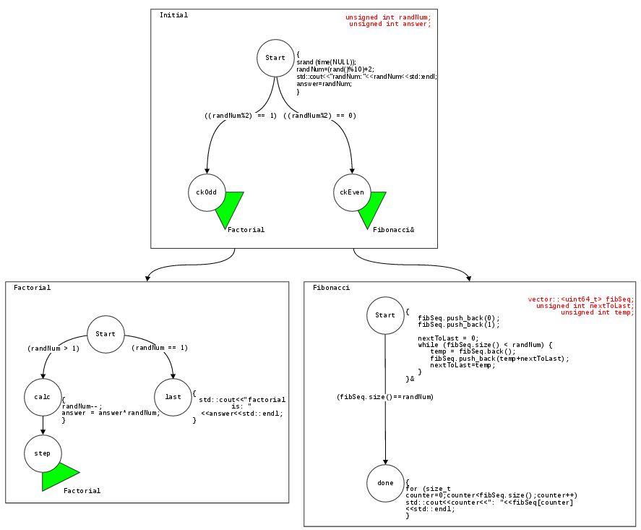
Illustration 1: An example HSM
Keywords: multi threaded finite state machine, hierarchy of hierarchies, two-level hierarchy, run-time tree, stack-like tree, linked state machines.

Static Components
An example fully-constructed machine is shown in Illustration 1. This example machine performs a simple task: it selects a random number between 2 and 11 inclusive; if the random number even, the machine calculates and prints its Factorial. If odd, the machine prints a Fibonacci set of that size. All eight static components are presented in this illustration: 1) sub-machine, 2) variable, 3) state, 4) edge, 5) forward link, 6) predicate, 7) code fragment, 8) threading primitive. Each is described in more detail below.
Several characteristics can be observed in Illustration 1 which apply to all HSM regardless of the size and shape of the problem at hand:
- Several sub-machines (named Initial, Factorial, and Fibonacci) comprise the overall HSM; the sub-machines are arranged in a hierarchy (the “outer hierarchy”).
- Each sub-machine is composed of several states (circles) which are also arranged in a hierarchy (the “inner hierarchies”).
- The HSM contains exactly one sub-machine named “Initial” at the top of its hierarchy of sub-machines. This name is chosen by convention for the top-most sub-machine of all HSM's.
- Each sub-machine contains exactly one state named “Start” at the top of its hierarchy of states. This name is also chosen by convention for the top-most state in each sub-machine.
The designer solving real problems may construct an HSM with any number of sub-machines and states arranged in any shape necessary; regardless of size and shape, these four basic characteristics will be retained.

1. Sub-machine
The sub-machine is the highest-level static component in the HSM and represents a basic unit of work, similar to a function, block, or compilation unit in a traditional language. In the illustration, three sub-machines are present and represented as large rectangles. Sub-machines decompose a large problem into several smaller, more manageable units of state machinery. The “Initial” sub-machine in every HSM is created automatically – every HSM contains at least one sub-machine. Additional sub-machines may be inserted by the designer to form a hierarchy of sub-machines rooted at the “Initial” sub-machine. Each additional sub-machine is assigned a unique name by the designer.

2. Variable
Variables may be declared by the designer within each sub-machine. In the illustration, the variable declarations are in red. Variables are typed and are uniquely named within each sub-machine. These are variable declarations – actual allocation of storage for the variables does not occur until execution.
Several predefined variables are available to the programmer, these are described below.

3 & 4. States and edges
Each sub-machine includes one or more states arranged into a hierarchy. Edges define the parent-child relationships between the states; each state besides Start has exactly one “inbound” edge. Every edge is associated with exactly one child state. In Illustration 1 the states are circles and the edges are directional arrows interconnecting the states. Every sub-machine contains at least one state “Start” which is created automatically. Additional states may be inserted into each sub-machine by the designer to form a hierarchy of states rooted at “Start”. States are uniquely named within each sub-machine. When a sub-machine executes, a current-state pointer is initialized to the Start state; the current-state pointer may traverse from state-by-state only along in in the direction of the prescribed edges until reaching a leaf or final-state. When a sub-machine reaches a final-state its execution is complete -- no further change to its current-state is possible.
Two more important characteristics of HSM's becomes clear here:
- Loops are not allowed within the states of a sub-machine. This is by definition since the states are arranged in a hierarchy. This is a significant difference from the prior art; repetition is accommodated via other means described below.
- State transitions cannot cross sub-machine boundaries. Connections between the sub-machines are possible via other means and are described below.

5. Predicates
Predicates are Boolean expressions associated with inbound edges. In the illustration, the predicates are enclosed in parenthesis. The predicates are specified by the designer and refer to the variables declared within and above the sub-machine in which the predicate appears. In Illustration 1 the predicate in sub-machine Factorial, state calc, references randNum, which is declared in sub-machine Initial. In Illustration 1, the predicate “(a>0)” in sub-machine Z state nonZero refers to variable “a” which was not declared in Z but declared in “Initial” - one level above it in the hierarchy of sub-machines.
During execution, predicates control transitions along edges and into the next-states during sub-machine execution. For any current-state pointer, the predicates of all potential next-states are continuously evaluated. State transition may proceed only upon evaluation to “true”. If multiple predicates evaluate true at the same time, the current-state may transition into any of those states (the order of evaluation is not defined).
If the programmer does not assign a predicate to a state, the default predicate “(true)” is used.
The programmer cannot apply a predicate to the Start state of a sub-machine -- this state has no inbound edge and is always entered automatically whenever the sub-machine is instantiated.

6. Code fragments
Code fragments are optional executable codes associated with the states. In Illustration 1 the code fragments are to the right of the states and enclosed in curly braces. These code fragments are executed once upon transition into the associated state. Code fragments are written by the designer and may read or write any variable declared within or above the sub-machine in which they appear. For threading purposes, code fragments may be asyncronous or syncronous. Syncronous code fragments block further state transitions until the fragment completes. Asyncronous code fragments are run in new, separate threads. In Illustration 1, the code fragment in sub-machine Fibonacci at state Start uses a trailing ampersand { ... }& to specify an asnycronous code fragment. When this state is entered, a new thread is created for the code fragment. Asynchronous code fragments allow state transitions to proceed immediately without blocking. As with any multi-threading, it is the designers responsibility to maintain practical limits on the number of threads launched and avoid data races.

7. Forward Links
Forward links are optional tags associated with states. In Illustration 1 the forward links are green and blue triangles. Forward links always refer to a target sub-machine by name and, when traversed during execution, instantiate a new copy of the target sub-machine - including a new current-state pointer and new instances of the targets variables. In Illustration 1, sub-machine Initial, state ckOdd contains a forward link to sub-machine Factorial. Forward in this context means “forward in time”; these links specify the temporal relationships between the various sub-machines. Forward links can be recursive -- they can target the same sub-machine in which they appear.
Two types of forward links are available to the designer -- “vertical” (in the illustration, green triangles pointing down) and “horizontal” (blue triangles pointing to the right). The difference between the two is described below.
Forward links allow the designer to control the logical flow of work during execution by controlling when the various sub-machines are instantiated.
Recursive forward links provide the designer with a mechanism to introduce repetition. Since sub-machines are not allowed to contain loops this is the only method by which repetition is allowed.
Sub-machine A traversing a forward link to B does not stop or wait for B in any way - A continues transitioning toward a final state, while B starts from its Start state. Both A and B are simultaneously active, each with its own current-state and each with it's own instantiated variables.
Several important restrictions on forward links are introduced below.

8. Threading Primitives
The HSM programmer also uses the ampersand character to specify asynchronous forward links. This enables multi-threaded sub-machine execution when desired. In Illustration 1, sub-machine Initial, state growVert contains an asyncronous forward link.
Asynchronous forward links create a new thread to execute the target sub-machine. Any additional sub-machines instantiated by that target are also executed within the new thread as well. As with any multi-threading, it is the designers responsibility to maintain practical limits on the number of threads launched and avoid data races.

Dynamic behavior during execution
After the designer has completely arranged all of the eight components above the HSM is ready for execution.
The HSM begins execution with one active instance of the Initial sub-machine, and with one current-state pointer pointing to the Start state therein. Forward links within Initial allow additional target sub-machines to be instantiated; and forward links within those targets allow even more sub-machines to be instantiated. An HSM may, therefore, simultaneously require many current-state pointers, one per instantiated sub-machine – a single current-state pointer is simply not sufficient. Complicated HSM's may have hundreds of concurrently instantiated sub-machines that will require hundreds of current-state pointers. Storage for these mutiple state pointers presents a basic challenge during execution and is achived by a “run-time” tree. The run-time tree is analogous to a run-time stack – except it is a tree, not a stack.
The run-time tree starts with one node, but grows and contracts during HSM execution. Each node in the run-time tree contains one current-state pointer and one set of instantiated variables from a single sub-machine. The run-time tree is initialized with a single root node whose current-state points to the Start state of the Initial sub-machine and contains instantiated variables from the Initial sub-machine. An additional node is inserted into the run-time tree upon traversal of each forward link. The new node contains the current-state pointer and instantiated variables for the target sub-machine.
When an instantiated sub-machine reaches a final state its node in the run-time tree becomes dormant. Actual deletion of the node is deferred until the node is a leaf – after it has no children.
The distinction between “dormant” and “deleted” is important – it is critical that instantiated variables remain instantiated for as long as access is possible.
The process of instantiation, transitioning, forward-linking, dormancy, and deletion continues recursively until all nodes in the run-time tree are deleted. At this moment execution of the HSM is complete.
Two types of forward links may be inserted by the designer into a sub-machine: vertical and horizontal. In illustration 1, the vertical links are shown as green trianges “pointed down”. The horizontal links are shown as blue trianges “pointing right”. The distinction between the two is as follows: a vertical link causes insertion of the new run-time node as a child of the current node; a horizontal link causes insertion of the new run-time node as a sibling of the current node.
Whenever a new node is inserted into the run-time tree, by either type of link, the new node is assigned a “sibling order” among it's peers. The first child is assigned sibling order of 0, the next child 1, the next child 2, etc.

Restrictions on Forward Links
There are several restrictions placed on forward links:
- The initial sub-machine is limited to only vertical forward links – it cannot contain any horizontal forward links. By definition, it is not possible for a tree's root node to have siblings, which a horizontal link creates.
- All sub-machines are limited to creating at most one child and at most one sibling in the run-time tree. This guarantees deterministic behavior in the run-time tree during execution – specifically in the assignment of sibling order. It also eliminates the need for locking when processing forward links.
Although a sub-machine overall may contain several of each type, each possible sequence of transitions from Start-to Final is limited to one of each type. In Illustration 1, sub-machine “Initial”, there are two leaf states and thus two possible sequences of transition:
  - {Start, ckEven}
  - {Start, ckOdd}
Each sequence contains just one vertical forward link.
- Vertical forward links can target only A) sub-machines declared as children of the containing sub-machine in the hierarchy of sub-machines, or B) the Initial sub-machine.
- Horizontal forward links can target only A) sub-machines declared as siblings of the containing sub-machine in the hierarchy of sub-machines, or B) the Initial sub-machine.

Predefined Variables
The following unsigned integer variables are always available to the HSM programmer:
- numChildren: the number of instantiated sub-machines “below” the current sub-machine.
- numSiblings: the number of instantiated sub-machines in the run-time tree that are siblings of the current sub-machine. This variable is not defined in the Initial sub-machine because it executes at the root of the run-time tree (which by definition cannot have siblings).
- nextChild: the number to be assigned to the next child node in the run-time tree.
- SiblingOrder: the order in which the current sub-machine was instantiated in the run-time tree relative to its siblings.

