**Remember the discussion about those two databases from the class, also remember, those data models are not perfect. You can always add new columns (but not alter or drop columns) to any tables. Suggesting adding Ingested DateTime and Surrogate Key columns. Study the Wide World Importers DW. Think the integration schema is the ODS. Come up with a TSQL Stored Procedure driven solution to move the data from WWI database to ODS, and then from the ODS to the fact tables and dimension tables. By the way, WWI DW is a galaxy schema db. Requirements:**

* 1. **Luckly, we only start with 1 fact: Order. Other facts can be ignored for now.**
  2. **Add a new dimension: Country of Manufacture. It should be given on top of Stock Items.**
  3. **Write script(s) and stored procedure(s) for the entire ETL from WWI db to DW. (not yet finished)**

This is the star schema for orders. We extract data from WWI and insert it to ODS. we add a new dimension to the country of manufacture.

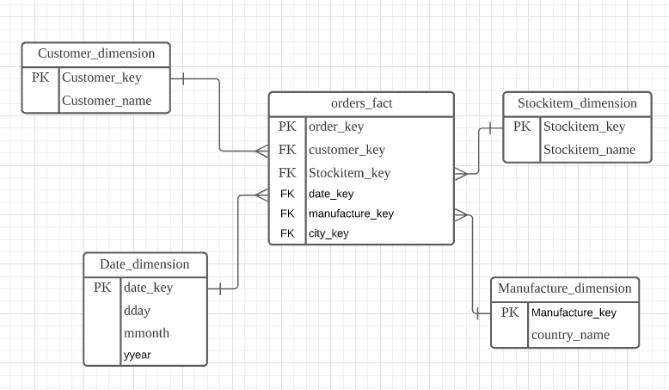

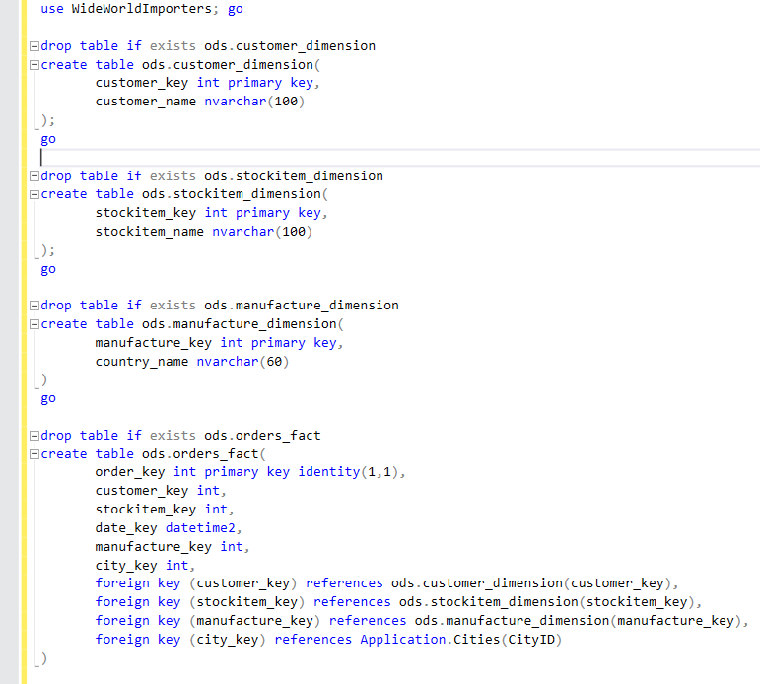

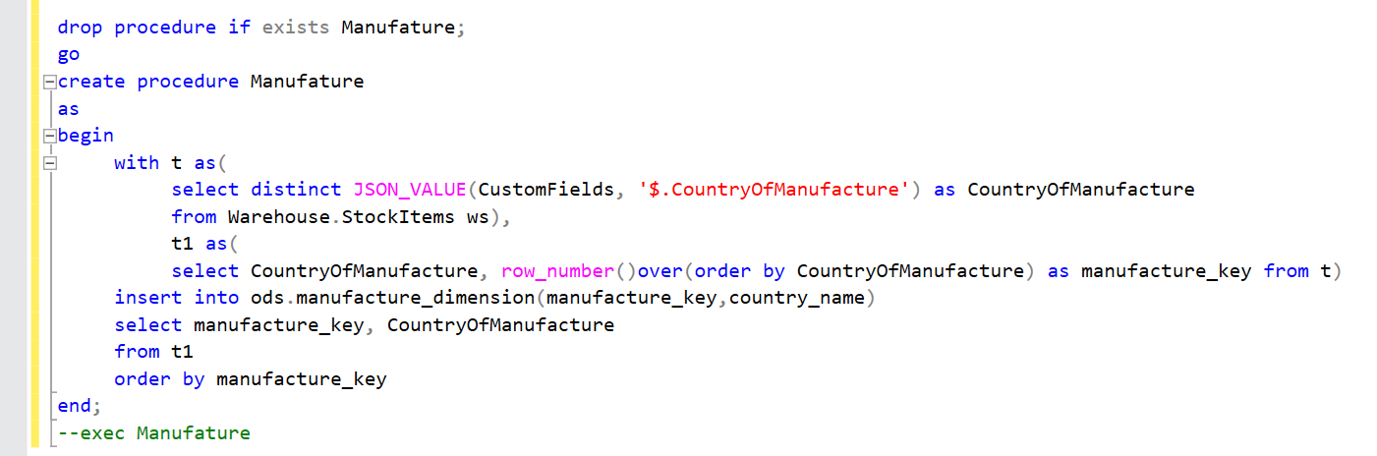Then, merge the data from ods to DW.