**Screenshots:**

1. 60 seconds & 167 Users

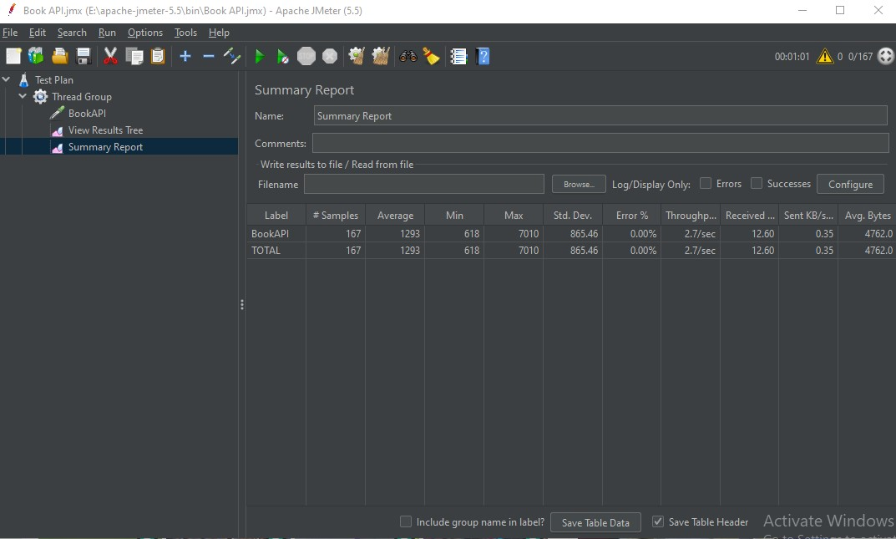

1. **600 seconds & 832 Users**

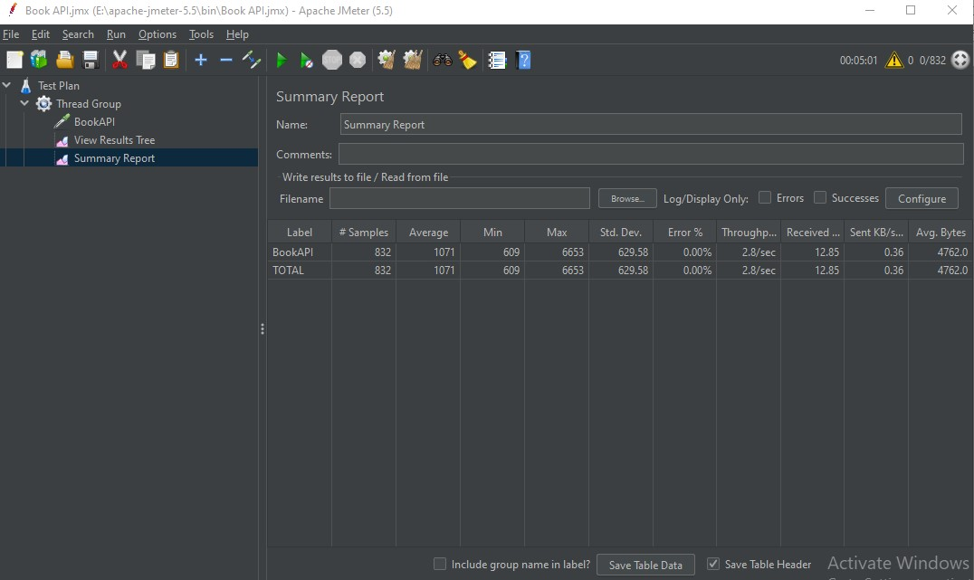

1. **600 secs & 1662 Users**

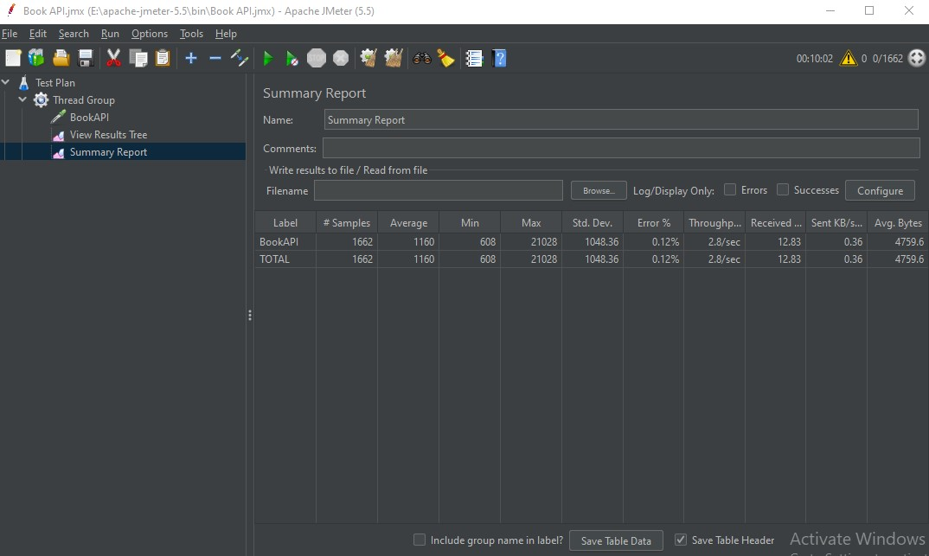

1. **650 seconds & 1662 Users:**

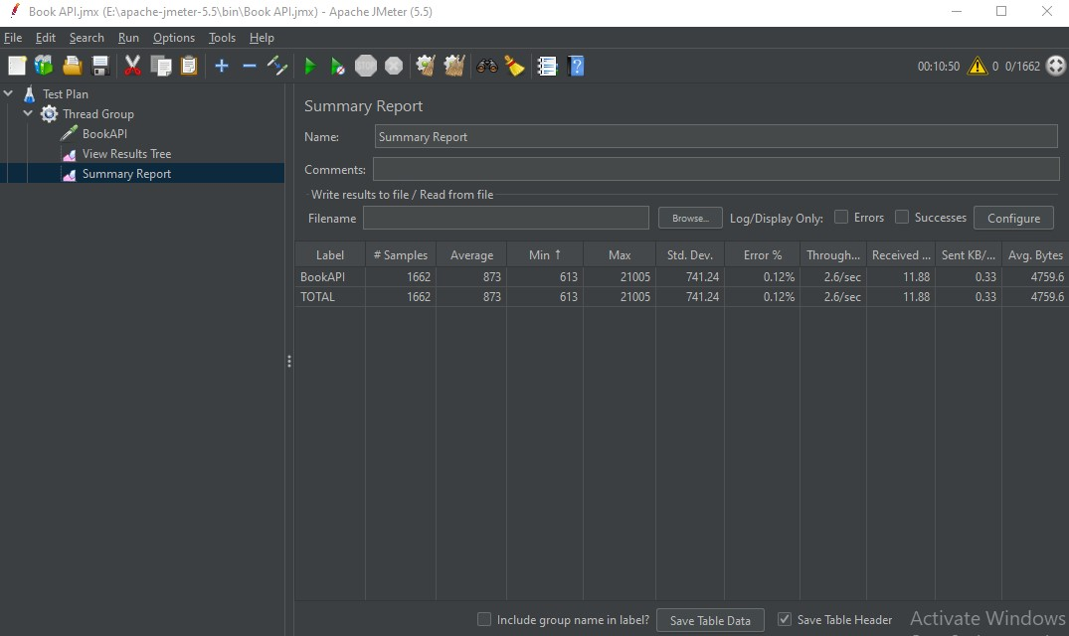

1. **700 seconds and 1662 users:**

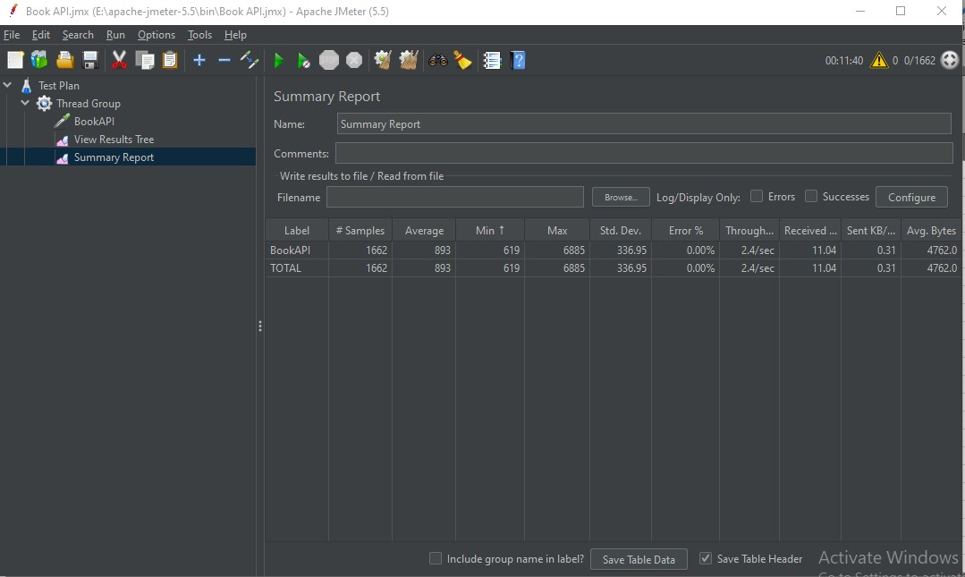

1. **900 seconds & 2493 Users**

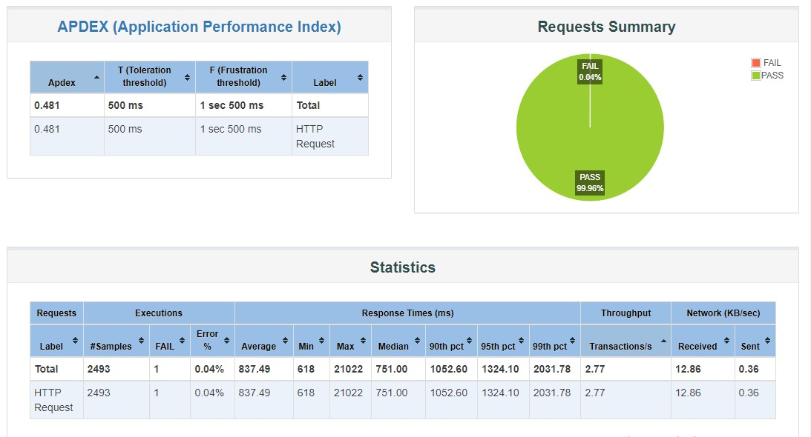

1. **950 seconds and 2493 users**

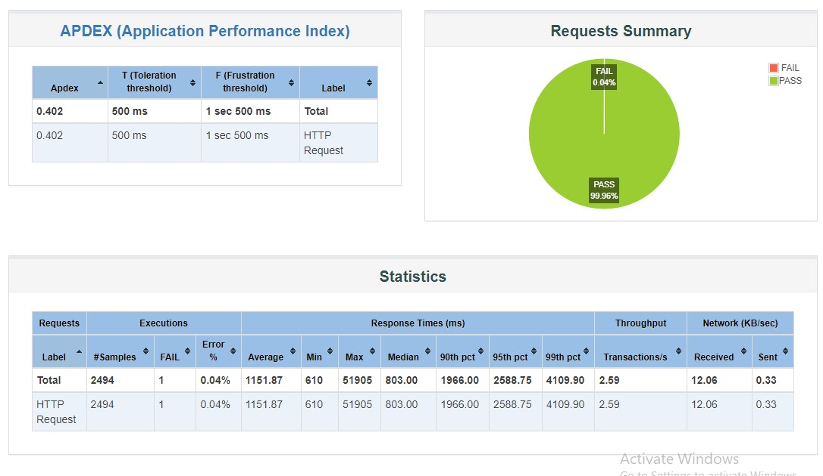

1. **1000 seconds and 2493 users**

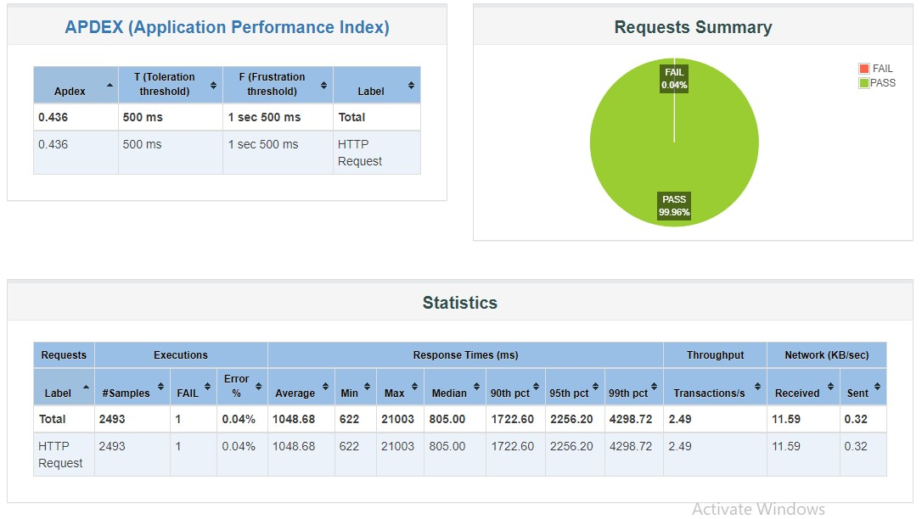

1. **1100 seconds and 2493 users**

